Zion Lutheran Church
Mascoutah, Illinois
September 22, 2019
14th Sunday after Trinity

In the Name of Christ Jesus our Lord, we bid you a warm welcome to this worship service. May your experience of worship and fellowship this morning be spiritually refreshing and ready you for the week ahead.

Pastor: Rev. Kirk Clayton
Church Secretary: Robin Phillips
Choir Director Team: Josh and Nancy Peterson
_________________________________________________________________________________
Church Office Phone: 618-566-7345
Pastor Clayton Cell: 618-447-1306
Office Hours: 8:00 am to 12:00 pm
Email: ChurchOffice@ZionMascoutah.org
Pastor Clayton email: Pastor@ZionMascoutah.org
Web site: www.ZionMascoutah.org
Find us at @ZionMascoutah on Facebook, Twitter, and Instagram
Electronic Devices
Please TURN OFF all cell phones, pagers, electronic devices, apps and games when entering the sanctuary for worship so those around you may focus on the Word of God without electronic distraction. Thank you.

A Prayer to Begin Worship
Gracious God, who in grace and mercy supplies our temporal needs, give us faith to await Your gifts and a spirit of thanksgiving whether they come or not, for by Your wisdom we have been chosen to live eternally; through Jesus Christ, our Lord, who with You and the Holy Spirit are one God with dominion over us forever.

DIVINE SERVICE I WITH COMMUNION
LSB p. 151
Confession and Absolution

Prelude Suite Brevis on ‘Beach Spring’ David Lasky

Hymn Praise the One Who Breaks the Darkness LSB 849

Stand

The sign of the cross may be made by all in remembrance of their Baptism.

Invocation
P In the name of the Father and of the T Son and of the Holy Spirit.
C Amen.

Exhortation
P If we say we have no sin, we deceive ourselves, and the truth is not in us.
C But if we confess our sins, God, who is faithful and just, will forgive our sins and cleanse us from all unrighteousness.

Silence for reflection on God's Word and for self-examination.

Confession of Sins
P Let us then confess our sins to God our Father.
C Most merciful God, we confess that we are by nature sinful and unclean. We have sinned against You in thought, word, and deed, by what we have done and by what we have left undone. We have not loved You with our whole heart; we have not loved our neighbors as ourselves. We justly deserve Your present and eternal punishment. For the sake of Your Son, Jesus Christ, have mercy on us. Forgive us, renew us, and lead us, so that we may delight in Your will and walk in Your ways to the glory of Your holy name. Amen.

Absolution
P Almighty God in His mercy has given His Son to die for you and for His sake forgives you all your sins. As a called and ordained servant of Christ, and by His authority, I therefore forgive you all your sins in the name of the Father and of the T Son and of the Holy Spirit.
C Amen.

Service of the Word
Introit Ps. 84:1–2a, 4, 10b, 11b; antiphon: Ps. 84:9–10a
L Behold our shield, O God; look on the face of Your anointed!
C For a day in Your courts is better than a thousand elsewhere.
L How lovely is Your dwelling place, O Lord of hosts!
C My soul longs, yes, faints for the courts of the Lord.
L Blessèd are those who dwell in Your house,
C ever singing Your praise!
L I would rather be a doorkeeper in the house of my God
C than dwell in the tents of wickedness.
L The Lord bestows favor and honor.
C No good thing does He withhold from those who walk uprightly.
Glory be to the Father and to the Son
and to the Holy Spirit;
as it was in the beginning,
is now, and will be forever. Amen.
L Behold our shield, O God; look on the face of Your anointed!
C For a day in Your courts is better than a thousand elsewhere.

Kyrie LSB 152
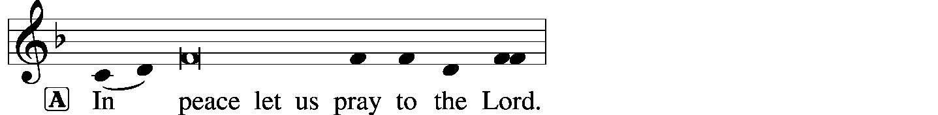
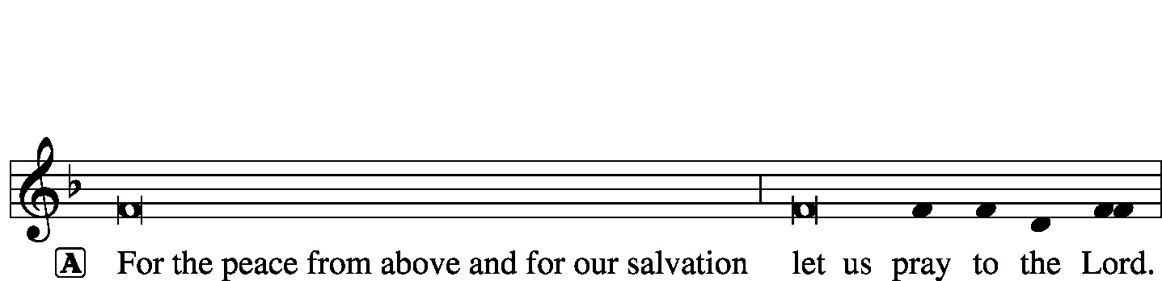
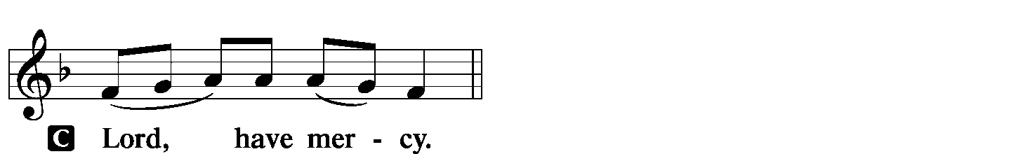
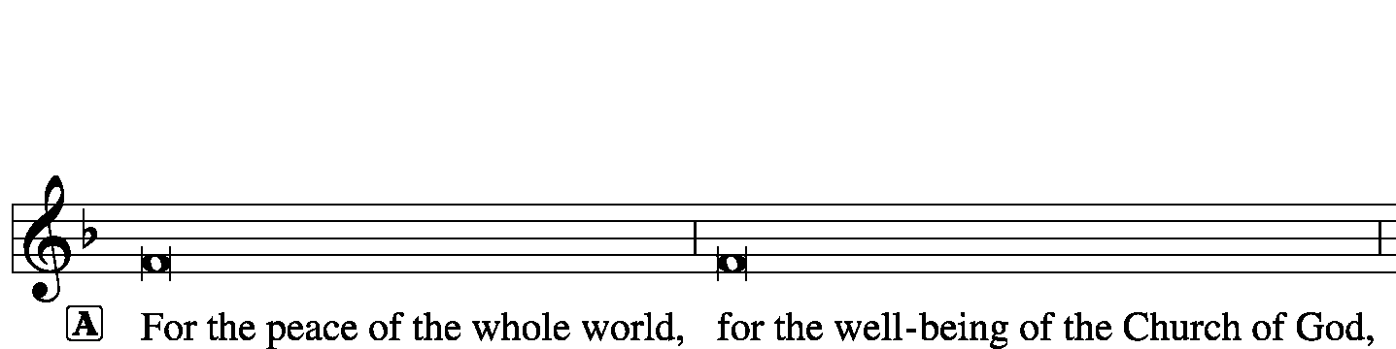
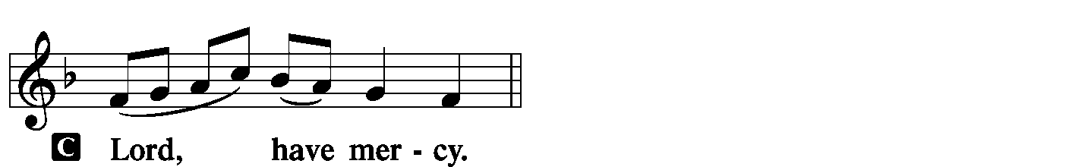
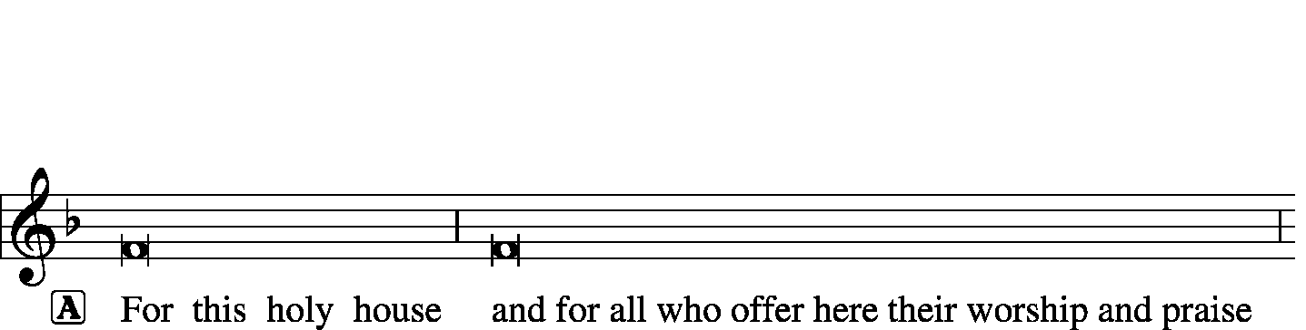
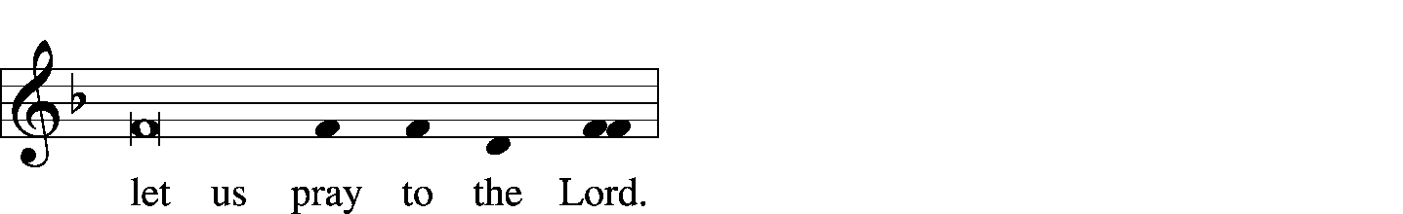
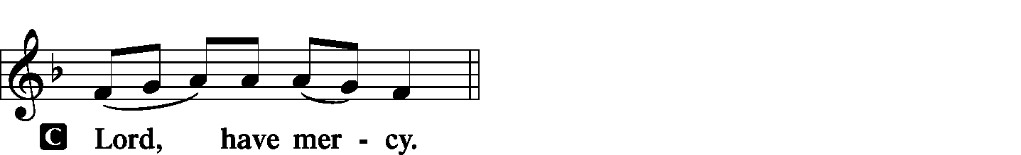
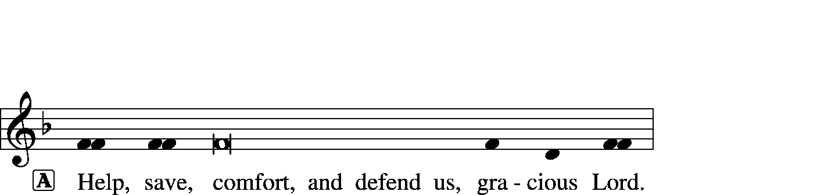

Hymn of Praise -- This Is the Feast LSB 155
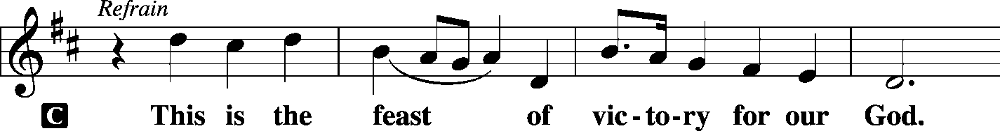
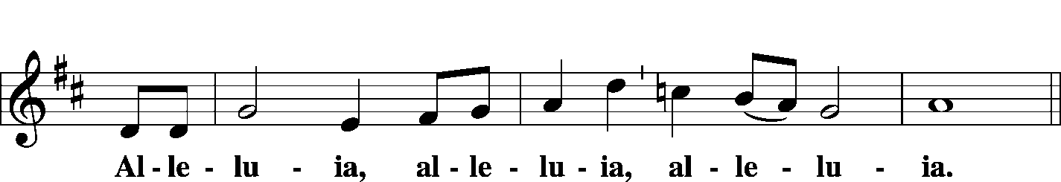
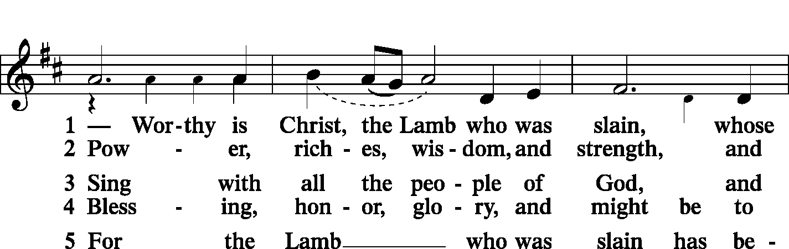
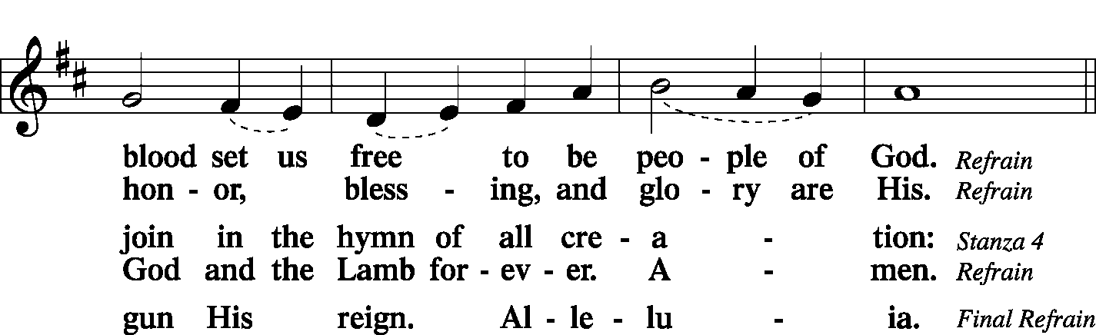
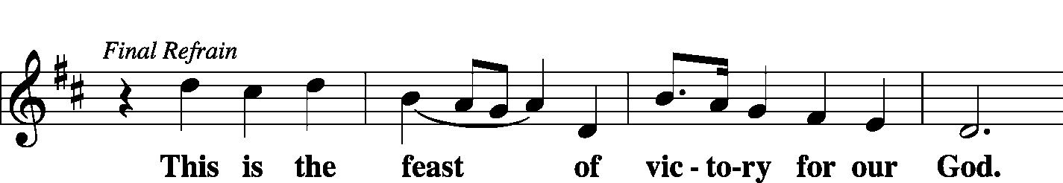
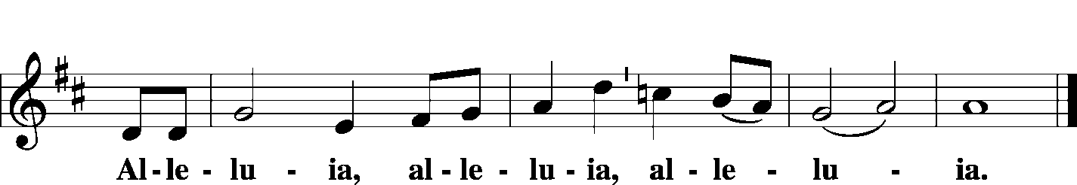

Salutation and Collect of the Day
L The Lord be with you.
C And also with you.
L Let us pray.
O Lord, keep Your Church with Your perpetual mercy; and because of our frailty we cannot but fall, keep us ever by Your help from all things hurtful and lead us to all things profitable to our salvation; through Jesus Christ, Your Son, our Lord, who lives and reigns with You and the Holy Spirit, one God, now and forever.
C Amen.

Sit

Old Testament Reading Proverbs 4:10–23
Hear, my son, and accept my words, that the years of your life may be many. I have taught you the way of wisdom; I have led you in the paths of uprightness. When you walk, your step will not be hampered, and if you run, you will not stumble. Keep hold of instruction; do not let go; guard her, for she is your life. Do not enter the path of the wicked, and do not walk in the way of the evil. Avoid it; do not go on it; turn away from it and pass on. For they cannot sleep unless they have done wrong; they are robbed of sleep unless they have made someone stumble. For they eat the bread of wickedness and drink the wine of violence. But the path of the righteous is like the light of dawn, which shines brighter and brighter until full day. The way of the wicked is like deep darkness; they do not know over what they stumble. My son, be attentive to my words; incline your ear to my sayings. Let them not escape from your sight; keep them within your heart. For they are life to those who find them, and healing to all their flesh. Keep your heart with all vigilance, for from it flow the springs of life.
L This is the Word of the Lord.
C Thanks be to God.

Choir A Song of Joy Allen Pote

Epistle Galatians 5:16-24
But I say, walk by the Spirit, and you will not gratify the desires of the flesh. For the desires of the flesh are against the Spirit, and the desires of the Spirit are against the flesh, for these are opposed to each other, to keep you from doing the things you want to do. But if you are led by the Spirit, you are not under the law. Now the works of the flesh are evident: sexual immorality, impurity, sensuality, idolatry, sorcery, enmity, strife, jealousy, fits of anger, rivalries, dissensions, divisions, envy, drunkenness, orgies, and things like these. I warn you, as I warned you before, that those who do such things will not inherit the kingdom of God. But the fruit of the Spirit is love, joy, peace, patience, kindness, goodness, faithfulness, gentleness, self-control; against such things there is no law. And those who belong to Christ Jesus have crucified the flesh with its passions and desires.
L This is the Word of the Lord.
C Thanks be to God.

Stand

Common Alleluia and Verse LSB 156
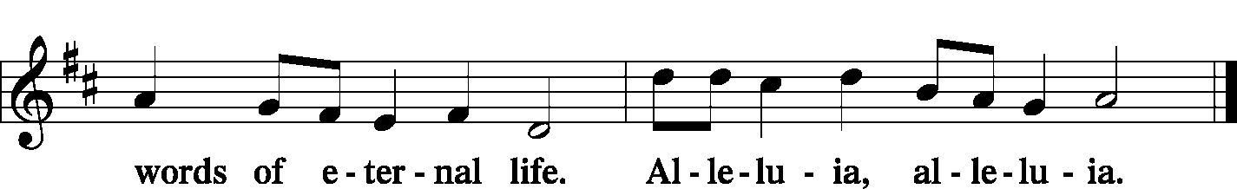

Holy Gospel Luke 17:11–19
P The Holy Gospel according to St. Luke, the 17th chapter.
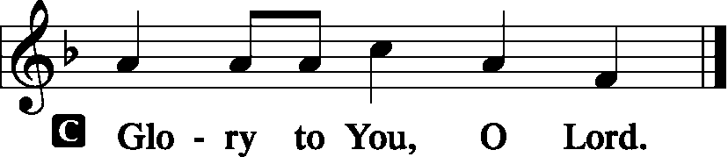
On the way to Jerusalem [Jesus] was passing along between Samaria and Galilee. And as He entered a village, He was met by ten lepers, who stood at a distance and lifted up their voices, saying, “Jesus, Master, have mercy on us.” When He saw them He said to them, “Go and show yourselves to the priests.” And as they went they were cleansed. Then one of them, when he saw that he was healed, turned back, praising God with a loud voice; and he fell on his face at Jesus’ feet, giving Him thanks. Now he was a Samaritan. Then Jesus answered, “Were not ten cleansed? Where are the nine? Was no one found to return and give praise to God except this foreigner?” And He said to him, “Rise and go your way; your faith has made you well.”
P This is the Gospel of the Lord.
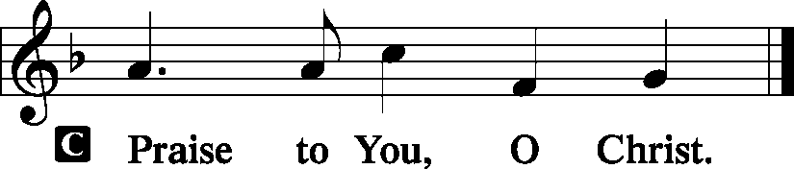

Sit

Hymn Your Hand, O Lord, in Days of Old LSB 846

Sermon Cleansed
Stand

Nicene Creed
C I believe in one God, the Father Almighty, maker of heaven and earth and of all things visible and invisible.
And in one Lord Jesus Christ, the only-begotten Son of God, begotten of His Father before all worlds, God of God, Light of Light, very God of very God, begotten, not made, being of one substance with the Father, by whom all things were made; who for us men and for our salvation came down from heaven and was incarnate by the Holy Spirit of the virgin Mary and was made man; and was crucified also for us under Pontius Pilate. He suffered and was buried. And the third day He rose again according to the Scriptures and ascended into heaven and sits at the right hand of the Father. And He will come again with glory to judge both the living and the dead, whose kingdom will have no end.
And I believe in the Holy Spirit, the Lord and giver of life, who proceeds from the Father and the Son, who with the Father and the Son together is worshiped and glorified, who spoke by the prophets. And I believe in one holy Christian and apostolic Church, I acknowledge one Baptism for the remission of sins, and I look for the resurrection of the dead and the life T of the world to come. Amen.

Prayer of the Church
P Lord God, heavenly Father, we come before You with thanksgiving.
C We praise You for Your mighty works which exceed anything we can think or do.
P With a mighty hand You delivered Your chosen people from the shackles of slavery.
C With an even mightier hand You raised Your Son Jesus Christ from the dead.
P Through Him we, who trust in Him as our Savior, have the hope of eternal life.
C For this, the mightiest of all works, we give You humble and hearty thanks.
P As we thank and praise You, O Lord, we realize how thankless and ungrateful we have often been in the past.
C We have been like the nine lepers who went on their way, enjoying Your merciful gifts but forgetting to give You thanks.
P The leprosy of sin still clings to us, O Lord, and prevents us from giving You the perfect praise due Your most holy name.
C Imperfect though it be, accept our thanks for delivering us from the internal consequences of this leprosy.
P In the name of Jesus Christ we beg Your forgiveness; in Your mercy, make us whole.
C Send us Your Holy Spirit that He may strengthen our faith and help us to accept Your forgiveness through Jesus Christ, our Lord.
P May our lives constantly reflect our gratitude for Your great mercy.
C Give us the courage to witness to our faith in Christ that others may obtain life in His name.

WE GO TO THE LORD IN PRAYER FOR
- James Barnard, Shannon Barnard, James Rehfeldt, Larry Richards, Lauren Twenhafel, and Brennen Magers, as they celebrate their baptismal anniversaries this week.
- The "Roots" Campus Ministry Conference at St. Louis Seminary Oct. 11 & 12 for our college students, sponsored by our district campus ministries.
- Zion’s Men’s Club and Ladies Aid, and Youth Group.
- Faithfulness in personal witness and evangelism.

P May Your mighty power, as revealed in Your Word, be a source of healing power to the sick.
C Accept our praise and thanksgiving in the name of Jesus Christ, our Lord. Amen.

Sit

Offering
[Please fill out a sheet in the attendance book. Visitors, please include your address. If you have a prayer request for the church prayer chain, please write it at the top of the sheet.]

Special Offering Music Lily McDaniel

Stand

Offertory LSB 159
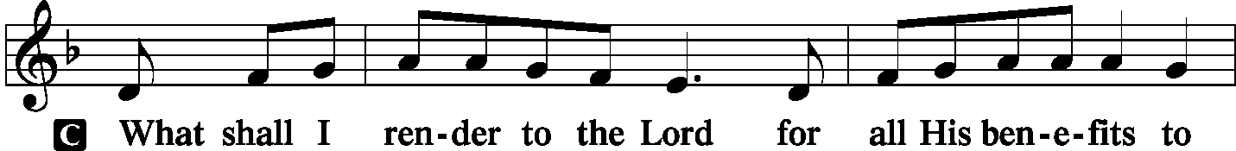
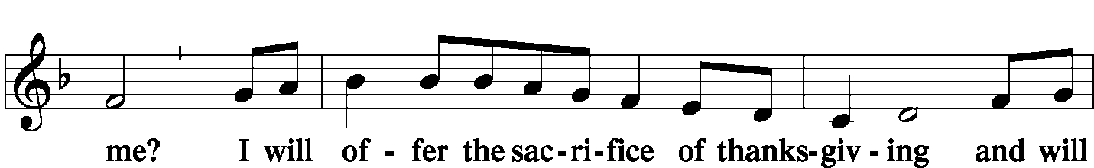
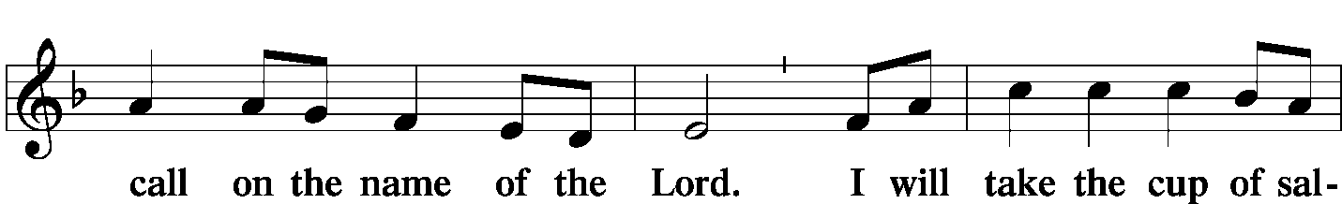
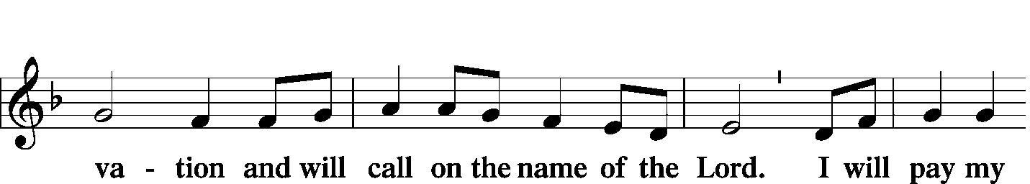
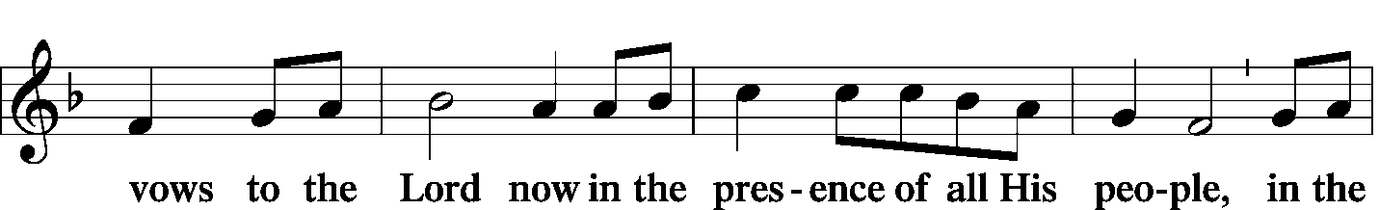
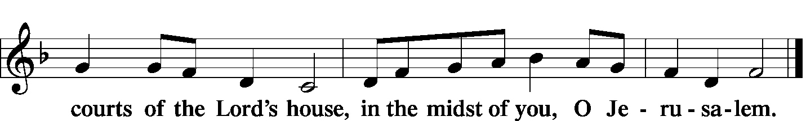

Service of the Sacrament
Preface LSB 160
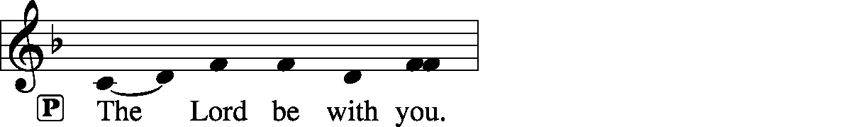
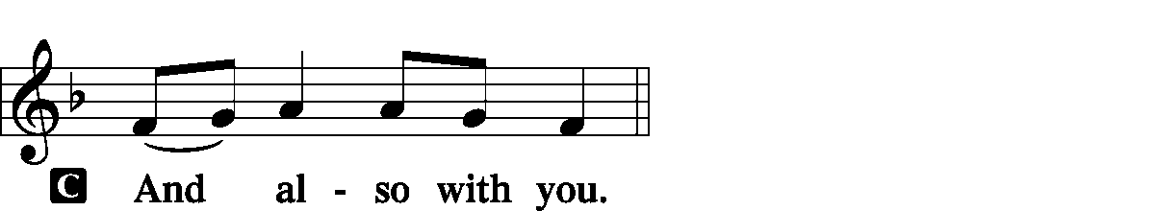
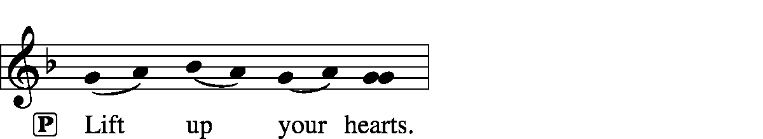
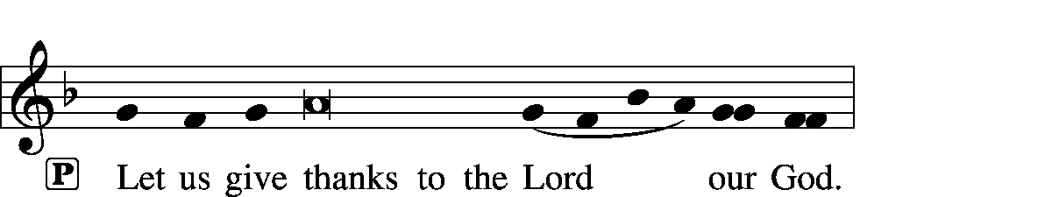
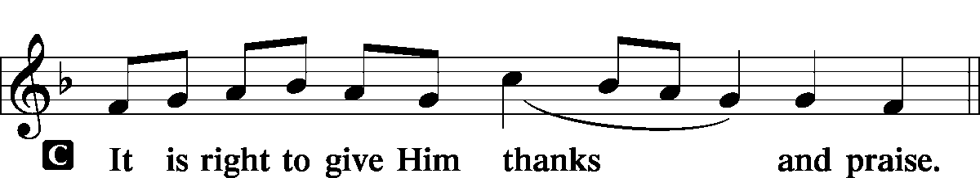

Proper Preface (Full)
P It is truly good, right, and salutary that we should at all times and in all places give thanks to You, holy Lord, almighty Father, everlasting God, through Jesus Christ, our Lord, who on this day overcame death and the grave and by His glorious resurrection opened to us the way of everlasting life. Therefore with angels and archangels and with all the company of heaven we laud and magnify Your glorious name, evermore praising You and saying:

Sanctus LSB 161
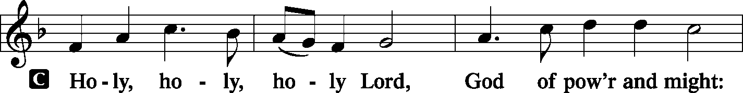
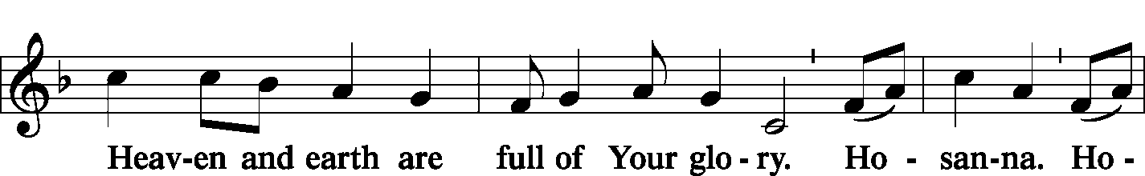
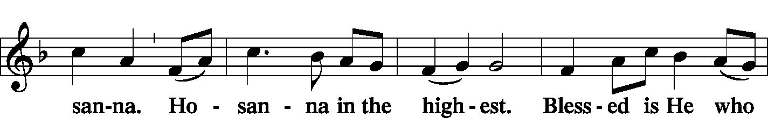
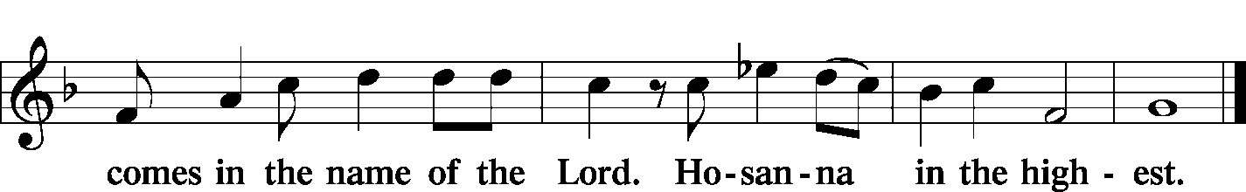

Prayer of Thanksgiving LSB 161
P Blessed are You, Lord of heaven and earth, for You have had mercy on those whom You created and sent Your only-begotten Son into our flesh to bear our sin and be our Savior. With repentant joy we receive the salvation accomplished for us by the all-availing sacrifice of His body and His blood on the cross.

Gathered in the name and the remembrance of Jesus, we beg You, O Lord, to forgive, renew, and strengthen us with Your Word and Spirit. Grant us faithfully to eat His body and drink His blood as He bids us do in His own testament. Gather us together, we pray, from the ends of the earth to celebrate with all the faithful the marriage feast of the Lamb in His kingdom, which has no end. Graciously receive our prayers; deliver and preserve us. To You alone, O Father, be all glory, honor, and worship, with the Son and the Holy Spirit, one God, now and forever.
C Amen.

Lord's Prayer LSB 162
P Lord, remember us in Your kingdom and teach us to pray:
C Our Father who art in heaven, hallowed be Thy name, Thy kingdom come, Thy will be done on earth as it is in heaven; give us this day our daily bread; and forgive us our trespasses as we forgive those who trespass against us; and lead us not into temptation, but deliver us from evil. For Thine is the kingdom and the power and the glory forever and ever. Amen.

The Words of Our Lord LSB 162
P Our Lord Jesus Christ, on the night when He was betrayed, took bread, and when He had given thanks, He broke it and gave it to the disciples and said: “Take, eat; this is My T body, which is given for you. This do in remembrance of Me.”
In the same way also He took the cup after supper, and when He had given thanks, He gave it to them, saying: “Drink of it, all of you; this cup is the new testament in My T blood, which is shed for you for the forgiveness of sins. This do, as often as you drink it, in remembrance of Me.”

Pax Domini LSB 163
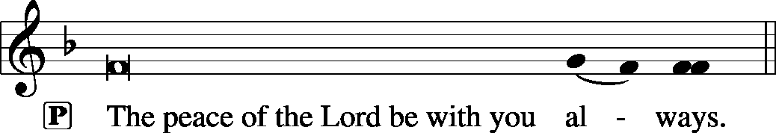

Agnus Dei LSB 163
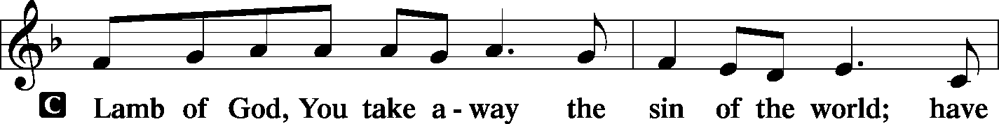
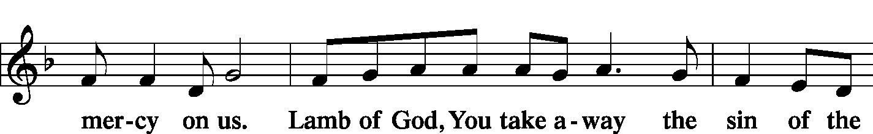
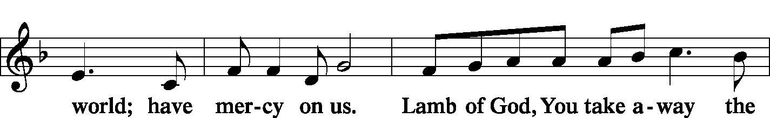
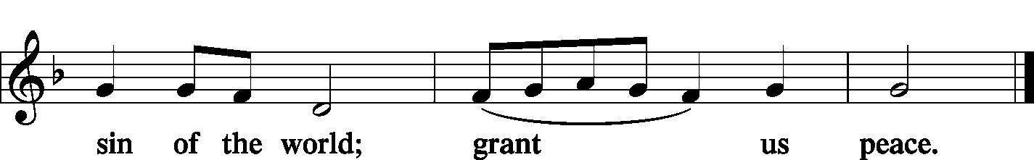

Sit

Distribution
Zion Lutheran practices the policy of close communion, communing only those who share our common Biblical view of the Lord's Supper. If you are not a confirmed LCMS Lutheran, please confer with the pastor before communing.

The pastor and those who assist him receive the body and blood of Christ first and then distribute them to those who come to receive, saying:

Take, eat; this is the true body of our Lord and Savior Jesus Christ, given into death for your sins.
Amen.

Take, drink; this is the true blood of our Lord and Savior Jesus Christ, shed for the forgiveness of your sins.
Amen.

Hymn Here, O My Lord, I See Thee Face to Face LSB 631

Hymn What Is This Bread LSB 629

Hymn O Jesus, Blessed Lord, to Thee LSB 632

Stand

In dismissing the communicants, the following is said:

The Dismissal
P The body and blood of our Lord Jesus Christ strengthen and preserve you in body and soul to life everlasting. Depart T in peace.
C Amen.

Post-Communion Canticle -- Thank the Lord LSB 164
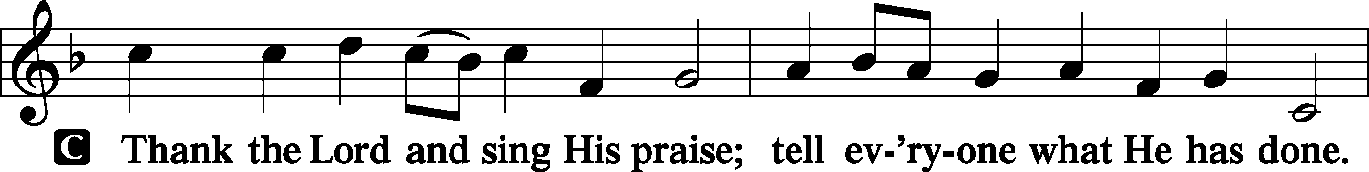
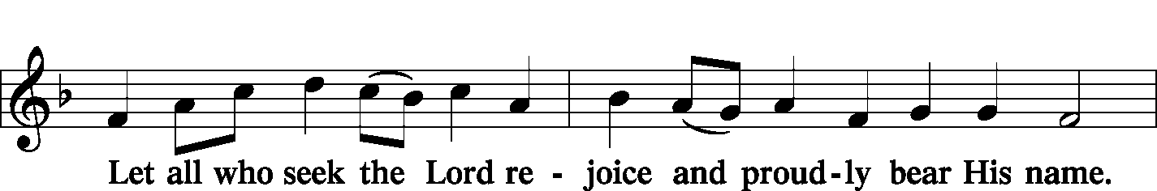
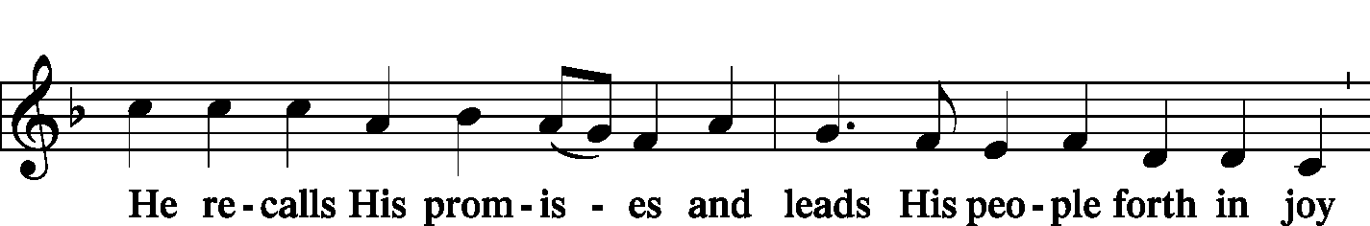
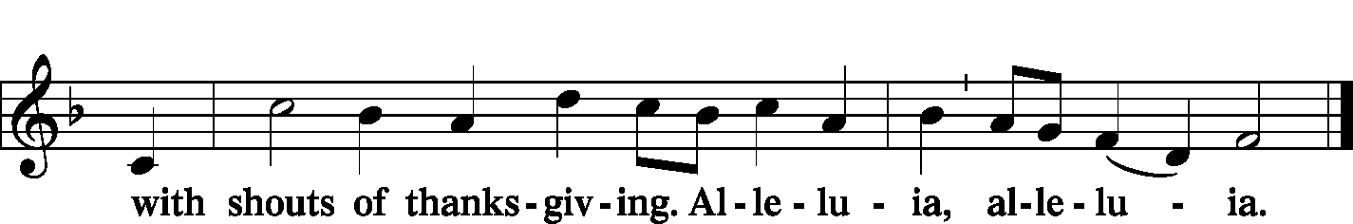
Post-Communion Collect
P Let us pray.
We give thanks to You, almighty God, that You have refreshed us through this salutary gift, and we implore You that of Your mercy You would strengthen us through the same in faith toward You and in fervent love toward one another; through Jesus Christ, Your Son, our Lord, who lives and reigns with You and the Holy Spirit, one God, now and forever.
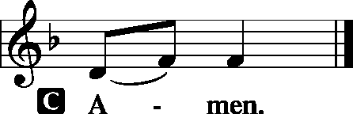

Benediction LSB 166
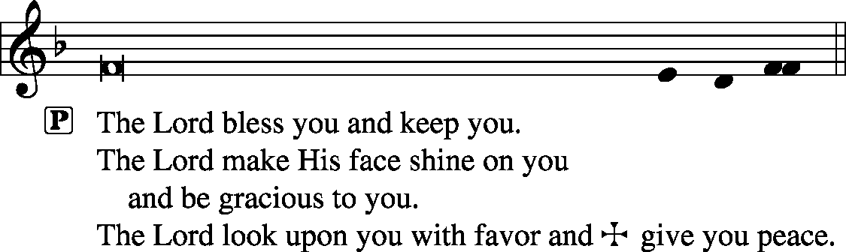

Sit

Hymn Praise to the Lord, the Almighty LSB 790

Postlude Praise to the Lord, the Almighty John Leavitt

Acknowledgments
Unless otherwise indicated, all scripture quotations are from The Holy Bible, English Standard Version, copyright © 2001 by Crossway Bibles, a division of Good News Publishers. Used by permission. All rights reserved. Created by Lutheran Service Builder © 2006 Concordia Publishing House.
LIFE AND LIVING ITEMS AT ZION
          

THE FLOWERS ON THE LORD’S ALTAR
The flowers on the Lord’s altar are given to the glory of God in thanksgiving and joy that we can sing praises to God for our many blessings.

THANK YOU FROM PASTOR BARTON
Zion received the following note from Pastor Jim Barton, who participated in the Adult Baptism of Amy Lin the first Sunday of September: "I wanted to thank you for your kindness in hosting the Baptism of Amy Lin...I was impressed with your congregation, the lively Bible Class, the participation in worship and singing, and the enthusiasm of your choir. The Lord's rich blessings as you continue to serve Christ our Savior together. Best wishes. Pastor Jim Barton"

PRESCHOOL FUNDRAISER – BACK BY POPULAR DEMAND!
The preschool is selling Butter Braid frozen pastry and Show Me Dough frozen cookie dough and frozen pizzas as our fundraiser again this year. These are wonderful products that require no work to prepare. Stock up for the upcoming holidays! Products will be delivered to the school by Saturday, October 5th. Make your purchases today at the table in the Narthex or see Marlene Lockwood, Preschool Director. We appreciate your continuous support!

TRUSTEES WORK DAY – OCTOBER 5th
The Trustees are planning a work day on Saturday, October 5th, and we are looking for helpers. The projects planned are: repair men’s toilet in basement, replace ballast in preschool girl’s bathroom, take down tree, install gym exhaust fan cover, adjust timers for time change, clean office/school AC condensers, replace furnace filter on church office unit in hall closet, change generator oil, and change float switches on sump pumps.

HARVEST TABLE
It’s harvest time again! Check the harvest table in the Narthex. Bring an extra vegetable or fruit from your garden, you can trade for another or buy the item with a donation to Concerned Christians.

HSHS ST. JOSEPH’S HOSPITAL BREESE FALL HEALTH FAIRS
Pre-registration is open for HSHS St. Joseph’s Hospital Breese’s upcoming Fall Health Fair screenings. The screenings will take place in four communities, each from 6-10 AM. The community is recommended to pre-register for the event. However, this year, on-site registration will only be available from 8 to 10 AM. The scheduled dates and locations are as follows: Wednesday, October 9 at the Trenton First United Methodist Church – Register by October 2. Wednesday, October 23 at the Germantown Legion –Register by October 16. Registration forms are available at the hospital’s front desk, the HealthPlex, local doctors’ offices, local libraries and on the hospital’s web site, stjoebreese.com/healthfairs. The 2019 Health Fair form must be received at the hospital one week before the health fair you plan to attend. Do not submit payment with the form, payment will be collected when you arrive at the Health Fair you are attending. The form may be dropped off at the hospital’s front entrance desk, faxed to 618-526-1404, mailed to “Health Fair, PO Box 99, Breese, IL 62230,” or emailed to sjb.healthfair@hshs.org. Pre-registration is highly recommended, on-site registration the day of the event will also be available from 8 to 10 a.m. For other registration information or questions regarding the health fair, please call Chris at 618-526-5351. For more information about HSHS St. Joseph’s Hospital Breese’s 2019 Health Fair, call 618-526-5351 or visit sjb.healthfair@hshs.org.

CAREERS FOR CHRIST WEEKEND 2019
Careers for Christ Weekend 2019 will take place October 4-6 at Concordia University Chicago. The weekend is for high school students who are interested in becoming LCMS church professionals. The entire weekend experience will cost $75 per person. Register online at CUChicago.edu/C4C. After you complete the online registration, download a permission form from the website and send the completed form, along with your registration fee, to CUC’s Office of Undergraduate Admission. Registration deadline is September 25, 2019.

SID JR HIGH YOUTH RETREAT 2019
The Southern Illinois District will be having a Jr. High Youth Retreat beginning Friday, October 4th at 6:00 PM and ending Saturday, October 5th at 6:00 PM. The cost is $55/person. Register and pay online by September 27th at CampWartburg.com. Click “register for camp” and create an account or sign in. Follow prompts and register for “SID Jr High Retreat”. For any questions contact Lauren at 618-939-7715 ext.10.

HYMN FESTIVAL – NEXT SUNDAY
The St. Louis Chapter of the American Guild of Organists will present a Hymn Festival honoring the 100th birthday of Dr. Paul Manz (1919-2009) at 4:00 PM on Sunday, September 29th at Ladue Chapel Presbyterian Church, 9450 Clayton Rd., St. Louis. Leading the Hymn Festival is Dr. Scott Hyslop of Frankenmuth, MI. The program will celebrate the church year in song featuring Manz’s original works for choir, organ, and instruments as well as showing the “Manz influence” on other composers, organists, and musicians. The public is invited to participate in the event, co-sponsored by MorningStar Music.

3rd ANNUAL NATIONAL NIGHT OUT
Mascoutah’s 3rd Annual National Night Out Celebration will be held on Tuesday, October 1st from 5-9 PM at Scheve Park. This is a FREE family and kid event. The night’s events will consist of free food and drinks, public safety personnel meet and greet, viewings and demonstrations of police cars, fire trucks, and ambulances, K-9 demonstration, DJ music, bounce houses, and giveaways.

VITAE FOUNDATION PRO-LIFE DINNER
You are invited to Vitae Foundation’s Southern Illinois Pro-Life Dinner featuring keynote speaker, Matt Walsh, on Thursday, October 3rd at 7 PM. The dinner is being held at the Four Points Sheraton, 319 Fountains Parkway, Fairview Heights. The cost of the dinner is $35. The Vitae Foundation is a non-profit 501(c)(3) organization based in Jefferson City, MO, which promotes pro-life issues, especially those dealing with abortions. The proceeds from this dinner help them make a significant difference in the lives of young women, especially those faced with an unplanned pregnancy. Registration may be made online at VitaeFoundation.org, by calling Vitae at 573-634-4316, or by sending a check or money order to Vitae Foundation, 1731 Southridge Dr., Suite D, Jefferson City, MO 65109.

ST. PETER, NEW MEMPHIS CHILI DINNER
St Peter Lutheran Church in New Memphis, IL will host its annual CHILI DINNER on Sunday, October 6th from 11:00 AM to 1:30 PM. Chili, hot dogs, drinks, and desserts will be served. There will be a free will offering. St Peter is located at 153 East Church Street in New Memphis.

CFNA GOLF BENEFIT
Christian Friends of New Americans (CFNA) – Sponsor, play, and/or dine. There will be a Golf Benefit on October 8th at Norwood Hills Country Club. There will be a deli lunch, 18-hole scramble, silent auction, hospitality hour, dinner, and entertainment. The Hospitality Hour/Dinner is $30. Your generosity funds: After School Tutoring, Adult ESL, Driver’s Ed, Health screenings, furniture distribution, scholarships in Lutheran schools, Bible studies, and much more for refugees. We see the blessings of baptisms, confirmations, and active church memberships in our local churches. For more information go to www.cfna-stl.org/golf or call (314)517-8513.

3rd ANNUAL ROOTS CONFERENCE
The LCMS U chapters of Metro St. Louis area will host the 3rd Annual Roots Conference: The reconstruction of Man in Christ: The Christian Response to Bioethical Questions on October 11, 2019. Topics to be discussed: The relationship of Science to Theology; The reconstruction of man in a throwaway culture and other cultural issues. The conference will begin on Friday, October 11th at 6:00 PM and conclude on Saturday, October 12th at 6 PM at Concordia Seminary, St. Louis, MO (Sieck 201). Theme: The reconstruction of Man in Christ, Speaker: Rev. Dr. Robert Weise, Professor Emeritus of Practical Theology. The registration fee is $15. Register on line at: ulue.org/event/roots.

IGNITION MIDDLE SCHOOL CONFERENCE
Ignition Middle School Conference, hosted by Troy UMC, is a day designed to ignite the faith of students in 6th -8th grades. The conference will take place on October 26th from 9 AM – 4:30 PM. Students will love the speakers, worship, music, the Ignition festival, lunch (Chick-Fil-A), seminars, and everything else! Register by October 10th to receive a free Ignition t-shirt. If you have any questions, call Tim Price at 618-541-8291 or go to ignitionconference.org.

HELP FEED MY STARVING CHILDREN
Volunteers age 5+ are needed to help hand-pack nutritious MannaPack™ meals, specifically designed to assist in reversing and preventing undernutrition throughout the world, at a MobilePack™ event that Thrivent is sponsoring with Feed My Starving Children on Saturday, Oct 19th from 8-11 AM at Good Shepherd Lutheran Church, 327 Woods Mill Road, Ballwin, MO. This is a great, family friendly, volunteer opportunity. The event is FREE and breakfast will be served. Guests do not need to be a Thrivent Financial member to participate. Wear a LIVE GENEROUSLY t-shirt to the event and the Thrivent Member Network will donate $3 to Feed My Starving Children on your behalf. Please register at TAMM.Eventbrite.com.

LISTEN TO WORLDWIDE KFUO AM850
KFUO Radio, AM850, a media ministry extension of LCMS congregations, shares Christ for you anytime, anywhere on AM850 via worship services, Bible and theology studies, practical talk programs, and sacred music. You can find programs on demand at kfuo.org and wherever you get your podcasts! Find us on social: @KFUOradio on Facebook, Twitter, and Instagram. This week on KFUO AM850, worship with us in chapel services from the LCMS International Center (weekdays at 10:00 a.m.), hear curious theological discussion with Rev. Bryan Wolfmueller on Cross Defense (9/24 at 2:00 p.m.), and dig into our Lutheran confession of faith on Concord Matters with host Rev. Sean Smith (9/25 at 2:00 p.m.). Find these programs and special podcasts at kfuo.org or your favorite podcast app!

EDUCATION & EDIFICATION
Issues, Etc. is a radio talk show and podcast produced by Lutheran Public Radio in Collinsville, IL and hosted by LCMS Pastor Todd Wilken. This week's teachings include: Pastoral Care for Members with Dementia/Alzheimer's, Christ's Victory, Jacob's Dream, The Ordination of a Minister and more. You can tune in live weekdays from 3-5 p.m. on KFUO, 850 AM in St. Louis. You can also listen on-demand at www.issuesetc.org and on the LPR mobile app.
THOSE WHO SERVE TODAY
Proclaimer: Rev. Kirk Clayton
Liturgist: Sem. Adam Wolfe
Liturgist: Sem. Don Stein
Organist: Nancy Peterson
Ushers: Ray Kemezys, Alan Kneschke, Ken Knutson, & Geoff Phillips
Sound Tech: Matt Krausz
Video Tech: Mark Hatcher
Welcome Team: Don & Joyce Krumsieg
Acolytes: Luke Morra & Bjorn Peterson
Altar Guild: Gail Frey

THOSE WHO SERVE NEXT WEEK, SEPTEMBER 29
Proclaimer: Rev. Kirk Clayton
Liturgist: Sem. Adam Wolfe
Liturgist: Sem. Don Stein
Organist: Nancy Peterson
Ushers: Tony Lara, Ray McDaniel, Dan Morra, & Torri Suedmeyer
Sound Tech: Jake Simon
Video Tech: Mark Hatcher
Welcome Team: Jerry Phillips & David Rowold
Acolytes: Gianna Sink & Daniel Bretz
Altar Guild: Kim Drinnon

THINGS WE ARE DOING AT ZION
Sun. Confirmation Class 8:30 AM
SS & Bible Class 8:45 AM
Worship DS I w/communion 10:00 AM
MarKa Service 1:30 PM
Mon. LifeLight 7:00 PM
Board of Ed 7:00 PM
Tues. Zion Preschool Planning Committee 7:00 PM
Wed. Choir Rehearsal 7:00 PM
New Member Class 7:00 PM
Thurs. Youth Bible Study 6:00 PM
Elders Meeting 6:30 PM
Fri. Senior Meal Delivery 10:30 AM
Sun. Confirmation Class 8:30 AM
SS & Bible Class 8:45 AM
Worship DS IV w/communion 10:00 AM

ATTENDANCE SEPTEMBER 15: Sunday: 207
Adult Bible Class: 26 High School: 8 Sunday School: 42

