Zion Lutheran Church
Mascoutah, Illinois
September 8, 2019
12th Sunday after Trinity

In the Name of Christ Jesus our Lord, we bid you a warm welcome to this worship service. May your experience of worship and fellowship this morning be spiritually refreshing and ready you for the week ahead.
 
Pastor: Rev. Kirk Clayton
Church Secretary: Robin Phillips
Choir Director Team: Josh and Nancy Peterson
_________________________________________________________________________________
Church Office Phone: 618-566-7345
Pastor Clayton Cell: 618-447-1306
Office Hours: 8:00 am to 12:00 pm
Email: ChurchOffice@ZionMascoutah.org
Pastor Clayton email: Pastor@ZionMascoutah.org
Web site: www.ZionMascoutah.org
Find us at @ZionMascoutah on Facebook, Twitter, and Instagram
Electronic Devices
Please TURN OFF all cell phones, pagers, electronic devices, apps and games when entering the sanctuary for worship so those around you may focus on the Word of God without electronic distraction. Thank you.

A Prayer to Begin Worship
Lord Jesus Christ, Ruler of the realm of nature, Healer of our mortal bodies, Redeemer of our eternal souls, still the trembling earth and tempestuous seas when lives are at stake, heal bodies when life and livelihood are threatened, but always according to Your divine purpose, and by the power of the Spirit hold us steadfast in the saving faith until the Judgment; who with the Father and the Holy Spirit are one God with dominion over us forever.

DIVINE SERVICE III WITH COMMUNION
LSB p. 184
Confession and Absolution

Prelude Just As I Am arr. Gordon Young

Hymn How Sweet the Name of Jesus Sounds LSB 524

Stand

The sign of the cross may be made by all in remembrance of their Baptism.

Invocation
P In the name of the Father and of the T Son and of the Holy Spirit.
C Amen.

Exhortation
P Beloved in the Lord! Let us draw near with a true heart and confess our sins unto God our Father, beseeching Him in the name of our Lord Jesus Christ to grant us forgiveness.
P Our help is in the name of the Lord,
C who made heaven and earth.
P I said, I will confess my transgressions unto the Lord,
C and You forgave the iniquity of my sin.

Silence for reflection on God's Word and for self-examination.

Confession with Absolution
P O almighty God, merciful Father,
C I, a poor, miserable sinner, confess unto You all my sins and iniquities with which I have ever offended You and justly deserved Your temporal and eternal punishment. But I am heartily sorry for them and sincerely repent of them, and I pray You of Your boundless mercy and for the sake of the holy, innocent, bitter sufferings and death of Your beloved Son, Jesus Christ, to be gracious and merciful to me, a poor, sinful being.

P Upon this your confession, I, by virtue of my office, as a called and ordained servant of the Word, announce the grace of God unto all of you, and in the stead and by the command of my Lord Jesus Christ I forgive you all your sins in the name of the Father and of the T Son and of the Holy Spirit.
C Amen.

Service of the Word
Introit
L Make haste, O God, to deliver me!
C O Lord, make haste to help me!
L Let them be put to shame and confusion
C who seek my life!
L Let them be turned back
C and brought to dishonor who desire my hurt!
L May all who seek You rejoice
C and be glad in You!
L You are my help and my deliverer;
C O Lord, do not delay!
L Make haste, O God, to deliver me!
C O Lord, make haste to help me!
L Let them be put to shame and confusion
C who seek my life!

Gloria Patri
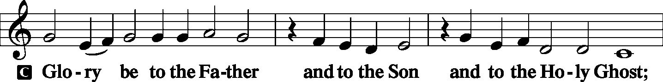
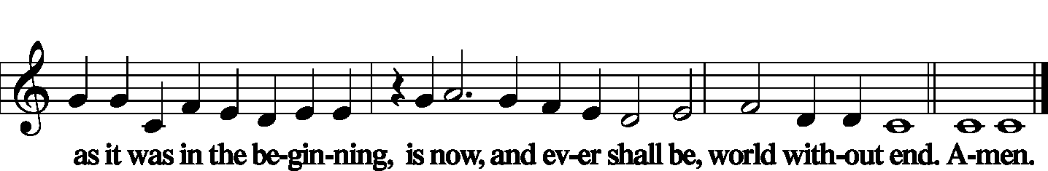
Kyrie LSB 186
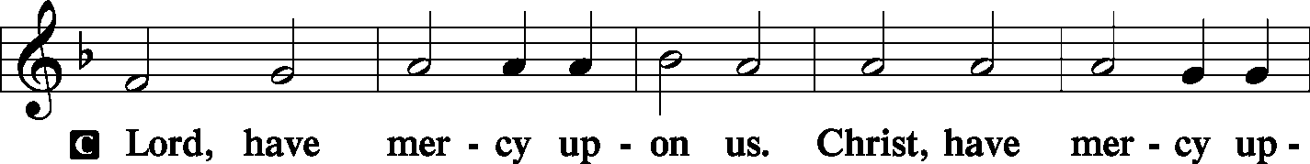
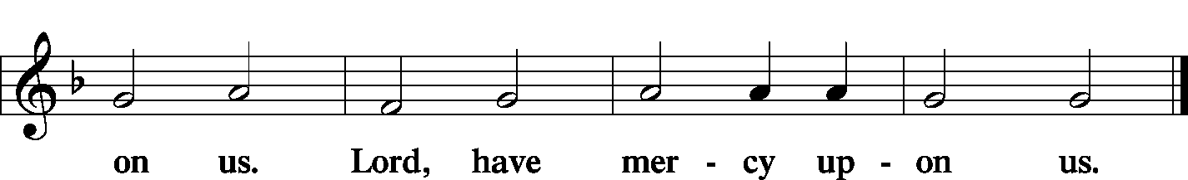

Gloria in Excelsis LSB 187
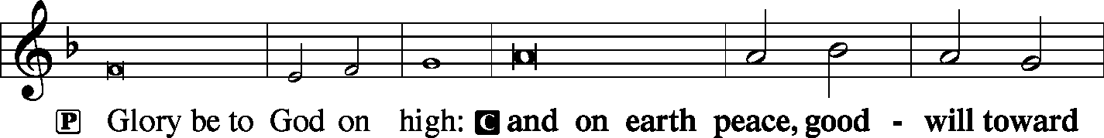
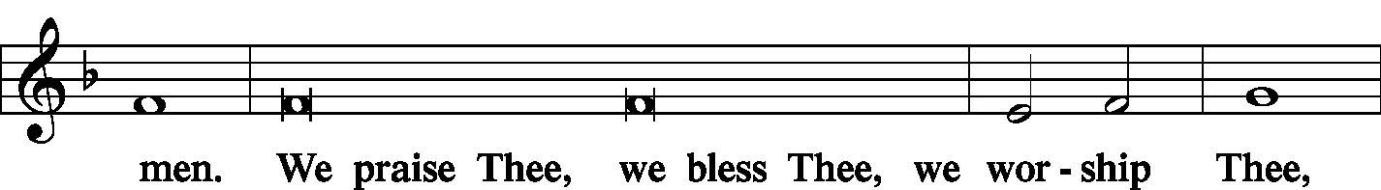
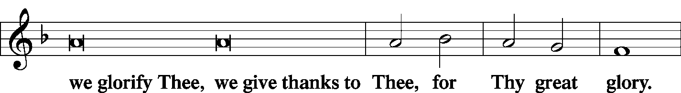
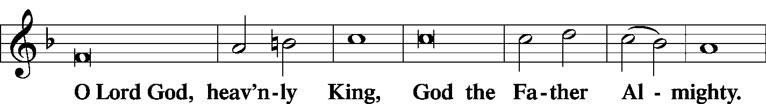
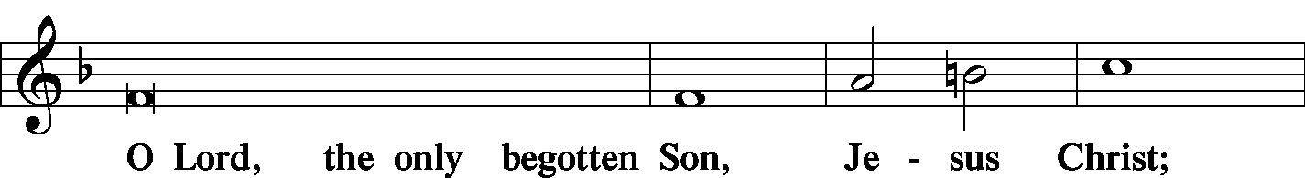
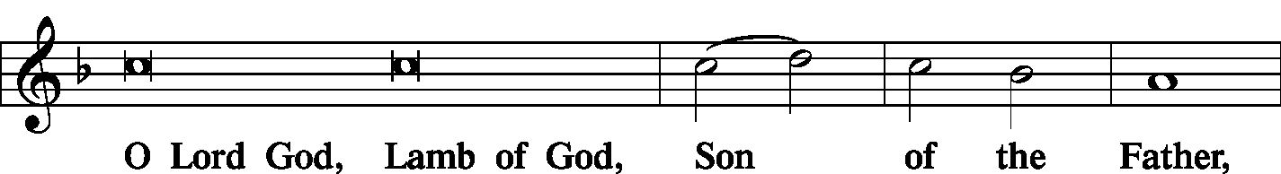
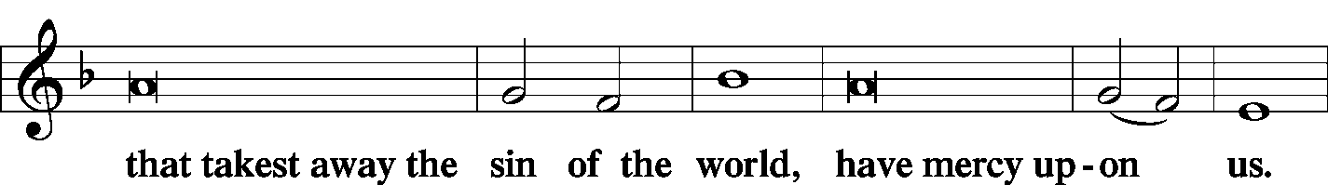
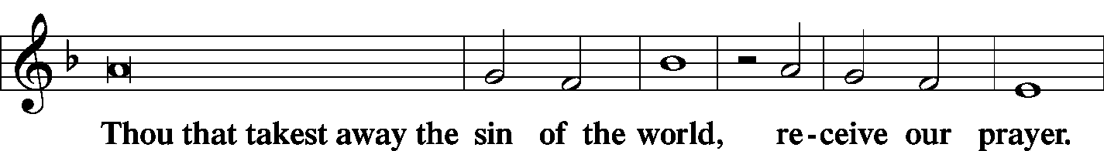
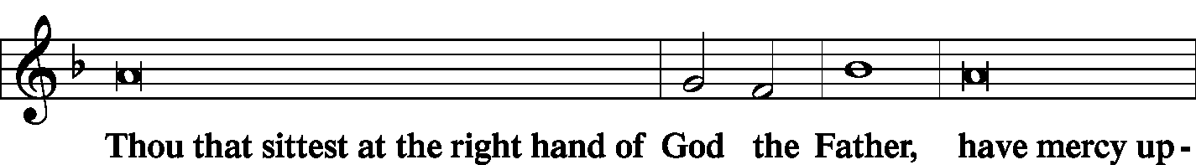
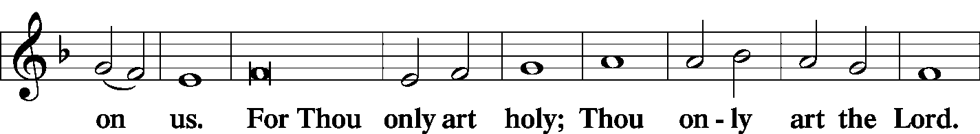
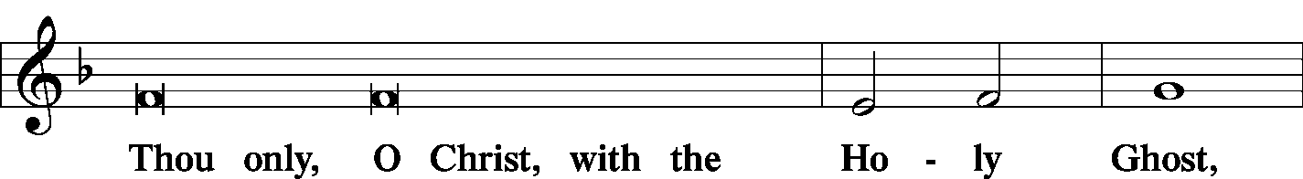
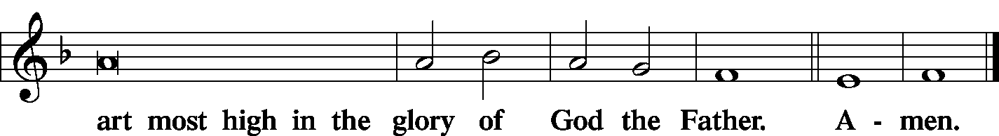

Salutation and Collect of the Day
P The Lord be with you.
C And with thy spirit.
P Let us pray.
Almighty and merciful God, by Your gift alone Your faithful people render true and laudable service. Help us steadfastly to live in this life according to Your promises and finally attain Your heavenly glory; through Jesus Christ, Your Son, our Lord, who lives and reigns with You and the Holy Spirit, one God, now and forever.
C Amen.

Sit

Old Testament Reading Isaiah 29:17-24
Is it not yet a very little while until Lebanon shall be turned into a fruitful field, and the fruitful field shall be regarded as a forest? In that day the deaf shall hear the words of a book, and out of their gloom and darkness the eyes of the blind shall see. The meek shall obtain fresh joy in the Lord, and the poor among mankind shall exult in the Holy One of Israel. For the ruthless shall come to nothing and the scoffer cease, and all who watch to do evil shall be cut off, who by a word make a man out to be an offender, and lay a snare for him who reproves in the gate, and with an empty plea turn aside him who is in the right. Therefore thus says the Lord, who redeemed Abraham, concerning the house of Jacob: “Jacob shall no more be ashamed, no more shall his face grow pale. For when he sees his children, the work of My hands, in his midst, they will sanctify My name; they will sanctify the Holy One of Jacob and will stand in awe of the God of Israel. And those who go astray in spirit will come to understanding, and those who murmur will accept instruction.”
L This is the Word of the Lord.
C Thanks be to God.

Choir Jesus, My Lord, My God arr. Marcus Wiley

Epistle Romans 10:9-17
If you confess with your mouth that Jesus is Lord and believe in your heart that God raised Him from the dead, you will be saved. For with the heart one believes and is justified, and with the mouth one confesses and is saved. For the Scripture says, “Everyone who believes in Him will not be put to shame.” For there is no distinction between Jew and Greek; for the same Lord is Lord of all, bestowing His riches on all who call on Him. For “everyone who calls on the name of the Lord will be saved.” How then will they call on Him in whom they have not believed? And how are they to believe in Him of whom they have never heard? And how are they to hear without someone preaching? And how are they to preach unless they are sent? As it is written, “How beautiful are the feet of those who preach the good news!” But they have not all obeyed the gospel. For Isaiah says, “Lord, who has believed what he has heard from us?” So faith comes from hearing, and hearing through the word of Christ
L This is the Word of the Lord.
C Thanks be to God.

Stand

Alleluia and Verse
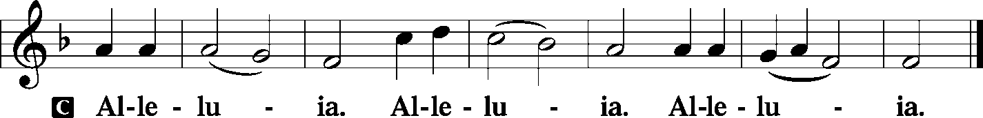

Holy Gospel Mark 7:31-37
P The Holy Gospel according to St. Mark, the 7th chapter.
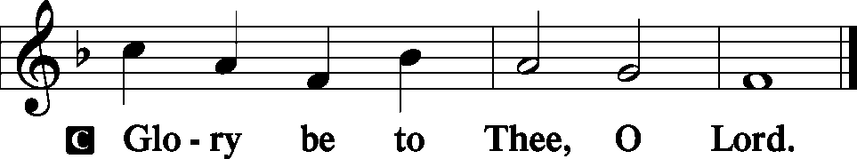
Then He returned from the region of Tyre and went through Sidon to the Sea of Galilee, in the region of the Decapolis. And they brought to Him a man who was deaf and had a speech impediment, and they begged Him to lay His hand on him. And taking him aside from the crowd privately, He put His fingers into his ears, and after spitting touched his tongue. And looking up to heaven, He sighed and said to him, “Ephphatha,” that is, “Be opened.” And his ears were opened, his tongue was released, and he spoke plainly. And Jesus charged them to tell no one. But the more He charged them, the more zealously they proclaimed it. And they were astonished beyond measure, saying, “He has done all things well. He even makes the deaf hear and the mute speak.”
P This is the Gospel of the Lord.
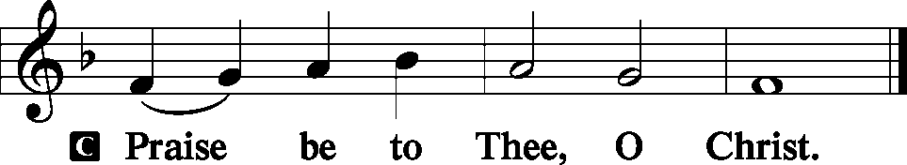

Nicene Creed
C I believe in one God, the Father Almighty, maker of heaven and earth and of all things visible and invisible.
And in one Lord Jesus Christ, the only-begotten Son of God, begotten of His Father before all worlds, God of God, Light of Light, very God of very God, begotten, not made, being of one substance with the Father, by whom all things were made; who for us men and for our salvation came down from heaven and was incarnate by the Holy Spirit of the virgin Mary and was made man; and was crucified also for us under Pontius Pilate. He suffered and was buried. And the third day He rose again according to the Scriptures and ascended into heaven and sits at the right hand of the Father. And He will come again with glory to judge both the living and the dead, whose kingdom will have no end.
And I believe in the Holy Spirit, the Lord and giver of life, who proceeds from the Father and the Son, who with the Father and the Son together is worshiped and glorified, who spoke by the prophets. And I believe in one holy Christian and apostolic Church, I acknowledge one Baptism for the remission of sins, and I look for the resurrection of the dead and the life T of the world to come. Amen.

Sit

Hymn Lord, Enthroned in Heavenly Splendor LSB 534

Sermon The Messianic Secret

Offering
[Please fill out a sheet in the attendance book. Visitors, please include your address. If you have a prayer request for the church prayer chain, please write it at the top of the sheet.]

Special Offering Music I Waited for the Lord Mendelssohn
(Cary Robinson & Josh Peterson, duet)

Stand

Offertory LSB 192
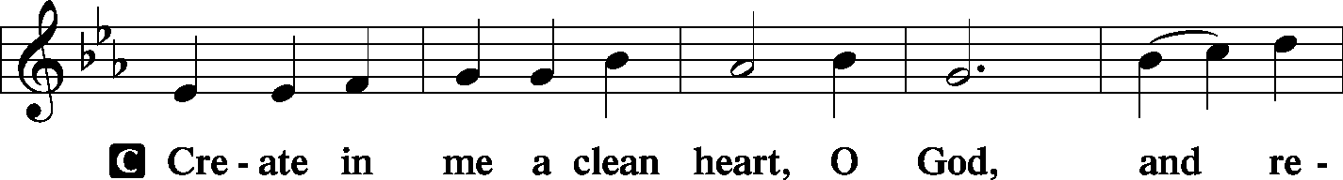
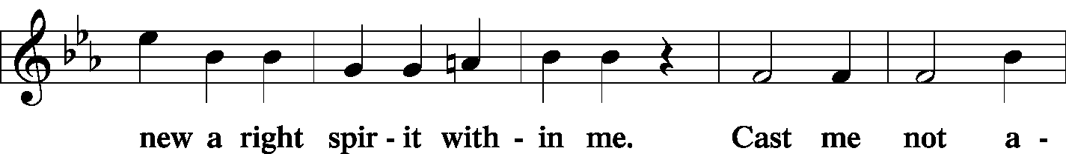
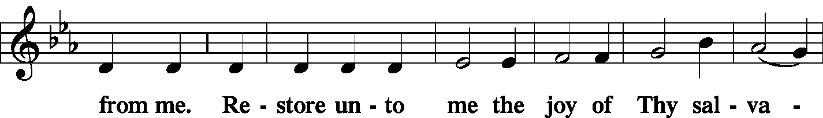
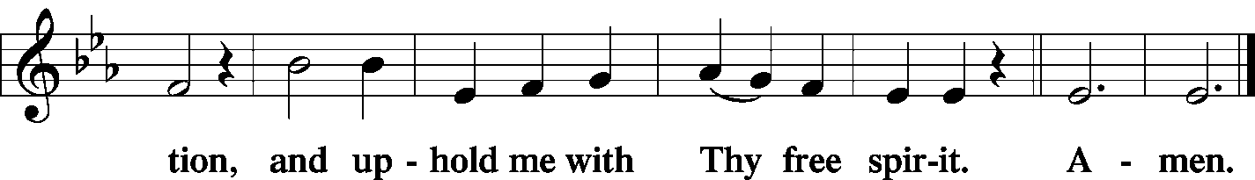

Stand

Prayer of the Church
P Eternal, almighty God, heavenly Father, how good it is to sing Your praises.
C how delightful it is to assemble in Your house with our fellow redeemed.
P You revive our hope in a world filled with the broken promises of man.
C Your Word is truth, and Your promises are sure fulfillment.
P You alone have the might and power to accomplish those things which we are unable to do.
C Accept our praise and thanksgiving for graciously using Your power among us.
P For trusting too much in human resources for the solutions to our problems,
C forgive us, O Lord.
P Open our eyes to Your goodness and to the needs of others.
C Unstop our ears that we may hear Your voice above the noise and confusion of our times.
P Unloose our tongues that we may speak of the wonders of Your mighty acts.
C Give us vision to see the world ripe for the harvest.
P May all ears be attentive to the message of Your heavenly Gospel.
C May all voices be tuned to sing Your praises.
P Give insight, understanding, and vision to our nation’s citizens and leaders.
C Grant the inspiration of Your Holy Spirit to all church members and religious leaders.
P In our families help us to listen to one another with patience.

WE GO TO THE LORD IN PRAYER FOR
- Johnathan Clayton and Nathan Schreiber, as they celebrate their Baptismal Anniversaries this week.
- All those affected by Hurricane Dorian.
- Zion’s President, Vice President, Secretary, and Treasurer.
- Faithfulness in Christian Worship.

P In the name of Him who restores sight to the blind, hearing to the deaf, and speech to the dumb,
C even Christ our Lord. Amen.

Sit

Service of the Sacrament
Preface LSB 194
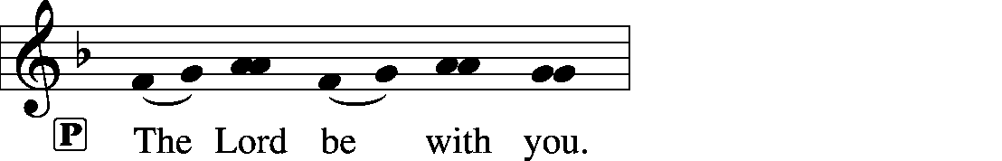
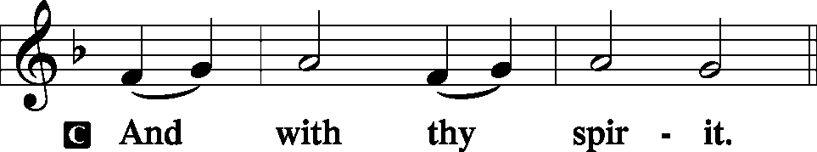

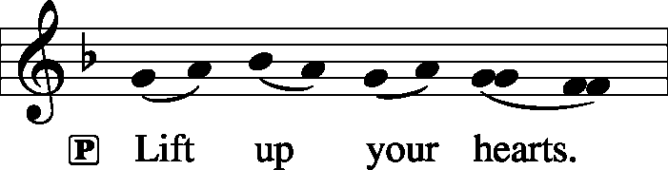

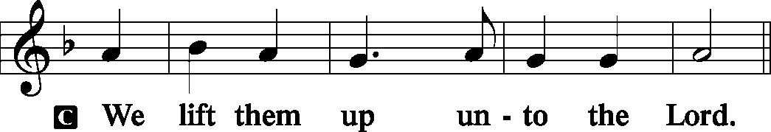

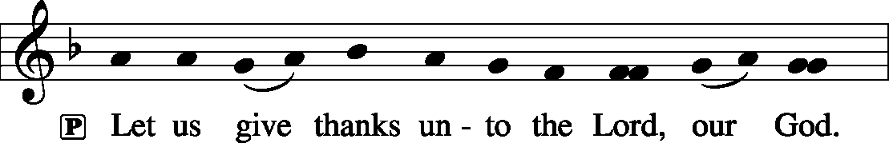

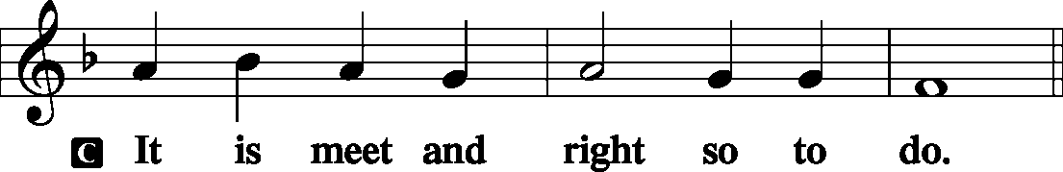

Proper Preface (Full)
P It is truly meet, right, and salutary that we should at all times and in all places give thanks to You, holy Lord, almighty Father, everlasting God. And most especially are we bound to praise You on this day for the glorious resurrection of Your Son, Jesus Christ, the very Paschal Lamb, who was sacrificed for us and bore the sins of the world. By His dying He has destroyed death, and by His rising again He has restored to us everlasting life. Therefore with Mary Magdalene, Peter and John, and with all the witnesses of the resurrection, with angels and archangels, and with all the company of heaven we laud and magnify Your glorious name, evermore praising You and saying:

Sanctus LSB 195
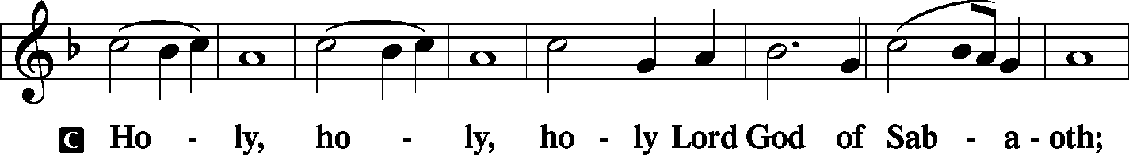
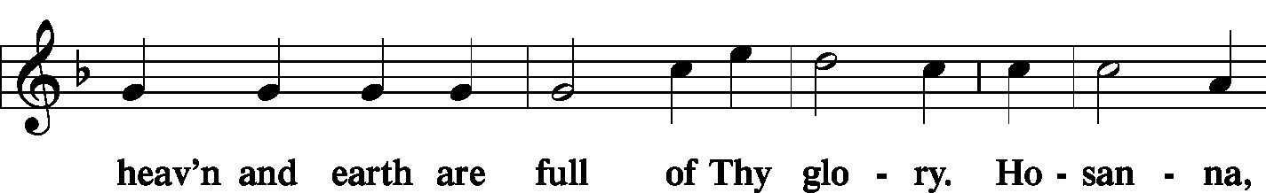
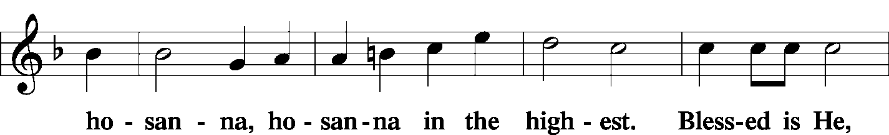
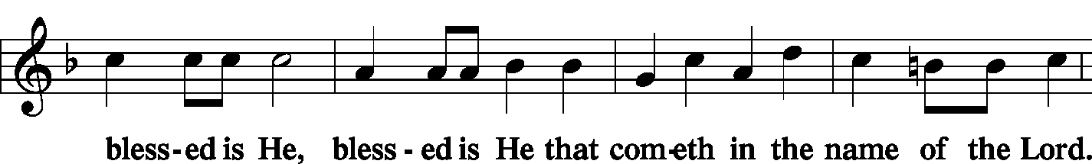
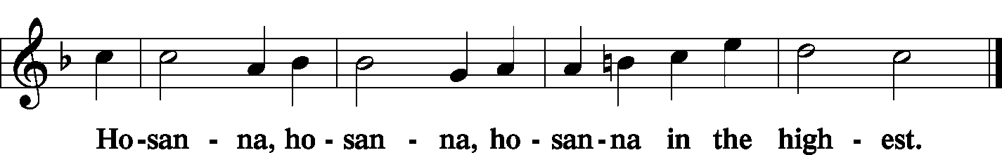

Lord's Prayer LSB 196
P Our Father who art in heaven, hallowed be Thy name, Thy kingdom come, Thy will be done on earth as it is in heaven; give us this day our daily bread; and forgive us our trespasses as we forgive those who trespass against us; and lead us not into temptation, but deliver us from evil
C | 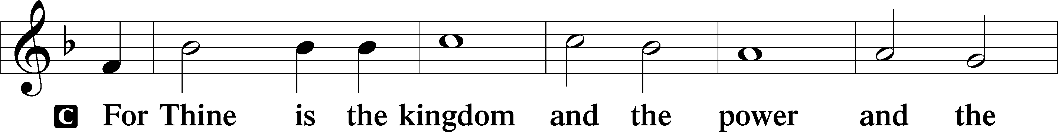  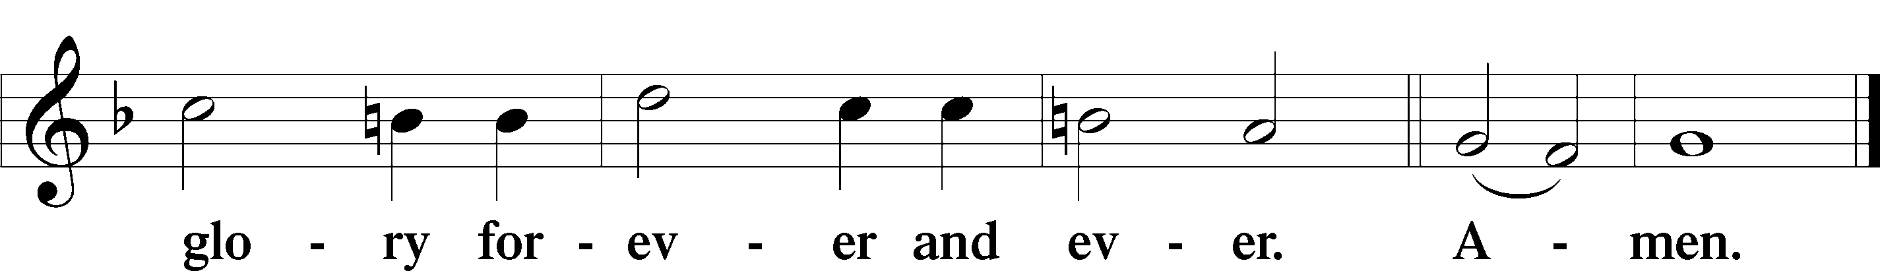
The Words of Our Lord LSB 197
P Our Lord Jesus Christ, on the night when He was betrayed, took bread, and when He had given thanks, He broke it and gave it to the disciples and said: “Take, eat; this is My T body, which is given for you. This do in remembrance of Me.”

P In the same way also He took the cup after supper, and when He had given thanks, He gave it to them, saying: “Drink of it, all of you; this cup is the new testament in My T blood, which is shed for you for the forgiveness of sins. This do, as often as you drink it, in remembrance of Me.”

Pax Domini LSB 197
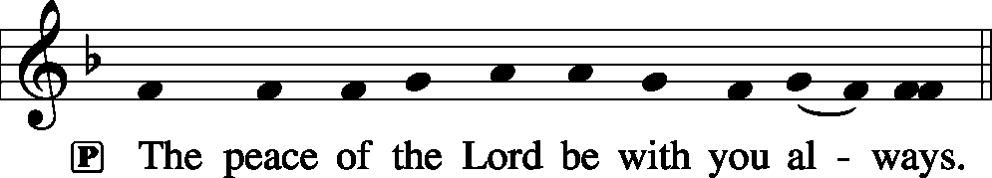

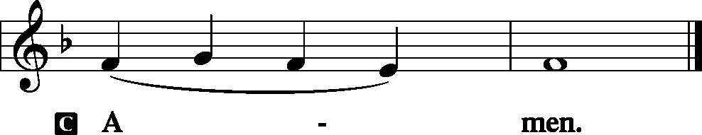

Agnus Dei LSB 198
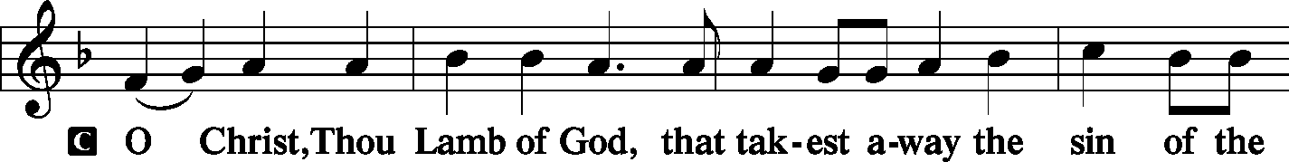
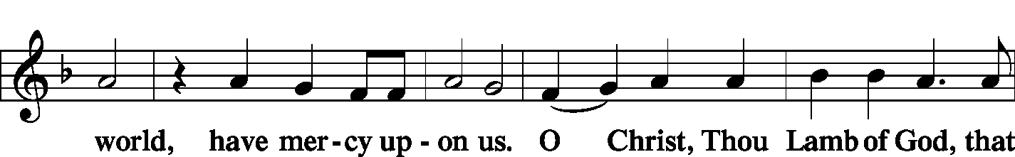
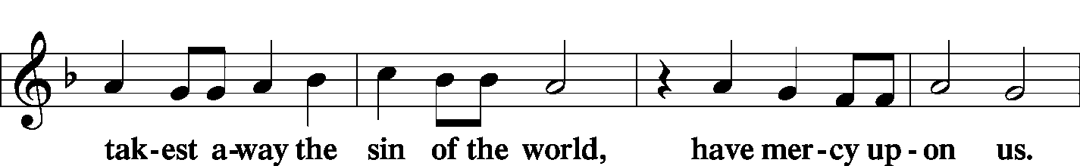
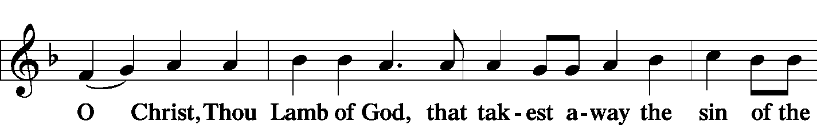
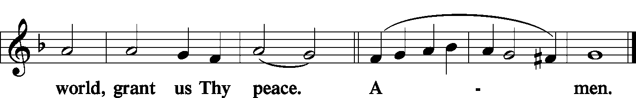
Sit

Distribution
Zion Lutheran practices the policy of close communion, communing only those who share our common Biblical view of the Lord's Supper. If you are not a confirmed LCMS Lutheran, please confer with the pastor before communing.

The pastor and those who assist him receive the body and blood of Christ first and then distribute them to those who come to receive, saying:

Take, eat; this is the true body of our Lord and Savior Jesus Christ, given into death for your sins.
Amen.

Take, drink; this is the true blood of our Lord and Savior Jesus Christ, shed for the forgiveness of your sins.
Amen.

Hymn Your Table I Approach LSB 628

Hymn Just as I Am, without One Plea LSB 570

Hymn Jesus Christ, Our Blessed Savior LSB 627

Stand

In dismissing the communicants, the following is said:

The Dismissal
P The body and blood of our Lord Jesus Christ strengthen and preserve you in body and soul to life everlasting. Depart T in peace.
C Amen.

Nunc Dimittis LSB 199
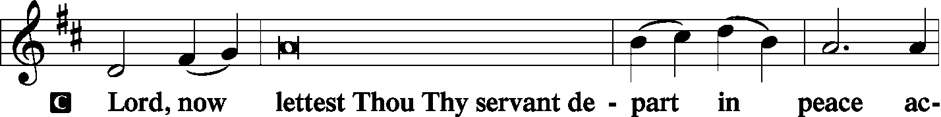
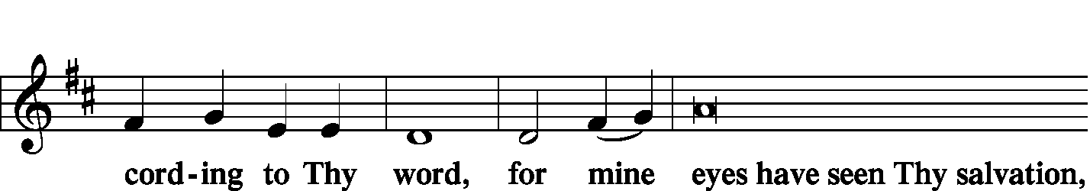
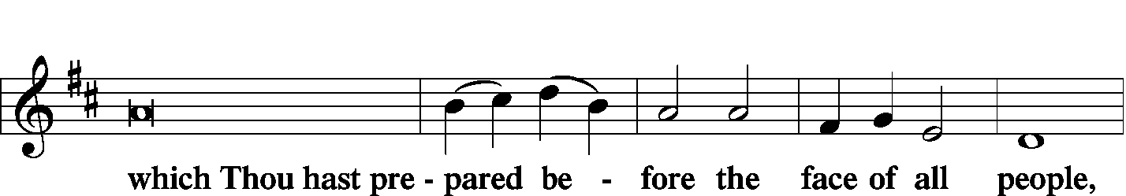
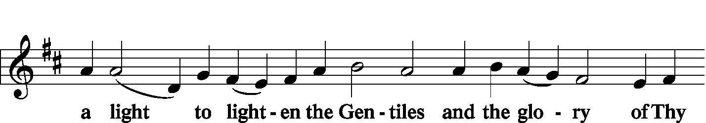
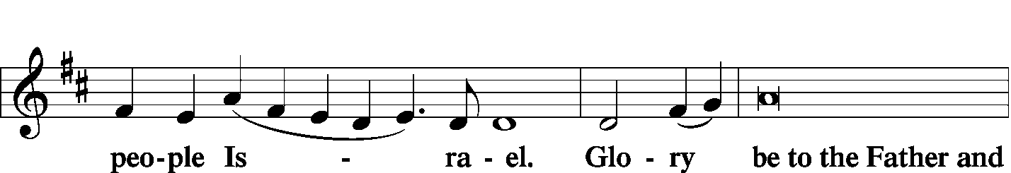
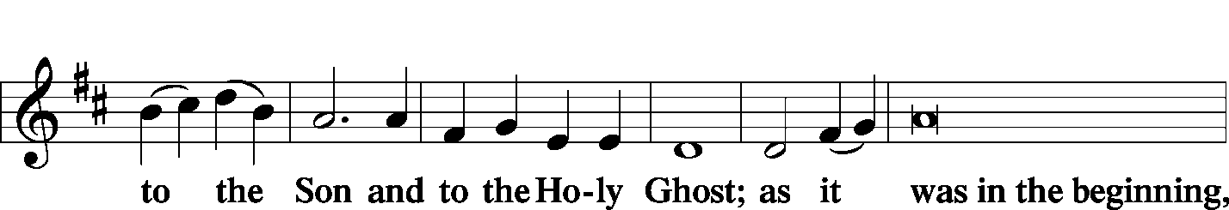
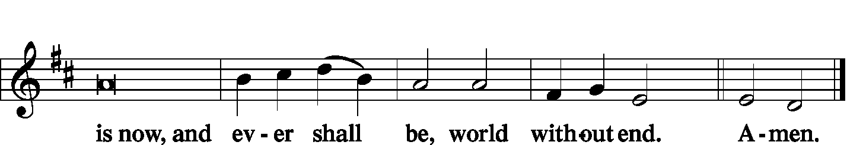

Thanksgiving LSB 200
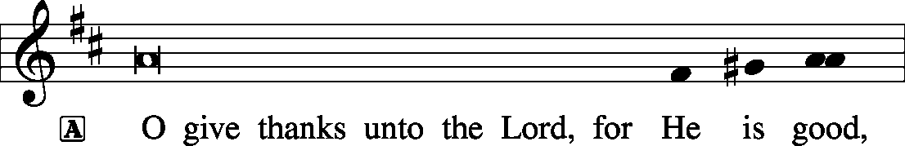

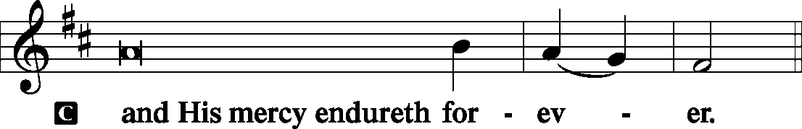

Post-Communion Collect
P Let us pray.
We give thanks to You, almighty God, that You have refreshed us through this salutary gift, and we implore You that of Your mercy You would strengthen us through the same in faith toward You and in fervent love toward one another; through Jesus Christ, Your Son, our Lord, who lives and reigns with You and the Holy Spirit, one God, now and forever.

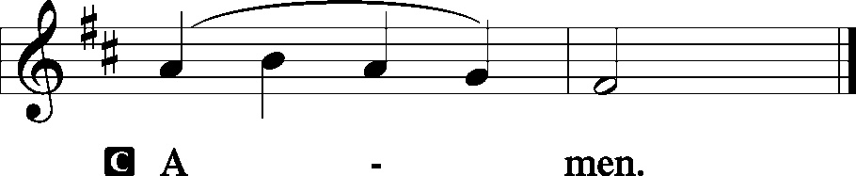

Salutation and Benedicamus
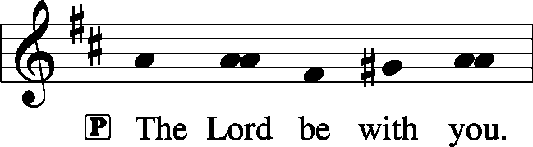

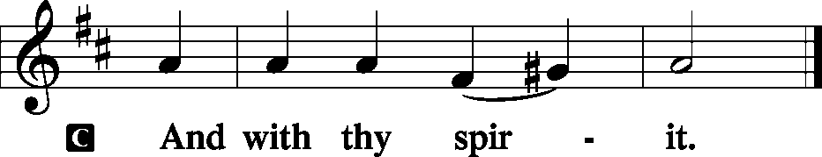

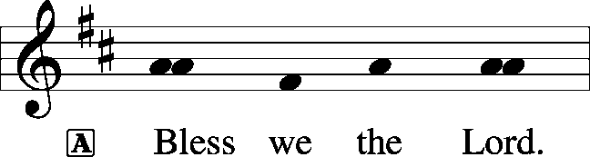

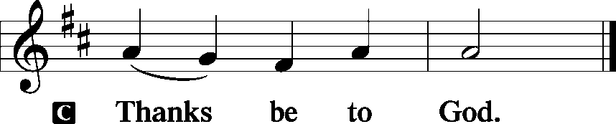

Benediction LSB 202
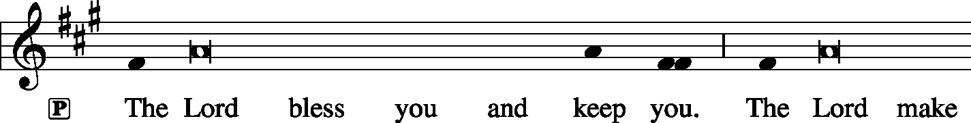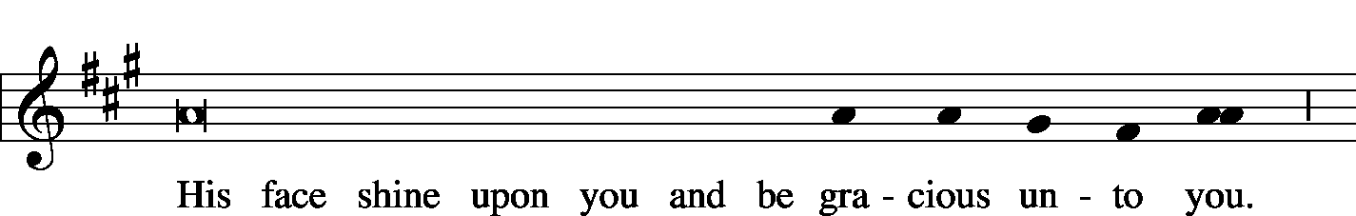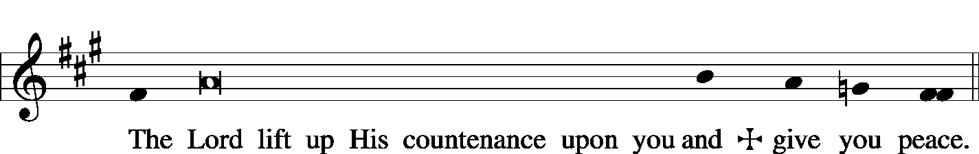

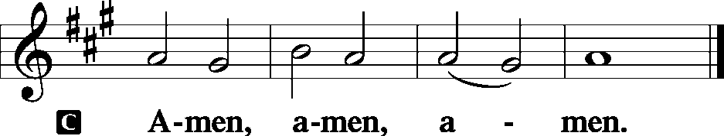

Sit

Hymn God Loved the World So That He Gave LSB 571

Postlude Lord Enthroned In Heavenly Pleasure
R. Vaughn Williams

Acknowledgments
Unless otherwise indicated, all scripture quotations are from The Holy Bible, English Standard Version, copyright © 2001 by Crossway Bibles, a division of Good News Publishers. Used by permission. All rights reserved. Created by Lutheran Service Builder © 2006 Concordia Publishing House.
LIFE AND LIVING ITEMS AT ZION
          

THE FLOWERS ON THE LORD’S ALTAR
The flowers on the Lord’s altar are given to the glory of God in celebration of Grant Ahner’s birthday.

LIFELIGHT BIBLE STUDY RESUMES TOMORROW
We will resume LifeLight, a 9-week adult in-depth Bible study consisting of daily individual home study and weekly group discussion on September 9th. Join us in the church conference room at 7 PM on Monday evenings as we study Job—and discover how we can apply the lessons to our lives. Call or text Lionel at 618-806-8993 to join.

LWML MEMBERS: REGISTRATION DEADLINE FOR FALL RETREAT
LWML Retreats are always very inspirational and refreshing for the spirit! This fall's retreat is at Lake Williamson Christian Center in Carlinville on Saturday, Oct 5th. They hold a two-day retreat but our ladies usually only go on Saturday. The registration deadline is September 14th. Registration forms are on the table in the narthex. The speaker Deb Burma is excellent; many of us have heard her before. Info on her and the agenda for the day are on the back of the registration form. Please consider going.

FRIENDSHIP/SOCIAL SUNDAY – NEXT SUNDAY!
Make plans now for Friendship Sunday on September 15th. The service will be held inside here at Zion. This service is an opportunity for you to invite friends and guests to attend church with you this day. A meal will be served following the service in the gym. Elders will be providing hamburgers and hot dogs (also buns and condiments). We are asking those with last name A-K to bring a dessert and L-Z to bring a side dish. Following lunch we (all ages) will be playing kick ball, corn hole/bean bag, and other games at Maple Park (just south, across the street from church). Following the games, we will have ice cream at the park at 1:30 PM. We look forward to seeing you and your friends/guests there!

ZION NEW MEMBER CLASSES—NOT TOO LATE TO JOIN
Several new friends have expressed an interest in becoming members of Zion. A “New Member Class” has started on Wednesday nights from 7:00 to about 8:15, with the first session held on Wednesday, September 4. Classes will run through Wednesday, November 20 (one week before Thanksgiving). The class is free, and all needed materials will be provided. The class is meeting at Zion in the Fellowship Hall in the church basement. It is not too late to join the class, even if you missed early sessions. All are welcome!

HARVEST TABLE
It’s harvest time again! Check the harvest table in the Narthex. Bring an extra vegetable or fruit from your garden, you can trade for another or buy the item with a donation to Concerned Christians.

ZION OFFERING FINANCIAL PEACE UNIVERSITY STARTING THIS THURSDAY, SEPT. 12th
Planning for the future is hard when you’re still paying for the past! Listen—there’s a better way! Join our Financial Peace University group, and we’ll learn how to beat debt and make a plan for the future...together! Interested? Join Joe Bloomquist at Zion Lutheran Church starting September 12th as he leads a 9-week session of Financial Peace University from Dave Ramsey. Zion has pre-ordered course kits that will be available for purchase. Feel free to message Joe about any questions you might have at 618-954-9462.

HSHS ST. JOSEPH’S HOSPITAL BREESE FALL HEALTH FAIRS
Pre-registration is open for HSHS St. Joseph’s Hospital Breese’s upcoming Fall Health Fair screenings. The screenings will take place in four communities, each from 6-10 AM. The community is recommended to pre-register for the event. However, this year, on-site registration will only be available from 8-10 AM. The scheduled dates and locations are as follows: Wednesday, September 11 at the Breese KC Hall – Register by September 4. Wednesday, September 25 at the Carlyle KC Hall – Register by September 18. Wednesday, October 9 at the Trenton First United Methodist Church – Register by October 2. Wednesday, October 23 at the Germantown Legion –Register by October 16. Registration forms are available at the hospital’s front desk, the HealthPlex, local doctors’ offices, local libraries and on the hospital’s web site, stjoebreese.com/healthfairs. The 2019 Health Fair form must be received at the hospital one week before the health fair you plan to attend. Do not submit payment with the form, payment will be collected when you arrive at the Health Fair you are attending. The form may be dropped off at the hospital’s front entrance desk, faxed to 618-526-1404, mailed to “Health Fair, PO Box 99, Breese, IL 62230,” or emailed to sjb.healthfair@hshs.org. Pre-registration is highly recommended, on-site registration the day of the event will also be available from 8-10 a.m. For other registration information or questions regarding the health fair, please call Chris at 618-526-5351. For more information about HSHS St. Joseph’s Hospital Breese’s 2019 Health Fair, call 618-526-5351 or visit sjb.healthfair@hshs.org.

ZION LUTHERAN, LITCHFIELD HIRING PRE-K TEACHER
Zion Lutheran School in Litchfield is now taking applications for a Pre-K teaching position. We are currently searching for a full-time Pre-K teacher for the 2019-2020 school year. Questions and/or applications may be directed to John Schaff, principal, at jschaff@zionlutheranlitchfield.com or Zion Lutheran School, 1301 N. State St., Litchfield, IL 62056. Deadline for applications is September 11, 2019.

YOU ARE INVITED TO AN INSTALLATION SERVICE -- FRIDAY
Please join us for a Service of Installation for President Rev. Dr. Matthew C. Harrison, the vice-presidents, other officers, and board and commission members of The Lutheran Church—Missouri Synod and other Synodwide entities. The service will be Friday, Sept. 13th beginning at 7 PM in the Chapel of St. Timothy and St. Titus, Concordia Seminary, St. Louis. Our worship will follow the prayer office of Vespers. This event is open to the public. A brief reception in Koburg Hall will follow the service. Questions? Contact the Church Information Center at 888-THE LCMS (843-5267) or infocenter@lcms.org.

HYMN FESTIVAL IN CARLYLE
Messiah/Carlyle is hosting a Hymn Festival on Tuesday, September 17th at 7 PM. Featured organist is Benjamin Kolodziej, organist at Southern Methodist University in Dallas, TX, and member of Faith Lutheran LCMS in Plano, TX. Mr. Kolodziej’s organ improvisations are published by Concordia Publishing House. Messiah Lutheran is located at 1091 13th St. in Carlyle. Contact Rev. Scott Schilbe at 618-594-3912 for more info.

VITAE FOUNDATION PRO-LIFE DINNER
You are invited to Vitae Foundation’s Southern Illinois Pro-Life Dinner featuring keynote speaker, Matt Walsh, on Thursday, October 3rd at 7 PM. The dinner is being held at the Four Points Sheraton, 319 Fountains Parkway, Fairview Heights. The cost of the dinner is $35. The Vitae Foundation is a non-profit 501(c)(3) organization based in Jefferson City, MO, which promotes pro-life issues, especially those dealing with abortions. The proceeds from this dinner help them make a significant difference in the lives of young women, especially those faced with an unplanned pregnancy. Registration may be made online at VitaeFoundation.org, by calling Vitae at 573-634-4316, or by sending a check or money order to Vitae Foundation, 1731 Southridge Dr., Suite D, Jefferson City, MO 65109.

SID JR HIGH YOUTH RETREAT 2019
The Southern Illinois District will be having a Jr. High Youth Retreat beginning Friday, October 4th at 6:00 PM and ending Saturday, October 5th at 6:00 PM. The cost is $55/person. Register and pay online by September 27th at CampWartburg.com. Click “register for camp” and create an account or sign in. Follow prompts and register for “SID Jr High Retreat”. For any questions contact Lauren at 618-939-7715 ext.10.

CAREERS FOR CHRIST WEEKEND 2019
Careers for Christ Weekend 2019 will take place October 4th-6th at Concordia University Chicago. The weekend is for high school students who are interested in becoming LCMS church professionals. The entire weekend experience will cost $75 per person. Register online at CUChicago.edu/C4C. After you complete the online registration, download a permission form from the website and send the completed form, along with your registration fee, to CUC’s Office of Undergraduate Admission. Registration deadline is September 25, 2019.

HYMN FESTIVAL
The St. Louis Chapter of the American Guild of Organists will present a Hymn Festival honoring the 100th birthday of Dr. Paul Manz (1919-2009) at 4:00 PM on Sunday, September 29th at Ladue Chapel Presbyterian Church, 9450 Clayton Rd., St. Louis. Leading the Hymn Festival is Dr. Scott Hyslop of Frankenmuth, MI. The program will celebrate the church year in song featuring Manz’s original works for choir, organ, and instruments as well as showing the “Manz influence” on other composers, organists, and musicians. The public is invited to participate in the event, co-sponsored by MorningStar Music.

3rd ANNUAL NATIONAL NIGHT OUT
Mascoutah’s 3rd Annual National Night Out Celebration will be held on Tuesday, October 1st from 5-9 PM at Scheve Park. This is a FREE family and kid event. The night’s events will consist of free food and drinks, public safety personnel meet and greet, viewings and demonstrations of police cars, fire trucks, and ambulances, K-9 demonstration, DJ music, bounce houses, and giveaways.

CFNA GOLF BENEFIT
Christian Friends of New Americans (CFNA) – Sponsor, play, and/or dine. There will be a Golf Benefit on October 8th at Norwood Hills Country Club. There will be a deli lunch, 18-hole scramble, silent auction, hospitality hour, dinner, and entertainment. The Hospitality Hour/Dinner is $30. Your generosity funds: After School Tutoring, Adult ESL, Driver’s Ed, Health screenings, furniture distribution, scholarships in Lutheran schools, Bible studies, and much more for refugees. We see the blessings of baptisms, confirmations, and active church memberships in our local churches. For more information go to www.cfna-stl.org/golf or call (314)517-8513.

LISTEN TO WORLDWIDE KFUO AM850
KFUO Radio, AM850, a media ministry extension of LCMS congregations, shares Christ for you anytime, anywhere on AM850 via worship services, Bible and theology studies, practical talk programs, and sacred music. You can find programs on demand at kfuo.org and wherever you get your podcasts! Find us on social: @KFUOradio on Facebook, Twitter, and Instagram.This week on KFUO AM850, it's Rally Week! Hear stories of Day Sponsors and considering giving a prayerful gift to support the ministry of KFUO Radio. Hear from Cindy Wrucke about her work with the church in the Eurasia Region on The Coffee Hour (9/10 at 9:15 a.m.), hear the Saga of Salvation in Exodus 25-27 on Sharper Iron (weekdays at 8:00 a.m.), and begin the book of Isaiah on Thy Strong Word (weekdays at 11:00 a.m.). Find your programs on demand at kfuo.org or on your favorite podcast app!

LUTHERANISM IN THE PUBLIC SQUARE
Issues, Etc. is a radio talk show and podcast produced by Lutheran Public Radio in Collinsville, IL and hosted by LCMS Pastor Todd Wilken. This week's teachings include: Suffering, Equipping Families to Use the Hymnal at Home, An Introduction to the Koran, Scripture in the Divine Service and more. You can tune in live weekdays from 3-5 p.m. on KFUO, 850 AM in St. Louis. You can also listen on-demand at www.issuesetc.org and on the LPR mobile app.
THOSE WHO SERVE TODAY
Proclaimer: Rev. Kirk Clayton
Lector: Sem. Adam Wolfe
Liturgist: Sem. Don Stein
Organist: Nancy Peterson
Ushers: Joe Crismon, Ken Frey, Mark Hatcher,
& Carl Sherrill
Sound Tech: Mark Krausz
Video Tech: Mark Hatcher
Welcome Team: Alan & Jenny Kneschke
Acolytes: Elizabeth Bretz & Makena Suedmeyer
Altar Guild: Beth Twenhafel

THOSE WHO SERVE NEXT WEEK, SEPTEMBER 15
Proclaimer: Rev. Kirk Clayton
Liturgist: Sem. Adam Wolfe
Liturgist: Sem. Don Stein
Organist: Nancy Peterson
Ushers: Ryan Heck, Tom Heck, Mark Krausz,
& Matt Krausz
Sound Tech: Gadge Corey
Video Tech: Mark Hatcher
Welcome Team: Ken Knutson & Matt Krausz
Acolytes: Abby McDaniel & Ezri Linnertz

THINGS WE ARE DOING AT ZION
Sun. Confirmation Classes start 8:30 AM
SS & Bible Class 8:45 AM
Worship DS III w/communion 10:00 AM
Men’s Club 6:30 PM
Mon. ECHO DEADLINE
LifeLight 7:00 PM
Wed. Choir Rehearsal 7:00 PM
New Member Class 7:00 PM
Fri. Senior Meal Delivery 10:30 AM
Sun. Social Sunday
Confirmation Class 8:30 AM
SS & Bible Class 8:45 AM
Worship Matins 10:00 AM
Social Sunday Meal with games to follow 11:30 AM

ATTENDANCE SEPTEMBER 1: Sunday: 155
Adult Bible Class: 24 High School: 6 Sunday School: 26

