Zion Lutheran Church
Mascoutah, Illinois
October 20, 2019
18th Sunday after Trinity

In the Name of Christ Jesus our Lord, we bid you a warm welcome to this worship service. May your experience of worship and fellowship this morning be spiritually refreshing and ready you for the week ahead.
 
Pastor: Rev. Kirk Clayton
Church Secretary: Robin Phillips
Choir Director Team: Josh and Nancy Peterson
_________________________________________________________________________________
Church Office Phone: 618-566-7345
Pastor Clayton Cell: 618-447-1306
Office Hours: 8:00 am to 12:00 pm
Email: ChurchOffice@ZionMascoutah.org
Pastor Clayton email: Pastor@ZionMascoutah.org
Web site: www.ZionMascoutah.org
Find us at @ZionMascoutah on Facebook, Twitter, and Instagram
Electronic Devices
Please TURN OFF all cell phones, pagers, electronic devices, apps and games when entering the sanctuary for worship so those around you may focus on the Word of God without electronic distraction. Thank you.

A Prayer to Begin Worship

Holy God, in whose hands are the issues of life and death for every person, we commit our mortality to Your wisdom and plan and our immortality to Your loving care with the prayer that while we are living in time we may be the Holy Spirit’s instruments for bringing new life to all the spiritually dead whose lives touch ours. Amen.

MATINS LSB p. 219

Prelude Lord, Keep Us Steadfast in Thy Word
Kevin Hildebrand

Hymn Preserve Your Word, O Savior LSB 658

Holy Baptism
(Due to the fact that this is a worship service, held in God’s House, conducted before His Altar, we respectfully request that no flash photographs be taken during the Baptism. Thank you for respecting the reverence of worship.)
Stand p268
The sign of the cross may be made by all in remembrance of their Baptism.
P | In the name of the Father and of the T Son and of the Holy Spirit.
C | Amen.
P | Dearly beloved, Christ our Lord says in the last chapter of Matthew, "All authority in heaven and on earth has been given to Me. Therefore go and make disciples of all nations, baptizing them in the name of the Father and of the Son and of the Holy Spirit." In the last chapter of Mark our Lord promises, "Whoever believes and is baptized will be saved." And the apostle Peter has written, "Baptism now saves you."  The Word of God also teaches that we are all conceived and born sinful and are under the power of the devil until Christ claims us as His own. We would be lost forever unless delivered from sin, death, and everlasting condemnation. But the Father of all mercy and grace has sent His Son Jesus Christ, who atoned for the sin of the whole world, that whoever believes in Him should not perish but have eternal life.
The pastor addresses the candidate:
P | How are you named?
R | Beatrice Mary Ruth Lockwood
The pastor makes the sign of the holy cross upon the forehead and heart of the candidate while saying:
P | Beatrice Mary Ruth Lockwood, receive the sign of the holy cross both upon your T forehead and upon your T heart to mark you as one redeemed by Christ the crucified.
P | Let us pray.  Almighty and eternal God, according to Your strict judgment You condemned the unbelieving world through the flood, yet according to Your great mercy You preserved believing Noah and his family, eight souls in all. You drowned hard-hearted Pharaoh and all his host in the Red Sea, yet led Your people Israel through the water on dry ground, foreshadowing this washing of Your Holy Baptism. Through the Baptism in the Jordan of Your beloved Son, our Lord Jesus Christ, You sanctified and instituted all waters to be a blessed flood and a lavish washing away of sin.  We pray that You would behold Beatrice Mary Ruth Lockwood according to Your boundless mercy and bless her with true faith by the Holy Spirit, that through this saving flood all sin in her which has been inherited from Adam and which she has committed since, would be drowned and die. Grant that she be kept safe and secure in the holy ark of the Christian Church, being separated from the multitude of unbelievers and serving Your name at all times with a fervent spirit and a joyful hope, so that, with all believers in Your promise, she would be declared worthy of eternal life; through Jesus Christ, our Lord.
C | Amen.
P | From ancient times the Church has observed the custom of appointing sponsors for baptismal candidates and catechumens. In the Evangelical Lutheran Church sponsors are to confess the faith expressed in the Apostles' Creed and taught in the Small Catechism. They are, whenever possible, to witness the Baptism of those they sponsor. They are to pray for them, support them in their ongoing instruction and nurture in the Christian faith, and encourage them toward the faithful reception of the Lord's Supper. They are at all times to be examples to them of the holy life of faith in Christ and love for the neighbor.
The pastor addresses the sponsors.
P | Is it your intention to serve Beatrice Mary Ruth Lockwood as sponsors in the Christian faith?
R | Yes, with the help of God.
P | God enable you to will and to do this faithful and loving work and with His grace fulfill what we are unable to do.
C | Amen.
P | Hear the Holy Gospel according to St. Mark.  They brought young children to Jesus that He might touch them; but the disciples rebuked those who brought them. But when Jesus saw it, He was greatly displeased and said to them, "Let the little children come to Me, and do not forbid them; for of such is the kingdom of God. Assuredly, I say to you, whoever does not receive the kingdom of God as a little child will by no means enter it." And He took them up in His arms, put His hands on them, and blessed them.
P | This is the Word of the Lord.
C | Thanks be to God.
The pastor places his hands on the head of the candidate, and the congregation joins in praying:
C | Our Father who art in heaven,  hallowed be Thy name,  Thy kingdom come,  Thy will be done on earth  as it is in heaven;  give us this day our daily bread;  and forgive us our trespasses  as we forgive those  who trespass against us;  and lead us not into temptation,  but deliver us from evil.  For Thine is the kingdom  and the power and the glory  forever and ever. Amen.
P | The Lord preserve your coming in and your going out from this time forth and even T forevermore.
C | Amen.
Sit
The pastor addresses the candidate(s) and asks the following questions:
P | Beatrice Mary Ruth Lockwood, do you renounce the devil?
R | Yes, I renounce him.
P | Do you renounce all his works?
R | Yes, I renounce them.
P | Do you renounce all his ways?
R | Yes, I renounce them.
P | Do you believe in God, the Father Almighty, maker of heaven and earth?
R | Yes, I believe.
P | Do you believe in Jesus Christ, His only Son, our Lord, who was conceived by the Holy Spirit, born of the virgin Mary, suffered under Pontius Pilate, was crucified, died and was buried; He descended into hell; the third day He rose again from the dead; He ascended into heaven and sits at the right hand of God the Father Almighty; from thence He will come to judge the living and the dead?
R | Yes, I believe.
P | Do you believe in the Holy Spirit, the holy Christian Church, the communion of saints, the forgiveness of sins, the resurrection of the body, and the life everlasting?
R | Yes, I believe.
P | Beatrice Mary Ruth Lockwood, do you desire to be baptized?
R | Yes, I do.
The pastor pours water three times on the head of the candidate while saying:
P | Beatrice Mary Ruth Lockwood, I baptize you in the name of the Father and of the Son and of the Holy Spirit.
C | Amen.
The pastor places his hands on the head of the newly baptized while saying:
P | The almighty God and Father of our Lord Jesus Christ, who has given you the new birth of water and of the Spirit and has forgiven you all your sins, strengthen you with His grace to life T everlasting.
C | Amen.
The pastor may place a white garment on the newly baptized while saying:
P | Receive this white garment to show that you have been clothed with the robe of Christ's righteousness that covers all your sin. So shall you stand without fear before the judgment seat of Christ to receive the inheritance prepared for you before the foundation of the world.
The pastor may light a baptismal candle from the paschal candle and give it to the newly baptized while saying:
P | Receive this burning light to show that you have received Christ who is the Light of the world. Live always in the light of Christ, and be ever watchful for His coming, that you may meet Him with joy and enter with Him into the marriage feast of the Lamb in His kingdom, which shall have no end.
P | In Holy Baptism God the Father has made you a member of His Son, our Lord Jesus Christ, and an heir with us of all the treasures of heaven in the one holy Christian and apostolic Church. We receive you in Jesus' name as our sister in Christ, that together we might hear His Word, receive His gifts, and proclaim the praises of Him who called out us of darkness into His marvelous light.
C | Amen. We welcome you in the name of the Lord.
Stand
P | Let us pray.  Almighty and most merciful God and Father, we thank and praise You that You graciously preserve and enlarge Your family and have granted Beatrice Mary Ruth Lockwood the new birth in Holy Baptism and made her a member of Your Son, our Lord Jesus Christ, and an heir of Your heavenly kingdom. We humbly implore You that, as she has now become Your child, You would keep her in her baptismal grace, that according to Your good pleasure she may faithfully grow to lead a godly life to the praise and honor of Your holy name and finally, with all Your saints, obtain the promised inheritance in heaven; through Jesus Christ, our Lord.
C | Amen.
P | Peace T be with you.
C | Amen.

Versicles LSB 219
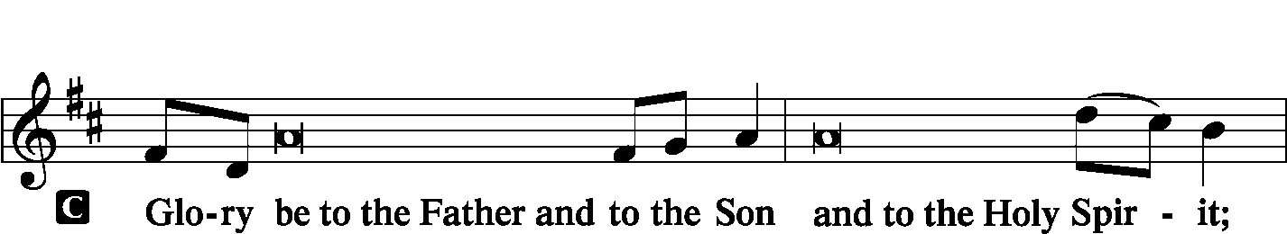
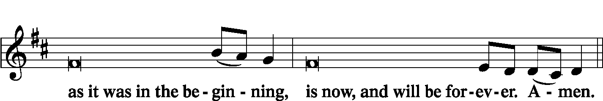
Psalmody
Antiphon (Common) LSB 220
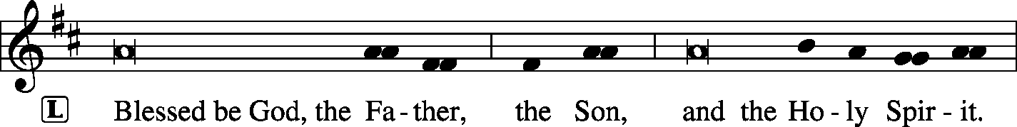

Venite LSB 220
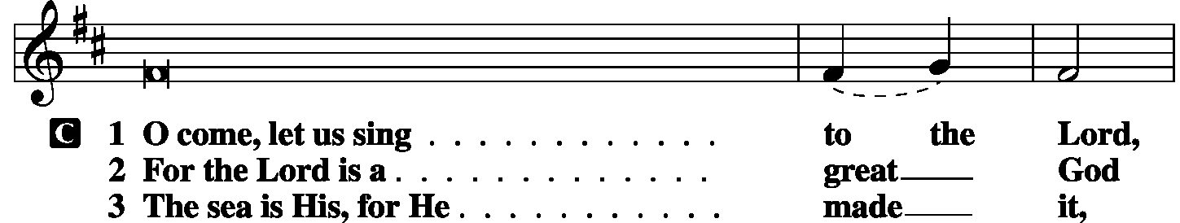
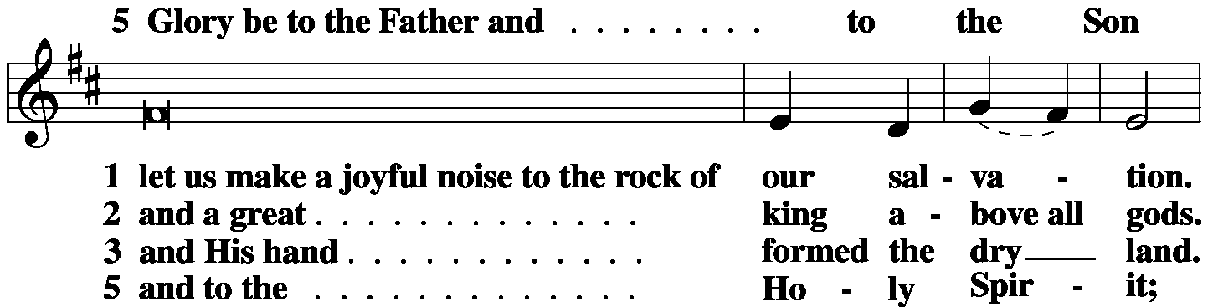
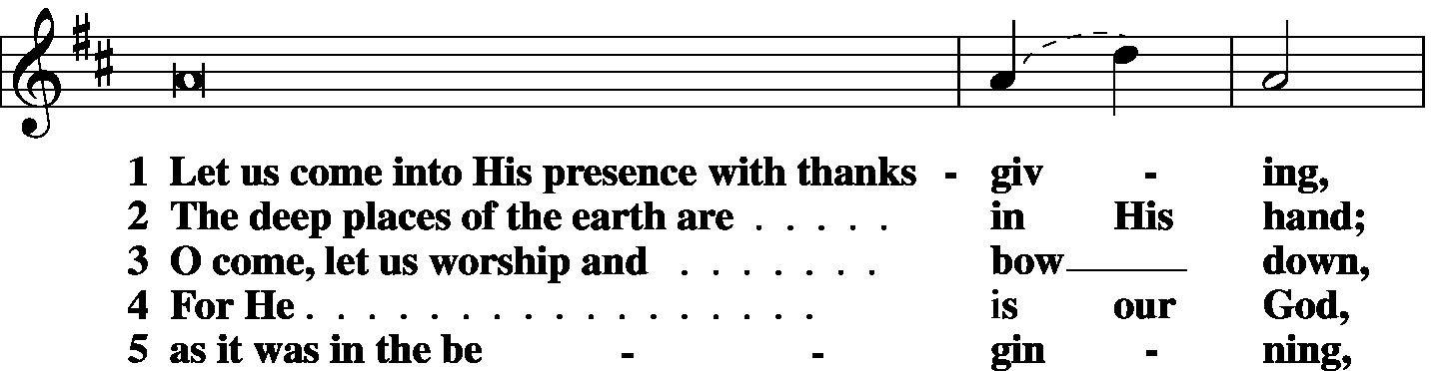
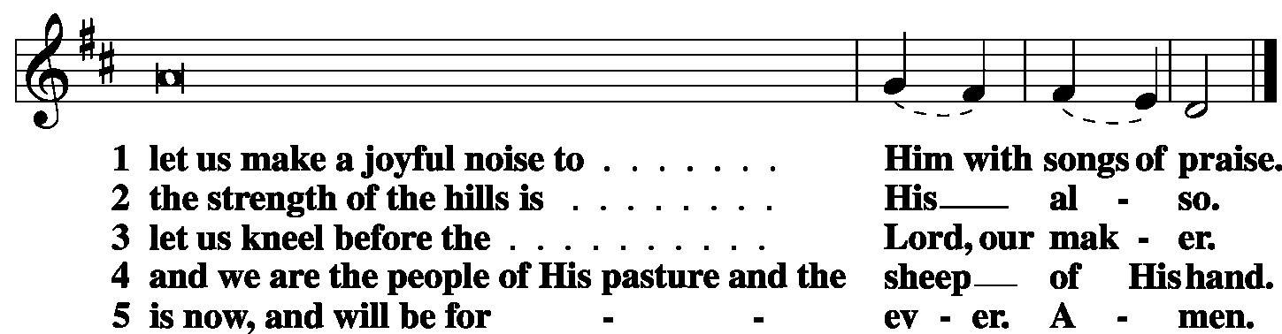

Antiphon (Common) LSB 221

Psalm Psalm 34:8-22 (antiphon: v. 19)
L Oh, taste and see that the Lord is good!
C Blesséd is the man who takes refuge in Him!
L Oh, fear the Lord, you His saints,
C for those who fear Him have no lack!
L The young lions suffer want and hunger;
C but those who seek the Lord lack no good thing.
L Come, O children, listen to me;
C I will teach you the fear of the Lord.
L What man is there who desires life
C and loves many days, that he may see good?
L Keep your tongue from evil
C and your lips from speaking deceit.
L Turn away from evil and do good;
C seek peace and pursue it.
L The eyes of the Lord are toward the righteous
C and His ears toward their cry.
L The face of the Lord is against those who do evil,
C to cut off the memory of them from the earth.
L When the righteous cry for help, the Lord hears
C and delivers them out of all their troubles.
L The Lord is near to the brokenhearted
C and saves the crushed in spirit.
L Many are the afflictions of the righteous,
C but the Lord delivers him out of them all.
L He keeps all his bones;
C not one of them is broken.
L Affliction will slay the wicked,
C and those who hate the righteous will be condemned.
L The Lord redeems the life of His servants;
C none of those who take refuge in Him will be condemned.
Glory be to the Father
and to the Son and to the Holy Spirit;
as it was in the beginning,
is now and will be forever. Amen.

Sit
Hymn Lord Jesus Christ, with Us Abide LSB 585

First Reading Deuteronomy 10:12–21
“And now, Israel, what does the Lord your God require of you, but to fear the Lord your God, to walk in all His ways, to love Him, to serve the Lord your God with all your heart and with all your soul, and to keep the commandments and statutes of the Lord, which I am commanding you today for your good? Behold, to the Lord your God belong heaven and the heaven of heavens, the earth with all that is in it. Yet the Lord set His heart in love on your fathers and chose their offspring after them, you above all peoples, as you are this day. Circumcise therefore the foreskin of your heart, and be no longer stubborn. For the Lord your God is God of gods and Lord of lords, the great, the mighty, and the awesome God, who is not partial and takes no bribe. He executes justice for the fatherless and the widow, and loves the sojourner, giving him food and clothing. Love the sojourner, therefore, for you were sojourners in the land of Egypt. You shall fear the Lord your God. You shall serve Him and hold fast to Him, and by His name you shall swear.
He is your praise. He is your God, who has done for you these great and terrifying things that your eyes have seen.”
L O Lord, have mercy on us.
C Thanks be to God.

Choir If You But Trust in God to Guide You David Cherwien

Second Reading 1 Corinthians 1:1–9
Paul, called by the will of God to be an apostle of Christ Jesus, and our brother Sosthenes, to the church of God that is in Corinth, to those sanctified in Christ Jesus, called to be saints together with all those who in every place call upon the name of our Lord Jesus Christ, both their Lord and ours: Grace to you and peace from God our Father and the Lord Jesus Christ. I give thanks to my God always for you because of the grace of God that was given you in Christ Jesus, that in every way you were enriched in Him in all speech and all knowledge— even as the testimony about Christ was confirmed among you— so that you are not lacking in any spiritual gift, as you wait for the revealing of our Lord Jesus Christ, who will sustain you to the end, guiltless in the day of our Lord Jesus Christ. God is faithful, by whom you were called into the fellowship of His Son, Jesus Christ our Lord.
L O Lord, have mercy on us.
C Thanks be to God.
Third Reading Matthew 22:34-46
When the Pharisees heard that [Jesus] had silenced the Sadducees, they gathered together. And one of them, a lawyer, asked Him a question to test Him. “Teacher, which is the great commandment in the Law?” And He said to him, “You shall love the Lord your God with all your heart and with all your soul and with all your mind. This is the great and first commandment. And a second is like it: You shall love your neighbor as yourself. On these two commandments depend all the Law and the Prophets.” Now while the Pharisees were gathered together, Jesus asked them a question, saying, “What do you think about the Christ? Whose son is He?” They said to Him, “The son of David.” He said to them, “How is it then that David, in the Spirit, calls Him Lord, saying, “‘The Lord said to My Lord, sit at My right hand, until I put Your enemies under Your feet’? If then David calls Him Lord, how is He his son?” And no one was able to answer Him a word, nor from that day did anyone dare to ask Him any more questions.
P O Lord, have mercy on us.
C Thanks be to God.

Common Responsory LSB 221
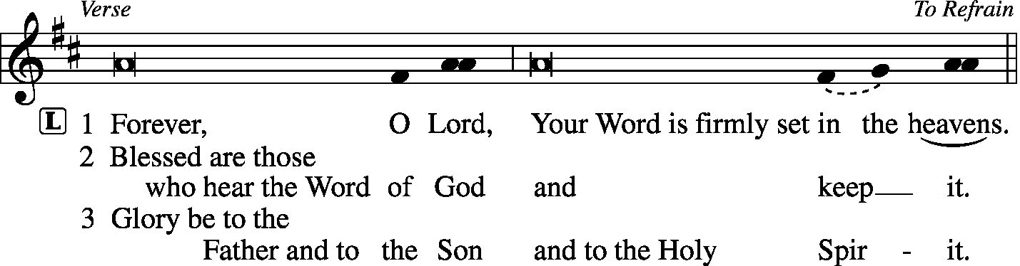
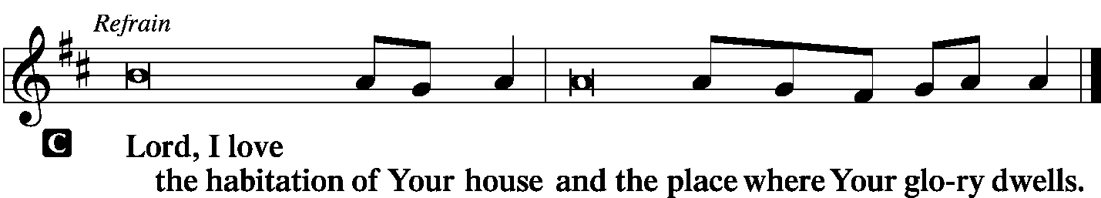

Children's Lunchbox Devotion

Hymn Lord, Keep Us Steadfast in Your Word LSB 655

Sermon Tricksy

Offering
[Please fill out a sheet in the attendance book. Visitors, please include your address. If you have a prayer request for the church prayer chain, please write it at the top of the sheet.]

Special Offering Music Abigail Clayton
Canticle
Stand
Te Deum – We Praise You and Acknowledge You LSB 941
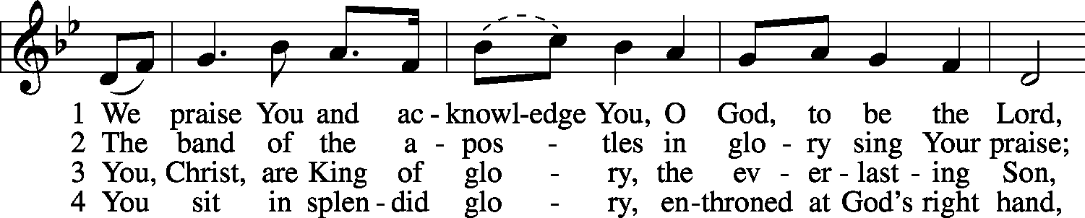
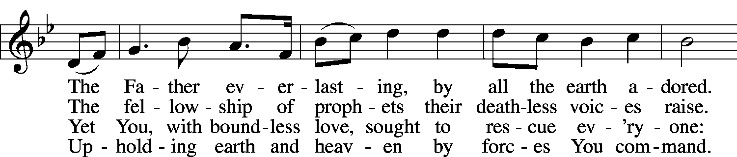
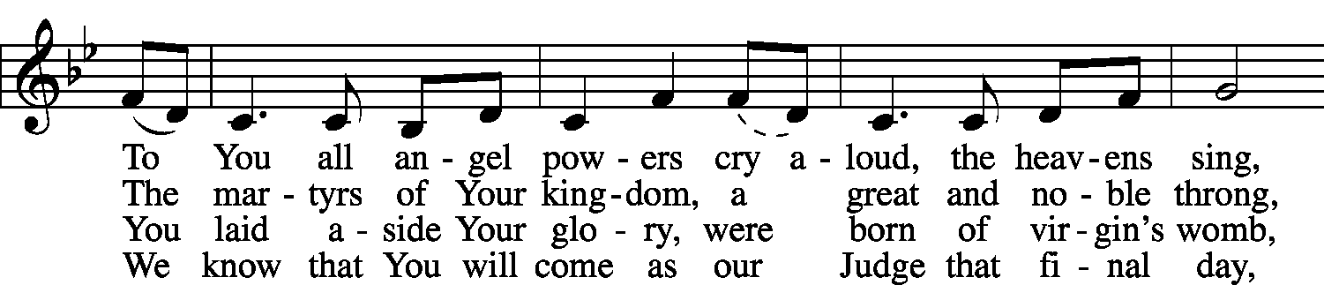
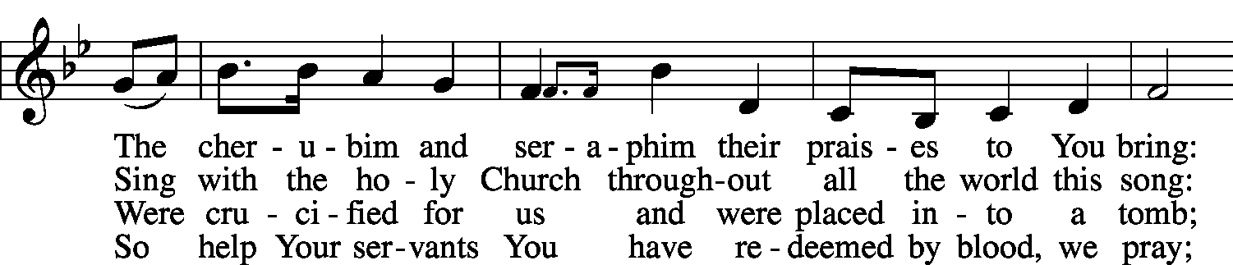
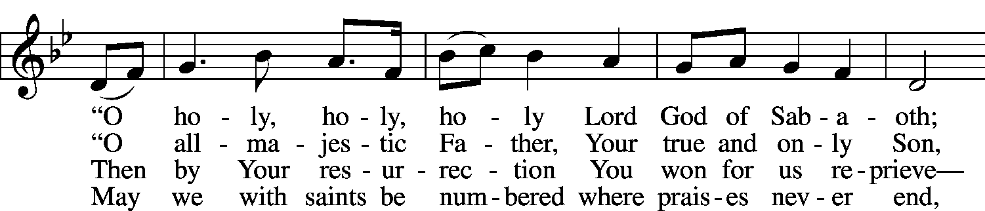
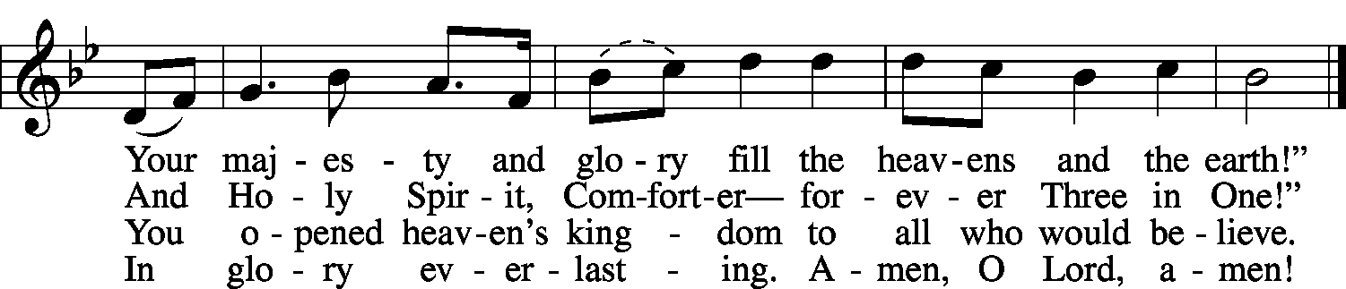
© 1999 Stephen P. Starke. Used by permission: , no. 10001344.
Public domain

Prayer
Kyrie LSB 227

Lord's Prayer
C Our Father who art in heaven, hallowed be Thy name, Thy kingdom come, Thy will be done on earth as it is in heaven; give us this day our daily bread; and forgive us our trespasses as we forgive those who trespass against us; and lead us not into temptation, but deliver us from evil. For Thine is the kingdom and the power and the glory forever and ever. Amen.

Salutation
P The Lord be with you.
C And also with you.

Collect of the Day
P O God, because without You we are not able to please You, mercifully grant that Your Holy Spirit may in all things direct and rule our hearts; through Jesus Christ, Your Son, our Lord, who lives and reigns with You and the Holy Spirit, one God, now and forever.
C Amen.

Prayer of the Church
P O holy and righteous Lord, whose judgments are always right and just, we come before You, trusting that You will hear us.
C Accept our praise and thanks for Your kindness and undeserved love.
P For the light of another day and the protection of the past night, we give You thanks.
C For making it possible for those who delight in Your Law and Gospel to assemble before You, we are thankful.
P We readily confess that we have failed to measure up to the demands of Your law.
C We have walked in the counsel of the wicked, stood in the way of sinners, and sat in the seat of the scornful.
P We are far from being holy; we have been unjust in our judgments.
C We have slandered our neighbor, borne grudges against him, and sought to pay back evil for evil.
P We have not loved others as ourselves because we have not loved You with all our heart, with all our soul, and with all our mind.
C For these departures from the demands of Your Law, forgive us, O Lord.
P By Your Holy Spirit enable us to love You more fully by loving others.
C Help us to love You as You have loved us.
P May we be fruitful trees planted by the streams of Your Word.
C Help us to meditate in Your Word day and night.
P Give us joy in serving You, the only true God, and Jesus Christ, whom You have sent.

WE GO TO THE LORD IN PRAYER FOR
- Allison Spomer, Maggie Harlan, Angie Walter, Ashlee Eatherton, Grant Ahner, and Ezri Linnertz, as they celebrate their baptismal anniversaries this week.
- Beatrice Mary Ruth Lockwood, as she is baptized today.
- Robert Corey, as he awaits test results about a mass on his kidney.
- Members of Zion’s Board of Trustees, Stewardship Committee, and Board of Finance.
- Faithfulness in support of world missions.

P Grant us peace in our nation and in the world.
C May Your Church reflect the love and harmony of our Lord Jesus Christ, in whose Name we pray. Amen.

Collect for Grace
P O Lord, our heavenly Father, almighty and everlasting God, You have safely brought us to the beginning of this day. Defend us in the same with Your mighty power and grant that this day we fall into no sin, neither run into any kind of danger, but that all our doings, being ordered by Your governance, may be righteous in Your sight; through Jesus Christ, Your Son, our Lord, who lives and reigns with You and the Holy Spirit, one God, now and forever.
C Amen.

Benedicamus LSB 228
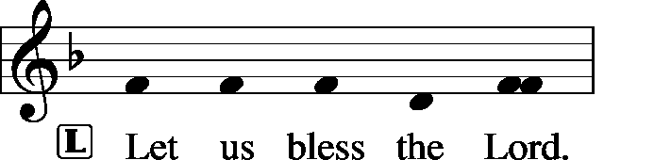
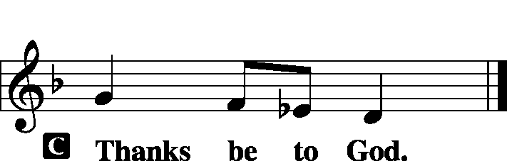

Benediction
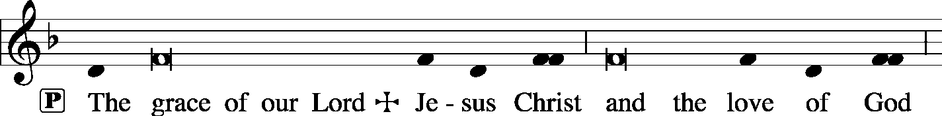
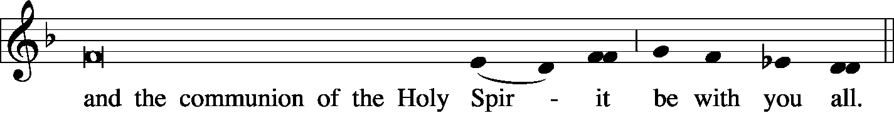

Remain Standing
Hymn Joyful, Joyful We Adore Thee LSB 803

Postlude Recessional of Joy Hal Hopson

Acknowledgments
Unless otherwise indicated, all scripture quotations are from The Holy Bible, English Standard Version, copyright © 2001 by Crossway Bibles, a division of Good News Publishers. Used by permission. All rights reserved. Created by Lutheran Service Builder © 2006 Concordia Publishing House.
LIFE AND LIVING ITEMS AT ZION
          

THE FLOWERS ON THE LORD’S ALTAR
The flowers on the Lord’s altar are given to the glory of God by Bob Twenhafel in memory of Jan, and by the Ahners.

WE WELCOME BEATRICE MARY RUTH LOCKWOOD
Congratulations to Brad and Gina Lockwood on the birth and rebirth in Baptism of Beatrice Mary Ruth Lockwood. Beatrice’s sponsors are Chris Lockwood, uncle, and Amanda Kemezys, cousin. Welcome, Beatrice!

ZION FALL FEST 2019 – TODAY!
"The joy of the Lord is your strength." Nehemiah 8:10. Jesus Brings S'more Joy! The Board of Education invites you to attend Fall Fest today, October 20th from 2-4 PM. Enjoy walking tacos, s'mores, and more! There will be face painting, caricature drawings, fire pits, bounce slide, and more. Youth group members will team up for a geocache hunt starting at 2:15 while the younger kids participate in crafts, a puppet show, and yard games. Bring a lawn chair and enjoy S'more fun and fellowship at Zion. If you would like to chaperone a geocache team or supervise an activity, please sign up in the narthex. If we have enough volunteers, we can have one hour shifts so you can still enjoy the activities. Also, if you have yard games or a fire pit to share, please note that on the sign-up sheet.

NEW CHRISTIAN GREETING CARDS
Lots of new greeting cards just came in! There are many new choices in every category –birthday, get well, sympathy, and more. All for only 50 cents each!

FEED THE FIELDWORKERS
Two new spreadsheets are available for you to invite seminary student fieldworkers, Don Stein and his family, and/or Adam and Morgan Wolfe to join you for your Sunday lunch at home or out. Please sign your name on one of the spreadsheets on the counter by the flower calendar. Let's show them Zion's hospitality!

BIBLE STUDY SURVEY
Do you have any Bible Study Topics that you would like the church to offer in the future? Then please write those topics on the note cards placed in the hymnal rack by the members need offering envelopes. Topics can be anything you have a desire to study with your church family, even if we have studied your topic of interest previously. (Examples: marriage, retirement, parenting, money, temptation, courage, teenage/young adult Christian life, prophecy/end times, life of Job, creation vs. science, historical evidence of the Bible, etc.). These Bible studies may occur Sunday mornings, but they could also occur at alternative times as well. So, if you have a preference for an alternative time for Bible study (Sunday evenings, weekday mornings, or weekday evenings) please include that on your note card. If you would be interested in an online/over your smart phone video Bible study or devotions please indicate that as well. If you are interested in certain group based studies please indicate this as well on the note card (examples: men's, women's, senior, widow, singles, young adult, teenage, etc.). This survey is to help us as a church attempt to provide Bible studies that you may be interested in. It may take some time to get to all the study requests, but our goal is for everyone to be involved in a weekly Bible study. Please place your note card in the glass offering jars as you leave church or present them to your elder. Please let your elder know of any future Bible Study requests that you may have even if you do not have any at this time. Elder - Matt Sink

HARVEST TABLE
It’s harvest time again! Check the harvest table in the Narthex. Bring an extra vegetable or fruit from your garden, you can trade for another or buy the item with a donation to Concerned Christians.

DOMINICAN REPUBLIC MISSION TRIP
Zion Mascoutah is looking seriously into sponsoring/sending a short term mission team to the Dominican Republic. This project has been discussed by the Evangelism Committee, the Board of Elders, and the Church Council, and it is time to take action. Over the next few weeks, a flier will be placed in the bulletin with short-term mission team volunteer opportunities. Fliers about the trip options are included in the bulletin this morning. If you are interested in participating in a trip, please circle which trip you would be most interested in doing, and sign your name so we can gauge where to apply our resources first. Short-term mission teams in the Dominican Republic typically consist of 8-10 people, and the trips run for one week, usually from Saturday to Saturday. Teams are assembled for specific purposes or themes, and have a set workload to be accomplished during the week. For next year, five different types of teams are possible, based on what the preference and interest of Zion is. The five types of trips are: EDUCATIONAL SUPPORT TEAM--Support education in the church’s two Lutheran schools and/or local public schools; HEALTH OUTREACH TEAM--Spend a week engaging in various outreach activities related to health (spiritual, mental, emotional, physical) and the promotion and preservation of life from conception to natural death; PLAYGROUND RENOVATION TEAM--Renovate two playgrounds (one for little kids and one for older kids) in Palmar Arriba; VACATION BIBLE SCHOOL TEAMS--Lead a week-long Vacation Bible School (Bible stories, crafts, games, music, snacks, etc.) at one of the local Lutheran congregations; and VOLLEYBALL CAMP TEAM--Lead a week-long volleyball camp for children & youth at Iglesia Luterana Amigos de Cristo. While volleyball skills and fundamentals should be the focus, traditional VBS elements like Bible stories, songs, games, snacks, and crafts may be included. Your team may also be able to assist with cleaning/preparing an unpaved, overgrown area near the church to be used as an outdoor play space. The cost per person for the week, including round-trip airfare, housing, and food for any of these mission trip options is likely to be about $1600. Dates are not yet set, but a timeframe shortly after school ends, late May or early June, might be a strong possibility. If you are interested in serving in one of these areas on a short-term mission team to the Dominican Republic, please begin to prayerfully consider how you might become more personally involved in our Lord’s mission work. Please fill out the information flier in the bulletin and place it in the basket on the card table in the narthex. Pray, and be prepared to volunteer!

2020 CHRISTIAN-THEMED CALENDARS NOW AVAILABLE
Zion’s Ladies Aid is selling Christian themed 2020 wall calendars. They are $6 each and are located on the table in the Narthex. There are a limited number so get yours today!

UNITY EAST ST. LOUIS WORK DAY -- SATURDAY
Unity Lutheran Church in East St. Louis, and its partner, Lansdowne Community Initiative, will be hosting a work day on Saturday, October 26th. Work crews are asked to meet in the parking lot of Unity Lutheran Church, 4200 Caseyville Ave, East St Louis, IL 62204, at 9:00 AM. Work projects for the day include final clean up on a home owned by the church that has been rehabbed and will be occupied soon, and some neighborhood cleanup as well. If you have them, bring cleaning supplies, trimmers, rakes, gloves, etc. Lunch will be provided at Unity Lutheran Church. The rehab work to be completed has been made possible by a grant from the Lutheran Foundation of St. Louis, and those funds are also being used to purchase a second house directly across the street from the church that will need minimal work to clean and prepare for occupancy. The Lansdowne Community Initiative has also received a $10,000 dollar-for-dollar matching grant to support the effort and to purchase and rehab additional homes. Donations to meet this matching grant would be welcome! If you cannot come to work in person, please help meet the matching grant by sending a check to Lansdowne Community Initiative, 4200 Caseyville Ave, East St Louis, IL 62204. And, if you are able to help with the work day, please assemble a crew from your congregation to meet at Unity Lutheran Church on Saturday, October 26th. Thanks in advance for all assistance given!
WINDSBACH BOYS CHOIR
Come listen to the World-Class Boys Choir from Bavaria performing sacred music by J. S. Bach, Händel, Mozart, Mendelssohn, Brahms and more. The best of German folk song! The performance takes place at 7:00 PM on Monday, October 28th, at St. Paul’s Lutheran Church, 12345 Manchester Road, Des Peres, MO. For more information: 314-822-0447.

69th ANNUAL SAUSAGE SUPPER
Please join us for our 69th Annual Sausage Supper on Sunday, October 27th from Noon – 6 PM at Trinity’s Parish Hall, 219 McGaughey St., Worden, IL. Adults are $10, children 6-12 are $4, children 1-5 are free, and carry-outs are $10. Liver, pork, blood sausage, ribs, and backbones will be sold at the Parish Hall on Friday from 8 AM – 5 PM and Saturday from 8 AM – Noon.

ST. JOHN’S UCC BEEF AND NOODLE DINNER
St. John’s UCC in Mascoutah is hosting their “All You Can Eat” Beef and Noodle Dinner on Friday, November 1st. Lunch will be served from 11 AM to 1 PM and dinner from 5 PM to 7 PM. Adults are $10, children 6-12 are $3, and children under 6 are free. Carry-outs are available. Benefits go to the Senior Center and Leu Civic Center.

61st ANNUAL WURSTMARKT
The Ferrin Men’s Club is holding their 61st Annual Wurstmarkt on Sunday November 3rd, from 12 PM to 6 PM in the Ferrin School Basement (handicap accessible). They will also have sausage for sale. Adults are $11, Children 6-12, $6, Carry-outs, $11, and Children under 6, free.

OSBORNE FAMILY CHICKEN & BEER BENEFIT
Richard “Dickie” Osborne lost his life after injuries sustained from a motorcycle accident on July 26th. We would like to come together as a community to raise money to help alleviate the financial burden for his wife, Whitney, and his son Wyatt. Come out and celebrate Dickie’s life and raise money for his family. The benefit will take place on November 9th at the Mascoutah Sportsmen’s Club beginning at 5 PM. Advance tickets are $20 for adults and $5 for kids. Tickets at the door are $25 for adults and $8 for kids. Bring your own snacks and soft drinks. Silent auction closes at 8:30 PM. For more information email osbornefamilybenefit@gmail.com.

CHI AUXILIARY ANNUAL CHRISTMAS LUNCHEON
The Auxiliary of the Concordia Historical Institute is pleased to announce its Annual Christmas Luncheon on Thursday, December 12, 2019, at 12 Noon in Koburg Hall, Concordia Seminary campus (804 Seminary Place, Clayton, MO). Meet and greet new or renewed acquaintances, hear the Village Lutheran Homeschool Handbell Choir,enjoy singing Christmas carols, and receive an update on CHI. The luncheon cost is $15 per person, with reservations to be made by December 5th. Checks may be made payable to "CHI Auxiliary" and sent to Nancy Fassold, 5609 Nantasket Court, St. Louis, MO 63128. For more information, please contact her at 314-843-3559 or nk21@live.com.

LISTEN TO WORLDWIDE KFUO AM850
KFUO Radio, AM850, a media ministry extension of LCMS congregations, shares Christ for you anytime, anywhere on AM850 via worship services, Bible and theology studies, practical talk programs, and sacred music. You can find programs on demand at kfuo.org and wherever you get your podcasts! Find us on social: @KFUOradio on Facebook, Twitter, and Instagram. This week on KFUO AM850, hear a curious theological topic discussed on Cross Defense with Rev. Bryan Wolfmueller (10/21 at 2:00 p.m.), study Psalm 26 & 27 along with Isaiah 26-28 on Thy Strong Word (weekdays at 11:00 a.m.), and dig into Amos 1-3 on Sharper Iron's mini-series "The Day is Surely Drawing Near" (weekdays at 8:00 a.m.). Find these and more podcasts, including the new Lutheran Ladies' Lounge, at kfuo.org or on your podcast app!

CONTINUING EDUCATION FOR THE CONFESSIONAL LUTHERAN
Issues, Etc. is a radio talk show and podcast produced by Lutheran Public Radio in Collinsville, IL and hosted by LCMS Pastor Todd Wilken. This week's teachings include: The Hymn "Salvation Unto Us Has Come," The Battle Over Religious Liberty in America, James of Jerusalem: Brother of Jesus & Martyr, The Book of Acts and more. You can listen live or at your convenience at www.issuesetc.org and on the LPR mobile app.
THOSE WHO SERVE TODAY
Proclaimer: Rev. Kirk Clayton
Liturgists: Sem. Adam Wolfe and Sem. Don Stein
Organist: Nancy Peterson
Ushers: Karl Bretz, Joe Crismon, Bob Eldridge, & Ken Frey
Sound Tech: Mike Segelhorst
Video Tech: Mark Hatcher
Welcome Team: Dan & Amy Morra
Acolytes: Elizabeth Bretz & Makena Suedmeyer

THOSE WHO SERVE NEXT WEEK, OCTOBER 27
Proclaimer: Rev. Kirk Clayton
Liturgists: Sem. Adam Wolfe and Sem. Don Stein
Organist: Nancy Peterson
Ushers: Lee Harlan, Mark Hatcher, Carl Sherrill, & Buzz Kandler
Sound Tech: Ken Frey
Video Tech: Mark Hatcher
Welcome Team: Darren & Lindsay Murphy
Acolytes: Abby McDaniel & Ezri Linnertz
Altar Guild: Lita Timmerman & Shirley Braeutigam

THINGS WE ARE DOING AT ZION
Sun. Confirmation Class 8:30 AM
SS & Bible Class 8:45 AM
Worship Matins 10:00 AM
Zion Fall Fest 2:00 – 4:00 PM
Mon. LifeLight 7:00 PM
Tues. Preschool Open House/Art Show 7:00 PM
Elders Meeting 7:00 PM
Wed. Preschool Pumpkin Picking 9:00 AM
Choir Rehearsal 7:00 PM
New Member Class 7:00 PM
Thurs. Preschool Pumpkin Picking 9:00 AM
Youth Bible Study 6:00 PM
Fri. Senior Meal Delivery 10:30 AM
Sun. Reformation Day
Confirmation Class 8:30 AM
SS & Bible Class 8:45 AM
Worship DS I w/communion 10:00 AM

ATTENDANCE OCTOBER 13: Sunday: 214
Adult Bible Class: 34 High School: 10 Sunday School: 45

