Zion Lutheran Church
Mascoutah, Illinois
October 27, 2019
Reformation Sunday

In the Name of Christ Jesus our Lord, we bid you a warm welcome to this worship service. May your experience of worship and fellowship this morning be spiritually refreshing and ready you for the week ahead.
 
Pastor: Rev. Kirk Clayton
Church Secretary: Robin Phillips
Choir Director Team: Josh and Nancy Peterson
_________________________________________________________________________________
Church Office Phone: 618-566-7345
Pastor Clayton Cell: 618-447-1306
Office Hours: 8:00 am to 12:00 pm
Email: ChurchOffice@ZionMascoutah.org
Pastor Clayton email: Pastor@ZionMascoutah.org
Web site: www.ZionMascoutah.org
Find us at @ZionMascoutah on Facebook, Twitter, and Instagram
Electronic Devices
Please TURN OFF all cell phones, pagers, electronic devices, apps and games when entering the sanctuary for worship so those around you may focus on the Word of God without electronic distraction. Thank you.

A Prayer to Begin Worship
Ascended Lord, who as Word came to dwell among us, that we might know the love of the Father, lead us ever deeper into the Scriptures – under the blessed guidance of the Holy Spirit—that we learn again and again of the freedom from sin and the Law that Your Gospel has brought us, and that we increase more and more in the life lived to Your Glory through willing service to our fellowman; who with the Father and the Holy Spirit are one God with dominion over us forever.

DIVINE SERVICE I WITH COMMUNION
LSB p. 151
Confession and Absolution

Prelude Partita on ‘Thy Strong Word’ Benjamin Culli

Hymn Thy Strong Word LSB 578

Stand

The sign of the cross may be made by all in remembrance of their Baptism.

Invocation
L In the name of the Father and of the T Son and of the Holy Spirit.
C Amen.

Exhortation
L If we say we have no sin, we deceive ourselves, and the truth is not in us.
C But if we confess our sins, God, who is faithful and just, will forgive our sins and cleanse us from all unrighteousness.

Silence for reflection on God's Word and for self-examination.

Confession of Sins
L Let us then confess our sins to God our Father.
C Most merciful God, we confess that we are by nature sinful and unclean. We have sinned against You in thought, word, and deed, by what we have done and by what we have left undone. We have not loved You with our whole heart; we have not loved our neighbors as ourselves. We justly deserve Your present and eternal punishment. For the sake of Your Son, Jesus Christ, have mercy on us. Forgive us, renew us, and lead us, so that we may delight in Your will and walk in Your ways to the glory of Your holy name. Amen.

Declaration of Grace
L In the mercy of almighty God, Jesus Christ was given to die for us, and for His sake God forgives us all our sins. To those who believe in Jesus Christ He gives the power to become the children of God and bestows on them the Holy Spirit. May the Lord, who has begun this good work in us, bring it to completion in the day of our Lord Jesus Christ.
C Amen.

Service of the Word
Introit Ps. 34:1–2, 11, 22; antiphon: Ps. 119:46
L I will speak of Your testimonies before kings, [O Lord,]
C and shall not be put to shame.
L I will bless the Lord at all times;
C His praise shall continually be in my mouth.
L My soul makes its boast in the Lord;
C let the humble hear and be glad.
L Come, O children, listen to me;
C I will teach you the fear of the Lord.
L The Lord redeems the life of His servants;
C none of those who take refuge in Him will be condemned.
Glory be to the Father
and to the Son and to the Holy Spirit;
as it was in the beginning,
is now, and will be forever. Amen.
L I will speak of Your testimonies before kings, [O Lord,]
C and shall not be put to shame.

Kyrie LSB 152
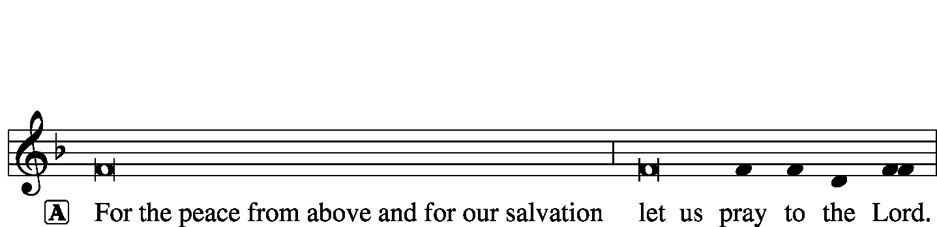
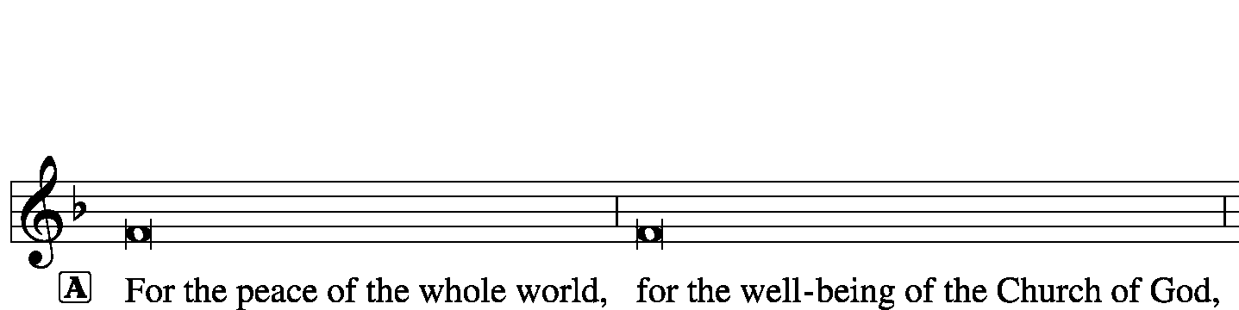
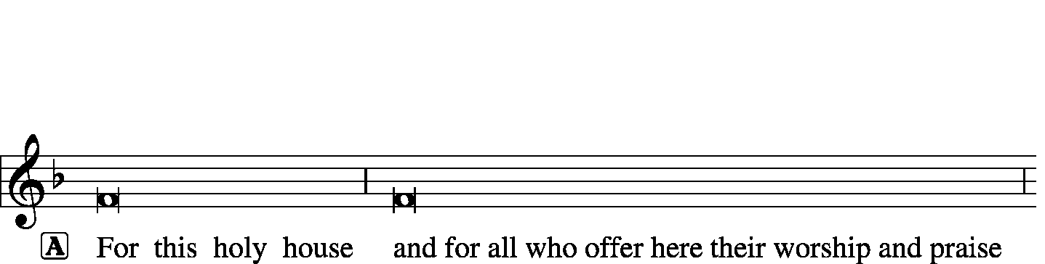
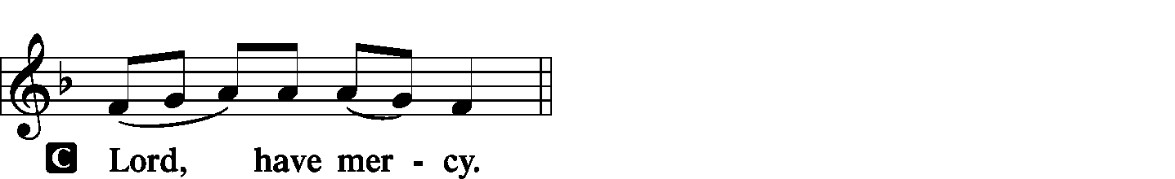
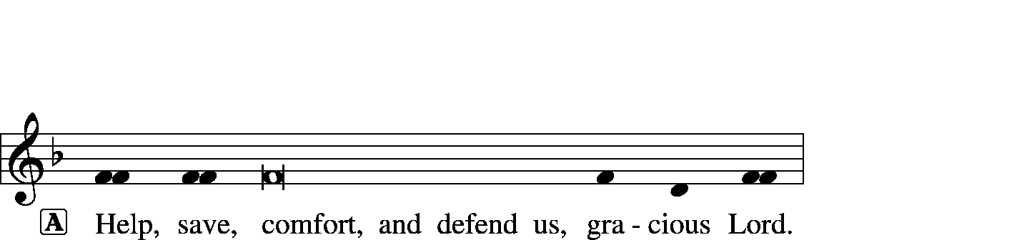

Hymn of Praise -- This Is the Feast LSB 155
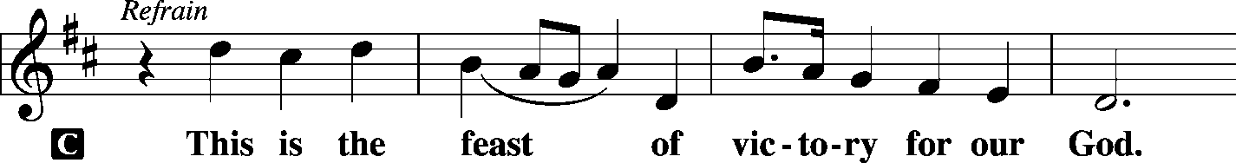
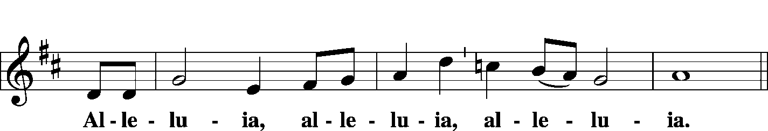
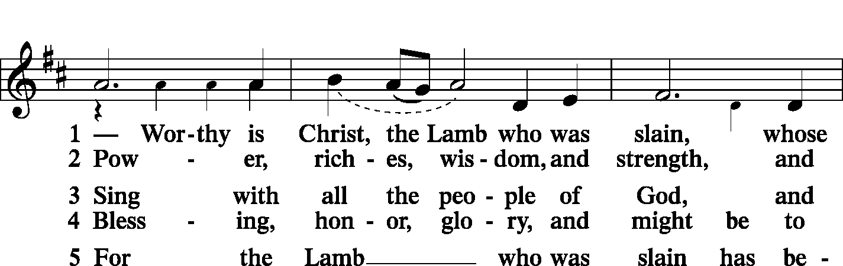
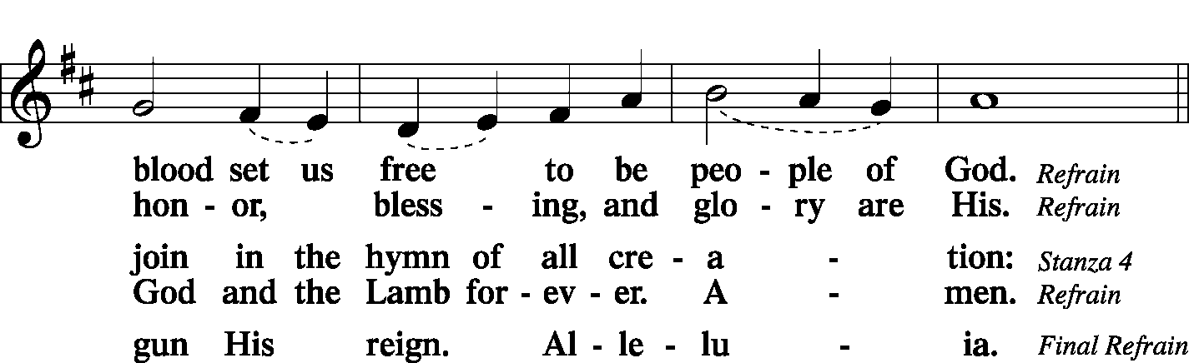
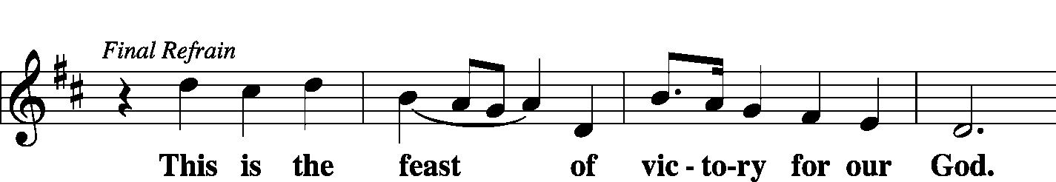
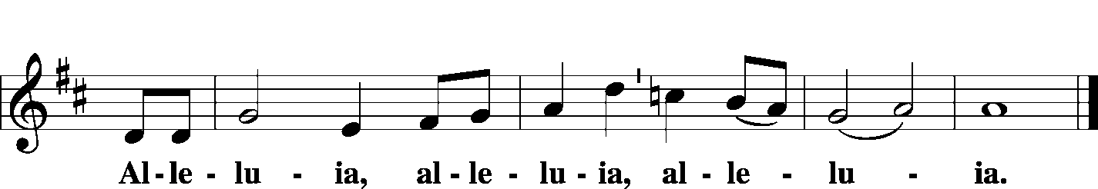

Salutation and Collect of the Day
P The Lord be with you.
C And also with you.
P Let us pray.
Almighty and gracious Lord, pour out Your Holy Spirit on Your faithful people. Keep us steadfast in Your grace and truth, protect and deliver us in times of temptation, defend us against all enemies, and grant to Your Church Your saving peace; through Jesus Christ, Your Son, our Lord, who lives and reigns with You and the Holy Spirit, one God, now and forever.
C Amen.

Sit

First Reading Revelation 14:6–7
Then I saw another angel flying directly overhead, with an eternal gospel to proclaim to those who dwell on earth, to every nation and tribe and language and people. And he said with a loud voice, “Fear God and give Him glory, because the hour of His judgment has come, and worship Him who made heaven and earth, the sea and the springs of water.”
P This is the Word of the Lord.
C Thanks be to God.

Choir God of Grace arr. Tom Fettke

Epistle Romans 3:19–28
Now we know that whatever the law says it speaks to those who are under the law, so that every mouth may be stopped, and the whole world may be held accountable to God. For by works of the law no human being will be justified in His sight, since through the law comes knowledge of sin.
But now the righteousness of God has been manifested apart from the law, although the Law and the Prophets bear witness to it— the righteousness of God through faith in Jesus Christ for all who believe. For there is no distinction: for all have sinned and fall short of the glory of God, and are justified by His grace as a gift, through the redemption that is in Christ Jesus, whom God put forward as a propitiation by His blood, to be received by faith. This was to show God’s righteousness, because in His divine forbearance He had passed over former sins. It was to show His righteousness at the present time, so that He might be just and the justifier of the one who has faith in Jesus.
Then what becomes of our boasting? It is excluded. By what kind of law? By a law of works? No, but by the law of faith. For we hold that one is justified by faith apart from works of the law.
P This is the Word of the Lord.
C Thanks be to God.
Stand

Common Alleluia and Verse LSB 156
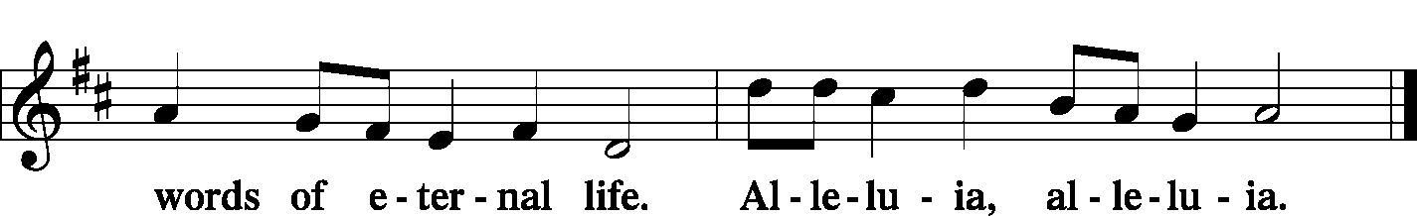

Holy Gospel John 8:31-36
P The Holy Gospel according to St. John, the 8th chapter.
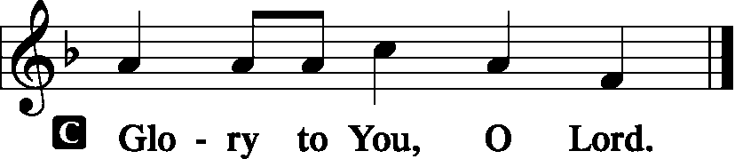
To the Jews who had believed Him, Jesus said, “If you hold to My teaching, you are really My disciples. Then you will know the truth, and the truth will set you free.”
They answered Him, “We are Abraham’s descendants and have never been slaves of anyone. How can You say that we shall be set free?”
Jesus replied, “Very truly I tell you, everyone who sins is a slave to sin. Now a slave has no permanent place in the family, but a son belongs to it forever. So if the Son sets you free, you will be free indeed.
P This is the Gospel of the Lord.
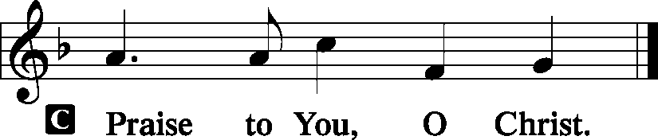
Sit

Hymn Water, Blood, and Spirit Crying LSB 597

Sermon Ecclesia Semper Reformanda

Stand

Nicene Creed
C I believe in one God, the Father Almighty, maker of heaven and earth and of all things visible and invisible.
And in one Lord Jesus Christ, the only-begotten Son of God, begotten of His Father before all worlds, God of God, Light of Light, very God of very God, begotten, not made, being of one substance with the Father, by whom all things were made; who for us men and for our salvation came down from heaven and was incarnate by the Holy Spirit of the virgin Mary and was made man; and was crucified also for us under Pontius Pilate. He suffered and was buried. And the third day He rose again according to the Scriptures and ascended into heaven and sits at the right hand of the Father. And He will come again with glory to judge both the living and the dead, whose kingdom will have no end.
And I believe in the Holy Spirit, the Lord and giver of life, who proceeds from the Father and the Son, who with the Father and the Son together is worshiped and glorified, who spoke by the prophets. And I believe in one holy Christian and apostolic Church, I acknowledge one Baptism for the remission of sins, and I look for the resurrection of the dead and the life T of the world to come. Amen.

Prayer of the Church
P Since the beginning of time, O Lord, You have spoken to humanity.
C Even though people have sought to silence Your voice, You have pierced the vale of silence with Your powerful Word.
P Through Moses and the prophets You made Your will known among us.
C When Your messages were ignored, You miraculously embodied Your Word in the person of Jesus Christ.
P Again some tried to still Your voice by nailing Your Word to a cross,
C but You could not be silenced.
P You raised Your “Word made flesh” from the dead so that many have heard the message.
C We thank You, Lord, that we have heard the message through Christ.
P Many have been the heroes and saints who have, at great personal sacrifice, handed the Gospel on to us today.
C Many sacrificed their lives in the defense of Your truth and the Gospel.
P In spite of their efforts, however, human barriers have often curtailed the free distribution, teaching, and preaching of Your Word.
C Many times Your Word has been buried under the rubble of man-made laws and traditions.
P But You have always brought forth one of Your chosen servants to restore Your Word.
C For giving us such men to lead us out of spiritual darkness into the marvelous light of the Gospel, we give You thanks.

WE GO TO THE LORD IN PRAYER FOR
- Joyce Trout, Helen Sauerhage, Ramona Witte, Glenda Pike, and Sharon Weier, as they celebrate their baptismal anniversaries this week.
- Robert Corey, as he faces health concerns.
- Zion’s Men’s Club and Ladies Aid, and Youth Group.
- Faithfulness in personal witness and evangelism.

P Be with the lonely, comfort the sick, and bring the assurance of Your forgiveness to the penitent.
C We pray in Jesus’ Name. Amen.

Sit

Offering
[Please fill out a sheet in the attendance book. Visitors, please include your address. If you have a prayer request for the church prayer chain, please write it at the top of the sheet.]

Stand

Offertory LSB 159
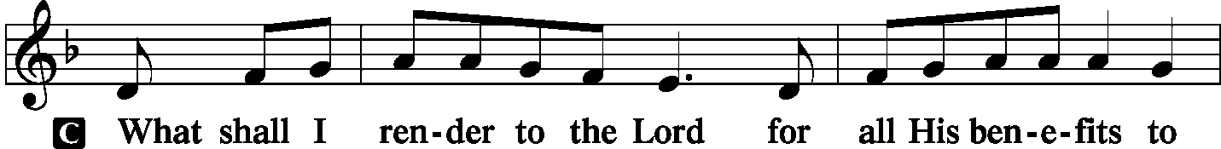
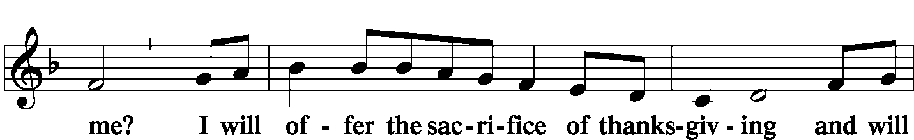
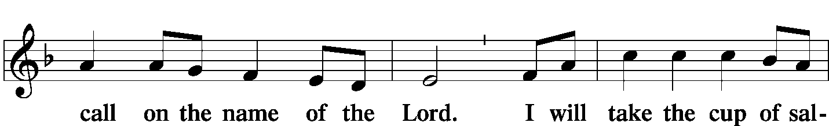
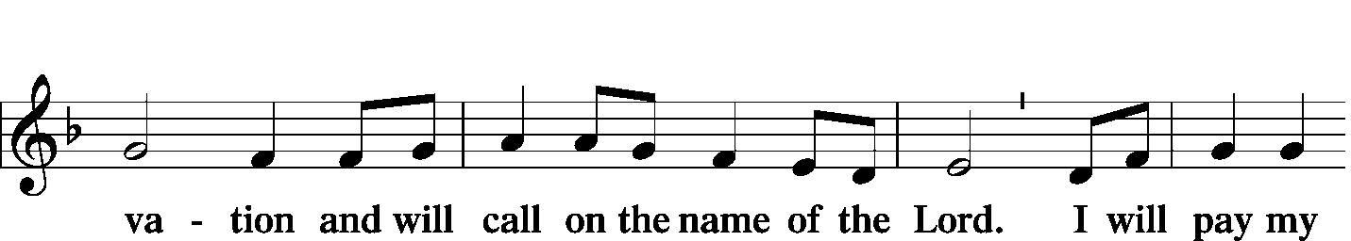
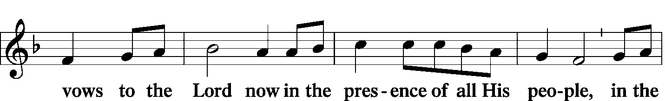
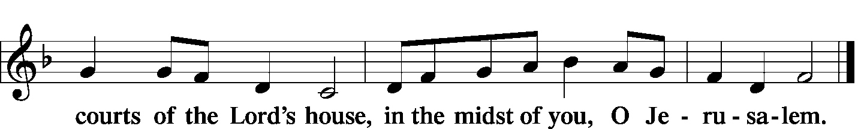

Service of the Sacrament
Preface LSB 160
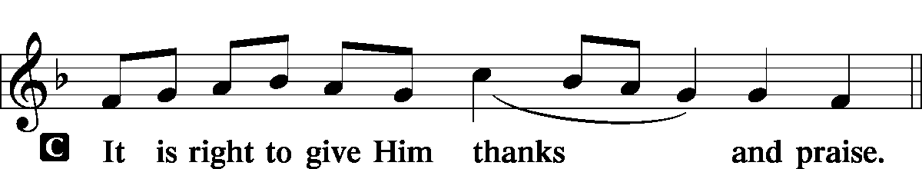

Proper Preface (Full)
P It is truly good, right, and salutary that we should at all times and in all places give thanks to You, holy Lord, almighty Father, everlasting God. And most especially are we bound to praise You on this day for the glorious resurrection of Your Son, Jesus Christ, the very Paschal Lamb, who was sacrificed for us and bore the sins of the world. By His dying He has destroyed death, and by His rising again He has restored to us everlasting life. Therefore with Mary Magdalene, Peter and John, and with all the witnesses of the resurrection, with angels and archangels, and with all the company of heaven we laud and magnify Your glorious name, evermore praising You and saying:

Sanctus LSB 161
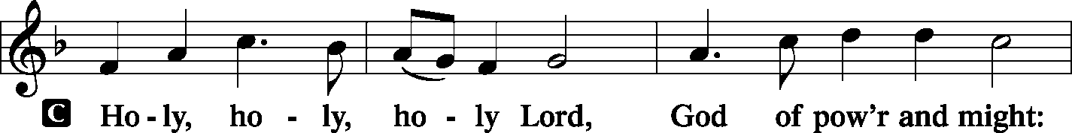
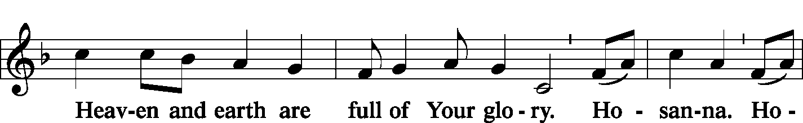
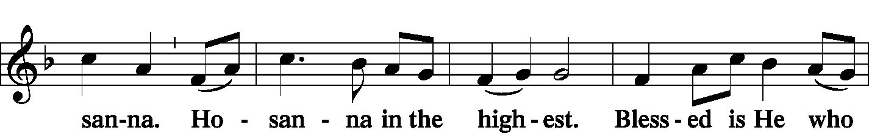
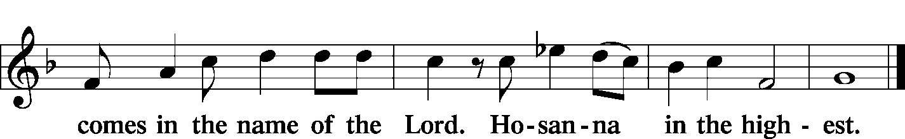

Prayer of Thanksgiving LSB 161
P Blessed are You, Lord of heaven and earth, for You have had mercy on those whom You created and sent Your only-begotten Son into our flesh to bear our sin and be our Savior. With repentant joy we receive the salvation accomplished for us by the all-availing sacrifice of His body and His blood on the cross.

Gathered in the name and the remembrance of Jesus, we beg You, O Lord, to forgive, renew, and strengthen us with Your Word and Spirit. Grant us faithfully to eat His body and drink His blood as He bids us do in His own testament. Gather us together, we pray, from the ends of the earth to celebrate with all the faithful the marriage feast of the Lamb in His kingdom, which has no end. Graciously receive our prayers; deliver and preserve us. To You alone, O Father, be all glory, honor, and worship, with the Son and the Holy Spirit, one God, now and forever.
C Amen.

Lord's Prayer LSB 162
P Lord, remember us in Your kingdom and teach us to pray:
C Our Father who art in heaven, hallowed be Thy name, Thy kingdom come, Thy will be done on earth as it is in heaven; give us this day our daily bread; and forgive us our trespasses as we forgive those who trespass against us; and lead us not into temptation, but deliver us from evil. For Thine is the kingdom and the power and the glory forever and ever. Amen.

The Words of Our Lord LSB 162
P Our Lord Jesus Christ, on the night when He was betrayed, took bread, and when He had given thanks, He broke it and gave it to the disciples and said: “Take, eat; this is My T body, which is given for you. This do in remembrance of Me.”
In the same way also He took the cup after supper, and when He had given thanks, He gave it to them, saying: “Drink of it, all of you; this cup is the new testament in My T blood, which is shed for you for the forgiveness of sins. This do, as often as you drink it, in remembrance of Me.”

Pax Domini LSB 163
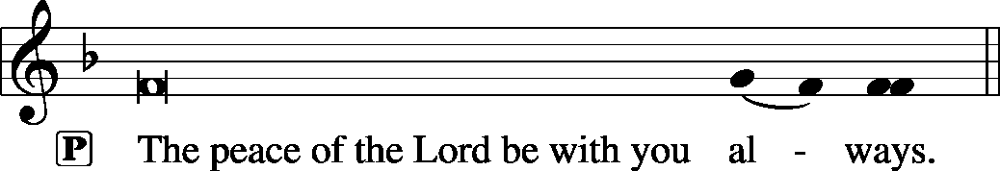

Agnus Dei LSB 163
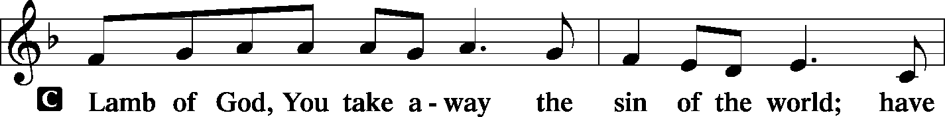
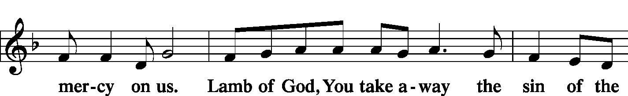
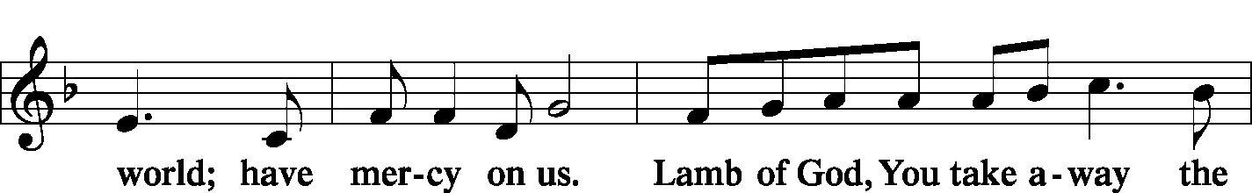
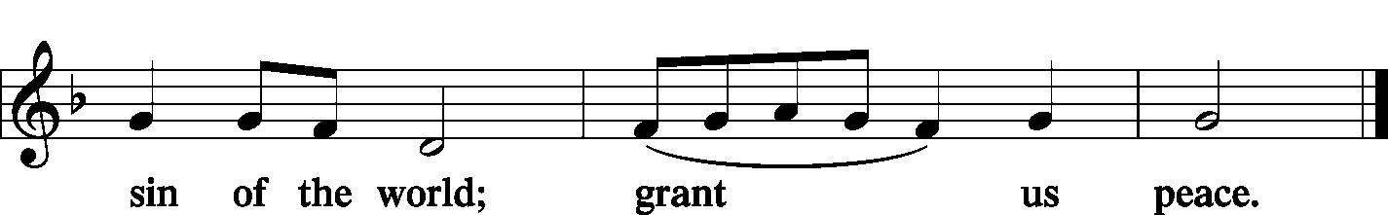

Sit

Distribution
Zion Lutheran practices the policy of close communion, communing only those who share our common Biblical view of the Lord's Supper. If you are not a confirmed LCMS Lutheran, please confer with the pastor before communing.

The pastor and those who assist him receive the body and blood of Christ first and then distribute them to those who come to receive, saying:

Take, eat; this is the true body of our Lord and Savior Jesus Christ, given into death for your sins.
Amen.

Take, drink; this is the true blood of our Lord and Savior Jesus Christ, shed for the forgiveness of your sins.
Amen.

Hymn Soul, Adorn Yourself with Gladness LSB 636

Hymn Dear Christians, One and All Rejoice LSB 556

Hymn O Lord, We Praise Thee LSB 617

Stand

In dismissing the communicants, the following is said:

The Dismissal
L May the body and blood of our Lord Jesus Christ strengthen and preserve you in body and soul to life everlasting. Depart T in peace.
C Amen.

Post-Communion Canticle -- Thank the Lord LSB 164
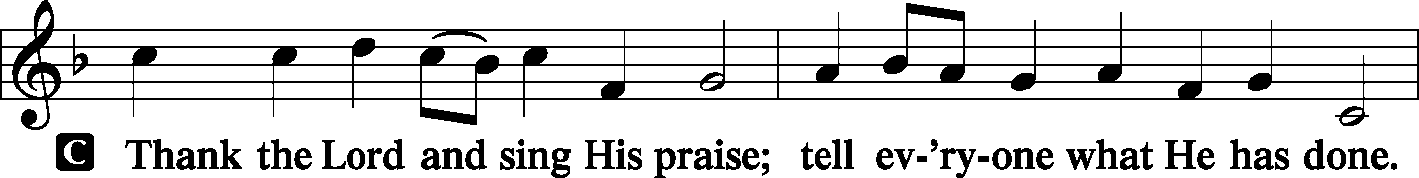
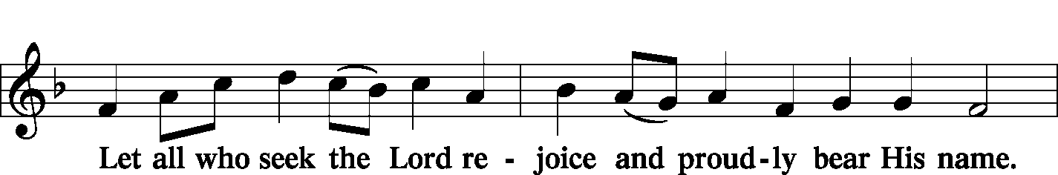
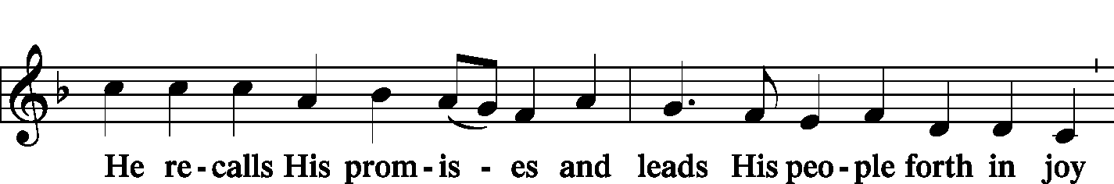
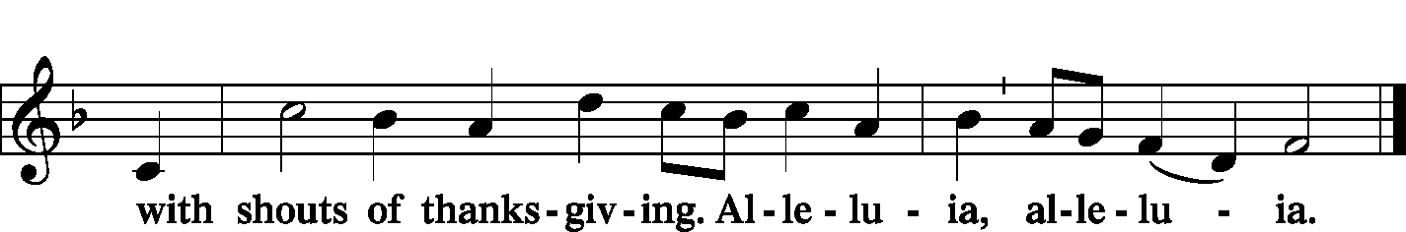

Post-Communion Collect
L Let us pray.
We give thanks to You, almighty God, that You have refreshed us through this salutary gift, and we implore You that of Your mercy You would strengthen us through the same in faith toward You and in fervent love toward one another; through Jesus Christ, Your Son, our Lord, who lives and reigns with You and the Holy Spirit, one God, now and forever.
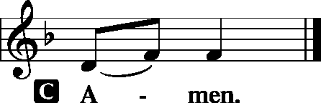

Benediction LSB 166
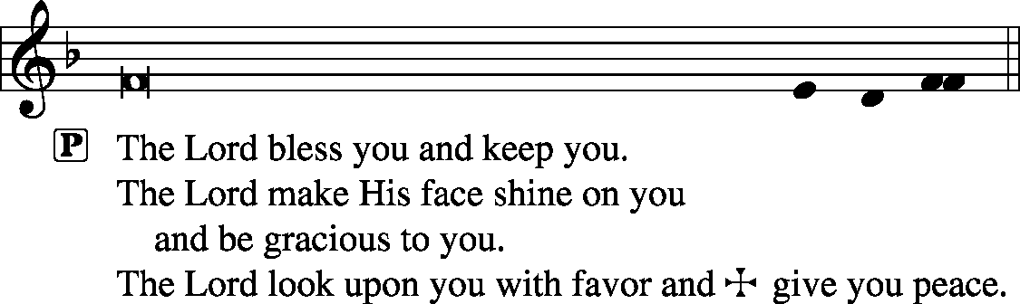

Remain standing

Hymn A Mighty Fortress is Our God LSB 656

Postlude Thy Strong Word – Toccata Benjamin Culli

Acknowledgments
Unless otherwise indicated, all scripture quotations are from The Holy Bible, English Standard Version, copyright © 2001 by Crossway Bibles, a division of Good News Publishers. Used by permission. All rights reserved. Created by Lutheran Service Builder © 2006 Concordia Publishing House.
LIFE AND LIVING ITEMS AT ZION
          

THE FLOWERS ON THE LORD’S ALTAR
The flowers on the Lord’s altar are given to the glory of God by the Kemezys family, in celebration of Katie Crismon’s birthday.

THANK YOU TO OUR BRASS MUSICIANS
Thanks to Josh Peterson and Pastor Clayton, trumpets; Bob Eldridge and Thor Peterson, trombones; Ashlee Eatherton, tuba; and Nathaniel Clayton, baritone and timpani.

NOVEMBER ECHO – NOW AVAILABLE
The November Echo is now available. Pick one up in the narthex today!

COMMEMORATION OF THE FAITHFUL DEPARTED ON NOV. 3
As a church, we find great comfort in the hope of the resurrection, and we find peace in the knowledge that our loved ones who have died rest in the Lord's glory. Each year around All Saints Day, we give thanks to God for the wonderful, loving, faithful witness of those who have gone before us in the faith and are now at rest with the Lord. If you have a loved one who has entered eternal rest this past year since last November 1, please pass that information on to the church office so we can include your loved one’s name in the Commemoration of the Faithful Departed.

SIGN UP FOR CHILDREN’S CHRISTMAS PROGRAM
Maggie Harlan and Pastor Clayton are writing the Children's Christmas Program for Zion for this year. In order to refine the script and make sure there are the right number of parts, we need to know which students will be participating. (The Children's Christmas Program will be held on Sunday, December 15, 2019 during the 10:00 morning service.) A list of all Zion students is on the table in the narthex under the church office window. IF YOU ARE NOT ABLE TO PARTICIPATE, PLEASE CROSS YOUR NAME OFF THE LIST. If you do not opt out, we will assume that you will participate and make a part for you. Thanks!

MEMBERS NEED FUND POTLUCK- SUNDAY - NOV 10TH
Please plan to attend a potluck lunch in the gym right after church on November 10th. We are requesting donations be given for those who attend to be used to fund the Zion’s Member’s Need Fund. Elders will be providing hamburgers and hot dogs (buns and condiments). We are asking those with last name A-K to bring a dessert and L-Z to bring a side dish. We look forward to seeing you there.

HARVEST TABLE
It’s harvest time again! Check the harvest table in the Narthex. Bring an extra vegetable or fruit from your garden, you can trade for another or buy the item with a donation to Concerned Christians.

2020 CHRISTIAN-THEMED CALENDARS NOW AVAILABLE
Zion’s Ladies Aid is selling Christian themed 2020 wall calendars. They are $6 each and are located on the table in the Narthex. There are a limited number so get yours today!

DOMINICAN REPUBLIC MISSION TRIP
Zion Mascoutah is looking seriously into sponsoring/sending a short term mission team to the Dominican Republic. This project has been discussed by the Evangelism Committee, the Board of Elders, and the Church Council, and it is time to take action. Over the next few weeks, a flier will be placed in the bulletin with short-term mission team volunteer opportunities. Fliers about the trip options are included in the bulletin this morning. If you are interested in participating in a trip, please circle which trip you would be most interested in doing, and sign your name so we can gauge where to apply our resources first. Short-term mission teams in the Dominican Republic typically consist of 8-10 people, and the trips run for one week, usually from Saturday to Saturday. Teams are assembled for specific purposes or themes, and have a set workload to be accomplished during the week. For next year, five different types of teams are possible, based on what the preference and interest of Zion is. The five types of trips are: EDUCATIONAL SUPPORT TEAM--Support education in the church’s two Lutheran schools and/or local public schools; HEALTH OUTREACH TEAM--Spend a week engaging in various outreach activities related to health (spiritual, mental, emotional, physical) and the promotion and preservation of life from conception to natural death; PLAYGROUND RENOVATION TEAM--Renovate two playgrounds (one for little kids and one for older kids) in Palmar Arriba; VACATION BIBLE SCHOOL TEAMS--Lead a week-long Vacation Bible School (Bible stories, crafts, games, music, snacks, etc.) at one of the local Lutheran congregations; and VOLLEYBALL CAMP TEAM--Lead a week-long volleyball camp for children & youth at Iglesia Luterana Amigos de Cristo. While volleyball skills and fundamentals should be the focus, traditional VBS elements like Bible stories, songs, games, snacks, and crafts may be included. Your team may also be able to assist with cleaning/preparing an unpaved, overgrown area near the church to be used as an outdoor play space. The cost per person for the week, including round-trip airfare, housing, and food for any of these mission trip options is likely to be about $1600. Dates are not yet set, but a timeframe shortly after school ends, late May or early June, might be a strong possibility. If you are interested in serving in one of these areas on a short-term mission team to the Dominican Republic, please begin to prayerfully consider how you might become more personally involved in our Lord’s mission work. Please fill out the information flier in the bulletin and place it in the basket on the card table in the narthex. Pray, and be prepared to volunteer!

69th ANNUAL SAUSAGE SUPPER -- TODAY
Please join us for our 69th Annual Sausage Supper today, October 27th from Noon – 6 PM at Trinity’s Parish Hall, 219 McGaughey St., Worden, IL. Adults are $10, children 6-12 are $4, children 1-5 are free, and carry-outs are $10.

WINDSBACH BOYS CHOIR -- TOMORROW
Come listen to the World-Class Boys Choir from Bavaria performing sacred music by J. S. Bach, Händel, Mozart, Mendelssohn, Brahms and more. The best of German folk song! The performance takes place at 7:00 PM on Monday, October 28th, at St. Paul’s Lutheran Church, 12345 Manchester Road, Des Peres, MO. For more information: 314-822-0447.

ST. JOHN’S UCC BEEF AND NOODLE DINNER
St. John’s UCC in Mascoutah is hosting their “All You Can Eat” Beef and Noodle Dinner on Friday, November 1st. Lunch will be served from 11 AM to 1 PM and dinner from 5 PM to 7 PM. Adults are $10, children 6-12 are $3, and children under 6 are free. Carry-outs are available. Benefits go to the Senior Center and Leu Civic Center.

61st ANNUAL WURSTMARKT
The Ferrin Men’s Club is holding their 61st Annual Wurstmarkt on Sunday November 3rd, from 12 PM to 6 PM in the Ferrin School Basement (handicap accessible). They will also have sausage for sale. Adults are $11, Children 6-12, $6, Carry-outs, $11, and Children under 6, free.

OSBORNE FAMILY BENEFIT
Richard “Dickie” Osborne lost his life after injuries sustained from a motorcycle accident on July 26th. We would like to come together as a community to raise money to help alleviate the financial burden for his wife, Whitney, and his son Wyatt. Come out and celebrate Dickie’s life and raise money for his family. The benefit will take place on November 9th at the Mascoutah Sportsmen’s Club beginning at 5 PM. Advance tickets are $20 for adults and $5 for kids. Tickets at the door are $25 for adults and $8 for kids. Bring your own snacks and soft drinks. Silent auction closes at 8:30 PM. For more information email osbornefamilybenefit@gmail.com.

CHRISTMAS STOCKINGS AND GIFTS WORKSHOP
The LWML workshop this year is at Christ Our Savior Church, Freeburg, on Saturday, Nov 16th, starting at 9 AM. You are welcome to bring friends along to help decorate. Please bring a pair of scissors and fabric glue, if you have any. The list of items suggested to donate for filling the stockings is on the small sheets by the display. Most stockings will go to Lutheran Child and Family Services, infant through sixth grade. The workshop will end with lunch and a closing devotion. (Last year over 200 stockings were decorated, filled, and donated.) SUGGESTED ITEMS FOR THE STOCKINGS: gloves, hats, Christmas ornaments, scarves, school supplies, small books (especially religious), markers, socks, jewelry, small stuffed animals, puzzles, small cars, dolls, purses, bubble bath, hair items, shampoo, body wash, perfume, toothpaste and toothbrushes, small toys, and baby items. ESPECIALLY NEEDED are items for boys.

CHI AUXILIARY ANNUAL CHRISTMAS LUNCHEON
The Auxiliary of the Concordia Historical Institute is pleased to announce its Annual Christmas Luncheon on Thursday, December 12, 2019, at 12 Noon in Koburg Hall, Concordia Seminary campus (804 Seminary Place, Clayton, MO). Meet and greet new or renewed acquaintances, hear the Village Lutheran Homeschool Handbell Choir,enjoy singing Christmas carols, and receive an update on CHI. The luncheon cost is $15 per person, with reservations to be made by December 5th. Checks may be made payable to "CHI Auxiliary" and sent to Nancy Fassold, 5609 Nantasket Court, St. Louis, MO 63128. For more information, please contact her at 314-843-3559 or nk21@live.com.

CHURCH BASEMENT LADIES: AWAY IN THE BASEMENT
Take a trip back in time to 1959 and celebrate the holidays with the CHURCH BASEMENT LADIES: AWAY IN THE BASEMENT. The ladies and the pastor try to save the Church Christmas pageant from disaster in this fun, family-friendly musical presented by Clinton County Showcase at the Avon Theater in Breese on Dec. 6, 7, 8, 13, 14, & 15. Tickets now on sale at clintoncountyshowcase.com.

LISTEN TO WORLDWIDE KFUO AM850
KFUO Radio, AM850, a media ministry extension of LCMS congregations, shares Christ for you anytime, anywhere on AM850 via worship services, Bible and theology studies, practical talk programs, and sacred music. You can find programs on demand at kfuo.org and wherever you get your podcasts! Find us on social: @KFUOradio on Facebook, Twitter, and Instagram. This week on KFUO AM850, hear about the roaring Word of God in Amos 3-5 on Sharper Iron (weekdays at 8:00 a.m.), learn about emotional wellness on Mental Health Monday with Deaconess Heidi Goehmann on The Coffee Hour (10/28 at 9:00 a.m.), and hear a special episode of Concord Matters on the Book of Concord with guest Rev. Paul McCain from Concordia Publishing House (10/29 at 2:00 p.m.). Blessed Reformation!

PATHS TO LUTHERANISM
Issues, Etc. is a radio talk show and podcast produced by Lutheran Public Radio in Collinsville, IL and hosted by LCMS Pastor Todd Wilken. This week's lineup features guests detailing their journeys to Lutheranism from Roman Catholicism, Mainline Protestantism, Calvinism, Anglicanism, Baptist and Pentecostalism. You can tune in live weekdays from 3-5 p.m. on KFUO, 850 AM in St. Louis. You can also listen on-demand at www.issuesetc.org and on the LPR mobile app.
THOSE WHO SERVE TODAY
Proclaimer: Rev. Kirk Clayton
Liturgist: Sem. Don Stein
Organist: Nancy Peterson
Ushers: Lee Harlan, Mark Hatcher, Carl Sherrill, & Buzz Kandler
Sound Tech: Ken Frey
Video Tech: Mark Hatcher
Welcome Team: Darren & Lindsay Murphy
Acolytes: Abby McDaniel & Ezri Linnertz
Altar Guild: Lita Timmerman & Shirley Braeutigam

THOSE WHO SERVE NEXT WEEK, NOVEMBER 3
Proclaimer: Sem. Don Stein
Liturgist: Rev. Kirk Clayton
Lector: Sem. Adam Wolfe
Organist: Pinky Ahner
Ushers: Ryan Heck, Tom Heck, Ray Kemezys, & Alan Kneschke
Sound Tech: Alex Tubbs
Video Tech: Mark Hatcher
Welcome Team: Rachel Pettis & Robin Phillips
Acolytes: Luke Morra & Bjorn Peterson
Altar Guild: Beth Twenhafel

THINGS WE ARE DOING AT ZION
Sun. Reformation Day
Confirmation Class 8:30 AM
SS & Bible Class 8:45 AM
Worship DS I w/communion 10:00 AM
Mon. LifeLight 7:00 PM
Board of Ed 7:00 PM
Tues. Zion Preschool Planning Committee 7:00 PM
Wed. Choir Rehearsal 7:00 PM
New Member Class 7:00 PM
Thurs. Youth Bible Study 6:00 PM
Fri. Senior Meal Delivery 10:30 AM
Sun. All Saints Day
Confirmation Class 8:30 AM
SS & Bible Class 8:45 AM
Worship DS II/I w/communion 10:00 AM

ATTENDANCE OCTOBER 20: Sunday: 189
Adult Bible Class: 28 High School: 8 Sunday School: 45

