Zion Lutheran Church
Mascoutah, Illinois
November 10, 2019
21st Sunday after Trinity
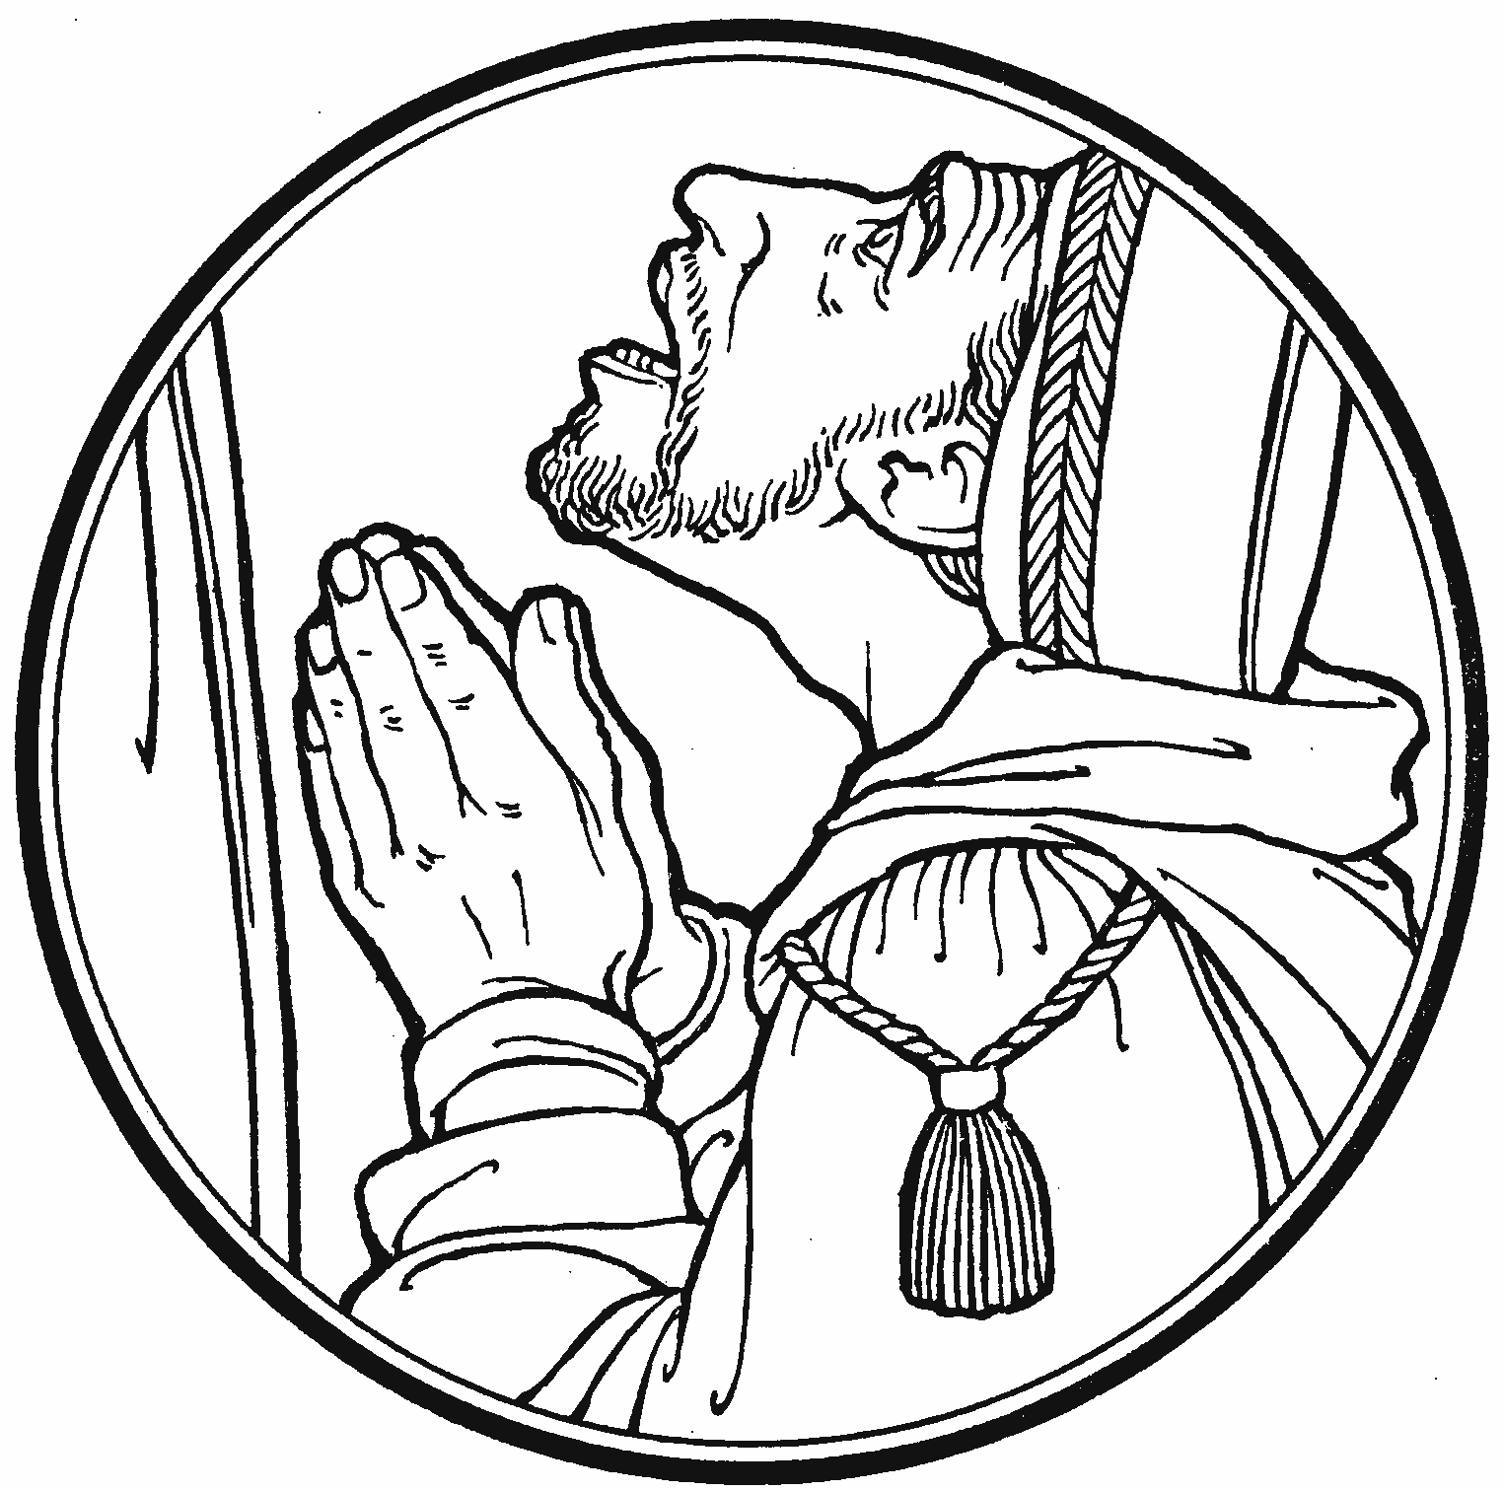

In the Name of Christ Jesus our Lord, we bid you a warm welcome to this worship service. May your experience of worship and fellowship this morning be spiritually refreshing and ready you for the week ahead.
 
Pastor: Rev. Kirk Clayton
Church Secretary: Robin Phillips
Choir Director Team: Josh and Nancy Peterson
_________________________________________________________________________________
Church Office Phone: 618-566-7345
Pastor Clayton Cell: 618-447-1306
Office Hours: 8:00 am to 12:00 pm
Email: ChurchOffice@ZionMascoutah.org
Pastor Clayton email: Pastor@ZionMascoutah.org
Web site: www.ZionMascoutah.org
Find us at @ZionMascoutah on Facebook, Twitter, and Instagram
Electronic Devices
Please TURN OFF all cell phones, pagers, electronic devices, apps and games when entering the sanctuary for worship so those around you may focus on the Word of God without electronic distraction. Thank you.

A Prayer to Begin Worship
Eternal and sovereign Lord, whose ways and wonders are beyond understanding and past finding out, we say our thanks to You for the election to grace of all our fellow members in Christ and plead with You that many may yet be called into Your Kingdom with us. Amen.

DIVINE SERVICE III WITH COMMUNION
LSB p. 184
Confession and Absolution

Prelude How Great Thou Art arr. Cindy Berry

Hymn How Great Thou Art LSB 801

Stand
The sign of the cross may be made by all in remembrance of their Baptism.

Invocation, Exhortation, and Confession with Absolution
P In the name of the Father and of the T Son and of the Holy Spirit.
C Amen.
P Beloved in the Lord! Let us draw near with a true heart and confess our sins unto God our Father, beseeching Him in the name of our Lord Jesus Christ to grant us forgiveness.
P Our help is in the name of the Lord,
C who made heaven and earth.
P I said, I will confess my transgressions unto the Lord,
C and You forgave the iniquity of my sin.
Silence for reflection on God's Word and for self-examination.
P O almighty God, merciful Father,
C I, a poor, miserable sinner, confess unto You all my sins and iniquities with which I have ever offended You and justly deserved Your temporal and eternal punishment. But I am heartily sorry for them and sincerely repent of them, and I pray You of Your boundless mercy and for the sake of the holy, innocent, bitter sufferings and death of Your beloved Son, Jesus Christ, to be gracious and merciful to me, a poor, sinful being.
P Upon this your confession, I, by virtue of my office, as a called and ordained servant of the Word, announce the grace of God unto all of you, and in the stead and by the command of my Lord Jesus Christ I forgive you all your sins in the name of the Father and of the T Son and of the Holy Spirit.
C Amen.

Service of the Word
Introit Ps. 119:1, 38–40; antiphon: Liturgical Text
L The whole world is in Your power;
C O Lord, King Almighty, no one can gainsay You.
L For You have made heaven and earth;
C You are Lord of all!
L Blessèd are those whose way is blameless,
C who walk in the law of the Lord!
L Confirm to Your servant Your promise,
C that You may be feared.
L Turn away the reproach that I dread,
C for Your just decrees are good.
L Behold, I long for Your precepts;
C in Your righteousness give me life!
L The whole world is in Your power;
C O Lord, King Almighty, no one can gainsay You.
L For You have made heaven and earth;
C You are Lord of all!

Gloria Patri
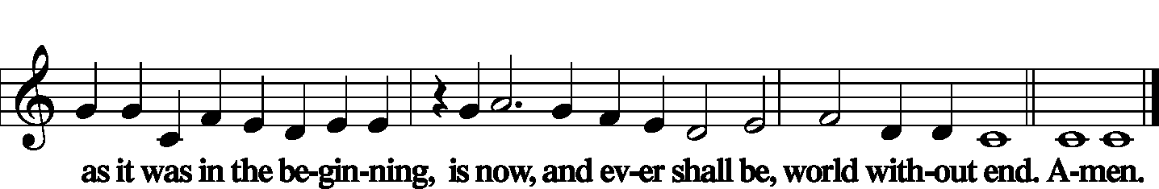

Kyrie LSB 186
Gloria in Excelsis LSB 187
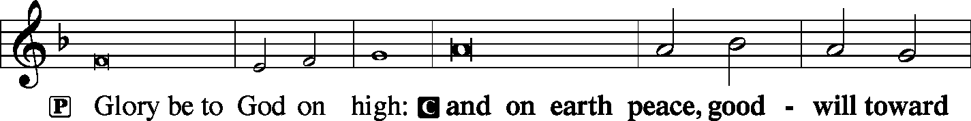
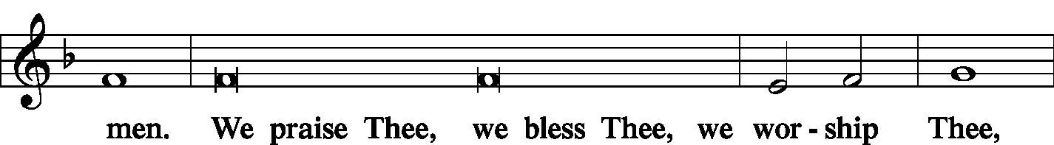
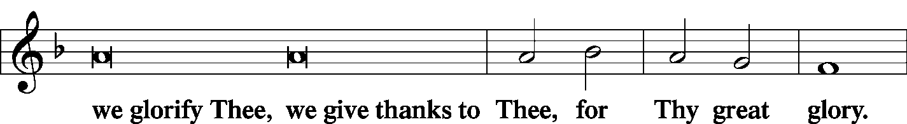
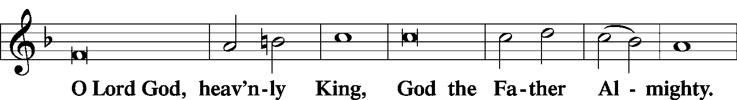
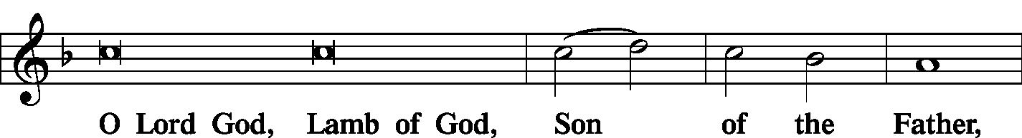
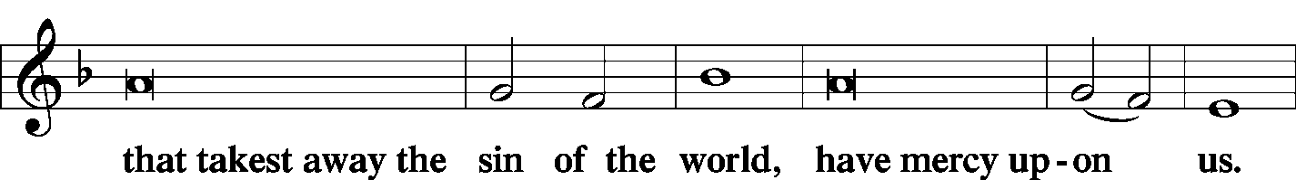
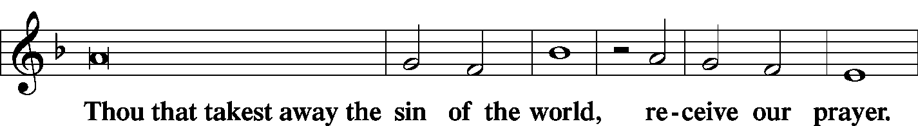
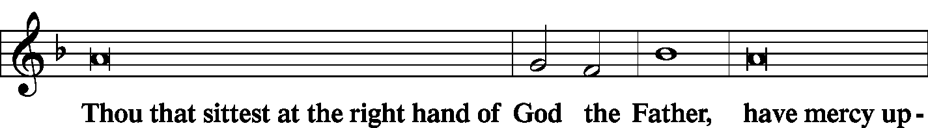
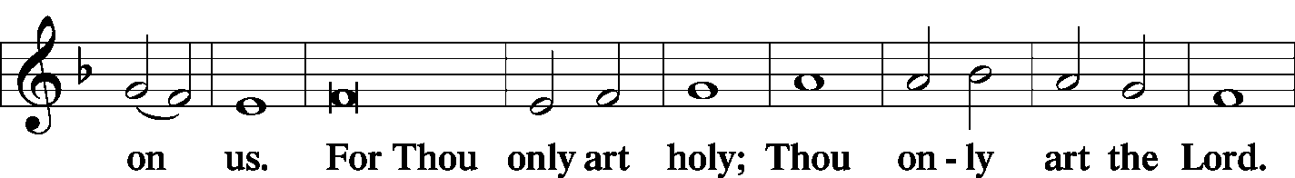
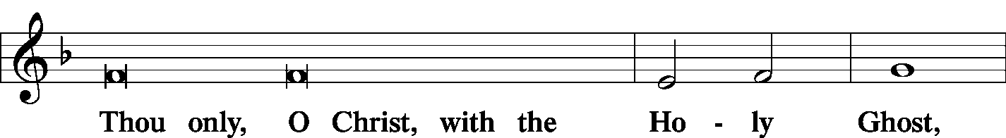
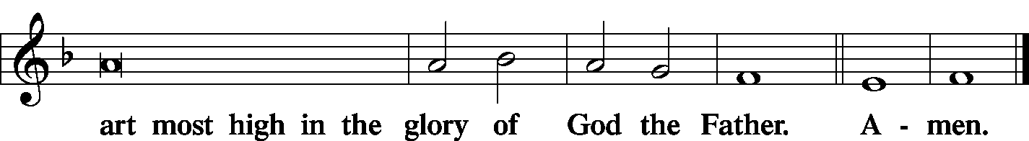

Salutation and Collect of the Day
L The Lord be with you.
C And with thy spirit.
L Let us pray.
O Lord, keep Your household, the Church, in continual godliness that through Your protection she may be free from all adversities and devoutly given to serve You in good works; through Jesus Christ, Your Son, our Lord, who lives and reigns with You and the Holy Spirit, one God, now and forever.
C Amen.

Sit
Old Testament Reading Genesis 1:1-2:3
In the beginning, God created the heavens and the earth. The earth was without form and void, and darkness was over the face of the deep. And the Spirit of God was hovering over the face of the waters.
And God said, “Let there be light,” and there was light. And God saw that the light was good. And God separated the light from the darkness. God called the light Day, and the darkness He called Night. And there was evening and there was morning, the first day.
And God said, “Let there be an expanse in the midst of the waters, and let it separate the waters from the waters.” And God made the expanse and separated the waters that were under the expanse from the waters that were above the expanse. And it was so. And God called the expanse Heaven. And there was evening and there was morning, the second day.
And God said, “Let the waters under the heavens be gathered together into one place, and let the dry land appear.” And it was so. God called the dry land Earth, and the waters that were gathered together He called Seas. And God saw that it was good.
And God said, “Let the earth sprout vegetation, plants yielding seed, and fruit trees bearing fruit in which is their seed, each according to its kind, on the earth.” And it was so. The earth brought forth vegetation, plants yielding seed according to their own kinds, and trees bearing fruit in which is their seed, each according to its kind. And God saw that it was good. And there was evening and there was morning, the third day.
And God said, “Let there be lights in the expanse of the heavens to separate the day from the night. And let them be for signs and for seasons, and for days and years, and let them be lights in the expanse of the heavens to give light upon the earth.” And it was so. And God made the two great lights—the greater light to rule the day and the lesser light to rule the night—and the stars. And God set them in the expanse of the heavens to give light on the earth, to rule over the day and over the night, and to separate the light from the darkness. And God saw that it was good. And there was evening and there was morning, the fourth day.
And God said, “Let the waters swarm with swarms of living creatures, and let birds fly above the earth across the expanse of the heavens.” So God created the great sea creatures and every living creature that moves, with which the waters swarm, according to their kinds, and every winged bird according to its kind. And God saw that it was good. And God blessed them, saying, “Be fruitful and multiply and fill the waters in the seas, and let birds multiply on the earth.” And there was evening and there was morning, the fifth day.
And God said, “Let the earth bring forth living creatures according to their kinds—livestock and creeping things and beasts of the earth according to their kinds.” And it was so. And God made the beasts of the earth according to their kinds and the livestock according to their kinds, and everything that creeps on the ground according to its kind. And God saw that it was good.
Then God said, “Let Us make man in Our image, after Our likeness. And let them have dominion over the fish of the sea and over the birds of the heavens and over the livestock and over all the earth and over every creeping thing that creeps on the earth.”
So God created man in His own image, in the image of God He created him; male and female He created them.
And God blessed them. And God said to them, “Be fruitful and multiply and fill the earth and subdue it and have dominion over the fish of the sea and over the birds of the heavens and over every living thing that moves on the earth.” And God said, “Behold, I have given you every plant yielding seed that is on the face of all the earth, and every tree with seed in its fruit. You shall have them for food. And to every beast of the earth and to every bird of the heavens and to everything that creeps on the earth, everything that has the breath of life, I have given every green plant for food.” And it was so. And God saw everything that He had made, and behold, it was very good. And there was evening and there was morning, the sixth day.
Thus the heavens and the earth were finished, and all the host of them. And on the seventh day God finished His work that He had done, and He rested on the seventh day from all His work that He had done. So God blessed the seventh day and made it holy, because on it God rested from all His work that He had done in creation.
L This is the Word of the Lord.
C Thanks be to God.

Gradual
L Lord, You have been our dwelling place
C in all generations.
L Before the mountains were brought forth, or ever You had formed the earth and the world,
C from everlasting to everlasting You are God.

Epistle Ephesians 6:10-17
Finally, be strong in the Lord and in the strength of His might. Put on the whole armor of God, that you may be able to stand against the schemes of the devil. For we do not wrestle against flesh and blood, but against the rulers, against the authorities, against the cosmic powers over this present darkness, against the spiritual forces of evil in the heavenly places. Therefore take up the whole armor of God, that you may be able to withstand in the evil day, and having done all, to stand firm. Stand therefore, having fastened on the belt of truth, and having put on the breastplate of righteousness, and, as shoes for your feet, having put on the readiness given by the gospel of peace. In all circumstances take up the shield of faith, with which you can extinguish all the flaming darts of the evil one; and take the helmet of salvation, and the sword of the Spirit, which is the word of God.
L This is the Word of the Lord.
C Thanks be to God.

Stand
Alleluia and Verse

Holy Gospel John 4:46-54
P The Holy Gospel according to St. John, the 4th chapter.
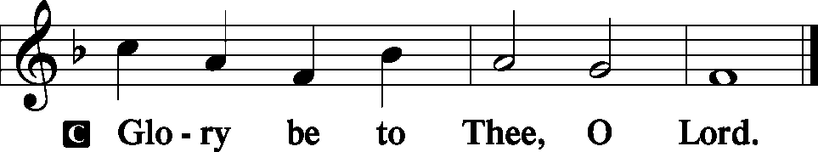
So He came again to Cana in Galilee, where He had made the water wine. And at Capernaum there was an official whose son was ill. When this man heard that Jesus had come from Judea to Galilee, he went to Him and asked Him to come down and heal his son, for he was at the point of death. So Jesus said to him, “Unless you see signs and wonders you will not believe.” The official said to Him, “Sir, come down before my child dies.” Jesus said to him, “Go; your son will live.” The man believed the word that Jesus spoke to him and went on his way. As he was going down, his servants met him and told him that his son was recovering. So he asked them the hour when he began to get better, and they said to him, “Yesterday at the seventh hour the fever left him.” The father knew that was the hour when Jesus had said to him, “Your son will live.” And he himself believed, and all his household. This was now the second sign that Jesus did when He had come from Judea to Galilee.
P This is the Gospel of the Lord.
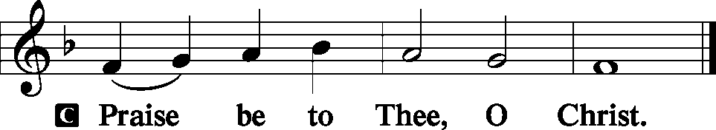

Nicene Creed
C I believe in one God, the Father Almighty, maker of heaven and earth and of all things visible and invisible.
And in one Lord Jesus Christ, the only-begotten Son of God, begotten of His Father before all worlds, God of God, Light of Light, very God of very God, begotten, not made, being of one substance with the Father, by whom all things were made; who for us men and for our salvation came down from heaven and was incarnate by the Holy Spirit of the virgin Mary and was made man; and was crucified also for us under Pontius Pilate. He suffered and was buried. And the third day He rose again according to the Scriptures and ascended into heaven and sits at the right hand of the Father. And He will come again with glory to judge both the living and the dead, whose kingdom will have no end.
And I believe in the Holy Spirit, the Lord and giver of life, who proceeds from the Father and the Son, who with the Father and the Son together is worshiped and glorified, who spoke by the prophets. And I believe in one holy Christian and apostolic Church, I acknowledge one Baptism for the remission of sins, and I look for the resurrection of the dead and the life T of the world to come. Amen.
Sit
Hymn Lord, Thee I Love with All My Heart LSB 708

Sermon What Does Healing Look Like?

Stand
Prayer of the Church
P Almighty Creator and everlasting Redeemer, we ask You to look upon Your children whom You have called by Your Name.
C Daily we enjoy the gifts You provide.
P Your heavenly dew falls on the just and the unjust.
C Your sun shines on the evil and on the good.
P Your mighty acts demonstrate that You are the true God.
C We praise and thank You for exerting Your power for our benefit.
P Especially are we grateful for sending us Your Son, our Savior, Jesus Christ.
C Yet for all Your mercies, O Lord, we have fallen short of Your expectations.
P The light, which You brought into being by the power of Your Word, we have taken too much for granted.
C The darkness, which You created, we have often used as a cover for our evil deeds.
P We have neglected to give You adequate thanks for the works of faith of those who are called by Your Name.
C We have enjoyed good government, but we complain about paying our taxes to support it.
P We have often neglected to render to You the things that are rightfully Yours.
C Forgive us, O Lord.
P Enliven us with Your Holy Spirit, O Lord, that we may fulfill our calling.
C Grant peace and unity to Your Church on earth that it may reflect Your honor and glory.
P Inspire us to search Your Word for answers to our problems.
C Keep us from expressing premature judgments against others.

WE GO TO THE LORD IN PRAYER FOR
- Kim Drinnon, Dawson Rowold, Lori Clayton, Roger Drinnon, Jen Lara, Ian Hutchinson, Brady Twenhafel, and Cohen Merrill, as they celebrate their Baptismal Anniversaries this week.
- Rhiannon Corey, as she will be having surgery this Tuesday.
- Hunter Phillips, who is hospitalized at Barnes.
- Robert Corey, as he has received the good news that he does not have cancer.
- Zion’s President, Vice President, Secretary, and Treasurer.
- Faithfulness in Christian Worship.

P Bless us with the desire to receive Your gifts of grace frequently and to respond joyfully in thanksgiving.
C We pray in Jesus’ Name. Amen.

Sit
Offering
[Please fill out a sheet in the attendance book. Visitors, please include your address. If you have a prayer request for the church prayer chain, please write it at the top of the sheet.]

Stand
Offertory LSB 192
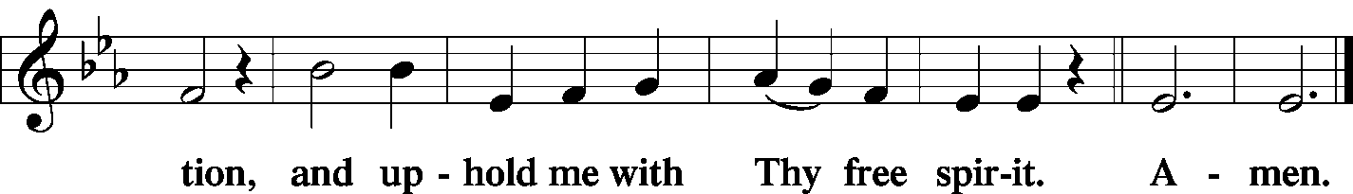
Service of the Sacrament
Preface LSB 194
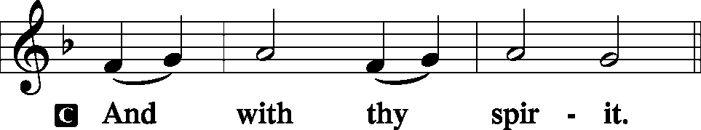

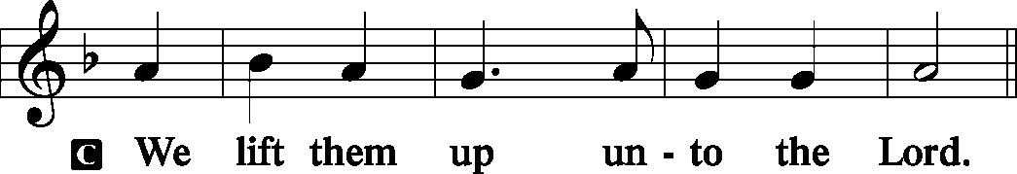

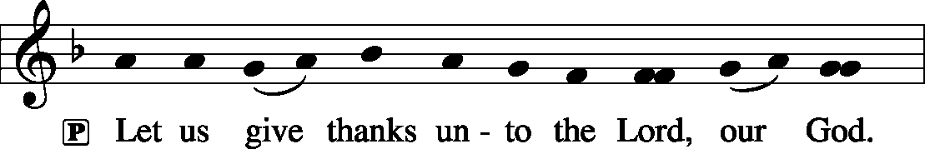

Proper Preface (Full)
P It is truly meet, right, and salutary that we should at all times and in all places give thanks to You, holy Lord, almighty Father, everlasting God. And most especially are we bound to praise You on this day for the glorious resurrection of Your Son, Jesus Christ, the very Paschal Lamb, who was sacrificed for us and bore the sins of the world. By His dying He has destroyed death, and by His rising again He has restored to us everlasting life. Therefore with Mary Magdalene, Peter and John, and with all the witnesses of the resurrection, with angels and archangels, and with all the company of heaven we laud and magnify Your glorious name, evermore praising You and saying:
Sanctus LSB 195
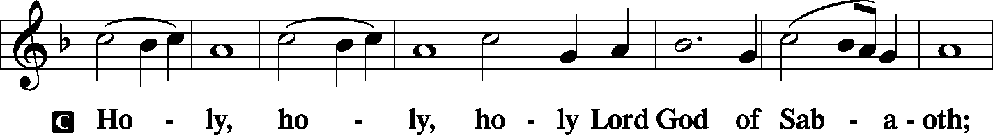
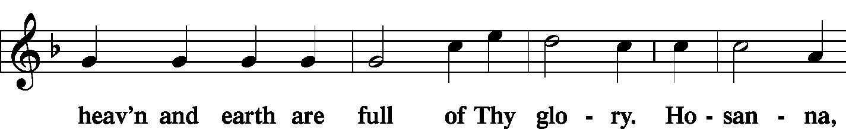
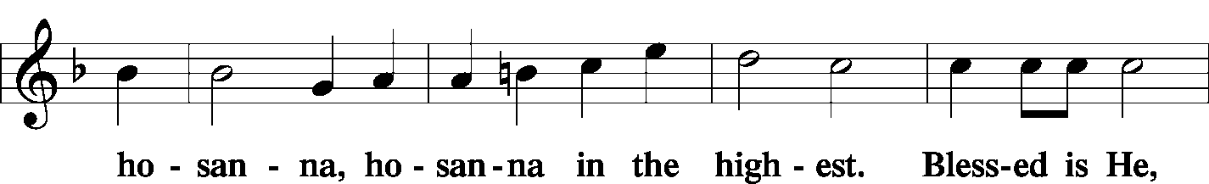
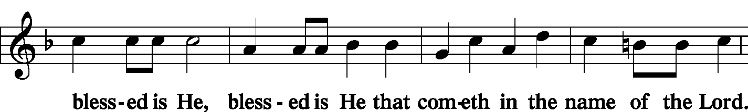
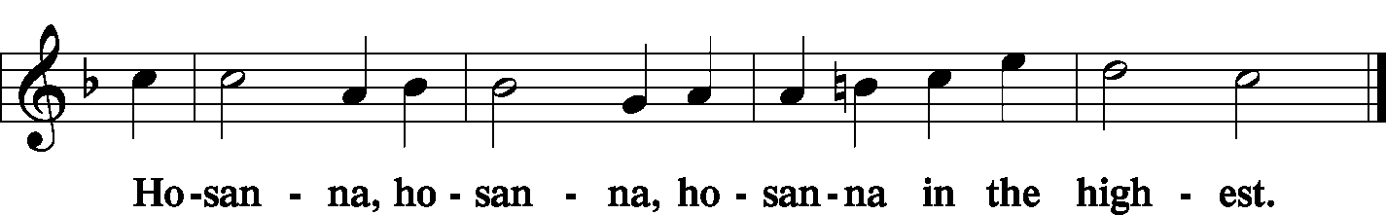

Lord's Prayer LSB 196
P Our Father who art in heaven, hallowed be Thy name, Thy kingdom come, Thy will be done on earth as it is in heaven; give us this day our daily bread; and forgive us our trespasses as we forgive those who trespass against us; and lead us not into temptation, but deliver us from evil
C
The Words of Our Lord LSB 197
P Our Lord Jesus Christ, on the night when He was betrayed, took bread, and when He had given thanks, He broke it and gave it to the disciples and said: “Take, eat; this is My T body, which is given for you. This do in remembrance of Me.”

P In the same way also He took the cup after supper, and when He had given thanks, He gave it to them, saying: “Drink of it, all of you; this cup is the new testament in My T blood, which is shed for you for the forgiveness of sins. This do, as often as you drink it, in remembrance of Me.”

Pax Domini LSB 197
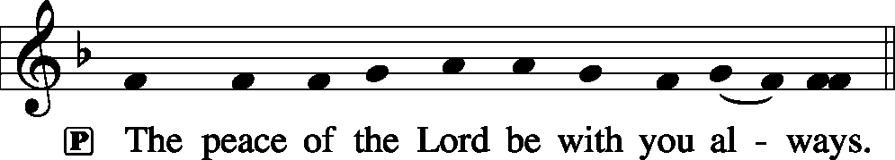

Agnus Dei LSB 198
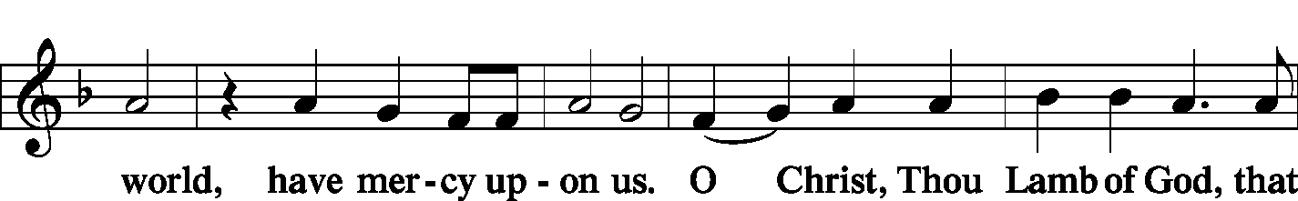

Sit
Distribution
Zion Lutheran practices the policy of close communion, communing only those who share our common Biblical view of the Lord's Supper. If you are not a confirmed LCMS Lutheran, please confer with the pastor before communing.

Hymn Jesus, Thy Blood and Righteouness LSB 563
Hymn We Are Called to Stand Together LSB 828
Hymn Jesus Comes Today with Healing LSB 620

Stand
In dismissing the communicants, the following is said:
The Dismissal
P The body and blood of our Lord Jesus Christ strengthen and preserve you in body and soul to life everlasting. Depart T in peace.
C Amen.
Nunc Dimittis LSB 199
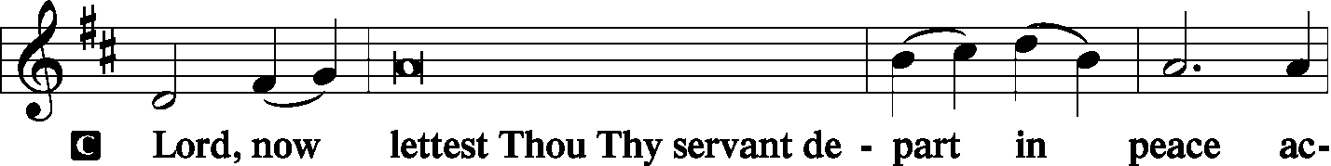
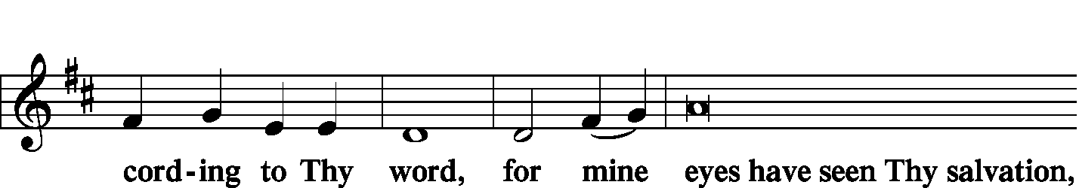
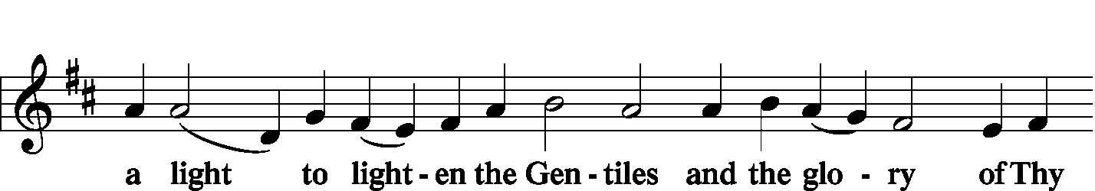
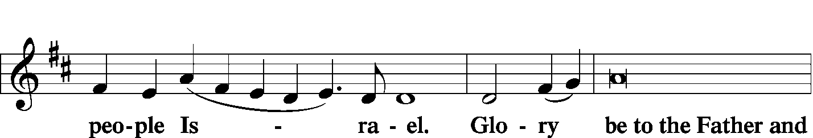
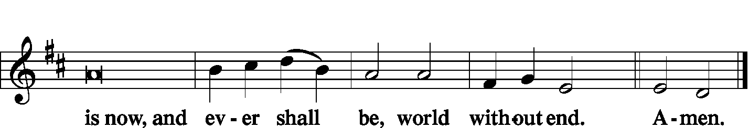

Thanksgiving LSB 200
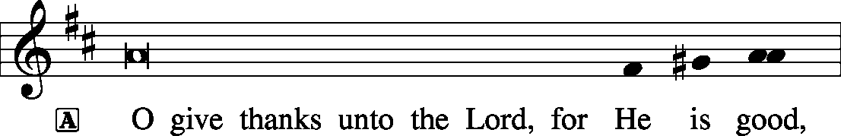

Post-Communion Collect
P Let us pray.
We give thanks to You, almighty God, that You have refreshed us through this salutary gift, and we implore You that of Your mercy You would strengthen us through the same in faith toward You and in fervent love toward one another; through Jesus Christ, Your Son, our Lord, who lives and reigns with You and the Holy Spirit, one God, now and forever.

Salutation, Benedicamus, and Benediction
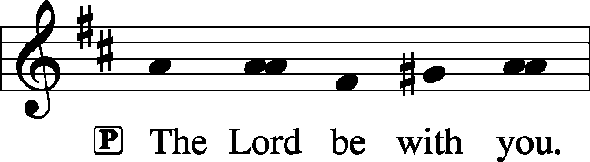

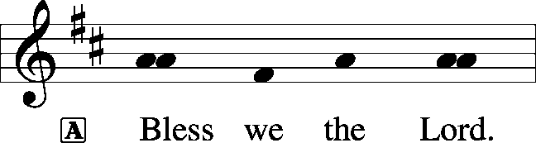

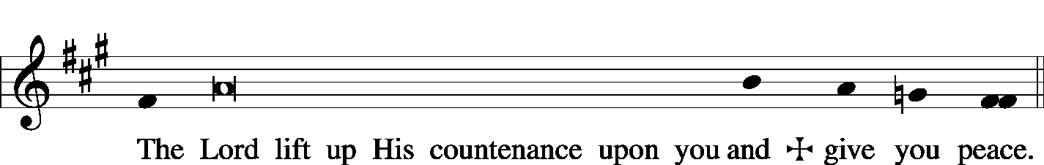

Sit
Hymn Eternal Father, Strong to Save LSB 717

Postlude How Great Thou Art arr. Robert Hobby

Acknowledgments
Unless otherwise indicated, all scripture quotations are from The Holy Bible, English Standard Version, copyright © 2001 by Crossway Bibles, a division of Good News Publishers. Used by permission. All rights reserved. Created by Lutheran Service Builder © 2006 Concordia Publishing House.
LIFE AND LIVING ITEMS AT ZION
          

MEMBERS NEEDS FUND POTLUCK - TODAY
Please plan to attend a potluck lunch in the gym right after church TODAY. We are requesting donations be given for those who attend to be used to fund the Zion’s Member’s Need Fund. Elders will be providing hamburgers and hot dogs (buns and condiments). We have asked those with last name A-O to bring a side dish and P-Z to bring a dessert. We look forward to seeing you there.

THANKSGIVING CARDS AVAILABLE NOW.
A selection of cards is on the table in the narthex for only 50 cents each!

HARVEST TABLE IS CLOSED
The Harvest Table is now closed. $16.50 was collected for Concerned Christians. Thank you for your donations!

THANK YOU FROM PASTOR CLAYTON
Dear Family at Zion, Thank you very much for the card and generous check that you presented to me for Pastor Appreciation Month in October. As I said that Sunday, while cards and gifts are great, one of the greatest blessings a congregation can give to a pastor is to pray for him. Several members mentioned after church that you do pray for the Clayton family regularly, and we really appreciate it. And, we appreciate the card and gift, as well as appreciating all the dear saints at Zion who shared it with us! Thank you! In Christ, Pastor Clayton

VOLUNTEERS NEEDED FOR PRESCHOOL THANKSGIVING DINNER
Zion Preschool will be hosting their annual family dinner on Tuesday, November 19th, in the gym at 5:30 PM. The children will perform a short program to entertain their families before the dinner is served. Volunteers will be needed to help serve drinks, place food on the serving tables, refill dishes, etc. We have a lot of fun and get to eat some great food. Please consider volunteering. Contact Marlene Lockwood to volunteer.

SIGN UP FOR CHILDREN’S CHRISTMAS PROGRAM
Maggie Harlan and Pastor Clayton are writing the Children's Christmas Program for Zion for this year. In order to refine the script and make sure there are the right number of parts, we need to know which students will be participating. (The Children's Christmas Program will be held on Sunday, December 15, 2019 during the 10:00 morning service.) A list of all Zion students is on the table in the narthex under the church office window. IF YOU ARE NOT ABLE TO PARTICIPATE, PLEASE CROSS YOUR NAME OFF THE LIST. If you do not opt out, we will assume that you will participate and make a part for you. Thanks!

9th ANNUAL OKAWVILLE MUSIC FESTIVAL -- TODAY
Immanuel Lutheran Church is hosting their 9th Annual Music Festival on Sunday, November 10th at 3 PM at 206 E. Schumacher in Okawville. Admission is free. An offering will be received to support the work of Rev. Dr. Hans Trinklein and family LCMS missionaries in South Korea. The Men’s Club chili supper will follow in the gym.

DOMINICAN REPUBLIC MISSION TRIP
Zion Mascoutah is looking seriously into sponsoring/sending a short term mission team to the Dominican Republic. This project has been discussed by the Evangelism Committee, the Board of Elders, and the Church Council, and it is time to take action. Over the next few weeks, a flier will be placed in the bulletin with short-term mission team volunteer opportunities. Fliers about the trip options are included in the bulletin this morning. If you are interested in participating in a trip, please circle which trip you would be most interested in doing, and sign your name so we can gauge where to apply our resources first. Short-term mission teams in the Dominican Republic typically consist of 8-10 people, and the trips run for one week, usually from Saturday to Saturday. Teams are assembled for specific purposes or themes, and have a set workload to be accomplished during the week. For next year, five different types of teams are possible, based on what the preference and interest of Zion is. The five types of trips are: EDUCATIONAL SUPPORT TEAM--Support education in the church’s two Lutheran schools and/or local public schools; HEALTH OUTREACH TEAM--Spend a week engaging in various outreach activities related to health (spiritual, mental, emotional, physical) and the promotion and preservation of life from conception to natural death; PLAYGROUND RENOVATION TEAM--Renovate two playgrounds (one for little kids and one for older kids) in Palmar Arriba; VACATION BIBLE SCHOOL TEAMS--Lead a week-long Vacation Bible School (Bible stories, crafts, games, music, snacks, etc.) at one of the local Lutheran congregations; and VOLLEYBALL CAMP TEAM--Lead a week-long volleyball camp for children & youth at Iglesia Luterana Amigos de Cristo. While volleyball skills and fundamentals should be the focus, traditional VBS elements like Bible stories, songs, games, snacks, and crafts may be included. Your team may also be able to assist with cleaning/preparing an unpaved, overgrown area near the church to be used as an outdoor play space. The cost per person for the week, including round-trip airfare, housing, and food for any of these mission trip options is likely to be about $1600. Dates are not yet set, but a timeframe shortly after school ends, late May or early June, might be a strong possibility. If you are interested in serving in one of these areas on a short-term mission team to the Dominican Republic, please begin to prayerfully consider how you might become more personally involved in our Lord’s mission work. Please fill out the information flier in the bulletin and place it in the basket on the card table in the narthex. Pray, and be prepared to volunteer!

CHILI, CHICKEN SOUP, AND PIE SUPPER -- TODAY
Immanuel Lutheran Church Men’s Club is hosting an “All You Can Eat” chili, chicken soup, and pie supper on Sunday, November 10th from 4-7 PM at Immanuel Lutheran School Gym, 606 S. Hanover in Okawville. Adults are $8 and children 10 and under are $4. Carry-outs are available. Please bring your own containers.

CHRISTMAS STOCKINGS AND GIFTS WORKSHOP – THIS SAT.
The LWML workshop this year is at Christ Our Savior Church, Freeburg, on Saturday, Nov 16th, starting at 9 AM. You are welcome to bring friends along to help decorate. Please bring a pair of scissors and fabric glue, if you have any. The list of items suggested to donate for filling the stockings is on the small sheets by the display. Most stockings will go to Lutheran Child and Family Services, infant through sixth grade. The workshop will end with lunch and a closing devotion. (Last year over 200 stockings were decorated, filled, and donated.) SUGGESTED ITEMS FOR THE STOCKINGS: gloves, hats, Christmas ornaments, scarves, school supplies, small books (especially religious), markers, socks, jewelry, small stuffed animals, puzzles, small cars, dolls, purses, bubble bath, hair items, shampoo, body wash, perfume, toothpaste and toothbrushes, small toys, and baby items. ESPECIALLY NEEDED are items for boys.

ANNUAL TREE OF HOPE CAMPAIGN
The Mascoutah Tuesday Women’s Club is excited to announce the annual Tree of Hope campaign. Donations will be used to provide Christmas gifts of shoes and clothes for the needy children of Mascoutah. Funds were also used to support the Mascoutah Township School Supply Drive through a donation of 100, $20 gift cards to provide shoes for children starting school. Thanks to the generosity of Mascoutah, donations totaling $10,580 for the Tree of Hope were received in 2018. We ask for your help again this year in order to fill the stockings of so many needy children. Please send your donation to: Tree of Hope, PO Box 244, Mascoutah, IL 62258. If you have any questions, call Rosalie Taylor at 618-566-2529.

12TH ANNUAL CHRISTIAN FRIENDS OF NEW AMERICANS TRIVIA AND SILENT AUCTION BENEFIT
Join us on Saturday, Nov. 16th at Webster Gardens, 8749 Watson Rd., St. Louis, MO. This is a fun way for you to help share the love of Christ in Word and deed with refugees! Doors open 5:45 PM, Trivia starts at 6:30 PM. Go online for details at cfna-stl.org/trivia-night/. Be a sponsor, give a donation. New and/or gently used items are needed. Gift certificates are always popular. For more information call Carol at 314-517-8513.

AFFORDABLE CARE ACT ENROLLMENT EVENT -- THURSDAY
On Thursday, November 14th, certified application counselors will be available by appointment only at HSHS St. Joseph’s Hospital Breese to help individuals and families sign up for health care coverage through the Affordable Care Act. Individuals and families have from November 1 - December 15, 2019 to enroll. This event is open to anyone served by the hospitals of HSHS St. Joseph’s Hospital Breese, HSHS Holy Family Hospital in Greenville, and HSHS St. Joseph’s Hospital Highland. Those interested in attending should call (217)972-7366 to schedule an appointment. Appointments will be offered in one-hour increments. When preparing for the event, please bring Social Security numbers as well as first and last name for all persons enrolling, proof of Illinois residency (Illinois driver’s license), employer and annual household income information (paycheck stubs, W-2). For more information about the marketplace, visit e or call the toll-free Get Covered Illinois Help Desk at (866)311-1119. For a list of health insurance plans that have chosen the hospital as a participating provider, visit stjoebreese.com/Patient-Guest/Billing-Information.

CHURCH BASEMENT LADIES: AWAY IN THE BASEMENT
Take a trip back in time to 1959 and celebrate the holidays with the CHURCH BASEMENT LADIES: AWAY IN THE BASEMENT. The ladies and the pastor try to save the Church Christmas pageant from disaster in this fun, family-friendly musical presented by Clinton County Showcase at the Avon Theater in Breese on Dec. 6, 7, 8, 13, 14, & 15. Tickets now on sale at clintoncountyshowcase.com.

CHI AUXILIARY ANNUAL CHRISTMAS LUNCHEON
The Auxiliary of the Concordia Historical Institute is pleased to announce its Annual Christmas Luncheon on Thursday, December 12, 2019, at 12 Noon in Koburg Hall, Concordia Seminary campus (804 Seminary Place, Clayton, MO). Meet and greet new or renewed acquaintances, hear the Village Lutheran Homeschool Handbell Choir, enjoy singing Christmas carols, and receive an update on CHI. The luncheon cost is $15 per person, with reservations to be made by December 5th. Checks may be made payable to "CHI Auxiliary" and sent to Nancy Fassold, 5609 Nantasket Court, St. Louis, MO 63128. For more information, please contact her at 314-843-3559 or nk21@live.com.

LISTEN TO WORLDWIDE KFUO AM850
KFUO Radio, AM850, a media ministry extension of LCMS congregations, shares Christ for you anytime, anywhere on AM850 via worship services, Bible and theology studies, practical talk programs, and sacred music. You can find programs on demand at kfuo.org and wherever you get your podcasts! Find us on social: @KFUOradio on Facebook, Twitter, and Instagram. This week on KFUO AM850, hear the Gospel for you in music and Scripture on Moments of Assurance (weekdays at 12:00 p.m. / weekends at 7:45 a.m.), hear a special Mental Health Monday episode for Veterans on The Coffee Hour (11/11 at 9:00 a.m.), and study the familiar chapters 37-41 in Isaiah on Thy Strong Word (weekdays at 11:00 a.m.). Find your favorite programs and podcasts on demand at kfuo.org!

YOUR COMPREHENSIVE SOURCE FOR NEWS, INFORMATION & TRUTH...Issues, Etc. is a radio talk show and podcast produced by Lutheran Public Radio in Collinsville, IL and hosted by LCMS Pastor Todd Wilken. This week's subjects include: Musician Kanye West's Conversion to Christianity, Jesus in the Koran, The Fall of the Berlin Wall, The Vocation of Soldier and more. You can listen live or on-demand at www.issuesetc.org and on the LPR mobile app.
THE FLOWERS ON THE LORD’S ALTAR
The flowers on the altar are given in appreciation for all our veterans who have served our nation.

THOSE WHO SERVE TODAY
Proclaimer: Rev. Kirk Clayton
Liturgists: Sem. Adam Wolfe & Sem. Don Stein
Organist: Nancy Peterson
Ushers: Mark Krausz, Matt Krausz, Tony Lara,
& Geoff Phillips
Sound Tech: Gadge Corey
Video Tech: Mark Hatcher
Welcome Team: Larry & Sandy Richards
Acolytes: Abigail Clayton & Maggie Harlan
Altar Guild: Mary Kay Krausz & Beth Twenhafel

THOSE WHO SERVE NEXT WEEK, NOVEMBER 17
Proclaimer: Rev. Kirk Clayton
Liturgists: Sem. Adam Wolfe & Sem. Don Stein
Organist: Nancy Peterson
Ushers: Ken Knutson, Dan Morra, Andy Sax,
& Tom Sax
Sound Tech: Matt Krausz
Video Tech: Mark Hatcher
Welcome Team: Jon & Cary Robinson
Acolytes: Isaac Robinson & Phoebe Corey

THINGS WE ARE DOING AT ZION
Sun. Confirmation Class 8:30 AM
SS & Bible Class 8:45 AM
Worship DS III w/communion 10:00 AM
Member Needs Fund Potluck 11:30 AM
Men’s Club 6:30 PM
Mon. Veteran’s Day – Office Closed, No Preschool
Tues. Echo Deadline
Evangelism 7:00 PM
Wed. Choir Rehearsal 7:00 PM
New Member Class 7:00 PM
Fri. Senior Meal Delivery 10:30 AM
Sun. Confirmation Class 8:30 AM
SS & Bible Class 8:45 AM
Worship Matins 10:00 AM

ATTENDANCE NOVEMBER 3: Sunday: 171
Adult Bible Class: 23 High School: 6 Sunday School: 43

