Zion Lutheran Church
Mascoutah, Illinois
December 4, 2019
1st Advent Midweek Service

In the Name of Christ Jesus our Lord, we bid you a warm welcome to this worship service. May your experience of worship and fellowship this evening be spiritually refreshing and ready you for the week ahead.

Pastor: Rev. Kirk Clayton
Church Secretary: Robin Phillips
Choir Director Team: Josh and Nancy Peterson
_________________________________________________________________________________
Church Office Phone: 618-566-7345
Pastor Clayton Cell: 618-447-1306
Office Hours: 8:00 am to 12:00 pm
Email: ChurchOffice@ZionMascoutah.org
Pastor Clayton email: Pastor@ZionMascoutah.org
Web site: www.ZionMascoutah.org
Find us at @ZionMascoutah on Facebook, Twitter, and Instagram
Electronic Devices
Please TURN OFF all cell phones, pagers, electronic devices, apps and games when entering the sanctuary for worship so those around you may focus on the Word of God without electronic distraction. Thank you.

Vespers

Hymn Lift Up Your Heads, Ye Mighty Gates LSB 341

Holy Baptism
(Due to the fact that this is a worship service, held in God’s House, conducted before His Altar, we respectfully request that no flash photographs be taken during the Baptism. Thank you for respecting the reverence of worship.)
Stand p268

The sign of the cross may be made by all in remembrance of their Baptism.

P | In the name of the Father and of the T Son and of the Holy Spirit.
C | Amen.
P | Dearly beloved, Christ our Lord says in the last chapter of Matthew, "All authority in heaven and on earth has been given to Me. Therefore go and make disciples of all nations, baptizing them in the name of the Father and of the Son and of the Holy Spirit." In the last chapter of Mark our Lord promises, "Whoever believes and is baptized will be saved." And the apostle Peter has written, "Baptism now saves you."  The Word of God also teaches that we are all conceived and born sinful and are under the power of the devil until Christ claims us as His own. We would be lost forever unless delivered from sin, death, and everlasting condemnation. But the Father of all mercy and grace has sent His Son Jesus Christ, who atoned for the sin of the whole world, that whoever believes in Him should not perish but have eternal life.

The pastor addresses the candidates:

P | How are you named?
R | Jennalee Elizabeth, Lauren Ashley, Eliza Rose, and Emily Grace Matthews
The pastor makes the sign of the holy cross upon the forehead and heart of the candidates while saying:

P | Jennalee Elizabeth, Lauren Ashley, Eliza Rose, and Emily Grace Matthews, receive the sign of the holy cross both upon your T forehead and upon your T heart to mark you as one redeemed by Christ the crucified.
P | Let us pray.  Almighty and eternal God, according to Your strict judgment You condemned the unbelieving world through the flood, yet according to Your great mercy You preserved believing Noah and his family, eight souls in all. You drowned hard-hearted Pharaoh and all his host in the Red Sea, yet led Your people Israel through the water on dry ground, foreshadowing this washing of Your Holy Baptism. Through the Baptism in the Jordan of Your beloved Son, our Lord Jesus Christ, You sanctified and instituted all waters to be a blessed flood and a lavish washing away of sin.  We pray that You would behold Jennalee Elizabeth, Lauren Ashley, Eliza Rose, and Emily Grace Matthews according to Your boundless mercy and bless them with true faith by the Holy Spirit, that through this saving flood all sin in them which has been inherited from Adam and which they have committed since, would be drowned and die. Grant that they be kept safe and secure in the holy ark of the Christian Church, being separated from the multitude of unbelievers and serving Your name at all times with a fervent spirit and a joyful hope, so that, with all believers in Your promise, they would be declared worthy of eternal life; through Jesus Christ, our Lord.
C | Amen.
P | Hear the Holy Gospel according to St. Mark.  They brought young children to Jesus that He might touch them; but the disciples rebuked those who brought them. But when Jesus saw it, He was greatly displeased and said to them, "Let the little children come to Me, and do not forbid them; for of such is the kingdom of God. Assuredly, I say to you, whoever does not receive the kingdom of God as a little child will by no means enter it." And He took them up in His arms, put His hands on them, and blessed them.
P | This is the Word of the Lord.
C | Thanks be to God.

The pastor places his hands on the heads of the candidates, and the congregation joins in praying:

C | Our Father who art in heaven,  hallowed be Thy name,  Thy kingdom come,  Thy will be done on earth  as it is in heaven;  give us this day our daily bread;  and forgive us our trespasses  as we forgive those  who trespass against us;  and lead us not into temptation,  but deliver us from evil.  For Thine is the kingdom  and the power and the glory  forever and ever. Amen.
P | The Lord preserve your coming in and your going out from this time forth and even T forevermore.
C | Amen.

Sit

The pastor addresses the candidates and asks the following questions:

P | Jennalee Elizabeth, Lauren Ashley, Eliza Rose, and Emily Grace Matthews, do you renounce the devil?
R | Yes, I renounce him.
P | Do you renounce all his works?
R | Yes, I renounce them.
P | Do you renounce all his ways?
R | Yes, I renounce them.
P | Do you believe in God, the Father Almighty, maker of heaven and earth?
R | Yes, I believe.
P | Do you believe in Jesus Christ, His only Son, our Lord, who was conceived by the Holy Spirit, born of the virgin Mary, suffered under Pontius Pilate, was crucified, died and was buried; He descended into hell; the third day He rose again from the dead; He ascended into heaven and sits at the right hand of God the Father Almighty; from thence He will come to judge the living and the dead?
R | Yes, I believe.
P | Do you believe in the Holy Spirit, the holy Christian Church, the communion of saints, the forgiveness of sins, the resurrection of the body, and the life everlasting?
R | Yes, I believe.
P | Jennalee Elizabeth, Lauren Ashley, Eliza Rose, and Emily Grace Matthews, do you desire to be baptized?
R | Yes, I do.

The pastor pours water three times on the head of the candidate while saying:

P | Jennalee Elizabeth, Lauren Ashley, Eliza Rose, and Emily Grace Matthews, I baptize you in the name of the Father and of the Son and of the Holy Spirit.
C | Amen.

The pastor places his hands on the head of the newly baptized while saying:

P | The almighty God and Father of our Lord Jesus Christ, who has given you the new birth of water and of the Spirit and has forgiven you all your sins, strengthen you with His grace to life T everlasting.
C | Amen.

The pastor may place a white garment on the newly baptized while saying:

P | Receive this white garment to show that you have been clothed with the robe of Christ's righteousness that covers all your sin. So shall you stand without fear before the judgment seat of Christ to receive the inheritance prepared for you before the foundation of the world.

The pastor may light a baptismal candle from the paschal candle and give it to the newly baptized while saying:

P | Receive this burning light to show that you have received Christ who is the Light of the world. Live always in the light of Christ, and be ever watchful for His coming, that you may meet Him with joy and enter with Him into the marriage feast of the Lamb in His kingdom, which shall have no end.
P | In Holy Baptism God the Father has made you a member of His Son, our Lord Jesus Christ, and an heir with us of all the treasures of heaven in the one holy Christian and apostolic Church. We receive you in Jesus' name as our sisters in Christ, that together we might hear His Word, receive His gifts, and proclaim the praises of Him who called out us of darkness into His marvelous light.
C | Amen. We welcome you in the name of the Lord.

Stand

P | Let us pray.  Almighty and most merciful God and Father, we thank and praise You that You graciously preserve and enlarge Your family and have granted Jennalee Elizabeth, Lauren Ashley, Eliza Rose, and Emily Grace Matthews the new birth in Holy Baptism and made them members of Your Son, our Lord Jesus Christ, and heirs of Your heavenly kingdom. We humbly implore You that, as they have now become Your children, You would keep them in their baptismal grace, that according to Your good pleasure they may faithfully grow to lead a godly life to the praise and honor of Your holy name and finally, with all Your saints, obtain the promised inheritance in heaven; through Jesus Christ, our Lord.
C | Amen.
P | Peace T be with you.
C | Amen.

Opening Versicles (Use Advent Response)
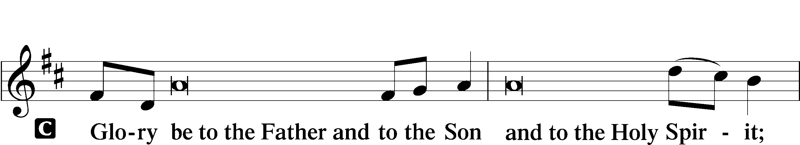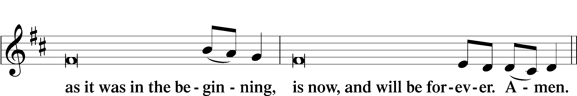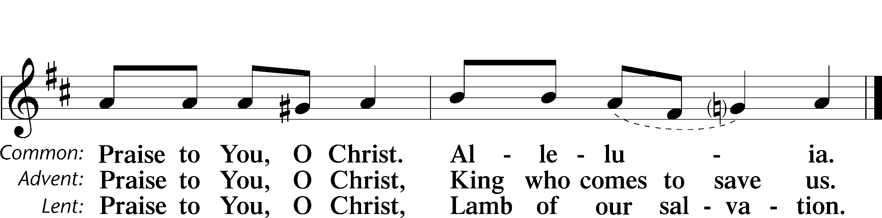
Psalmody
Psalm 24
L The earth is the Lord’s and the fullness thereof,
C the world and those who dwell therein,
L for He has founded it upon the seas
C and established it upon the rivers.
L Who shall ascend the hill of the Lord?
C And who shall stand in His holy place?
L He who has clean hands and a pure heart,
C who does not lift up his soul to what is false and does not swear deceitfully.
L He will receive blessing from the Lord
C and righteousness from the God of his salvation.
L Such is the generation of those who seek Him,
C who seek the face of the God of Jacob.
L Lift up your heads, O gates!
C And be lifted up, O ancient doors, that the King of glory may come in.
L Who is this King of glory?
C The Lord, strong and mighty, the Lord, mighty in battle!
L Lift up your heads, O gates!
C And lift them up, O ancient doors, that the King of glory may come in.
L Who is this King of glory?
C The Lord of hosts, He is the King of glory!
Glory be to the Father and to the Son and to the Holy Spirit;
as it was in the beginning, is now, and will be forever. Amen.

Sit

First Reading Isaiah 7:10-14
Again the Lord spoke to Ahaz: “Ask a sign of the Lord your God; let it be deep as Sheol or high as heaven.” But Ahaz said, “I will not ask, and I will not put the Lord to the test.” And he said, “Hear then, O house of David! Is it too little for you to weary men, that you weary my God also? Therefore the Lord Himself will give you a sign. Behold, the virgin shall conceive and bear a son, and shall call His name Immanuel.
L O Lord, have mercy on us.
C Thanks be to God.

Second Reading 1 John 4:7-16
Beloved, let us love one another, for love is from God, and whoever loves has been born of God and knows God. Anyone who does not love does not know God, because God is love. In this the love of God was made manifest among us, that God sent His only Son into the world, so that we might live through Him. In this is love, not that we have loved God but that He loved us and sent His Son to be the propitiation for our sins. Beloved, if God so loved us, we also ought to love one another. No one has ever seen God; if we love one another, God abides in us and His love is perfected in us.
By this we know that we abide in Him and He in us, because He has given us of His Spirit. And we have seen and testify that the Father has sent His Son to be the Savior of the world. Whoever confesses that Jesus is the Son of God, God abides in Him, and He in God. So we have come to know and to believe the love that God has for us. God is love, and whoever abides in love abides in God, and God abides in him.
L O Lord, have mercy on us.
C Thanks be to God.

Third Reading Matthew 1:18-25
Now the birth of Jesus Christ took place in this way. When His mother Mary had been betrothed to Joseph, before they came together she was found to be with child from the Holy Spirit. And her husband Joseph, being a just man and unwilling to put her to shame, resolved to divorce her quietly. But as he considered these things, behold, an angel of the Lord appeared to him in a dream, saying, “Joseph, son of David, do not fear to take Mary as your wife, for that which is conceived in her is from the Holy Spirit. She will bear a son, and you shall call His name Jesus, for He will save His people from their sins.” All this took place to fulfill what the Lord had spoken by the prophet: “Behold, the virgin shall conceive and bear a son, and they shall call His name Immanuel” (which means, God with us). When Joseph woke from sleep, he did as the angel of the Lord commanded him: he took his wife, but knew her not until she had given birth to a son. And he called His name Jesus.
L O Lord, have mercy on us.
C Thanks be to God.

Advent Responsory
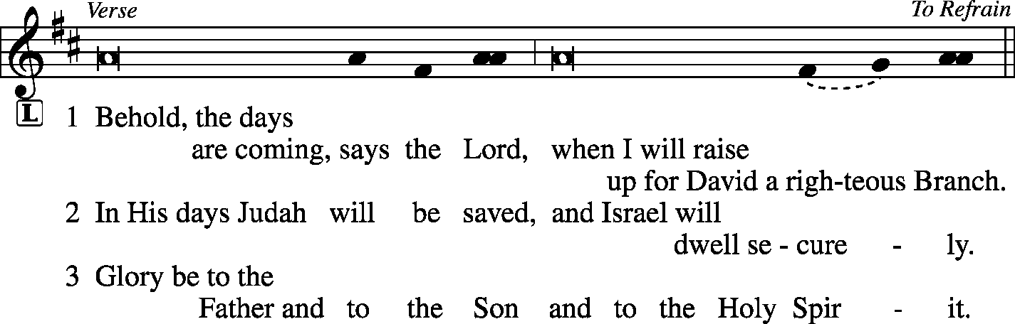
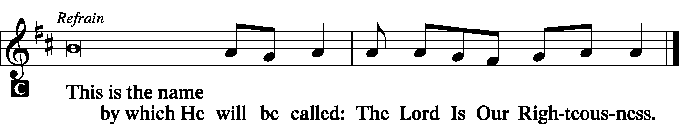

Hymn Lo, How a Rose E’er Blooming LSB 359

Sermon Righteousness Born…Received by Faith

Offering
[Please fill out a sheet in the attendance book. Visitors, please include your address. If you have a prayer request for the church prayer chain, please write it at the top of the sheet.]

Stand

Antiphon (Common) LSB 231
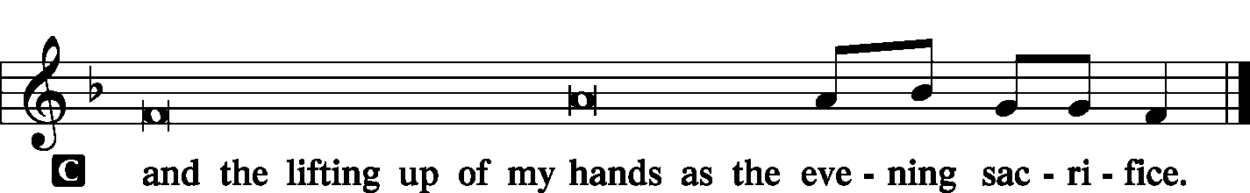

Canticle
Magnificat LSB 248
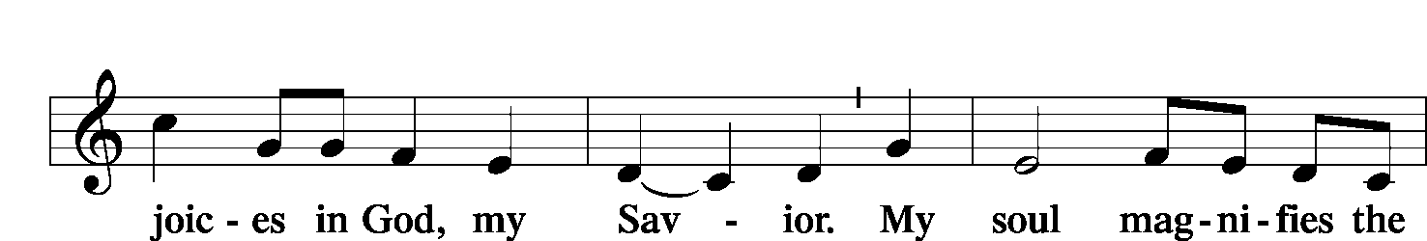
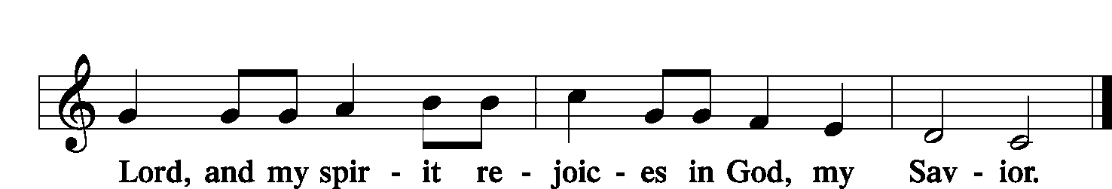
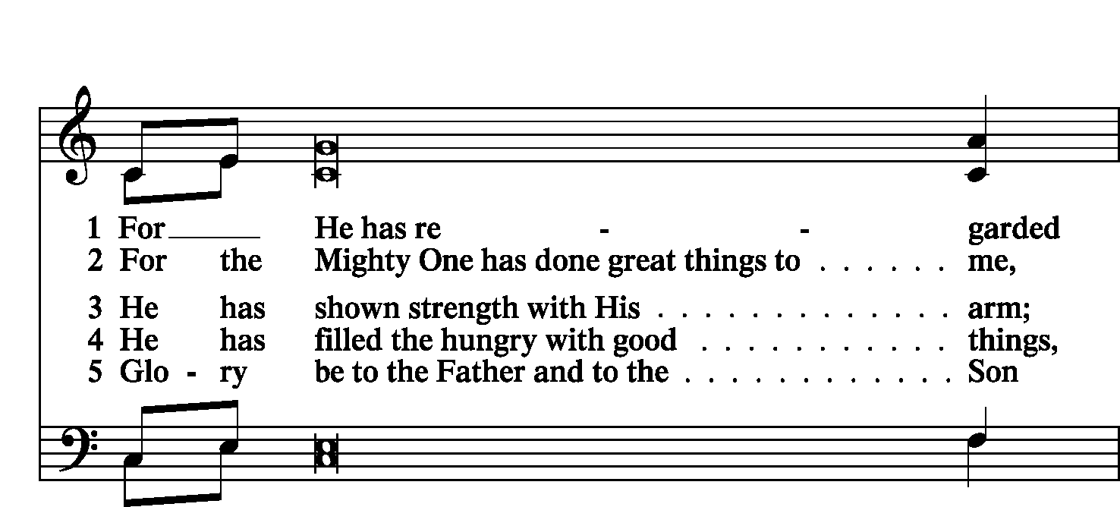
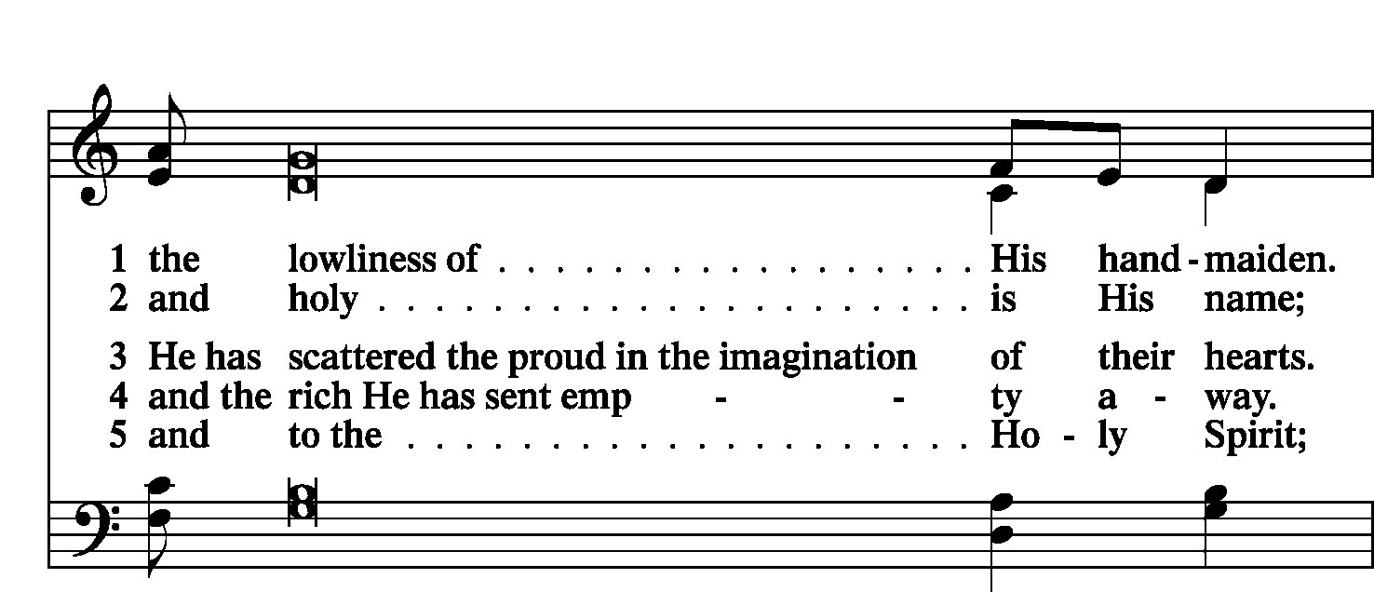
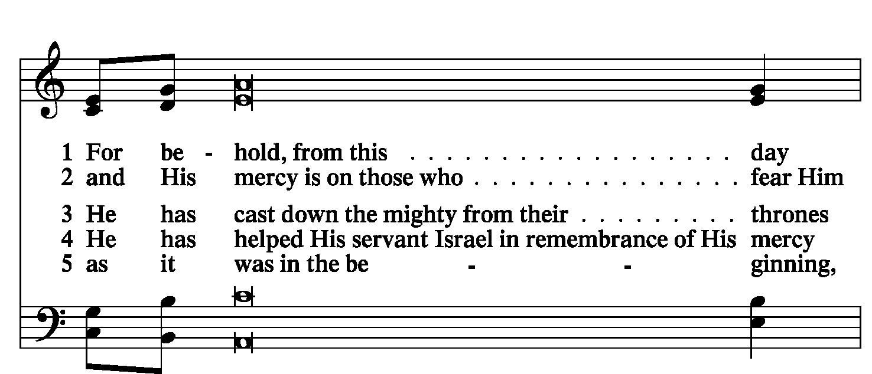
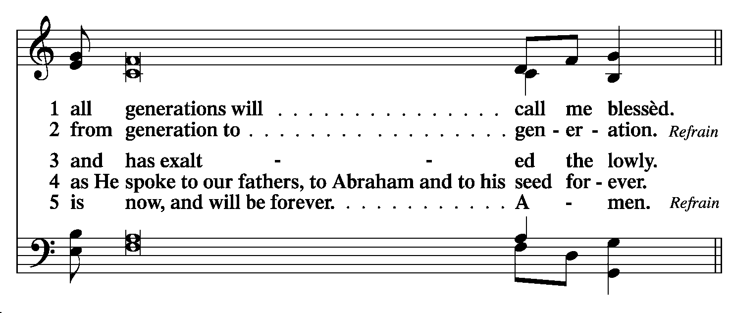

Prayer
Litany LSB 249
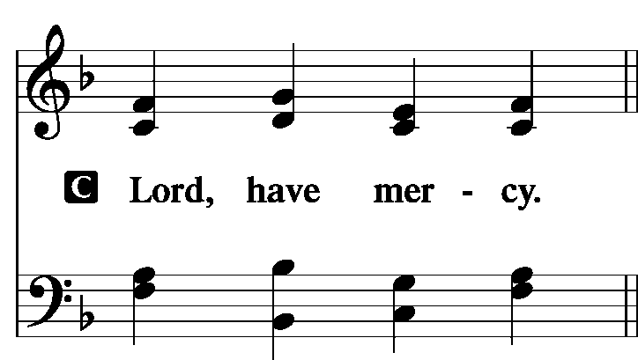

P For the peace from above and for our salvation, let us pray to the Lord:
C Lord, have mercy.
P For the peace of the whole world, for the well-being of the Church of God, and for the unity of all, let us pray to the Lord:
C Lord, have mercy.
P For this holy house and for all who offer here their worship and praise, let us pray to the Lord:
C Lord, have mercy.
P For our Synodical President, Pastor Matthew Harrison, for our District President, Pastor Tim Scharr, for all pastors in Christ, for all servants of the Church, and for all the people, let us pray to the Lord:
C Lord, have mercy.
P For our President, for all public servants, for the government and those who protect us, that they may be upheld and strengthened in every good deed, let us pray to the Lord:
C Lord, have mercy.
P For those who work to bring peace, justice, health, and protection in this and every place, let us pray to the Lord:
C Lord, have mercy.
P For those who bring offerings, those who do good works in this congregation, those who toil, those who sing, and all the people here present who await from the Lord great and abundant mercy, let us pray to the Lord:
C Lord, have mercy.
P For favorable weather, for an abundance of the fruits of the earth, and for peaceful times, let us pray to the Lord:
C Lord, have mercy.
P For our deliverance from all affliction, wrath, danger, and need, let us pray to the Lord:
C Lord, have mercy.
P For the faithful who have gone before us and are with Christ, let us give thanks to the Lord:
C Alleluia!
P Help, save, comfort, and defend us, gracious Lord.

Silence for individual prayer may follow.

P Rejoicing in the fellowship of all the saints, let us commend ourselves, one another, and our whole life to Christ, our Lord:
C To You, O Lord.

Collect For Peace
P O God, from whom come all holy desires, all good counsels, and all just works, give to us, Your servants, that peace which the world cannot give, that our hearts may be set to obey Your commandments and also that we, being defended from the fear of our enemies, may live in peace and quietness; through Jesus Christ, Your Son, our Lord, who lives and reigns with You and the Holy Spirit, one God, now and forever.
C Amen.

Collect For the First Sunday of Advent
P Stir up our hearts, O Lord, to make ready the way of Your only begotten Son, that by His coming we may be enabled to serve You with pure minds; through the same Jesus Christ, our Lord, who lives and reigns with You and the Holy Spirit, one God, now and forever.
C | Amen.
WE GO TO THE LORD IN PRAYER FOR
- Jennalee, Lauren, Eliza, and Emily Matthews, as they are baptized this evening.
- Zachary Matthews, as he was baptized at home this afternoon.

Lord's Prayer LSB 251
P Taught by our Lord and trusting in His promises, we are bold to pray:
C Our Father who art in heaven, hallowed be thy name, Thy kingdom come, Thy will be done on earth as it is in heaven; give us this day our daily bread; and forgive us our trespasses as we forgive those who trespass against us; and lead us not into temptation, but deliver us from evil. For Thine is the kingdom and the power and the glory forever and ever. Amen.

Benedicamus and Benediction LSB 252
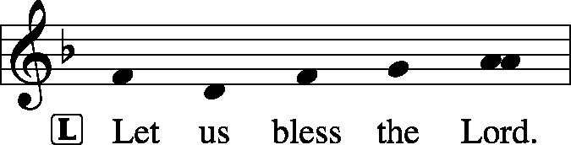
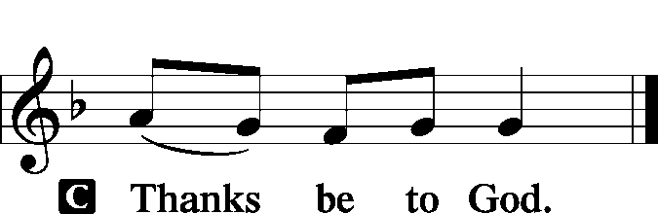

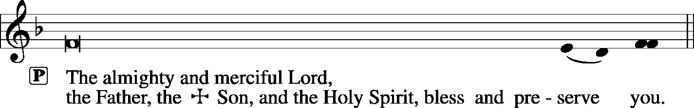

Sit

Hymn O Come, O Come, Emmanuel LSB 357

Acknowledgments
Unless otherwise indicated, all scripture quotations are from The Holy Bible, English Standard Version, copyright © 2001 by Crossway Bibles, a division of Good News Publishers. Used by permission. All rights reserved. Created by Lutheran Service Builder © 2006 Concordia Publishing House.
LIFE AND LIVING ITEMS AT ZION
          

WE WELCOME JENNALEE ELIZABETH, ZACHARY SCOTT, LAUREN ASHLEY, ELIZA ROSE, AND EMILY GRACE MATTHEWS
Congratulations to Alan and Joanna Matthews on the rebirth in Baptism of Jennalee Elizabeth, Zachary Scott, Lauren Ashley, Eliza Rose, and Emily Grace Matthews. Welcome, Jennalee, Zachary, Lauren, Eliza, and Emily!

CHURCH CHRISTMAS DECORATING – THIS SATURDAY
We will be decorating the church this Saturday, December 7th at 10:00 AM. If you would like to help, please join us! Any and all help is welcomed.

ADVENT AND CHRISTMAS SCHEDULE
December is a busy month, but our focus should be preparing for the joyful news of our Savior's birth and preparing to meet Him when He comes again in glory. Among all the other December activities, make sure that worship and church activities are central. All of us need to make choices as to how we will spend our time. What will your choices be? Will they reflect what is truly most important and of eternal significance. Or will your choices indicate a priority of the temporary over the eternal? Choose how you spend your time wisely. We look forward to seeing you at Zion at every opportunity!

ADVENT DEVOTIONS AVAILABLE
Devotion Booklets for the season of Advent are now available. Pick one up from the table in the narthex if you have not already done so. This month, as we approach Christmas, make additional time with family in prayer, devotion, and the Word of God a priority.

ADVENT MIDWEEK SERVICES
Advent Midweek Services will be held on Wednesday evenings in December. Advent Services will be December 4th, 11th, and 18th at 7:00 PM. These services are a blessed way to step back from the hectic rush of December and focus on what is truly most important about Christmas--the birth of our Lord Jesus Christ. Don't let secular scheduling pressures keep you out of worship in God's house!

PARSONAGE OPEN HOUSE – DECEMBER 14th
The Steins are happy to invite you all to the parsonage to give back one small piece of the generosity they have received from Zion. We are holding an open house on Saturday, December 14th, from 4 pm to 8 pm. You and your family are welcome to come and bring a friend. There will be many sweets, some savory options, Christmas music sheets on a piano and choral music playing on the television. Seminarian Stein would also like to see you all in your ugliest Christmas sweaters.

CHRISTMAS CAROLERS NEEDED -- SUNDAY
Would you like to bring the sounds of the season to those who need to hear the joyous message of God's love to them in the Christ Child? Would you like to enjoy the fellowship and fun of a potluck with brothers and sisters in Christ? If so, please join us as we meet at church at 4:30 p.m. on Sunday, Dec 8. After we have made the rounds of caroling, we will return to the school for fellowship and a potluck supper.
Please bring a dish from the below list according to your last name:

A-J Salad/Vegetable K-Q Dessert R-Z Main Dish

WHAT: Christmas Caroling and Potluck
WHEN: Sunday, Dec 8 at 4:30 p.m.
WHERE: Meet in the church kitchen to carpool to caroling sites

SECRET PAL PROGRAM
Ladies, would you like to have a Secret Pal at Zion? Have you noticed gifts mysteriously appearing at church? Zion's Ladies Aid/LWML members have had secret pals for the past years and have enjoyed it so much, this program is offered to any member of Zion who wishes to participate. You will receive a slip of paper on which to write your name, favorites, etc. from Glenda Pike. You are to pray for this person and can send cards or leave cards or small gifts at church during the year. See Glenda by Dec. 8 to get details and sign up. Sh-h-h, don't tell anyone!

DONATIONS NEEDED FOR UNITY SCHOOL, EAST ST. LOUIS
This Sunday, we will have the jars out in the back of the church for contributions to Unity Lutheran Christian Elementary School. They are having financial issues. This school is a vital tool to reach many young children and their families desperately needing to hear about God and His saving love, and we have the opportunity to support it NOW! The Ladies Aid will take up a collection at their Christmas Program, and this will be added to it as a donation from Zion.

THOSE WHO SERVE TODAY
Proclaimer: Sem. Adam Wolfe
Liturgist: Rev. Kirk Clayton
Liturgist: Sem. Don Stein
Organist: Nancy Peterson

THOSE WHO SERVE SUNDAY, DECEMBER 8
Proclaimer: Rev. Kirk Clayton
Liturgist: Sem. Adam Wolfe
Liturgist: Sem. Don Stein
Organist: Nancy Peterson
Ushers: Karl Bretz, Joe Crismon, Bob Eldridge, & Ken Frey
Sound Tech: Buzz Kandler
Video Tech: Mark Hatcher
Welcome Team: Torri & Alicia Suedmeyer
Acolytes: Ella Bretz & Daniel Bretz
Altar Guild: Gail Frey

THINGS WE ARE DOING AT ZION
Wed. Choir Rehearsal 6:00 PM
First Advent Midweek Service 7:00 PM
Fri. Senior Meal Delivery 10:30 AM
Sat. Church Christmas Decorating 10:00 AM
Sun. Children’s Christmas Program Practice 8:45 AM
Bible Class 8:45 AM
Worship DS III w/communion 10:00 AM
Christmas Caroling and Potluck 4:30 PM

