Zion Lutheran Church
Mascoutah, Illinois
November 24, 2019
Last Sunday of the Church Year

In the Name of Christ Jesus our Lord, we bid you a warm welcome to this worship service. May your experience of worship and fellowship this morning be spiritually refreshing and ready you for the week ahead.
 
Pastor: Rev. Kirk Clayton
Church Secretary: Robin Phillips
Choir Director Team: Josh and Nancy Peterson
_________________________________________________________________________________
Church Office Phone: 618-566-7345
Pastor Clayton Cell: 618-447-1306
Office Hours: 8:00 am to 12:00 pm
Email: ChurchOffice@ZionMascoutah.org
Pastor Clayton email: Pastor@ZionMascoutah.org
Web site: www.ZionMascoutah.org
Find us at @ZionMascoutah on Facebook, Twitter, and Instagram
Electronic Devices
Please TURN OFF all cell phones, pagers, electronic devices, apps and games when entering the sanctuary for worship so those around you may focus on the Word of God without electronic distraction. Thank you.

A Prayer to Begin Worship
Son of Man, before whom all people of all the nations will stand at the Judgment, increase our love for You at Your divine plan’s end, for we cannot conceive a time or an event of greater significance or majesty in all of Your dealing with Your creation; through Jesus Christ, our Lord, who with You and the Holy Spirit are one God with dominion over us forever.

DIVINE SERVICE I WITH COMMUNION
LSB p. 151
Confession and Absolution
Prelude Praise My Soul the King of Heaven arr. Burkhardt

Hymn Wake, Awake, for Night Is Flying LSB 516

Stand
The sign of the cross may be made by all in remembrance of their Baptism.
Invocation
P In the name of the Father and of the T Son and of the Holy Spirit.
C Amen.

Exhortation
P If we say we have no sin, we deceive ourselves, and the truth is not in us.
C But if we confess our sins, God, who is faithful and just, will forgive our sins and cleanse us from all unrighteousness.

Silence for reflection on God's Word and for self-examination.
Confession of Sins
P Let us then confess our sins to God our Father.
C Most merciful God, we confess that we are by nature sinful and unclean. We have sinned against You in thought, word, and deed, by what we have done and by what we have left undone. We have not loved You with our whole heart; we have not loved our neighbors as ourselves. We justly deserve Your present and eternal punishment. For the sake of Your Son, Jesus Christ, have mercy on us. Forgive us, renew us, and lead us, so that we may delight in Your will and walk in Your ways to the glory of Your holy name. Amen.
Absolution
P Almighty God in His mercy has given His Son to die for you and for His sake forgives you all your sins. As a called and ordained servant of Christ, and by His authority, I therefore forgive you all your sins in the name of the Father and of the T Son and of the Holy Spirit.
C Amen.
Service of the Word
Introit Ps. 39:4–5, 7– 8; antiphon: Is. 35:10
L The ransomed of the Lord shall return and come to Zion with singing;
C everlasting joy shall be upon their heads.
L They shall obtain gladness and joy,
C and sorrow and sighing shall flee away.
L O Lord, make me know my end and what is the measure of my days;
C let me know how fleeting I am!
L Behold, You have made my days a few handbreadths, and my lifetime is as nothing before You.
C Surely all mankind stands as a mere breath!
L And now, O Lord, for what do I wait?
C My hope is in You.
L Deliver me from all my transgressions.
C Do not make me the scorn of the fool!
Glory be to the Father and to the Son
and to the Holy Spirit;
as it was in the beginning,
is now, and will be forever. Amen.
L The ransomed of the Lord shall return and come to Zion with singing;
C everlasting joy shall be upon their heads.
L They shall obtain gladness and joy,
C and sorrow and sighing shall flee away.

Kyrie LSB 152
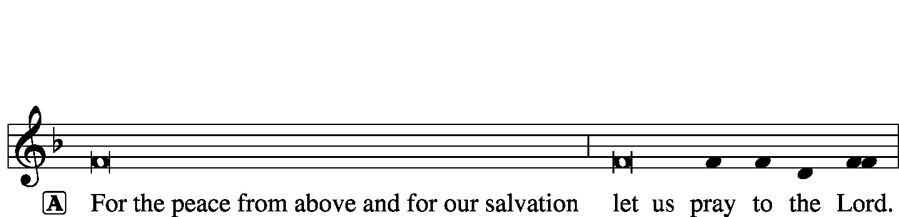
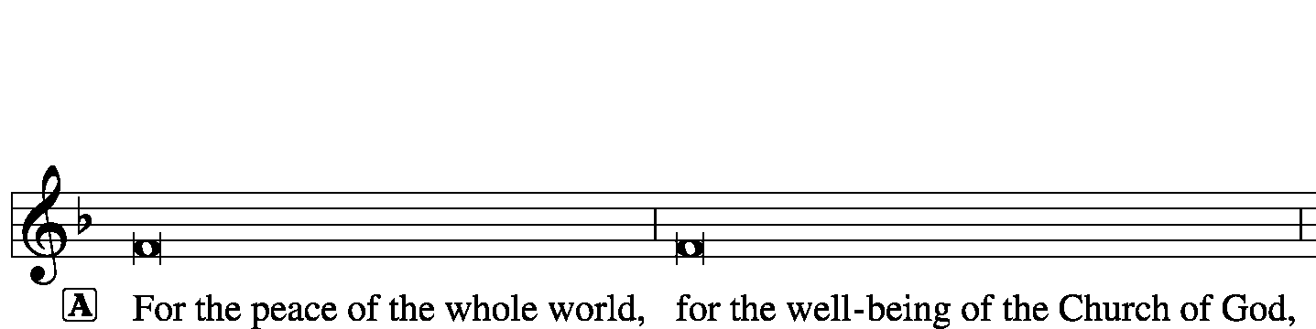
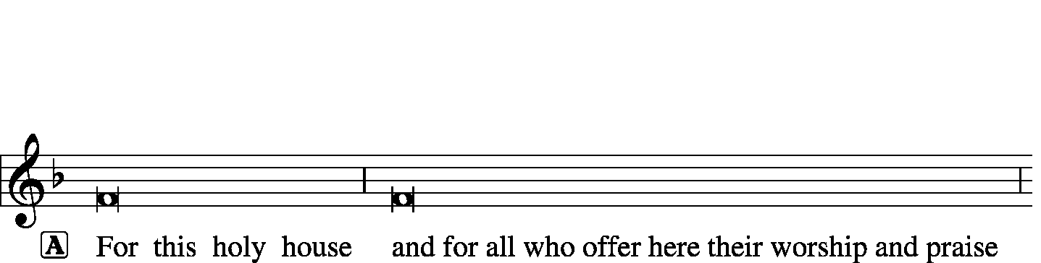
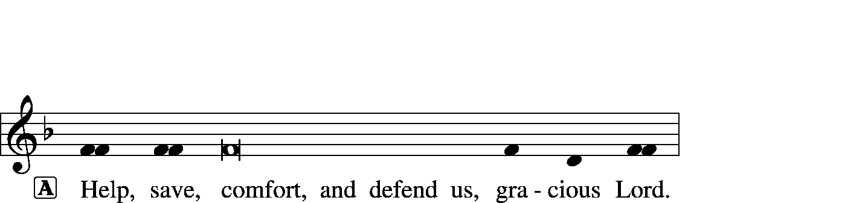

Hymn of Praise -- This Is the Feast LSB 155
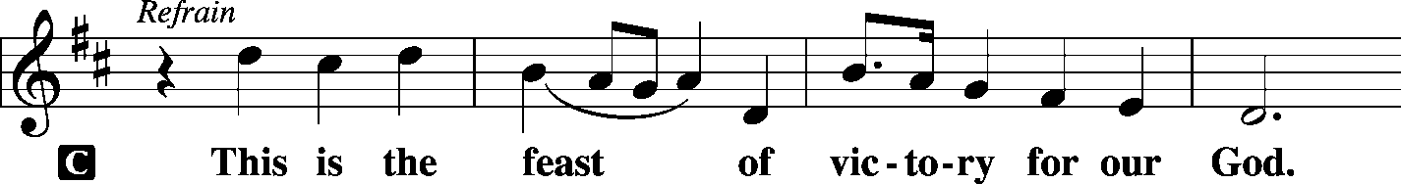
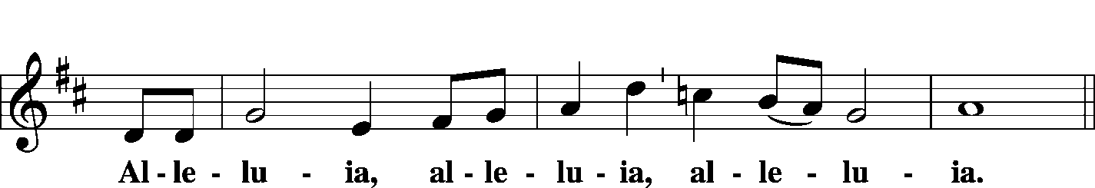
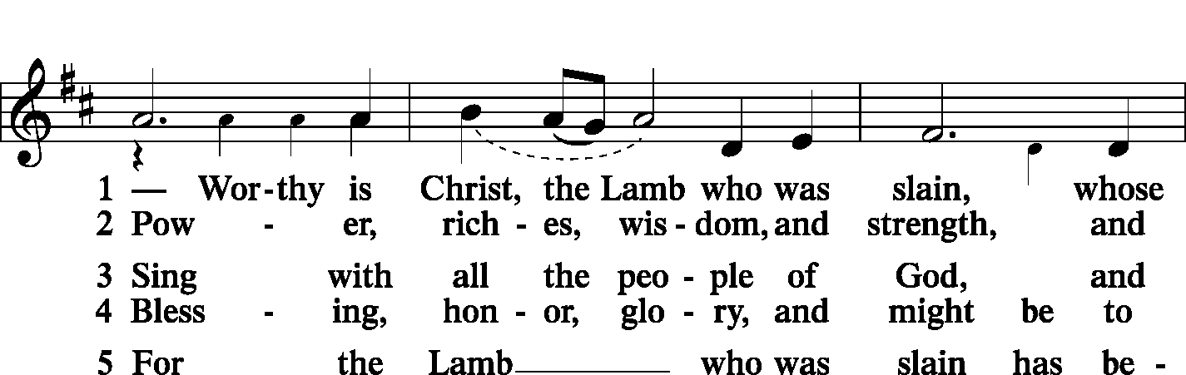
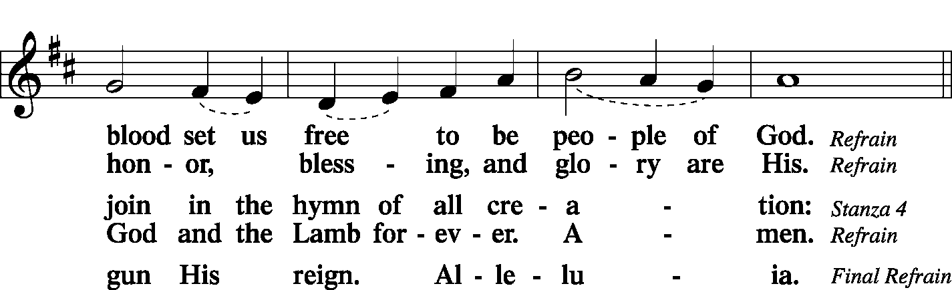
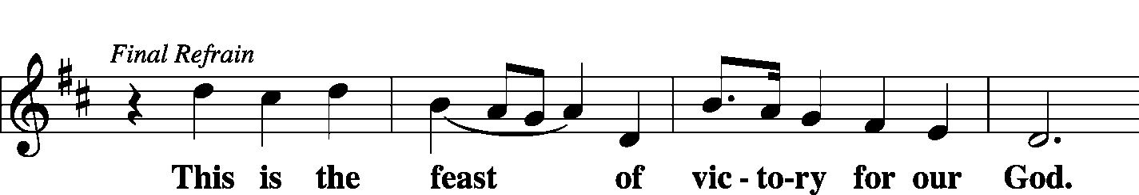
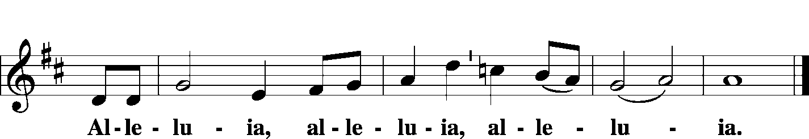

Salutation and Collect of the Day
L The Lord be with you.
C And also with you.
L Let us pray.
O Lord, absolve Your people from their offenses that, from the bonds of our sins which by reason of our frailty we have brought upon ourselves, we may be delivered by Your bountiful goodness; through Jesus Christ, Your Son, our Lord, who lives and reigns with You and the Holy Spirit, one God, now and forever.
C Amen.

Sit

Old Testament Reading Isaiah 65:17–25
“For behold, I create new heavens and a new earth, and the former things shall not be remembered or come into mind. But be glad and rejoice forever in that which I create; for behold, I create Jerusalem to be a joy, and her people to be a gladness. I will rejoice in Jerusalem and be glad in My people; no more shall be heard in it the sound of weeping and the cry of distress. No more shall there be in it an infant who lives but a few days, or an old man who does not fill out his days, for the young man shall die a hundred years old, and the sinner a hundred years old shall be accursed. They shall build houses and inhabit them; they shall plant vineyards and eat their fruit. They shall not build and another inhabit; they shall not plant and another eat; for like the days of a tree shall the days of My people be, and My chosen shall long enjoy the work of their hands. They shall not labor in vain or bear children for calamity, for they shall be the offspring of the blessed of the Lord, and their descendants with them. Before they call I will answer; while they are yet speaking I will hear. The wolf and the lamb shall graze together; the lion shall eat straw like the ox, and dust shall be the serpent’s food. They shall not hurt or destroy in all My holy mountain,” says the Lord.
L This is the Word of the Lord.
C Thanks be to God.

Choir The King Is Coming Soon Jon Paige

Epistle 1 Thessalonians 5:1–11
Now concerning the times and the seasons, brothers, you have no need to have anything written to you. For you yourselves are fully aware that the day of the Lord will come like a thief in the night. While people are saying, “There is peace and security,” then sudden destruction will come upon them as labor pains come upon a pregnant woman, and they will not escape. But you are not in darkness, brothers, for that day to surprise you like a thief. For you are all children of light, children of the day. We are not of the night or of the darkness. So then let us not sleep, as others do, but let us keep awake and be sober. For those who sleep, sleep at night, and those who get drunk, are drunk at night. But since we belong to the day, let us be sober, having put on the breastplate of faith and love, and for a helmet the hope of salvation. For God has not destined us for wrath, but to obtain salvation through our Lord Jesus Christ, who died for us so that whether we are awake or asleep we might live with Him. Therefore encourage one another and build one another up, just as you are doing.
L This is the Word of the Lord.
C Thanks be to God.

Stand
Common Alleluia and Verse LSB 156
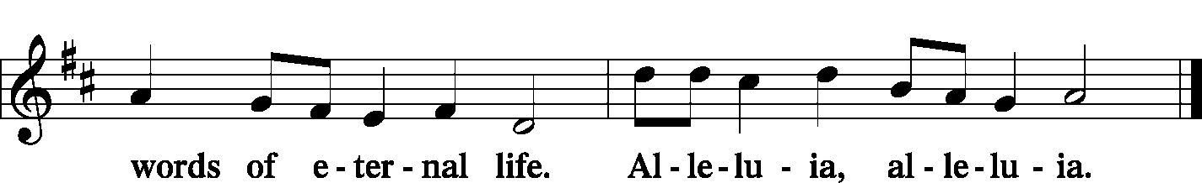

Holy Gospel Matthew 25:1–13
P The Holy Gospel according to St. Matthew, the 25th chapter.
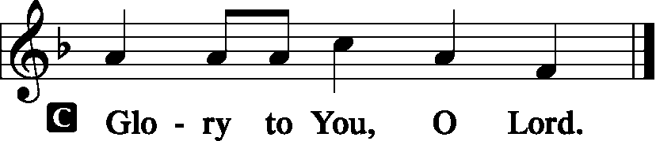
“Then the kingdom of heaven will be like ten virgins who took their lamps and went to meet the bridegroom. Five of them were foolish, and five were wise. For when the foolish took their lamps, they took no oil with them, but the wise took flasks of oil with their lamps. As the bridegroom was delayed, they all became drowsy and slept. But at midnight there was a cry, ‘Here is the bridegroom! Come out to meet him.’ Then all those virgins rose and trimmed their lamps. And the foolish said to the wise, ‘Give us some of your oil, for our lamps are going out.’ But the wise answered, saying, ‘Since there will not be enough for us and for you, go rather to the dealers and buy for yourselves.’ And while they were going to buy, the bridegroom came, and those who were ready went in with him to the marriage feast, and the door was shut. Afterward the other virgins came also, saying, ‘Lord, Lord, open to us.’ But He answered, ‘Truly, I say to you, I do not know you.’ Watch therefore, for you know neither the day nor the hour.
P This is the Gospel of the Lord.
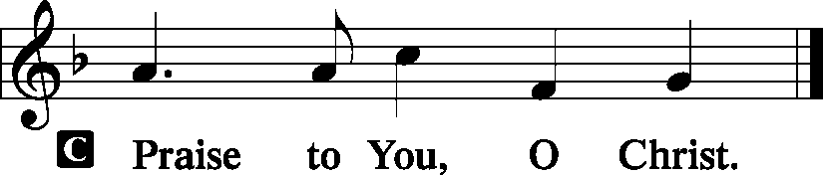

Sit
Hymn Praise, My Soul, the King of Heaven LSB 793

Sermon Celebration…For Some

Adult Confirmation

Stand
Nicene Creed
C I believe in one God, the Father Almighty, maker of heaven and earth and of all things visible and invisible.
And in one Lord Jesus Christ, the only-begotten Son of God, begotten of His Father before all worlds, God of God, Light of Light, very God of very God, begotten, not made, being of one substance with the Father, by whom all things were made; who for us men and for our salvation came down from heaven and was incarnate by the Holy Spirit of the virgin Mary and was made man; and was crucified also for us under Pontius Pilate. He suffered and was buried. And the third day He rose again according to the Scriptures and ascended into heaven and sits at the right hand of the Father. And He will come again with glory to judge both the living and the dead, whose kingdom will have no end.
And I believe in the Holy Spirit, the Lord and giver of life, who proceeds from the Father and the Son, who with the Father and the Son together is worshiped and glorified, who spoke by the prophets. And I believe in one holy Christian and apostolic Church, I acknowledge one Baptism for the remission of sins, and I look for the resurrection of the dead and the life T of the world to come. Amen.

Sit
Offering
[Please fill out a sheet in the attendance book. Visitors, please include your address. If you have a prayer request for the church prayer chain, please write it at the top of the sheet.]

Special Offering Music Wachet Auf J. S. Bach
Zion Orchestra

Stand
Offertory LSB 159
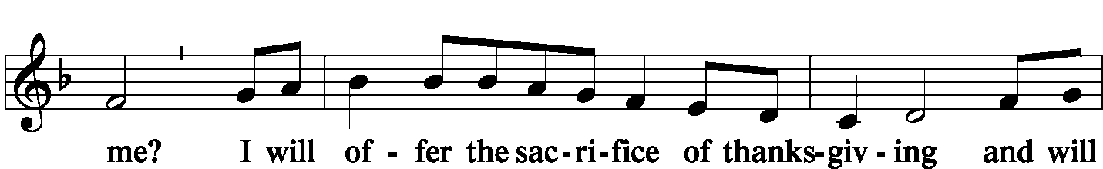
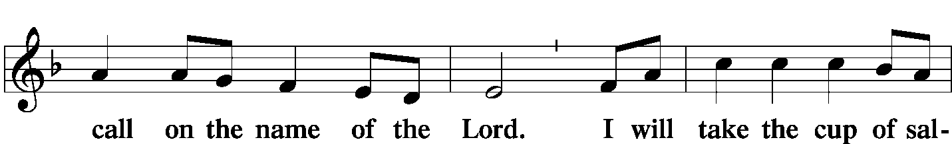
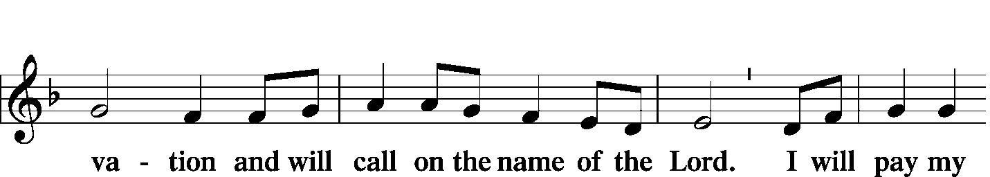
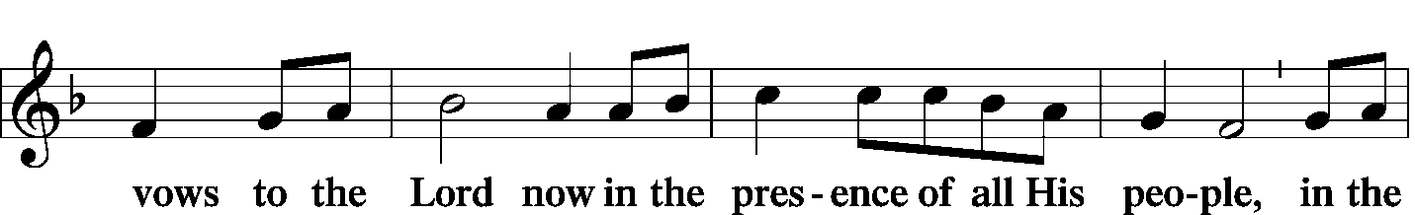
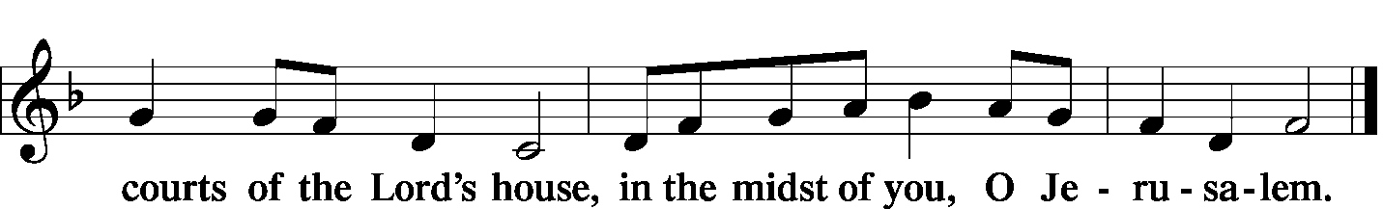

Prayer of the Church
L We serve You, O Lord, with gladness and come into Your presence with singing.
C You have made us Your people and the sheep of Your pasture.
L We enter Your gates with thanksgiving and Your courts with praise.
C We give thanks to You for You are good and Your love endures forever.
L Your faithfulness endures to all generations.
C Your promise of creating new heavens and a new earth keeps us hopeful for the future.
L We shall then rejoice and be glad forever, for we shall hear no sound of weeping or cry of distress.
C There will be no more death, and time will stand still.
L Before we call, You will answer, and while we are yet speaking, You will hear.
C We look forward to the indescribable peace that You have prepared for those who love You.
L Send us Your Holy Spirit that He may keep us alert and prepared to meet Christ, who will come as a bridegroom to claim His bride, the Church.
C Help keep our lamps filled with the oil of faith.
L Protect us from the evil one, who would have us believe that we can enter the nuptial hall on the faith of someone else.
C Keep us from thinking that Judgment Day will not come during our lifetime.
L Even though the earth be burned up and the elements melt with fervent heat, we will not fear.
C According to Your promise in Christ Jesus assure us that we shall be with You in everlasting life.

WE GO TO THE LORD IN PRAYER FOR
- Hunter Phillips, Garrett Sax, Charlotte Pivoras, and Pat Meier, as they celebrate their baptismal anniversaries this week.
- Hunter Phillips, who is again hospitalized at Barnes.
- Ashton Dunn, Hayden and Alex Farmer, Kayla Hollenkamp, Joanna Matthews, Trent and Sharon Morris, Ian Robinson, and Isaac Robinson as they are confirmed this morning.
- Zion’s Men’s Club, Ladies Aid, and Youth Group.
- Faithfulness in personal witness and evangelism.

L Enable us to spread Your kingdom without hindrance.
C Grant peace to our nation and the nations of the world. In Jesus’ name we pray. Amen
Service of the Sacrament
Preface LSB 160
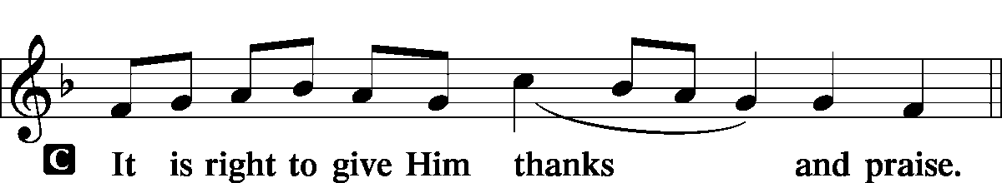

Proper Preface (Full)
P It is truly good, right, and salutary that we should at all times and in all places give thanks to You, holy Lord, almighty Father, everlasting God, through Jesus Christ, our Lord, who on this day overcame death and the grave and by His glorious resurrection opened to us the way of everlasting life. Therefore with angels and archangels and with all the company of heaven we laud and magnify Your glorious name, evermore praising You and saying:

Sanctus LSB 161
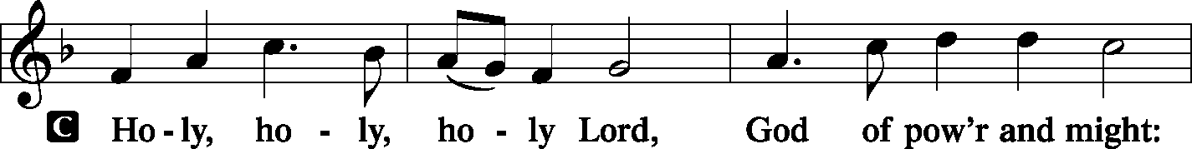
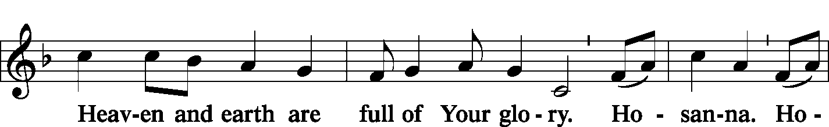
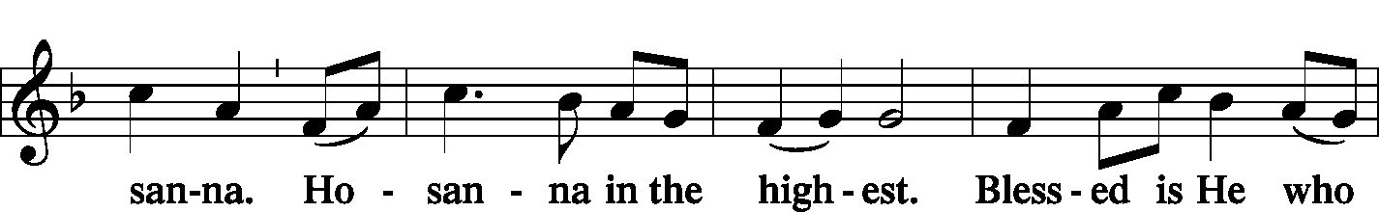
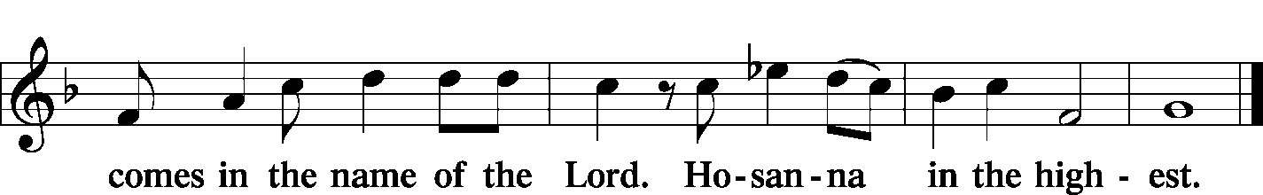

Prayer of Thanksgiving LSB 161
P Blessed are You, Lord of heaven and earth, for You have had mercy on those whom You created and sent Your only-begotten Son into our flesh to bear our sin and be our Savior. With repentant joy we receive the salvation accomplished for us by the all-availing sacrifice of His body and His blood on the cross. Gathered in the name and the remembrance of Jesus, we beg You, O Lord, to forgive, renew, and strengthen us with Your Word and Spirit. Grant us faithfully to eat His body and drink His blood as He bids us do in His own testament. Gather us together, we pray, from the ends of the earth to celebrate with all the faithful the marriage feast of the Lamb in His kingdom, which has no end. Graciously receive our prayers; deliver and preserve us. To You alone, O Father, be all glory, honor, and worship, with the Son and the Holy Spirit, one God, now and forever.
C Amen.

Lord's Prayer LSB 162
P Lord, remember us in Your kingdom and teach us to pray:
C Our Father who art in heaven, hallowed be Thy name, Thy kingdom come, Thy will be done on earth as it is in heaven; give us this day our daily bread; and forgive us our trespasses as we forgive those who trespass against us; and lead us not into temptation, but deliver us from evil. For Thine is the kingdom and the power and the glory forever and ever. Amen.

The Words of Our Lord LSB 162
P Our Lord Jesus Christ, on the night when He was betrayed, took bread, and when He had given thanks, He broke it and gave it to the disciples and said: “Take, eat; this is My T body, which is given for you. This do in remembrance of Me.”
P In the same way also He took the cup after supper, and when He had given thanks, He gave it to them, saying: “Drink of it, all of you; this cup is the new testament in My T blood, which is shed for you for the forgiveness of sins. This do, as often as you drink it, in remembrance of Me.”

Pax Domini LSB 163
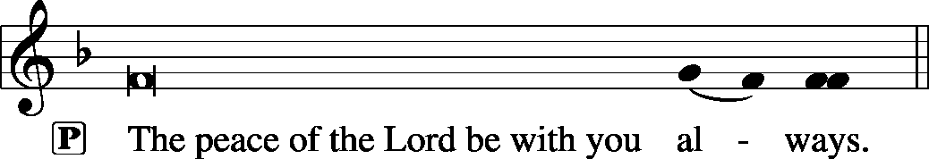

Agnus Dei LSB 163
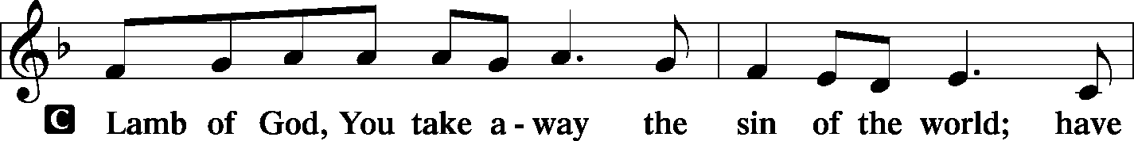
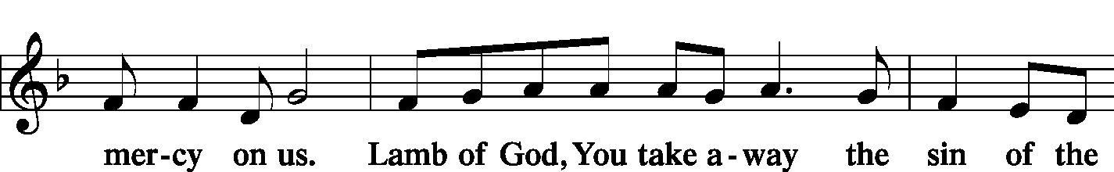
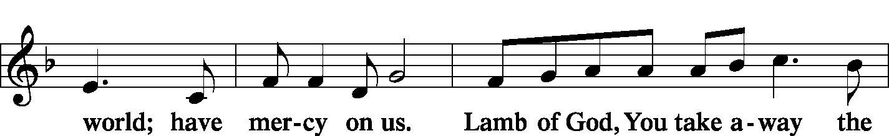
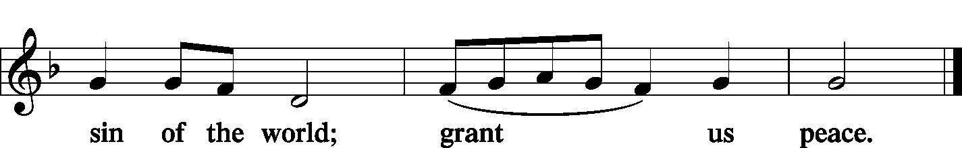

Sit
Distribution
Zion Lutheran practices the policy of close communion, communing only those who share our common Biblical view of the Lord's Supper. If you are not a confirmed LCMS Lutheran, please confer with the pastor before communing.

Hymn O Lord, We Praise Thee LSB 617
Hymn Soul, Adorn Yourself with Gladness LSB 636
Hymn Rejoice, Rejoice, Believers LSB 515

Stand
In dismissing the communicants, the following is said:
The Dismissal
L The body and blood of our Lord Jesus Christ strengthen and preserve you in body and soul to life everlasting. Depart T in peace.
C Amen.

Post-Communion Canticle -- Thank the Lord LSB 164
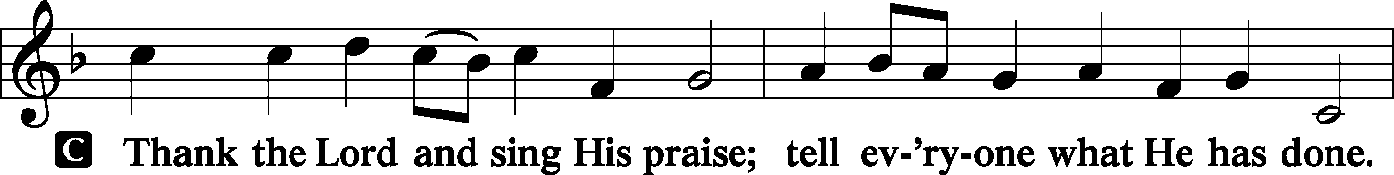
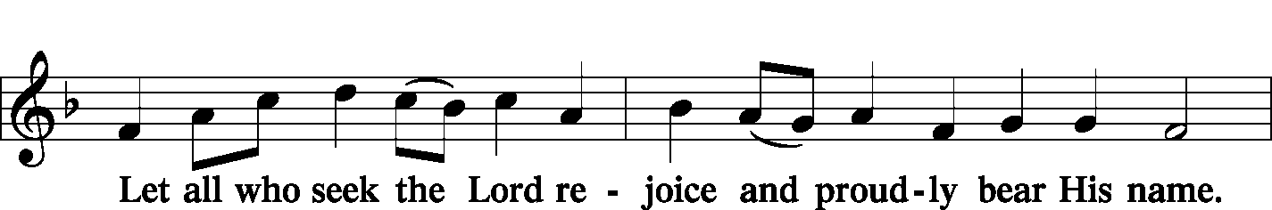
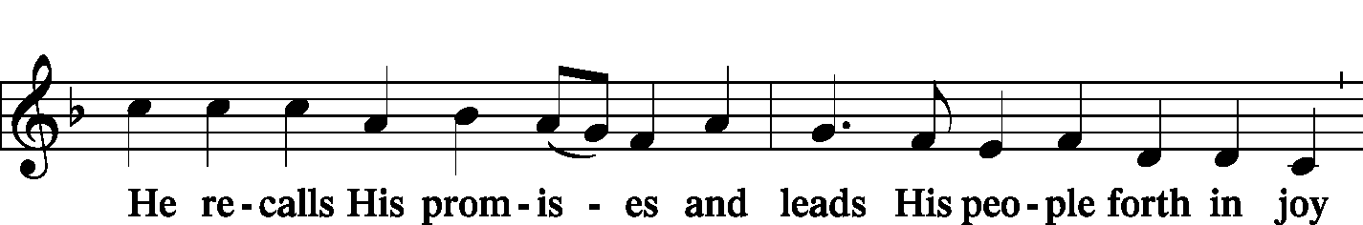
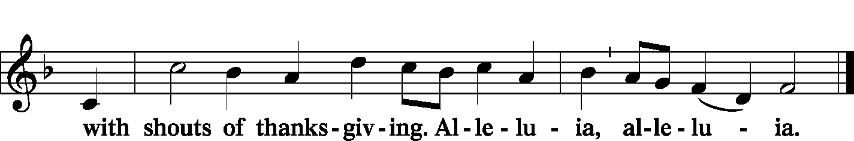

Post-Communion Collect and Benediction LSB 166
L Let us pray. We give thanks to You, almighty God, that You have refreshed us through this salutary gift, and we implore You that of Your mercy You would strengthen us through the same in faith toward You and in fervent love toward one another; through Jesus Christ, Your Son, our Lord, who lives and reigns with You and the Holy Spirit, one God, now and forever.

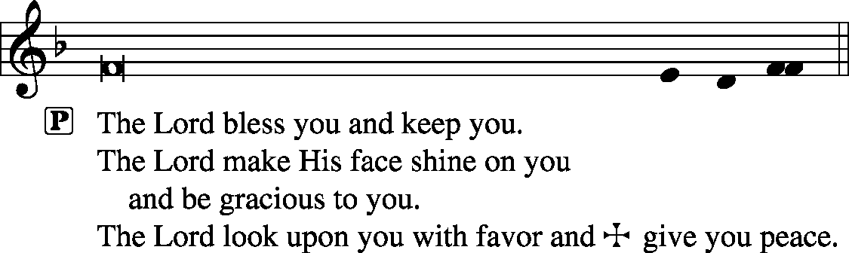

Remain Standing
Hymn Crown Him with Many Crowns LSB 525
THE CHOIR SINGS STANZA 3 ALONE
Postlude Voluntary in C Major Henry Purcell

Acknowledgments
Unless otherwise indicated, all scripture quotations are from The Holy Bible, English Standard Version, copyright © 2001 by Crossway Bibles, a division of Good News Publishers. Used by permission. All rights reserved. Created by Lutheran Service Builder © 2006 Concordia Publishing House.
LIFE AND LIVING ITEMS AT ZION
          

THANK YOU FROM THE PRESCHOOL!!!
Thank you to everyone who helped with our annual Preschool Thanksgiving Dinner. A special thanks to Sue Kandler who prepared all the turkey, Mark Krausz who transported borrowed tables and chairs, and all the people in the kitchen who served and cleaned up. We could not do this without all of you wonderful volunteers. We served over 225 people. Thank you so much for making it a successful and enjoyable evening for our preschool families. Marlene Lockwood, Preschool Director

THANK YOU FOR BIRTHDAY WISHES
Dear Zion Family, Thank you to all of you who sent me cards, texted, emailed, or contacted me on my birthday last week. I appreciate all of your greetings and prayers. Thank you for all the care that you show! In Christ, Pastor Clayton

THANK YOU TO OUR MUSICIANS THIS MORNING
Thanks to the Zion Orchestra who shared their talents with the congregation to provide special music today, including violins: Abigail and Matthew Clayton, Bella Harlan, and Rosemary Peterson; viola: Gloria Peterson; cello: Bjorn Peterson; flute: Maggie Harlan; trumpets: Aidan Bloomquist, Johnathan and Kirk Clayton, Josh and Knut Peterson; horn: Goldie Derezotes; trombones: Bob Eldridge and Thor Peterson; and baritone: Nathaniel Clayton. We give thanks to God for the opportunity to praise Him through music.

CHURCH CHRISTMAS DECORATING – VOLUNTEERS NEEDED!
We will be decorating the church on Saturday, December 7th at 10:00 AM. If you would like to help, please join us! Any and all help is welcomed.

LINUS BLANKETS ON DISPLAY NEXT SUNDAY
The Ladies Aid made blankets this past summer for the Linus Blankets of Southwestern Illinois, Belleville. Since 1997, more than 63,000 have been delivered across the bi-state area to children’s hospitals and crisis centers to be handed out to children who are seriously ill, traumatized, or otherwise in need of some comfort. We have made at least 30 blankets in sizes ranging from those for preemies to teens. They will be delivered next week.

2020 CHRISTIAN-THEMED CALENDARS NOW AVAILABLE
Zion’s Ladies Aid is selling Christian themed 2020 wall calendars. They are $6 each and are located on the table in the Narthex. There are a limited number so get yours today!
YOUTH COUNSELORS NEEDED AT ZION
After many years of dedicated and loving service to our youth, Karen and Bob Eldridge have advised the Zion Board of Education that they are ready to pass the responsibility of sponsoring our Jr./Sr. Youth Group to new advisors. The Board is in need of volunteers compelled to work with middle and high school aged youth as mentors and advisors for the youth in our congregation as they grow and develop in their Christian faith and fellowship. Please contact Alicia Suedmeyer, Christa Sink, or Marianne McDaniel before November 25 if you feel compelled to fulfill this responsibility.

SECRET PAL PROGRAM
Ladies, would you like to have a Secret Pal at Zion? Have you noticed gifts mysteriously appearing at church? Zion's Ladies Aid/LWML members have had secret pals for the past years and have enjoyed it so much, this program is offered to any member of Zion who wishes to participate. You will receive a slip of paper on which to write your name, favorites, etc. from Glenda Pike. You are to pray for this person and can send cards or leave cards or small gifts at church during the year. See Glenda by Dec 8 to get details and sign up. Sh-h-h, don't tell anyone!

MASCOUTAH FOOD PANTRY ITEMS FOR DECEMBER
Oil, Sugar, Mandarin Oranges, Apple Sauce, Hot Chocolate, Canned Spinach, Pineapple

DOMINICAN REPUBLIC MISSION TRIP UPDATE
We have received 7 responses of interest in a mission trip to the Dominican Republic, and considering that a full team consists of 8-10 people, this is a phenomenal response and a very real possibility! The highest "vote total" for type of trip was the "Educational Support Team," followed by "Playground Renovation Team" and "Volleyball Camp Team." As of now, trip dates of May 30 - June 6, June 13 - June 20, and June 20 - June 27 are possibilities

CHRISTMAS CAROLERS NEEDED!
Would you like to bring the sounds of the season to those who need to hear the joyous message of God's love to them in the Christ Child? Would you like to enjoy the fellowship and fun of a potluck with brothers and sisters in Christ? If so, please join us as we meet at church at 4:30 p.m. on Sunday, Dec 8. After we have made the rounds of caroling, we will return to the school for fellowship and a potluck supper.

Please bring a dish from the below list according to your last name:
A-J Salad/Vegetable K-Q Dessert R-Z Main Dish
WHAT: Christmas Caroling and Potluck
WHEN: Sunday, Dec 8 at 4:30 p.m.
WHERE: Meet in the church kitchen to carpool to caroling sites

UNITY LUTHERAN SCHOOL SEWING CLUB NEEDS SUPPLIES
The sewing club at Unity Lutheran Christian Elementary School is in need of some sewing supplies. We currently have about 20 boys and girls that come every Thursday to sewing club. We have plenty of donated material for right now. Supplies still needed are: pins, thread, rotary cutters, cutting mats, and a Basic sewing machine (newer editions). Thank you for your continued support for Unity!

HANDEL’S MESSIAH AT ZION, BELLEVILLE
Zion’s Music and Ministry and Community will present Handel’s Messiah on Sunday, December 22, at 3:00PM at Zion, 1810 McClintock Ave, Belleville.

ANNUAL TREE OF HOPE CAMPAIGN
The Mascoutah Tuesday Women’s Club is excited to announce the annual Tree of Hope campaign. Donations will be used to provide Christmas gifts of shoes and clothes for the needy children of Mascoutah. Funds were also used to support the Mascoutah Township School Supply Drive through a donation of 100, $20 gift cards to provide shoes for children starting school. Thanks to the generosity of Mascoutah, donations totaling $10,580 for the Tree of Hope were received in 2018. We ask for your help again this year in order to fill the stockings of so many needy children. Please send your donation to: Tree of Hope, PO Box 244, Mascoutah, IL 62258. If you have any questions, call Rosalie Taylor at 618-566-2529.

ROCK & ROLL BINGO AT LEU CIVIC CENTER
Join us on Saturday, December 7th at the Leu Civic Center for Rock & Roll Bingo. Doors open at 6:00 PM. Cost is $20 per person in advance and $25 at the door. Tickets may be purchased at Leu Civic Center. Attendees may bring food and beverages. For more information, call 618-566-2175.

TRINITY LUTHERAN ANNUAL COOKIE WALK
Trinity Lutheran Church at 503 E. Washington in Millstadt is hosting a Cookie Walk on Saturday, December 7th from 9 AM to Noon. Homemade cookies sold by the pound. Mixed are $10/lb. and fancy are $11/lb. Advance orders are being taken. Please call Shirley Boehm at 618-476-1113.

CHI AUXILIARY ANNUAL CHRISTMAS LUNCHEON
The Auxiliary of the Concordia Historical Institute is pleased to announce its Annual Christmas Luncheon on Thursday, December 12, 2019, at 12 Noon in Koburg Hall, Concordia Seminary campus (804 Seminary Place, Clayton, MO). Meet and greet new or renewed acquaintances, hear the Village Lutheran Homeschool Handbell Choir, enjoy singing Christmas carols, and receive an update on CHI. The luncheon cost is $15 per person, with reservations to be made by December 5th. Checks may be made payable to "CHI Auxiliary" and sent to Nancy Fassold, 5609 Nantasket Court, St. Louis, MO 63128. For more information, please contact her at 314-843-3559 or nk21@live.com.

CHURCH BASEMENT LADIES: AWAY IN THE BASEMENT
Take a trip back in time to 1959 and celebrate the holidays with the CHURCH BASEMENT LADIES: AWAY IN THE BASEMENT. The ladies and the pastor try to save the Church Christmas pageant from disaster in this fun, family-friendly musical presented by Clinton County Showcase at the Avon Theater in Breese on Dec. 6, 7, 8, 13, 14, & 15. Tickets now on sale at clintoncountyshowcase.com.

GOOD SHEPHERD CHRISTMAS CANTATA
On Sunday, December 29th at 3:00 PM, as a celebration of Christ’s coming at Christmas, the musicians of Good Shepherd Lutheran Church in Collinsville are presenting a special Christmas cantata featuring John Leavitt’s What Child Is This. The GSLS choir will be accompanied by member and guest professional instrumentalists. Good Shepherd Lutheran Church is located at 1300 Beltline Rd., Collinsville, IL. For more information, call 618-344-3151.

LISTEN TO WORLDWIDE KFUO AM850
KFUO Radio, AM850, a media ministry extension of LCMS congregations, shares Christ for you anytime, anywhere on AM850 via worship services, Bible and theology studies, practical talk programs, and sacred music. You can find programs on demand at kfuo.org and wherever you get your podcasts! Find us on social: @KFUOradio on Facebook, Twitter, and Instagram. This week on KFUO AM850, celebrate Thanksgiving with special episodes of Sharper Iron studying the theme of thanksgiving in God's Word (11/27-11/29 at 8:00 a.m.), hear words of comfort on Moments of Assurance (weekdays at 12:00 p.m.), and hear about mental health topics with Deaconess Heidi Goehmann on The Coffee Hour's Mental Health Monday (11/25 at 9:00 a.m.). Find these programs on demand at kfuo.org!

ISSUES ETC.
SANCTIFYING YOUR HOBBIES WITH THE WORD OF GOD...Issues, Etc. is a radio talk show and podcast produced by Lutheran Public Radio in Collinsville, IL and hosted by LCMS Pastor Todd Wilken. This week's teachings include: Give Us This Day Our Daily Bread, The Advent Hymn "Hark! A Thrilling Voice Is Sounding," Old Testament Patriarch Noah, The Psalter and more. You can listen live or on-demand at www.issuesetc.org and on the LPR mobile app.

          

THOSE WHO SERVE THANKSGIVING DAY, NOVEMBER 28
Proclaimer: Rev. Kirk Clayton
Organist: Nancy Peterson
Ushers: Lionel Timmerman, Alex Tubbs, Mike Twenhafel,
Terry Twenhafel
Sound Tech: Jake Simon
Video Tech: Mark Hatcher
Welcome Team: Doug & Amber Sax
Acolytes: Phoebe Corey & Abigail Clayton

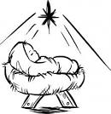
Reverse Advent
Calendar

An Advent calendar is a special calendar used to count the days of Advent in anticipation of Christmas. Traditionally, this countdown is marked by opening a small door of a calendar and retrieving a small candy or toy from a hidden compartment. This year, instead of receiving, let us give back in thankfulness for the ultimate gift of Jesus Christ our Lord and Savior.

Directions: Each day, add an item to a box. To keep this a mindful activity, this can be done in conjunction with your daily Advent devotional. On Christmas Eve, donate the contents to Mascoutah Food Pantry. The Food Pantry is open on Tuesdays and Saturdays from 10:00 - 12:00. You can also drop your box off at the church or call Beth Twenhafel (618-660-8872) for a pick up at your house.

December 1 - box of cereal
December 2 - peanut butter
December 3 - stuffing mix
December 4 - boxed potatoes
December 5 - macaroni and cheese
December 6 - canned tomatoes
December 7 - cream of mushroom soup
December 8 - canned tuna
December 9 - dessert mix
December 10 - jar of applesauce
December 11 - canned sweet potatoes
December 12 - cranberry sauce
December 13 - canned beans
December 14 - box of crackers
December 15 - package of rice
December 16 - package of oatmeal
December 17 - package of pasta
December 18 - spaghetti sauce
December 19 - chicken noodle soup
December 20 - tomato soup
December 21 - can corn
December 22- can mixed vegetables
December 23 - can carrots
THE FLOWERS ON THE LORD’S ALTAR
The flowers on the Lord’s altar are given to the glory of God by Jon and Cary Robinson in celebration of confirmation.

THOSE WHO SERVE TODAY
Proclaimer: Rev. Kirk Clayton
Liturgist: Sem. Adam Wolfe and Sem. Don Stein
Organist: Nancy Peterson
Ushers: Ray McDaniel, Randy Schorfheide, Matt Sink,
& Torri Suedmeyer
Sound Tech: Mark Krausz
Video Tech: Mark Hatcher
Welcome Team: Andy & Rhea Sax
Acolytes: Cadence Dunn & Jake Lara
Altar Guild: Linda Hoskins

THOSE WHO SERVE NEXT WEEK, DECEMBER 1
Proclaimer: Rev. Kirk Clayton
Organist: Nancy Peterson
Ushers: Bob Walter, Dale Wehmeyer, Eldon Ahner, & Ted Ahner
Sound Tech: Lionel Timmerman
Video Tech: Mark Hatcher
Welcome Team: Tom & Cheryl Sax
Acolytes: William Bretz & Rainer Bretz

THINGS WE ARE DOING AT ZION
Sun. Adult Confirmation
Christmas Program Practice 8:45 AM
Bible Class 8:45 AM
Worship DS I w/communion 10:00 AM
Mon. Board of Ed 7:00 PM
Wed. No Preschool
No Choir Rehearsal
Thurs. Office Closed – No Preschool
Thanksgiving Day Matins Service 9:00 AM
Fri. Office Closed – No Preschool
Senior Meal Delivery 10:30 AM
Sun. Confirmation Class 8:30 AM
SS & Bible Class 8:45 AM
Worship DS II n/communion 10:00 AM

ATTENDANCE NOVEMBER 17: Sunday: 209
Adult Bible Class: 28 High School: 7 Sunday School: 51

“Those Who Serve for Thanksgiving Day” is printed on the previous page.

