Zion Lutheran Church
Mascoutah, Illinois
November 28, 2019
Thanksgiving Day

In the Name of Christ Jesus our Lord, we bid you a warm welcome to this worship service. May your experience of worship and fellowship this morning be spiritually refreshing and ready you for the week ahead.
 
Pastor: Rev. Kirk Clayton
Church Secretary: Robin Phillips
Choir Director Team: Josh and Nancy Peterson
_________________________________________________________________________________
Church Office Phone: 618-566-7345
Pastor Clayton Cell: 618-447-1306
Office Hours: 8:00 am to 12:00 pm
Email: ChurchOffice@ZionMascoutah.org
Pastor Clayton email: Pastor@ZionMascoutah.org
Web site: www.ZionMascoutah.org
Find us at @ZionMascoutah on Facebook, Twitter, and Instagram
Electronic Devices
Please TURN OFF all cell phones, pagers, electronic devices, apps and games when entering the sanctuary for worship so those around you may focus on the Word of God without electronic distraction. Thank you.

A Prayer to Begin Worship
Lord Jesus Christ, Ruler of the affairs of mankind, for the fearful people who settled our land when it was new, we tender thanks to You and pray for fearless men and women who will continue to contend for our way of life under God with the kind of freedom that we cherish; who with the Father and the Holy Spirit are one God with dominion over us forever.

MATINS LSB p. 219

Prelude Come, Ye Thankful People Gerhardt Krapf

Hymn Come, Ye Thankful People, Come LSB 892

Stand

Versicles LSB 219
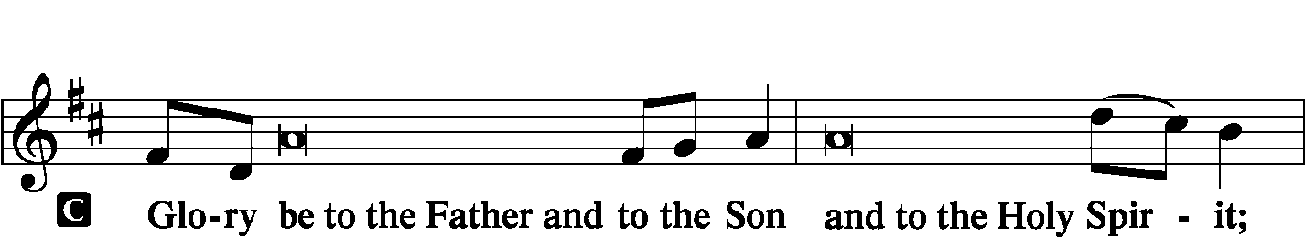
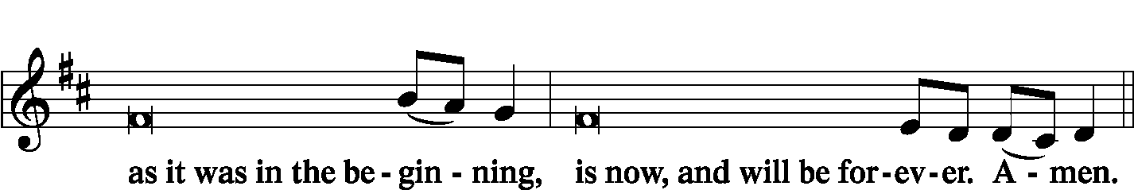
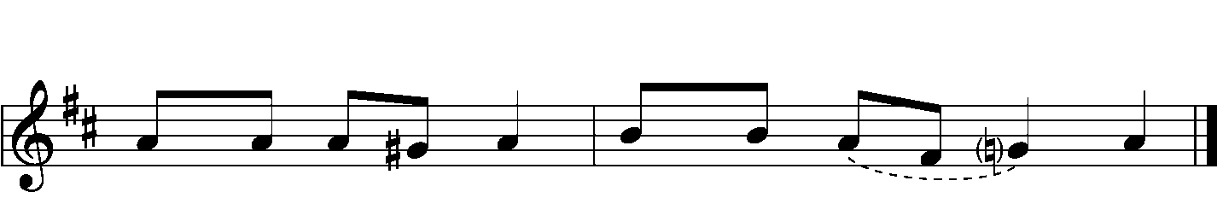

Psalmody
Antiphon (Common) LSB 220
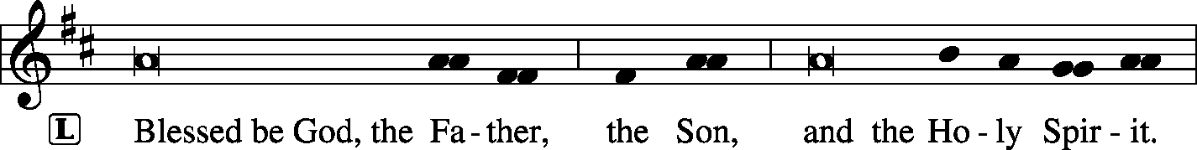

Venite LSB 220
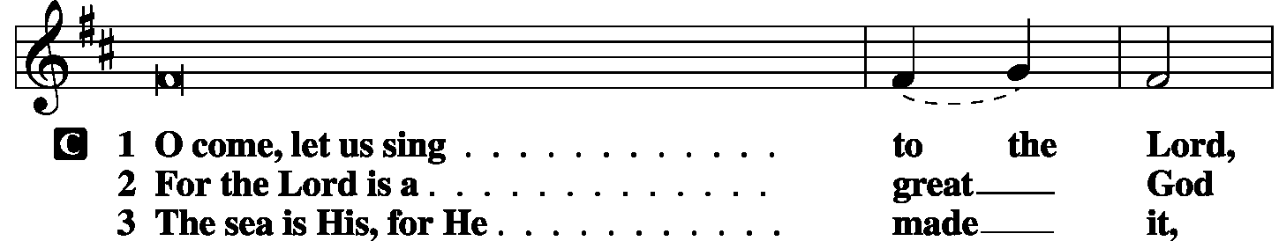
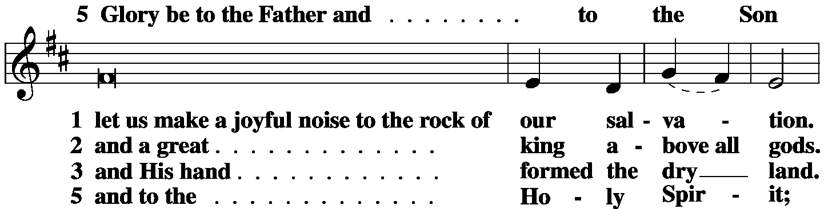
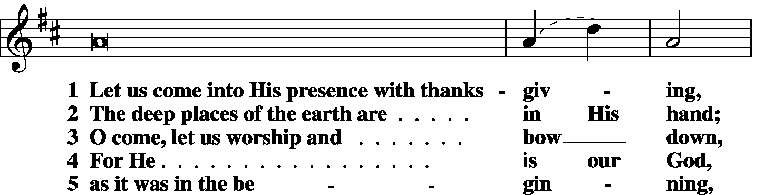
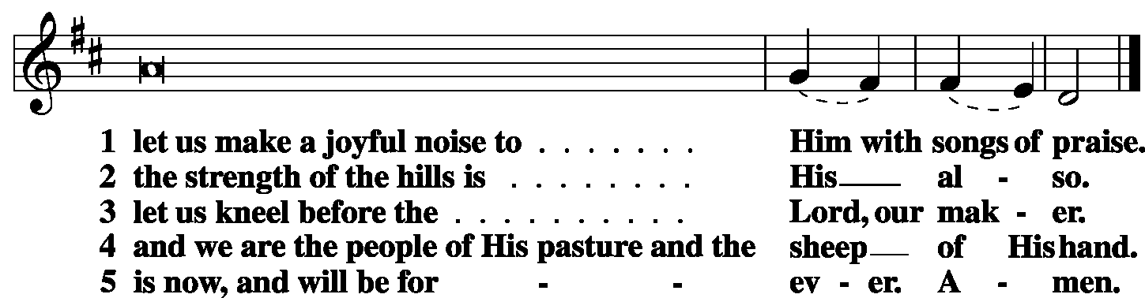

Antiphon (Common) LSB 221

Psalm Psalm 67
P May God be gracious to us and bless us
C and make His face to shine upon us,
P that Your way may be known on earth,
C Your saving power among all nations.
P Let the peoples praise You, O God;
C let all the peoples praise You!
P Let the nations be glad and sing for joy,
C for You judge the peoples with equity
P and guide the nations upon earth.
C Let the peoples praise You, O God;
P let all the peoples praise You!
C The earth has yielded its increase;
P God, our God, shall bless us.
C God shall bless us; let all the ends of the earth fear Him!
Glory be to the Father and to the Son
and to the Holy Spirit;
as it was in the beginning,
is now, and will be forever. Amen.

Sit

Hymn We Praise You, O God LSB 785

First Reading Deuteronomy 8-1-10
The whole commandment that I command you today you shall be careful to do, that you may live and multiply, and go in and possess the land that the Lord swore to give to your fathers. And you shall remember the whole way that the Lord your God has led you these forty years in the wilderness, that He might humble you, testing you to know what was in your heart, whether you would keep His commandments or not. And He humbled you and let you hunger and fed you with manna, which you did not know, nor did your fathers know, that He might make you know that man does not live by bread alone, but man lives by every word that comes from the mouth of the Lord. Your clothing did not wear out on you and your foot did not swell these forty years. Know then in your heart that, as a man disciplines his son, the Lord your God disciplines you. So you shall keep the commandments of the Lord your God by walking in His ways and by fearing Him. For the Lord your God is bringing you into a good land, a land of brooks of water, of fountains and springs, flowing out in the valleys and hills, a land of wheat and barley, of vines and fig trees and pomegranates, a land of olive trees and honey, a land in which you will eat bread without scarcity, in which you will lack nothing, a land whose stones are iron, and out of whose hills you can dig copper. And you shall eat and be full, and you shall bless the Lord your God for the good land He has given you.
P O Lord, have mercy on us.
C Thanks be to God.

Second Reading Philippians 4:6–20
Do not be anxious about anything, but in everything by prayer and supplication with thanksgiving let your requests be made known to God. And the peace of God, which surpasses all understanding, will guard your hearts and your minds in Christ Jesus. Finally, brothers, whatever is true, whatever is honorable, whatever is just, whatever is pure, whatever is lovely, whatever is commendable, if there is any excellence, if there is anything worthy of praise, think about these things. What you have learned and received and heard and seen in me—practice these things, and the God of peace will be with you. I rejoiced in the Lord greatly that now at length you have revived your concern for me. You were indeed concerned for me, but you had no opportunity. Not that I am speaking of being in need, for I have learned in whatever situation I am to be content. I know how to be brought low, and I know how to abound. In any and every circumstance, I have learned the secret of facing plenty and hunger, abundance and need. I can do all things through Him who strengthens me. Yet it was kind of you to share my trouble. And you Philippians yourselves know that in the beginning of the gospel, when I left Macedonia, no church entered into partnership with me in giving and receiving, except you only. Even in Thessalonica you sent me help for my needs once and again. Not that I seek the gift, but I seek the fruit that increases to your credit. I have received full payment, and more. I am well supplied, having received from Epaphroditus the gifts you sent, a fragrant offering, a sacrifice acceptable and pleasing to God. And my God will supply every need of yours according to His riches in glory in Christ Jesus. To our God and Father be glory forever and ever. Amen.
P O Lord, have mercy on us.
C Thanks be to God.

Choir My Heart is Filled with Thankfulness arr. Molly Ijames

Third Reading Luke 17:11–19
On the way to Jerusalem [Jesus] was passing along between Samaria and Galilee. And as He entered a village, He was met by ten lepers, who stood at a distance and lifted up their voices, saying, “Jesus, Master, have mercy on us.” When He saw them He said to them, “Go and show yourselves to the priests.” And as they went they were cleansed. Then one of them, when he saw that he was healed, turned back, praising God with a loud voice; and he fell on his face at Jesus’ feet, giving Him thanks. Now he was a Samaritan. Then Jesus answered, “Were not ten cleansed? Where are the nine? Was no one found to return and give praise to God except this foreigner?” And He said to him, “Rise and go your way; your faith has made you well.”
P O Lord, have mercy on us.
C Thanks be to God.

Common Responsory LSB 221
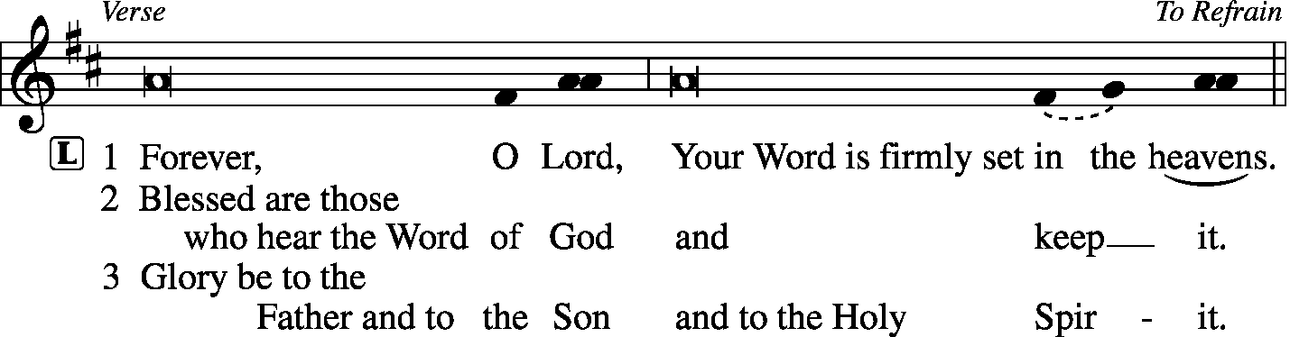
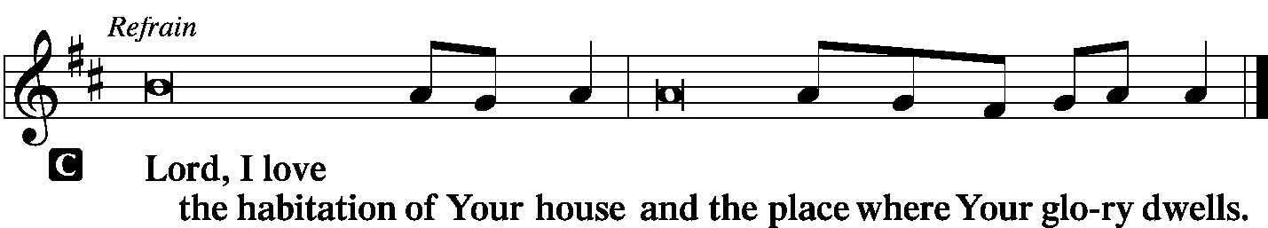

Hymn Sing to the Lord of Harvest LSB 893

Sermon Peace

Stand
Canticle
Te Deum -- We Praise You LSB 941
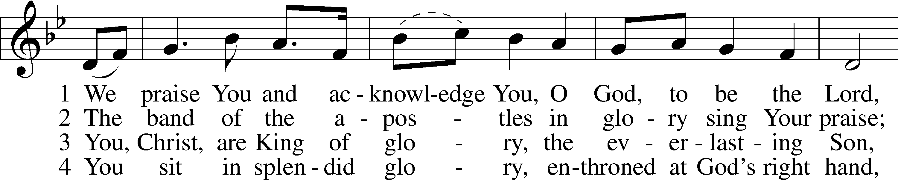
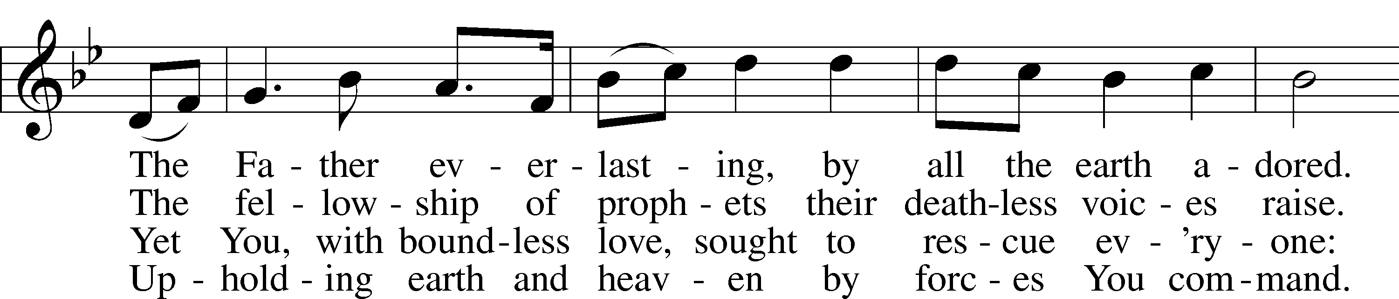
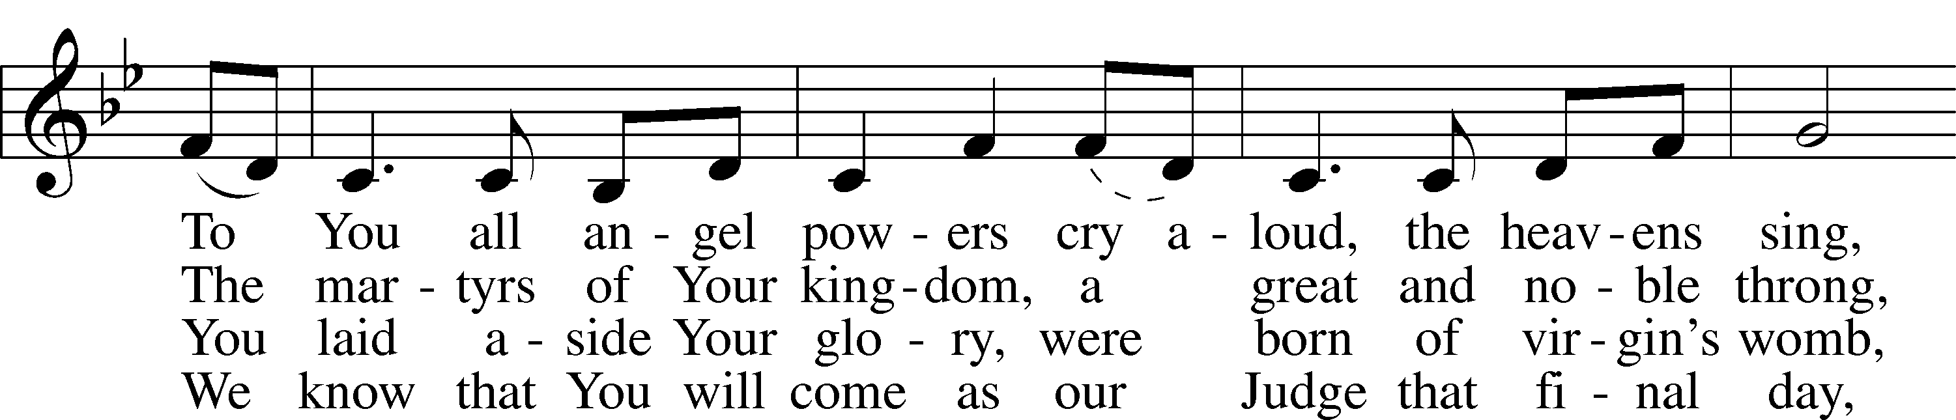
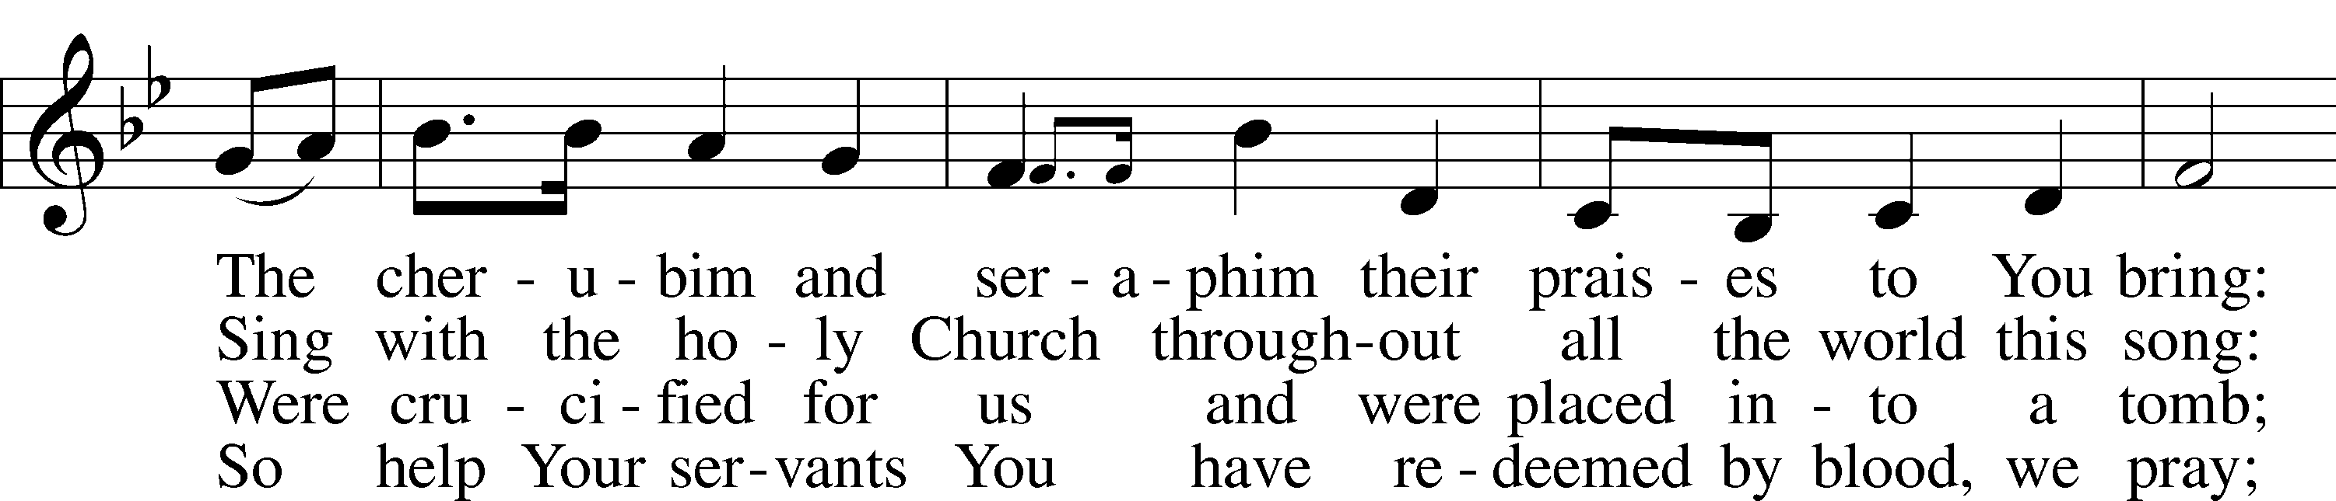
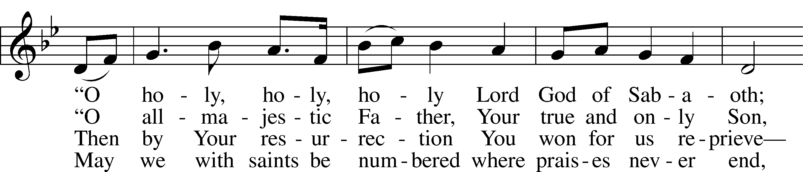
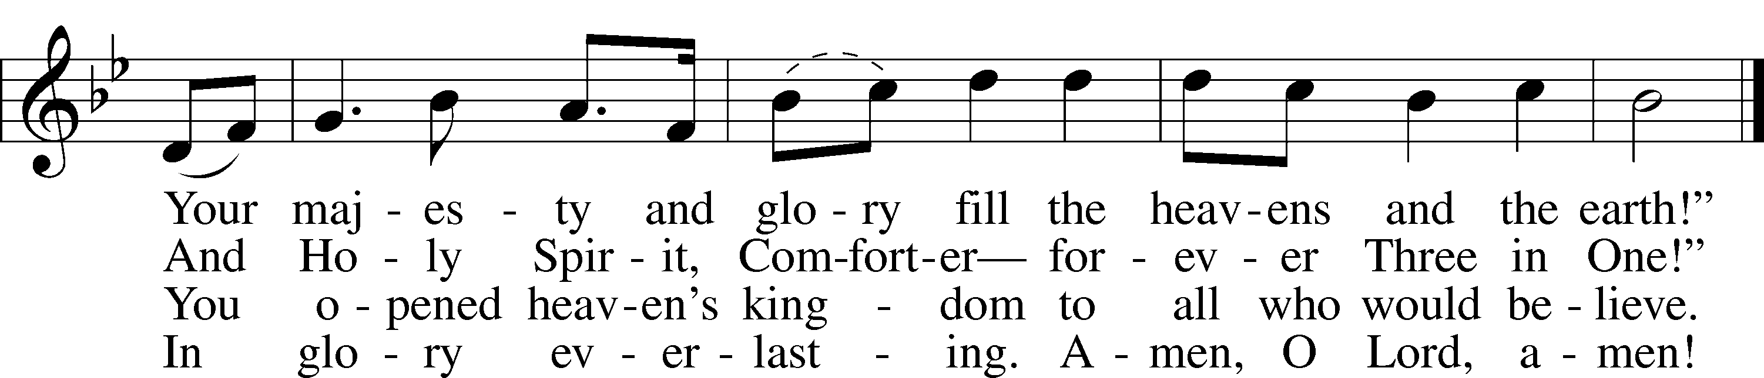
Test: © 1999 Stephen P. Starke. Used by permission: LSB Hymn License .NET, no. 100010983.
Tune: Public domain

Sit

Offering
[Please fill out a sheet in the attendance book. Visitors, please include your address. If you have a prayer request for the church prayer chain, please write it at the top of the sheet.]

Special Offering Music For the Beauty of the Earth
Prayer
Stand

Kyrie LSB 227
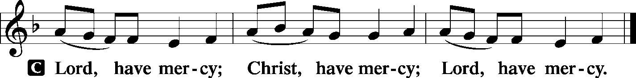

Lord's Prayer
C Our Father who art in heaven, hallowed be Thy name, Thy kingdom come, Thy will be done on earth as it is in heaven; give us this day our daily bread; and forgive us our trespasses as we forgive those who trespass against us; and lead us not into temptation, but deliver us from evil. For Thine is the kingdom and the power and the glory forever and ever. Amen.

Salutation
P The Lord be with you.
C And also with you.

Collect of the Day
Almighty God, You crown the fields with Your blessing and permit us to gather in the fruits of the earth. As stewards of Your creation, may we receive Your gifts in humble thankfulness and share Your bounty with those in need; through Jesus Christ, our Lord, who lives and reigns with You and the Holy Spirit, one God, now and forever.
C Amen.

Prayer of the Church
P Most Gracious God, who gives us so freely of Your bounty,
C we call to remembrance in glad thanksgiving Your loving kindness and tender mercies.
P For the world in which we live, for its fruitfulness and order, for its wonder, and for the life You have given us here to enjoy, we praise You, O God.
C For our home, for our families and friends, for the fellowship we share, and for the love that lifts our hearts and nurtures our spirits, we praise You, O God.
P For the common blessings of our everyday life, for food and clothing, for shelter and rest, for work and leisure, we praise You, O Lord.
C For this land we love, for our nation’s heritage of liberty, for the sacrifices of our forefathers, for all noble hopes and efforts that mankind may be one in brotherhood and peace, we thank You, Lord.
P For Your gracious gifts to our minds and spirits, for memory that links us to the past, for hope that leads us to the future, for courage in times of trouble, for patience in tribulation, for wisdom in perplexity, for faith in every moment and love at all times, we thank You, heavenly Father.
C For Yourself, O God, for Your majesty and power, for Your wisdom and goodness, for Your justice and truth, for Your Son, Your blessed Gift of love through whom we have the forgiveness of all our sins, for Your Holy Spirit, enlightening our hearts, we thank You, O God.

WE GO TO THE LORD IN PRAYER FOR
- Safety for all who travel this Thanksgiving weekend.
- Thanksgiving for the Harvest.
- Thanksgiving for all the blessings of body and soul we have received in the past year.

P So direct us in thought, word and deed that our gratitude may be reflected in how we live.
C In the name of Jesus Christ, our Savior. Amen

Collect for Grace LSB 228
P O Lord, our heavenly Father, almighty and everlasting God, You have safely brought us to the beginning of this day. Defend us in the same with Your mighty power and grant that this day we fall into no sin, neither run into any kind of danger, but that all our doings, being ordered by Your governance, may be righteous in Your sight; through Jesus Christ, Your Son, our Lord, who lives and reigns with You and the Holy Spirit, one God, now and forever.
C Amen.

Benedicamus
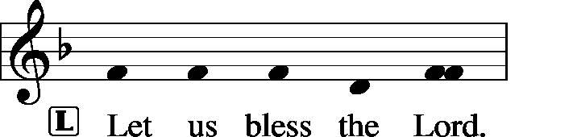
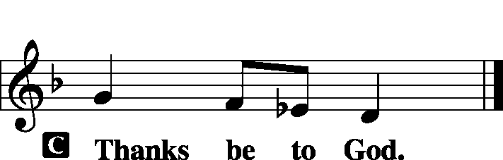

Benediction
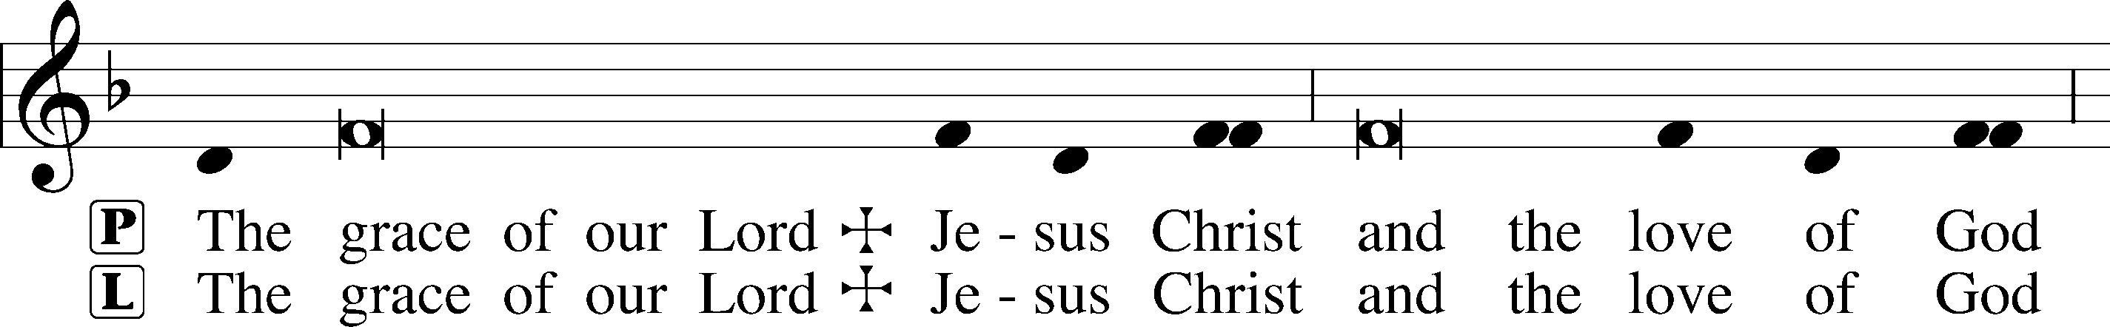
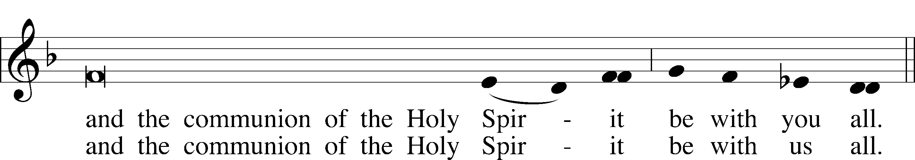

Remain standing

Hymn Now Thank We All Our God LSB 895

Acknowledgments
Unless otherwise indicated, all scripture quotations are from The Holy Bible, English Standard Version, copyright © 2001 by Crossway Bibles, a division of Good News Publishers. Used by permission. All rights reserved. Created by Lutheran Service Builder © 2006 Concordia Publishing House.

LIFE AND LIVING ITEMS AT ZION
          

ADVENT DEVOTIONS – NOW AVAILABLE
Advent devotions are now available on the table in the narthex.

DECEMBER ECHO – NOW AVAILABLE
The December Echo is now available. Pick one up in the narthex today!

ADVENT AND CHRISTMAS SCHEDULE
December is a busy month, but our focus should be preparing for the joyful news of our Savior's birth and preparing to meet Him when He comes again in glory. Among all the other December activities, make sure that worship and church activities are central. All of us need to make choices as to how we will spend our time. What will your choices be? Will they reflect what is truly most important and of eternal significance? Or will your choices indicate a priority of the temporary over the eternal? Choose how you spend your time wisely. We look forward to seeing you at Zion at every opportunity!

ADVENT MIDWEEK SERVICES
Advent Midweek Services will be held on Wednesday evenings in December. Advent Services will be December 4th, 11th, and 18th at 7:00 PM. These services are a blessed way to step back from the hectic rush of December and focus on what is truly most important about Christmas--the birth of our Lord Jesus Christ. Don't let secular scheduling pressures keep you out of worship in God's house!

CHURCH CHRISTMAS DECORATING – VOLUNTEERS NEEDED!
We will be decorating the church on Saturday, December 7th at 10:00 AM. If you would like to help, please join us! Any and all help is welcomed.

LINUS BLANKETS ON DISPLAY SUNDAY
The Ladies Aid made blankets this past summer for the Linus Blankets of Southwestern Illinois, Belleville. Since 1997, more than 63,000 have been delivered across the bi-state area to children’s hospitals and crisis centers to be handed out to children who are seriously ill, traumatized, or otherwise in need of some comfort. We have made at least 30 blankets in sizes ranging from those for preemies to teens. They will be delivered this week.

CHRISTMAS CAROLERS NEEDED!
Would you like to bring the sounds of the season to those who need to hear the joyous message of God's love to them in the Christ Child? Would you like to enjoy the fellowship and fun of a potluck with brothers and sisters in Christ? If so, please join us as we meet at church at 4:30 p.m. on Sunday, Dec 8. After we have made the rounds of caroling, we will return to the school for fellowship and a potluck supper.
Please bring a dish from the below list according to your last name:

A-J Salad/Vegetable K-Q Dessert R-Z Main Dish

WHAT: Christmas Caroling and Potluck
WHEN: Sunday, Dec 8 at 4:30 p.m.
WHERE: Meet in the church kitchen to carpool to caroling sites

SECRET PAL PROGRAM
Ladies, would you like to have a Secret Pal at Zion? Have you noticed gifts mysteriously appearing at church? Zion's Ladies Aid/LWML members have had secret pals for the past years and have enjoyed it so much, this program is offered to any member of Zion who wishes to participate. You will receive a slip of paper on which to write your name, favorites, etc. from Glenda Pike. You are to pray for this person and can send cards or leave cards or small gifts at church during the year. See Glenda by Dec 8 to get details and sign up. Sh-h-h, don't tell anyone!

THOSE WHO SERVE TODAY
Proclaimer: Rev. Kirk Clayton
Organist: Nancy Peterson
Ushers: Lionel Timmerman, Alex Tubbs, Mike Twenhafel,
Terry Twenhafel
Sound Tech: Jake Simon
Video Tech: Mark Hatcher
Welcome Team: Doug & Amber Sax
Acolytes: Phoebe Corey & Abigail Clayton

THOSE WHO SERVE SUNDAY, DECEMBER 1
Proclaimer: Rev. Kirk Clayton
Organist: Nancy Peterson
Ushers: Bob Walter, Dale Wehmeyer, Eldon Ahner,
& Ted Ahner
Sound Tech: Lionel Timmerman
Video Tech: Mark Hatcher
Welcome Team: Tom & Cheryl Sax
Acolytes: William Bretz & Rainer Bretz

THINGS WE ARE DOING AT ZION
Thurs. Day of Thanksgiving Worship Matins 9:00 AM
Fri. Office Closed
Sun. Children’s Christmas Program Practice 8:45 AM
SS & Bible Class 8:45 AM
Worship DS I w/communion 10:00 AM

