Zion Lutheran Church
Mascoutah, Illinois
September 1, 2019
11th Sunday after Trinity

In the Name of Christ Jesus our Lord, we bid you a warm welcome to this worship service. May your experience of worship and fellowship this morning be spiritually refreshing and ready you for the week ahead.

Pastor: Rev. Kirk Clayton
Church Secretary: Robin Phillips
Choir Director Team: Josh and Nancy Peterson
_________________________________________________________________________________
Church Office Phone: 618-566-7345
Pastor Clayton Cell: 618-447-1306
Office Hours: 8:00 am to 12:00 pm
Email: ChurchOffice@ZionMascoutah.org
Pastor Clayton email: Pastor@ZionMascoutah.org
Web site: www.ZionMascoutah.org
Find us at @ZionMascoutah on Facebook, Twitter, and Instagram
Electronic Devices
Please TURN OFF all cell phones, pagers, electronic devices, apps and games when entering the sanctuary for worship so those around you may focus on the Word of God without electronic distraction. Thank you.

A Prayer to Begin Worship
Holy Spirit, whose working place in the plan of the Godhead is faith and life, purify our motives for living after the example of Christ in order that our lives properly honor Christ and glorify the Father; who together are one God with dominion over us forever.

DIVINE SERVICE II
LSB p. 167
Confession and Absolution

Prelude Rock of Ages arr. Ashdown

Hymn Great Is Thy Faithfulness LSB 809

Stand

The sign of the cross may be made by all in remembrance of their Baptism.
Holy Baptism
(Due to the fact that this is a worship service, held in God’s House, conducted before His Altar, we respectfully request that no flash photographs be taken during the Baptism. Thank you for respecting the reverence of worship.)
Stand p268
P | In the name of the Father and of the T Son and of the Holy Spirit.
C | Amen.
P | Dearly beloved, Christ our Lord says in the last chapter of Matthew, "All authority in heaven and on earth has been given to Me. Therefore go and make disciples of all nations, baptizing them in the name of the Father and of the Son and of the Holy Spirit." In the last chapter of Mark our Lord promises, "Whoever believes and is baptized will be saved." And the apostle Peter has written, "Baptism now saves you."  The Word of God also teaches that we are all conceived and born sinful and are under the power of the devil until Christ claims us as His own. We would be lost forever unless delivered from sin, death, and everlasting condemnation. But the Father of all mercy and grace has sent His Son Jesus Christ, who atoned for the sin of the whole world, that whoever believes in Him should not perish but have eternal life.

The pastor addresses the candidate:
P | How are you named?
R | Amy Lin

The pastor makes the sign of the holy cross upon the forehead and heart of the candidate while saying:
P | Amy Lin, receive the sign of the holy cross both upon your T forehead and upon your T heart to mark you as one redeemed by Christ the crucified.
P | Let us pray.  Almighty and eternal God, according to Your strict judgment You condemned the unbelieving world through the flood, yet according to Your great mercy You preserved believing Noah and his family, eight souls in all. You drowned hard-hearted Pharaoh and all his host in the Red Sea, yet led Your people Israel through the water on dry ground, foreshadowing this washing of Your Holy Baptism. Through the Baptism in the Jordan of Your beloved Son, our Lord Jesus Christ, You sanctified and instituted all waters to be a blessed flood and a lavish washing away of sin.  We pray that You would behold Amy Lin, according to Your boundless mercy and bless her with true faith by the Holy Spirit, that through this saving flood all sin in her which has been inherited from Adam and which she has committed since, would be drowned and die. Grant that she be kept safe and secure in the holy ark of the Christian Church, being separated from the multitude of unbelievers and serving Your name at all times with a fervent spirit and a joyful hope, so that, with all believers in Your promise, she would be declared worthy of eternal life; through Jesus Christ, our Lord.
C | Amen.
P | From ancient times the Church has observed the custom of appointing sponsors for baptismal candidates and catechumens. In the Evangelical Lutheran Church sponsors are to confess the faith expressed in the Apostles' Creed and taught in the Small Catechism. They are, whenever possible, to witness the Baptism of those they sponsor. They are to pray for them, support them in their ongoing instruction and nurture in the Christian faith, and encourage them toward the faithful reception of the Lord's Supper. They are at all times to be examples to them of the holy life of faith in Christ and love for the neighbor.
The pastor addresses the sponsors.
P | Is it your intention to serve Amy Lin, as sponsors in the Christian faith?
R | Yes, with the help of God.
P | God enable you to will and to do this faithful and loving work and with His grace fulfill what we are unable to do.
C | Amen.
P | Hear the Holy Gospel according to St. Mark.  They brought young children to Jesus that He might touch them; but the disciples rebuked those who brought them. But when Jesus saw it, He was greatly displeased and said to them, "Let the little children come to Me, and do not forbid them; for of such is the kingdom of God. Assuredly, I say to you, whoever does not receive the kingdom of God as a little child will by no means enter it." And He took them up in His arms, put His hands on them, and blessed them.
P | This is the Word of the Lord.
C | Thanks be to God.

The pastor places his hands on the head of the candidate, and the congregation joins in praying:
C | Our Father who art in heaven,  hallowed be Thy name,  Thy kingdom come,  Thy will be done on earth  as it is in heaven;  give us this day our daily bread;  and forgive us our trespasses  as we forgive those  who trespass against us;  and lead us not into temptation,  but deliver us from evil.  For Thine is the kingdom  and the power and the glory  forever and ever. Amen.
P | The Lord preserve your coming in and your going out from this time forth and even T forevermore.
C | Amen.

Sit
The pastor addresses the candidate(s) and asks the following questions:
P | Amy Lin, do you renounce the devil?
R | Yes, I renounce him.
P | Do you renounce all his works?
R | Yes, I renounce them.
P | Do you renounce all his ways?
R | Yes, I renounce them.
P | Do you believe in God, the Father Almighty, maker of heaven and earth?
R | Yes, I believe.
P | Do you believe in Jesus Christ, His only Son, our Lord, who was conceived by the Holy Spirit, born of the virgin Mary, suffered under Pontius Pilate, was crucified, died and was buried; He descended into hell; the third day He rose again from the dead; He ascended into heaven and sits at the right hand of God the Father Almighty; from thence He will come to judge the living and the dead?
R | Yes, I believe.
P | Do you believe in the Holy Spirit, the holy Christian Church, the communion of saints, the forgiveness of sins, the resurrection of the body, and the life everlasting?
R | Yes, I believe.
P | Amy Lin, do you desire to be baptized?
R | Yes, I do.

The pastor pours water three times on the head of the candidate while saying:
P | Amy Lin, I baptize you in the name of the Father and of the Son and of the Holy Spirit.
C | Amen.

The pastor places his hands on the head of the newly baptized while saying:
P | The almighty God and Father of our Lord Jesus Christ, who has given you the new birth of water and of the Spirit and has forgiven you all your sins, strengthen you with His grace to life T everlasting.
C | Amen.

The pastor may place a white garment on the newly baptized while saying:
P | Receive this white garment to show that you have been clothed with the robe of Christ's righteousness that covers all your sin. So shall you stand without fear before the judgment seat of Christ to receive the inheritance prepared for you before the foundation of the world.
The pastor may light a baptismal candle from the paschal candle and give it to the newly baptized while saying:
P | Receive this burning light to show that you have received Christ who is the Light of the world. Live always in the light of Christ, and be ever watchful for His coming, that you may meet Him with joy and enter with Him into the marriage feast of the Lamb in His kingdom, which shall have no end.
P | In Holy Baptism God the Father has made you a member of His Son, our Lord Jesus Christ, and an heir with us of all the treasures of heaven in the one holy Christian and apostolic Church. We receive you in Jesus' name as our sister in Christ, that together we might hear His Word, receive His gifts, and proclaim the praises of Him who called out us of darkness into His marvelous light.
C | Amen. We welcome you in the name of the Lord.

Stand
P | Let us pray.  Almighty and most merciful God and Father, we thank and praise You that You graciously preserve and enlarge Your family and have granted Amy Lin, the new birth in Holy Baptism and made her a member of Your Son, our Lord Jesus Christ, and an heir of Your heavenly kingdom. We humbly implore You that, as she has now become Your child, You would keep her in her baptismal grace, that according to Your good pleasure she may faithfully grow to lead a godly life to the praise and honor of Your holy name and finally, with all Your saints, obtain the promised inheritance in heaven; through Jesus Christ, our Lord.
C | Amen.
P | Peace T be with you.
C | Amen.
Service of the Word
Introit Ps. 68:1, 3, 7a, 10b, 19; antiphon: Ps. 68:5b, 6a, 35b
L God is in His holy habitation;
C [He] settles the solitary in a home.
L The God of Israel—He is the one
C who gives power and strength to His people.
L God shall arise, His enemies shall be scattered;
C and those who hate Him shall flee before Him!
L But the righteous shall be glad; they shall exult before God;
C they shall be jubilant with joy!
L O God, when You went out before Your people,
C in Your goodness, O God, You provided for the needy.
L Blessèd be the Lord, who daily bears us up;
C God is our salvation.
Glory be to the Father and to the Son
and to the Holy Spirit;
as it was in the beginning,
is now, and will be forever. Amen.
L God is in His holy habitation;
C [He] settles the solitary in a home.
L The God of Israel—He is the one
C who gives power and strength to His people.

Kyrie LSB 168
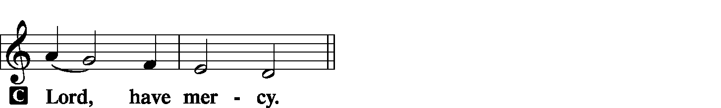

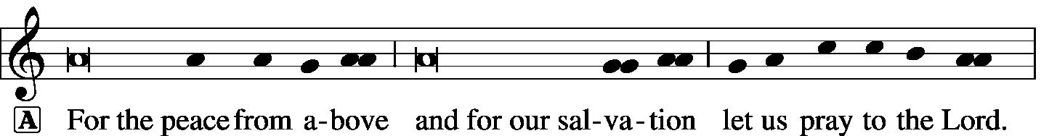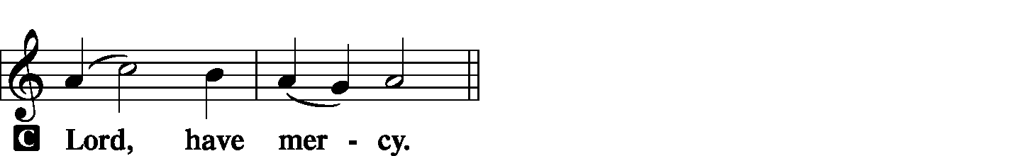

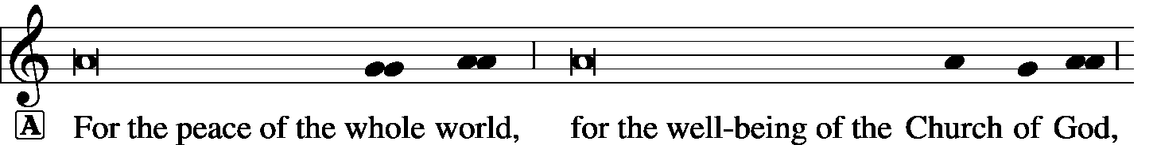

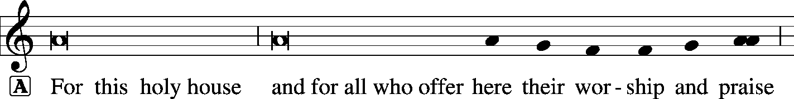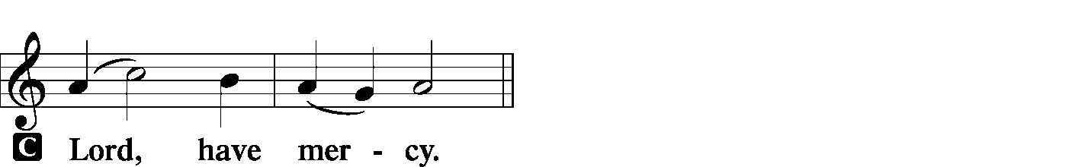

Hymn of Praise -- This is the Feast LSB 171
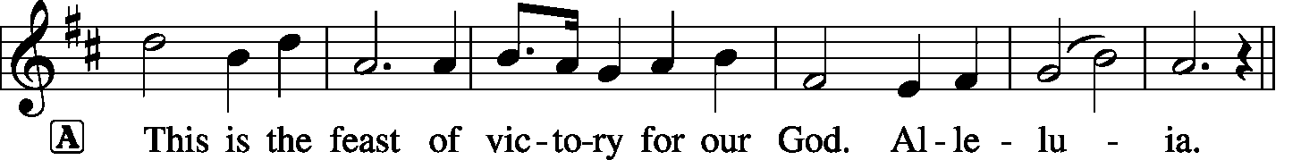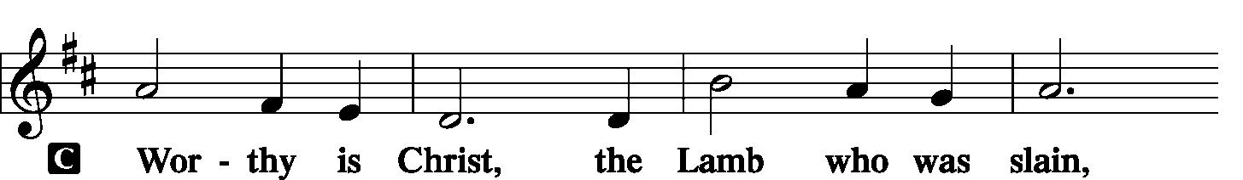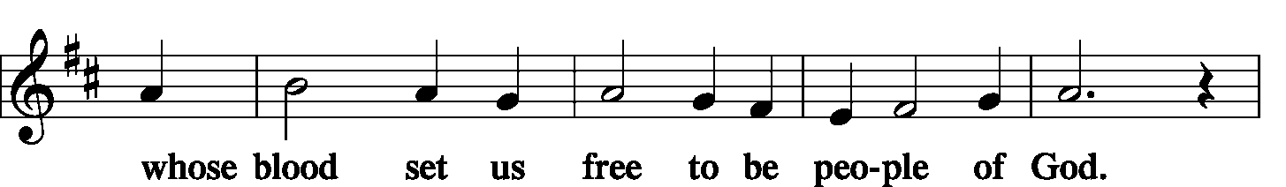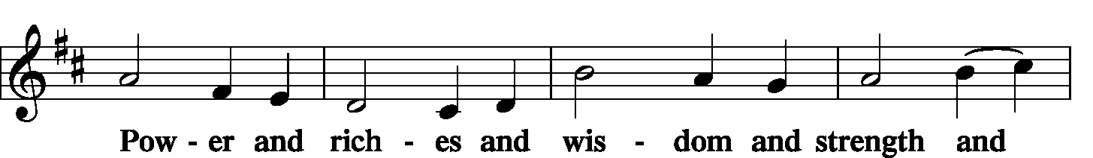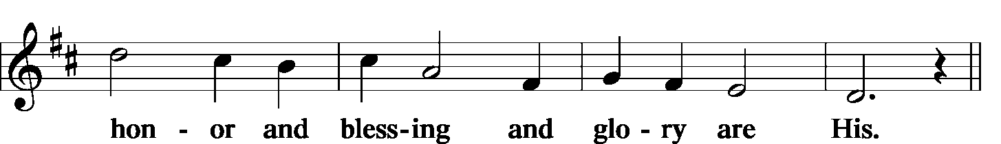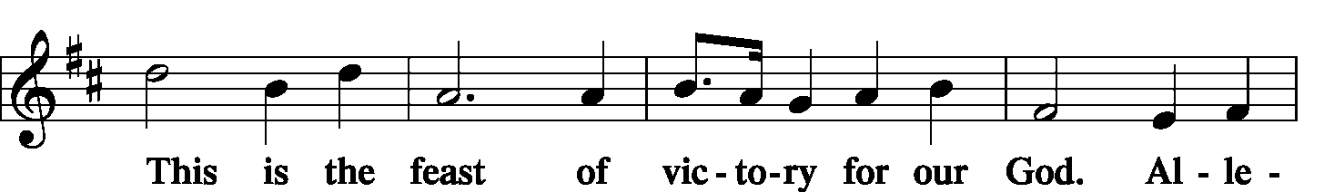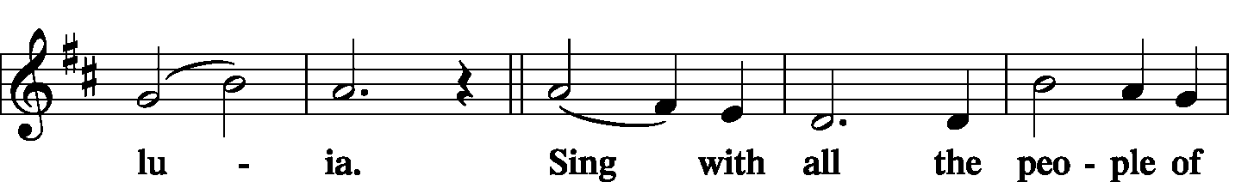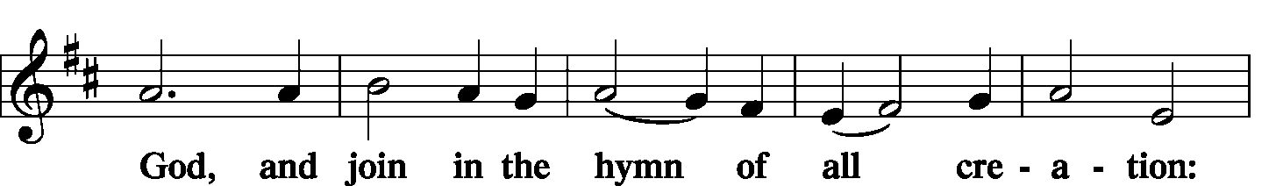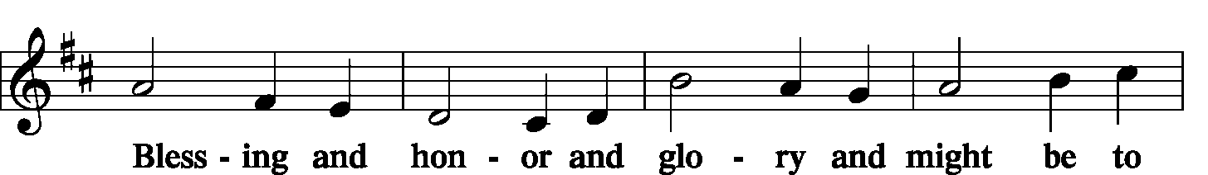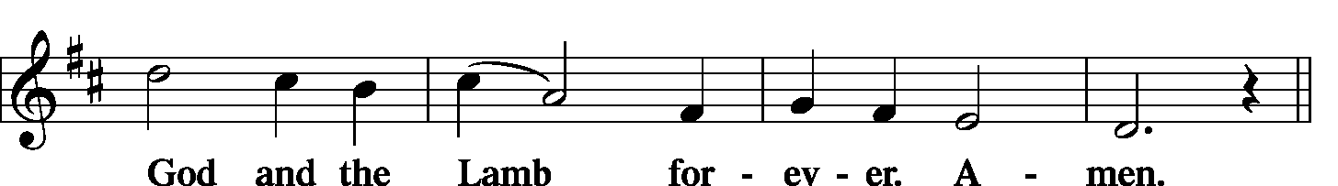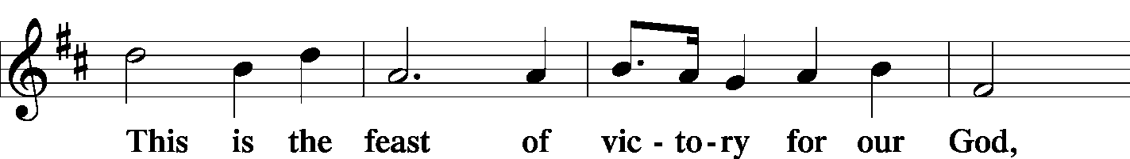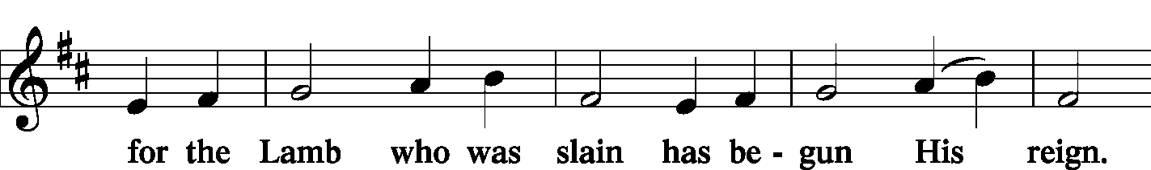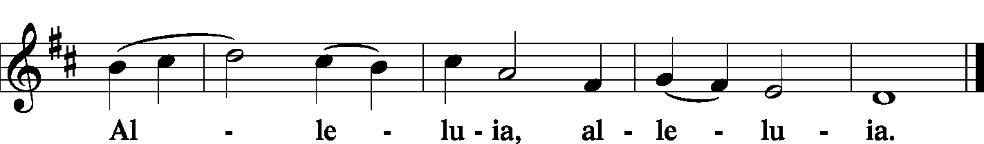
Salutation and Collect of the Day
L The Lord be with you.
C And also with you.
L Let us pray.
Almighty and everlasting God, always more ready to hear than we to pray and to give more than we either desire or deserve, pour down upon us the abundance of Your mercy, forgiving those things of which our conscience is afraid and giving us those good things that we are not worthy to ask, except through the merits and mediation of Christ, our Lord, who lives and reigns with You and the Holy Spirit, one God, now and forever.
C Amen.

Sit

Hymn Take My Life and Let It Be LSB 783

Old Testament Reading Genesis 4:1-15
Now Adam knew Eve his wife, and she conceived and bore Cain, saying, “I have gotten a man with the help of the Lord.” And again, she bore his brother Abel. Now Abel was a keeper of sheep, and Cain a worker of the ground. In the course of time Cain brought to the Lord an offering of the fruit of the ground, and Abel also brought of the firstborn of his flock and of their fat portions. And the Lord had regard for Abel and his offering, but for Cain and his offering He had no regard. So Cain was very angry, and his face fell. The Lord said to Cain, “Why are you angry, and why has your face fallen? If you do well, will you not be accepted? And if you do not do well, sin is crouching at the door. Its desire is for you, but you must rule over it.”
Cain spoke to Abel his brother. And when they were in the field, Cain rose up against his brother Abel and killed him. Then the Lord said to Cain, “Where is Abel your brother?” He said, “I do not know; am I my brother’s keeper?” And the Lord said, “What have you done? The voice of your brother’s blood is crying to Me from the ground. And now you are cursed from the ground, which has opened its mouth to receive your brother’s blood from your hand. When you work the ground, it shall no longer yield to you its strength. You shall be a fugitive and a wanderer on the earth.” Cain said to the Lord, “My punishment is greater than I can bear. Behold, You have driven me today away from the ground, and from Your face I shall be hidden. I shall be a fugitive and a wanderer on the earth, and whoever finds me will kill me.” Then the Lord said to him, “Not so! If anyone kills Cain, vengeance shall be taken on him sevenfold.” And the Lord put a mark on Cain, lest any who found him should attack him.
L This is the Word of the Lord.
C Thanks be to God.

Choir Blessed Assurance, Jesus Is Mine Cindy Berry

Epistle Ephesians 2:1–10
And you were dead in the trespasses and sins in which you once walked, following the course of this world, following the prince of the power of the air, the spirit that is now at work in the sons of disobedience—among whom we all once lived in the passions of our flesh, carrying out the desires of the body and the mind, and were by nature children of wrath, like the rest of mankind. But God, being rich in mercy, because of the great love with which He loved us, even when we were dead in our trespasses, made us alive together with Christ—by grace you have been saved—and raised us up with Him and seated us with Him in the heavenly places in Christ Jesus, so that in the coming ages He might show the immeasurable riches of His grace in kindness toward us in Christ Jesus. For by grace you have been saved through faith. And this is not your own doing; it is the gift of God, not a result of works, so that no one may boast. For we are His workmanship, created in Christ Jesus for good works, which God prepared beforehand, that we should walk in them.
L This is the Word of the Lord.
C Thanks be to God.

Stand

Alleluia and Verse
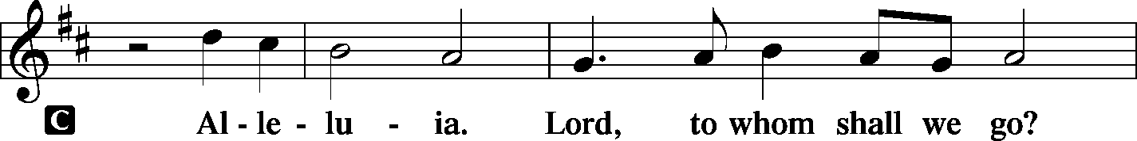
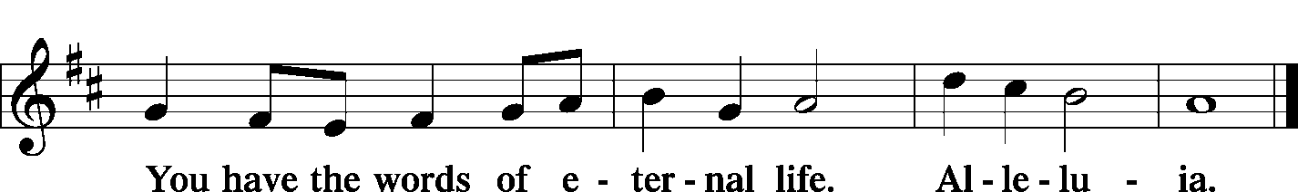

Holy Gospel Luke 18:9–14
L The Holy Gospel according to St. Luke, the 18th chapter.
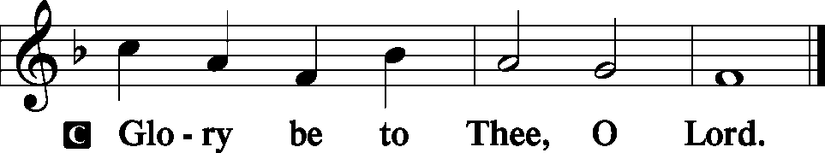
[Jesus] also told this parable to some who trusted in themselves that they were righteous, and treated others with contempt: “Two men went up into the temple to pray, one a Pharisee and the other a tax collector.
The Pharisee, standing by himself, prayed thus: ‘God, I thank You that I am not like other men, extortioners, unjust, adulterers, or even like this tax collector. I fast twice a week; I give tithes of all that I get.’ But the tax collector, standing far off, would not even lift up his eyes to heaven, but beat his breast, saying, ‘God, be merciful to me, a sinner!’ I tell you, this man went down to his house justified, rather than the other. For everyone who exalts himself will be humbled, but the one who humbles himself will be exalted.”
L This is the Gospel of the Lord.
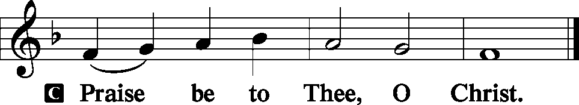

Sit

Children's Lunchbox Devotion

Hymn I Am Trusting Thee, Lord Jesus LSB 729

Sermon

Offering
[Please fill out a sheet in the attendance book. Visitors, please include your address. If you have a prayer request for the church prayer chain, please write it at the top of the sheet.]

Stand

Offertory LSB 176
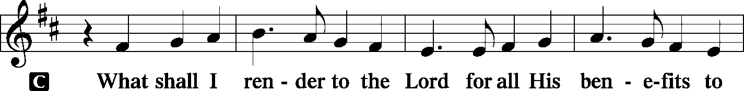
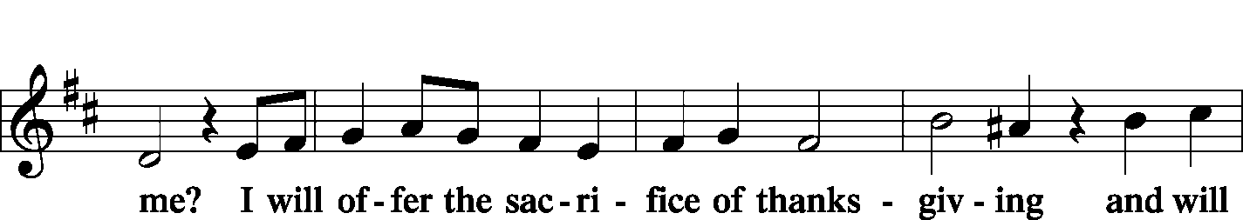
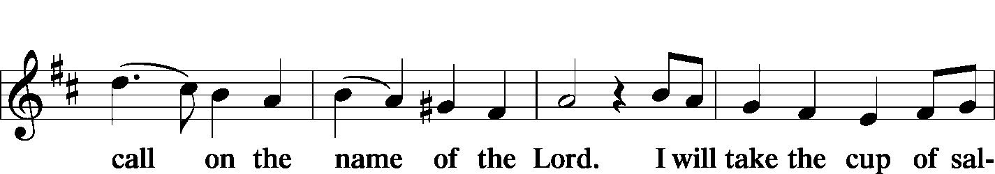
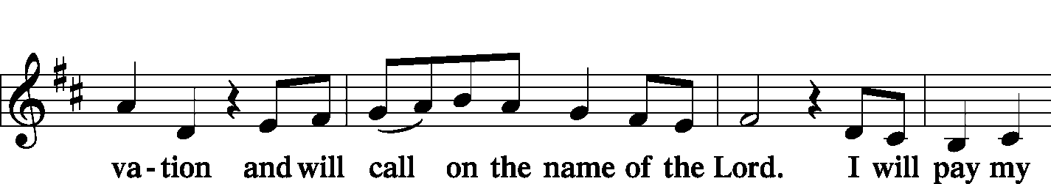
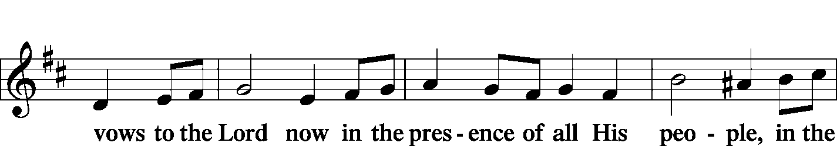
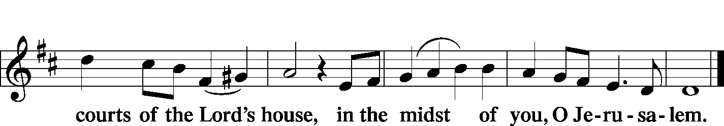

Prayer of the Church
P We praise You, O Lord; we exalt Your most holy name.
C In the midst of trouble we praise You for Your goodness.
P Though our lot on earth may not always be easy and pleasant, Your mercies have been our strength and stay.
C To know that You have chosen us to be Your own is all we need to know to make life worth living.
P We confess that we are not worthy of all Your blessings.
C We have exalted ourselves when we should have been humble.
P We have thought highly of ourselves while despising others.
C We have not always served You nor walked in Your ways.
P We have not loved You with all of our hearts, souls, and minds.
C We have weakened in the good fight of faith.
P We have been discouraged, forgetting that Your power is ours for the asking.
C We have overlooked many opportunities to spread Your Gospel.
P We have been proud of our goodness when we should have proclaimed Your justice and mercy.
C For these, our many sins, we beg Your forgiveness.
P May Your Holy Spirit strengthen our faith.
C Give us a spirit of true humility to recognize the merits of others.
P Help us to be concerned about the spiritual and physical wellbeing of all who dwell on the face of the earth.
C Bless the witness of our words and lives on the hearts of those who do not know You.

WE GO TO THE LORD IN PRAYER FOR
- Christa Sink, Parker Roehrig, Dawn Corey, and David Rowold, as they celebrate their baptismal anniversaries this week.
- Amy Lin, as she is baptized today.
- Roger Drinnon, as he begins a new round of radiation.
- The family of Justin Schulte, as they mourn his sudden and unexpected death.
- Ben Campbell, as he has been hospitalized for severe abdominal pains.
- Mary Boeker, mother of Angie Twenhafel, as she has major surgery on Tuesday at Barnes.
- Zion’s Elders, Board of Education, Sunday School staff, and Evangelism Committee.
- Faithfulness in our lives as Christian Stewards.

P When we have finished the race, grant us the crown of righteousness earned by our Lord and Savior Jesus Christ.
C We pray in His name. Amen.

Lord's Prayer LSB 179
P Lord, remember us in Your kingdom and teach us to pray:
C Our Father who art in heaven, hallowed be Thy name, Thy kingdom come, Thy will be done on earth as it is in heaven; give us this day our daily bread; and forgive us our trespasses as we forgive those who trespass against us; and lead us not into temptation, but deliver us from evil. For Thine is the kingdom and the power and the glory forever and ever. Amen.

Collect
P Blessed Lord, since You have caused all Holy Scriptures to be written for our learning,
C Grant that we may so hear them, read, mark, learn and take them to heart that by patience and comfort of Your holy Word we may embrace and ever hold fast the blessed hope of everlasting life;
P Through Jesus Christ, Your Son, our Lord, who lives and reigns with You and the Holy Spirit, one God, now and forever.
C Amen.

Benediction LSB 183
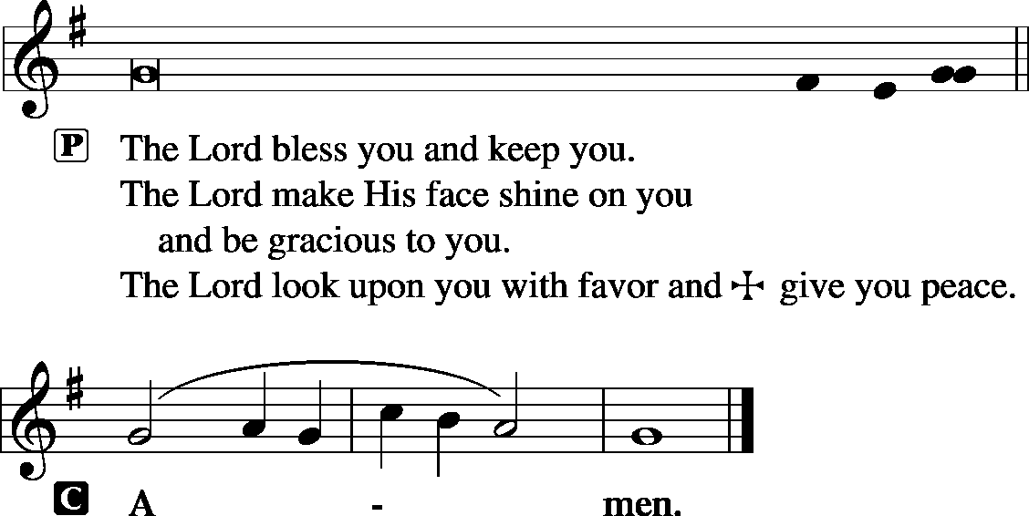

Sit

Hymn Rock of Ages, Cleft for Me LSB 761

Postlude Great is Thy Faithfulness arr. Hustad

Acknowledgments
Unless otherwise indicated, all scripture quotations are from The Holy Bible, English Standard Version, copyright © 2001 by Crossway Bibles, a division of Good News Publishers. Used by permission. All rights reserved. Created by Lutheran Service Builder © 2006 Concordia Publishing House.
LIFE AND LIVING ITEMS AT ZION
          

THE FLOWERS ON THE LORD’S ALTAR
The flowers on the Lord’s altar are given to the glory of God by Mike and Lisa Segelhorst in honor of their wedding anniversary and by Helen Sauerhage in memory of Chuck.

WE WELCOME AMY LIN
Congratulations to Amy Lin on her rebirth in Baptism. Amy’s sponsors are Jeff and Bessie Fick and Pastor Jim Barton, all of whom are longtime friends and mentors on the Christian faith for Amy. Welcome, Amy!

SEPTEMBER ECHO – NOW AVAILABLE
The September Echo is now available in the Narthex. Pick one up today!

CLOTHING IN THE COAT ROOM
If you have any information about the girls' clothing in the coat room, please contact Lori Clayton. If I don't hear from you in two weeks, I will donate to the items. Thank you.

ZION’S FINAL GOLF SCRAMBLE A SUCCESS!
The 21st annual, and last, Zion Golf Scramble was held last Sunday and despite a constant rain for the first 9 plus holes, it was another success. Every team finished even though we all looked like drowned rats. Thanks to everyone who helped make the tournament a success including the golfers, hole sponsors, business contributors, volunteers, Thrivent Financial, and Roland Barkau Memorial Golf Course. We raised approximately $3,500 which will be split between the Leu Civic Center and Zion. This tournament was originally started by Norman Rowold and Bob Twenhafel when we started planning to build a new church. Proceeds were used to help defray building expenses. As the mortgage went down, the committee began to focus on outreach in the community and starting splitting the profits with various organizations, programs, etc. Thank you to everyone for all of your support over the years. It was a great run but now it’s time to move on.

LIFELIGHT BIBLE STUDY RESUMES NEXT WEEK
We will resume LifeLight, a 9-week adult in-depth Bible study consisting of daily individual home study and weekly group discussion on September 9th. Join us in the church conference room at 7 PM on Monday evenings as we study Job—and discover how we can apply the lessons to our lives. Call or text Lionel at 618-806-8993 to join.

FRIENDSHIP/SOCIAL SUNDAY – SEPTEMBER 15th
Make plans now for Friendship Sunday on September 15th. The service will be held inside here at Zion. This service is an opportunity for you to invite friends and guests to attend church with you this day. A meal will be served following the service in the gym. Elders will be providing hamburgers and hot dogs (also buns and condiments). We are asking those with last name A-K to bring a dessert and L-Z to bring a side dish. Following lunch we (all ages) will be playing kick ball, corn hole/bean bag, and other games at Maple Park (just south, across the street from church). Following the games, we will have ice cream at the park at 1:30 PM. We look forward to seeing you and your friends/guests there!

MEMBER NEEDS FUND ENVELOPES
Zion's Elders maintain and administer a fund to help members of the congregation who are facing financial difficulties. "Member Needs Fund" envelopes are available in the pews, they are the small manila envelopes in the holders next to the hymnal racks. If you would like to make a donation to the Member Needs Fund, place your donation in the marked small manila envelope and place it in the collection plate. The Finance Board will pass the donation along to the Elders, and if the donor is identified, the Elders will give a letter for tax deduction purposes. Thank you for your support of this ministry of the congregation.

SID-LCMS OFFICER CHANGES
At the LCMS Synodical Convention in July, Rev. Ben Ball from Hamel, IL was elected to serve as a Synodical Vice President. He had been elected as a SID Vice President at our last District convention, with Pastor Clayton receiving the next highest votes after Pastor Ball. With Pastor Ball now beginning his term as Synodical Vice President, Pastor Clayton will take Pastor Ball's place as District Vice President. This change takes effect Sept. 1, 2019. Pastor Clayton will now fill out the remaining term of the SID-LCMS Vice President, until the next District Convention in 2021.

HARVEST TABLE
It’s harvest time again! Check the harvest table in the Narthex. Bring an extra vegetable or fruit from your garden, you can trade for another or buy the item with a donation to Concerned Christians.

ZION OFFERING FINANCIAL PEACE UNIVERSITY STARTING SEPT. 12th
Planning for the future is hard when you’re still paying for the past! Listen—there’s a better way! Join our Financial Peace University group, and we’ll learn how to beat debt and make a plan for the future...together! Interested? Join Joe Bloomquist at Zion Lutheran Church starting September 12th as he leads a 9-week session of Financial Peace University from Dave Ramsey. Zion has pre-ordered course kits that will be available for purchase. Feel free to message Joe about any questions you might have at 618-954-9462.

ZION LUTHERAN, LITCHFIELD HIRING PRE-K TEACHER
Zion Lutheran School in Litchfield is now taking applications for a Pre-K teaching position. We are currently searching for a full-time Pre-K teacher for the 2019-2020 school year. Questions and/or applications may be directed to John Schaff, principal, at jschaff@zionlutheranlitchfield.com or Zion Lutheran School, 1301 N. State St., Litchfield, IL 62056. Deadline for applications is September 11, 2019.

MASCOUTAH COMMUNITY BLOOD DRIVE
The American Red Cross is holding a blood drive at Holy Childhood Parish Center on Thursday, September 5th, from 2-7 PM. Please call 1-800-733-2767 or visit RedCrossBlood.org and enter: HolyChildhood to schedule an appointment.

YOU ARE INVITED TO AN INSTALLATION SERVICE
Please join us for a Service of Installation for President Rev. Dr. Matthew C. Harrison, the vice-presidents, other officers, and board and commission members of The Lutheran Church—Missouri Synod and other Synodwide entities. The service will be Friday, Sept. 13th beginning at 7 PM in the Chapel of St. Timothy and St. Titus, Concordia Seminary, St. Louis. Our worship will follow the prayer office of Vespers. This event is open to the public. A brief reception in Koburg Hall will follow the service. Questions? Contact the Church Information Center at 888-THE LCMS (843-5267) or infocenter@lcms.org.

SID JR HIGH YOUTH RETREAT 2019
The Southern Illinois District will be having a Jr. High Youth Retreat beginning Friday, October 4th at 6:00 PM and ending Saturday, October 5th at 6:00 PM. The cost is $55/person. Register and pay online by September 27th at CampWartburg.com. Click “register for camp” and create an account or sign in. Follow prompts and register for “SID Jr High Retreat”. For any questions contact Lauren at 618-939-7715 ext.10.

HYMN FESTIVAL
The St. Louis Chapter of the American Guild of Organists will present a Hymn Festival honoring the 100th birthday of Dr. Paul Manz (1919-2009) at 4:00 PM on Sunday, September 29th at Ladue Chapel Presbyterian Church, 9450 Clayton Rd., St. Louis. Leading the Hymn Festival is Dr. Scott Hyslop of Frankenmuth, MI. The program will celebrate the church year in song featuring Manz’s original works for choir, organ, and instruments as well as showing the “Manz influence” on other composers, organists, and musicians. The public is invited to participate in the event, co-sponsored by MorningStar Music.

3rd ANNUAL NATIONAL NIGHT OUT
Mascoutah’s 3rd Annual National Night Out Celebration will be held on Tuesday, October 1st from 5-9 PM at Scheve Park. This is a FREE family and kid event. The night’s events will consist of free food and drinks, public safety personnel meet and greet, viewings and demonstrations of police cars, fire trucks, and ambulances, K-9 demonstration, DJ music, bounce houses, and giveaways.

CFNA GOLF BENEFIT
Christian Friends of New Americans (CFNA) – Sponsor, play, and/or dine. There will be a Golf Benefit on October 8th at Norwood Hills Country Club. There will be a deli lunch, 18-hole scramble, silent auction, hospitality hour, dinner, and entertainment. The Hospitality Hour/Dinner is $30. Your generosity funds: After School Tutoring, Adult ESL, Driver’s Ed, Health screenings, furniture distribution, scholarships in Lutheran schools, Bible studies, and much more for refugees. We see the blessings of baptisms, confirmations, and active church memberships in our local churches. For more information go to www.cfna-stl.org/golf or call (314)517-8513.

LISTEN TO WORLDWIDE KFUO AM850
KFUO Radio, AM850, a media ministry extension of LCMS congregations, shares Christ for you anytime, anywhere on AM850 via worship services, Bible and theology studies, practical talk programs, and sacred music. You can find programs on demand at kfuo.org and wherever you get your podcasts! Find us on social: @KFUOradio on Facebook, Twitter, and Instagram. This week on KFUO AM850, hear about the opening of the new Lutheran North Middle School in St. Louis on The Coffee Hour (9/5 at 9:00 a.m.), study Psalm 30 and Ezra 5-8 on Thy Strong Word (weekdays at 11:00 a.m.), and hear about the Saga of Salvation in Exodus 23-25 on Sharper Iron (weekdays at 8:00 a.m.). Find these programs on your favorite podcast app!

THE ENEMIES OF CHRIST AND HIS WORD
Issues, Etc. is a radio talk show and podcast produced by Lutheran Public Radio in Collinsville, IL and hosted by LCMS Pastor Todd Wilken. This week's teachings feature a series on The Devil, The World, and The Sinful Nature. The guest will be LCMS Worship Director Rev. William Weedon. You can tune in live weekdays from 3-5 p.m. on KFUO, 850 AM in St. Louis. You can also listen at your convenience at www.issuesetc.org and on the LPR mobile app.
THOSE WHO SERVE TODAY
Proclaimer: Sem. Don Stein
Liturgist: Rev. Kirk Clayton
Guest: Rev. James Barton
Organist: Nancy Peterson
Ushers: Karl Bretz, Bob Eldridge, Lee Harlan,
& Buzz Kandler
Sound Tech: Alex Tubbs
Video Tech: Mark Hatcher
Welcome Team: Amanda & Jean Kemezys
Acolytes: Isaac Robinson & Abigail Clayton

THOSE WHO SERVE NEXT WEEK, SEPTEMBER 8
Proclaimer: Rev. Kirk Clayton
Liturgist: Sem. Adam Wolfe
Liturgist: Sem. Don Stein
Organist: Nancy Peterson
Ushers: Joe Crismon, Ken Frey, Mark Hatcher,
& Carl Sherrill
Sound Tech: Mark Krausz
Video Tech: Mark Hatcher
Welcome Team: Alan & Jenny Kneschke
Acolytes: Elizabeth Bretz & Makena Suedmeyer
Altar Guild: Beth Twenhafel

THINGS WE ARE DOING AT ZION
Sun. SS & Bible Class 8:45 AM
Worship DS II n/communion 10:00 AM
Mon. Labor Day – Office Closed
Tues. Preschool Parent Orientation 7:00 PM
Evangelism 7:00 PM
Wed. First Day of Preschool
Choir Rehearsal 7:00 PM
New Member Class 7:00 PM
Thurs. First Day of Preschool
Church Council 6:00 PM
Fri. Senior Meal Delivery 10:30 AM
Sun. Confirmation Classes start 8:30 AM
SS & Bible Class 8:45 AM
Worship DS III w/communion 10:00 AM
Men’s Club 6:30 PM

ATTENDANCE AUGUST 25: Sunday: 172

