Zion Lutheran Church
Mascoutah, Illinois
September 15, 2019
13th Sunday after Trinity

In the Name of Christ Jesus our Lord, we bid you a warm welcome to this worship service. May your experience of worship and fellowship this morning be spiritually refreshing and ready you for the week ahead.

Pastor: Rev. Kirk Clayton
Church Secretary: Robin Phillips
Choir Director Team: Josh and Nancy Peterson
_________________________________________________________________________________
Church Office Phone: 618-566-7345
Pastor Clayton Cell: 618-447-1306
Office Hours: 8:00 am to 12:00 pm
Email: ChurchOffice@ZionMascoutah.org
Pastor Clayton email: Pastor@ZionMascoutah.org
Web site: www.ZionMascoutah.org
Find us at @ZionMascoutah on Facebook, Twitter, and Instagram
Electronic Devices
Please TURN OFF all cell phones, pagers, electronic devices, apps and games when entering the sanctuary for worship so those around you may focus on the Word of God without electronic distraction. Thank you.

A Prayer to Begin Worship
Beloved Jesus, who comes to us in our times of need to comfort, to strengthen, and to heal us, pressure us by Your compassion for us to be likewise compassionate for every needy fellowman, lest we, passing by unheeding, fail to minister to You; who with the Father and the Spirit are one God with dominion over us forever.

MATINS LSB p. 219

Prelude By Grace I’m Saved arr. Burkhardt

Hymn By Grace I’m Saved LSB 566

The sign of the cross may be made by all in remembrance of their Baptism.
Holy Baptism
(Due to the fact that this is a worship service, held in God’s House, conducted before His Altar, we respectfully request that no flash photographs be taken during the Baptism. Thank you for respecting the reverence of worship.)
Stand p268
P | In the name of the Father and of the T Son and of the Holy Spirit.
C | Amen.
P | Dearly beloved, Christ our Lord says in the last chapter of Matthew, "All authority in heaven and on earth has been given to Me. Therefore go and make disciples of all nations, baptizing them in the name of the Father and of the Son and of the Holy Spirit." In the last chapter of Mark our Lord promises, "Whoever believes and is baptized will be saved." And the apostle Peter has written, "Baptism now saves you."  The Word of God also teaches that we are all conceived and born sinful and are under the power of the devil until Christ claims us as His own. We would be lost forever unless delivered from sin, death, and everlasting condemnation. But the Father of all mercy and grace has sent His Son Jesus Christ, who atoned for the sin of the whole world, that whoever believes in Him should not perish but have eternal life.
The pastor addresses the candidate:
P | How are you named?
R | Alaina Susan Gryga

The pastor makes the sign of the holy cross upon the forehead and heart of the candidate while saying:
P | Alaina Susan Gryga, receive the sign of the holy cross both upon your T forehead and upon your T heart to mark you as one redeemed by Christ the crucified.
P | Let us pray.  Almighty and eternal God, according to Your strict judgment You condemned the unbelieving world through the flood, yet according to Your great mercy You preserved believing Noah and his family, eight souls in all. You drowned hard-hearted Pharaoh and all his host in the Red Sea, yet led Your people Israel through the water on dry ground, foreshadowing this washing of Your Holy Baptism. Through the Baptism in the Jordan of Your beloved Son, our Lord Jesus Christ, You sanctified and instituted all waters to be a blessed flood and a lavish washing away of sin.  We pray that You would behold Alaina Susan Gryga, according to Your boundless mercy and bless her with true faith by the Holy Spirit, that through this saving flood all sin in her which has been inherited from Adam and which she has committed since, would be drowned and die. Grant that she be kept safe and secure in the holy ark of the Christian Church, being separated from the multitude of unbelievers and serving Your name at all times with a fervent spirit and a joyful hope, so that, with all believers in Your promise, she would be declared worthy of eternal life; through Jesus Christ, our Lord.
C | Amen.
P | From ancient times the Church has observed the custom of appointing sponsors for baptismal candidates and catechumens. In the Evangelical Lutheran Church sponsors are to confess the faith expressed in the Apostles' Creed and taught in the Small Catechism. They are, whenever possible, to witness the Baptism of those they sponsor. They are to pray for them, support them in their ongoing instruction and nurture in the Christian faith, and encourage them toward the faithful reception of the Lord's Supper. They are at all times to be examples to them of the holy life of faith in Christ and love for the neighbor.
The pastor addresses the sponsors.
P | Is it your intention to serve Alaina Susan Gryga, as sponsors in the Christian faith?
R | Yes, with the help of God.
P | God enable you to will and to do this faithful and loving work and with His grace fulfill what we are unable to do.
C | Amen.
P | Hear the Holy Gospel according to St. Mark.  They brought young children to Jesus that He might touch them; but the disciples rebuked those who brought them. But when Jesus saw it, He was greatly displeased and said to them, "Let the little children come to Me, and do not forbid them; for of such is the kingdom of God. Assuredly, I say to you, whoever does not receive the kingdom of God as a little child will by no means enter it." And He took them up in His arms, put His hands on them, and blessed them.
P | This is the Word of the Lord.
C | Thanks be to God.

The pastor places his hands on the head of the candidate, and the congregation joins in praying:
C | Our Father who art in heaven,  hallowed be Thy name,  Thy kingdom come,  Thy will be done on earth  as it is in heaven;  give us this day our daily bread;  and forgive us our trespasses  as we forgive those  who trespass against us;  and lead us not into temptation,  but deliver us from evil.  For Thine is the kingdom  and the power and the glory  forever and ever. Amen.
P | The Lord preserve your coming in and your going out from this time forth and even T forevermore.
C | Amen.

Sit
The pastor addresses the candidate(s) and asks the following questions:
P | Alaina Susan Gryga, do you renounce the devil?
R | Yes, I renounce him.
P | Do you renounce all his works?
R | Yes, I renounce them.
P | Do you renounce all his ways?
R | Yes, I renounce them.
P | Do you believe in God, the Father Almighty, maker of heaven and earth?
R | Yes, I believe.
P | Do you believe in Jesus Christ, His only Son, our Lord, who was conceived by the Holy Spirit, born of the virgin Mary, suffered under Pontius Pilate, was crucified, died and was buried; He descended into hell; the third day He rose again from the dead; He ascended into heaven and sits at the right hand of God the Father Almighty; from thence He will come to judge the living and the dead?
R | Yes, I believe.
P | Do you believe in the Holy Spirit, the holy Christian Church, the communion of saints, the forgiveness of sins, the resurrection of the body, and the life everlasting?
R | Yes, I believe.
P | Alaina Susan Gryga, do you desire to be baptized?
R | Yes, I do.

The pastor pours water three times on the head of the candidate while saying:
P | Alaina Susan Gryga, I baptize you in the name of the Father and of the Son and of the Holy Spirit.
C | Amen.

The pastor places his hands on the head of the newly baptized while saying:
P | The almighty God and Father of our Lord Jesus Christ, who has given you the new birth of water and of the Spirit and has forgiven you all your sins, strengthen you with His grace to life T everlasting.
C | Amen.

The pastor may place a white garment on the newly baptized while saying:
P | Receive this white garment to show that you have been clothed with the robe of Christ's righteousness that covers all your sin. So shall you stand without fear before the judgment seat of Christ to receive the inheritance prepared for you before the foundation of the world.
The pastor may light a baptismal candle from the paschal candle and give it to the newly baptized while saying:
P | Receive this burning light to show that you have received Christ who is the Light of the world. Live always in the light of Christ, and be ever watchful for His coming, that you may meet Him with joy and enter with Him into the marriage feast of the Lamb in His kingdom, which shall have no end.
P | In Holy Baptism God the Father has made you a member of His Son, our Lord Jesus Christ, and an heir with us of all the treasures of heaven in the one holy Christian and apostolic Church. We receive you in Jesus' name as our sister in Christ, that together we might hear His Word, receive His gifts, and proclaim the praises of Him who called out us of darkness into His marvelous light.
C | Amen. We welcome you in the name of the Lord.

Stand
P | Let us pray.  Almighty and most merciful God and Father, we thank and praise You that You graciously preserve and enlarge Your family and have granted Alaina Susan Gryga, the new birth in Holy Baptism and made her a member of Your Son, our Lord Jesus Christ, and an heir of Your heavenly kingdom. We humbly implore You that, as she has now become Your child, You would keep her in her baptismal grace, that according to Your good pleasure she may faithfully grow to lead a godly life to the praise and honor of Your holy name and finally, with all Your saints, obtain the promised inheritance in heaven; through Jesus Christ, our Lord.
C | Amen.
P | Peace T be with you.
C | Amen.

Versicles LSB 219
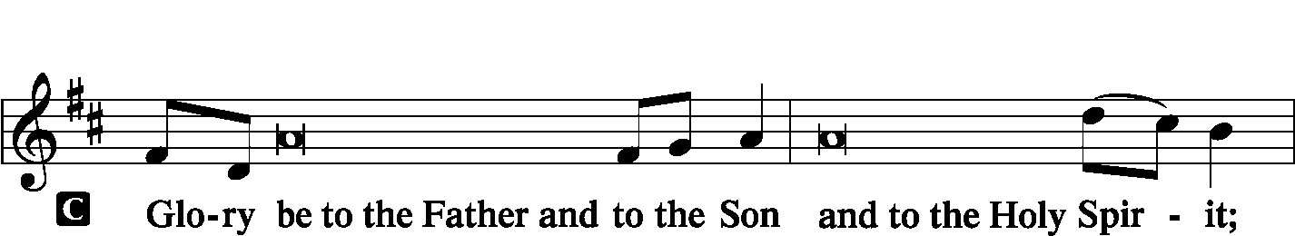
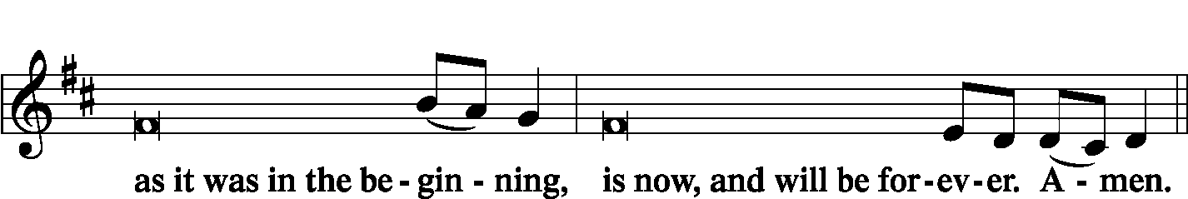

Psalmody
Antiphon (Common) LSB 220
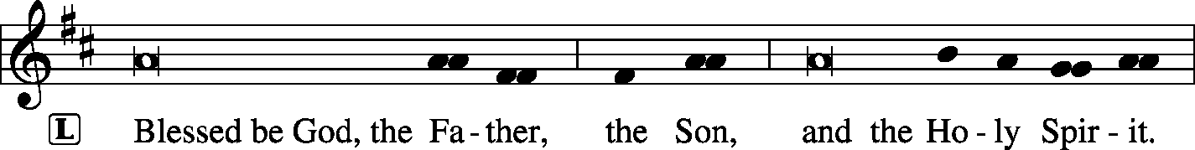

Venite LSB 220
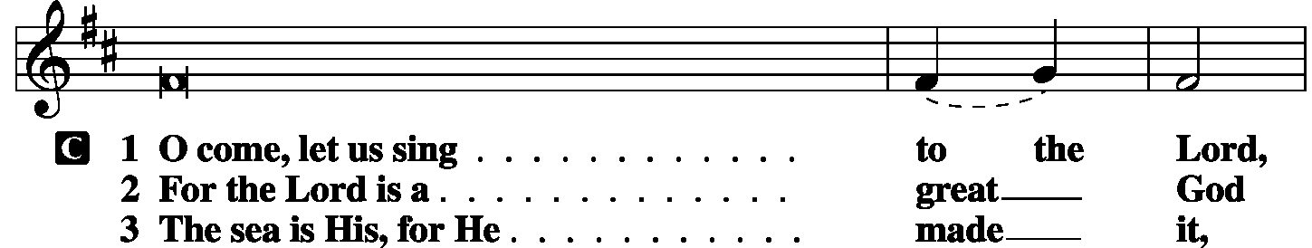
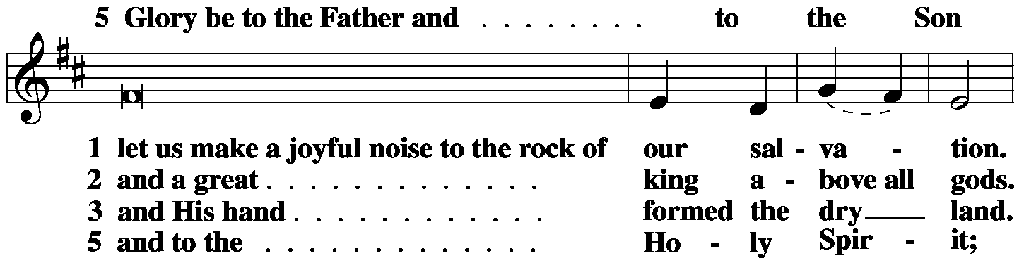
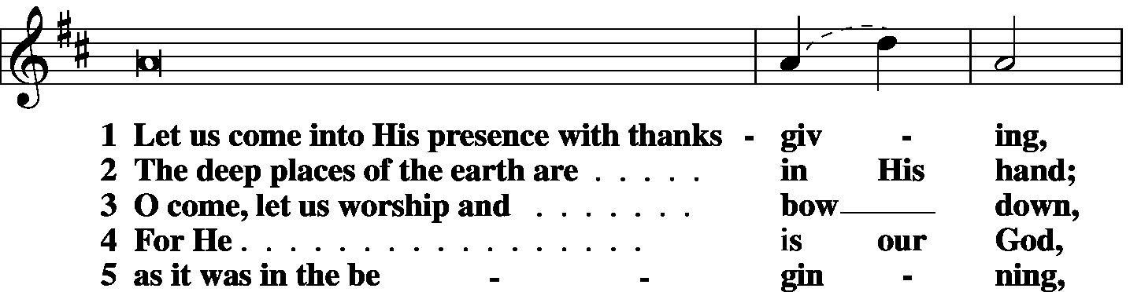
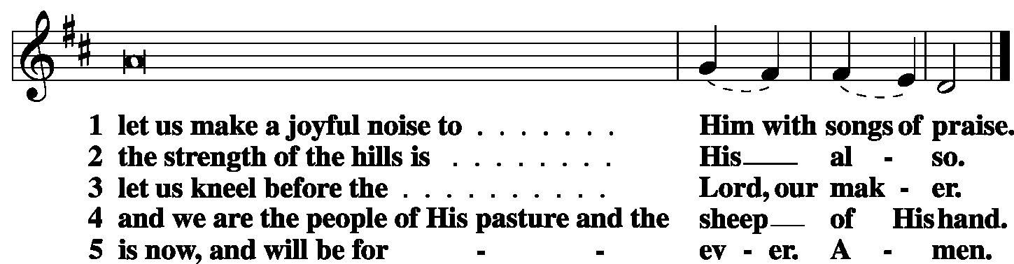

Antiphon (Common) LSB 221

Psalm Psalm 32 (antiphon: v.2)
L Blessèd is the one whose transgression is forgiven,
C whose sin is covered.
L Blessèd is the man against whom the LORD counts no iniquity,
C and in whose spirit there is no deceit.
L For when I kept silent, my bones wasted away
C through my groaning all day long.
L For day and night Your hand was heavy upon me;
C my strength was dried up as by the heat of summer.
L I acknowledged my sin to You,
C and I did not cover my iniquity;
L I said, “I will confess my transgressions to the LORD,”
C and You forgave the iniquity of my sin.
L Therefore let everyone who is godly
C offer prayer to You at a time when You may be found;
L surely in the rush of great waters,
C they shall not reach him.
L You are a hiding place for me;
C You preserve me from trouble;
L You surround me with shouts of deliverance.
C I will instruct you and teach you in the way you should go;
L I will counsel you with My eye upon you.
C Be not like a horse or a mule, without understanding,
L which must be curbed with bit and bridle,
C or it will not stay near you.
L Many are the sorrows of the wicked,
C but steadfast love surrounds the one who trusts in the LORD.
L Be glad in the LORD, and rejoice, O righteous,
C and shout for joy, all you upright in heart!
Glory be to the Father
and to the Son and to the Holy Spirit;
as it was in the beginning,
is now and will be forever. Amen.

Sit

Hymn Lord of Glory, You Have Bought Us LSB 851

First Reading 2 Chronicles 28:8-15
The men of Israel took captive 200,000 of their relatives, women, sons, and daughters. They also took much spoil from them and brought the spoil to Samaria. But a prophet of the Lord was there, whose name was Oded, and he went out to meet the army that came to Samaria and said to them, “Behold, because the Lord, the God of your fathers, was angry with Judah, He gave them into your hand, but you have killed them in a rage that has reached up to heaven. And now you intend to subjugate the people of Judah and Jerusalem, male and female, as your slaves. Have you not sins of your own against the Lord your God? Now hear me, and send back the captives from your relatives whom you have taken, for the fierce wrath of the Lord is upon you.”
Certain chiefs also of the men of Ephraim, Azariah the son of Johanan, Berechiah the son of Meshillemoth, Jehizkiah the son of Shallum, and Amasa the son of Hadlai, stood up against those who were coming from the war and said to them, “You shall not bring the captives in here, for you propose to bring upon us guilt against the Lord in addition to our present sins and guilt. For our guilt is already great, and there is fierce wrath against Israel.” So the armed men left the captives and the spoil before the princes and all the assembly. And the men who have been mentioned by name rose and took the captives, and with the spoil they clothed all who were naked among them. They clothed them, gave them sandals, provided them with food and drink, and anointed them, and carrying all the feeble among them on donkeys, they brought them to their kinsfolk at Jericho, the city of palm trees. Then they returned to Samaria.
P O Lord, have mercy on us.
C Thanks be to God.

Choir The Gift of Love Hal Hopson

Second Reading Galatians 3:15-22
To give a human example, brothers: even with a man-made covenant, no one annuls it or adds to it once it has been ratified. Now the promises were made to Abraham and to his offspring. It does not say, “And to offsprings,” referring to many, but referring to one, “And to your offspring,” who is Christ. This is what I mean: the law, which came 430 years afterward, does not annul a covenant previously ratified by God, so as to make the promise void. For if the inheritance comes by the law, it no longer comes by promise; but God gave it to Abraham by a promise.
Why then the law? It was added because of transgressions, until the offspring should come to whom the promise had been made, and it was put in place through angels by an intermediary. Now an intermediary implies more than one, but God is one.
Is the law then contrary to the promises of God? Certainly not! For if a law had been given that could give life, then righteousness would indeed be by the law. But the Scripture imprisoned everything under sin, so that the promise by faith in Jesus Christ might be given to those who believe.
P O Lord, have mercy on us.
C Thanks be to God.

Third Reading Luke 10:23-37
Turning to the disciples [Jesus] said privately, “Blessed are the eyes that see what you see! For I tell you that many prophets and kings desired to see what you see, and did not see it, and to hear what you hear, and did not hear it.”
And behold, a lawyer stood up to put Him to the test, saying, “Teacher, what shall I do to inherit eternal life?” He said to him, “What is written in the Law? How do you read it?” And he answered, “You shall love the Lord your God with all your heart and with all your soul and with all your strength and with all your mind, and your neighbor as yourself.” And He said to him, “You have answered correctly; do this, and you will live.”
But he, desiring to justify himself, said to Jesus, “And who is my neighbor?” Jesus replied, “A man was going down from Jerusalem to Jericho, and he fell among robbers, who stripped him and beat him and departed, leaving him half dead. Now by chance a priest was going down that road, and when he saw him he passed by on the other side. So likewise a Levite, when he came to the place and saw him, passed by on the other side. But a Samaritan, as he journeyed, came to where he was, and when he saw him, he had compassion. He went to him and bound up his wounds, pouring on oil and wine. Then he set him on his own animal and brought him to an inn and took care of him. And the next day he took out two denarii and gave them to the innkeeper, saying, ‘Take care of him, and whatever more you spend, I will repay you when I come back.’ Which of these three, do you think, proved to be a neighbor to the man who fell among the robbers?” He said, “The one who showed him mercy.” And Jesus said to him, “You go, and do likewise.”
P O Lord, have mercy on us.
C Thanks be to God.

Common Responsory LSB 221
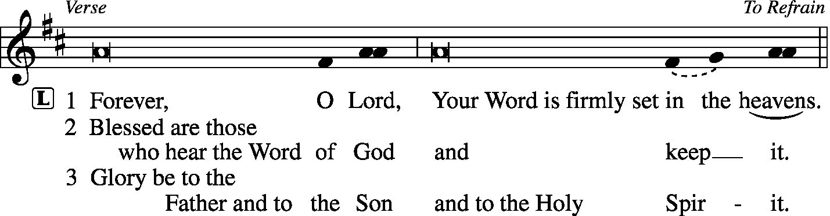
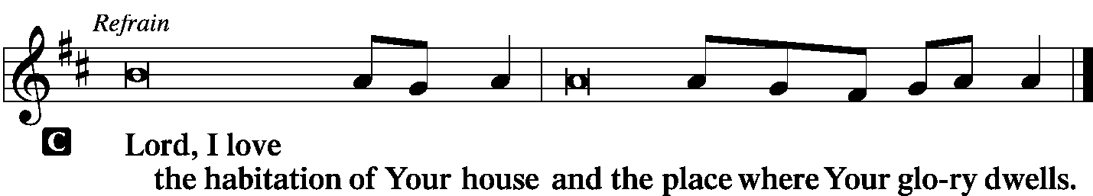

Children's Lunchbox Devotion

Hymn Beautiful Savior LSB 537

Sermon Double Trouble

Offering
[Please fill out a sheet in the attendance book. Visitors, please include your address. If you have a prayer request for the church prayer chain, please write it at the top of the sheet.]

Special Offering Music Come, Thou Fount of Every Blessing
(String Trio)

Canticle
Stand

Te Deum LSB 223
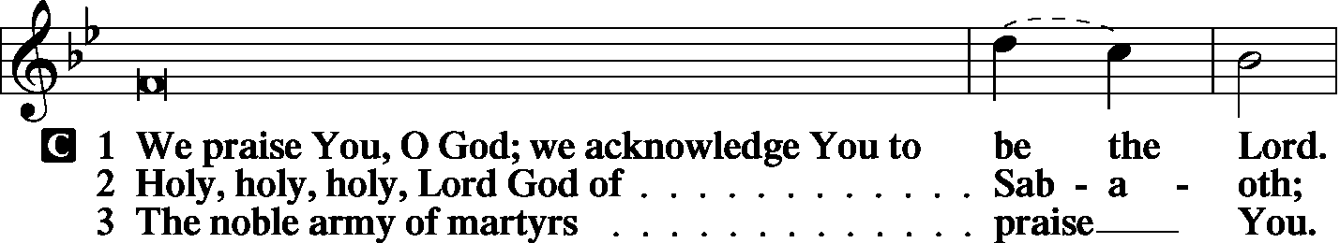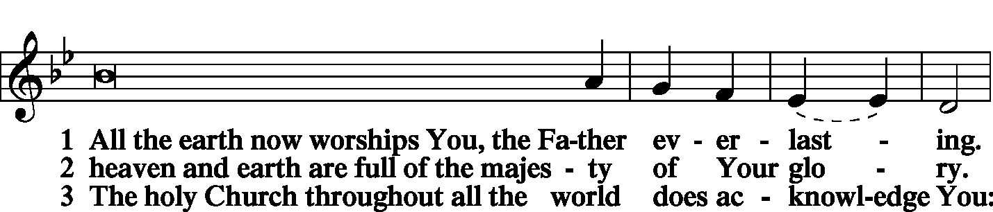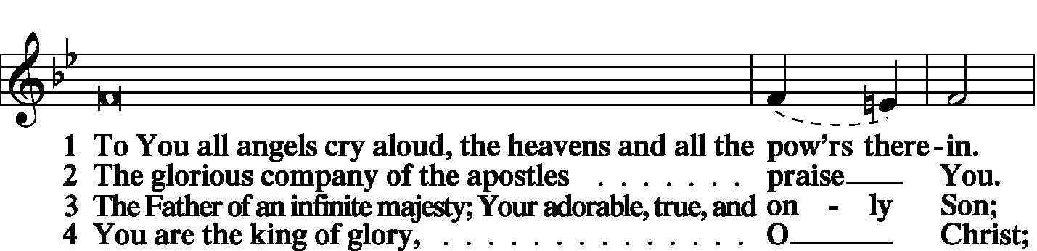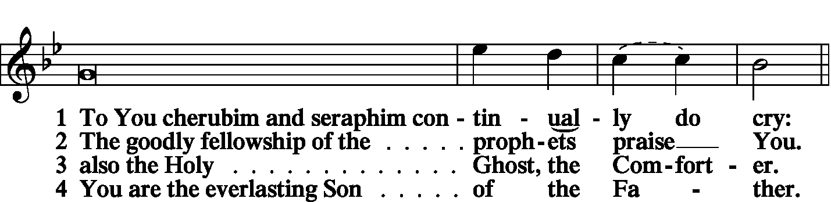

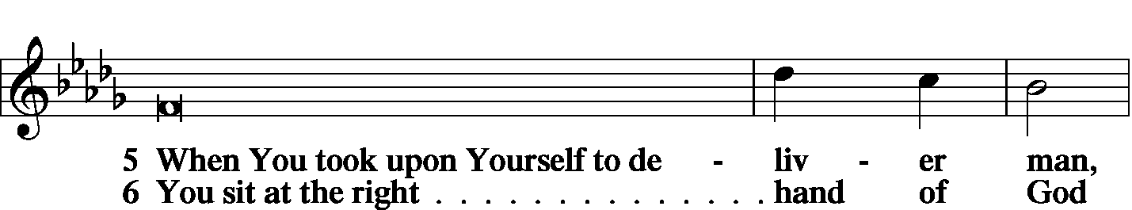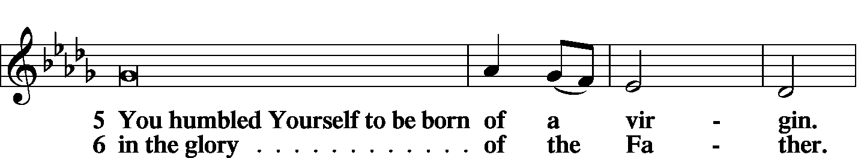
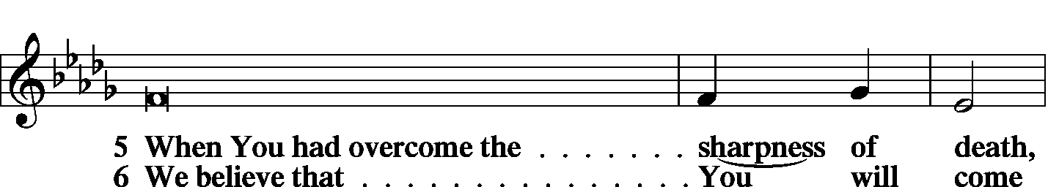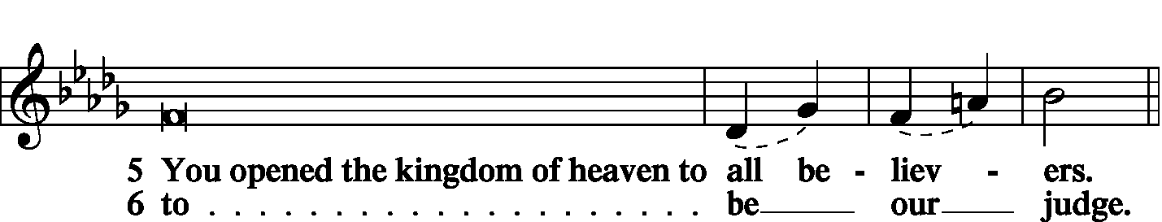

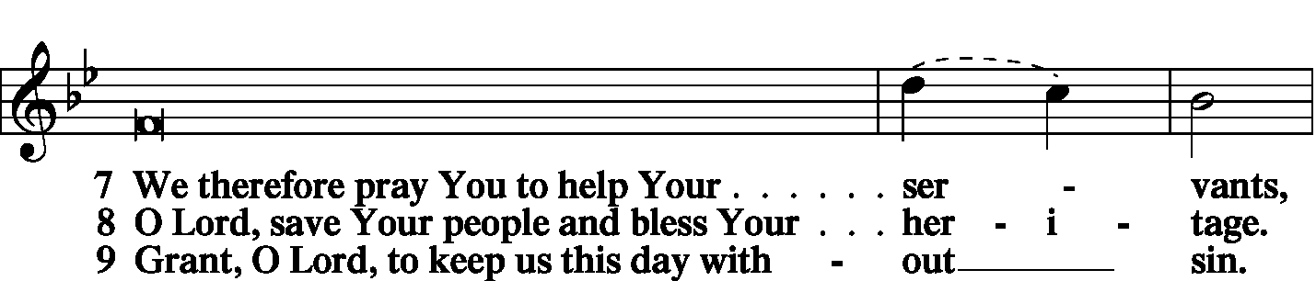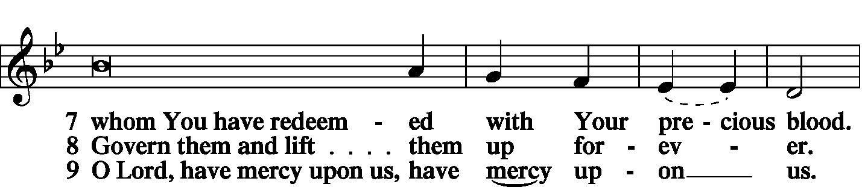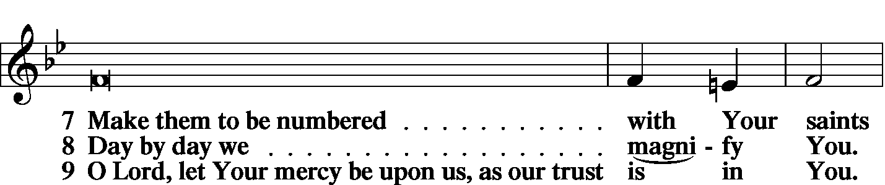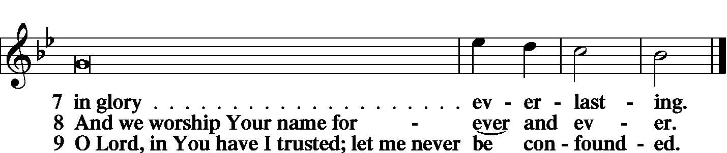

Prayer
Kyrie LSB 227

Lord's Prayer
C Our Father who art in heaven, hallowed be Thy name, Thy kingdom come, Thy will be done on earth as it is in heaven; give us this day our daily bread; and forgive us our trespasses as we forgive those who trespass against us; and lead us not into temptation, but deliver us from evil. For Thine is the kingdom and the power and the glory forever and ever. Amen.

Salutation
L The Lord be with you.
C And also with you.

Collect of the Day
O God, You make the minds of Your faithful to be of one will. Grant that we may love what You have commanded and desire what You promise, that among the many changes of this world our hearts may be fixed where true joys are found; through Jesus Christ, Your Son, our Lord, who lives and reigns with You and the Holy Spirit, one God, now and forever.
C Amen.

Prayer of the Church
L We lift up our souls to You, O Lord, in whom we trust.
C Mindful of Your mercy and Your steadfast truth, accept our adoration and praise.
L Surrounded by humanity’s injustice and untruthfulness, it is refreshing to know and believe that You are the Source for all truth and mercy.
C We thank You for Your undeserved love, which prompted You to send us salvation through the person of Your Son Jesus Christ.
L As recipients of Your gracious love, we regret that we have failed to show You adequate thanks.
C We have not loved You with all our heart, soul, strength, and mind.
L As a result, we have also not loved our neighbor as ourselves.
C Aware of those who need our help, we like the priest and the Levite, have often passed by on the other side.
L Not only have we neglected to meet our neighbor’s physical needs, but we have also failed to supply his spiritual needs.
C For our lack of zeal in sharing our earthly gifts and the gift of salvation, forgive us, O Lord.
L Help us to be strengthened with all power according to Your glorious might that we may bear fruit in every good work and increase in divine knowledge.
C Give us that endurance which reveals itself in patience and joy as we work for the expansion of Your kingdom.
L We pray for those who are in physical or spiritual need.

WE GO TO THE LORD IN PRAYER FOR
- Isabella Allen, Kynan Drinnon, Cierrah Lovett, Daniel Mileur, and Ella Sax, as they celebrate their baptismal anniversaries this week.
- Alaina Susan Gryga, as she is baptized today.
- Sandy Richards, as she recovers from surgery.
- Marilyn Clayton, as she was hospitalized last week.
- Members of Zion’s Board of Trustees, Stewardship Committee, and Board of Finance.
- Faithfulness in support of world missions.

L Bless our nation with peace, and help us to remain in harmony with Your will.
C In Jesus’ name we pray. Amen.
Collect for Grace
L O Lord, our heavenly Father, almighty and everlasting God, You have safely brought us to the beginning of this day. Defend us in the same with Your mighty power and grant that this day we fall into no sin, neither run into any kind of danger, but that all our doings, being ordered by Your governance, may be righteous in Your sight; through Jesus Christ, Your Son, our Lord, who lives and reigns with You and the Holy Spirit, one God, now and forever.
C Amen.

Benedicamus LSB 228
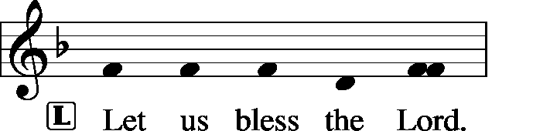
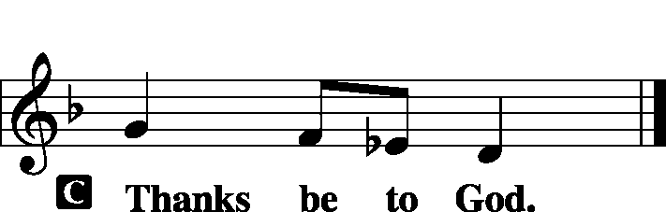

Benediction

Remain Standing

Hymn Stand Up, Stand Up for Jesus LSB 660

Postlude Stand Up, Stand Up for Jesus arr. Jason Payne

Acknowledgments
Unless otherwise indicated, all scripture quotations are from The Holy Bible, English Standard Version, copyright © 2001 by Crossway Bibles, a division of Good News Publishers. Used by permission. All rights reserved. Created by Lutheran Service Builder © 2006 Concordia Publishing House.
LIFE AND LIVING ITEMS AT ZION
          

THE FLOWERS ON THE LORD’S ALTAR
The flowers on the Lord’s altar are given to the glory of God in remembrance of 9/11, in thanksgiving for all first responders who daily and willingly help keep us safe, and by Ruth Rincker.

ATTENDANCE SEPTEMBER 8: Sunday: 178
Adult Bible Class: 26 High School: 11 Sunday School: 33

WE WELCOME ALAINA SUSAN GRYGA
Congratulations to Troy and Lynette Grgya on the birth and rebirth in Baptism of Alaina Susan Gryga. Alaina’s sponsors are Darrin and Maggie Seymour, friends of the family. Welcome, Alaina!

THANK YOU FROM PASTOR BARTON
Zion received the following note from Pastor Jim Barton, who participated in the Adult Baptism of Amy Lin the first Sunday of September: "I wanted to thank you for your kindness in hosting the Baptism of Amy Lin...I was impressed with your congregation, the lively Bible Class, the participation in worship and singing, and the enthusiasm of your choir. The Lord's rich blessings as you continue to serve Christ our Savior together. Best wishes. Pastor Jim Barton"

PRESCHOOL FUNDRAISER – BACK BY POPULAR DEMAND!
The preschool is selling Butter Braid frozen pastry and Show Me Dough frozen cookie dough and frozen pizzas as our fundraiser again this year. These are wonderful products that require no work to prepare. Stock up for the upcoming holidays! Products will be delivered to the school by Saturday, October 5th. Make your purchases today at the table in the Narthex or see Marlene Lockwood, Preschool Director. We appreciate your continuous support!

LADIES: HEAR SEMINARIAN STEIN TALK AND JOIN IN OUR SURPRISE AUCTION!
Ladies Aid resumes this Thursday, September 19th at 7:00 PM (no meetings during the summer). We invite YOU to come to our meeting and hear Seminarian Stein speak about his life and path to the ministry. Learn more about our work at Zion, the surrounding area, and internationally. We will have a surprise auction after a short business meeting. You can bring a home-baked item, gift item, etc. Wrap it in gift wrap (Christmas, birthday, newspaper…it’s a fun thing). These will be auctioned off (sight unseen), and the profits will go toward our mission work. HOPE TO SEE YOU THERE!
TRUSTEES WORK DAY – OCTOBER 5th
The Trustees are planning a work day on Saturday, October 5th, and we are looking for helpers. The projects planned are: repair men’s toilet in basement, replace ballast in preschool girl’s bathroom, take down tree, install gym exhaust fan cover, adjust timers for time change, clean office/school AC condensers, replace furnace filter on church office unit in hall closet, change generator oil, and change float switches on sump pumps.

HARVEST TABLE
It’s harvest time again! Check the harvest table in the Narthex. Bring an extra vegetable or fruit from your garden, you can trade for another or buy the item with a donation to Concerned Christians.

HYMN FESTIVAL IN CARLYLE -- TUESDAY
Messiah/Carlyle is hosting a Hymn Festival on Tuesday, September 17th at 7 PM. Featured organist is Benjamin Kolodziej, organist at Southern Methodist University in Dallas, TX, and member of Faith Lutheran LCMS in Plano, TX. Mr. Kolodziej’s organ improvisations are published by Concordia Publishing House. Messiah Lutheran is located at 1091 13th St. in Carlyle. Contact Rev. Scott Schilbe at 618-594-3912 for more info.

CAREERS FOR CHRIST WEEKEND 2019
Careers for Christ Weekend 2019 will take place October 4th-6th at Concordia University Chicago. The weekend is for high school students who are interested in becoming LCMS church professionals. The entire weekend experience will cost $75 per person. Register online at CUChicago.edu/C4C. After you complete the online registration, download a permission form from the website and send the completed form, along with your registration fee, to CUC’s Office of Undergraduate Admission. Registration deadline is September 25, 2019.

HSHS ST. JOSEPH’S HOSPITAL BREESE FALL HEALTH FAIRS
Pre-registration is open for HSHS St. Joseph’s Hospital Breese’s upcoming Fall Health Fair screenings. The screenings will take place in four communities, each from 6-10 AM. The community is recommended to pre-register for the event. However, this year, on-site registration will only be available from 8 to 10 AM. The scheduled dates and locations are as follows: Wednesday, September 25 at the Carlyle KC Hall – Register by September 18. Wednesday, October 9 at the Trenton First United Methodist Church – Register by October 2. Wednesday, October 23 at the Germantown Legion –Register by October 16. Registration forms are available at the hospital’s front desk, the HealthPlex, local doctors’ offices, local libraries and on the hospital’s web site, stjoebreese.com/healthfairs. The 2019 Health Fair form must be received at the hospital one week before the health fair you plan to attend. Do not submit payment with the form, payment will be collected when you arrive at the Health Fair you are attending. The form may be dropped off at the hospital’s front entrance desk, faxed to 618-526-1404, mailed to “Health Fair, PO Box 99, Breese, IL 62230,” or emailed to sjb.healthfair@hshs.org. Pre-registration is highly recommended, on-site registration the day of the event will also be available from 8 to 10 a.m. For other registration information or questions regarding the health fair, please call Chris at 618-526-5351. For more information about HSHS St. Joseph’s Hospital Breese’s 2019 Health Fair, call 618-526-5351 or visit sjb.healthfair@hshs.org.

HYMN FESTIVAL
The St. Louis Chapter of the American Guild of Organists will present a Hymn Festival honoring the 100th birthday of Dr. Paul Manz (1919-2009) at 4:00 PM on Sunday, September 29th at Ladue Chapel Presbyterian Church, 9450 Clayton Rd., St. Louis. Leading the Hymn Festival is Dr. Scott Hyslop of Frankenmuth, MI. The program will celebrate the church year in song featuring Manz’s original works for choir, organ, and instruments as well as showing the “Manz influence” on other composers, organists, and musicians. The public is invited to participate in the event, co-sponsored by MorningStar Music.

SID JR HIGH YOUTH RETREAT 2019
The Southern Illinois District will be having a Jr. High Youth Retreat beginning Friday, October 4th at 6:00 PM and ending Saturday, October 5th at 6:00 PM. The cost is $55/person. Register and pay online by September 27th at CampWartburg.com. Click “register for camp” and create an account or sign in. Follow prompts and register for “SID Jr High Retreat”. For any questions contact Lauren at 618-939-7715 ext.10.

3rd ANNUAL NATIONAL NIGHT OUT
Mascoutah’s 3rd Annual National Night Out Celebration will be held on Tuesday, October 1st from 5-9 PM at Scheve Park. This is a FREE family and kid event. The night’s events will consist of free food and drinks, public safety personnel meet and greet, viewings and demonstrations of police cars, fire trucks, and ambulances, K-9 demonstration, DJ music, bounce houses, and giveaways.

VITAE FOUNDATION PRO-LIFE DINNER
You are invited to Vitae Foundation’s Southern Illinois Pro-Life Dinner featuring keynote speaker, Matt Walsh, on Thursday, October 3rd at 7 PM. The dinner is being held at the Four Points Sheraton, 319 Fountains Parkway, Fairview Heights. The cost of the dinner is $35. The Vitae Foundation is a non-profit 501(c)(3) organization based in Jefferson City, MO, which promotes pro-life issues, especially those dealing with abortions. The proceeds from this dinner help them make a significant difference in the lives of young women, especially those faced with an unplanned pregnancy. Registration may be made online at VitaeFoundation.org, by calling Vitae at 573-634-4316, or by sending a check or money order to Vitae Foundation, 1731 Southridge Dr., Suite D, Jefferson City, MO 65109.

CFNA GOLF BENEFIT
Christian Friends of New Americans (CFNA) – Sponsor, play, and/or dine. There will be a Golf Benefit on October 8th at Norwood Hills Country Club. There will be a deli lunch, 18-hole scramble, silent auction, hospitality hour, dinner, and entertainment. The Hospitality Hour/Dinner is $30. Your generosity funds: After School Tutoring, Adult ESL, Driver’s Ed, Health screenings, furniture distribution, scholarships in Lutheran schools, Bible studies, and much more for refugees. We see the blessings of baptisms, confirmations, and active church memberships in our local churches. For more information go to www.cfna-stl.org/golf or call (314)517-8513.

3rd ANNUAL ROOTS CONFERENCE
The LCMS U chapters of Metro St. Louis area will host the 3rd Annual Roots Conference: The reconstruction of Man in Christ: The Christian Response to Bioethical Questions. The conference will begin on Friday, October 11th at 6:00 PM and conclude on Saturday, October 12th at 6 PM at Concordia Seminary, St. Louis, MO (Sieck 201). Theme: The reconstruction of Man in Christ, Speaker: Rev. Dr. Robert Weise, Professor Emeritus of Practical Theology. The registration fee is $15. Register on line at: ulue.org/event/roots.

LISTEN TO WORLDWIDE KFUO AM850
This week on KFUO AM850, we'll hear about a local church's Oktoberfest on The Coffee Hour (9/19 at 9:00 a.m.), dig into Psalm 42 and Isaiah 3-6 on Thy Strong Word (weekdays at 11:00 a.m.), and follow the Saga of Salvation in Exodus 27-29 on Sharper Iron (weekdays at 8:00 a.m.). Find new podcasts "Lutheran Ladies Lounge" and "End Goals (from LCMS Youth Ministry)" at kfuo.org or your favorite podcast app!

SANCTIFYING YOUR YARD WORK WITH THE WORD OF GOD
Issues, Etc. is a radio talk show and podcast produced by Lutheran Public Radio in Collinsville, IL and hosted by LCMS Pastor Todd Wilken. This week’s teachings include: The Day of Pentecost, The Apostle Matthew, The Sinful Flesh, 3rd Century Bishop & Martyr Cyprian of Carthage, and more. You can tune in live weekdays from 3-5 p.m. on KFUO, 850 AM in St. Louis. You can also listen at your convenience at www.issuesetc.org and on the LPR mobile app.
THOSE WHO SERVE TODAY
Proclaimer: Rev. Kirk Clayton
Liturgist: Sem. Adam Wolfe
Liturgist: Sem. Don Stein
Organist: Nancy Peterson
Ushers: Ryan Heck, Tom Heck, Mark Krausz, & Matt Krausz
Sound Tech: Gadge Corey
Video Tech: Mark Hatcher
Welcome Team: Ken Knutson & Matt Krausz
Acolytes: Abby McDaniel & Ezri Linnertz

THOSE WHO SERVE NEXT WEEK, SEPTEMBER 22
Proclaimer: Rev. Kirk Clayton
Liturgist: Sem. Adam Wolfe
Liturgist: Sem. Don Stein
Organist: Nancy Peterson
Ushers: Ray Kemezys, Alan Kneschke, Ken Knutson, & Geoff Phillips
Sound Tech: Matt Krausz
Video Tech: Mark Hatcher
Welcome Team: Don & Joyce Krumsieg
Acolytes: Luke Morra & Bjorn Peterson
Altar Guild: Gail Frey

THINGS WE ARE DOING AT ZION
Sun. Social Sunday
Confirmation Class 8:30 AM
SS & Bible Class 8:45 AM
Worship Matins 10:00 AM
Social Sunday Meal with games to follow 11:30 AM
Mon. LifeLight 7:00 PM
Wed. Choir Rehearsal 7:00 PM
New Member Class 7:00 PM
Thurs. Financial Peace 6:00 PM
Youth Bible Study 6:00 PM
Exec Board 6:30 PM
Ladies Aid Meeting 7:00 PM
Trustees Meeting 7:00 PM
Fri. Senior Meal Delivery 10:30 AM
Sun. Confirmation Class 8:30 AM
SS & Bible Class 8:45 AM
Worship DS I w/communion 10:00 AM
MarKa Service 7:00 PM

