Zion Lutheran Church
Mascoutah, Illinois
September 29, 2019
St. Michael and All Angels

In the Name of Christ Jesus our Lord, we bid you a warm welcome to this worship service. May your experience of worship and fellowship this morning be spiritually refreshing and ready you for the week ahead.
 
Pastor: Rev. Kirk Clayton
Church Secretary: Robin Phillips
Choir Director Team: Josh and Nancy Peterson
_________________________________________________________________________________
Church Office Phone: 618-566-7345
Pastor Clayton Cell: 618-447-1306
Office Hours: 8:00 am to 12:00 pm
Email: ChurchOffice@ZionMascoutah.org
Pastor Clayton email: Pastor@ZionMascoutah.org
Web site: www.ZionMascoutah.org
Find us at @ZionMascoutah on Facebook, Twitter, and Instagram
Electronic Devices
Please TURN OFF all cell phones, pagers, electronic devices, apps and games when entering the sanctuary for worship so those around you may focus on the Word of God without electronic distraction. Thank you.

A Prayer to Begin Worship
Almighty God, under whose dominion are all creatures great and small, and all the spirits, good and evil, of the unseen world, hasten the day when St. Michael and all the holy angels will gather the believers in Christ to their eternal home; through Jesus Christ, our Lord, who with the Father and the Holy Spirit are one God with dominion over us forever.

LSB Divine Service Setting IV
With Communion (p. 203)
Confession and Absolution

Prelude Ye Watchers and Ye Holy Ones arr. Burkhardt

Hymn Ye Watchers and Ye Holy Ones LSB 670

Stand

Holy Baptism
(Due to the fact that this is a worship service, held in God’s House, conducted before His Altar, we respectfully request that no flash photographs be taken during the Baptism. Thank you for respecting the reverence of worship.)

The sign of the cross may be made by all in remembrance of their Baptism.

P | In the name of the Father and of the T Son and of the Holy Spirit.
C | Amen.
P | Dearly beloved, Christ our Lord says in the last chapter of Matthew, "All authority in heaven and on earth has been given to Me. Therefore go and make disciples of all nations, baptizing them in the name of the Father and of the Son and of the Holy Spirit." In the last chapter of Mark our Lord promises, "Whoever believes and is baptized will be saved." And the apostle Peter has written, "Baptism now saves you."  The Word of God also teaches that we are all conceived and born sinful and are under the power of the devil until Christ claims us as His own. We would be lost forever unless delivered from sin, death, and everlasting condemnation. But the Father of all mercy and grace has sent His Son Jesus Christ, who atoned for the sin of the whole world, that whoever believes in Him should not perish but have eternal life.
The pastor addresses the candidate:

P | How are you named?
R | Connor Axel Hatcher
The pastor makes the sign of the holy cross upon the forehead and heart of the candidate while saying:

P | Connor Axel Hatcher, receive the sign of the holy cross both upon your T forehead and upon your T heart to mark you as one redeemed by Christ the crucified.
P | Let us pray.  Almighty and eternal God, according to Your strict judgment You condemned the unbelieving world through the flood, yet according to Your great mercy You preserved believing Noah and his family, eight souls in all. You drowned hard-hearted Pharaoh and all his host in the Red Sea, yet led Your people Israel through the water on dry ground, foreshadowing this washing of Your Holy Baptism. Through the Baptism in the Jordan of Your beloved Son, our Lord Jesus Christ, You sanctified and instituted all waters to be a blessed flood and a lavish washing away of sin.  We pray that You would behold Connor Axel Hatcher according to Your boundless mercy and bless him with true faith by the Holy Spirit, that through this saving flood all sin in him which has been inherited from Adam and which he himself has committed since, would be drowned and die. Grant that he be kept safe and secure in the holy ark of the Christian Church, being separated from the multitude of unbelievers and serving Your name at all times with a fervent spirit and a joyful hope, so that, with all believers in Your promise, he would be declared worthy of eternal life; through Jesus Christ, our Lord.
C | Amen.
P | From ancient times the Church has observed the custom of appointing sponsors for baptismal candidates and catechumens. In the Evangelical Lutheran Church sponsors are to confess the faith expressed in the Apostles' Creed and taught in the Small Catechism. They are, whenever possible, to witness the Baptism of those they sponsor. They are to pray for them, support them in their ongoing instruction and nurture in the Christian faith, and encourage them toward the faithful reception of the Lord's Supper. They are at all times to be examples to them of the holy life of faith in Christ and love for the neighbor.

The pastor addresses the sponsors.
P | Is it your intention to serve Connor Axel Hatcher as sponsors in the Christian faith?
R | Yes, with the help of God.
P | God enable you both to will and to do this faithful and loving work and with His grace fulfill what we are unable to do.
C | Amen.
P | Hear the Holy Gospel according to St. Mark.  They brought young children to Jesus that He might touch them; but the disciples rebuked those who brought them. But when Jesus saw it, He was greatly displeased and said to them, "Let the little children come to Me, and do not forbid them; for of such is the kingdom of God. Assuredly, I say to you, whoever does not receive the kingdom of God as a little child will by no means enter it." And He took them up in His arms, put His hands on them, and blessed them.
P | This is the Word of the Lord.
C | Thanks be to God.

The pastor places his hands on the head of the candidate, and the congregation joins in praying:

C | Our Father who art in heaven, hallowed be Thy name, Thy kingdom come, Thy will be done on earth as it is in heaven; give us this day our daily bread; and forgive us our trespasses as we forgive those who trespass against us; and lead us not into temptation, but deliver us from evil. For Thine is the kingdom and the power and the glory forever and ever. Amen.
P | The Lord preserve your coming in and your going out from this time forth and even T forevermore.
C | Amen.

Sit
When a candidate for Baptism is too young to answer the following questions, the child’s parents and sponsors faithfully answer the questions addressed to the child on behalf of the one under their care:

P | Connor Axel Hatcher, do you renounce the devil?
R | Yes, I renounce him.
P | Do you renounce all his works?
R | Yes, I renounce them.
P | Do you renounce all his ways?
R | Yes, I renounce them.
P | Do you believe in God, the Father Almighty, maker of heaven and earth?
R | Yes, I believe.
P | Do you believe in Jesus Christ, His only Son, our Lord, who was conceived by the Holy Spirit, born of the virgin Mary, suffered under Pontius Pilate, was crucified, died and was buried; He descended into hell; the third day He rose again from the dead; He ascended into heaven and sits at the right hand of God the Father Almighty; from thence He will come to judge the living and the dead?
R | Yes, I believe.
P | Do you believe in the Holy Spirit, the holy Christian Church, the communion of saints, the forgiveness of sins, the resurrection of the body, and the life everlasting?
R | Yes, I believe.
P | Connor Axel Hatcher, do you desire to be baptized?
R | Yes, I do.

The pastor pours water three times on the head of the candidate while saying:

P | Connor Axel Hatcher, I baptize you in the name of the Father and of the Son and of the Holy Spirit.
C | Amen.

The pastor places his hands on the head of the newly baptized while saying:

P | The almighty God and Father of our Lord Jesus Christ, who has given you the new birth of water and of the Spirit and has forgiven you all your sins, strengthen you with His grace to life T everlasting.
C | Amen.

The pastor may place a white garment on the newly baptized while saying:

P | Receive this white garment to show that you have been clothed with the robe of Christ's righteousness that covers all your sin. So shall you stand without fear before the judgment seat of Christ to receive the inheritance prepared for you before the foundation of the world.

The pastor may light a baptismal candle from the paschal candle and give it to the newly baptized while saying:

P | Receive this burning light to show that you have received Christ who is the Light of the world. Live always in the light of Christ, and be ever watchful for His coming, that you may meet Him with joy and enter with Him into the marriage feast of the Lamb in His kingdom, which shall have no end.
P | In Holy Baptism God the Father has made you a member of His Son, our Lord Jesus Christ, and an heir with us of all the treasures of heaven in the one holy Christian and apostolic Church. We receive you in Jesus' name as our brother in Christ, that together we might hear His Word, receive His gifts, and proclaim the praises of Him who called us out of darkness into His marvelous light.
C | Amen. We welcome you in the name of the Lord.

Stand

P | Let us pray.  Almighty and most merciful God and Father, we thank and praise You that You graciously preserve and enlarge Your family and have granted Connor Axel Hatcher the new birth in Holy Baptism and made him a member of Your Son, our Lord Jesus Christ, and an heir of Your heavenly kingdom. We humbly implore You that, as he has now become Your child, You would keep him in his baptismal grace, that according to Your good pleasure he may faithfully grow to lead a godly life to the praise and honor of Your holy name and finally, with all Your saints, obtain the promised inheritance in heaven; through Jesus Christ, our Lord.
C | Amen.
P | Peace T be with you.
C | Amen.
Service of the Word
Introit Ps. 103:20–22; antiphon: Ps. 103:1
L Bless the Lord, O my soul,
C and all that is within me, bless His holy name!
L Bless the Lord, O you His angels,
C you mighty ones who do His word, obeying the voice of His word!
L Bless the Lord, all His hosts,
C His ministers, who do His will!
L Bless the Lord, all His works, in all places of His dominion.
C Bless the Lord, O my soul!
Glory be to the Father and to the Son
and to the Holy Spirit;
as it was in the beginning,
is now, and will be forever. Amen.
L Bless the Lord, O my soul,
C and all that is within me, bless His holy name!

Kyrie LSB 204
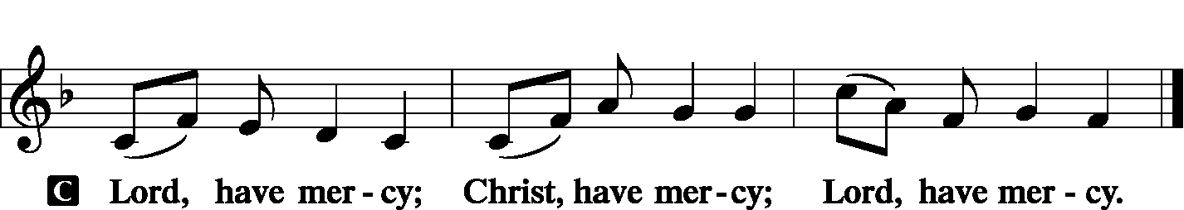
A For the gift of divine peace and of pardon, with all our heart and with all our mind, let us pray to the Lord.

A For the holy Christian Church, here and scattered throughout the world, and for the proclamation of the Gospel and the calling of all to faith, let us pray to the Lord.

A For this nation, for our cities and communities, and for the common welfare of us all, let us pray to the Lord.

A For seasonable weather and for the fruitfulness of the earth, let us pray to the Lord.

A For those who labor, those whose work is difficult or dangerous, and for all who travel, let us pray to the Lord.

A For all those in need, for the hungry and homeless, for the widowed and orphaned, and for all those in prison, let us pray to the Lord.

A For the sick and dying and for all those who care for them, let us pray to the Lord.

A For these and for all our needs of body and soul, let us pray to the Lord.

A Help, save, comfort, and defend us gracious Lord.

Gloria in Excelsis LSB 204
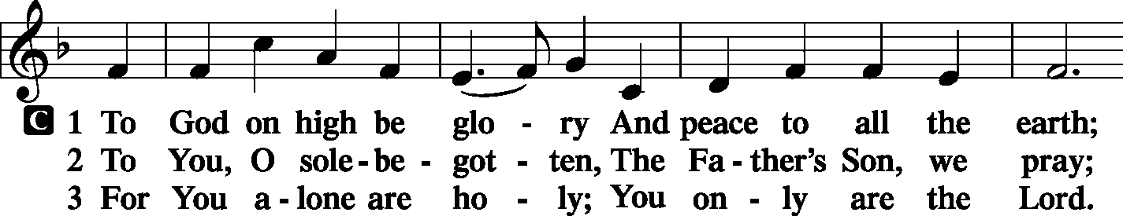
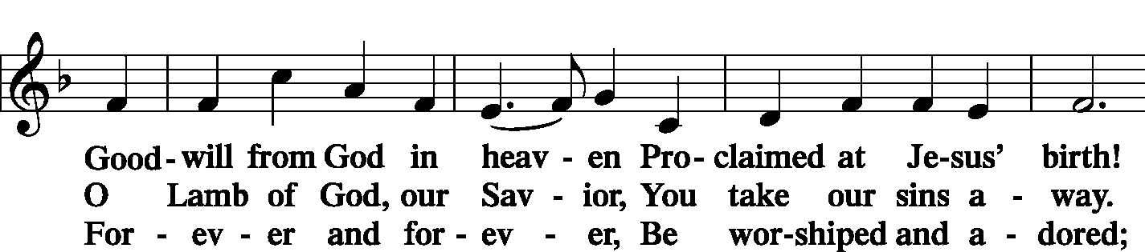
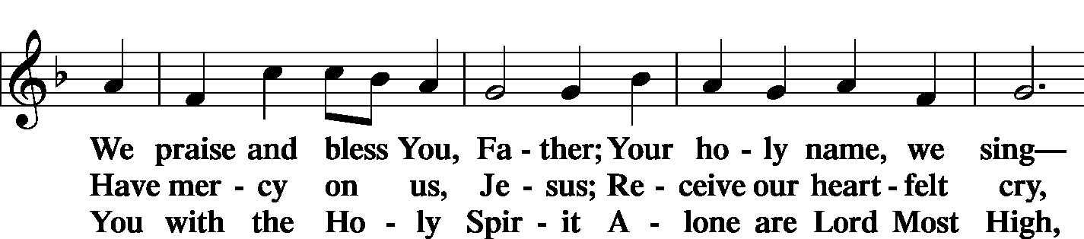
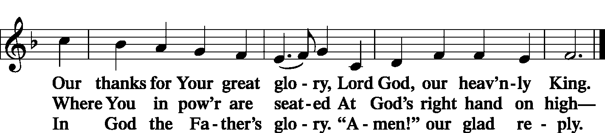

Salutation and Collect of the Day
L The Lord be with you.
C And also with you.
L Let us pray.
Everlasting God, You have ordained and constituted the service of angels and men in a wonderful order. Mercifully grant that, as Your holy angels always serve and worship You in heaven, so by Your appointment they may also help and defend us here on earth; through Your Son, Jesus Christ, our Lord, who lives and reigns with You and the Holy Spirit, one God, now and forever.
C Amen.
Sit

Old Testament Reading Daniel 10:10–14; 12:1–3
And behold, a hand touched me and set me trembling on my hands and knees. And he said to me, “O Daniel, man greatly loved, understand the words that I speak to you, and stand upright, for now I have been sent to you.” And when he had spoken this word to me, I stood up trembling. Then he said to me, “Fear not, Daniel, for from the first day that you set your heart to understand and humbled yourself before your God, your words have been heard, and I have come because of your words. The prince of the kingdom of Persia withstood me twenty-one days, but Michael, one of the chief princes, came to help me, for I was left there with the kings of Persia, and came to make you understand what is to happen to your people in the latter days. For the vision is for days yet to come.”
“At that time shall arise Michael, the great prince who has charge of your people. And there shall be a time of trouble, such as never has been since there was a nation till that time. But at that time your people shall be delivered, everyone whose name shall be found written in the book. And many of those who sleep in the dust of the earth shall awake, some to everlasting life, and some to shame and everlasting contempt. And those who are wise shall shine like the brightness of the sky above; and those who turn many to righteousness, like the stars forever and ever.
L This is the Word of the Lord.
C Thanks be to God.
Gradual Ps. 91:11; 103:1
L He will command His angels concerning you
C to guard you in all your ways.
L Bless the Lord, O my soul,
C and all that is within me, bless His holy name!

Epistle Revelation 12:7–12
Now war arose in heaven, Michael and his angels fighting against the dragon. And the dragon and his angels fought back, but he was defeated and there was no longer any place for them in heaven. And the great dragon was thrown down, that ancient serpent, who is called the devil and Satan, the deceiver of the whole world—he was thrown down to the earth, and his angels were thrown down with him. And I heard a loud voice in heaven, saying, “Now the salvation and the power and the kingdom of our God and the authority of his Christ have come, for the accuser of our brothers has been thrown down, who accuses them day and night before our God. And they have conquered him by the blood of the Lamb and by the word of their testimony, for they loved not their lives even unto death. Therefore, rejoice, O heavens and you who dwell in them! But woe to you, O earth and sea, for the devil has come down to you in great wrath, because he knows that his time is short!”
L This is the Word of the Lord.
C Thanks be to God.

Stand

Alleluia and Verse LSB 205
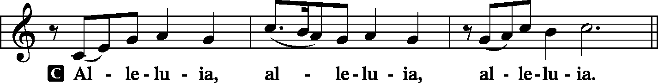
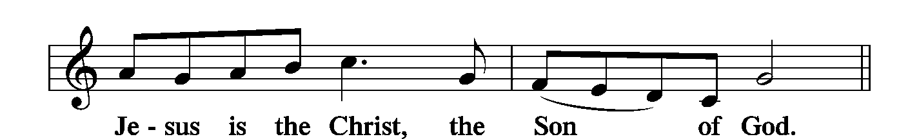
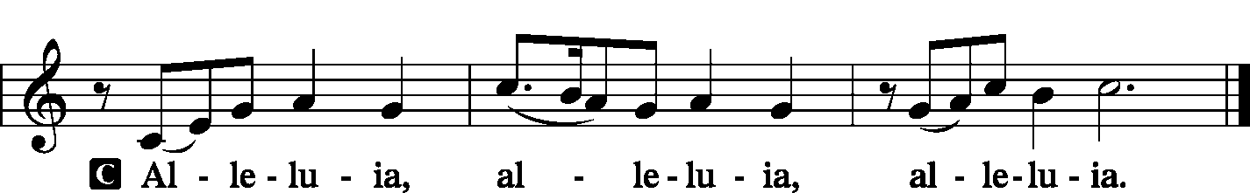

Holy Gospel Matthew 18:1–11
P The Holy Gospel according to St. Matthew, the 18th chapter.
C Glory to You, O Lord.
At that time the disciples came to Jesus, saying, “Who is the greatest in the kingdom of heaven?” And calling to him a child, he put him in the midst of them and said, “Truly, I say to you, unless you turn and become like children, you will never enter the kingdom of heaven. Whoever humbles himself like this child is the greatest in the kingdom of heaven.
“Whoever receives one such child in my name receives me, but whoever causes one of these little ones who believe in me to sin, it would be better for him to have a great millstone fastened around his neck and to be drowned in the depth of the sea.
“Woe to the world for temptations to sin! For it is necessary that temptations come, but woe to the one by whom the temptation comes! And if your hand or your foot causes you to sin, cut it off and throw it away. It is better for you to enter life crippled or lame than with two hands or two feet to be thrown into the eternal fire. And if your eye causes you to sin, tear it out and throw it away. It is better for you to enter life with one eye than with two eyes to be thrown into the hell of fire.
“See that you do not despise one of these little ones. For I tell you that in heaven their angels always see the face of my Father who is in heaven.
P This is the Gospel of the Lord.
C Praise to You, O Christ.

Sit

Hymn All Hail the Power of Jesus’ Name LSB 549

Sermon What Are Angels?

Stand

Prayer of the Church
P With all that is within us, O Lord, we bless Your holy name.
C You forgive all our iniquities and heal our diseases.
P You redeem our life from destruction and crown us with loving-kindness and tender mercies.
C For all these blessings, O Lord, we give you thanks.
P Your mercies remind us that we have not always treated others with the same undeserved love.
C We expect constant forgiveness from others but count the times we forgive them.
P We expect full payment from others while attempting to get discounts for ourselves.
C We live too much for ourselves and not enough to Your honor and glory.
P We become impatient with others but expect them to be patient with us.
C We often forget that it’s not up to us to settle all accounts, but that You have the power to bring good out of evil.
P For these, our many transgressions,
C forgive us, O Lord.
P By Your Spirit help us reflect Your mercy toward others.
C Make us confident that You will take our mistakes and turn them into blessings.
P Be with the president, governor, and legislators, and help them to represent us in answering people’s needs.
C Be with the lonely, comfort the sick, and bring the assurance of Your forgiveness to the penitent.

WE GO TO THE LORD IN PRAYER FOR
- Tom Heck, Laurie Knutson, and Reese Roehrig, as they celebrate their baptismal anniversaries this week.
- Connor Axel Hatcher, as he is baptized today.
- The campus ministry at SIU-Carbondale with Rev. Robert Gray and Rev. Jason Holden, including Chinese Bible Fellowship and a Table Talk meal on Sundays
- All officers, board members, and committee members of Zion.
- Faithfulness in reception of Word and Sacraments.
P This we ask in the name of and for the sake of Him who taught us how to forgive,
C even, Jesus Christ, our Lord and Savior. Amen

Sit

Offering
[Please fill out a sheet in the attendance book. Visitors, please include your address. If you have a prayer request for the church prayer chain, please write it at the top of the sheet.]

Service of the Sacrament
Stand

Preface LSB 208
P The Lord be with you.
C And also with you.
P Lift up your hearts.
C We lift them to the Lord.
P Let us give thanks to the Lord our God.
C It is right to give Him thanks and praise.
P It is truly good, right, and salutary that we should at all times and in all places give thanks to You, O Lord, holy Father, almighty and everlasting God, for the countless blessings You so freely bestow on us and all creation. Above all, we give thanks for Your boundless love shown to us when You sent Your only-begotten Son, Jesus Christ, into our flesh and laid on Him our sin, giving Him into death that we might not die eternally. Because He is now risen from the dead and lives and reigns to all eternity, all who believe in Him will overcome sin and death and will rise again to new life. Therefore with angels and archangels and with all the company of heaven we laud and magnify Your glorious name, evermore praising You and saying:

Sanctus LSB 208
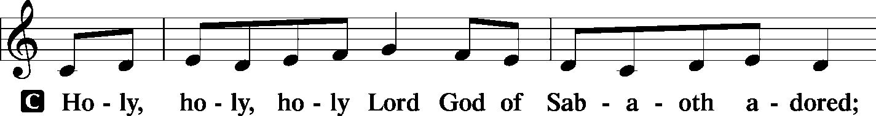
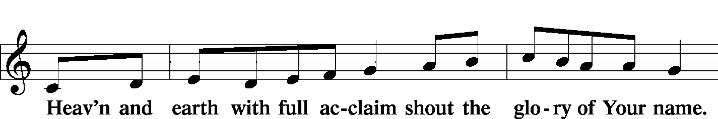
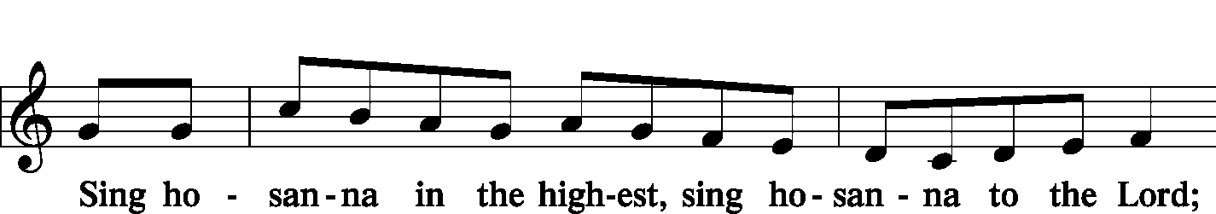
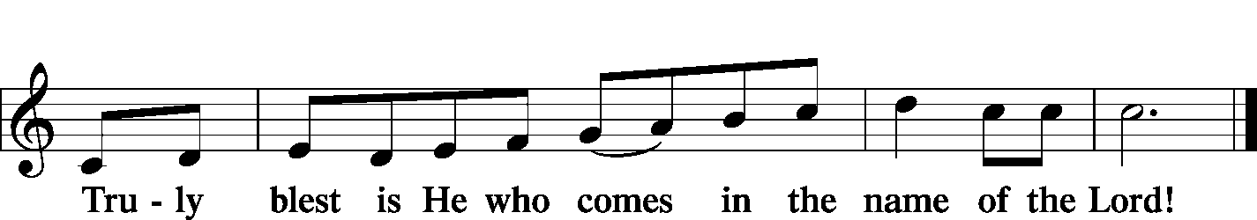

Prayer of Thanksgiving
P In Your righteous judgment You condemned the sin of Adam and Eve, who ate the forbidden fruit, and You justly barred them and all their children from the tree of life. Yet, in Your great mercy, You promised salvation by a second Adam, Your Son, Jesus Christ, our Lord, and made His cross a life-giving tree for all who trust in Him.
We give You thanks for the redemption You have prepared for us through Jesus Christ. Grant us Your Holy Spirit that we may faithfully eat and drink of the fruits of His cross and receive the blessings of forgiveness, life, and salvation that come to us in His body and blood.

Lord's Prayer
C Our Father who art in heaven, hallowed be Thy name, Thy kingdom come, Thy will be done on earth as it is in heaven; give us this day our daily bread; and forgive us our trespasses as we forgive those who trespass against us; and lead us not into temptation, but deliver us from evil. For Thine is the kingdom and the power and the glory forever and ever. Amen.

The Words of Our Lord
P Our Lord Jesus Christ, on the night when He was betrayed, took bread, and when He had given thanks, He broke it and gave it to the disciples and said: “Take, eat; this is My T body, which is given for you. This do in remembrance of Me.”

P In the same way also He took the cup after supper, and when He had given thanks, He gave it to them, saying: “Drink of it, all of you; this cup is the new testament in My T blood, which is shed for you for the forgiveness of sins. This do, as often as you drink it, in remembrance of Me.”

Pax Domini LSB 209
P The peace of the Lord be with you always.
C Amen.

Agnus Dei LSB 210
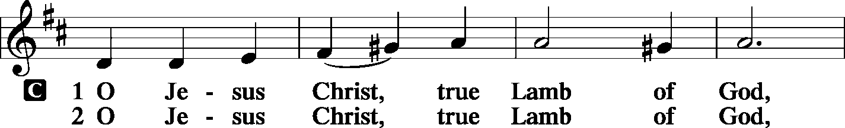
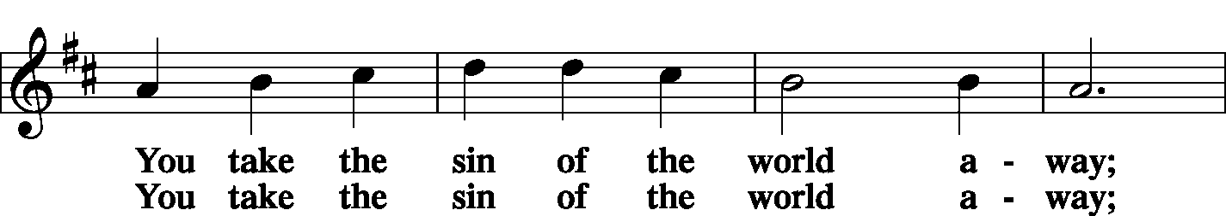
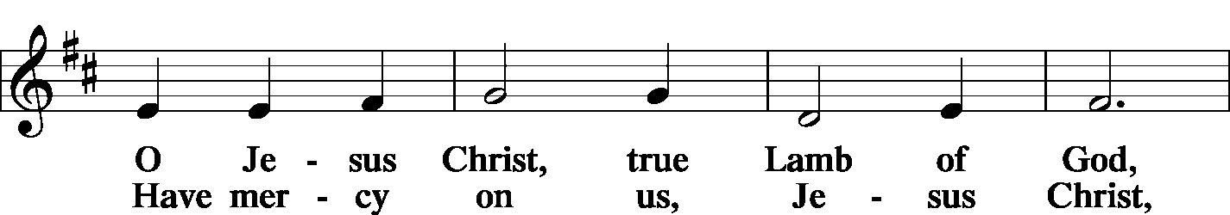
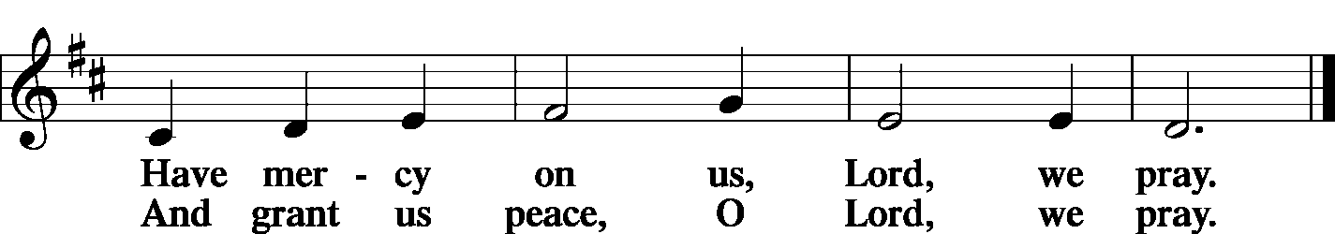

Sit

Distribution
Zion Lutheran practices the policy of close communion, communing only those who share our common Biblical view of the Lord's Supper. If you are not a confirmed LCMS Lutheran, please confer with the pastor before communing.

Hymn Soul, Adorn Yourself with Gladness LSB 636
Hymn Let All Mortal Flesh Keep Silence LSB 621
Hymn Thine the Amen, Thine the Praise LSB 680

Stand
In dismissing the communicants, the following is said:

The Dismissal
P The body and blood of our Lord Jesus Christ strengthen and preserve you in body and soul to life everlasting. Depart T in peace.
C Amen.

Nunc Dimittis LSB 211
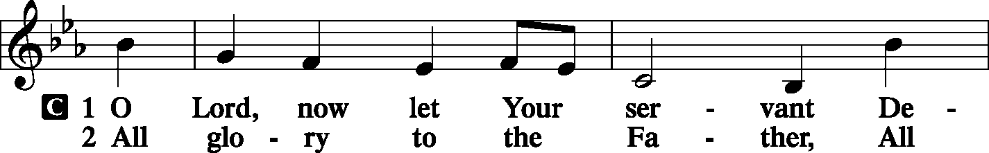
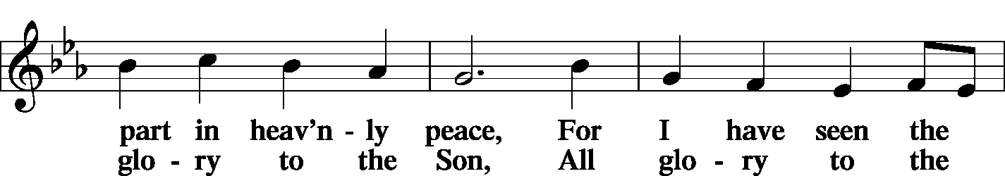
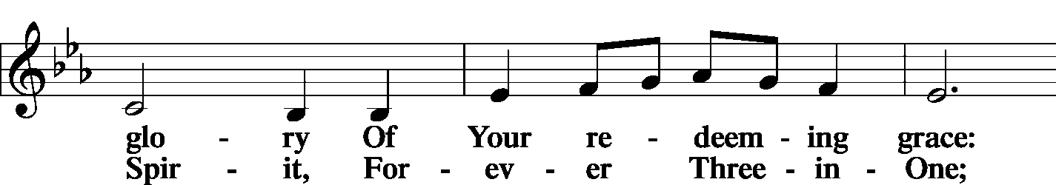
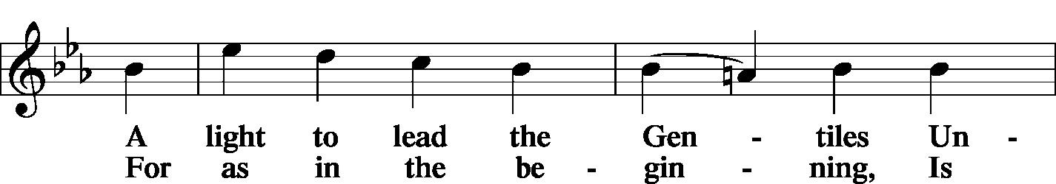
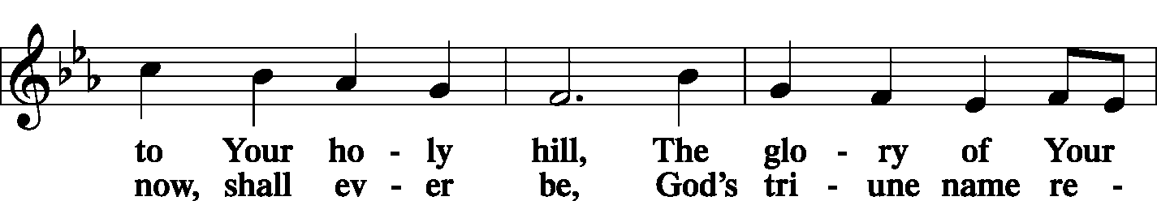
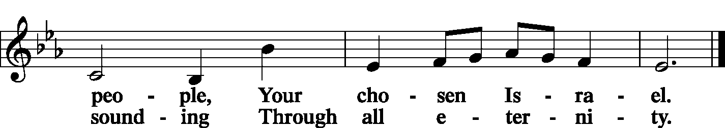
Post-Communion Collect
P Let us pray.
We give thanks to You, almighty God, that You have refreshed us through this salutary gift, and we implore You that of Your mercy You would strengthen us through the same in faith toward You and in fervent love toward one another; through Jesus Christ, Your Son, our Lord, who lives and reigns with You and the Holy Spirit, one God, now and forever.
C Amen.

Benedicamus LSB 212
P Let us bless the Lord.
C Thanks be to God.

Benediction
P The Lord bless you and keep you.
The Lord make His face shine on you and be gracious to you.
The Lord look upon you with favor and T give you peace.
C Amen.

Sit

Hymn Crown Him with Many Crowns LSB 525

Postlude Crown Him with Many Crowns arr. Westenkuehler

Acknowledgments
Unless otherwise indicated, all scripture quotations are from The Holy Bible, English Standard Version, copyright © 2001 by Crossway Bibles, a division of Good News Publishers. Used by permission. All rights reserved. Created by Lutheran Service Builder © 2006 Concordia Publishing House.
LIFE AND LIVING ITEMS AT ZION
          

WE WELCOME CONNOR AXEL HATCHER
Congratulations to David and Jessica Hatcher on the birth and rebirth in Baptism of Connor Axel Hatcher. Connor’s sponsors are Cassie and Tyler Staley-Foster, friends of the family. Welcome, Connor!

THANK YOU FROM SANDY RICHARDS
Thank you to Pastor Clayton for his prayers and visits during my recent hospitalization. Also, to all my church family for their prayers, cards, and well wishes during this time of my hospitalization and recovery. Everything that you did was greatly appreciated by Larry and myself. Thank you all, Sandy Richards.

OCTOBER ECHO – NOW AVAILABLE
The October Echo is now available. Pick one up in the narthex today!

TRUSTEES WORK DAY – THIS SATURDAY, OCTOBER 5th
The Trustees are planning a work day on Saturday, October 5th at 8:00 AM, and we are looking for helpers. The projects planned are: repair men’s toilet in basement, replace ballast in preschool girl’s bathroom, take down tree, install gym exhaust fan cover, adjust timers for time change, clean office/school AC condensers, replace furnace filter on church office unit in hall closet, change generator oil, and change float switches on sump pumps.

HARVEST TABLE
It’s harvest time again! Check the harvest table in the Narthex. Bring an extra vegetable or fruit from your garden, you can trade for another or buy the item with a donation to Concerned Christians.

HYMN FESTIVAL -- TODAY
The St. Louis Chapter of the American Guild of Organists will present a Hymn Festival honoring the 100th birthday of Dr. Paul Manz (1919-2009) at 4:00 PM on Sunday, September 29th at Ladue Chapel Presbyterian Church, 9450 Clayton Rd., St. Louis. Leading the Hymn Festival is Dr. Scott Hyslop of Frankenmuth, MI. The program will celebrate the church year in song featuring Manz’s original works for choir, organ, and instruments as well as showing the “Manz influence” on other composers, organists, and musicians. The public is invited to participate in the event, co-sponsored by MorningStar Music.

3rd ANNUAL NATIONAL NIGHT OUT -- TUESDAY
Mascoutah’s 3rd Annual National Night Out Celebration will be held on Tuesday, October 1st from 5-9 PM at Scheve Park. This is a FREE family and kid event. The night’s events will consist of free food and drinks, public safety personnel meet and greet, viewings and demonstrations of police cars, fire trucks, and ambulances, K-9 demonstration, DJ music, bounce houses, and giveaways.

PLEASE PRAY FOR SIU-CARBONDALE OUTREACH EFFORTS
The campus ministry at SIU-Carbondale is linked to the congregational ministry of Our Savior Lutheran Church with Pastor Robert Gray and Jason Holden. Outreach efforts at SIU-Carbondale include Chinese Bible Fellowship on Fridays, a Table Talk meal and Bible Study on Sundays, and a special Monday Bible study for those in neurorestorative therapy. Please keep this mission ministry in your prayers.

VITAE FOUNDATION PRO-LIFE DINNER
You are invited to Vitae Foundation’s Southern Illinois Pro-Life Dinner featuring keynote speaker, Matt Walsh, on Thursday, October 3rd at 7 PM. The dinner is being held at the Four Points Sheraton, 319 Fountains Parkway, Fairview Heights. The cost of the dinner is $35. The Vitae Foundation is a non-profit 501(c)(3) organization based in Jefferson City, MO, which promotes pro-life issues, especially those dealing with abortions. The proceeds from this dinner help them make a significant difference in the lives of young women, especially those faced with an unplanned pregnancy. Registration may be made online at VitaeFoundation.org, by calling Vitae at 573-634-4316, or by sending a check or money order to Vitae Foundation, 1731 Southridge Dr., Suite D, Jefferson City, MO 65109.

ST. PETER, NEW MEMPHIS CHILI DINNER
St Peter Lutheran Church in New Memphis, IL will host its annual CHILI DINNER on Sunday, October 6th from 11:00 AM to 1:30 PM. Chili, hot dogs, drinks, and desserts will be served. There will be a free will offering. St Peter is located at 153 East Church Street in New Memphis.

CFNA GOLF BENEFIT
Christian Friends of New Americans (CFNA) – Sponsor, play, and/or dine. There will be a Golf Benefit on October 8th at Norwood Hills Country Club. There will be a deli lunch, 18-hole scramble, silent auction, hospitality hour, dinner, and entertainment. The Hospitality Hour/Dinner is $30. Your generosity funds: After School Tutoring, Adult ESL, Driver’s Ed, Health screenings, furniture distribution, scholarships in Lutheran schools, Bible studies, and much more for refugees. We see the blessings of baptisms, confirmations, and active church memberships in our local churches. For more information go to www.cfna-stl.org/golf or call (314)517-8513.

3rd ANNUAL ROOTS CONFERENCE
The LCMS U chapters of Metro St. Louis area will host the 3rd Annual Roots Conference: The reconstruction of Man in Christ: The Christian Response to Bioethical Questions on October 11, 2019. Topics to be discussed: The relationship of Science to Theology; The reconstruction of man in a throwaway culture and other cultural issues. The conference will begin on Friday, October 11th at 6:00 PM and conclude on Saturday, October 12th at 6 PM at Concordia Seminary, St. Louis, MO (Sieck 201). Theme: The reconstruction of Man in Christ, Speaker: Rev. Dr. Robert Weise, Professor Emeritus of Practical Theology. The registration fee is $15. Register on line at: ulue.org/event/roots.

HELP FEED MY STARVING CHILDREN
Volunteers age 5+ are needed to help hand-pack nutritious MannaPack™ meals, specifically designed to assist in reversing and preventing undernutrition throughout the world, at a MobilePack™ event that Thrivent is sponsoring with Feed My Starving Children on Saturday, Oct 19th from 8-11 AM at Good Shepherd Lutheran Church, 327 Woods Mill Road, Ballwin, MO. Wear a LIVE GENEROUSLY t-shirt to the event and the Thrivent Member Network will donate $3 to Feed My Starving Children on your behalf. Please register at TAMM.Eventbrite.com.

LISTEN TO WORLDWIDE KFUO AM850
This week on KFUO AM850, hear from Deaconess Heidi Goehmann on our Mental Health Monday series on The Coffee Hour (9/30 at 9:00 a.m.), study Isaiah 12-16 on Thy Strong Word (weekdays at 11:00 a.m.), and dig into things about the Tabernacle in Exodus 31-33 on Sharper Iron: Saga of Salvation (weekdays at 8:00 a.m.). Check out our new podcast, The Lutheran Ladies' Lounge, available on kfuo.org and your podcast apps!

DAILY EXERCISE FOR THE CHRISTIAN MIND
Issues, Etc. is a radio talk show and podcast produced by Lutheran Public Radio in Collinsville, IL and hosted by LCMS Pastor Todd Wilken. This week's topics include: A Christian-Friendly Government, St. Michael & All Angels, The Movie "Downton Abbey," The Patriarch Joseph and more. You can tune in live weekdays from 3-5 p.m. on KFUO, 850 AM in St. Louis. You can also listen at your convenience at www.issuesetc.org and on the LPR mobile app.

THE FLOWERS ON THE LORD’S ALTAR
The flowers on the Lord’s altar are given to the glory of God by the Hatcher family in honor of Connor’s baptism.

THOSE WHO SERVE TODAY
Proclaimer: Rev. Kirk Clayton
Liturgist: Sem. Adam Wolfe
Liturgist: Sem. Don Stein
Organist: Nancy Peterson
Ushers: Tony Lara, Ray McDaniel, Dan Morra, & Torri Suedmeyer
Sound Tech: Jake Simon
Video Tech: Mark Hatcher
Welcome Team: Jerry Phillips & David Rowold
Acolytes: Gianna Sink & Daniel Bretz
Altar Guild: Kim Drinnon

THOSE WHO SERVE NEXT WEEK, OCTOBER 6
Proclaimer: Sem. Adam Wolfe
Liturgist: Rev. Kirk Clayton
Liturgist: Sem. Don Stein
Organist: Nancy Peterson
Ushers: Lionel Timmerman, Alex Tubbs, Mike Twenhafel,
& Terry Twenhafel
Sound Tech: Buzz Kandler
Video Tech: Mark Hatcher
Welcome Team: Jen Lara & Marianne McDaniel
Acolytes: Mia Simon & Laith Fanous

THINGS WE ARE DOING AT ZION
Sun. Confirmation Class 8:30 AM
SS & Bible Class 8:45 AM
Worship DS IV w/communion 10:00 AM
Mon. LifeLight 7:00 PM
Wed. Choir Rehearsal 7:00 PM
New Member Class 7:00 PM
Thurs. Youth Bible Study 6:00 PM
Fri. Senior Meal Delivery 10:30 AM
Sat. Church Work Day 8:00 AM
Sun. Confirmation Class 8:30 AM
SS & Bible Class 8:45 AM
Worship DS II n/communion 10:00 AM

ATTENDANCE SEPTEMBER 22: Sunday: 191
Adult Bible Class: 19 High School: 6 Sunday School: 48

