Zion Lutheran Church
Mascoutah, Illinois
October 13, 2019
17th Sunday after Trinity

In the Name of Christ Jesus our Lord, we bid you a warm welcome to this worship service. May your experience of worship and fellowship this morning be spiritually refreshing and ready you for the week ahead.

 
Pastor: Rev. Kirk Clayton
Church Secretary: Robin Phillips
Choir Director Team: Josh and Nancy Peterson
_________________________________________________________________________________
Church Office Phone: 618-566-7345
Pastor Clayton Cell: 618-447-1306
Office Hours: 8:00 am to 12:00 pm
Email: ChurchOffice@ZionMascoutah.org
Pastor Clayton email: Pastor@ZionMascoutah.org
Web site: www.ZionMascoutah.org
Find us at @ZionMascoutah on Facebook, Twitter, and Instagram
Electronic Devices
Please TURN OFF all cell phones, pagers, electronic devices, apps and games when entering the sanctuary for worship so those around you may focus on the Word of God without electronic distraction. Thank you.

A Prayer to Begin Worship
Benevolent Father, gracious God, Host at the end-time banquet for all who are in Christ, stay us from pride in our faith and life, and give us enough insight into Christ to follow His example of servanthood to all through the same Jesus Christ, our Lord, who with You and the Holy Spirit are one God with dominion over us forever.

DIVINE SERVICE III WITH COMMUNION
LSB p. 184
Confession and Absolution

Hymn O Day of Rest and Gladness LSB 906

Stand

The sign of the cross may be made by all in remembrance of their Baptism.

Invocation
P In the name of the Father and of the T Son and of the Holy Spirit.
C Amen.

Exhortation
P Beloved in the Lord! Let us draw near with a true heart and confess our sins unto God our Father, beseeching Him in the name of our Lord Jesus Christ to grant us forgiveness.
P Our help is in the name of the Lord,
C who made heaven and earth.
P I said, I will confess my transgressions unto the Lord,
C and You forgave the iniquity of my sin.

Silence for reflection on God's Word and for self-examination.

Confession with Absolution
P O almighty God, merciful Father,
C I, a poor, miserable sinner, confess unto You all my sins and iniquities with which I have ever offended You and justly deserved Your temporal and eternal punishment. But I am heartily sorry for them and sincerely repent of them, and I pray You of Your boundless mercy and for the sake of the holy, innocent, bitter sufferings and death of Your beloved Son, Jesus Christ, to be gracious and merciful to me, a poor, sinful being.

P Upon this your confession, I, by virtue of my office, as a called and ordained servant of the Word, announce the grace of God unto all of you, and in the stead and by the command of my Lord Jesus Christ I forgive you all your sins in the name of the Father and of the T Son and of the Holy Spirit.
C Amen.

Service of the Word
Introit Ps. 119:1–2, 5–6; antiphon: Ps. 119:137, 124
L Righteous are You, O Lord,
C and right are Your just decrees.
L Deal with Your servant according to Your steadfast love,
C and teach me Your statutes.
L Blessèd are those whose way is blameless,
C who walk in the law of the Lord!
L Blessèd are those who keep His testimonies,
C who seek Him with their whole heart.
L Oh that my ways may be steadfast
C in keeping Your statutes!
L Then I shall not be put to shame,
C having my eyes fixed on all Your commandments.
L Righteous are You, O Lord,
C and right are Your just decrees.
L Deal with Your servant according to Your steadfast love,
C and teach me Your statutes.

Gloria Patri
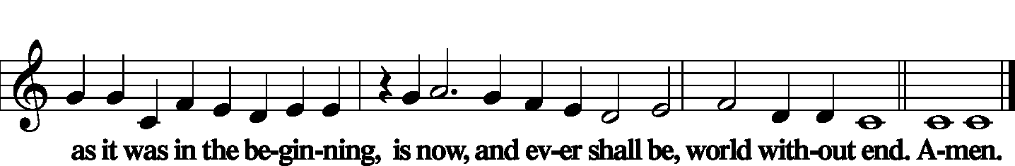

Kyrie LSB 186
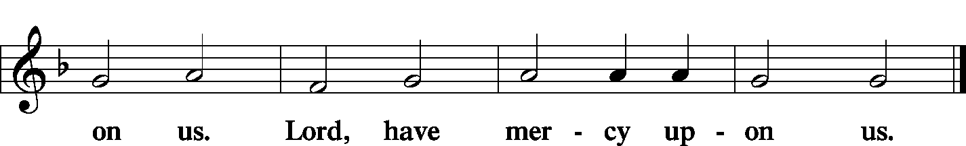

Gloria in Excelsis LSB 187
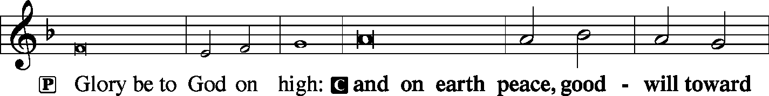
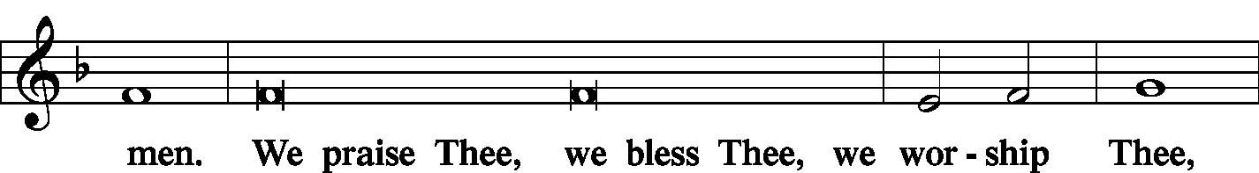
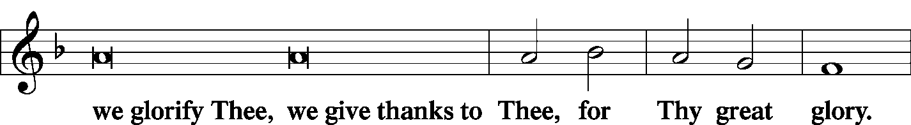
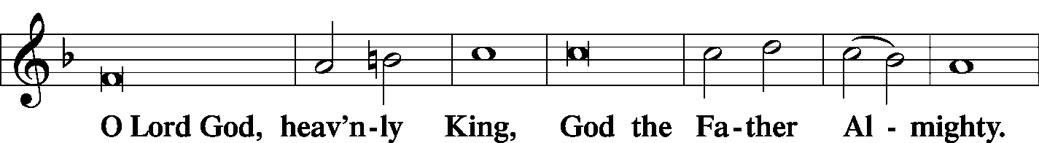
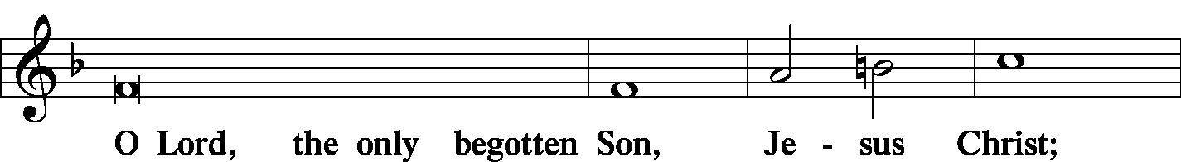
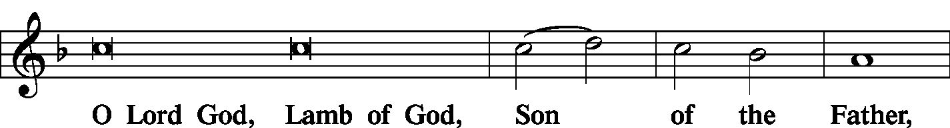
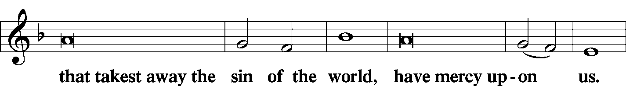
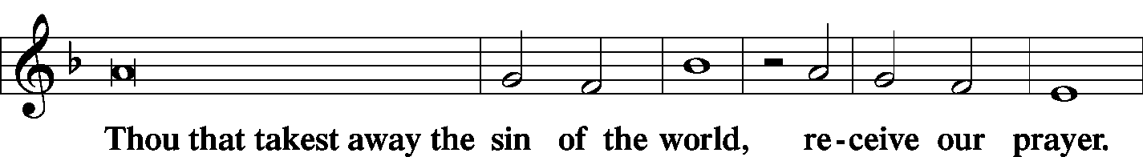
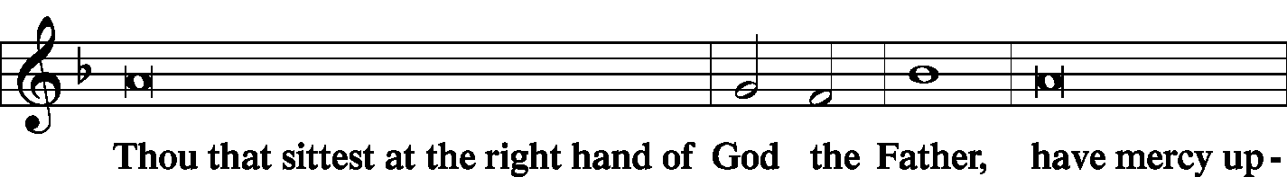
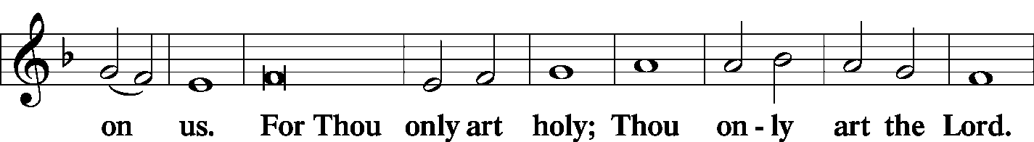
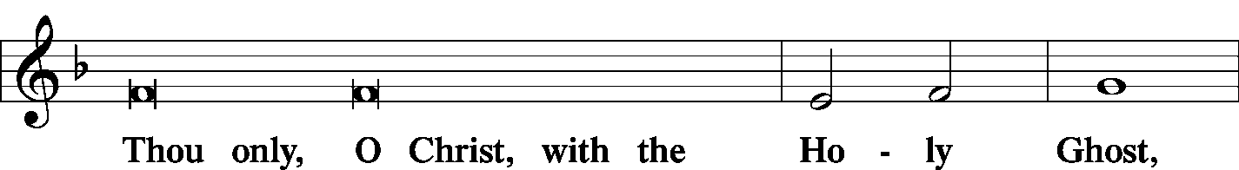
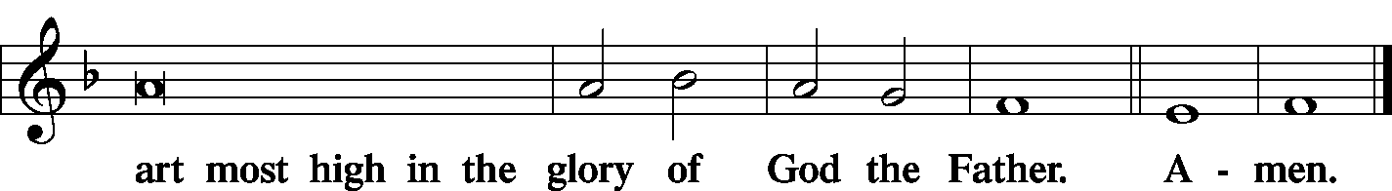

Salutation and Collect of the Day
L The Lord be with you.
C And with thy spirit.
L Let us pray.
Lord, we implore You, grant Your people grace to withstand the temptations of the devil and with pure hearts and minds to follow You, the only God; through Jesus Christ, Your Son, our Lord, who lives and reigns with You and the Holy Spirit, one God, now and forever.
C Amen.

Sit

Old Testament Reading Proverbs 25:6–14
Do not put yourself forward in the king’s presence or stand in the place of the great, for it is better to be told, “Come up here,” than to be put lower in the presence of a noble. What your eyes have seen do not hastily bring into court, for what will you do in the end when your neighbor puts you to shame? Argue your case with your neighbor himself and do not reveal another’s secret lest he who hears you bring shame upon you and your ill repute have no end. A word fitly spoken is like apples of gold in a setting of silver. Like a gold ring or an ornament of gold is a wise reprover to a listening ear. Like the cold of snow in the time of harvest is a faithful messenger to those who send him; he refreshes the soul of his masters. Like clouds and wind without rain is a man who boasts of a gift he does not give.
L This is the Word of the Lord.
C Thanks be to God.

Choir Before You I Kneel arr. Mary McDonald

Epistle Ephesians 4:1–6
I therefore, a prisoner for the Lord, urge you to walk in a manner worthy of the calling to which you have been called, with all humility and gentleness, with patience, bearing with one another in love, eager to maintain the unity of the Spirit in the bond of peace. There is one body and one Spirit—just as you were called to the one hope that belongs to your call— one Lord, one faith, one baptism, one God and Father of all, who is over all and through all and in all.
L This is the Word of the Lord.
C Thanks be to God.

Stand

Alleluia and Verse
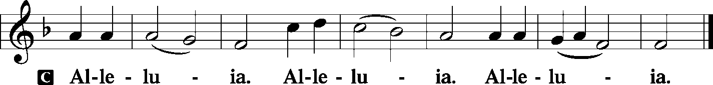

Holy Gospel Luke 14:1–11
P The Holy Gospel according to St. Luke, the fourteenth chapter.
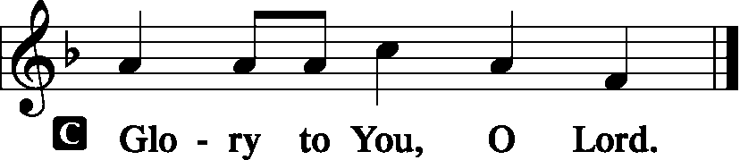
One Sabbath, when [Jesus] went to dine at the house of a ruler of the Pharisees, they were watching Him carefully.
And behold, there was a man before Him who had dropsy. And Jesus responded to the lawyers and Pharisees, saying, “Is it lawful to heal on the Sabbath, or not?” But they remained silent. Then He took him and healed him and sent him away. And He said to them, “Which of you, having a son or an ox that has fallen into a well on a Sabbath day, will not immediately pull him out?” And they could not reply to these things.
Now He told a parable to those who were invited, when He noticed how they chose the places of honor, saying to them, “When you are invited by someone to a wedding feast, do not sit down in a place of honor, lest someone more distinguished than you be invited by him, and he who invited you both will come and say to you, ‘Give your place to this person,’ and then you will begin with shame to take the lowest place. But when you are invited, go and sit in the lowest place, so that when your host comes he may say to you, ‘Friend, move up higher.’ Then you will be honored in the presence of all who sit at table with you. For everyone who exalts himself will be humbled, and he who humbles himself will be exalted.”
P This is the Gospel of the Lord.
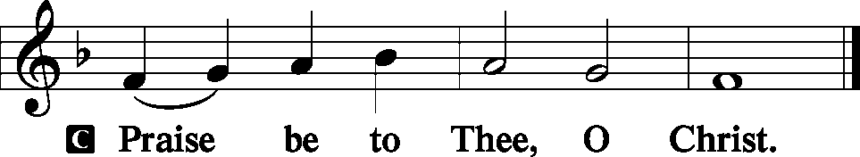

Nicene Creed
C I believe in one God, the Father Almighty, maker of heaven and earth and of all things visible and invisible.
And in one Lord Jesus Christ, the only-begotten Son of God, begotten of His Father before all worlds, God of God, Light of Light, very God of very God, begotten, not made, being of one substance with the Father, by whom all things were made; who for us men and for our salvation came down from heaven and was incarnate by the Holy Spirit of the virgin Mary and was made man; and was crucified also for us under Pontius Pilate. He suffered and was buried. And the third day He rose again according to the Scriptures and ascended into heaven and sits at the right hand of the Father. And He will come again with glory to judge both the living and the dead, whose kingdom will have no end.
And I believe in the Holy Spirit, the Lord and giver of life, who proceeds from the Father and the Son, who with the Father and the Son together is worshiped and glorified, who spoke by the prophets. And I believe in one holy Christian and apostolic Church, I acknowledge one Baptism for the remission of sins, and I look for the resurrection of the dead and the life T of the world to come. Amen.
Sit

Hymn Blest Be the Tie That Binds LSB 649

Sermon Healing on the Sabbath

Stand

Prayer of the Church
P Lord God, heavenly Father, with thanksgiving we come before You.
C You have made known Your will in Your commandments.
P You have bestowed Your blessings on those who live by faith in Christ and seek to keep Your commandments.
C By our own efforts we cannot walk blamelessly before You.
P But through the merits of Jesus we dare approach Your holy majesty.
C For making it possible to appear blameless before You, we give You humble and hearty thanks.
P We confess that we have often tried to stand in our own strength rather than trust in the strength of Your might.
C We have yielded to some of Satan’s temptations because we failed to put on the whole armor of God.
P Our loins were not always girded with truth, nor did we always face the world with the breastplate of righteousness.
C Our feet have not always been shod with the Gospel of peace, and we have often forgotten to put on the shield of faith.
P Our performance as Christian soldiers has left much to be desired.
C Forgive us, O Lord.
P Cleanse our hearts with the sanctifying power of Your Holy Spirit.
C May the hearing of Your Word and the use of Your sacraments produce in us a living faith.
P May our faith show itself in deeds of love toward others, especially to those in need.
C May our church and state leaders be more intent on doing Your will than pleasing people.

WE GO TO THE LORD IN PRAYER FOR
- Avery Boehm, Chloe Pannier, Gadge Corey, Ava Pettis, and Dillan Schorfheide, as they celebrate their Baptismal Anniversaries this week.
- The school ministry at Unity School, East St. Louis under the direction of Rev. Aaron Dickerson, that students grow both in their studies and in their faith in Jesus.
- Zion’s President, Vice President, Secretary, and Treasurer.
- Faithfulness in Christian Worship.

P May we all recognize Your hand in our afflictions that through them we may be strengthened.
C We pray in Jesus’ name. Amen

Sit

Offering
[Please fill out a sheet in the attendance book. Visitors, please include your address. If you have a prayer request for the church prayer chain, please write it at the top of the sheet.]

Stand

Offertory LSB 192
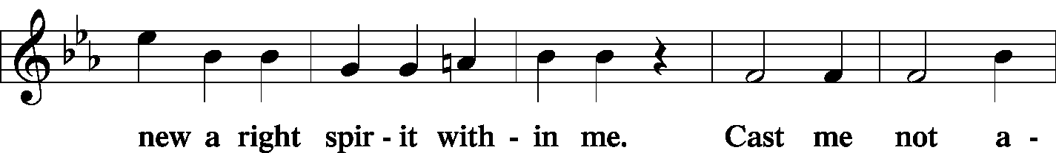
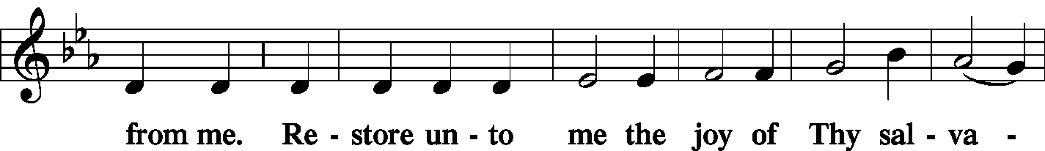
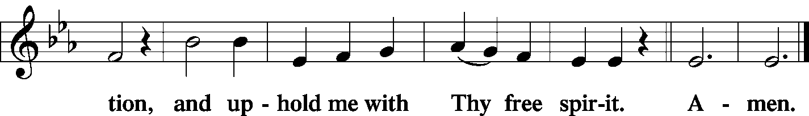

Service of the Sacrament
Preface LSB 194
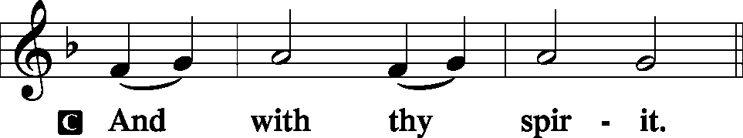

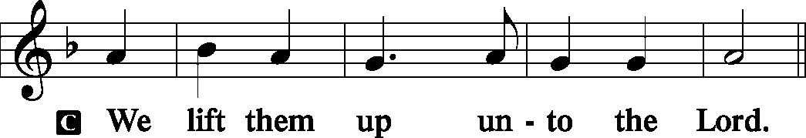

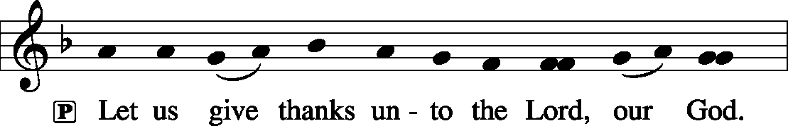

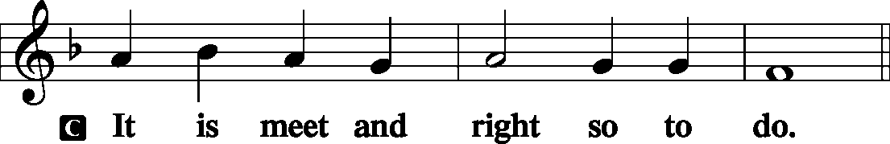

Proper Preface (Full)
P It is truly meet, right, and salutary that we should at all times and in all places give thanks to You, holy Lord, almighty Father, everlasting God. And most especially are we bound to praise You on this day for the glorious resurrection of Your Son, Jesus Christ, the very Paschal Lamb, who was sacrificed for us and bore the sins of the world. By His dying He has destroyed death, and by His rising again He has restored to us everlasting life. Therefore with Mary Magdalene, Peter and John, and with all the witnesses of the resurrection, with angels and archangels, and with all the company of heaven we laud and magnify Your glorious name, evermore praising You and saying:

Sanctus LSB 195
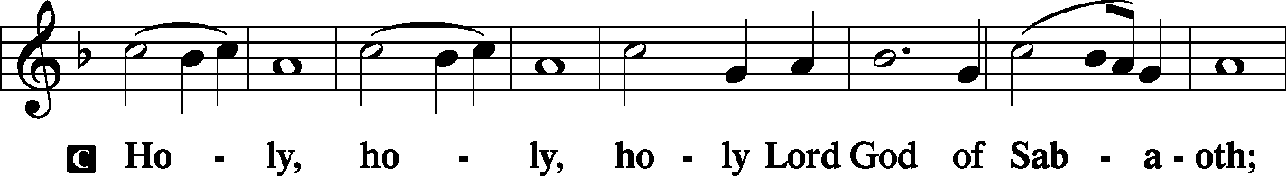
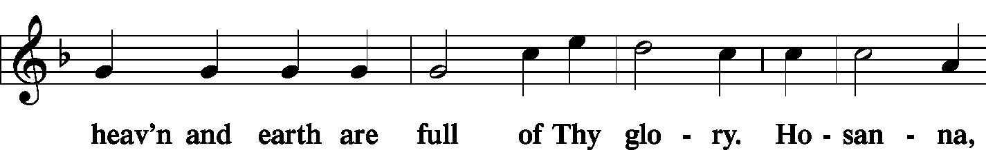
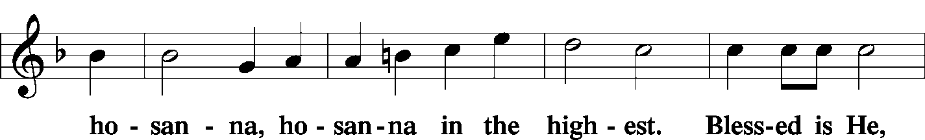
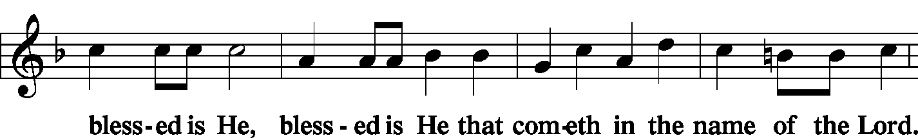
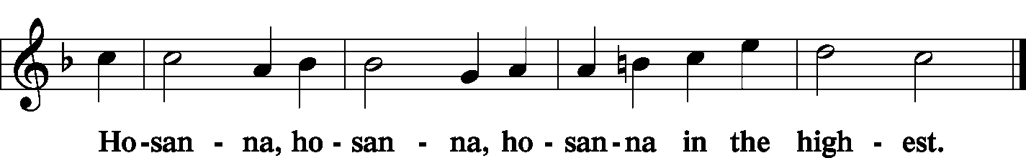

Lord's Prayer LSB 196
P Our Father who art in heaven, hallowed be Thy name, Thy kingdom come, Thy will be done on earth as it is in heaven; give us this day our daily bread; and forgive us our trespasses as we forgive those who trespass against us; and lead us not into temptation, but deliver us from evil
C | 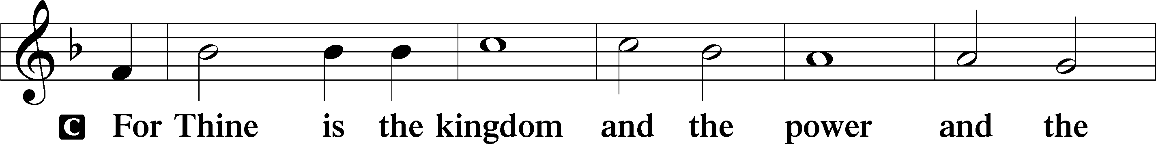  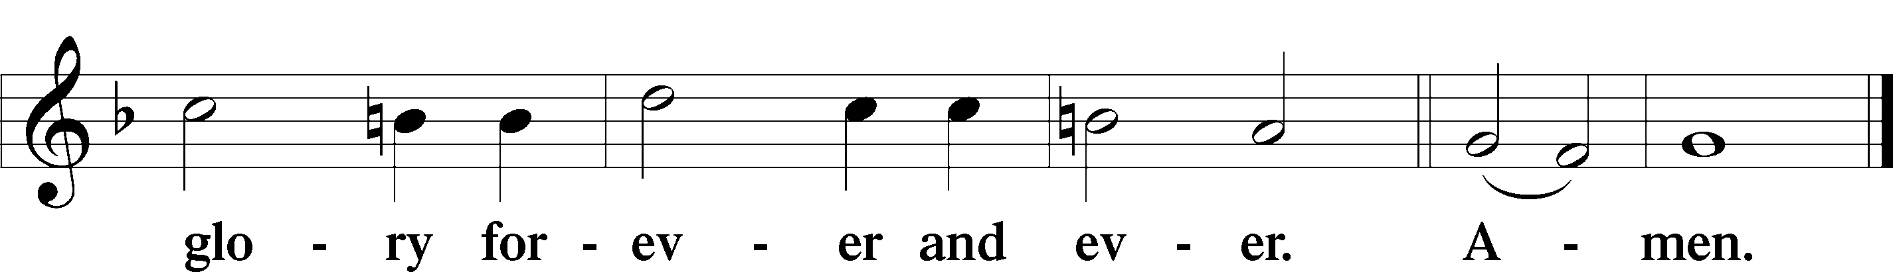
The Words of Our Lord LSB 197
P Our Lord Jesus Christ, on the night when He was betrayed, took bread, and when He had given thanks, He broke it and gave it to the disciples and said: “Take, eat; this is My T body, which is given for you. This do in remembrance of Me.”
P In the same way also He took the cup after supper, and when He had given thanks, He gave it to them, saying: “Drink of it, all of you; this cup is the new testament in My T blood, which is shed for you for the forgiveness of sins. This do, as often as you drink it, in remembrance of Me.”
Pax Domini LSB 197
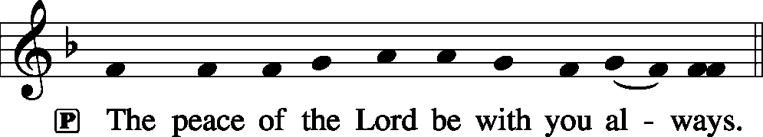

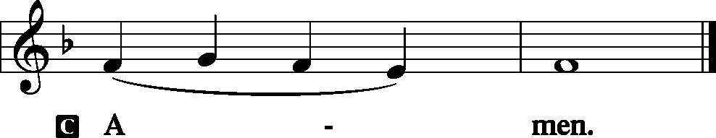

Agnus Dei LSB 198
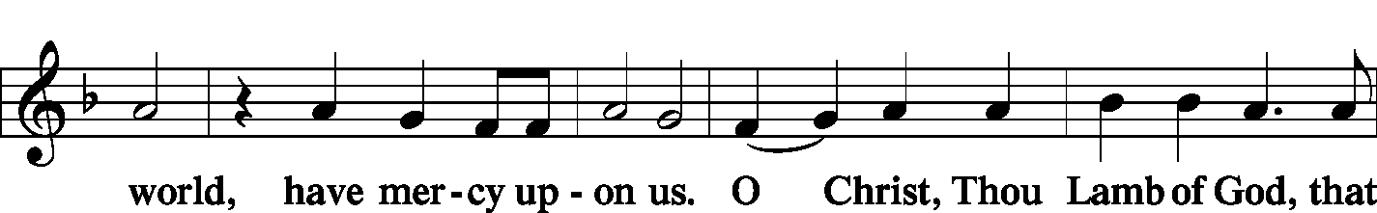
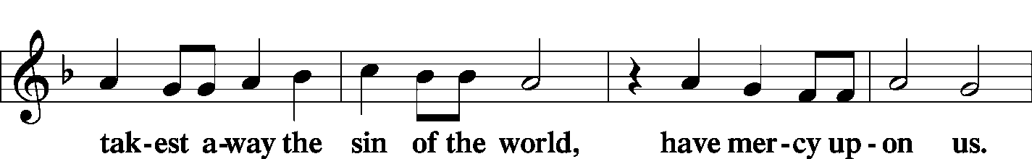
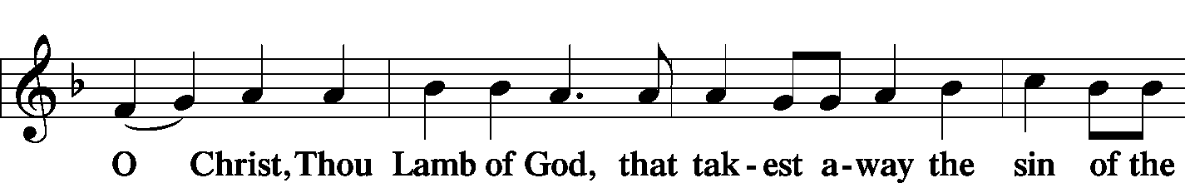

Sit

Distribution
Zion Lutheran practices the policy of close communion, communing only those who share our common Biblical view of the Lord's Supper. If you are not a confirmed LCMS Lutheran, please confer with the pastor before communing.

The pastor and those who assist him receive the body and blood of Christ first and then distribute them to those who come to receive, saying:

Take, eat; this is the true body of our Lord and Savior Jesus Christ, given into death for your sins.
Amen.

Take, drink; this is the true blood of our Lord and Savior Jesus Christ, shed for the forgiveness of your sins.
Amen.
Hymn Lord Jesus Christ, We Humbly Pray LSB 623

Hymn Draw Near and Take the Body of the Lord LSB 637

Hymn Eat This Bread LSB 638

Stand

In dismissing the communicants, the following is said:

The Dismissal
P The body and blood of our Lord Jesus Christ strengthen and preserve you in body and soul to life everlasting. Depart T in peace.
C Amen.

Nunc Dimittis LSB 199
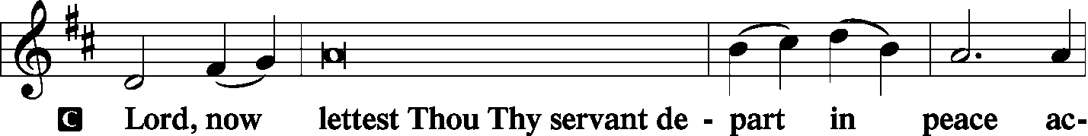
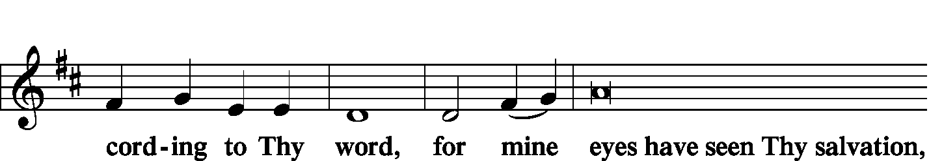
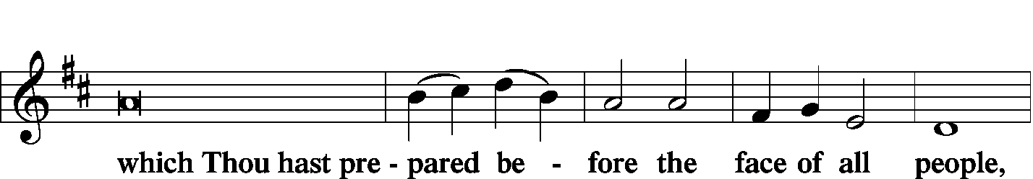
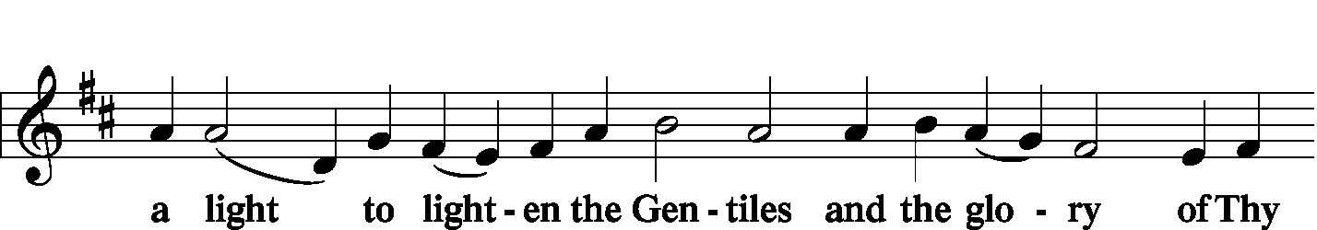
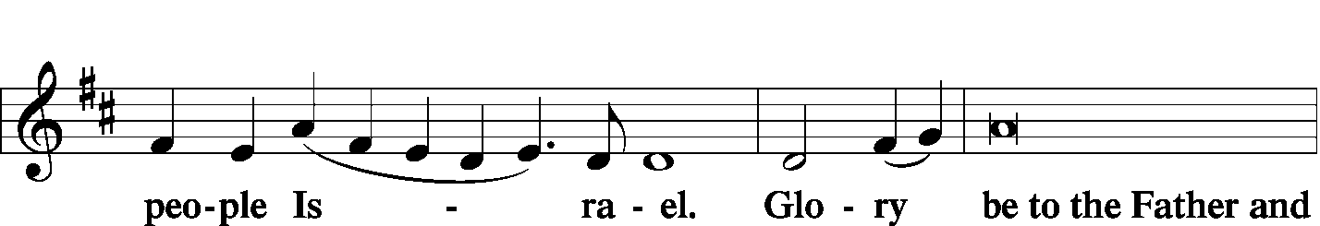
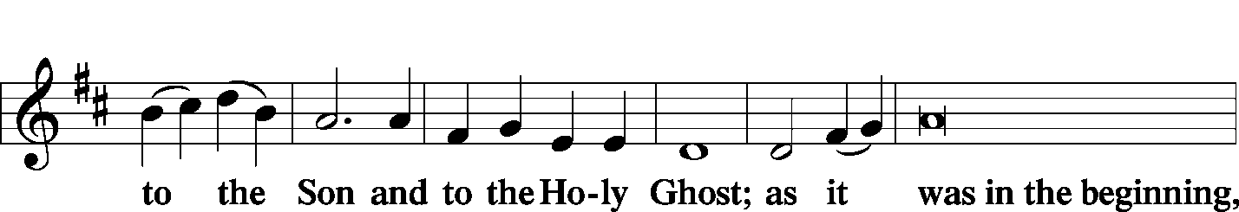
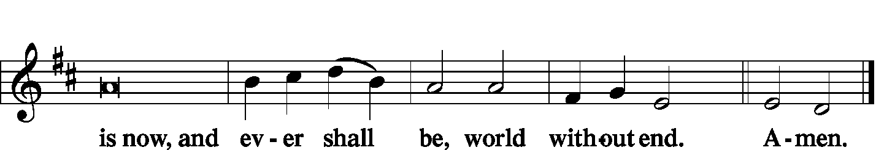

Thanksgiving LSB 200
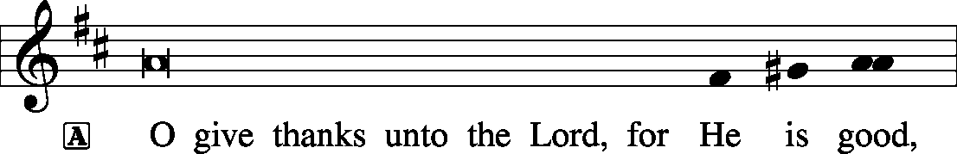

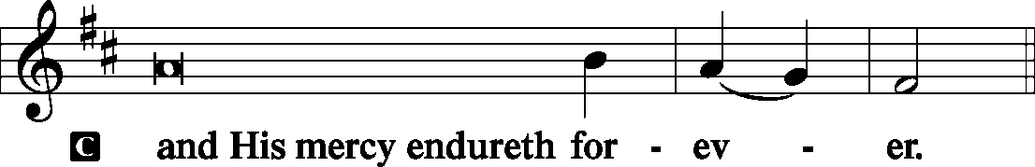

Post-Communion Collect
P Let us pray.
We give thanks to You, almighty God, that You have refreshed us through this salutary gift, and we implore You that of Your mercy You would strengthen us through the same in faith toward You and in fervent love toward one another; through Jesus Christ, Your Son, our Lord, who lives and reigns with You and the Holy Spirit, one God, now and forever.

Salutation and Benedicamus
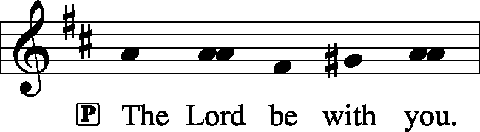

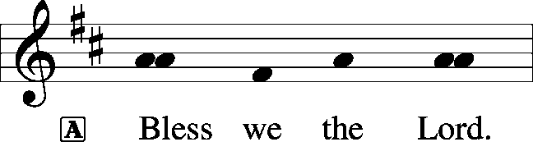

Benediction LSB 202
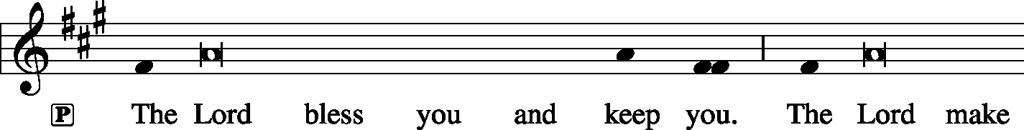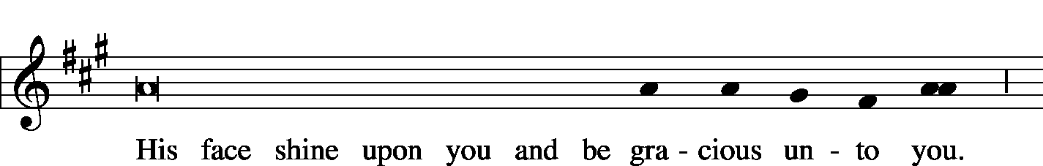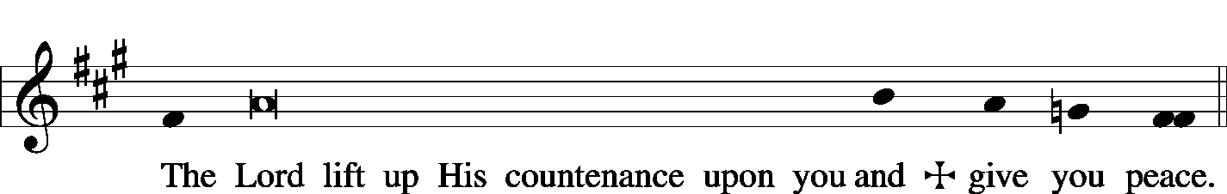

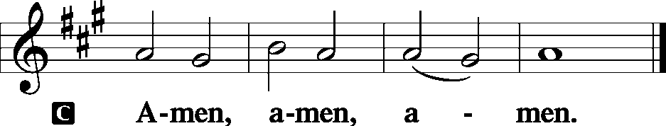

Sit

Hymn Thine the Amen, Thine the Praise LSB 680

Acknowledgments
Unless otherwise indicated, all scripture quotations are from The Holy Bible, English Standard Version, copyright © 2001 by Crossway Bibles, a division of Good News Publishers. Used by permission. All rights reserved. Created by Lutheran Service Builder © 2006 Concordia Publishing House.
LIFE AND LIVING ITEMS AT ZION
          

THE FLOWERS ON THE LORD’S ALTAR
The flowers on the Lord’s altar are given to the glory of God by the Timmerman’s, in honor of their daughter, Mary.

ATTENDANCE OCTOBER 6: Sunday: 163
Adult Bible Class: 27 High School: 9 Sunday School: 36

NEW CHRISTIAN GREETING CARDS
Lots of new greeting cards just came in! There are many new choices in every category –birthday, get well, sympathy, and more. All for only 50 cents each!

FEED THE FIELDWORKERS
Two new spreadsheets are available for you to invite seminary student fieldworkers, Don Stein and his family, and/or Adam and Morgan Wolfe to join you for your Sunday lunch at home or out. Please sign your name on one of the spreadsheets on the counter by the flower calendar. Let's show them Zion's hospitality!

ZION FALL FEST 2019
"The joy of the Lord is your strength." Nehemiah 8:10. Jesus Brings S'more Joy! The Board of Education invites you to attend Fall Fest on October 20th from 2-4 PM. Enjoy walking tacos, s'mores, and more! There will be face painting, caricature drawings, fire pits, bounce slide, and more. Youth group members will team up for a geocache hunt starting at 2:15 while the younger kids participate in crafts, a puppet show, and yard games. Bring a lawn chair and enjoy S'more fun and fellowship at Zion. If you would like to chaperone a geocache team or supervise an activity, please sign up in the narthex. If we have enough volunteers, we can have one hour shifts so you can still enjoy the activities. Also, if you have yard games or a fire pit to share, please note that on the sign-up sheet.

BIBLE STUDY SURVEY
Do you have any Bible Study Topics that you would like the church to offer in the future? Then please write those topics on the note cards placed in the hymnal rack by the members need offering envelopes. Topics can be anything you have a desire to study with your church family, even if we have studied your topic of interest previously. (Examples: marriage, retirement, parenting, money, temptation, courage, teenage/young adult Christian life, prophecy/end times, life of Job, creation vs. science, historical evidence of the Bible, etc.). These Bible studies may occur Sunday mornings, but they could also occur at alternative times as well. So, if you have a preference for an alternative time for Bible study (Sunday evenings, weekday mornings, or weekday evenings) please include that on your note card. If you would be interested in an online/over your smart phone video Bible study or devotions please indicate that as well. If you are interested in certain group based studies please indicate this as well on the note card (examples: men's, women's, senior, widow, singles, young adult, teenage, etc.). This survey is to help us as a church attempt to provide Bible studies that you may be interested in. It may take some time to get to all the study requests, but our goal is for everyone to be involved in a weekly Bible study. Please place your note card in the glass offering jars as you leave church or present them to your elder. Please let your elder know of any future Bible Study requests that you may have even if you do not have any at this time. Elder - Matt Sink

HARVEST TABLE
It’s harvest time again! Check the harvest table in the Narthex. Bring an extra vegetable or fruit from your garden, you can trade for another or buy the item with a donation to Concerned Christians.

DOMINICAN REPUBLIC MISSION TRIP
Zion Mascoutah is looking seriously into sponsoring/sending a short term mission team to the Dominican Republic. This project has been discussed by the Evangelism Committee, the Board of Elders, and the Church Council, and it is time to take action. Over the next few weeks, a flier will be placed in the bulletin with short-term mission team volunteer opportunities. If you are interested in participating in a trip, starting next week when the fliers are inserted in the bulletin, please circle which trip you would be most interested in doing, and sign your name so we can gauge where to apply our resources first. Short-term mission teams in the Dominican Republic typically consist of 8-10 people, and the trips run for one week, usually from Saturday to Saturday. Teams are assembled for specific purposes or themes, and have a set workload to be accomplished during the week. For next year, five different types of teams are possible, based on what the preference and interest of Zion is. The five types of trips are: EDUCATIONAL SUPPORT TEAM--Support education in the church’s two Lutheran schools and/or local public schools; HEALTH OUTREACH TEAM--Spend a week engaging in various outreach activities related to health (spiritual, mental, emotional, physical) and the promotion and preservation of life from conception to natural death; PLAYGROUND RENOVATION TEAM--Renovate two playgrounds (one for little kids and one for older kids) in Palmar Arriba; VACATION BIBLE SCHOOL TEAMS--Lead a week-long Vacation Bible School (Bible stories, crafts, games, music, snacks, etc.) at one of the local Lutheran congregations; and VOLLEYBALL CAMP TEAM--Lead a week-long volleyball camp for children & youth at Iglesia Luterana Amigos de Cristo. While volleyball skills and fundamentals should be the focus, traditional VBS elements like Bible stories, songs, games, snacks, and crafts may be included. Your team may also be able to assist with cleaning/preparing an unpaved, overgrown area near the church to be used as an outdoor play space. The cost per person for the week, including round-trip airfare, housing, and food for any of these mission trip options is likely to be about $1600. Dates are not yet set, but a timeframe shortly after school ends, late May or early June, might be a strong possibility. If you are interested in serving in one of these areas on a short-term mission team to the Dominican Republic, please begin to prayerfully consider how you might become more personally involved in our Lord’s mission work. Starting next week, you will have the opportunity to indicate your preferences as to how to serve by submitting a flier from the bulletin. Pray, and be prepared to volunteer!

2020 CHRISTIAN-THEMED CALENDARS NOW AVAILABLE
Zion’s Ladies Aid is selling Christian themed 2020 wall calendars. They are $6 each and are located on the table in the Narthex. There are a limited number so get yours today!

PLEASE PRAY FOR UNITY SCHOOL, EAST ST. LOUIS
The school ministry at Unity School, East St. Louis is under the direction of Rev. Aaron Dickerson, who serves as the School Principal. Pray for the students' growth both in their studies and in their faith in Jesus. Please also pray especially for the financial challenges of the school and the ongoing efforts to find a new development director. Thanks for your prayers!

UNITY EAST ST. LOUIS WORK DAY SATURDAY, OCTOBER 26th
Unity Lutheran Church in East St. Louis, and its partner, Lansdowne Community Initiative, will be hosting a work day on Saturday, October 26th. Work crews are asked to meet in the parking lot of Unity Lutheran Church, 4200 Caseyville Ave, East St Louis, IL 62204, at 9:00 AM. Work projects for the day include final clean up on a home owned by the church that has been rehabbed and will be occupied soon, and some neighborhood cleanup as well. If you have them, bring cleaning supplies, trimmers, rakes, gloves, etc. Lunch will be provided at Unity Lutheran Church. The rehab work to be completed has been made possible by a grant from the Lutheran Foundation of St. Louis, and those funds are also being used to purchase a second house directly across the street from the church that will need minimal work to clean and prepare for occupancy. The Lansdowne Community Initiative has also received a $10,000 dollar-for-dollar matching grant to support the effort and to purchase and rehab additional homes. Donations to meet this matching grant would be welcome! If you cannot come to work in person, please help meet the matching grant by sending a check to Lansdowne Community Initiative, 4200 Caseyville Ave, East St Louis, IL 62204. And, if you are able to help with the work day, please assemble a crew from your congregation to meet at Unity Lutheran Church on Saturday, October 26th. Thanks in advance for all assistance given!

HSHS ST. JOSEPH’S HOSPITAL BREESE FALL HEALTH FAIR
Pre-registration is open for HSHS St. Joseph’s Hospital Breese’s upcoming Fall Health Fair screenings. The screening will take place from 6-10 AM. The community is recommended to pre-register for the event. However, this year, on-site registration will only be available from 8-10 AM. The scheduled date and location are as follows: Wednesday, October 23 at the Germantown Legion–Register by October 16. Registration forms are available at the hospital’s front desk, the HealthPlex, local doctors’ offices, local libraries and on the hospital’s web site, stjoebreese.com/healthfairs. The 2019 Health Fair form must be received at the hospital one week before the health fair you plan to attend. Do not submit payment with the form, payment will be collected when you arrive at the Health Fair you are attending. The form may be dropped off at the hospital’s front entrance desk, faxed to 618-526-1404, mailed to “Health Fair, PO Box 99, Breese, IL 62230,” or emailed to sjb.healthfair@hshs.org. Pre-registration is highly recommended, on-site registration the day of the event will also be available from 8 to 10 a.m. For other registration information or questions regarding the health fair, please call Chris at 618-526-5351. For more information about HSHS St. Joseph’s Hospital Breese’s 2019 Health Fair, call 618-526-5351 or visit sjb.healthfair@hshs.org.

HELP FEED MY STARVING CHILDREN -- SATURDAY
Volunteers age 5+ are needed to help hand-pack nutritious MannaPack™ meals, specifically designed to assist in reversing and preventing undernutrition throughout the world, at a MobilePack™ event that Thrivent is sponsoring with Feed My Starving Children on Saturday, Oct 19th from 8-11 AM at Good Shepherd Lutheran Church, 327 Woods Mill Road, Ballwin, MO. This is a great, family friendly, volunteer opportunity. The event is FREE and breakfast will be served. Guests do not need to be a Thrivent Financial member to participate. Wear a LIVE GENEROUSLY t-shirt to the event and the Thrivent Member Network will donate $3 to Feed My Starving Children on your behalf. Please register at TAMM.Eventbrite.com.

69th ANNUAL SAUSAGE SUPPER
Please join us for our 69th Annual Sausage Supper on Sunday, October 27th from Noon – 6 PM at Trinity’s Parish Hall, 219 McGaughey St., Worden, IL. Adults are $10, children 6-12 are $4, children 1-5 are free, and carry-outs are $10. Liver, pork, blood sausage, ribs, and backbones will be sold at the Parish Hall on Friday from 8 AM – 5 PM and Saturday from 8 AM – Noon.

ST. JOHN’S UCC BEEF AND NOODLE DINNER
St. John’s UCC in Mascoutah is hosting their “All You Can Eat” Beef and Noodle Dinner on Friday, November 1st. Lunch will be served from 11 AM to 1 PM and dinner from 5 PM to 7 PM. Adults are $10, children 6-12 are $3, and children under 6 are free. Carry-outs are available. Benefits go to the Senior Center and Leu Civic Center.

OSBORNE FAMILY CHICKEN & BEER BENEFIT
Richard “Dickie” Osborne lost his life after injuries sustained from a motorcycle accident on July 26th. We would like to come together as a community to raise money to help alleviate the financial burden for his wife, Whitney, and his son Wyatt. Come out and celebrate Dickie’s life and raise money for his family. The benefit will take place on November 9th at the Mascoutah Sportsmen’s Club beginning at 5 PM. Advance tickets are $20 for adults and $5 for kids. Tickets at the door are $25 for adults and $8 for kids. Bring your own snacks and soft drinks. Silent auction closes at 8:30 PM. For more information email osbornefamilybenefit@gmail.com.

LISTEN TO WORLDWIDE KFUO AM850
KFUO Radio, AM850, a media ministry extension of LCMS congregations, shares Christ for you anytime, anywhere on AM850 via worship services, Bible and theology studies, practical talk programs, and sacred music. You can find programs on demand at kfuo.org and wherever you get your podcasts! Find us on social: @KFUOradio on Facebook, Twitter, and Instagram. This week on KFUO AM850, begin a new mini-series on Sharper Iron in Amos titled "The Day Is Surely Drawing Near" (weekdays at 8:00 a.m.), study Isaiah 21-25 on Thy Strong Word (weekdays at 11:00 a.m.), and hear about a mental health topic on Mental Health Mondays on The Coffee Hour (10/14 at 9:00 a.m.). Find your favorite podcasts, including the new Lutheran Ladies' Lounge, at kfuo.org or on your podcast app!

ISSUES, ETC.
We are proud to announce the production of a new podcast hosted by one of your favorite guests, Pastor Will Weedon. The Word of the Lord Endures Forever debuts on Reformation Day, October 31st. The Word of the Lord Endures Forever is a short-form, daily, verse-by-verse Bible study.
THOSE WHO SERVE TODAY
Proclaimer: Rev. Kirk Clayton
Liturgist: Sem. Adam Wolfe
Liturgist: Sem. Don Stein
Organist: Pinky Ahner
Ushers: Bob Walter, Dale Wehmeyer, Eldon Ahner, & Ted Ahner
Sound Tech: Lionel Timmerman
Video Tech: Mark Hatcher
Welcome Team: Ray McDaniel & Carolyn Overmyer
Acolytes: Isaac Robinson & Luke Lara
Altar Guild: Jenny Kneschke

THOSE WHO SERVE NEXT WEEK, OCTOBER 20
Proclaimer: Rev. Kirk Clayton
Liturgist: Sem. Adam Wolfe
Liturgist: Sem. Don Stein
Organist: Nancy Peterson
Ushers: Karl Bretz, Joe Crismon, Bob Eldridge, & Ken Frey
Sound Tech: Mike Segelhorst
Video Tech: Mark Hatcher
Welcome Team: Dan & Amy Morra
Acolytes: Elizabeth Bretz & Makena Suedmeyer

THINGS WE ARE DOING AT ZION
Sun. Confirmation Class 8:30 AM
SS & Bible Class 8:45 AM
Worship DS III w/communion 10:00 AM
Men’s Club 6:30 PM
Mon. ECHO DEADLINE
Columbus Day – Office Closed; No Preschool
LifeLight 7:00 PM
Tues. Evangelism 7:00 PM
Wed. Choir Rehearsal 7:00 PM
New Member Class 7:00 PM
Thurs. Youth Bible Study 6:00 PM
Exec Board 6:30 PM
LWML Meeting 7:00 PM
Trustees Meeting 7:00 PM
Fri. Senior Meal Delivery 10:30 AM
Sun. Confirmation Class 8:30 AM
SS & Bible Class 8:45 AM
Worship Matins 10:00 AM
Zion Fall Fest 2:00 – 4:00 PM

