Zion Lutheran Church
Mascoutah, Illinois
October 6, 2019
16th Sunday after Trinity
LWML Sunday

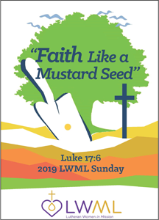

In the Name of Christ Jesus our Lord, we bid you a warm welcome to this worship service. May your experience of worship and fellowship this morning be spiritually refreshing and ready you for the week ahead.

Pastor: Rev. Kirk Clayton
Church Secretary: Robin Phillips
Choir Director Team: Josh and Nancy Peterson
_________________________________________________________________________________
Church Office Phone: 618-566-7345
Pastor Clayton Cell: 618-447-1306
Office Hours: 8:00 am to 12:00 pm
Email: ChurchOffice@ZionMascoutah.org
Pastor Clayton email: Pastor@ZionMascoutah.org
Web site: www.ZionMascoutah.org
Find us at @ZionMascoutah on Facebook, Twitter, and Instagram
Electronic Devices
Please TURN OFF all cell phones, pagers, electronic devices, apps and games when entering the sanctuary for worship so those around you may focus on the Word of God without electronic distraction. Thank you.

A Prayer to Begin Worship
Holy God, in whose hands are the issues of life and death for every person, we commit our mortality to Your wisdom and plan and our immortality to Your loving care with the prayer that while we are living in time we may be the Holy Spirit’s instruments for bringing new life to all the spiritually dead whose lives touch ours; through Jesus Christ, our Lord, who with You and the Holy Spirit are one God with dominion over us forever.

DIVINE SERVICE II
LSB p. 167
Confession and Absolution

Prelude Be Still My Soul Sibelius/Cronham

Hymn O Worship the King LSB 804

Stand

The sign of the cross may be made by all in remembrance of their Baptism.

Invocation
P In the name of the Father and of the T Son and of the Holy Spirit.
C Amen.

Exhortation
P If we say we have no sin, we deceive ourselves, and the truth is not in us.
C But if we confess our sins, God, who is faithful and just, will forgive our sins and cleanse us from all unrighteousness.

Silence for reflection on God's Word and for self-examination.

Confession with Absolution
P Let us then confess our sins to God our Father.
C Most merciful God, we confess that we are by nature sinful and unclean. We have sinned against You in thought, word, and deed, by what we have done and by what we have left undone. We have not loved You with our whole heart; we have not loved our neighbors as ourselves. We justly deserve Your present and eternal punishment. For the sake of Your Son, Jesus Christ, have mercy on us. Forgive us, renew us, and lead us, so that we may delight in Your will and walk in Your ways to the glory of Your holy name. Amen.

P Almighty God in His mercy has given His Son to die for you and for His sake forgives you all your sins. As a called and ordained servant of Christ, and by His authority, I therefore forgive you all your sins in the name of the Father and of the T Son and of the Holy Spirit.
C Amen.

Service of the Word
Introit Ps. 86:1, 7, 12–13; antiphon: Ps. 86:3, 5
P Be gracious to me, O Lord,
C for to You do I cry all the day.
P For You, O Lord, are good and forgiving,
C abounding in steadfast love to all who call upon You.
P Incline Your ear, O Lord, and answer me,
C for I am poor and needy.
P In the day of my trouble I call upon You,
C for You answer me.
P I give thanks to You, O Lord my God, with my whole heart,
C and I will glorify Your name forever.
P For great is Your steadfast love toward me;
C You have delivered my soul from the depths of Sheol.
Glory be to the Father and to the Son
and to the Holy Spirit;
as it was in the beginning,
is now, and will be forever. Amen.
P Be gracious to me, O Lord,
C for to You do I cry all the day.
P For You, O Lord, are good and forgiving,
C abounding in steadfast love to all who call upon You.

Kyrie LSB 168
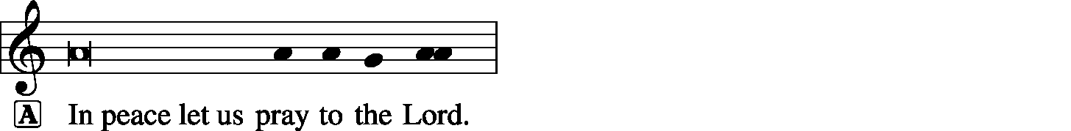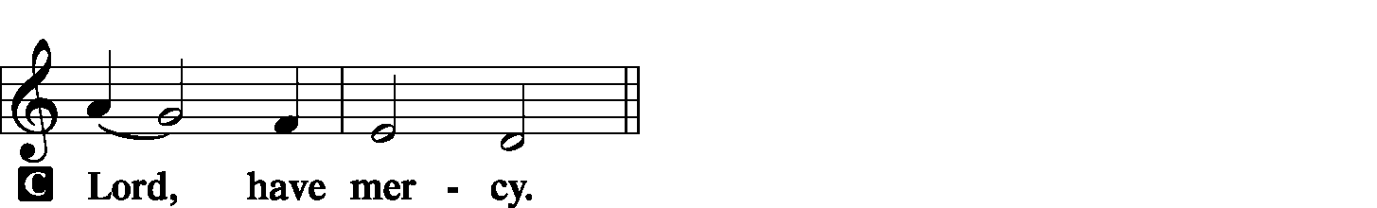

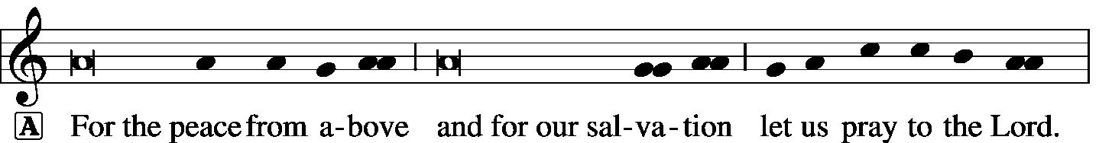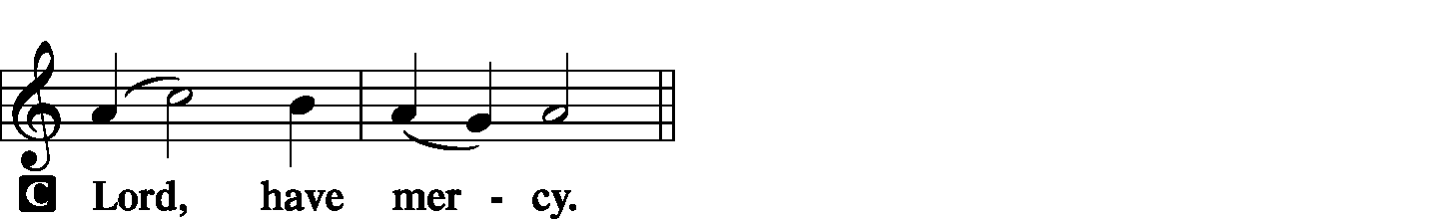

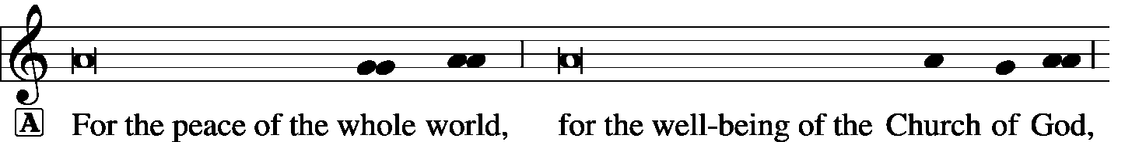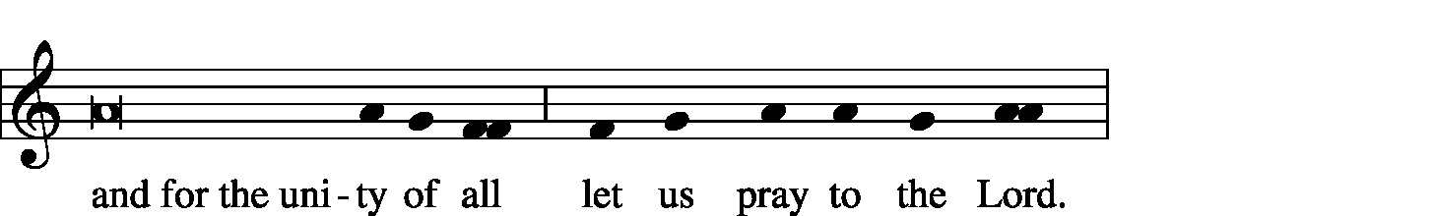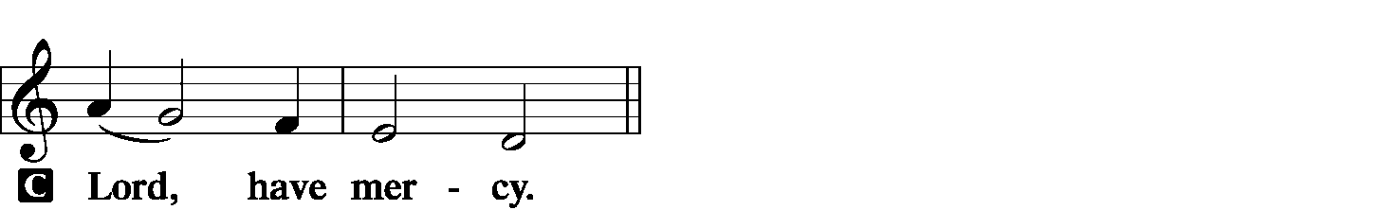

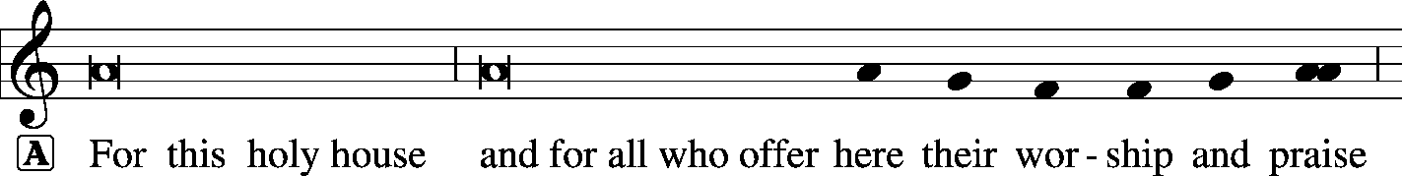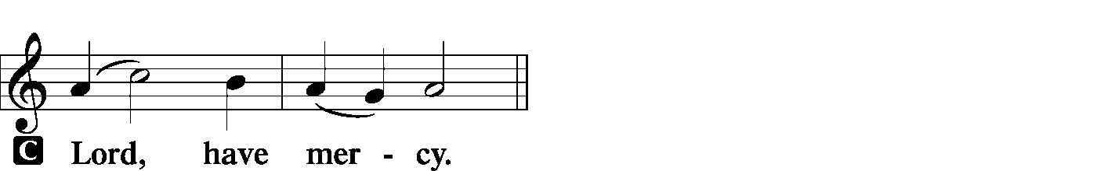

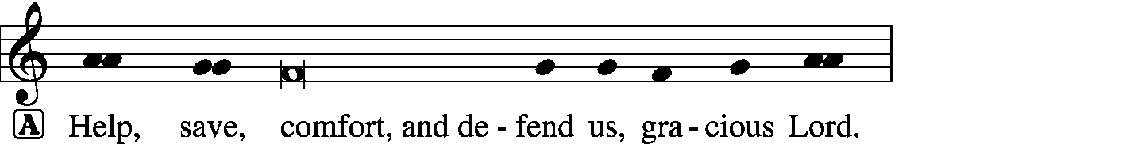
Hymn of Praise -- This is the Feast LSB 171
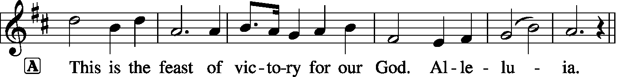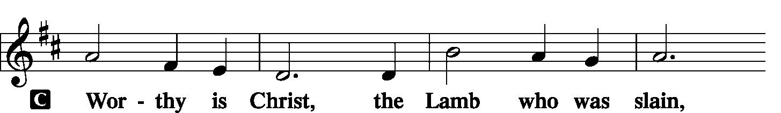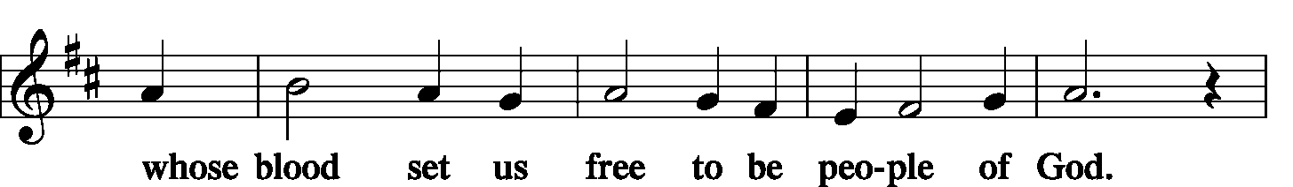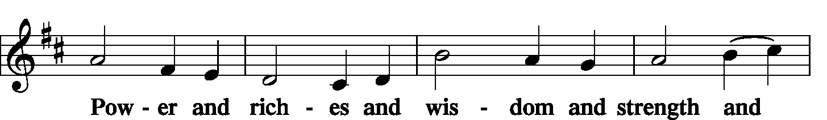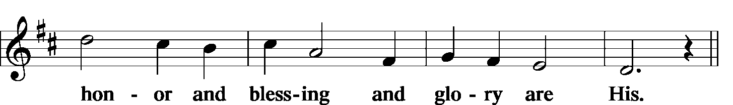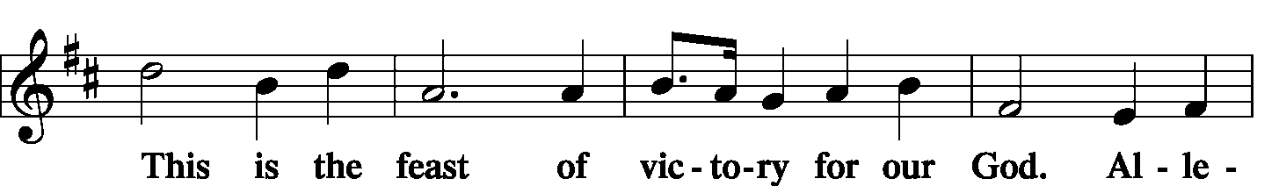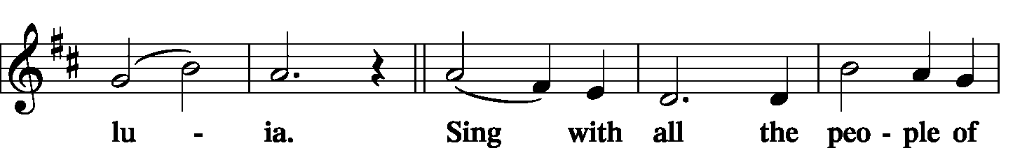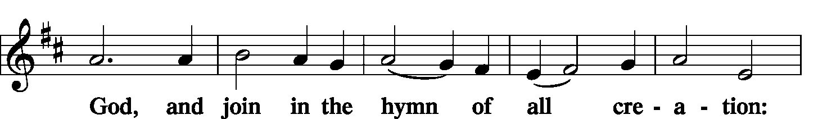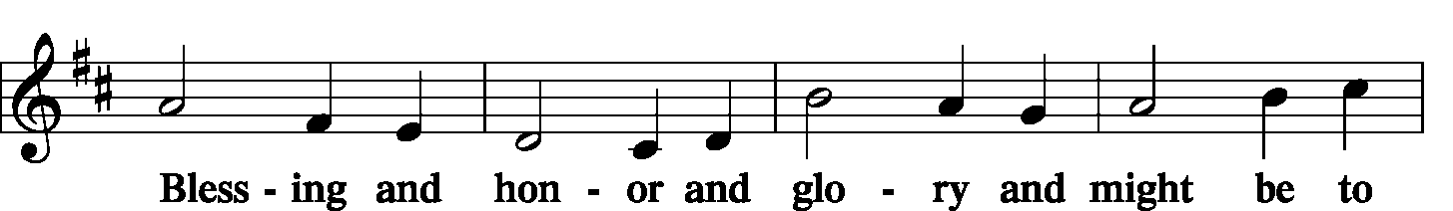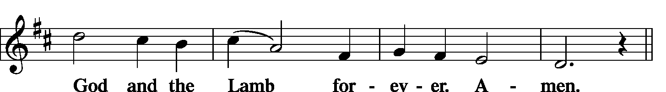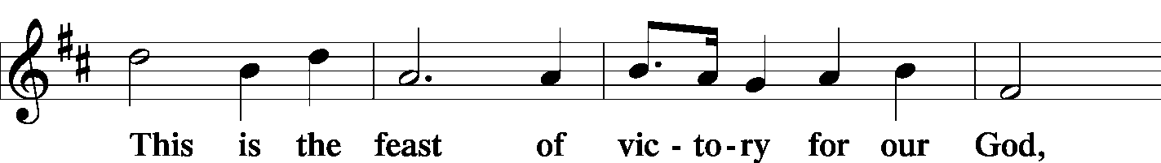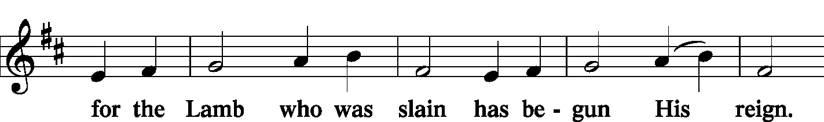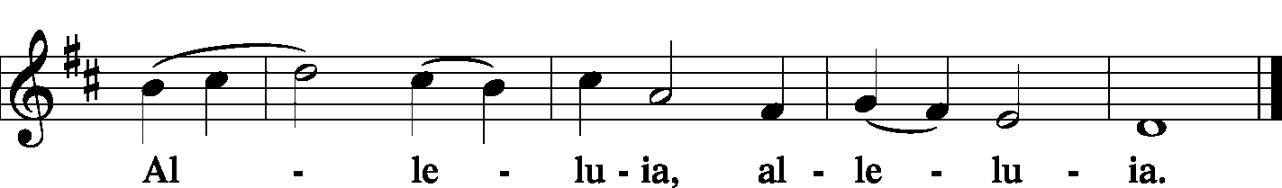
Salutation and Collect of the Day
P The Lord be with you.
C And also with you.
P Let us pray.
O Lord, we pray that Your grace may always go before and follow after us, that we may continually be given to all good works; through Jesus Christ, Your Son, our Lord, who lives and reigns with You and the Holy Spirit, one God, now and forever.
C Amen.

Sit

Hymn Be Still, My Soul LSB 752

Old Testament Reading 1 Kings 17:17-24
After this the son of the woman, the mistress of the house, became ill. And his illness was so severe that there was no breath left in him. And she said to Elijah, “What have you against me, O man of God? You have come to me to bring my sin to remembrance and to cause the death of my son!” And he said to her, “Give me your son.” And he took him from her arms and carried him up into the upper chamber where he lodged, and laid him on his own bed. And he cried to the Lord, “O Lord my God, have You brought calamity even upon the widow with whom I sojourn, by killing her son?” Then he stretched himself upon the child three times and cried to the Lord, “O Lord my God, let this child’s life come into him again.” And the Lord listened to the voice of Elijah. And the life of the child came into him again, and he revived. And Elijah took the child and brought him down from the upper chamber into the house and delivered him to his mother. And Elijah said, “See, your son lives.” And the woman said to Elijah, “Now I know that you are a man of God, and that the word of the Lord in your mouth is truth.”
P This is the Word of the Lord.
C Thanks be to God.

Choir Be Strong in the Lord Thomas Matthews

Epistle Ephesians 3:13-21
So I ask you not to lose heart over what I am suffering for you, which is your glory.
For this reason I bow my knees before the Father, from whom every family in heaven and on earth is named, that according to the riches of His glory He may grant you to be strengthened with power through His Spirit in your inner being, so that Christ may dwell in your hearts through faith—that you, being rooted and grounded in love, may have strength to comprehend with all the saints what is the breadth and length and height and depth, and to know the love of Christ that surpasses knowledge, that you may be filled with all the fullness of God.
Now to Him who is able to do far more abundantly than all that we ask or think, according to the power at work within us, to Him be glory in the church and in Christ Jesus throughout all generations, forever and ever. Amen.
P This is the Word of the Lord.
C Thanks be to God.

Stand

Alleluia and Verse
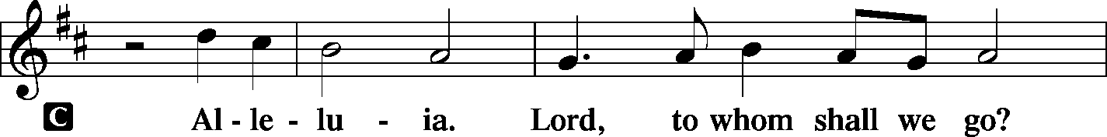
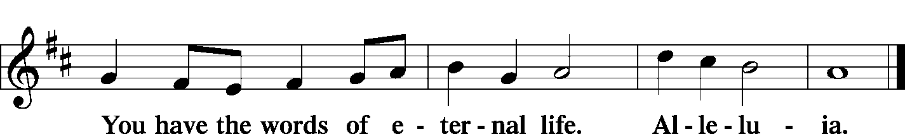

Holy Gospel Luke 7:11-17
L The Holy Gospel according to St. Luke, the 7th chapter.
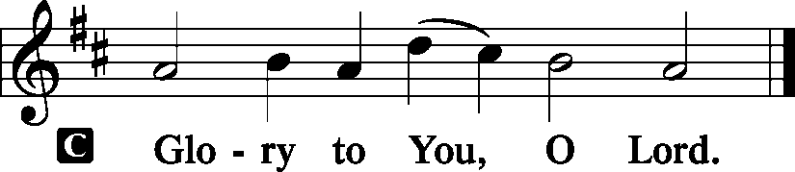
Soon afterward [Jesus] went to a town called Nain, and His disciples and a great crowd went with Him.
As He drew near to the gate of the town, behold, a man who had died was being carried out, the only son of his mother, and she was a widow, and a considerable crowd from the town was with her. And when the Lord saw her, He had compassion on her and said to her, “Do not weep.” Then He came up and touched the bier, and the bearers stood still. And He said, “Young man, I say to you, arise.” And the dead man sat up and began to speak, and Jesus gave him to his mother. Fear seized them all, and they glorified God, saying, “A great prophet has arisen among us!” and “God has visited His people!” And this report about Him spread through the whole of Judea and all the surrounding country.
L This is the Gospel of the Lord.
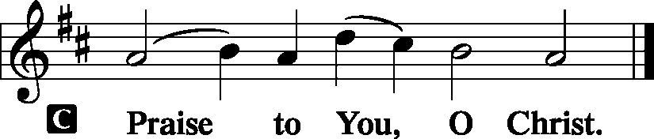
Sit

Children's Lunchbox Devotion

Hymn O Love, How Deep LSB 544

Sermon A New Lease on Life

Stand

Apostles' Creed
C I believe in God, the Father Almighty, maker of heaven and earth.
And in Jesus Christ, His only Son, our Lord, who was conceived by the Holy Spirit, born of the virgin Mary, suffered under Pontius Pilate, was crucified, died and was buried. He descended into hell. The third day He rose again from the dead. He ascended into heaven and sits at the right hand of God the Father Almighty. From thence He will come to judge the living and the dead.
I believe in the Holy Spirit, the holy Christian Church, the communion of saints, the forgiveness of sins, the resurrection of the body, and the life T everlasting. Amen.

Sit (LWML members remain standing)

LWML Sunday Recognition

The League Pledge
C In fervent gratitude for the Savior's dying love and His blood-bought gift of redemption, we dedicate ourselves to Him with all that we are and have; and in obedience to His call for workers in the harvest fields, we pledge Him our willing service wherever and whenever He has need of us. We consecrate to our Savior our hands to work for Him, our feet to go on His errands, our voice to sing His praises, our lips to proclaim His redeeming love, our silver and our gold to extend His Kingdom, our will to do His will, and every power of our life to the great task of bringing the lost and the erring into eternal fellowship with Him. Amen.

Offering
[Please fill out a sheet in the attendance book. Visitors, please include your address. If you have a prayer request for the church prayer chain, please write it at the top of the sheet.]

Special Offering Music On Eagle’s Wings
(Emily Stein, soloist)

Stand

Offertory LSB 176
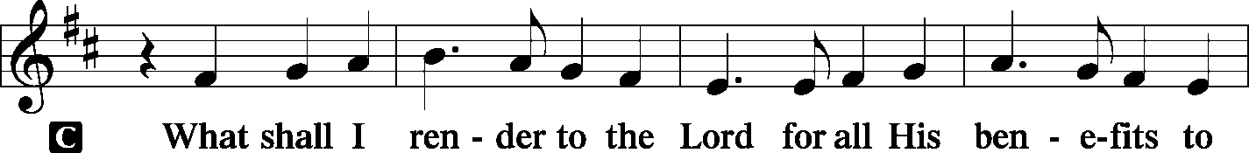
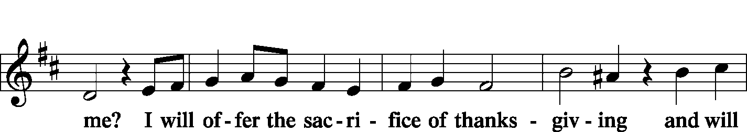
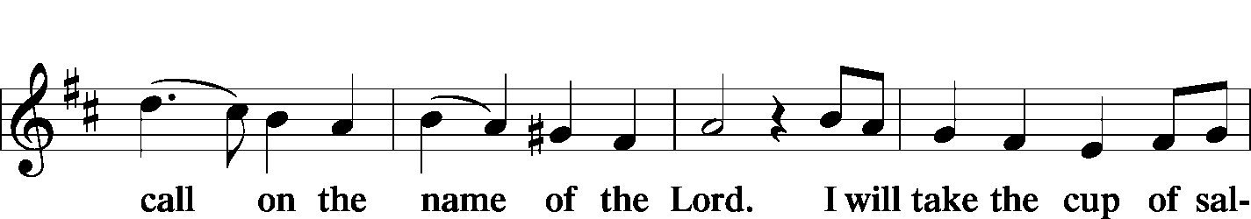
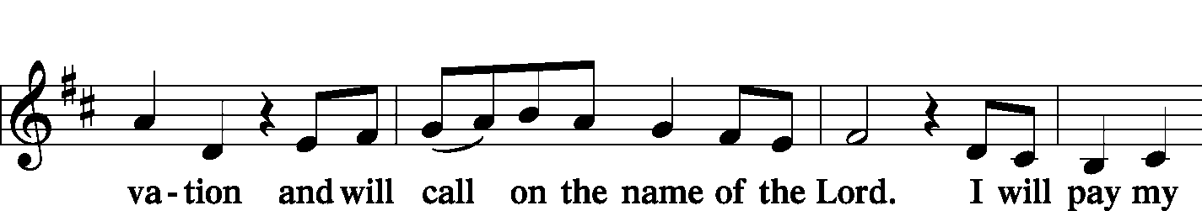
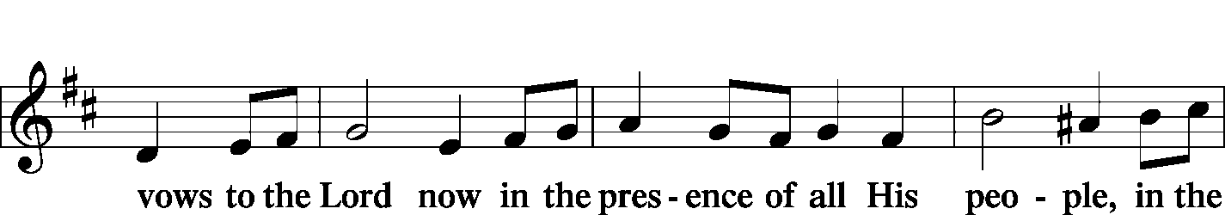
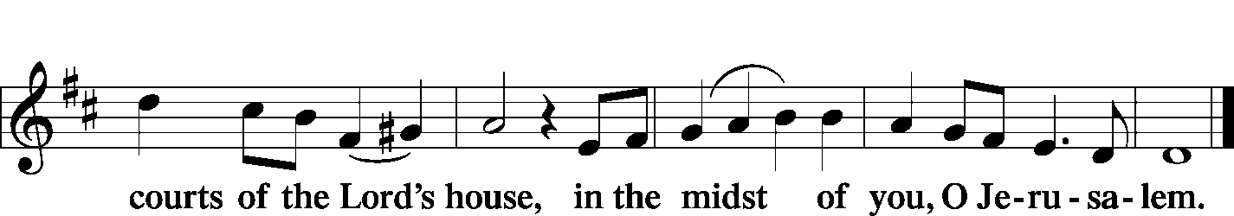

Prayer of the Church
P Lord God, heavenly Father, we come before You with thanksgiving and praise.
C We praise You for our creation, preservation, and redemption.
P We thank You for raising Your Son Jesus Christ from the dead and for preparing a place eternal in the heavens for all who trust in Your Son as their Savior.
C For sending us Your Holy Spirit so that we might know Jesus Christ as Lord, we give You thanks.
P We confess, O Lord, that we have often attempted to hide from You.
C Our sins have often broken the lines of communication between us.
P We claim to be Your children through faith in Christ, but we have often failed to do Your will.
C We have not always behaved as members of Your family and have often permitted Satan to drive a wedge of division between us.
P For giving the world the impression that Your kingdom is divided against itself,
C forgive us, O Lord.
P May Your Holy Spirit never leave us or forsake us.
C When we stray from Your fold graciously search us out and find us.
P When troubles and afflictions seem greater than we can bear,
C help us to remember that our mortal bodies are only the temporary dwelling place of Your Spirit.
P Keep in our hearts and minds the assurance that You have built for us a house eternal in the heavens.
C When the time of our departure from this earth draws near, take us to live with You eternally.

WE GO TO THE LORD IN PRAYER FOR
- Justin Linn, Derek Schanz, Austin Tanck, Ken Knutson, Jeff Zimmermann, and Kurt Spomer, as they celebrate their baptismal anniversaries this week.
- The work of the LWML in the congregation and around the world.
- The campus ministry SIU-Edwardsville with Bessie Fick and Rev. John Shank, including a Bible Conversation study with international students and a new Bible Study for commuting students.
- Zion’s Elders, Board of Education, Sunday School staff, and Evangelism Committee.
- Faithfulness in our lives as Christian Stewards.

P We pray for our leaders in both state and church.
C We ask these favors, O Lord, in the name of Jesus Christ, our Lord and Savior. Amen.

Lord's Prayer LSB 179
P Lord, remember us in Your kingdom and teach us to pray:
C Our Father who art in heaven, hallowed be Thy name, Thy kingdom come, Thy will be done on earth as it is in heaven; give us this day our daily bread; and forgive us our trespasses as we forgive those who trespass against us; and lead us not into temptation, but deliver us from evil. For Thine is the kingdom and the power and the glory forever and ever. Amen.

Collect
P Blessed Lord, since You have caused all Holy Scriptures to be written for our learning,
C Grant that we may so hear them, read, mark, learn and take them to heart that by patience and comfort of Your holy Word we may embrace and ever hold fast the blessed hope of everlasting life;
P Through Jesus Christ, Your Son, our Lord, who lives and reigns with You and the Holy Spirit, one God, now and forever.
C Amen.

Benediction LSB 183
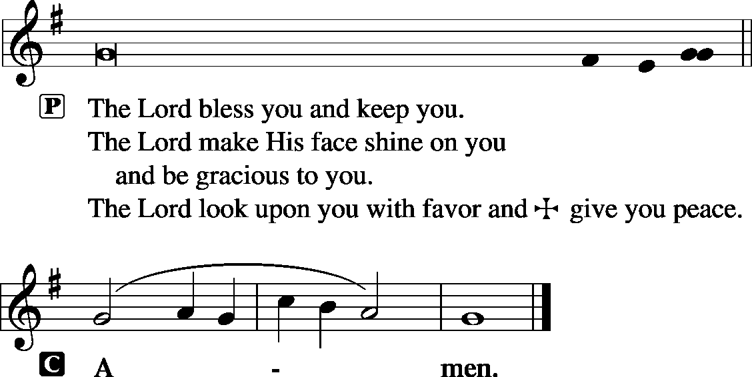

Remain standing

Hymn Immortal, Invisible, God Only Wise LSB 802

Acknowledgments
Unless otherwise indicated, all scripture quotations are from The Holy Bible, English Standard Version, copyright © 2001 by Crossway Bibles, a division of Good News Publishers. Used by permission. All rights reserved. Created by Lutheran Service Builder © 2006 Concordia Publishing House.

LIFE AND LIVING ITEMS AT ZION
          

THE FLOWERS ON THE LORD’S ALTAR
The flowers on the Lord’s altar are given to the glory of God in honor of LWML Sunday and by Jennifer Trame in celebration of her birthday.

SATURDAY FAMILY MOVIE RESTARTS THIS SATURDAY
The Men’s Club will present C.S. Lewis’ timeless and beloved adventure Narnia: The Lion, the Witch and the Wardrobe for kids of all ages on Saturday, October 12th at 2:30 PM. Join us in the church basement for a free movie, soda, candy, and popcorn.

UNITY EAST ST. LOUIS WORK DAY SATURDAY, OCTOBER 26th
Unity Lutheran Church in East St. Louis, and its partner, Lansdowne Community Initiative, will be hosting a work day on Saturday, October 26th. Work crews are asked to meet in the parking lot of Unity Lutheran Church, 4200 Caseyville Ave, East St Louis, IL 62204, at 9:00 AM. Work projects for the day include final clean up on a home owned by the church that has been rehabbed and will be occupied soon, and some neighborhood cleanup as well. If you have them, bring cleaning supplies, trimmers, rakes, gloves, etc. Lunch will be provided at Unity Lutheran Church. The rehab work to be completed has been made possible by a grant from the Lutheran Foundation of St. Louis, and those funds are also being used to purchase a second house directly across the street from the church that will need minimal work to clean and prepare for occupancy. The Lansdowne Community Initiative has also received a $10,000 dollar-for-dollar matching grant to support the effort and to purchase and rehab additional homes. Donations to meet this matching grant would be welcome! If you cannot come to work in person, please help meet the matching grant by sending a check to Lansdowne Community Initiative, 4200 Caseyville Ave, East St Louis, IL 62204. And, if you are able to help with the work day, please assemble a crew from your congregation to meet at Unity Lutheran Church on Saturday, October 26th. Thanks in advance for all assistance given!

MEMBER NEEDS FUND ENVELOPES
Zion's Elders maintain and administer a fund to help members of the congregation who are facing financial difficulties. "Member Needs Fund" envelopes are available in the pews, they are the small manila envelopes in the holders next to the hymnal racks. If you would like to make a donation to the Member Needs Fund, place your donation in the marked small manila envelope and place it in the collection plate. The Finance Board will pass the donation along to the Elders, and if the donor is identified, the Elders will give a letter for tax deduction purposes. Thank you for your support of this ministry of the congregation.

2020 CHRISTIAN-THEMED CALENDARS NOW AVAILABLE
Zion’s Ladies Aid is selling Christian themed 2020 wall calendars. They are $6 each and are located on the table in the Narthex. There are a limited number so get yours today!

ST. PETER, NEW MEMPHIS CHILI DINNER -- TODAY
St Peter Lutheran Church in New Memphis, IL will host its annual CHILI DINNER today, October 6th from 11:00 AM to 1:30 PM. Chili, hot dogs, drinks, and desserts will be served. There will be a free will offering. St Peter is located at 153 East Church Street in New Memphis.

CFNA GOLF BENEFIT
Christian Friends of New Americans (CFNA) – Sponsor, play, and/or dine. There will be a Golf Benefit on October 8th at Norwood Hills Country Club. There will be a deli lunch, 18-hole scramble, silent auction, hospitality hour, dinner, and entertainment. The Hospitality Hour/Dinner is $30. Your generosity funds: After School Tutoring, Adult ESL, Driver’s Ed, Health screenings, furniture distribution, scholarships in Lutheran schools, Bible studies, and much more for refugees. We see the blessings of baptisms, confirmations, and active church memberships in our local churches. For more information go to www.cfna-stl.org/golf or call (314)517-8513.

PLEASE PRAY FOR SIU-EDWARDSVILLE AND TRINITY EDWARDSVILLE
The campus ministry at SIU-Edwardsville is linked to the congregational ministry of Trinity Edwardsville with Bessie Fick (a member at Zion, Mascoutah) and Rev. John Shank serving as leaders. Pray for the ministry as they continue to discuss how to serve American students on campus. Please pray also the Nigerians who are attending the Bible Conversation study led by Bessie. Finally pray for the success of a new Bible Study for commuting students. Thanks for your prayers!

3rd ANNUAL ROOTS CONFERENCE
The LCMS U chapters of Metro St. Louis area will host the 3rd Annual Roots Conference: The reconstruction of Man in Christ: The Christian Response to Bioethical Questions on October 11, 2019. Topics to be discussed: The relationship of Science to Theology; The reconstruction of man in a throwaway culture and other cultural issues. The conference will begin on Friday, October 11th at 6:00 PM and conclude on Saturday, October 12th at 6 PM at Concordia Seminary, St. Louis, MO (Sieck 201). Theme: The reconstruction of Man in Christ, Speaker: Rev. Dr. Robert Weise, Professor Emeritus of Practical Theology. The registration fee is $15. Register on line at: ulue.org/event/roots.

HELP FEED MY STARVING CHILDREN
Volunteers age 5+ are needed to help hand-pack nutritious MannaPack™ meals, specifically designed to assist in reversing and preventing undernutrition throughout the world, at a MobilePack™ event that Thrivent is sponsoring with Feed My Starving Children on Saturday, Oct 19th from 8-11 AM at Good Shepherd Lutheran Church, 327 Woods Mill Road, Ballwin, MO. This is a great, family friendly, volunteer opportunity. The event is FREE and breakfast will be served. Guests do not need to be a Thrivent Financial member to participate. Wear a LIVE GENEROUSLY t-shirt to the event and the Thrivent Member Network will donate $3 to Feed My Starving Children on your behalf. Please register at TAMM.Eventbrite.com.

HSHS ST. JOSEPH’S HOSPITAL BREESE FALL HEALTH FAIRS
Pre-registration is open for HSHS St. Joseph’s Hospital Breese’s upcoming Fall Health Fair screenings. The screening will take place from 6-10 AM. The community is recommended to pre-register for the event. However, this year, on-site registration will only be available from 8-10 AM. The scheduled date and location are as follows: Wednesday, October 23 at the Germantown Legion –Register by October 16. Registration forms are available at the hospital’s front desk, the HealthPlex, local doctors’ offices, local libraries and on the hospital’s web site, stjoebreese.com/healthfairs. The 2019 Health Fair form must be received at the hospital one week before the health fair you plan to attend. Do not submit payment with the form, payment will be collected when you arrive at the Health Fair you are attending. The form may be dropped off at the hospital’s front entrance desk, faxed to 618-526-1404, mailed to “Health Fair, PO Box 99, Breese, IL 62230,” or emailed to sjb.healthfair@hshs.org. Pre-registration is highly recommended, on-site registration the day of the event will also be available from 8 to 10 a.m. For other registration information or questions regarding the health fair, please call Chris at 618-526-5351. For more information about HSHS St. Joseph’s Hospital Breese’s 2019 Health Fair, call 618-526-5351 or visit sjb.healthfair@hshs.org.

69th ANNUAL SAUSAGE SUPPER
Please join us for our 69th Annual Sausage Supper on Sunday, October 27th from Noon – 6 PM at Trinity’s Parish Hall, 219 McGaughey St., Worden, IL. Adults are $10, children 6-12 are $4, children 1-5 are free, and carry-outs are $10. Liver, pork, blood sausage, ribs, and backbones will be sold at the Parish Hall on Friday from 8 AM – 5 PM and Saturday from 8 AM – Noon.
LISTEN TO WORLDWIDE KFUO AM850
KFUO Radio, AM850, a media ministry extension of LCMS congregations, shares Christ for you anytime, anywhere on AM850 via worship services, Bible and theology studies, practical talk programs, and sacred music. You can find programs on demand at kfuo.org. Find us on social: @KFUOradio on Facebook, Twitter, and Instagram. This week on KFUO AM850, hear about mental health from Deaconess Heidi Goehmann on The Coffee Hour's Mental Health Mondays (10/7 at 9:00 a.m.), study the Saga of Salvation on Sharper Iron in Exodus 34-40 (weekdays at 8 a.m.), and continue our reading of Isaiah on Thy Strong Word (weekdays at 11:00 a.m.). Find new podcast "The Lutheran Ladies Lounge" at kfuo.org or your favorite podcast app!

SANCTIFYING YOUR CHILDREARING WITH THE WORD OF GOD
Issues, Etc. is a radio talk show and podcast produced by Lutheran Public Radio in Collinsville, IL and hosted by LCMS Pastor Todd Wilken. This week's teachings include: The Book of John, Responding to Roman Catholic Proof Texts, The Lord's Prayer, The Patriarch Abraham and more. You can tune in live weekdays from 3-5 p.m. on KFUO, 850 AM in St. Louis. You can also listen on-demand at www.issuesetc.org and on the LPR mobile app.
THOSE WHO SERVE TODAY
Proclaimer: Sem. Adam Wolfe
Liturgist: Rev. Kirk Clayton
Organist: Nancy Peterson
Ushers: Lionel Timmerman, Alex Tubbs, Mike Twenhafel,
& Terry Twenhafel
Sound Tech: Buzz Kandler
Video Tech: Mark Hatcher
Welcome Team: Jen Lara & Marianne McDaniel
Acolytes: Mia Simon & Laith Fanous

THOSE WHO SERVE NEXT WEEK, OCTOBER 13
Proclaimer: Rev. Kirk Clayton
Liturgist: Sem. Adam Wolfe
Liturgist: Sem. Don Stein
Organist: Pinky Ahner
Ushers: Bob Walter, Dale Wehmeyer, Eldon Ahner,
& Ted Ahner
Sound Tech: Lionel Timmerman
Video Tech: Mark Hatcher
Welcome Team: Ray McDaniel & Carolyn Overmyer
Acolytes: Isaac Robinson & Luke Lara
Altar Guild: Jenny Kneschke

THINGS WE ARE DOING AT ZION
Sun. LWML Sunday
Confirmation Class 8:30 AM
SS & Bible Class 8:45 AM
Worship DS II n/communion 10:00 AM
Mon. LifeLight 7:00 PM
Tues. Church Council 7:00 PM
Wed. Choir Rehearsal 7:00 PM
New Member Class 7:00 PM
Thurs. No Preschool
Youth Bible Study 6:00PM
Financial Peace University 6:00PM
Fri. No Preschool
Senior Meal Delivery 10:30 AM
Sun. Confirmation Class 8:30 AM
SS & Bible Class 8:45 AM
Worship DS III w/communion 10:00 AM
Men’s Club 6:30 PM

ATTENDANCE SEPTEMBER 29: Sunday: 198
Adult Bible Class: 30 High School: 7 Sunday School: 45

