Zion Lutheran Church
Mascoutah, Illinois
November 17, 2019
22nd Sunday after Trinity

In the Name of Christ Jesus our Lord, we bid you a warm welcome to this worship service. May your experience of worship and fellowship this morning be spiritually refreshing and ready you for the week ahead.
 
Pastor: Rev. Kirk Clayton
Church Secretary: Robin Phillips
Choir Director Team: Josh and Nancy Peterson
_________________________________________________________________________________
Church Office Phone: 618-566-7345
Pastor Clayton Cell: 618-447-1306
Office Hours: 8:00 am to 12:00 pm
Email: ChurchOffice@ZionMascoutah.org
Pastor Clayton email: Pastor@ZionMascoutah.org
Web site: www.ZionMascoutah.org
Find us at @ZionMascoutah on Facebook, Twitter, and Instagram
Electronic Devices
Please TURN OFF all cell phones, pagers, electronic devices, apps and games when entering the sanctuary for worship so those around you may focus on the Word of God without electronic distraction. Thank you.

A Prayer to Begin Worship
Gracious God, as You maintain the purity of the Kingdom of Grace by constant forgiveness because of Christ, so help us to purify the community of saints by constant forgiveness like Yours, each to the other because of Christ; who with You and the Holy Spirit are one God with dominion over us forever. Amen.

MATINS LSB p. 219

Prelude Earth and All Stars arr. Burkhardt

Hymn Earth and All Stars LSB 817

Stand

Versicles LSB 219
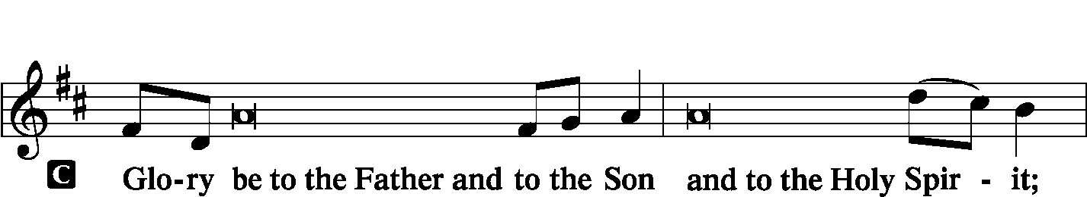
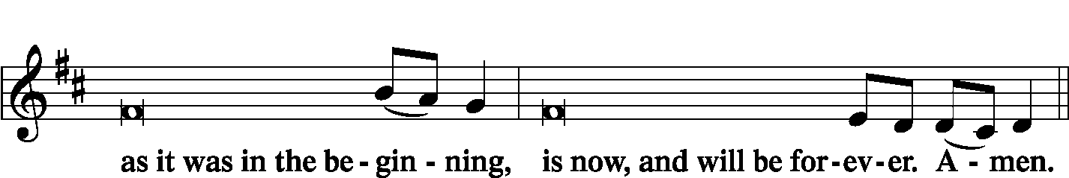

Psalmody
Antiphon (Common) LSB 220
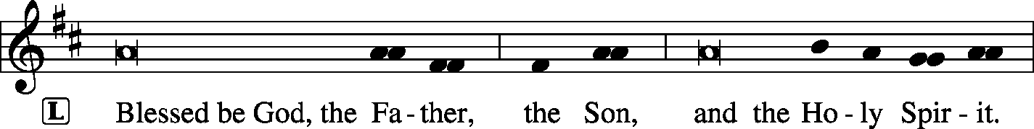

Venite LSB 220
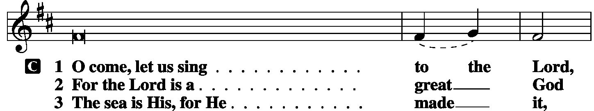
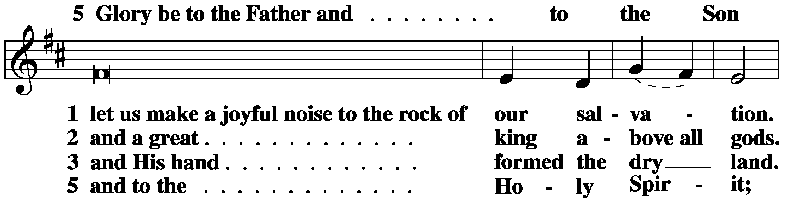
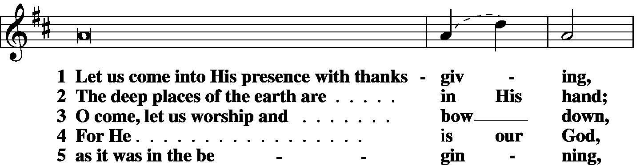
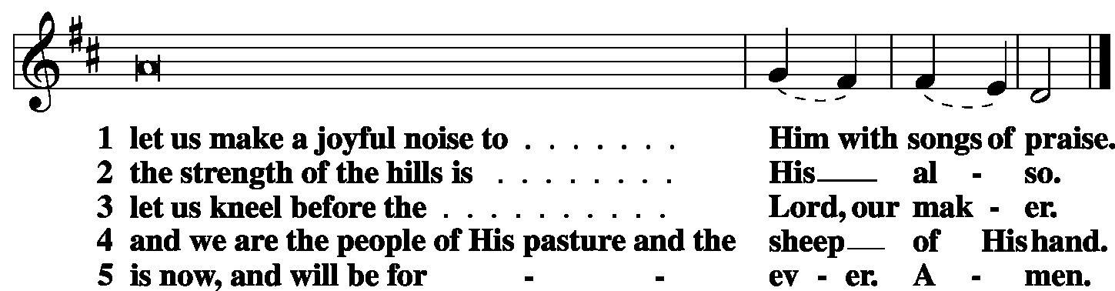

Antiphon (Common) LSB 221

Psalm Psalm 116:12–19 (antiphon: v.13)
L What shall I render to the Lord
C for all His benefits to me?
L I will lift up the cup of salvation
C and call on the name of the Lord,
L I will pay my vows to the Lord
C in the presence of all His people.
L Precious in the sight of the Lord
C is the death of His saints.
L O Lord, I am Your servant;
C I am Your servant, the son of Your maidservant.
L You have loosed my bonds.
C I will offer to You the sacrifice of thanksgiving
L and call on the name of the Lord.
C I will pay my vows to the Lord
L in the presence of all His people,
C in the courts of the house of the Lord,
L in Your midst, O Jerusalem.
C Praise the Lord!
Glory be to the Father and to the Son
and to the Holy Spirit;
as it was in the beginning,
is now, and will be forever. Amen.

Sit

Hymn Alabare LSB 799

First Reading Micah 6:6-8
“With what shall I come before the Lord, and bow myself before God on high? Shall I come before Him with burnt offerings, with calves a year old? Will the Lord be pleased with thousands of rams, with ten thousands of rivers of oil? Shall I give my firstborn for my transgression, the fruit of my body for the sin of my soul?” He has told you, O man, what is good; and what does the Lord require of you but to do justice, and to love kindness, and to walk humbly with your God?
L O Lord, have mercy on us.
C Thanks be to God.

Choir Offertory John Ness Beck

Second Reading Philippians 1:3–11
I thank my God in all my remembrance of you, always in every prayer of mine for you all making my prayer with joy, because of your partnership in the gospel from the first day until now. And I am sure of this, that He who began a good work in you will bring it to completion at the day of Jesus Christ. It is right for me to feel this way about you all, because I hold you in my heart, for you are all partakers with me of grace, both in my imprisonment and in the defense and confirmation of the gospel. For God is my witness, how I yearn for you all with the affection of Christ Jesus. And it is my prayer that your love may abound more and more, with knowledge and all discernment, so that you may approve what is excellent, and so be pure and blameless for the day of Christ, filled with the fruit of righteousness that comes through Jesus Christ, to the glory and praise of God.
L O Lord, have mercy on us.
C Thanks be to God.

Third Reading Matthew 18:21-35
Peter came up and said to [Jesus], “Lord, how often will my brother sin against me, and I forgive him? As many as seven times?” Jesus said to him, “I do not say to you seven times, but seventy times seven.
“Therefore the kingdom of heaven may be compared to a king who wished to settle accounts with his servants. When he began to settle, one was brought to him who owed him ten thousand talents. And since he could not pay, his master ordered him to be sold, with his wife and children and all that he had, and payment to be made. So the servant fell on his knees, imploring him, ‘Have patience with me, and I will pay you everything.’ And out of pity for him, the master of that servant released him and forgave him the debt. But when that same servant went out, he found one of his fellow servants who owed him a hundred denarii, and seizing him, he began to choke him, saying, ‘Pay what you owe.’ So his fellow servant fell down and pleaded with him, ‘Have patience with me, and I will pay you.’ He refused and went and put him in prison until he should pay the debt. When his fellow servants saw what had taken place, they were greatly distressed, and they went and reported to their master all that had taken place. Then his master summoned him and said to him, ‘You wicked servant! I forgave you all that debt because you pleaded with me. And should not you have had mercy on your fellow servant, as I had mercy on you?’ And in anger his master delivered him to the jailers, until he should pay all his debt. So also My heavenly Father will do to every one of you, if you do not forgive your brother from your heart.”
P O Lord, have mercy on us.
C Thanks be to God.

Common Responsory LSB 221
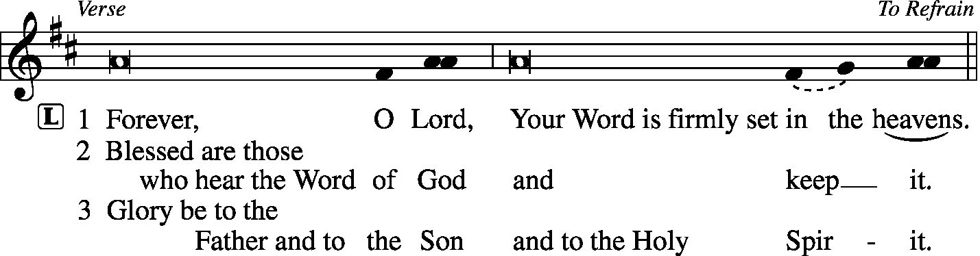
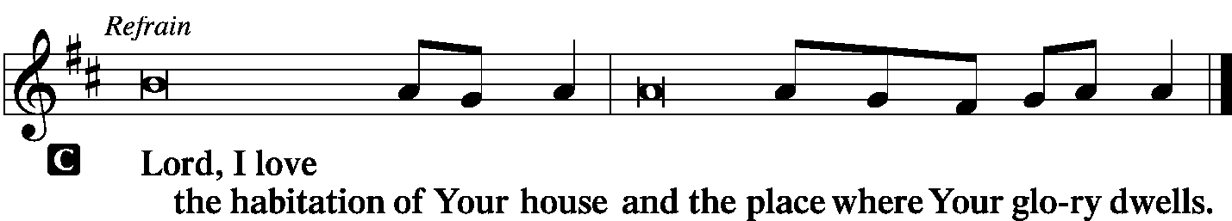

Children's Lunchbox Devotion

Hymn Lift High the Cross LSB 837

Sermon The Love of Christ Proclaim

Offering
[Please fill out a sheet in the attendance book. Visitors, please include your address. If you have a prayer request for the church prayer chain, please write it at the top of the sheet.]

Special Offering Music Maggie Harlan

Canticle
Stand

Te Deum LSB 223
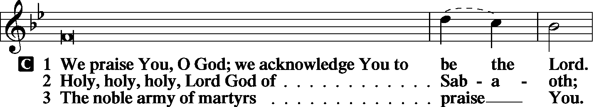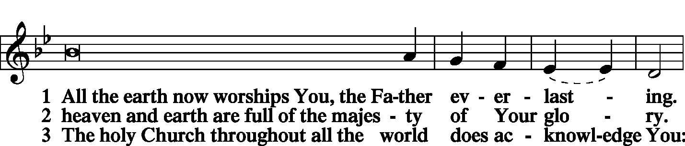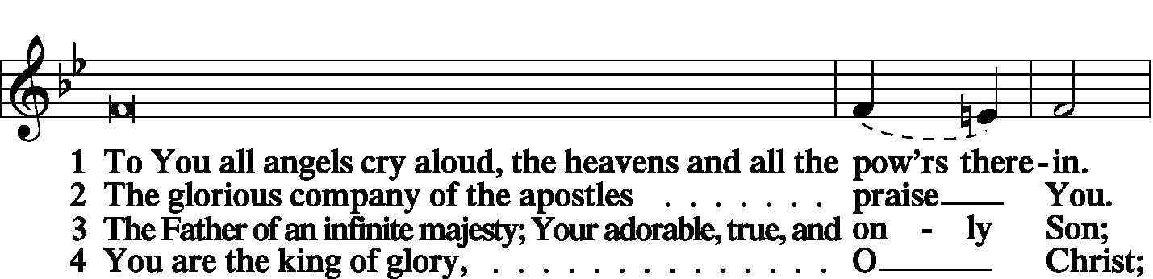
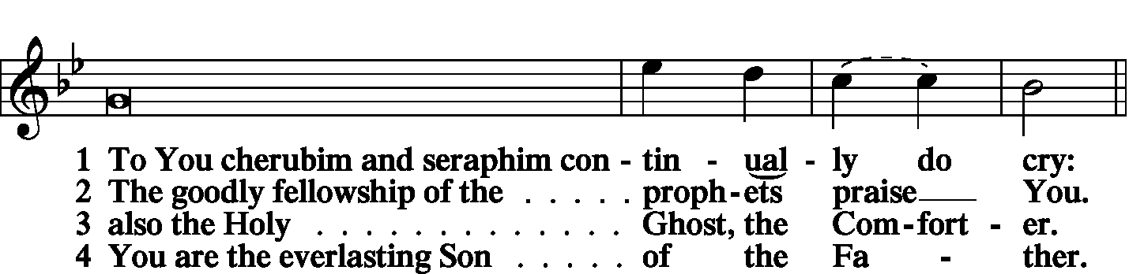

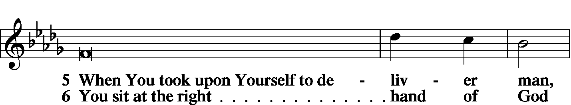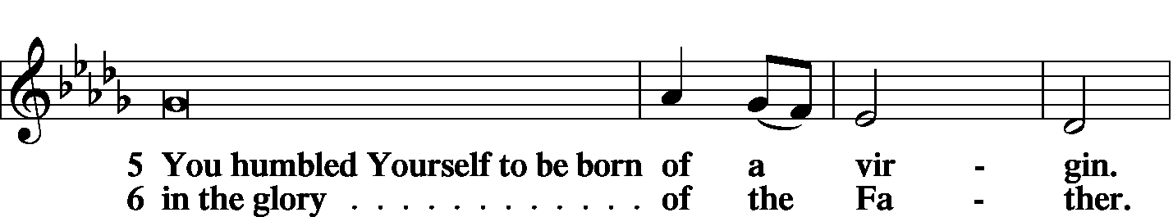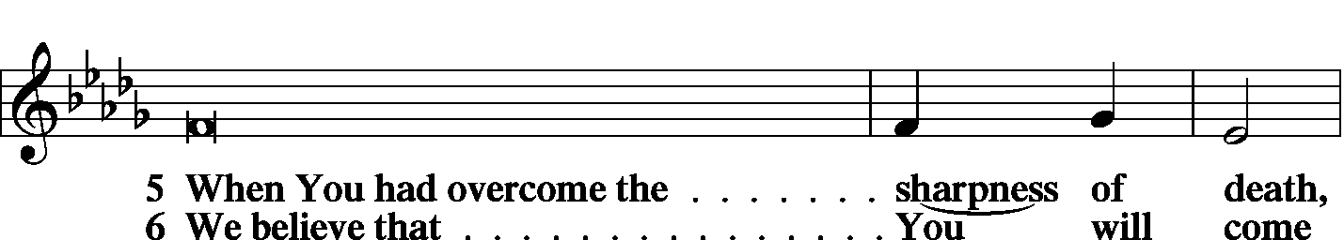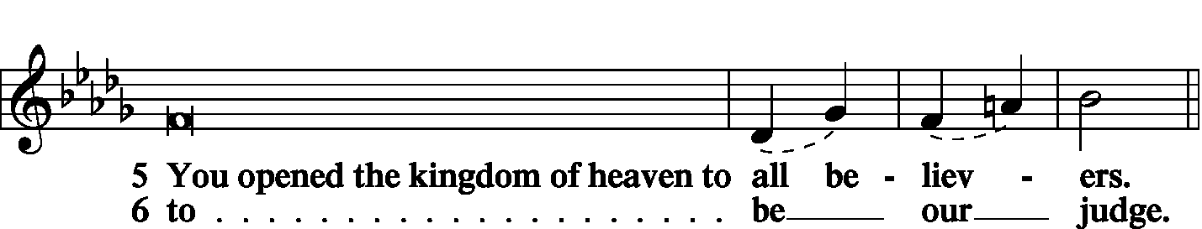

Te Deum is continued on the next page.
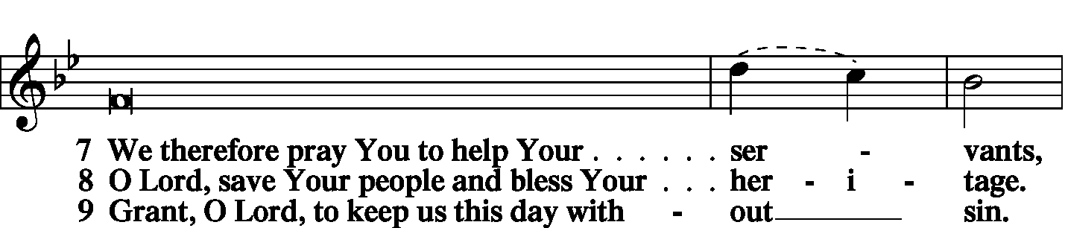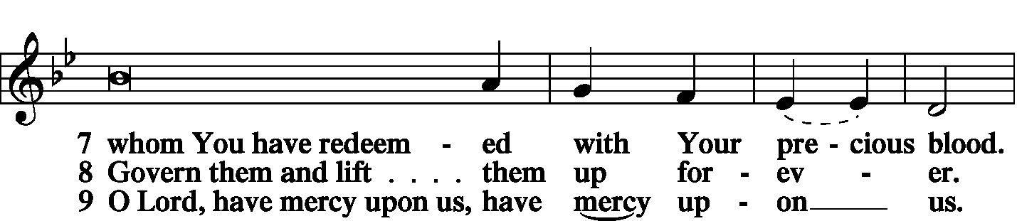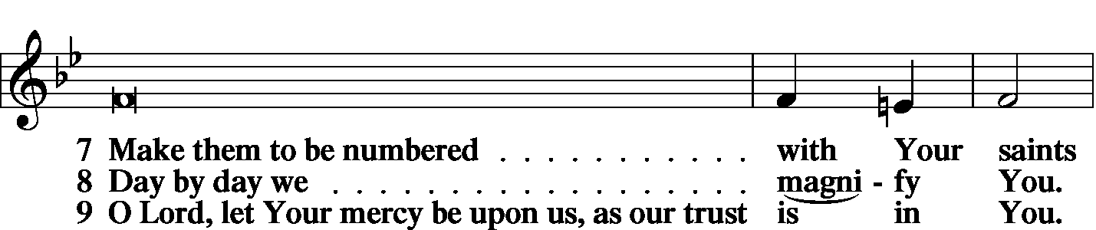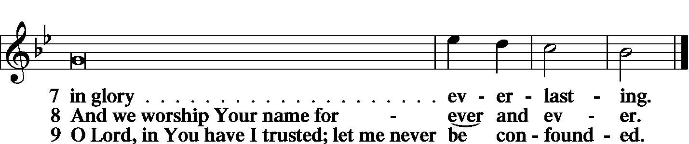
Prayer
Kyrie LSB 227

Lord's Prayer
C Our Father who art in heaven, hallowed be Thy name, Thy kingdom come, Thy will be done on earth as it is in heaven; give us this day our daily bread; and forgive us our trespasses as we forgive those who trespass against us; and lead us not into temptation, but deliver us from evil. For Thine is the kingdom and the power and the glory forever and ever. Amen.

Salutation and Collect of the Day
L The Lord be with you.
C And also with you.
O God, You make the minds of Your faithful to be of one will. Grant that we may love what You have commanded and desire what You promise, that among the many changes of this world our hearts may be fixed where true joys are found; through Jesus Christ, Your Son, our Lord, who lives and reigns with You and the Holy Spirit, one God, now and forever.
C Amen.

Prayer of the Church
L With all that is within us, O Lord, we bless Your holy name.
C You forgive all our iniquities and heal our diseases.
L You redeem our life from destruction and crown us with loving-kindness and tender mercies.
C For all these blessings, O Lord, we give You thanks.
L Your mercies remind us that we have not always treated others with the same undeserved love.
C We expect constant forgiveness from others but count the times we forgive them.
L We expect full payment from others while attempting to get discounts for ourselves.
C We live too much for ourselves and not enough to Your honor and glory.
L We become impatient with others but expect them to be patient with us.
C We often forget that it’s not up to us to settle all accounts, but that You have the power to bring good out of evil.
L For these, our many transgressions,
C forgive us, O Lord.
L By Your Spirit help us to reflect Your mercy toward others.
C Make us confident that You will take our mistakes and turn them into blessings.
L Be with the president, governor, and legislators, and help them to represent us in answering people’s needs.

WE GO TO THE LORD IN PRAYER FOR
- Savannah Murphy, Darla Lancey, Zackery Schreiber, Alexander Allen, Jessica Hatcher, Benjamin Pannier, Jeannette Schorfheide, and Jennifer Trame, as they celebrate their baptismal anniversaries this week.
- Hunter Phillips, recovering at home.
- Rhiannon Corey, following surgery.
- Family of Donna Wiesen, who died last week.
- Members of Zion’s Board of Trustees, Stewardship Committee, and Board of Finance.
- Faithfulness in support of world missions.

L Be with the lonely, comfort the sick, and bring the assurance of Your forgiveness to the penitent.
C We pray in Jesus’ Name. Amen.
Collect for Grace
L O Lord, our heavenly Father, almighty and everlasting God, You have safely brought us to the beginning of this day. Defend us in the same with Your mighty power and grant that this day we fall into no sin, neither run into any kind of danger, but that all our doings, being ordered by Your governance, may be righteous in Your sight; through Jesus Christ, Your Son, our Lord, who lives and reigns with You and the Holy Spirit, one God, now and forever.
C Amen.

Benedicamus LSB 228
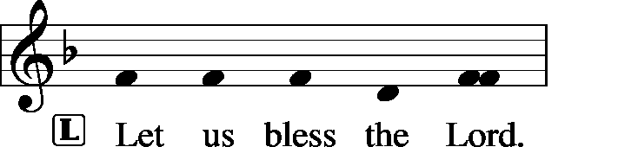
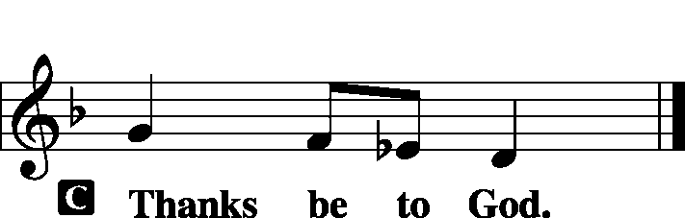

Benediction
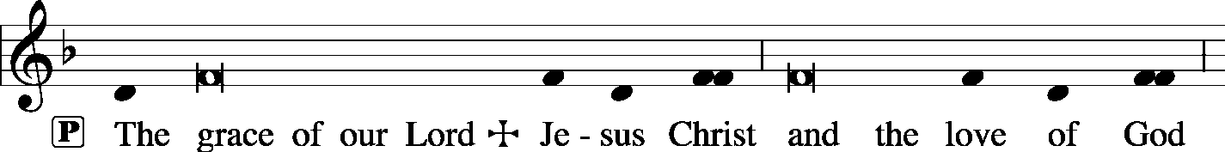
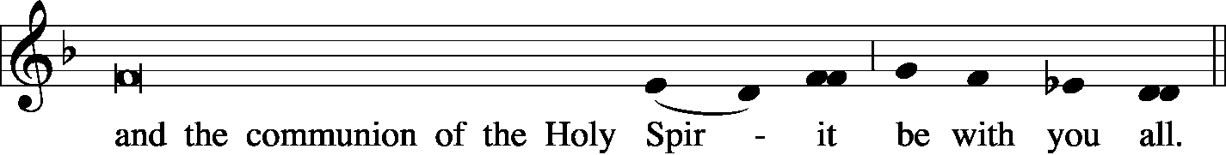

Sit

Hymn Jerusalem the Golden LSB 672

Shoebox Blessing

Postlude Lift High the Cross arr. Charles Ore

Acknowledgments
Unless otherwise indicated, all scripture quotations are from The Holy Bible, English Standard Version, copyright © 2001 by Crossway Bibles, a division of Good News Publishers. Used by permission. All rights reserved. Created by Lutheran Service Builder © 2006 Concordia Publishing House.
LIFE AND LIVING ITEMS AT ZION
          

THE FLOWERS ON THE LORD’S ALTAR
The flowers on the Lord’s altar are given to the glory of God by the Suedmeyer family, in memory of Gerald Suedmeyer, and in celebration of Pastor Clayton’s birthday.

CHILDREN'S CHRISTMAS PROGRAM PRACTICE THIS AFTERNOON
The first rehearsal for the Children's Christmas Program will be THIS SUNDAY AFTERNOON for the older students in the program. We will meet in the Sanctuary at Zion from 1:00 until 2:30 PM on Sunday, November 17, 2019. For the practice this afternoon, we would like to ask all students in 2nd Grade through 7th Grade to attend. (We will not plan to have the younger students at this first rehearsal.) The hope is to read through the script so the students can get a feel for how the program will flow. Each Sunday after today, we will have Children’s Program Practice during the Sunday School/Confirmation time from 8:45 to 9:45. These practices will be on November 24, December 1, December 8, and December 15. We will also have an extra practice on Saturday, December 14, from 10:00 AM to 12:00 PM, concluding with our annual “Happy Birthday Jesus” party in the church basement at noon. (As amazing as it sounds, the Children’s Christmas Program is approaching, in fact it is just over one month away! The program will be during the Sunday morning service at 10:00 AM on Sunday, December 15, 2019.) We will look forward to seeing 2nd Grade through 7th Grade students at Zion THIS SUNDAY, November 17, from 1:00 to 2:30 PM.

DONNA WIESEN’S DAUGHTER’S ADDRESS
Many of you knew Donna, as she grew up here at Zion with us. If you would like to send a note of sympathy, this is her daughter Sharon Cooper’s address: 654 N. 62nd St., East St. Louis IL 62203. You might note to pass your sympathy on to her brother, Geoffrey, as well.

NO MORTGAGE NOVEMBER
This month, November, 2019 is the first month in 19 years that Zion has not had a mortgage payment on the church building! That’s right, our last mortgage payment on the building itself was sent in October, 2019. The church building is completely paid for! Thanks and praise be to God for the opportunity to pay this debt off over a decade ahead of schedule! We still have a debt on the organ of about $36,000, but in the near future, Zion should be completely DEBT FREE! Again, thanks and praise be to God for His generosity and blessings!
VOLUNTEERS NEEDED FOR PRESCHOOL THANKSGIVING DINNER
Zion Preschool will be hosting their annual family dinner on Tuesday, November 19th, in the gym at 5:30 PM. The children will perform a short program to entertain their families before the dinner is served. Volunteers will be needed to help serve drinks, place food on the serving tables, refill dishes, etc. We have a lot of fun and get to eat some great food. Please consider volunteering. Contact Marlene Lockwood to volunteer.

NEW ADULT BIBLE STUDY STARTING DECEMBER 8
Please come to Adult Bible Study! We meet at 8:45 sharp each Sunday morning downstairs in the Fellowship Room. We’re wrapping up a six-week series on Apologetics with a real-life story of apologetics in action: Lee Strobel’s “The Case for Christ.” Next, we’ll learn how to put that knowledge to use. December 1, we’ll read and discuss a Scriptural example of sharing God’s love. Then, starting December 8, Sem. Stein will start a new series of videos with discussion, entitled “Everyone His Witness” to learn about sharing God’s truth in everyday life. Join us!

YOUTH COUNSELORS NEEDED AT ZION
After many years of dedicated and loving service to our youth, Karen and Bob Eldridge have advised the Zion Board of Education that they are ready to pass the responsibility of sponsoring our Jr./Sr. Youth Group to new advisors. The Board is in need of volunteers compelled to work with middle and high school aged youth as mentors and advisors for the youth in our congregation as they grow and develop in their Christian faith and fellowship. Please contact Alicia Suedmeyer, Christa Sink, or Marianne McDaniel before November 25 if you feel compelled to fulfill this responsibility.

DOMINICAN REPUBLIC MISSION TRIP UPDATE
We have received 7 responses of interest in a mission trip to the Dominican Republic, and considering that a full team consists of 8-10 people, this is a phenomenal response and a very real possibility! The highest "vote total" for type of trip was the "Educational Support Team," followed by "Playground Renovation Team" and "Volleyball Camp Team." As of now, trip dates of May 30 - June 6, June 13 - June 20, and June 20 - June 27 are possibilities

CHURCH CHRISTMAS DECORATING – VOLUNTEERS NEEDED!
We will be decorating the church on Saturday, December 7th at 10:00 AM. If you would like to help, please join us! Any and all help is welcomed.

ELECTIONS AT DECEMBER VOTERS MEETING
At the December Voters Meeting, the congregation will need to elect the following positions: Vice Chairman, Secretary, 1 Elder, 1 Board of Finance member, 1 Board of Education member, 1 Assistant Sunday School Superintendent, and 2 Trustees. If you would like to volunteer to be considered for any of these positions, please see a Church Council member. Thanks.

DID YOU DO A THRIVENT ACTION TEAM ACTIVITY IN 2019?
Please let Glenda know of ANY Thrivent Action Team cards you applied for and used this past year for an event or activity. We want an accurate record of when and what these cards were used for. i.e., VBS, Puzzle Night, Fourth of July stand, etc.

2020 CHRISTIAN-THEMED CALENDARS NOW AVAILABLE
Zion’s Ladies Aid is selling Christian themed 2020 wall calendars. They are $6 each and are located on the table in the Narthex. There are a limited number so get yours today!

CHRISTMAS CAROLERS NEEDED!!
Would you like to bring the sounds of the season to those who need to hear the joyous message of God's love to them in the Christ Child? Would you like to enjoy the fellowship and fun of a potluck with brothers and sisters in Christ? If so, please join us as we meet at church at 4:30 p.m. on Sunday, Dec 8. After we have made the rounds of caroling, we will return to the school for fellowship and a potluck supper.
Please bring a dish from the below list according to your last name:

A-J Salad/Vegetable K-Q Dessert R-Z Main Dish

WHAT: Christmas Caroling and Potluck
WHEN: Sunday, Dec 8 at 4:30 p.m.
WHERE: Meet in the church kitchen to carpool to caroling sites

ANNUAL TREE OF HOPE CAMPAIGN
The Mascoutah Tuesday Women’s Club is excited to announce the annual Tree of Hope campaign. Donations will be used to provide Christmas gifts of shoes and clothes for the needy children of Mascoutah. Funds were also used to support the Mascoutah Township School Supply Drive through a donation of 100, $20 gift cards to provide shoes for children starting school. Thanks to the generosity of Mascoutah, donations totaling $10,580 for the Tree of Hope were received in 2018. We ask for your help again this year in order to fill the stockings of so many needy children. Please send your donation to: Tree of Hope, PO Box 244, Mascoutah, IL 62258. If you have any questions, call Rosalie Taylor at 618-566-2529.

CHI AUXILIARY ANNUAL CHRISTMAS LUNCHEON
The Auxiliary of the Concordia Historical Institute is pleased to announce its Annual Christmas Luncheon on Thursday, December 12, 2019, at 12 Noon in Koburg Hall, Concordia Seminary campus (804 Seminary Place, Clayton, MO). Meet and greet new or renewed acquaintances, hear the Village Lutheran Homeschool Handbell Choir, enjoy singing Christmas carols, and receive an update on CHI. The luncheon cost is $15 per person, with reservations to be made by December 5th. Checks may be made payable to "CHI Auxiliary" and sent to Nancy Fassold, 5609 Nantasket Court, St. Louis, MO 63128. For more information, please contact her at 314-843-3559 or nk21@live.com.

CHURCH BASEMENT LADIES: AWAY IN THE BASEMENT
Take a trip back in time to 1959 and celebrate the holidays with the CHURCH BASEMENT LADIES: AWAY IN THE BASEMENT. The ladies and the pastor try to save the Church Christmas pageant from disaster in this fun, family-friendly musical presented by Clinton County Showcase at the Avon Theater in Breese on Dec. 6, 7, 8, 13, 14, & 15. Tickets now on sale at clintoncountyshowcase.com.

LISTEN TO WORLDWIDE KFUO AM850
KFUO Radio, AM850, a media ministry extension of LCMS congregations, shares Christ for you anytime, anywhere on AM850 via worship services, Bible and theology studies, practical talk programs, and sacred music. You can find programs on demand at kfuo.org and wherever you get your podcasts! Find us on social: @KFUOradio on Facebook, Twitter, and Instagram. This week on KFUO AM850, hear curious theological topics with Rev. Bryan Wolfmueller on Cross Defense (11/18 at 2:00 p.m.), study Psalm 29 and Isaiah 42-45 on Thy Strong Word (weekdays at 11:00 p.m.), and hear Pastor "Jolly" John Lukomski and Pastor Matt "Youngblood" Clark wrestle the basics of Scripture on Wrestling with the Basics (11/23 at 9:00 a.m.). Find your favorite programs on demand at kfuo.org or your favorite podcast app!

RENEWING OF YOUR MIND
Issues, Etc. is a radio talk show and podcast produced by Lutheran Public Radio in Collinsville, IL and hosted by LCMS Pastor Todd Wilken. This week's topics include: 1 Corinthians, Is Divorce Contagious?, First Century Bishop Clement of Rome, Temptation, Evil and more. You can listen live or at your convenience at www.issuesetc.org and on the LPR mobile app.
Reverse Advent Calendar

An Advent calendar is a special calendar used to count the days of Advent in anticipation of Christmas. Traditionally, this countdown is marked by opening a small door of a calendar and retrieving a small candy or toy from a hidden compartment. This year, instead of receiving, let us give back in thankfulness for the ultimate gift of Jesus Christ our Lord and Savior.

Directions: Each day, add an item to a box. To keep this a mindful activity, this can be done in conjunction with your daily Advent devotional. On Christmas Eve, donate the contents to Mascoutah Food Pantry. The Food Pantry is open on Tuesdays and Saturdays from 10:00 - 12:00. You can also drop your box off at the church or call Beth Twenhafel (618-660-8872) for a pick up at your house.

December 1 - box of cereal
December 2 - peanut butter
December 3 - stuffing mix
December 4 - boxed potatoes
December 5 - macaroni and cheese
December 6 - canned tomatoes
December 7 - cream of mushroom soup
December 8 - canned tuna
December 9 - dessert mix
December 10 - jar of applesauce
December 11 - canned sweet potatoes
December 12 - cranberry sauce
December 13 - canned beans
December 14 - box of crackers
December 15 - package of rice
December 16 - package of oatmeal
December 17 - package of pasta
December 18 - spaghetti sauce
December 19 - chicken noodle soup
December 20 - tomato soup
December 21 - can corn
December 22- can mixed vegetables
December 23 - can carrots
THOSE WHO SERVE TODAY
Proclaimer: Rev. Kirk Clayton
Liturgists: Sem. Adam Wolfe and Sem. Don Stein
Organist: Nancy Peterson
Ushers: Ken Knutson, Dan Morra, Andy Sax,
& Tom Sax
Sound Tech: Matt Krausz
Video Tech: Mark Hatcher
Welcome Team: Jon & Cary Robinson
Acolytes: Isaac Robinson & Phoebe Corey

THOSE WHO SERVE NEXT WEEK, NOVEMBER 24
Proclaimer: Rev. Kirk Clayton
Liturgists: Sem. Adam Wolfe and Sem. Don Stein
Organist: Nancy Peterson
Ushers: Ray McDaniel, Randy Schorfheide, Matt Sink,
& Torri Suedmeyer
Sound Tech: Mark Krausz
Video Tech: Mark Hatcher
Welcome Team: Andy & Rhea Sax
Acolytes: Cadence Dunn & Jake Lara
Altar Guild: Linda Hoskins

THINGS WE ARE DOING AT ZION
Sun. Confirmation Class 8:30 AM
SS & Bible Class 8:45 AM
Worship Matins 10:00 AM
Tues. Preschool Thanksgiving Potluck 6:00 PM
Wed. Choir Rehearsal 7:00 PM
Thurs. Exec Board 6:30 PM
Ladies Aid Meeting 7:00 PM
Trustees Meeting 7:00 PM
Elders Meeting 7:00 PM
Fri. Senior Meal Delivery 10:30 AM
Sun. Adult Confirmation
Children’s Christmas Program Practice 8:45 AM
SS & Bible Class 8:45 AM
Worship DS I w/communion 10:00 AM

ATTENDANCE NOVEMBER 10 Sunday: 175
Adult Bible Class: 18 High School: 8 Sunday School: 40

