Zion Lutheran Church
Mascoutah, Illinois
November 3, 2019
All Saints Day

In the Name of Christ Jesus our Lord, we bid you a warm welcome to this worship service. May your experience of worship and fellowship this morning be spiritually refreshing and ready you for the week ahead.
 
Pastor: Rev. Kirk Clayton
Church Secretary: Robin Phillips
Choir Director Team: Josh and Nancy Peterson
_________________________________________________________________________________
Church Office Phone: 618-566-7345
Pastor Clayton Cell: 618-447-1306
Office Hours: 8:00 am to 12:00 pm
Email: ChurchOffice@ZionMascoutah.org
Pastor Clayton email: Pastor@ZionMascoutah.org
Web site: www.ZionMascoutah.org
Find us at @ZionMascoutah on Facebook, Twitter, and Instagram
Electronic Devices
Please TURN OFF all cell phones, pagers, electronic devices, apps and games when entering the sanctuary for worship so those around you may focus on the Word of God without electronic distraction. Thank you.

A Prayer to Begin Worship
Lamb of God, in whose blood the robes of the saints are washed white to gleaming, and through whom they reign in glory even now, we offer thanks for the gift of eternal life given to Your saints now in glory with You and pray that we may follow their example of faith, that we may be ready and eager to come to You when the distant trumpet blows to summon us; who with the Father and the Holy Spirit are one God with dominion over us forever.

DIVINE SERVICE II/I WITH COMMUNION
LSB p. 167
Confession and Absolution

Hymn Ye Watchers and Ye Holy Ones LSB 670

Stand

The sign of the cross may be made by all in remembrance of their Baptism.

Invocation
P In the name of the Father and of the T Son and of the Holy Spirit.
C Amen.

Exhortation
P If we say we have no sin, we deceive ourselves, and the truth is not in us.
C But if we confess our sins, God, who is faithful and just, will forgive our sins and cleanse us from all unrighteousness.

Silence for reflection on God's Word and for self-examination.
Confession with Absolution
P Let us then confess our sins to God our Father.
C Most merciful God, we confess that we are by nature sinful and unclean. We have sinned against You in thought, word, and deed, by what we have done and by what we have left undone. We have not loved You with our whole heart; we have not loved our neighbors as ourselves. We justly deserve Your present and eternal punishment. For the sake of Your Son, Jesus Christ, have mercy on us. Forgive us, renew us, and lead us, so that we may delight in Your will and walk in Your ways to the glory of Your holy name. Amen.
P Almighty God in His mercy has given His Son to die for you and for His sake forgives you all your sins. As a called and ordained servant of Christ, and by His authority, I therefore forgive you all your sins in the name of the Father and of the T Son and of the Holy Spirit.
C Amen.
Service of the Word
Introit Psalm 149:1-9
P Praise the Lord!
C Sing to the Lord a new song, His praise in the assembly of the godly!
P Let Israel be glad in his Maker;
C let the children of Zion rejoice in their King!
P Let them praise His name with dancing,
C making melody to Him with tambourine and lyre!
P For the Lord takes pleasure in His people;
C He adorns the humble with salvation.
P Let the godly exult in glory;
C let them sing for joy on their beds.
P Let the high praises of God be in their throats
C and two-edged swords in their hands,
P to execute vengeance on the nations
C and punishments on the peoples,
P to bind their kings with chains
C and their nobles with fetters of iron,
P to execute on them the judgment written!
C This is honor for all His godly ones. Praise the Lord!
Glory be to the Father and to the Son and to the Holy Spirit;
as it was in the beginning, is now, and will be forever. Amen.
P Praise the Lord!
C Sing to the Lord a new song, His praise in the assembly of the godly!

Kyrie LSB 168
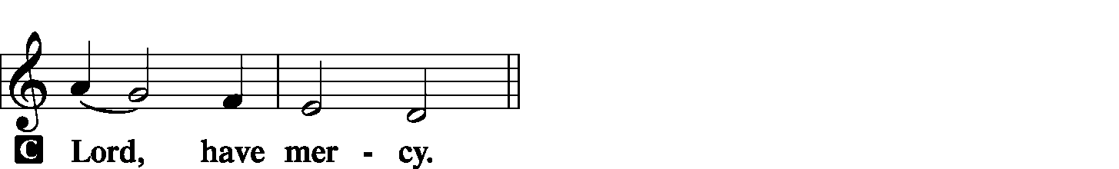
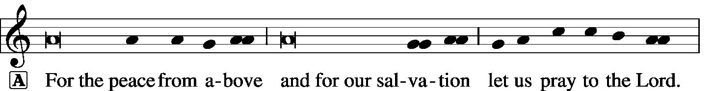

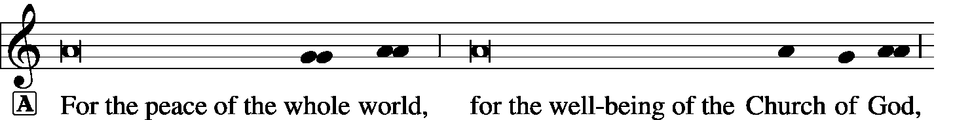

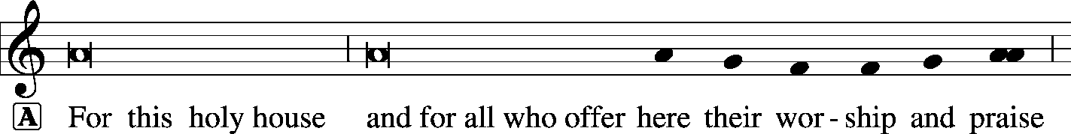

Hymn of Praise -- This is the Feast LSB 171
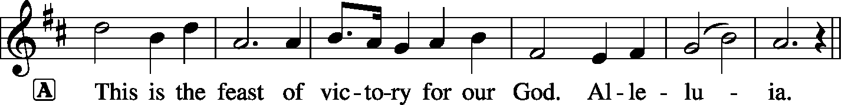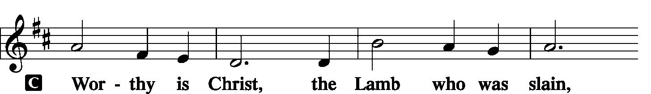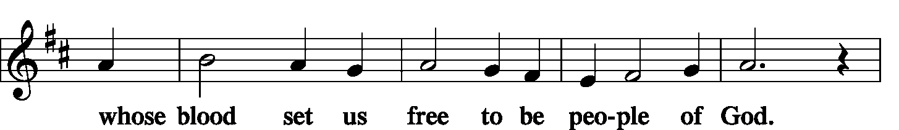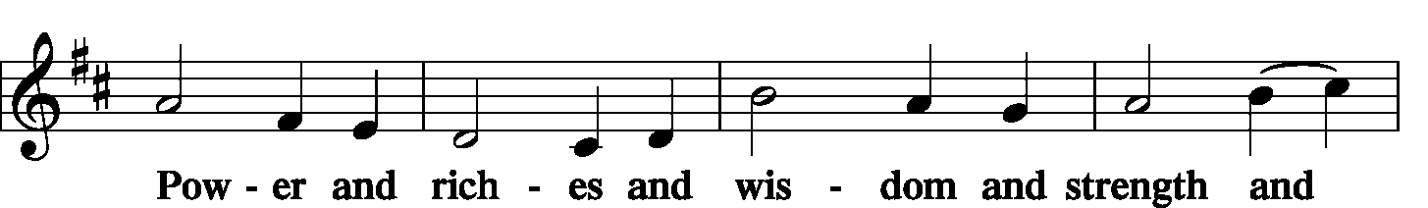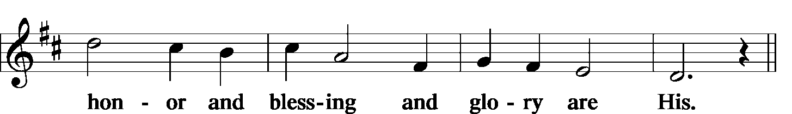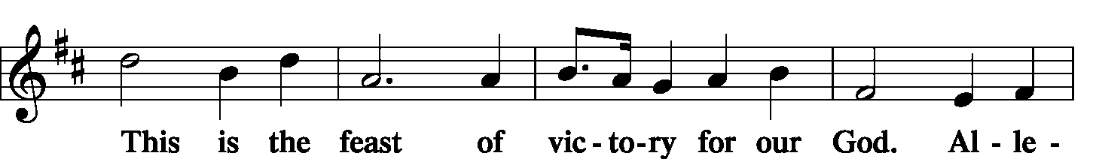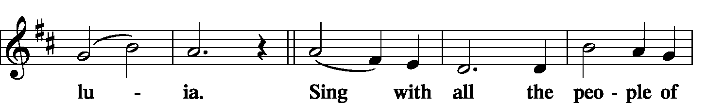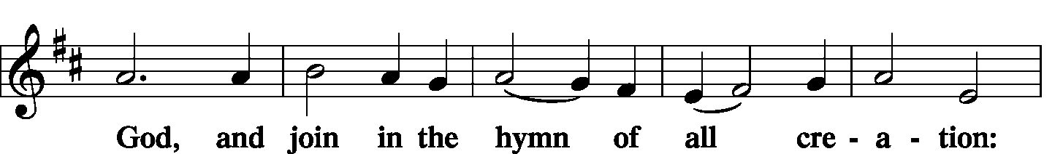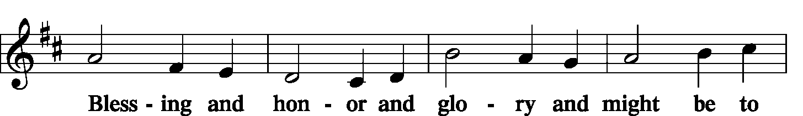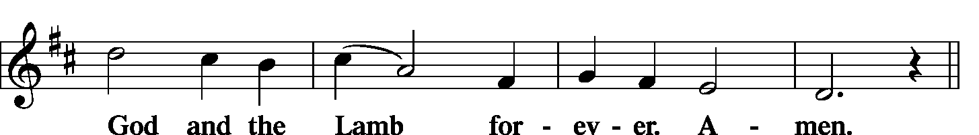
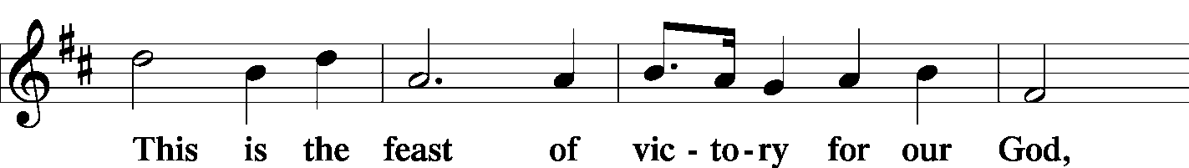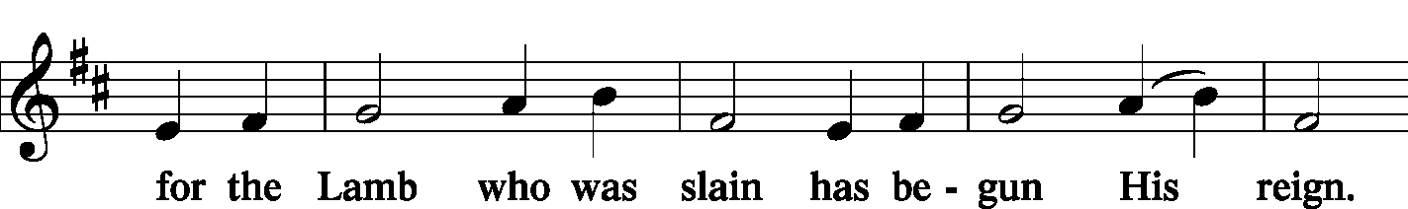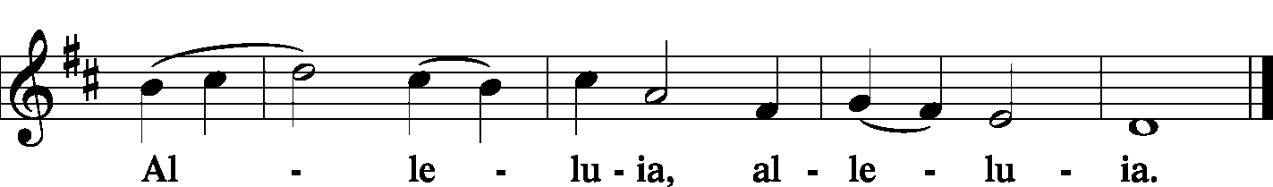

Salutation and Collect of the Day
P The Lord be with you.
C And also with you.
P Let us pray. Almighty and everlasting God, You knit together Your faithful people of all times and places into one holy communion, the mystical body of Your Son, Jesus Christ. Grant us so to follow Your blessed saints in all virtuous and godly living that, together with them, we may come to the unspeakable joys You have prepared for those who love You; through Jesus Christ, our Lord, who lives and reigns with You and the Holy Spirit, one God, now and forever.
C Amen.

Sit

First Reading Revelation 7:9–17
After this I looked, and behold, a great multitude that no one could number, from every nation, from all tribes and peoples and languages, standing before the throne and before the Lamb, clothed in white robes, with palm branches in their hands, and crying out with a loud voice, “Salvation belongs to our God who sits on the throne, and to the Lamb!” And all the angels were standing around the throne and around the elders and the four living creatures, and they fell on their faces before the throne and worshiped God, saying, “Amen! Blessing and glory and wisdom and thanksgiving and honor and power and might be to our God forever and ever! Amen.” Then one of the elders addressed me, saying, “Who are these, clothed in white robes, and from where have they come?” I said to him, “Sir, you know.” And he said to me, “These are the ones coming out of the great tribulation. They have washed their robes and made them white in the blood of the Lamb. “Therefore they are before the throne of God, and serve Him day and night in His temple; and He who sits on the throne will shelter them with His presence. They shall hunger no more, neither thirst anymore; the sun shall not strike them, nor any scorching heat. For the Lamb in the midst of the throne will be their shepherd, and He will guide them to springs of living water, and God will wipe away every tear from their eyes.”
L This is the Word of the Lord.
C Thanks be to God.

Choir Lord, It Belongs Not to My Care Carl Schalk

Epistle 1 John 3:1–3
See what kind of love the Father has given to us, that we should be called children of God; and so we are. The reason why the world does not know us is that it did not know Him. Beloved, we are God’s children now, and what we will be has not yet appeared; but we know that when He appears we shall be like Him, because we shall see Him as He is. And everyone who thus hopes in Him purifies himself as He is pure.
L This is the Word of the Lord.
C Thanks be to God.

Stand

Alleluia and Verse
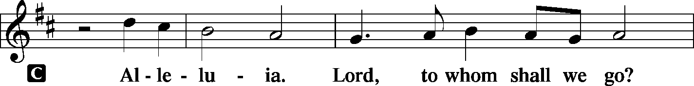
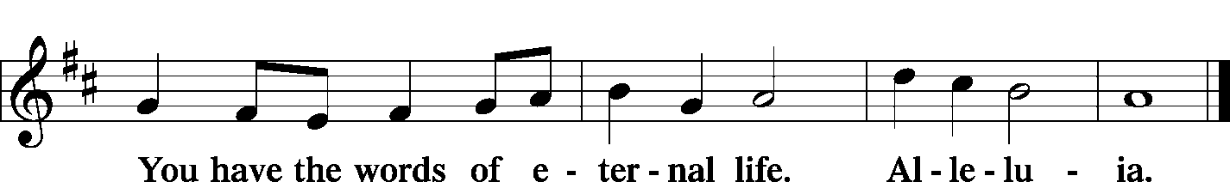

Holy Gospel Matthew 5:1–12
L The Holy Gospel according to St. Matthew, the 5th chapter.
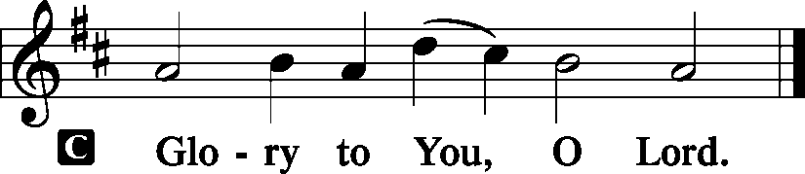
Seeing the crowds, [Jesus] went up on the mountain, and when He sat down, His disciples came to Him. And He opened His mouth and taught them, saying: “Blessed are the poor in spirit, for theirs is the kingdom of heaven. “Blessed are those who mourn, for they shall be comforted. “Blessed are the meek, for they shall inherit the earth. “Blessed are those who hunger and thirst for righteousness, for they shall be satisfied. “Blessed are the merciful, for they shall receive mercy. “Blessed are the pure in heart, for they shall see God. “Blessed are the peacemakers, for they shall be called sons of God. “Blessed are those who are persecuted for righteousness’ sake, for theirs is the kingdom of heaven. “Blessed are you when others revile you and persecute you and utter all kinds of evil against you falsely on My account. Rejoice and be glad, for your reward is great in heaven, for so they persecuted the prophets who were before you.
L This is the Gospel of the Lord.

Sit

Hymn For All the Saints LSB 677

Sermon Blessed Now

Stand

Nicene Creed
C I believe in one God, the Father Almighty, maker of heaven and earth and of all things visible and invisible.
And in one Lord Jesus Christ, the only-begotten Son of God, begotten of His Father before all worlds, God of God, Light of Light, very God of very God, begotten, not made, being of one substance with the Father, by whom all things were made; who for us men and for our salvation came down from heaven and was incarnate by the Holy Spirit of the virgin Mary and was made man; and was crucified also for us under Pontius Pilate. He suffered and was buried. And the third day He rose again according to the Scriptures and ascended into heaven and sits at the right hand of the Father. And He will come again with glory to judge both the living and the dead, whose kingdom will have no end.
And I believe in the Holy Spirit, the Lord and giver of life, who proceeds from the Father and the Son, who with the Father and the Son together is worshiped and glorified, who spoke by the prophets. And I believe in one holy Christian and apostolic Church, I acknowledge one Baptism for the remission of sins, and I look for the resurrection of the dead and the life T of the world to come. Amen.

Sit

Commemoration of the Faithful Departed

Offering
[Please fill out a sheet in the attendance book. Visitors, please include your address. If you have a prayer request for the church prayer chain, please write it at the top of the sheet.]

Special Offering Music Bjorn Peterson

Stand

Prayer of the Church
P Alleluia, Alleluia, with saints and angels,
C we praise You, O Lord.
P Gracious Father, You brought forth Your Son, Jesus Christ, from the dead. With joy we remember His victory over death and hell. He is the Head of the holy Church both here on earth and in eternal glory. Alleluia, alleluia, with saints and angels,
C we praise You, O Lord.
P Holy and almighty God, we do not forget those who have finished their course of faith and now rest from their labors. We remember with love those dear ones and friends who confessed Your name on earth and who now sing Your praise in eternal glory. We thank You for their time among us. May their earthly witness of the blessed Savior remind us of His goodness and His promise of life eternal to all who confess the name of Your Son. Alleluia, alleluia, with saints and angels,
C we praise You, O Lord.
P Dearest Jesus, adored by saints and angels, You have promised to be with us even to our old age. Hear the prayers of all who in later years call upon You for needed strength of body and mind. Continue to guide, protect and watch over those whose long life has been blessed by You. Alleluia, alleluia, with saints and angels,
C we praise You, O Lord.
P For those whose earthly life draws to an end, give them patience as they wait upon You, Holy Father. Comfort these Your children in their last hours of earthly life. May they be renewed in spirit with Your steadfast love that they may rejoice and be glad throughout their remaining days. Alleluia, alleluia, with saints and angels,
C we praise You, O Lord.
P As we remember the aged and dying, strengthen the hands of all who care for these loved ones and friends, loving Savior. Give all caregivers energy and patience to kindly care for Your children whose eternal rest draws near. Alleluia, alleluia, with saints and angels,
C we praise You, O Lord.
P Bless all those who partake of the Lord’s Supper this day, that they may receive the body and blood of the Lord and trust in the good things and abundant riches which He offers in the Sacrament. Alleluia, alleluia, with saints and angels,
C we praise You, O Lord.

WE GO TO THE LORD IN PRAYER FOR
- Ahren Kneschke, Max Lara, Chelsea Mann, Rebecca Allen, Hannah Drinnon, Jordan Rehfeldt, and Emerson Segelhorst, as they celebrate their baptismal anniversaries this week.
- Zion’s Elders, Board of Education, Sunday School staff, and Evangelism Committee.
- Faithfulness in our lives as Christian Stewards.

P Be with the lonely, comfort the sick, and bring the assurance of Your forgiveness to the penitent.
C We pray in Jesus’ Name. Amen.

Service of the Sacrament
Preface LSB 160
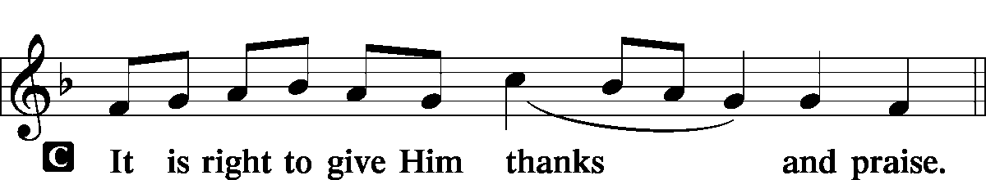

Proper Preface (Full)
P It is truly good, right, and salutary that we should at all times and in all places give thanks to You, holy Lord, almighty Father, everlasting God. In the communion of all Your saints gathered into the one body of Your Son, You have surrounded us with so great a cloud of witnesses that we, encouraged by their faith and strengthened by their fellowship, may run with perseverance the race that is set before us and, together with them, receive the crown of glory that does not fade away. Therefore with angels and archangels and with all the company of heaven we laud and magnify Your glorious name, evermore praising You and saying:

Sanctus LSB 161
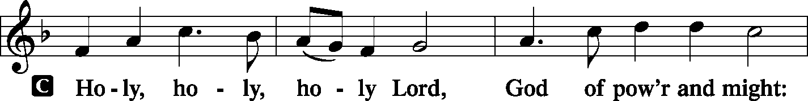
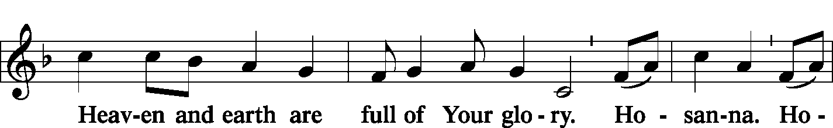
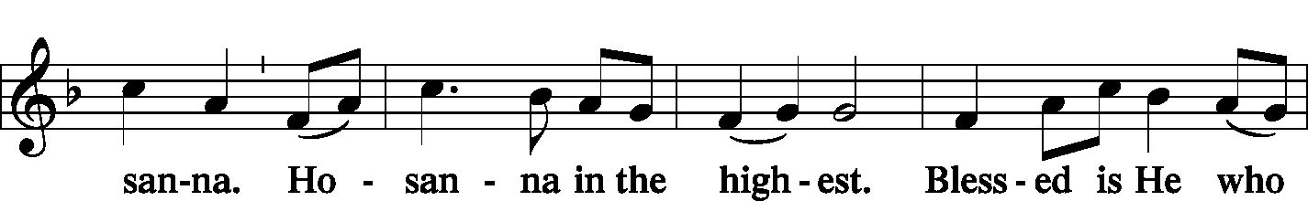
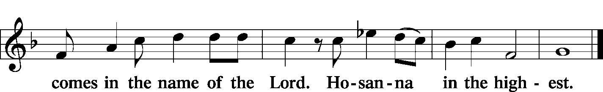

Prayer of Thanksgiving LSB 178
P Blessed are You, Lord of heaven and earth, for You have had mercy on those whom You created and sent Your only-begotten Son into our flesh to bear our sin and be our Savior. With repentant joy we receive the salvation accomplished for us by the all-availing sacrifice of His body and His blood on the cross. Gathered in the name and the remembrance of Jesus, we beg You, O Lord, to forgive, renew, and strengthen us with Your Word and Spirit. Grant us faithfully to eat His body and drink His blood as He bids us do in His own testament. Gather us together, we pray, from the ends of the earth to celebrate with all the faithful the marriage feast of the Lamb in His kingdom, which has no end. Graciously receive our prayers; deliver and preserve us. To You alone, O Father, be all glory, honor, and worship, with the Son and the Holy Spirit, one God, now and forever.
C Amen.

Lord's Prayer LSB 179
P Lord, remember us in Your kingdom and teach us to pray:
C Our Father who art in heaven, hallowed be Thy name, Thy kingdom come, Thy will be done on earth as it is in heaven; give us this day our daily bread; and forgive us our trespasses as we forgive those who trespass against us; and lead us not into temptation, but deliver us from evil. For Thine is the kingdom and the power and the glory forever and ever. Amen.

The Words of Our Lord LSB 179
P Our Lord Jesus Christ, on the night when He was betrayed, took bread, and when He had given thanks, He broke it and gave it to the disciples and said: “Take, eat; this is My T body, which is given for you. This do in remembrance of Me.”

P In the same way also He took the cup after supper, and when He had given thanks, He gave it to them, saying: “Drink of it, all of you; this cup is the new testament in My T blood, which is shed for you for the forgiveness of sins. This do, as often as you drink it, in remembrance of Me.”
Pax Domini LSB 163
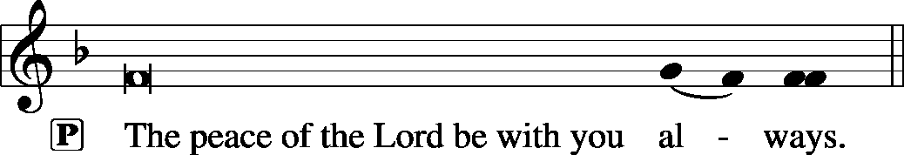

Agnus Dei LSB 163
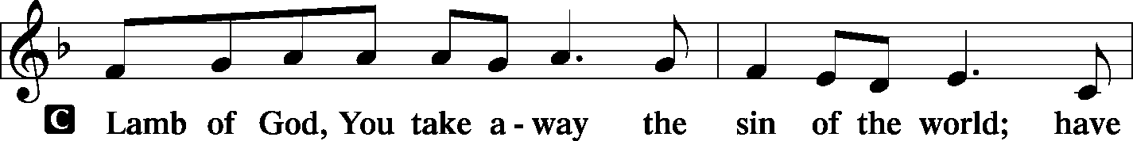
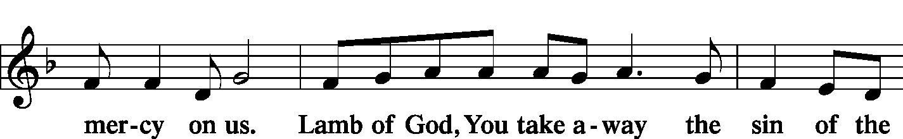
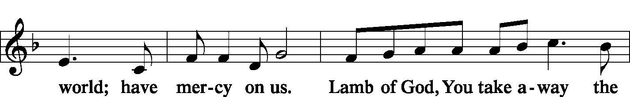
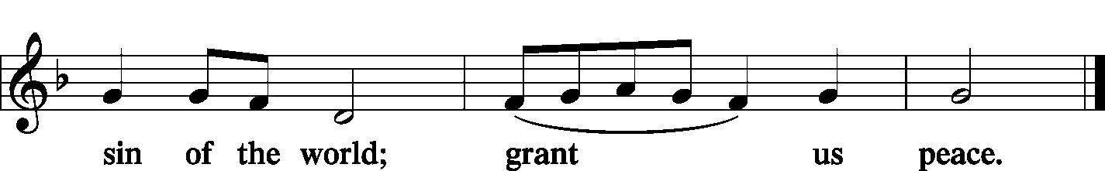

Sit

Distribution
Zion Lutheran practices the policy of close communion, communing only those who share our common Biblical view of the Lord's Supper. If you are not a confirmed LCMS Lutheran, please confer with the pastor before communing.

Hymn The Church’s One Foundation LSB 644
Hymn We Are Called to Stand Together LSB 828
Hymn At the Lamb’s High Feast We Sing LSB 633

Stand

In dismissing the communicants, the following is said:

The Dismissal
P The body and blood of our Lord Jesus Christ strengthen and preserve you in body and soul to life everlasting. Depart T in peace.
C Amen.

Post Communion Canticle -- Thank the Lord LSB 164
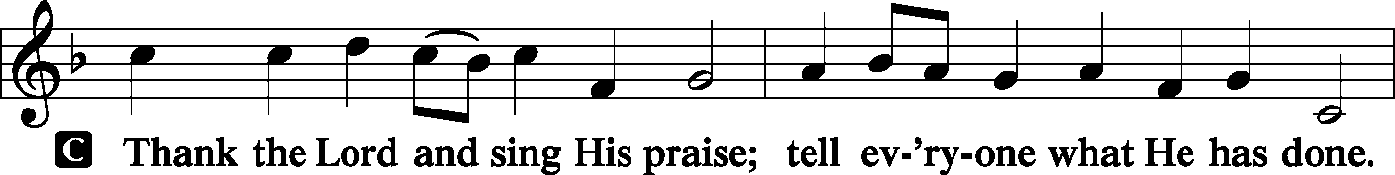
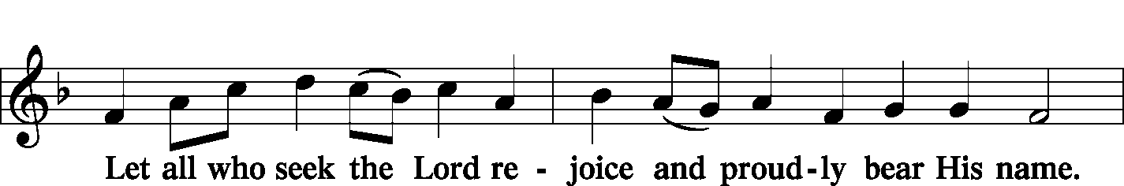
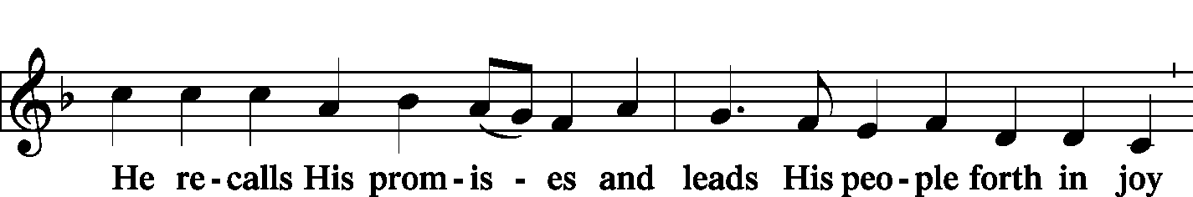
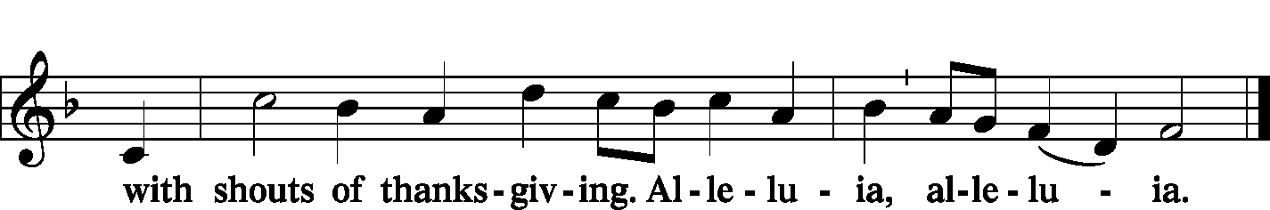

Post-Communion Collect
P Let us pray.
We give thanks to You, almighty God, that You have refreshed us through this salutary gift, and we implore You that of Your mercy You would strengthen us through the same in faith toward You and fervent love toward one another; through Jesus Christ, Your Son, our Lord, who lives and reigns with You and the Holy Spirit, one God, now and forever.
C Amen.

Benediction
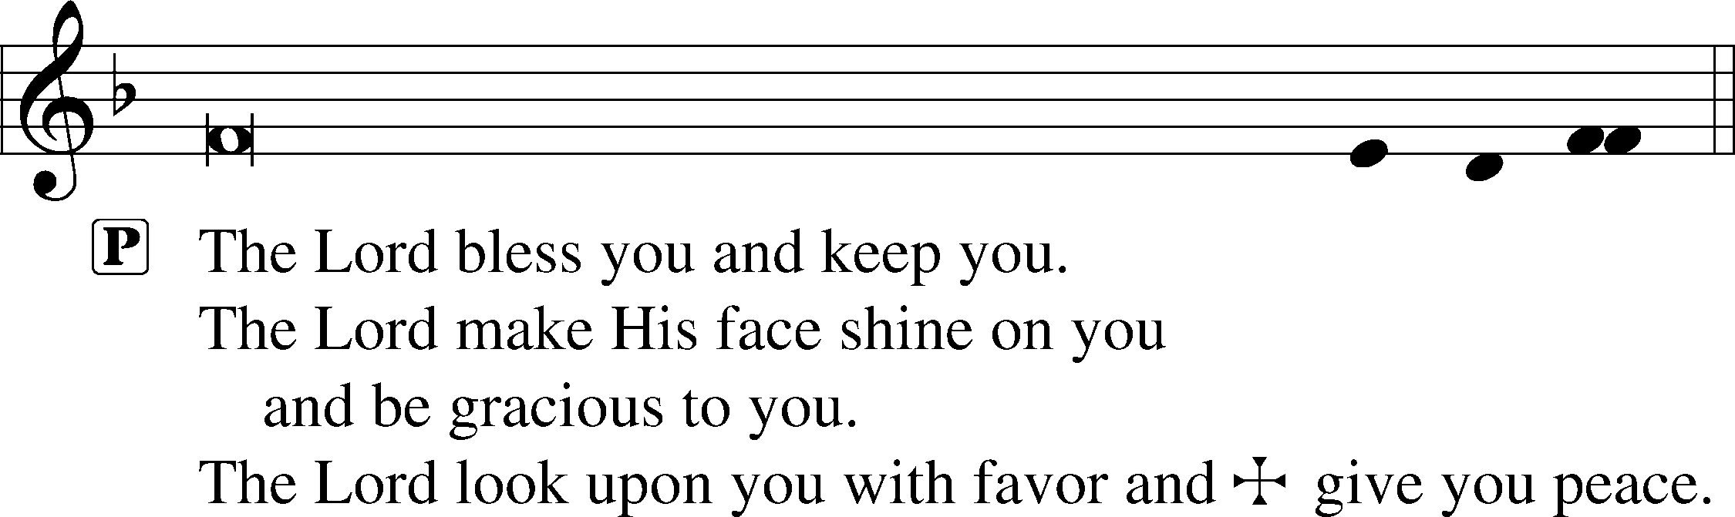

Sit

Hymn Sing with All the Saints in Glory LSB 671
(Sung to the tune of ‘Ode to Joy’)

Acknowledgments
Divine Service, Setting Two from Lutheran Service Book Unless otherwise indicated, all scripture quotations are from The Holy Bible, English Standard Version, copyright © 2001 by Crossway Bibles, a division of Good News Publishers. Used by permission. All rights reserved. Created by Lutheran Service Builder © 2006 Concordia Publishing House.
LIFE AND LIVING ITEMS AT ZION
          

THE FLOWERS ON THE LORD’S ALTAR
The flowers on the Lord’s altar are given to the glory of God in remembrance of those who have gone before us into their eternal rest and are with the Lord.

NOVEMBER ECHO – NOW AVAILABLE
The November Echo is now available. Pick one up in the narthex today!

THANK YOU FROM PASTOR CLAYTON
Dear Family at Zion, Thank you very much for the card and generous check that you presented to me for Pastor Appreciation Month in October. As I said that Sunday, while cards and gifts are great, one of the greatest blessings a congregation can give to a pastor is to pray for him. Several members mentioned after church that you do pray for the Clayton family regularly, and we really appreciate it. And, we appreciate the card and gift, as well as appreciating all the dear saints at Zion who shared it with us! Thank you! In Christ, Pastor Clayton

YOUTH AND FAMILY BONFIRE
Zion Jr./Sr Youth Group will be holding its annual Bonfire and Cookout on Saturday, November 9, 2018 at Roy Klingelhoefer's Pecan Grove picnic area, located at the end of Klingelhoefer Lane a couple miles east of Mascoutah off of IL 177. (To get to the location, turn south--right if you are coming out of Mascoutah--on Klingelhoefer Lane off of 177, and keep following Klingelhoefer Lane until it ends. You will pass several houses, go over a hill, and curve around to the left...and then you should see a picnic pavilion, an firepit, and a pond with a grove of trees beside it and behind it. The nearest GPS address is 7124 Klingelhoefer Lane, Mascoutah...but keep on going past that on the gravel lane for another half mile or so!) The fun will start at 4:30 PM. Bring lawn chairs, flashlight (there is no electricity out there, so without streetlights it gets DARK), a stick for roasting, and a bag of chips or dessert to share. The Youth Group will provide chili, hot dogs, drinks, and s'more fixings. By all means, make plans to come! This is one of the most enjoyable and relaxing events of the year, and it's only more fun with more friends.

MEMBERS NEED FUND POTLUCK- SUNDAY - NOV 10TH
Please plan to attend a potluck lunch in the gym right after church on November 10th. We are requesting donations be given for those who attend to be used to fund the Zion’s Member’s Need Fund. Elders will be providing hamburgers and hot dogs (buns and condiments). We are asking those with last name A-K to bring a dessert and L-Z to bring a side dish. We look forward to seeing you there.

VOLUNTEERS NEEDED FOR PRESCHOOL THANKSGIVING DINNER
Zion Preschool will be hosting their annual family dinner on Tuesday, November 19th, in the gym at 5:30 PM. The children will perform a short program to entertain their families before the dinner is served. Volunteers will be needed to help serve drinks, place food on the serving tables, refill dishes, etc. We have a lot of fun and get to eat some great food. Please consider volunteering. Contact Marlene Lockwood to volunteer.

SIGN UP FOR CHILDREN’S CHRISTMAS PROGRAM
Maggie Harlan and Pastor Clayton are writing the Children's Christmas Program for Zion for this year. In order to refine the script and make sure there are the right number of parts, we need to know which students will be participating. (The Children's Christmas Program will be held on Sunday, December 15, 2019 during the 10:00 morning service.) A list of all Zion students is on the table in the narthex under the church office window. IF YOU ARE NOT ABLE TO PARTICIPATE, PLEASE CROSS YOUR NAME OFF THE LIST. If you do not opt out, we will assume that you will participate and make a part for you. Thanks!

2020 CHRISTIAN-THEMED CALENDARS NOW AVAILABLE
Zion’s Ladies Aid is selling Christian themed 2020 wall calendars. They are $6 each and are located on the table in the Narthex. There are a limited number so get yours today!

MEMBER NEEDS FUND ENVELOPES
Zion's Elders maintain and administer a fund to help members of the congregation who are facing financial difficulties. "Member Needs Fund" envelopes are available in the pews, they are the small manila envelopes in the holders next to the hymnal racks. If you would like to make a donation to the Member Needs Fund, place your donation in the marked small manila envelope and place it in the collection plate. The Finance Board will pass the donation along to the Elders, and if the donor is identified, the Elders will give a letter for tax deduction purposes. Thank you for your support of this ministry of the congregation.

DOMINICAN REPUBLIC MISSION TRIP
Zion Mascoutah is looking seriously into sponsoring/sending a short term mission team to the Dominican Republic. This project has been discussed by the Evangelism Committee, the Board of Elders, and the Church Council, and it is time to take action. Over the next few weeks, a flier will be placed in the bulletin with short-term mission team volunteer opportunities. Fliers about the trip options are included in the bulletin this morning. If you are interested in participating in a trip, please circle which trip you would be most interested in doing, and sign your name so we can gauge where to apply our resources first. Short-term mission teams in the Dominican Republic typically consist of 8-10 people, and the trips run for one week, usually from Saturday to Saturday. Teams are assembled for specific purposes or themes, and have a set workload to be accomplished during the week. For next year, five different types of teams are possible, based on what the preference and interest of Zion is. The five types of trips are: EDUCATIONAL SUPPORT TEAM--Support education in the church’s two Lutheran schools and/or local public schools; HEALTH OUTREACH TEAM--Spend a week engaging in various outreach activities related to health (spiritual, mental, emotional, physical) and the promotion and preservation of life from conception to natural death; PLAYGROUND RENOVATION TEAM--Renovate two playgrounds (one for little kids and one for older kids) in Palmar Arriba; VACATION BIBLE SCHOOL TEAMS--Lead a week-long Vacation Bible School (Bible stories, crafts, games, music, snacks, etc.) at one of the local Lutheran congregations; and VOLLEYBALL CAMP TEAM--Lead a week-long volleyball camp for children & youth at Iglesia Luterana Amigos de Cristo. While volleyball skills and fundamentals should be the focus, traditional VBS elements like Bible stories, songs, games, snacks, and crafts may be included. Your team may also be able to assist with cleaning/preparing an unpaved, overgrown area near the church to be used as an outdoor play space. The cost per person for the week, including round-trip airfare, housing, and food for any of these mission trip options is likely to be about $1600. Dates are not yet set, but a timeframe shortly after school ends, late May or early June, might be a strong possibility. If you are interested in serving in one of these areas on a short-term mission team to the Dominican Republic, please begin to prayerfully consider how you might become more personally involved in our Lord’s mission work. Please fill out the information flier in the bulletin and place it in the basket on the card table in the narthex. Pray, and be prepared to volunteer!

61st ANNUAL WURSTMARKT -- TODAY
The Ferrin Men’s Club is holding their 61st Annual Wurstmarkt today, November 3rd, from 12 PM to 6 PM in the Ferrin School Basement (handicap accessible). They will also have sausage for sale. Adults are $11, Children 6-12, $6, Carry-outs, $11, and Children under 6, free.

ST MARK’S ANNUAL WURSTMART -- TODAY
St. Mark’s Annual Wurstmart will be held today, November 3rd at St. Mark’s Lutheran School Gymnasium, 504 N. James, Steelville, IL. We will have quite a meal, consisting of; whole hog sausage, sauerkraut, turkey, green beans, mashed potatoes and gravy, our FAMOUS fried apples as well as an awesome array of homemade desserts. Serving will be from 11 AM to 1:30 PM in our school gym. The cost is adults $11, children $5, and children 5 and under are free. We also have a country store with many baked and canned goods as well as crafts to look through, and a meat market where you can purchase fresh whole hog sausage, bacon and maybe even some liver sausage.

OSBORNE FAMILY BENEFIT – THIS SATURDAY
Richard “Dickie” Osborne lost his life after injuries sustained from a motorcycle accident on July 26th. We would like to come together as a community to raise money to help alleviate the financial burden for his wife, Whitney, and his son Wyatt. Come out and celebrate Dickie’s life and raise money for his family. The benefit will take place on November 9th at the Mascoutah Sportsmen’s Club beginning at 5 PM. Advance tickets are $20 for adults and $5 for kids. Tickets at the door are $25 for adults and $8 for kids. Bring your own snacks and soft drinks. Silent auction closes at 8:30 PM. For more information email osbornefamilybenefit@gmail.com.

ANNUAL TREE OF HOPE CAMPAIGN
The Mascoutah Tuesday Women’s Club is excited to announce the annual Tree of Hope campaign. Donations will be used to provide Christmas gifts of shoes and clothes for the needy children of Mascoutah. Funds were also used to support the Mascoutah Township School Supply Drive through a donation of 100, $20 gift cards to provide shoes for children starting school. Thanks to the generosity of Mascoutah, donations totaling $10,580 for the Tree of Hope were received in 2018. We ask for your help again this year in order to fill the stockings of so many needy children. Please send your donation to: Tree of Hope, PO Box 244, Mascoutah, IL 62258. If you have any questions, call Rosalie Taylor at 618-566-2529.

9th ANNUAL OKAWVILLE MUSIC FESTIVAL
Immanuel Lutheran Church is hosting their 9th Annual Music Festival on Sunday, November 10th at 3 PM at 206 E. Schumacher in Okawville. Admission is free. An offering will be received to support the work of Rev. Dr. Hans Trinklein and family LCMS missionaries in South Korea. The Men’s Club chili supper will follow in the gym.

CHILI, CHICKEN SOUP, AND PIE SUPPER
Immanuel Lutheran Church Men’s Club is hosting an “All You Can Eat” chili, chicken soup, and pie supper on Sunday, November 10th from 4-7 PM at Immanuel Lutheran School Gym, 606 S. Hanover in Okawville. Adults are $8 and children 10 and under are $4. Carry-outs are available. Please bring your own containers.

AFFORDABLE CARE ACT ENROLLMENT EVENT
On Thursday, November 14th, certified application counselors will be available by appointment only at HSHS St. Joseph’s Hospital Breese to help individuals and families sign up for health care coverage through the Affordable Care Act. Individuals and families have from November 1 - December 15, 2019 to enroll. This event is open to anyone served by the hospitals of HSHS St. Joseph’s Hospital Breese, HSHS Holy Family Hospital in Greenville, and HSHS St. Joseph’s Hospital Highland. Those interested in attending should call (217)972-7366 to schedule an appointment. Appointments will be offered in one-hour increments. When preparing for the event, please bring Social Security numbers as well as first and last name for all persons enrolling, proof of Illinois residency (Illinois driver’s license), employer and annual household income information (paycheck stubs, W-2). For more information about the marketplace, visit getcoveredillinois.gov or call the toll-free Get Covered Illinois Help Desk at (866)311-1119. For a list of health insurance plans that have chosen the hospital as a participating provider, visit stjoebreese.com/Patient-Guest/Billing-Information.

CHRISTMAS STOCKINGS AND GIFTS WORKSHOP
The LWML workshop this year is at Christ Our Savior Church, Freeburg, on Saturday, Nov 16th, starting at 9 AM. You are welcome to bring friends along to help decorate. Please bring a pair of scissors and fabric glue, if you have any. The list of items suggested to donate for filling the stockings is on the small sheets by the display. Most stockings will go to Lutheran Child and Family Services, infant through sixth grade. The workshop will end with lunch and a closing devotion. (Last year over 200 stockings were decorated, filled, and donated.) SUGGESTED ITEMS FOR THE STOCKINGS: gloves, hats, Christmas ornaments, scarves, school supplies, small books (especially religious), markers, socks, jewelry, small stuffed animals, puzzles, small cars, dolls, purses, bubble bath, hair items, shampoo, body wash, perfume, toothpaste and toothbrushes, small toys, and baby items. ESPECIALLY NEEDED are items for boys.

12TH ANNUAL CHRISTIAN FRIENDS OF NEW AMERICANS TRIVIA AND SILENT AUCTION BENEFIT
Join us on Saturday, Nov. 16th at Webster Gardens, 8749 Watson Rd., St. Louis, MO. This is a fun way for you to help share the love of Christ in Word and deed with refugees! Doors open 5:45 PM, Trivia starts at 6:30 PM. Go online for details at cfna-stl.org/trivia-night/. Be a sponsor, give a donation. New and/or gently used items are needed. Gift certificates are always popular. For more information call Carol at 314-517-8513.

CHI AUXILIARY ANNUAL CHRISTMAS LUNCHEON
The Auxiliary of the Concordia Historical Institute is pleased to announce its Annual Christmas Luncheon on Thursday, December 12, 2019, at 12 Noon in Koburg Hall, Concordia Seminary campus (804 Seminary Place, Clayton, MO). Meet and greet new or renewed acquaintances, hear the Village Lutheran Homeschool Handbell Choir, enjoy singing Christmas carols, and receive an update on CHI. The luncheon cost is $15 per person, with reservations to be made by December 5th. Checks may be made payable to "CHI Auxiliary" and sent to Nancy Fassold, 5609 Nantasket Court, St. Louis, MO 63128. For more information, please contact her at 314-843-3559 or nk21@live.com.

CHURCH BASEMENT LADIES: AWAY IN THE BASEMENT
Take a trip back in time to 1959 and celebrate the holidays with the CHURCH BASEMENT LADIES: AWAY IN THE BASEMENT. The ladies and the pastor try to save the Church Christmas pageant from disaster in this fun, family-friendly musical presented by Clinton County Showcase at the Avon Theater in Breese on Dec. 6, 7, 8, 13, 14, & 15. Tickets now on sale at clintoncountyshowcase.com.

LISTEN TO WORLDWIDE KFUO AM850
KFUO Radio, AM850, a media ministry extension of LCMS congregations, shares Christ for you anytime, anywhere on AM850 via worship services, Bible and theology studies, practical talk programs, and sacred music. You can find programs on demand at kfuo.org and wherever you get your podcasts! Find us on social: @KFUOradio on Facebook, Twitter, and Instagram. This week on KFUO AM850, study Psalm 28 and Isaiah 33-36 on Thy Strong Word (weekdays at 11:00 a.m.), dig into "The Day is Surely Drawing Near" on Sharper Iron in Amos 5-6 (weekdays at 8:00 a.m.), and worship with us in Daily Chapel services from the LCMS International Center (weekdays at 10:00 a.m.). Blessed All Saints' Day!

LISTEN TO WHAT YOU WANT, WHEN YOU WANT
Issues, Etc. is a radio talk show and podcast produced by Lutheran Public Radio in Collinsville, IL and hosted by LCMS Pastor Todd Wilken. This week's topics include: Parenting an Autistic Child, The Church Triumphant Hymn "Oh, How Blest Are They," Martin Luther's Father Confessor Johannes von Staupitz, 16th Century Lutheran Theologian Martin Chemnitz and more. You can tune in live weekdays from 3-5 p.m. on KFUO, 850 AM in St. Louis. You can also listen at your convenience at www.issuesetc.org and on the LPR mobile app.
THOSE WHO SERVE TODAY
Proclaimer: Sem. Don Stein
Liturgist: Rev. Kirk Clayton
Lector: Sem. Adam Wolfe
Organist: Pinky Ahner
Ushers: Ryan Heck, Tom Heck, Ray Kemezys, & Alan Kneschke
Sound Tech: Alex Tubbs
Video Tech: Mark Hatcher
Welcome Team: Rachel Pettis & Robin Phillips
Acolytes: Luke Morra & Bjorn Peterson
Altar Guild: Beth Twenhafel

THOSE WHO SERVE NEXT WEEK, NOVEMBER 10
Proclaimer: Rev. Kirk Clayton
Liturgists: Sem. Adam Wolfe & Sem. Don Stein
Organist: Nancy Peterson
Ushers: Mark Krausz, Matt Krausz, Tony Lara, & Geoff Phillips
Sound Tech: Gadge Corey
Video Tech: Mark Hatcher
Welcome Team: Larry & Sandy Richards
Acolytes: Abigail Clayton & Maggie Harlan
Altar Guild: Mary Kay Krausz & Beth Twenhafel

THINGS WE ARE DOING AT ZION
Sun. All Saints Day
Confirmation Class 8:30 AM
SS & Bible Class 8:45 AM
Worship DS II/I w/communion 10:00 AM
Mon. LifeLight 7:00 PM
Wed. Choir Rehearsal 7:00 PM
New Member Class 7:00 PM
Thurs. No Preschool – Parent/Teacher Conferences
Church Council 7:00 PM
Fri. No Preschool – Parent/Teacher Conferences
Senior Meal Delivery 10:30 AM
Sat. Youth and Family Bonfire 4:30 PM
Sun. Confirmation Class 8:30 AM
SS & Bible Class 8:45 AM
Worship DS III w/communion 10:00 AM
Member Needs Fund Potluck 11:30 AM
Men’s Club 6:30 PM

ATTENDANCE OCTOBER 27: Sunday: 172
Adult Bible Class: 29 High School: 6 Sunday School: 37

