Zion Lutheran Church
Mascoutah, Illinois
December 1, 2019
1st Sunday of Advent
Ad Te Levavi
(To You, O Lord, I Lift Up My Soul)
In the Name of Christ Jesus our Lord, we bid you a warm welcome to this worship service. May your experience of worship and fellowship this morning be spiritually refreshing and ready you for the week ahead.


Pastor: Rev. Kirk Clayton
Church Secretary: Robin Phillips
Choir Director Team: Josh and Nancy Peterson
_________________________________________________________________________________
Church Office Phone: 618-566-7345
Pastor Clayton Cell: 618-447-1306
Office Hours: 8:00 am to 12:00 pm
Email: ChurchOffice@ZionMascoutah.org
Pastor Clayton email: Pastor@ZionMascoutah.org
Web site: www.ZionMascoutah.org
Find us at @ZionMascoutah on Facebook, Twitter, and Instagram
Electronic Devices
Please TURN OFF all cell phones, pagers, electronic devices, apps and games when entering the sanctuary for worship so those around you may focus on the Word of God without electronic distraction. Thank you.

A Prayer to Begin Worship
Fill us with anticipation, activate our hope, O Son of God and Son of Man, who, having redeemed us at Your first advent, has promised to come again in the fullness of time, in radiant splendor, to lead us into eternal glory; who with the Father and the Holy Spirit are one God with dominion over us forever.

DIVINE SERVICE II
LSB p. 167
Confession and Absolution

Prelude Savior of the Nations, Come J.S. Bach

Hymn Hark the Glad Sound LSB 349

Stand
The sign of the cross may be made by all in remembrance of their Baptism.

Invocation
P In the name of the Father and of the T Son and of the Holy Spirit.
C Amen.

Exhortation
P If we say we have no sin, we deceive ourselves, and the truth is not in us.
C But if we confess our sins, God, who is faithful and just, will forgive our sins and cleanse us from all unrighteousness.

Silence for reflection on God's Word and for self-examination.
Confession with Absolution
P Let us then confess our sins to God our Father.
C Most merciful God, we confess that we are by nature sinful and unclean. We have sinned against You in thought, word, and deed, by what we have done and by what we have left undone. We have not loved You with our whole heart; we have not loved our neighbors as ourselves. We justly deserve Your present and eternal punishment. For the sake of Your Son, Jesus Christ, have mercy on us. Forgive us, renew us, and lead us, so that we may delight in Your will and walk in Your ways to the glory of Your holy name. Amen.

P Almighty God in His mercy has given His Son to die for you and for His sake forgives you all your sins. As a called and ordained servant of Christ, and by His authority, I therefore forgive you all your sins in the name of the Father and of the T Son and of the Holy Spirit.
C Amen.
Service of the Word
Introit Ps. 25:4 –5, 21–22; antiphon: Ps. 25:1–3a
P To You, O Lord, I lift up my soul.
C O my God, in You I trust; let me not be put to shame.
P Let not my enemies exult over me.
C Indeed, none who wait for You shall be put to shame.
P Make me to know Your ways, O Lord;
C teach me Your paths.
P Lead me in Your truth and teach me, for You are the God of my salvation;
C for You I wait all the day long.
P May integrity and uprightness preserve me,
C for I wait for You.
P Redeem Israel, O God,
C out of all his troubles.
Glory be to the Father
and to the Son and to the Holy Spirit;
as it was in the beginning,
is now, and will be forever. Amen.
P To You, O Lord, I lift up my soul.
C O my God, in You I trust; let me not be put to shame.
P Let not my enemies exult over me.
C Indeed, none who wait for You shall be put to shame.

Kyrie LSB 168

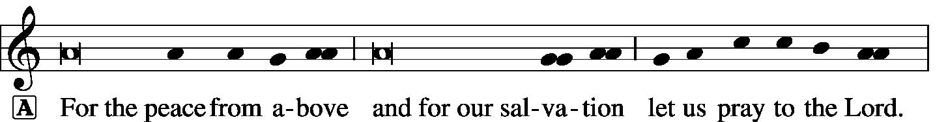

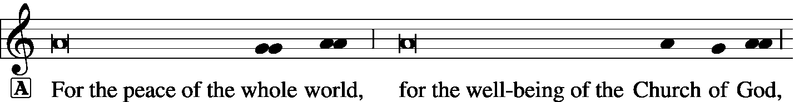

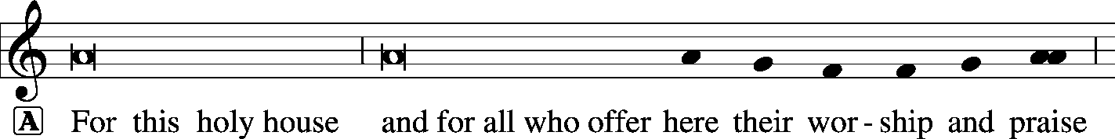

The Hymn of Praise is omitted during Advent.

Salutation and Collect of the Day
P The Lord be with you.
C And also with you.
P Let us pray.
Stir up Your power, O Lord, and come, that by Your protection we may be rescued from the threatening perils of our sins and saved by Your mighty deliverance; for You live and reign with the Father and the Holy Spirit, one God, now and forever.
C Amen.

Sit
Hymn Savior of the Nations, Come LSB 332

Old Testament Reading Jeremiah 23:5–8
“Behold, the days are coming, declares the Lord, when I will raise up for David a righteous Branch, and He shall reign as king and deal wisely, and shall execute justice and righteousness in the land. In His days Judah will be saved, and Israel will dwell securely. And this is the name by which He will be called: ‘The Lord is our righteousness.’
“Therefore, behold, the days are coming, declares the Lord, when they shall no longer say, ‘As the Lord lives who brought up the people of Israel out of the land of Egypt,’ but ‘As the Lord lives who brought up and led the offspring of the house of Israel out of the north country and out of all the countries where He had driven them.’ Then they shall dwell in their own land.”
P This is the Word of the Lord.
C Thanks be to God.

Epistle Romans 13:8–14
Owe no one anything, except to love each other, for the one who loves another has fulfilled the law. The commandments, “You shall not commit adultery, You shall not murder, You shall not steal, You shall not covet,” and any other commandment, are summed up in this word: “You shall love your neighbor as yourself.” Love does no wrong to a neighbor; therefore love is the fulfilling of the law.
Besides this you know the time, that the hour has come for you to wake from sleep. For salvation is nearer to us now than when we first believed. The night is far gone; the day is at hand. So then let us cast off the works of darkness and put on the armor of light. Let us walk properly as in the daytime, not in orgies and drunkenness, not in sexual immorality and sensuality, not in quarreling and jealousy. But put on the Lord Jesus Christ, and make no provision for the flesh, to gratify its desires.
P This is the Word of the Lord.
C Thanks be to God.

Stand
Alleluia and Verse
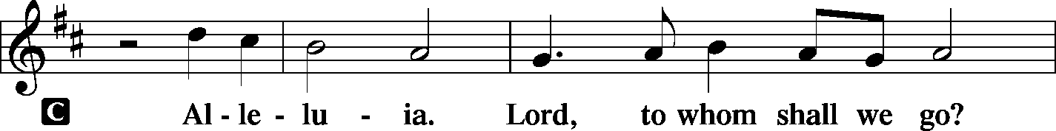
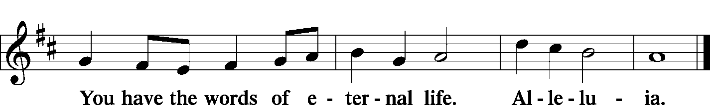

Holy Gospel Matthew 21:1–9
P The Holy Gospel according to St. Matthew, the 21st chapter.
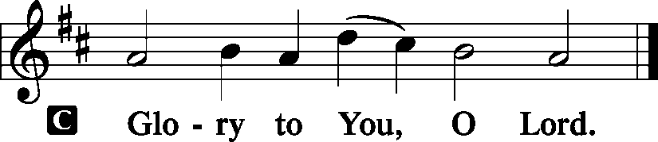
Now when they drew near to Jerusalem and came to Bethphage, to the Mount of Olives, then Jesus sent two disciples, saying to them, “Go into the village in front of you, and immediately you will find a donkey tied, and a colt with her. Untie them and bring them to Me. If anyone says anything to you, you shall say, ‘The Lord needs them,’ and he will send them at once.” This took place to fulfill what was spoken by the prophet, saying,
“Say to the daughter of Zion,
‘Behold, your king is coming to you,
humble, and mounted on a donkey,
and on a colt, the foal of a beast of burden.’”
The disciples went and did as Jesus had directed them. They brought the donkey and the colt and put on them their cloaks, and He sat on them. Most of the crowd spread their cloaks on the road, and others cut branches from the trees and spread them on the road. And the crowds that went before Him and that followed Him were shouting, “Hosanna to the Son of David! Blessed is He who comes in the name of the Lord! Hosanna in the highest!”
P This is the Gospel of the Lord.
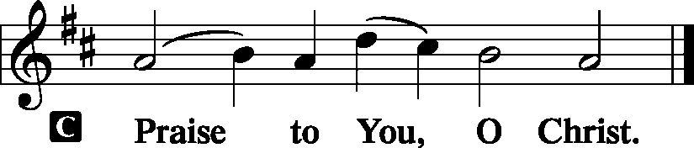

Sit
Children's Lunchbox Devotion

Hymn Lift Up Your Heads, Ye Mighty Gates LSB 341
Sermon Drawing Near

Stand
Apostles' Creed
C I believe in God, the Father Almighty, maker of heaven and earth.
And in Jesus Christ, His only Son, our Lord, who was conceived by the Holy Spirit, born of the virgin Mary, suffered under Pontius Pilate, was crucified, died and was buried. He descended into hell. The third day He rose again from the dead. He ascended into heaven and sits at the right hand of God the Father Almighty. From thence He will come to judge the living and the dead.
I believe in the Holy Spirit, the holy Christian Church, the communion of saints, the forgiveness of sins, the resurrection of the body, and the life T everlasting. Amen.

Sit
Offering
[Please fill out a sheet in the attendance book. Visitors, please include your address. If you have a prayer request for the church prayer chain, please write it at the top of the sheet.]

Special Offering Music Ashlee Eatherton

Stand
Offertory LSB 176
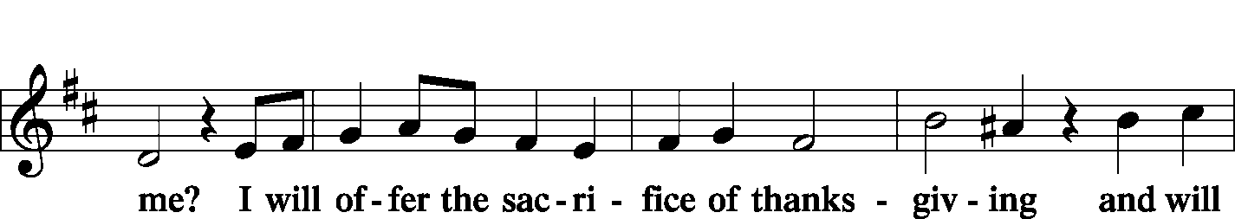
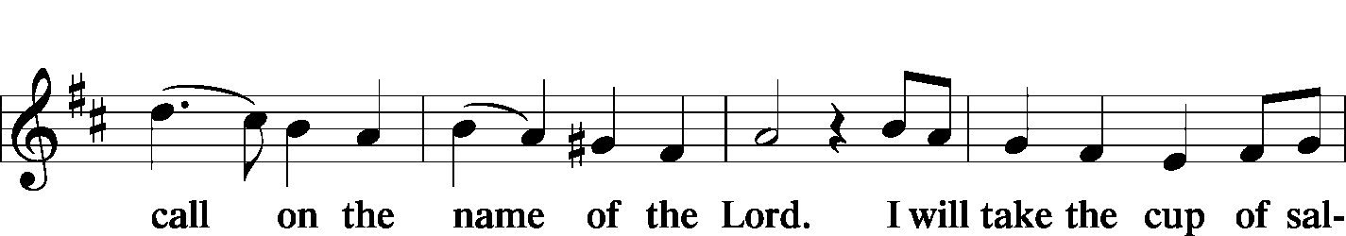
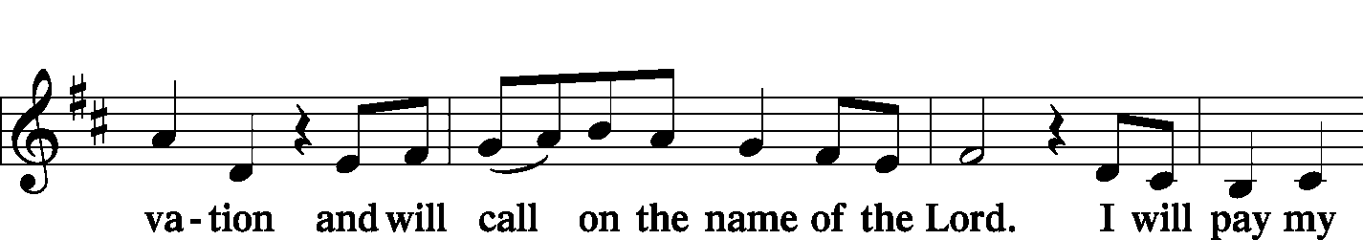
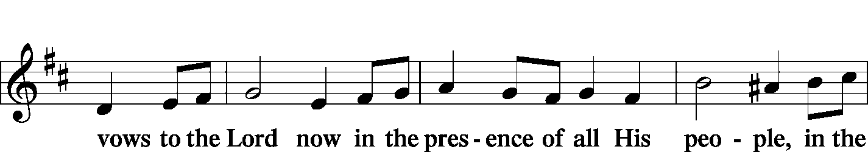
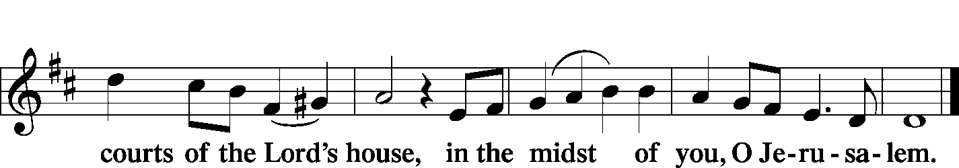

Prayer of the Church
P By Your grace, O Lord, we enter a new church year.
C We praise You for Your goodness, which has followed us through many generations.
P Yours is the kingdom, the power, and the glory.
C We thank You for giving to a world in darkness a ray of hope in the promise of the Messiah.
P Graciously help us to rejoice in that promise and prepare for His coming.
C As the citizens of Jerusalem welcomed Christ with shouts of hosanna, grant that we too rejoice in His coming.
P Unlike the citizens of Jerusalem, let us recognize Him as our Savior from sin and our hope for everlasting life.
C We long for that peace promised by Isaiah:
P when nations “shall beat their swords into plowshares and their spears into pruning hooks…”
C Help us to realize that Christ came to bring a higher and more enduring peace between us and Your divine majesty.
P As a King whose kingdom is not of this world, but from everlasting to everlasting,
C grant that Christ may always rule our hearts.
P Keep us awake and alert that we may always be found ready for the end time when He shall suddenly appear as the Judge of all.
C Help us to conduct ourselves as becomes those who bear Your name-
P “not in revelry and drunkenness, not in debauchery and licentiousness, not quarreling and jealousy.”
C Bless our witness to His peace, which comes as Your gift to us.

WE GO TO THE LORD IN PRAYER FOR
- Matt Krausz, Rainer Bretz, William Bretz, Andy Sax, Erin Beville, Isaiah Clayton, Pastor Kirk Clayton, David Hatcher, Jadon Lorton, Lily McDaniel, Dan Morra, and Marion Kneschke, as they celebrate their baptismal anniversaries this week.
- Mike Harriss, brother of Jennifer Trame, having surgery tomorrow.
- Kevin Derezotes, who was hospitalized this past week.
- Zion’s Elders, Board of Education, Sunday School staff, and Evangelism Committee.
- Faithfulness in our lives as Christian Stewards.

P Grant, O Lord, that our lips and lives be a reflection of hearts that are truly thankful for Your great mercy.
C This we ask in the name of the King of kings and the Lord of Lords, our Savior, Jesus Christ. Amen

Lord's Prayer and Collect for Grace
P Lord, remember us in Your kingdom and teach us to pray:
C Our Father who art in heaven, hallowed be Thy name, Thy kingdom come, Thy will be done on earth as it is in heaven; give us this day our daily bread; and forgive us our trespasses as we forgive those who trespass against us; and lead us not into temptation, but deliver us from evil. For Thine is the kingdom and the power and the glory forever and ever. Amen.

P O Lord, our heavenly Father, almighty and everlasting God, You have safely brought us to the beginning of this day. Defend us in the same with Your mighty power and grant that this day we fall into no sin, neither run into any kind of danger, but that all our doings, being ordered by Your governance, may be righteous in Your sight; through Jesus Christ, Your Son, our Lord, who lives and reigns with You and the Holy Spirit, one God, now and forever.
C Amen.

Benediction LSB 183
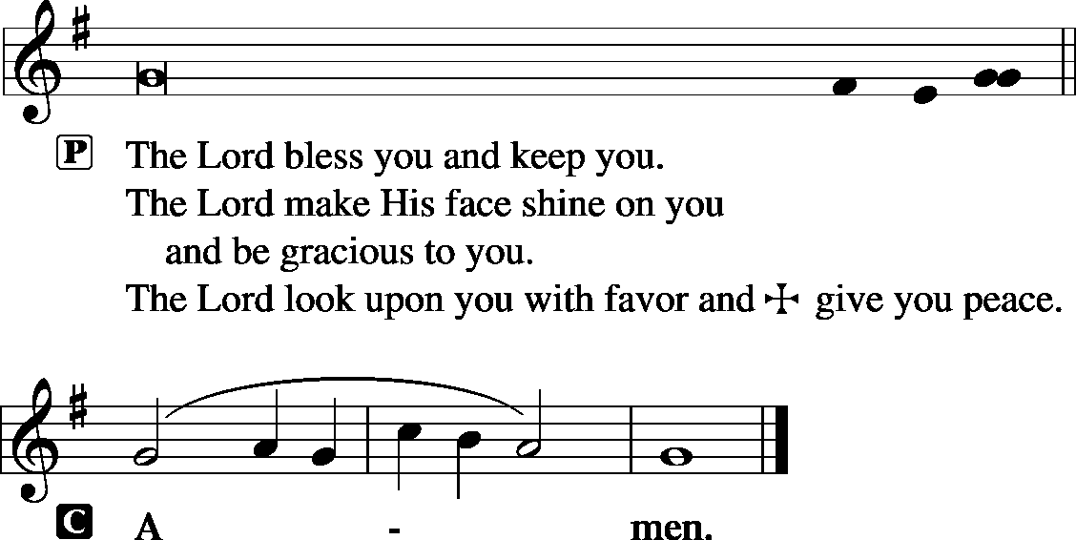

Sit
Hymn Prepare the Royal Highway LSB 343

Postlude Lift Up Your Heads James Biery

Acknowledgments
Unless otherwise indicated, all scripture quotations are from The Holy Bible, English Standard Version, copyright © 2001 by Crossway Bibles, a division of Good News Publishers. Used by permission. All rights reserved. Created by Lutheran Service Builder © 2006 Concordia Publishing House.
LIFE AND LIVING ITEMS AT ZION
          

CHURCH CHRISTMAS DECORATING – THIS SATURDAY
We will be decorating the church this Saturday, December 7th at 10:00 AM. If you would like to help, please join us! Any and all help is welcomed.

DECEMBER ECHO – NOW AVAILABLE
The December Echo is now available. Pick one up in the narthex today!

ADVENT DEVOTIONS – NOW AVAILABLE
Advent devotions are now available on the table in the narthex.

ADVENT AND CHRISTMAS SCHEDULE
December is a busy month, but our focus should be preparing for the joyful news of our Savior's birth and preparing to meet Him when He comes again in glory. Among all the other December activities, make sure that worship and church activities are central. All of us need to make choices as to how we will spend our time. What will your choices be? Will they reflect what is truly most important and of eternal significance? Or will your choices indicate a priority of the temporary over the eternal? Choose how you spend your time wisely. We look forward to seeing you at Zion at every opportunity!

ADVENT MIDWEEK SERVICES
Advent Midweek Services will be held on Wednesday evenings in December. Advent Services will be December 4th, 11th, and 18th at 7:00 PM. These services are a blessed way to step back from the hectic rush of December and focus on what is truly most important about Christmas--the birth of our Lord Jesus Christ. Don't let secular scheduling pressures keep you out of worship in God's house!

PARSONAGE OPEN HOUSE – DECEMBER 14th
The Steins are happy to invite you all to the parsonage to give back one small piece of the generosity they have received from Zion. We are holding an open house on Saturday, December 14th, from 4 pm to 8 pm. You and your family are welcome to come and bring a friend. There will be many sweets, some savory options, Christmas music sheets on a piano and choral music playing on the television. Seminarian Stein would also like to see you all in your ugliest Christmas sweaters.

MEMBER NEEDS FUND ENVELOPES
Zion's Elders maintain and administer a fund to help members of the congregation who are facing financial difficulties. "Member Needs Fund" envelopes are available in the pews, they are the small manila envelopes in the holders next to the hymnal racks. If you would like to make a donation to the Member Needs Fund, place your donation in the marked small manila envelope and place it in the collection plate. The Finance Board will pass the donation along to the Elders, and if the donor is identified, the Elders will give a letter for tax deduction purposes. Thank you for your support of this ministry of the congregation.

LINUS BLANKETS ON DISPLAY TODAY
The Ladies Aid made blankets this past summer for the Linus Blankets of Southwestern Illinois, Belleville. Since 1997, more than 63,000 have been delivered across the bi-state area to children’s hospitals and crisis centers to be handed out to children who are seriously ill, traumatized, or otherwise in need of some comfort. We have made more than 30 blankets in sizes ranging from those for preemies to teens. They will be delivered this week.

DONATIONS NEEDED FOR UNITY SCHOOL, EAST ST. LOUIS
Next Sunday, we will have the jars out in the back of the church for contributions to Unity Lutheran Christian Elementary School. They are having financial issues. This school is a vital tool to reach many young children and their families desperately needing to hear about God and His saving love, and we have the opportunity to support it NOW! The Ladies Aid will take up a collection at their Christmas Program, and this will be added to it as a donation from Zion.

CHRISTMAS CAROLERS NEEDED!
Would you like to bring the sounds of the season to those who need to hear the joyous message of God's love to them in the Christ Child? Would you like to enjoy the fellowship and fun of a potluck with brothers and sisters in Christ? If so, please join us as we meet at church at 4:30 p.m. on Sunday, Dec 8. After we have made the rounds of caroling, we will return to the school for fellowship and a potluck supper.
Please bring a dish from the below list according to your last name:

A-J Salad/Vegetable K-Q Dessert R-Z Main Dish

WHAT: Christmas Caroling and Potluck
WHEN: Sunday, Dec 8 at 4:30 p.m.
WHERE: Meet in the church kitchen to carpool to caroling sites

SECRET PAL PROGRAM
Ladies, would you like to have a Secret Pal at Zion? Have you noticed gifts mysteriously appearing at church? Zion's Ladies Aid/LWML members have had secret pals for the past years and have enjoyed it so much, this program is offered to any member of Zion who wishes to participate. You will receive a slip of paper on which to write your name, favorites, etc. from Glenda Pike. You are to pray for this person and can send cards or leave cards or small gifts at church during the year. See Glenda by Dec 8 to get details and sign up. Sh-h-h, don't tell anyone!

LADIES AID CHRISTMAS POTLUCK
All ladies of the congregation are invited to join us on Thursday, Dec 19, for our annual Christmas party and potluck (side dishes only, meat will be furnished). We eat at 6:00 and then will have a short program. NOTE: We are not doing the $5 gift exchange this year, but rather bringing several items for the Mascoutah Food Pantry; if you have a Secret Pal, that gift may be brought also. We will take a special collection for Unity Lutheran Christian Elementary School. It’s a fun and special evening. Plan to attend. See Glenda for more details. BABYSITTING will be provided.

ZION’S 140th ANNIVERSARY COOKBOOKS – GREAT GIFT IDEA!
REDUCED PRICE! ONLY $10 EACH!
Zion has added many new members in the past eleven years; Get to know other members by their submitted recipes! . Have you looked through our cookbook? It contains more than 475 recipes, as well as some history about Zion and some fun entries as well. Don't forget our wonderful cookbooks as you look over your Christmas list. They make great gifts!

CHRISTIAN-THEMED CHRISTMAS CARDS AND CALENDARS
The Ladies Aid has beautiful Christian-themed 2020 calendars for sale. We still have a few left, so get yours now! They are $6 each. We also have a wide variety of Christmas Cards for sale at very reasonable prices. See the table in the hall outside the office to shop. See Candy or Glenda to pay.

HOLY CHILDHOOD BLOOD DRIVE -- THURSDAY
The American Red Cross is holding a blood drive on Thursday, December 5th from 2-7 PM at Holy Childhood Parish Center, 419 E. Church St., Mascoutah. Please call 1-800-733-2767 or visit RedCrossBlood.org and enter: HolyChildhood to schedule an appointment.

HANDEL’S MESSIAH AT ZION, BELLEVILLE
Zion’s Music and Ministry and Community will present Handel’s Messiah on Sunday, December 22, at 3:00PM at Zion, 1810 McClintock Ave, Belleville.

UNITY LUTHERAN SCHOOL SEWING CLUB NEEDS SUPPLIES
The sewing club at Unity Lutheran Christian Elementary School is in need of some sewing supplies. We currently have about 20 boys and girls that come every Thursday to sewing club. We have plenty of donated material for right now. Supplies still needed are: pins, thread, rotary cutters, cutting mats, and a Basic sewing machine (newer editions). Thank you for your continued support for Unity!

ANNUAL TREE OF HOPE CAMPAIGN
The Mascoutah Tuesday Women’s Club is excited to announce the annual Tree of Hope campaign. Donations will be used to provide Christmas gifts of shoes and clothes for the needy children of Mascoutah. Funds were also used to support the Mascoutah Township School Supply Drive through a donation of 100, $20 gift cards to provide shoes for children starting school. Thanks to the generosity of Mascoutah, donations totaling $10,580 for the Tree of Hope were received in 2018. We ask for your help again this year in order to fill the stockings of so many needy children. Please send your donation to: Tree of Hope, PO Box 244, Mascoutah, IL 62258. If you have any questions, call Rosalie Taylor at 618-566-2529.

ROCK & ROLL BINGO AT LEU CIVIC CENTER -- SATURDAY
Join us on Saturday, December 7th at the Leu Civic Center for Rock & Roll Bingo. Doors open at 6:00 PM. Cost is $20 per person in advance and $25 at the door. Tickets may be purchased at Leu Civic Center. Attendees may bring food and beverages. For more information, call 618-566-2175.

TRINITY LUTHERAN ANNUAL COOKIE WALK -- SATURDAY
Trinity Lutheran Church at 503 E. Washington in Millstadt is hosting a Cookie Walk on Saturday, December 7th from 9 AM to Noon. Homemade cookies sold by the pound. Mixed are $10/lb. and fancy are $11/lb. Advance orders are being taken. Please call Shirley Boehm at 618-476-1113.

CHI AUXILIARY ANNUAL CHRISTMAS LUNCHEON
The Auxiliary of the Concordia Historical Institute is pleased to announce its Annual Christmas Luncheon on Thursday, December 12, 2019, at 12 Noon in Koburg Hall, Concordia Seminary campus (804 Seminary Place, Clayton, MO). Meet and greet new or renewed acquaintances, hear the Village Lutheran Homeschool Handbell Choir, enjoy singing Christmas carols, and receive an update on CHI. The luncheon cost is $15 per person, with reservations to be made by December 5th. Checks may be made payable to "CHI Auxiliary" and sent to Nancy Fassold, 5609 Nantasket Court, St. Louis, MO 63128. For more information, please contact her at 314-843-3559 or nk21@live.com.

CHURCH BASEMENT LADIES: AWAY IN THE BASEMENT
Take a trip back in time to 1959 and celebrate the holidays with the CHURCH BASEMENT LADIES: AWAY IN THE BASEMENT. The ladies and the pastor try to save the Church Christmas pageant from disaster in this fun, family-friendly musical presented by Clinton County Showcase at the Avon Theater in Breese on Dec. 6, 7, 8, 13, 14, & 15. Tickets now on sale at clintoncountyshowcase.com.

GOOD SHEPHERD CHRISTMAS CANTATA
On Sunday, December 29th at 3:00 PM, as a celebration of Christ’s coming at Christmas, the musicians of Good Shepherd Lutheran Church in Collinsville are presenting a special Christmas cantata featuring John Leavitt’s What Child Is This. The GSLS choir will be accompanied by member and guest professional instrumentalists. Good Shepherd Lutheran Church is located at 1300 Beltline Rd., Collinsville, IL. For more information, call 618-344-3151.

LISTEN TO WORLDWIDE KFUO AM850
KFUO Radio, AM850, a media ministry extension of LCMS congregations, shares Christ for you anytime, anywhere on AM850 via worship services, Bible and theology studies, practical talk programs, and sacred music. You can find programs on demand at kfuo.org and wherever you get your podcasts! Find us on social: @KFUOradio on Facebook, Twitter, and Instagram. This week on KFUO AM850, we wish you a blessed Advent! Hear the Coffee Hour Choir demonstrate how to simply go Christmas Caroling this season (12/4 at 9:00 a.m.), begin the book of 1 Thessalonians on Sharper Iron (weekdays at 8:00 a.m.), and worship with us in chapel service from the LCMS International Center (weekdays at 10:00 a.m.). Find programs on demand at kfuo.org or wherever you get your podcasts!

A DAILY, 15-MINUTE, VERSE-BY-VERSE BIBLE STUDY
The Word of the Lord Endures Forever is a podcast hosted by LCMS Pastor Will Weedon and produced by Lutheran Public Radio in Collinsville, IL. Pastor Weedon will be leading a study this week on John 5: The Healing at the Pool on the Sabbath, Jesus Is Equal with God, The Authority of the Son, Witnesses to Jesus and more. You can listen on-demand at thewordendures.org and on the LPR mobile app.
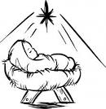
Reverse Advent
Calendar

An Advent calendar is a special calendar used to count the days of Advent in anticipation of Christmas. Traditionally, this countdown is marked by opening a small door of a calendar and retrieving a small candy or toy from a hidden compartment. This year, instead of receiving, let us give back in thankfulness for the ultimate gift of Jesus Christ our Lord and Savior.

Directions: Each day, add an item to a box. To keep this a mindful activity, this can be done in conjunction with your daily Advent devotional. On Christmas Eve, donate the contents to Mascoutah Food Pantry. The Food Pantry is open on Tuesdays and Saturdays from 10:00 - 12:00. You can also drop your box off at the church or call Beth Twenhafel (618-660-8872) for a pick up at your house.

December 1 - box of cereal
December 2 - peanut butter
December 3 - stuffing mix
December 4 - boxed potatoes
December 5 - macaroni and cheese
December 6 - canned tomatoes
December 7 - cream of mushroom soup
December 8 - canned tuna
December 9 - dessert mix
December 10 - jar of applesauce
December 11 - canned sweet potatoes
December 12 - cranberry sauce
December 13 - canned beans
December 14 - box of crackers
December 15 - package of rice
December 16 - package of oatmeal
December 17 - package of pasta
December 18 - spaghetti sauce
December 19 - chicken noodle soup
December 20 - tomato soup
December 21 - can corn
December 22- can mixed vegetables
December 23 - can carrots
THOSE WHO SERVE TODAY
Proclaimer: Rev. Kirk Clayton
Organist: Nancy Peterson
Ushers: Bob Walter, Dale Wehmeyer, Eldon Ahner,
& Ted Ahner
Sound Tech: Lionel Timmerman
Video Tech: Mark Hatcher
Welcome Team: Tom & Cheryl Sax
Acolytes: William Bretz & Rainer Bretz

THOSE WHO SERVE NEXT WEEK, DECEMBER 8
Proclaimer: Rev. Kirk Clayton
Liturgist: Sem. Adam Wolfe
Liturgist: Sem. Don Stein
Organist: Nancy Peterson
Ushers: Karl Bretz, Joe Crismon, Bob Eldridge, & Ken Frey
Sound Tech: Buzz Kandler
Video Tech: Mark Hatcher
Welcome Team: Torri & Alicia Suedmeyer
Acolytes: Ella Bretz & Daniel Bretz
Altar Guild: Gail Frey

THINGS WE ARE DOING AT ZION
Sun. Children’s Christmas Program Practice 8:45 AM
Bible Class 8:45 AM
Worship DS II n/communion 10:00 AM
Tues. Church Council 6:30 PM
Evangelism 7:00 PM
Wed. Choir Rehearsal 6:00 PM
First Advent Midweek Service 7:00 PM
Fri. Senior Meal Delivery 10:30 AM
Sat. Church Christmas Decorating 10:00 AM
Sun. Children’s Christmas Program Practice 8:45 AM
Bible Class 8:45 AM
Worship DS III w/communion 10:00 AM
Men’s Club 6:30 PM

ATTENDANCE NOVEMBER 24: Sunday: 174
Adult Bible Class: 28 High School: 10 Sunday School: 46

