Zion Lutheran Church
Mascoutah, Illinois
December 18, 2019
3rd Advent Midweek Service

In the Name of Christ Jesus our Lord, we bid you a warm welcome to this worship service. May your experience of worship and fellowship this evening be spiritually refreshing and ready you for the week ahead.

Pastor: Rev. Kirk Clayton
Church Secretary: Robin Phillips
Choir Director Team: Josh and Nancy Peterson
_________________________________________________________________________________
Church Office Phone: 618-566-7345
Pastor Clayton Cell: 618-447-1306
Office Hours: 8:00 am to 12:00 pm
Email: ChurchOffice@ZionMascoutah.org
Pastor Clayton email: Pastor@ZionMascoutah.org
Web site: www.ZionMascoutah.org
Find us at @ZionMascoutah on Facebook, Twitter, and Instagram
Electronic Devices
Please TURN OFF all cell phones, pagers, electronic devices, apps and games when entering the sanctuary for worship so those around you may focus on the Word of God without electronic distraction. Thank you.

Vespers
Hymn Once He Came in Blessing LSB 333

Stand

Opening Versicles (Use Advent Response)
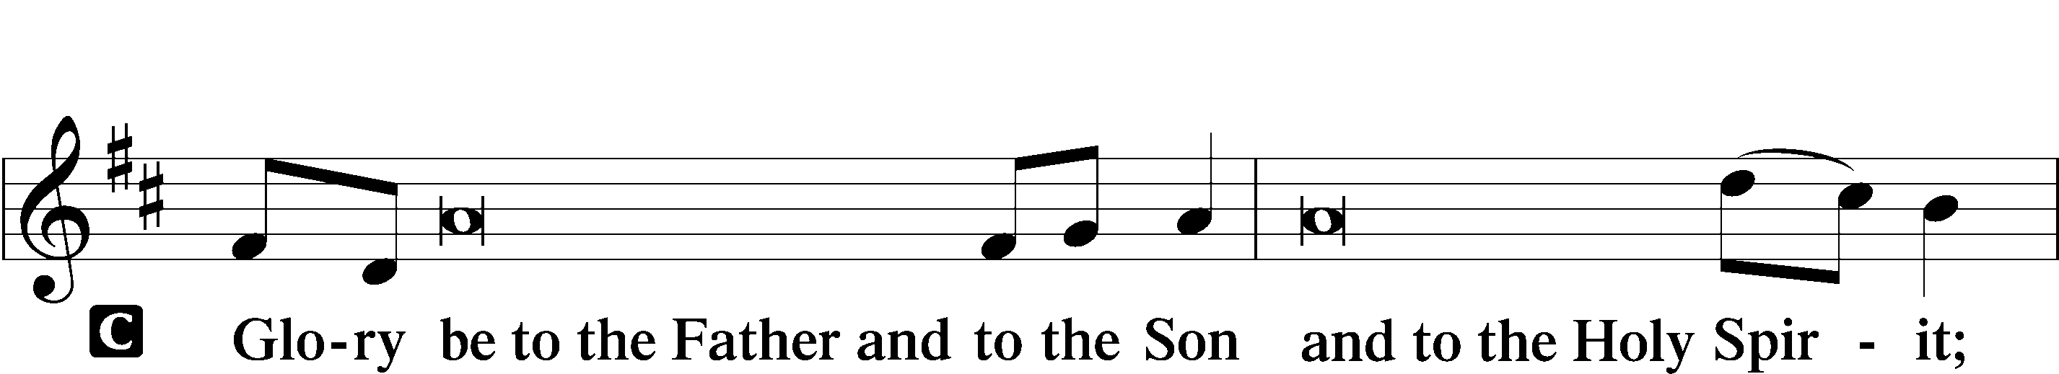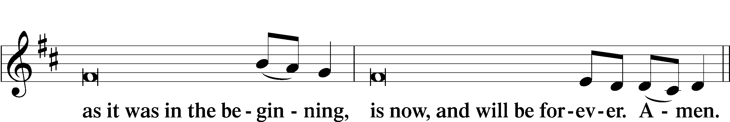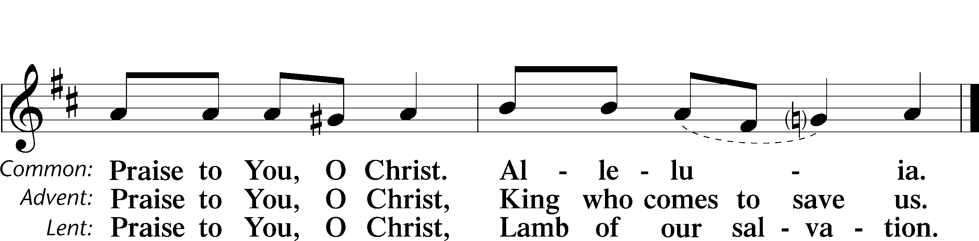
Psalmody
Psalm Psalm 85
L Lord, You were favorable to Your land;
C You restored the fortunes of Jacob.
L You forgave the iniquity of Your people;
C You covered all their sin.
L You withdrew all Your wrath;
C You turned from Your hot anger.
L Restore us again, O God of our salvation,
C and put away Your indignation toward us!
L Will You be angry with us forever?
C Will You prolong Your anger to all generations?
L Will You not revive us again,
C that Your people may rejoice in You?
L Show us Your steadfast love, O Lord,
C and grant us Your salvation.
L Let me hear what God the Lord will speak, for He will speak peace to His people, to His saints;
C but let them not turn back to folly.
L Surely His salvation is near to those who fear Him,
C that glory may dwell in our land.
L Steadfast love and faithfulness meet;
C righteousness and peace kiss each other.
L Faithfulness springs up from the ground,
C and righteousness looks down from the sky.
L Yes, the Lord will give what is good,
C and our land will yield its increase.
L Righteousness will go before Him
C and make His footsteps away.
Glory be to the Father and to the Son and to the Holy Spirit;
as it was in the beginning, is now, and will be forever. Amen.

Sit

First Reading Isaiah 61:10-62:3
I will greatly rejoice in the Lord;
my soul shall exult in my God,
for He has clothed me with the garments of salvation;
He has covered me with the robe of righteousness,
as a bridegroom decks himself like a priest with a beautiful headdress,
and as a bride adorns herself with her jewels.
For as the earth brings forth its sprouts,
and as a garden causes what is sown in it to sprout up,
so the Lord God will cause righteousness and praise
to sprout up before all the nations.
For Zion's sake I will not keep silent,
and for Jerusalem's sake I will not be quiet,
until her righteousness goes forth as brightness,
and her salvation as a burning torch.
The nations shall see your righteousness,
and all the kings your glory,
and you shall be called by a new name
that the mouth of the Lord will give.
You shall be a crown of beauty in the hand of the Lord,
and a royal diadem in the hand of your God.
L Oh Lord, have mercy on us.
C Thanks be to God.

Second Reading Galatians 4:1-7
I mean that the heir, as long as he is a child, is no different from a slave, though he is the owner of everything, but he is under guardians and managers until the date set by his father. In the same way we also, when we were children, were enslaved to the elementary principles of the world. But when the fullness of time had come, God sent forth His Son, born of woman, born under the law, to redeem those who were under the law, so that we might receive adoption as sons. And because you are sons, God has sent the Spirit of His Son into our hearts, crying, “Abba! Father!” So you are no longer a slave, but a son, and if a son, then an heir through God.
L Oh Lord, have mercy on us.
C Thanks be to God.

Third Reading Luke 2: 22-40
And when the time came for their purification according to the Law of Moses, they brought Him up to Jerusalem to present Him to the Lord (as it is written in the Law of the Lord, “Every male who first opens the womb shall be called Holy to the Lord”) and to offer a sacrifice according to what is said in the Law of the Lord, “a pair of turtledoves, or two young pigeons.” Now there was a man in Jerusalem, whose name was Simeon, and this man was righteous and devout, waiting for the consolation of Israel, and the Holy Spirit was upon him. And it had been revealed to him by the Holy Spirit that he would not see death before he had seen the Lord's Christ. And he came in the Spirit into the temple, and when the parents brought in the child Jesus, to do for Him according to the custom of the Law, he took Him up in his arms and blessed God and said,
“Lord, now You are letting Your servant depart in peace,
according to Your word;
for my eyes have seen Your salvation
that You have prepared in the presence of all peoples,
a light for revelation to the Gentiles,
and for glory to Your people Israel.”
And His father and His mother marveled at what was said about Him. And Simeon blessed them and said to Mary His mother, “Behold, this child is appointed for the fall and rising of many in Israel, and for a sign that is opposed (and a sword will pierce through your own soul also), so that thoughts from many hearts may be revealed.”
And there was a prophetess, Anna, the daughter of Phanuel, of the tribe of Asher. She was advanced in years, having lived with her husband seven years from when she was a virgin, and then as a widow until she was eighty-four. She did not depart from the temple, worshiping with fasting and prayer night and day. And coming up at that very hour she began to give thanks to God and to speak of Him to all who were waiting for the redemption of Jerusalem.
And when they had performed everything according to the Law of the Lord, they returned into Galilee, to their own town of Nazareth. And the child grew and became strong, filled with wisdom. And the favor of God was upon Him.
L Oh Lord, have mercy on us.
C Thanks be to God.

Advent Responsory
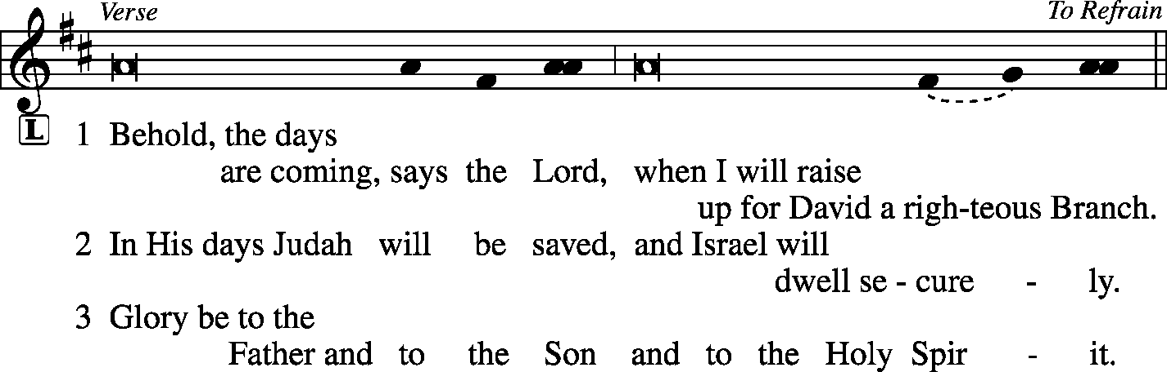
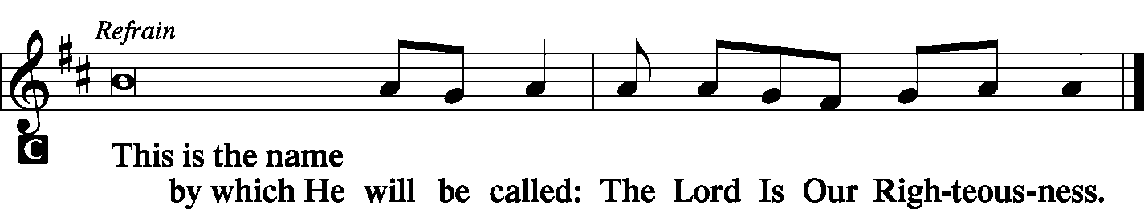

Hymn Hark the Glad Sound LSB 349

Sermon Righteousness Born…to Redeem Us

Offering
[Please fill out a sheet in the attendance book. Visitors, please include your address. If you have a prayer request for the church prayer chain, please write it at the top of the sheet.]

Stand

Antiphon (Common) LSB 231
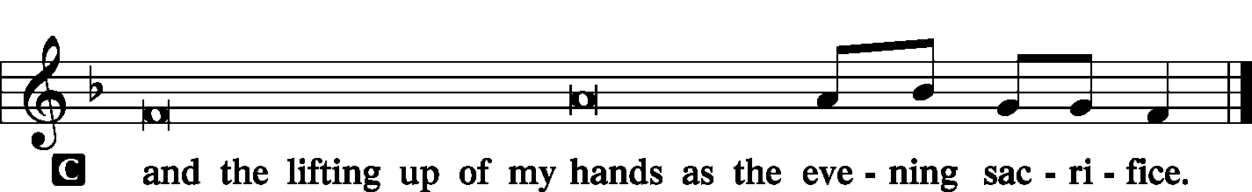

Canticle
Magnificat LSB 248
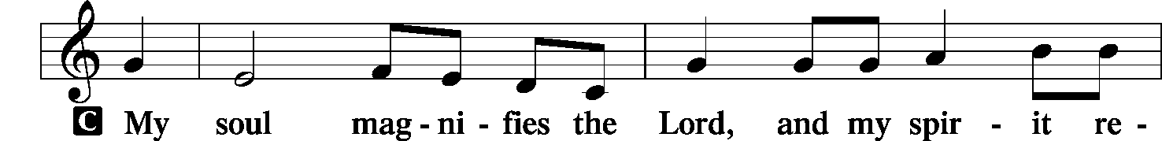
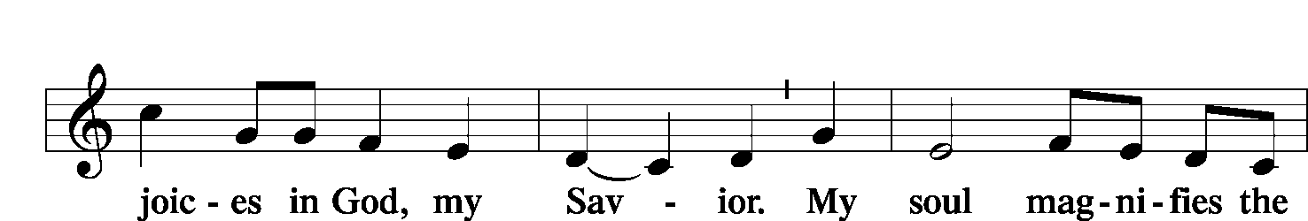
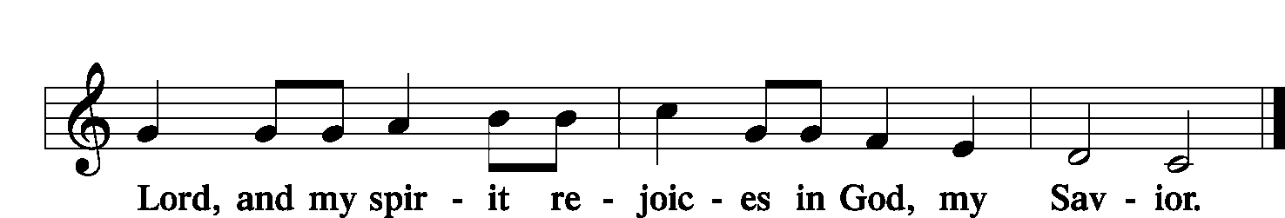
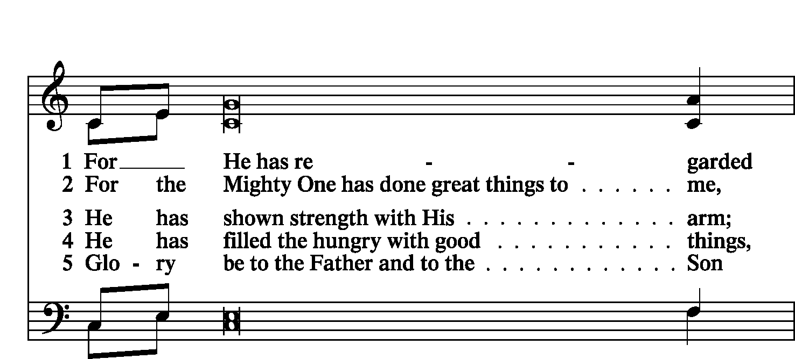
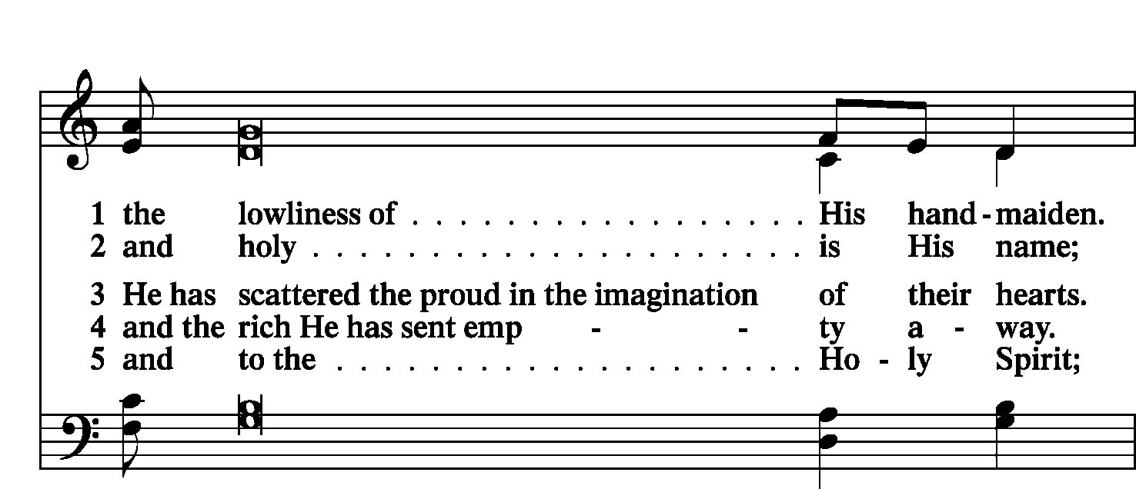
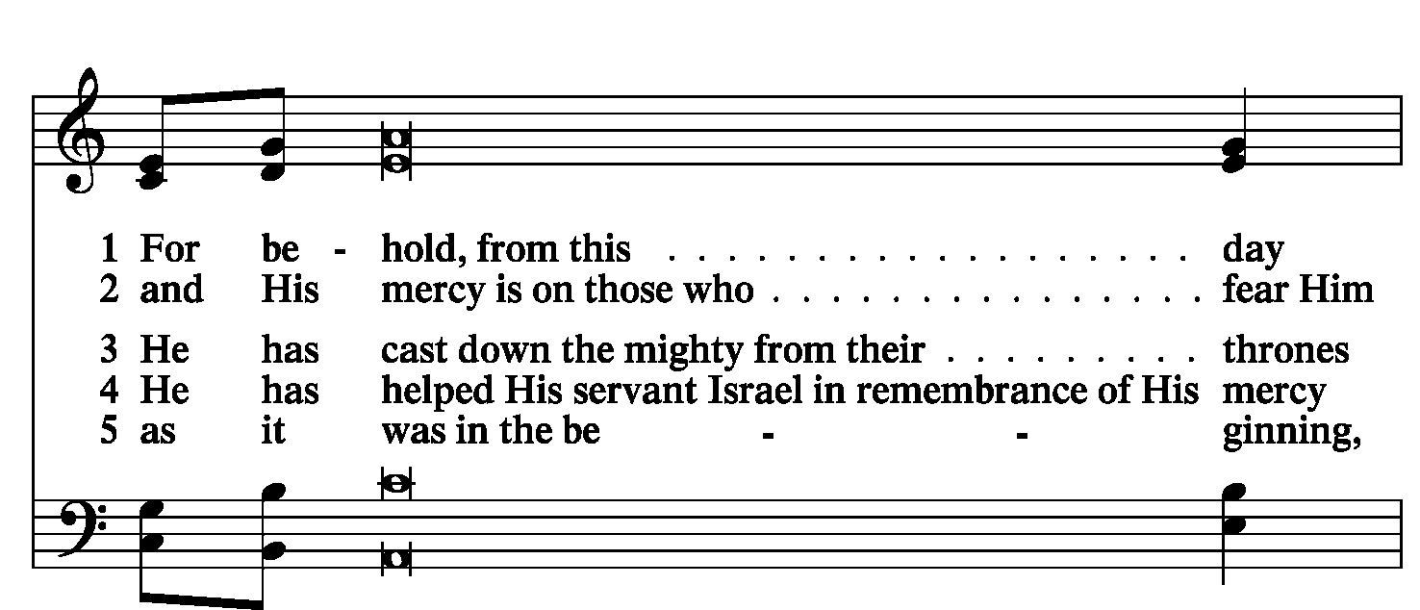
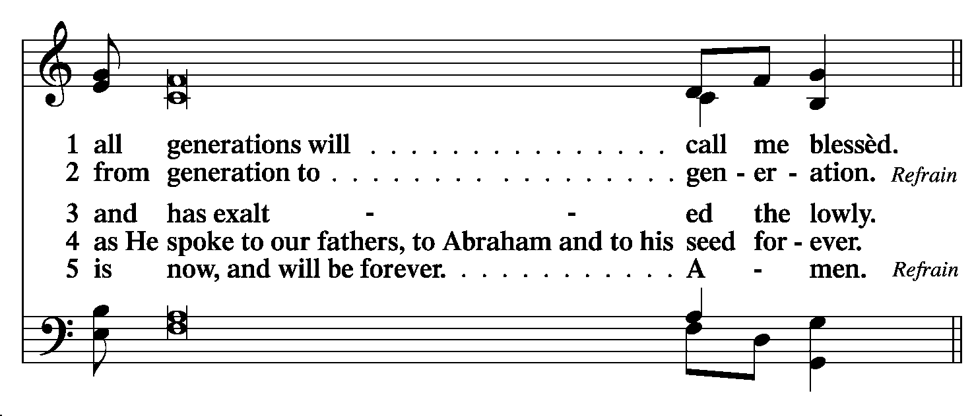
Prayer
Litany LSB 249
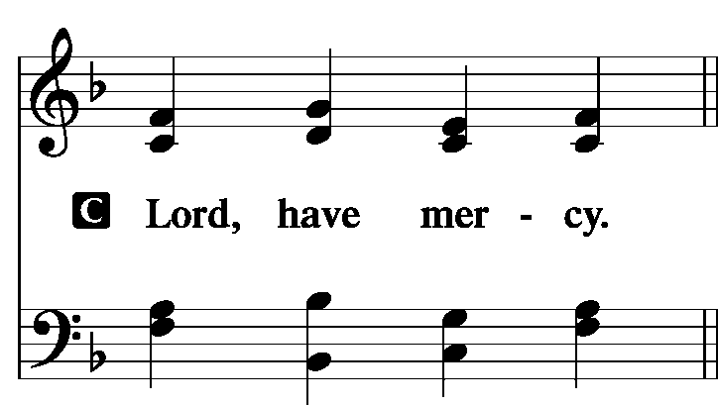
P For the peace from above and for our salvation, let us pray to the Lord:
C Lord, have mercy.
P For the peace of the whole world, for the well-being of the Church of God, and for the unity of all, let us pray to the Lord:
C Lord, have mercy.
P For this holy house and for all who offer here their worship and praise, let us pray to the Lord:
C Lord, have mercy.
P For our Synodical President, Pastor Matthew Harrison, for our District President, Pastor Tim Scharr, for all pastors in Christ, for all servants of the Church, and for all the people, let us pray to the Lord:
C Lord, have mercy.
P For our President, for all public servants, for the government and those who protect us, that they may be upheld and strengthened in every good deed, let us pray to the Lord:
C Lord, have mercy.
P For those who work to bring peace, justice, health, and protection in this and every place, let us pray to the Lord:
C Lord, have mercy.
P For those who bring offerings, those who do good works in this congregation, those who toil, those who sing, and all the people here present who await from the Lord great and abundant mercy, let us pray to the Lord:
C Lord, have mercy.
P For favorable weather, for an abundance of the fruits of the earth, and for peaceful times, let us pray to the Lord:
C Lord, have mercy.
P For our deliverance from all affliction, wrath, danger, and need, let us pray to the Lord:
C Lord, have mercy.
P For the faithful who have gone before us and are with Christ, let us give thanks to the Lord:
C Alleluia!
P Help, save, comfort, and defend us, gracious Lord.

Silence for individual prayer may follow.

P Rejoicing in the fellowship of all the saints, let us commend ourselves, one another, and our whole life to Christ, our Lord:
C To You, O Lord.

Collect For Peace
P O God, from whom come all holy desires, all good counsels, and all just works, give to us, Your servants, that peace which the world cannot give, that our hearts may be set to obey Your commandments and also that we, being defended from the fear of our enemies, may live in peace and quietness; through Jesus Christ, Your Son, our Lord, who lives and reigns with You and the Holy Spirit, one God, now and forever.
C Amen.

Collect For the Third Sunday of Advent
P The Lord be with you.
C And also with you.
P Let us pray. Lord Jesus Christ, we implore You to hear our prayers and to lighten the darkness of our hearts by Your gracious visitation; for You live and reign with the Father and the Holy Spirit, one God, now and forever.
C Amen.

Lord's Prayer LSB 251
P Taught by our Lord and trusting in His promises, we are bold to pray:
C Our Father who art in heaven, hallowed be thy name, Thy kingdom come, Thy will be done on earth as it is in heaven; give us this day our daily bread; and forgive us our trespasses as we forgive those who trespass against us; and lead us not into temptation, but deliver us from evil. For Thine is the kingdom and the power and the glory forever and ever. Amen.

Benedicamus and Benediction LSB 252
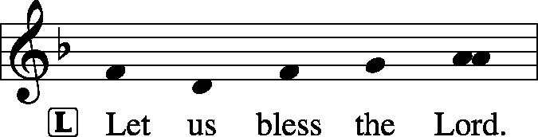
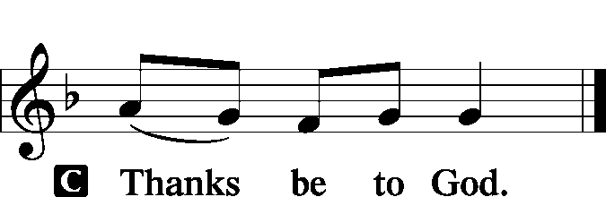
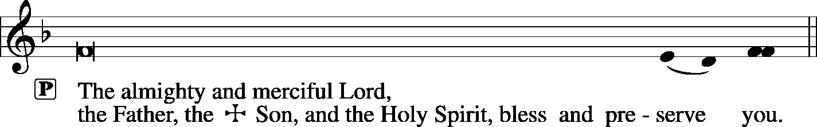

Sit

Hymn Come, Thou Long-Expected Jesus LSB 338

Acknowledgments
Unless otherwise indicated, all scripture quotations are from The Holy Bible, English Standard Version, copyright © 2001 by Crossway Bibles, a division of Good News Publishers. Used by permission. All rights reserved. Created by Lutheran Service Builder © 2006 Concordia Publishing House.
LIFE AND LIVING ITEMS AT ZION
          
ADVENT AND CHRISTMAS SCHEDULE
December is a busy month, but our focus should be preparing for the joyful news of our Savior's birth and preparing to meet Him when He comes again in glory. Among all the other December activities, make sure that worship and church activities are central. All of us need to make choices as to how we will spend our time. What will your choices be? Will they reflect what is truly most important and of eternal significance. Or will your choices indicate a priority of the temporary over the eternal? Choose how you spend your time wisely. We look forward to seeing you at Zion at every opportunity!

CONGRATULATIONS TO ZION'S NEWLY ELECTED BOARD MEMBERS
At the Voters Meeting held on Thursday, December 12th, the following people were elected to serve in leadership roles at Zion: Vice President, Dale Wehmeyer; Board of Elders, Randy Schorfheide; Trustees, Gadge Corey and Mike Twenhafel; Secretary, Rachel Bretz; Board of Finance, Deb Heck; Board of Education, Amanda Ganey; and Asst. Sunday School Superintendant, Jenna Dunn. We also want to thank those faithful servants whose terms are ending: Chairman, Bob Walter; Elder, Ray Kemezys; Secretary, Jean Kemezys; Trustees, Mike Segelhorst and Mike Ganey; Finance, Sharon Weier; and Board of Education, Alicia Suedmeyer. Please say a big "THANK YOU" both to those who have served the congregation in the past year and those who have been chosen to serve in the coming year.

NEW OFFERING ENVELOPES ARE IN
The 2020 offering envelopes are in and ready for pick-up. Please locate yours on the table in the narthex by the office window, and take your box home with you today. Thank you!

INSTALLATION OF ZION OFFICERS -- JANUARY 5th
Attention, all congregational officers and board members: Installation of officers for the new year will be held during the 10:00 AM worship service on Sunday, January 5, 2020. All officers and board members, please be in attendance. Thank you.

LIFELIGHT BIBLE STUDY RESUMES
We will resume LifeLight on January 6th. Join us in the church conference room at 7 PM on Mondays as we study Galatians/Philippians/Colossians. Call or text Lionel (618-806-8993) to join or if you have questions.

THOSE WHO SERVE TODAY
Proclaimer: Sem. Adam Wolfe
Liturgist: Rev. Kirk Clayton
Liturgist: Sem. Don Stein
Organist: Pinky Ahner

THOSE WHO SERVE THIS SUNDAY, DECEMBER 22
Proclaimer: Rev. Kirk Clayton
Liturgist: Sem. Adam Wolfe
Liturgist: Sem. Don Stein
Organist: Nancy Peterson
Ushers: Ryan Heck, Tom Heck, Ray Kemezys, & Alan Kneschke
Sound Tech: Ken Frey
Video Tech: Mark Hatcher
Welcome Team: Matt & Emily Wambold
Acolytes: Cadence Dunn & Lilah Fanous
Altar Guild: Linda Hoskins

THINGS WE ARE DOING AT ZION
Wed. Choir Rehearsal 6:00 PM
Third Advent Midweek Service 7:00 PM
Thurs. Ladies Aid Christmas Potluck 6:00 PM
Trustees Meeting 7:00 PM
Fri. Senior Meal Delivery 10:30 AM
Sun. Confirmation Class 8:30 AM
SS & Bible Class 8:45 AM
Worship DS I w/communion 10:00 AM
MarKa Service 1:30 PM

