Zion Lutheran Church
Mascoutah, Illinois
December 8, 2019
2nd Sunday of Advent
“Populous Zion”
(Daughter of Zion)

In the Name of Christ Jesus our Lord, we bid you a warm welcome to this worship service. May your experience of worship and fellowship this morning be spiritually refreshing and ready you for the week ahead.
 
Pastor: Rev. Kirk Clayton
Church Secretary: Robin Phillips
Choir Director Team: Josh and Nancy Peterson
_________________________________________________________________________________
Church Office Phone: 618-566-7345
Pastor Clayton Cell: 618-447-1306
Office Hours: 8:00 am to 12:00 pm
Email: ChurchOffice@ZionMascoutah.org
Pastor Clayton email: Pastor@ZionMascoutah.org
Web site: www.ZionMascoutah.org
Find us at @ZionMascoutah on Facebook, Twitter, and Instagram
Electronic Devices
Please TURN OFF all cell phones, pagers, electronic devices, apps and games when entering the sanctuary for worship so those around you may focus on the Word of God without electronic distraction. Thank you.

A Prayer to Begin Worship
Fill us with anticipation, activate our hope, O Son of God and Son of Man, who, having redeemed us at Your first advent, has promised to come again in the fullness of time, in radiant splendor, to lead us into eternal glory; who with the Father and the Holy Spirit are one God with dominion over us forever.

DIVINE SERVICE III WITH COMMUNION
LSB p. 184
Confession and Absolution
Prelude Rejoice, Rejoice, Believers arr. Sadowski

Hymn Rejoice, Rejoice, Believers LSB 515

Stand

The sign of the cross may be made by all in remembrance of their Baptism.

Invocation
P In the name of the Father and of the T Son and of the Holy Spirit.
C Amen.

Exhortation
P Beloved in the Lord! Let us draw near with a true heart and confess our sins unto God our Father, beseeching Him in the name of our Lord Jesus Christ to grant us forgiveness.
P Our help is in the name of the Lord,
C who made heaven and earth.
P I said, I will confess my transgressions unto the Lord,
C and You forgave the iniquity of my sin.

Silence for reflection on God's Word and for self-examination.

Confession with Absolution
P O almighty God, merciful Father,
C I, a poor, miserable sinner, confess unto You all my sins and iniquities with which I have ever offended You and justly deserved Your temporal and eternal punishment. But I am heartily sorry for them and sincerely repent of them, and I pray You of Your boundless mercy and for the sake of the holy, innocent, bitter sufferings and death of Your beloved Son, Jesus Christ, to be gracious and merciful to me, a poor, sinful being.

P Upon this your confession, I, by virtue of my office, as a called and ordained servant of the Word, announce the grace of God unto all of you, and in the stead and by the command of my Lord Jesus Christ I forgive you all your sins in the name of the Father and of the T Son and of the Holy Spirit.
C Amen.

Service of the Word
Introit Ps. 80:1, 3, 14, 17; antiphon: Is. 62:11b; 30:30, 29
L Say to the daughter of Zion,
C “Behold, your salvation comes.”
L The Lord will cause His majestic voice to be heard,
C and you shall have gladness of heart.
L Give ear, O Shepherd of Israel, You who lead Joseph like a flock!
C You who are enthroned upon the cherubim, shine forth.
L Restore us, O God;
C let Your face shine, that we may be saved!
L Turn again, O God of hosts!
C Look down from heaven, and see.
L But let Your hand be on the man of Your right hand,
C the son of man whom You have made strong for Yourself!
L Say to the daughter of Zion,
C “Behold, your salvation comes.”
L The Lord will cause His majestic voice to be heard,
C and you shall have gladness of heart.

Gloria Patri
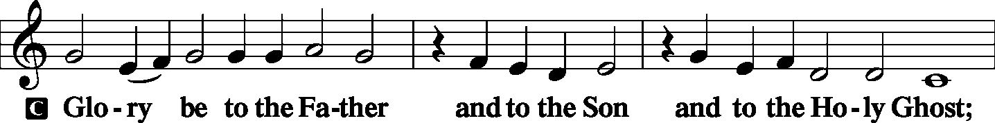
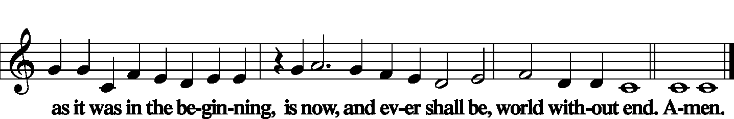

Kyrie LSB 186
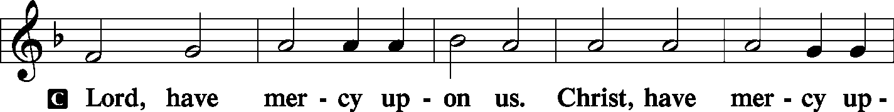
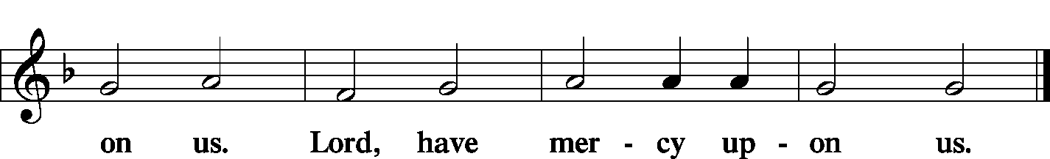

Gloria in Excelsis is omitted for Advent

Salutation and Collect of the Day
L The Lord be with you.
C And with thy spirit.
L Let us pray.
Stir up our hearts, O Lord, to make ready the way of Your only-begotten Son, that by His coming we may be enabled to serve You with pure minds; through the same Jesus Christ, our Lord, who lives and reigns with You and the Holy Spirit, one God, now and forever.
C Amen.

Sit

Old Testament Reading Malachi 4:1–6
“For behold, the day is coming, burning like an oven, when all the arrogant and all evildoers will be stubble. The day that is coming shall set them ablaze, says the Lord of hosts, so that it will leave them neither root nor branch. But for you who fear My name, the sun of righteousness shall rise with healing in its wings. You shall go out leaping like calves from the stall. And you shall tread down the wicked, for they will be ashes under the soles of your feet, on the day when I act, says the Lord of hosts.
“Remember the law of My servant Moses, the statutes and just decrees that I commanded him at Horeb for all Israel.
“Behold, I will send you Elijah the prophet before the great and awesome day of the Lord comes. And he will turn the hearts of fathers to their children and the hearts of children to their fathers, lest I come and strike the land with a decree of utter destruction.”
L This is the Word of the Lord.
C Thanks be to God.

Choir O Come, Redeemer Glorious Henry Kihlken

Epistle Romans 15:4–13
For whatever was written in former days was written for our instruction, that through endurance and through the encouragement of the Scriptures we might have hope. May the God of endurance and encouragement grant you to live in such harmony with one another, in accord with Christ Jesus, that together you may with one voice glorify the God and Father of our Lord Jesus Christ. Therefore welcome one another as Christ has welcomed you, for the glory of God.
For I tell you that Christ became a servant to the circumcised to show God’s truthfulness, in order to confirm the promises given to the patriarchs, and in order that the Gentiles might glorify God for His mercy. As it is written,
“Therefore I will praise You among the Gentiles,
and sing to Your name.”
And again it is said,
“Rejoice, O Gentiles, with His people.”
And again,
“Praise the Lord, all you Gentiles,
and let all the peoples extol Him.”
And again Isaiah says,
“The root of Jesse will come,
even He who arises to rule the Gentiles;
in Him will the Gentiles hope.”
May the God of hope fill you with all joy and peace in believing, so that by the power of the Holy Spirit you may abound in hope.
L This is the Word of the Lord.
C Thanks be to God.

Stand

Alleluia and Verse
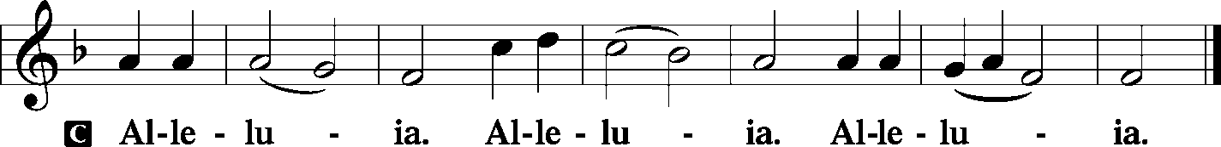

Holy Gospel Luke 21:25–36
P The Holy Gospel according to St. Luke, the twenty-first chapter.
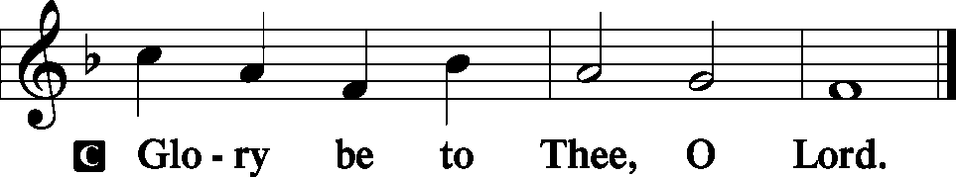
“And there will be signs in sun and moon and stars, and on the earth distress of nations in perplexity because of the roaring of the sea and the waves, people fainting with fear and with foreboding of what is coming on the world. For the powers of the heavens will be shaken. And then they will see the Son of Man coming in a cloud with power and great glory. Now when these things begin to take place, straighten up and raise your heads, because your redemption is drawing near.”
And He told them a parable: “Look at the fig tree, and all the trees. As soon as they come out in leaf, you see for yourselves and know that the summer is already near. So also, when you see these things taking place, you know that the kingdom of God is near. Truly, I say to you, this generation will not pass away until all has taken place. Heaven and earth will pass away, but My words will not pass away.
“But watch yourselves lest your hearts be weighed down with dissipation and drunkenness and cares of this life, and that day come upon you suddenly like a trap. For it will come upon all who dwell on the face of the whole earth. But stay awake at all times, praying that you may have strength to escape all these things that are going to take place, and to stand before the Son of Man.”
P This is the Gospel of the Lord.
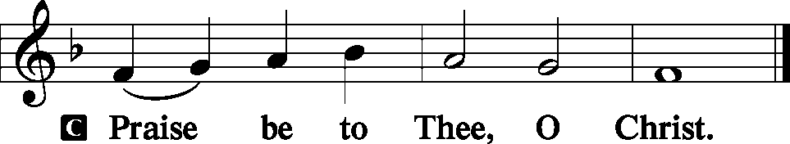

Nicene Creed
C I believe in one God, the Father Almighty, maker of heaven and earth and of all things visible and invisible.
And in one Lord Jesus Christ, the only-begotten Son of God, begotten of His Father before all worlds, God of God, Light of Light, very God of very God, begotten, not made, being of one substance with the Father, by whom all things were made; who for us men and for our salvation came down from heaven and was incarnate by the Holy Spirit of the virgin Mary and was made man; and was crucified also for us under Pontius Pilate. He suffered and was buried. And the third day He rose again according to the Scriptures and ascended into heaven and sits at the right hand of the Father. And He will come again with glory to judge both the living and the dead, whose kingdom will have no end.
And I believe in the Holy Spirit, the Lord and giver of life, who proceeds from the Father and the Son, who with the Father and the Son together is worshiped and glorified, who spoke by the prophets. And I believe in one holy Christian and apostolic Church, I acknowledge one Baptism for the remission of sins, and I look for the resurrection of the dead and the life T of the world to come. Amen.
Sit

Hymn In the Shattered Bliss of Eden LSB 572

Sermon Fig Leaves

Stand

Prayer of the Church
L We lift our souls to You, O Lord.
C Make us to know Your ways and teach us Your paths.
L Lead us in Your truth and teach us, for You are the God of our salvation.
C O holy Father, we humbly implore You, help us believe Your promises.
L As Your servant Israel anticipated the coming of the Messiah, the Deliverer,
C help us to recognize Jesus Christ as that Messiah and welcome Him into our hearts by faith.
L Lead us by Your Holy Spirit to an understanding of our sinfulness and our need of repentance.
C Help us to hate sin and love righteousness.
L Be our strength in the hour of temptation and help us to serve You and bring glory to Your name.
C Send the light of the Gospel to the ends of the earth that all may know Your love in Jesus Christ.
L Increase the number of those who can confess with sincerity and conviction:
C blessed is He who comes in the name of the Lord! Hosanna in the highest.
L May such faith enable all nations to melt their weapons of war into instruments of peace.
C Grant Your abiding peace to all who are gathered in Your house today.
L To those among us who are afflicted, grant them strength to bear their burdens.
C Give us all patience to await the joy of Your abiding presence.
L Especially, O Lord, we implore You to look with favor upon our land.
C Grant wisdom, understanding, and honesty to those who govern and those who are governed.
WE GO TO THE LORD IN PRAYER FOR
- Katie Crismon and Melissa Kohnen, as they celebrate their baptismal anniversaries this week.
- Rose Hatcher, Sven Peterson, London Mann, Bentley Randol, Jennalee, Zachary, Lauren, Eliza, and Emily Matthews, as they have all been baptized in the last two weeks.
- Zion’s President, Vice President, Secretary, and Treasurer.
- Faithfulness in Christian Worship.

L Help us to recognize the signs of Your coming and be prepared for that great day.
C We pray in the name of and for the sake of our Lord Jesus Christ. Amen.

Sit

Offering
[Please fill out a sheet in the attendance book. Visitors, please include your address. If you have a prayer request for the church prayer chain, please write it at the top of the sheet.]

Special Offering Music O Come, Emmanuel

Stand

Offertory LSB 192
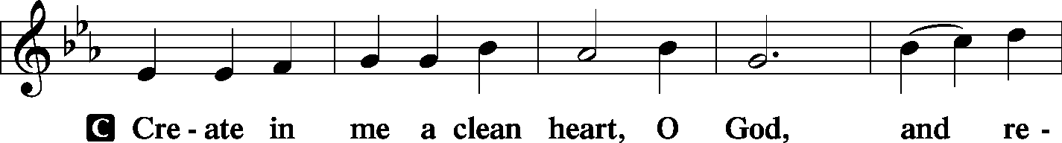
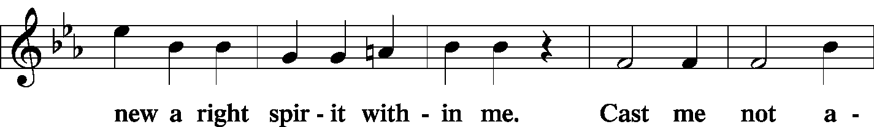
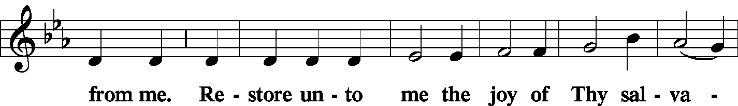
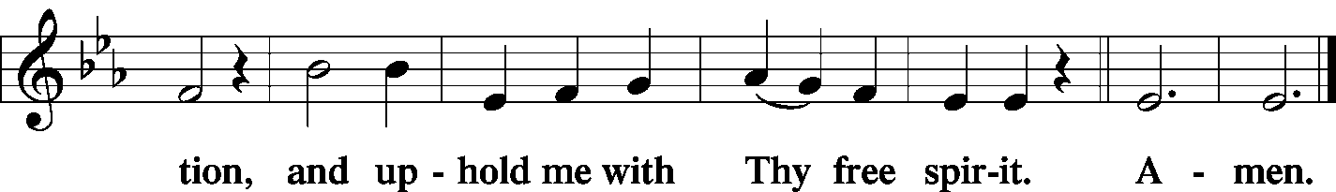

Service of the Sacrament

Preface LSB 194
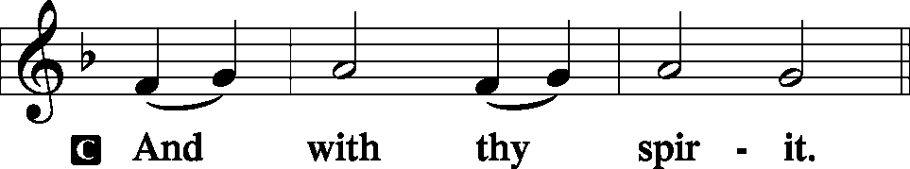

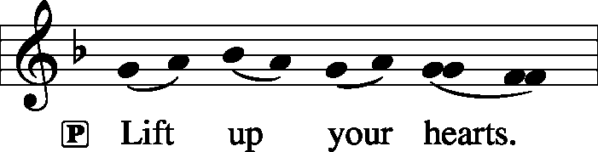

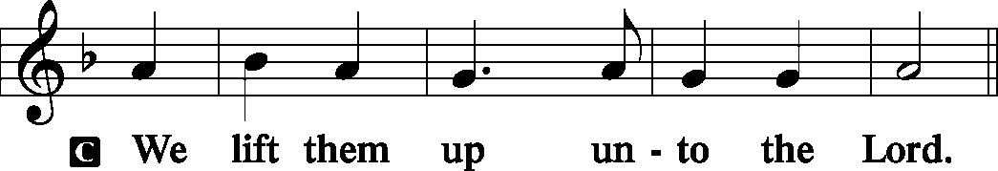

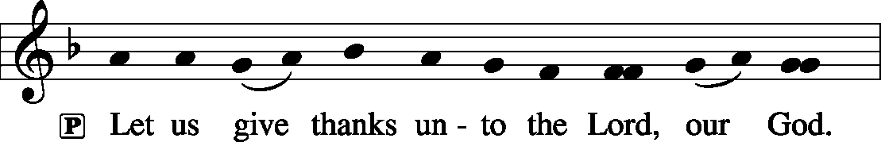

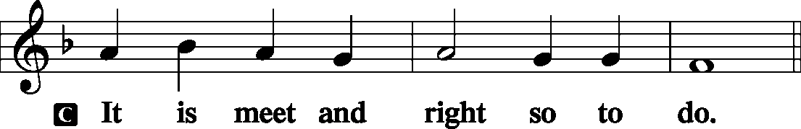

Proper Preface (Full)
P It is truly meet, right, and salutary that we should at all times and in all places give thanks to You, holy Lord, almighty Father, everlasting God, through Jesus Christ, our Lord, whose way John the Baptist prepared, proclaiming Him the promised Messiah, the very Lamb of God who takes away the sin of the world, and calling sinners to repentance that they might escape from the wrath to be revealed when He comes again in glory. Therefore with angels and archangels and with all the company of heaven we laud and magnify Your glorious name, evermore praising You and saying:

Sanctus LSB 195
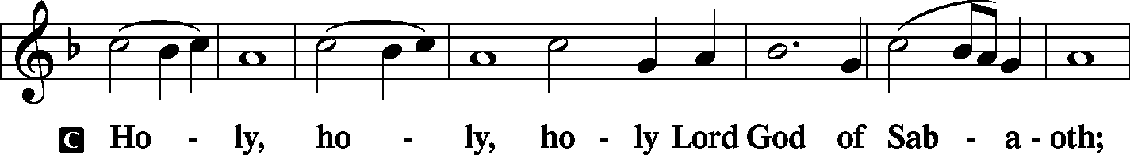
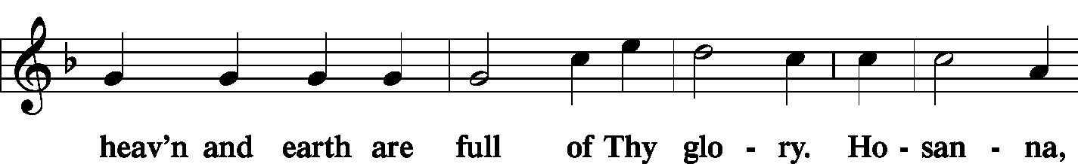
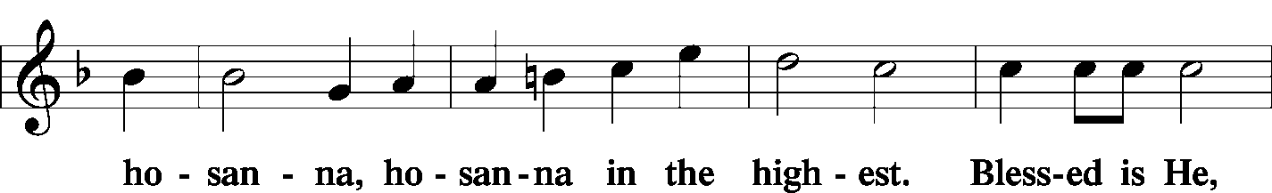
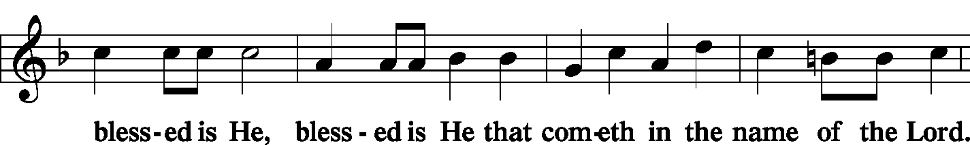
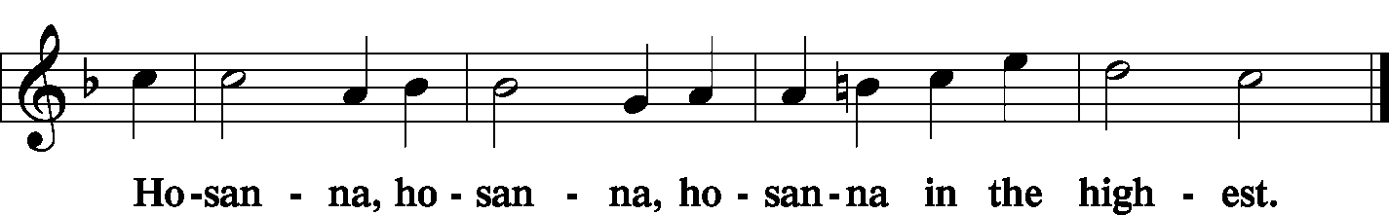

Lord's Prayer LSB 196
P | Our Father who art in heaven, hallowed be Thy name, Thy kingdom come, Thy will be done on earth as it is in heaven; give us this day our daily bread; and forgive us our trespasses as we forgive those who trespass against us; and lead us not into temptation, but deliver us from evil.
C | 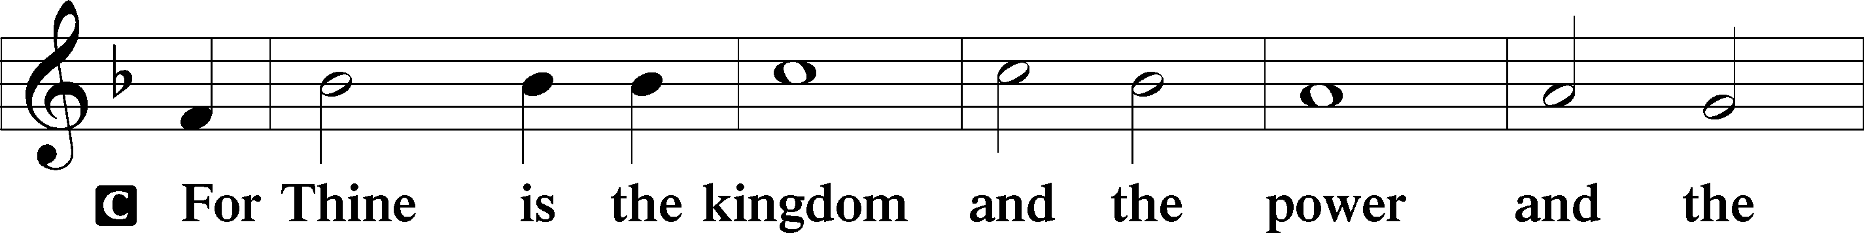  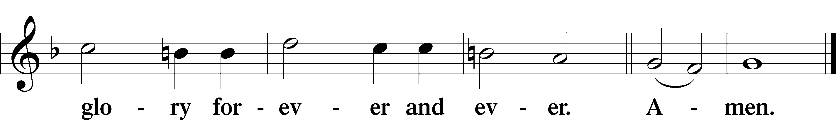
The Words of Our Lord LSB 197
P Our Lord Jesus Christ, on the night when He was betrayed, took bread, and when He had given thanks, He broke it and gave it to the disciples and said: “Take, eat; this is My T body, which is given for you. This do in remembrance of Me.”

P In the same way also He took the cup after supper, and when He had given thanks, He gave it to them, saying: “Drink of it, all of you; this cup is the new testament in My T blood, which is shed for you for the forgiveness of sins. This do, as often as you drink it, in remembrance of Me.”

Pax Domini LSB 197
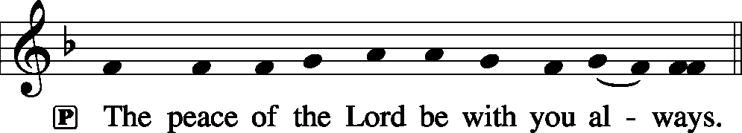
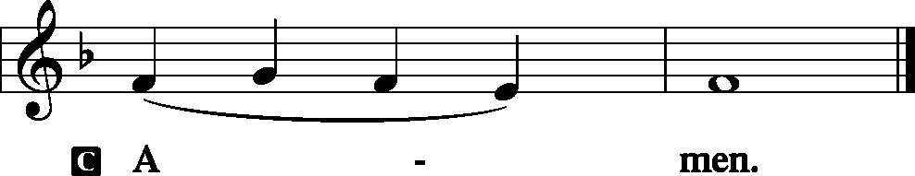

Agnus Dei LSB 198
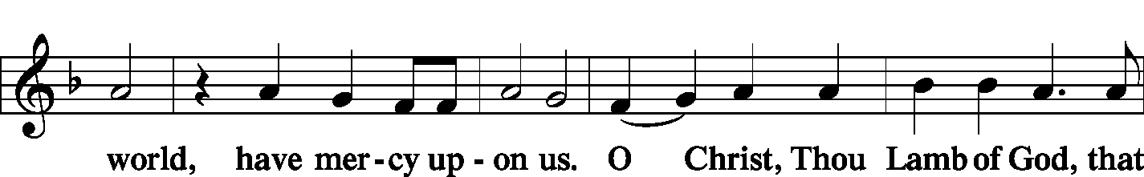
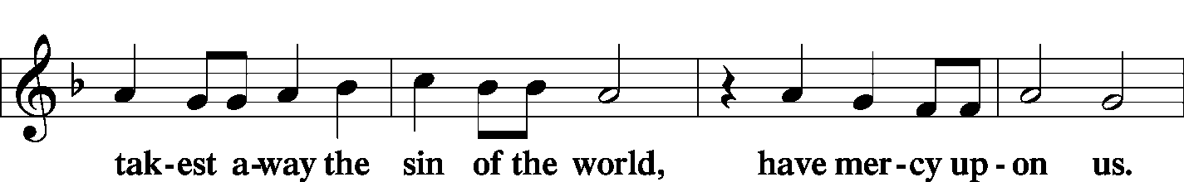
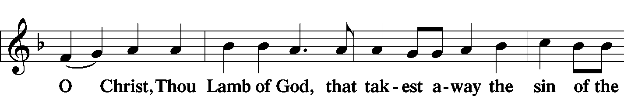
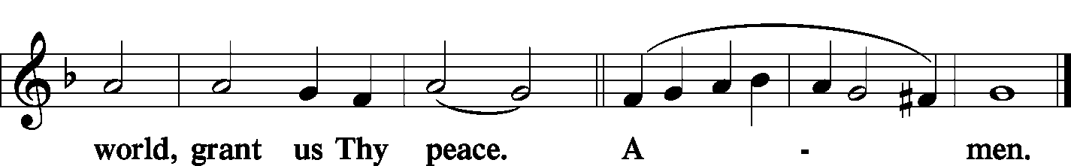

Sit

Distribution
Zion Lutheran practices the policy of close communion, communing only those who share our common Biblical view of the Lord's Supper. If you are not a confirmed LCMS Lutheran, please confer with the pastor before communing.

Hymn The Advent of Our King LSB 331
Hymn The Day Is Surely Drawing Near LSB 508
Hymn O Lord, How Shall I Meet You LSB 334

Stand

In dismissing the communicants, the following is said:

The Dismissal
P The body and blood of our Lord Jesus Christ strengthen and preserve you in body and soul to life everlasting. Depart T in peace.
C Amen.

Nunc Dimittis LSB 199
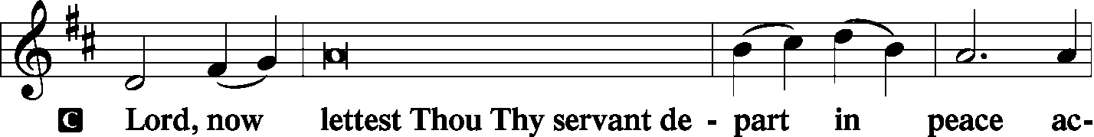
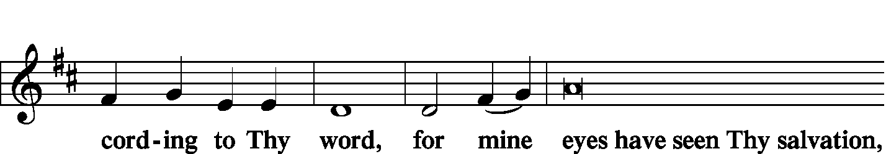
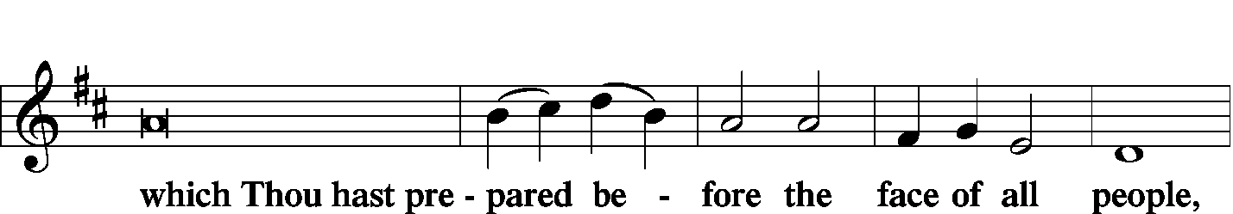
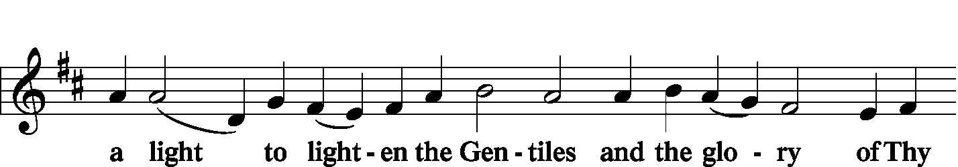
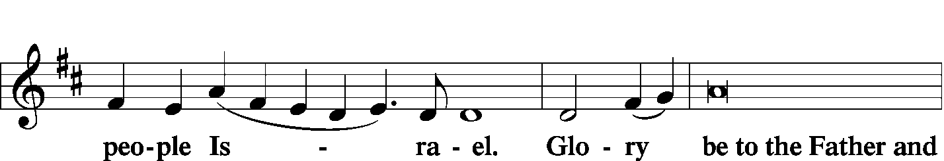
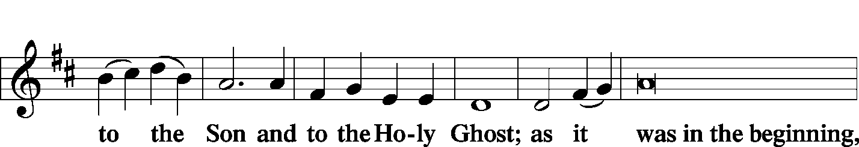
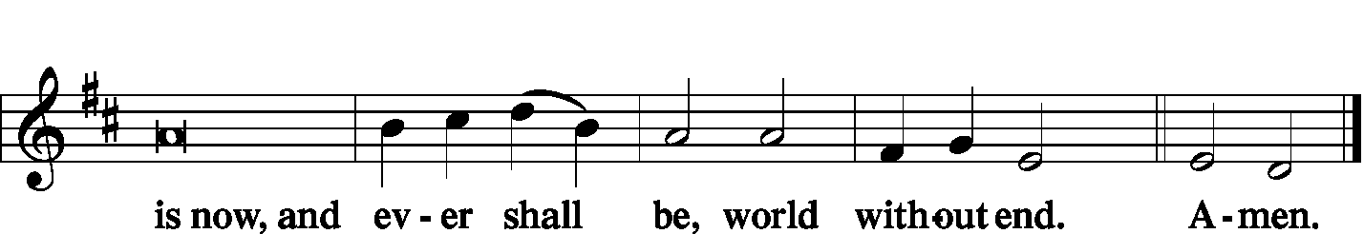

Thanksgiving LSB 200
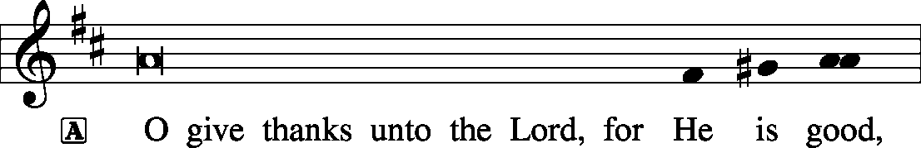

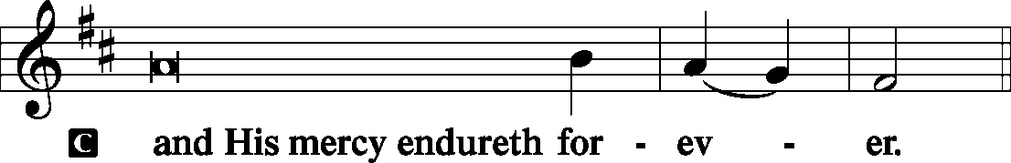

Post-Communion Collect
P Let us pray.
We give thanks to You, almighty God, that You have refreshed us through this salutary gift, and we implore You that of Your mercy You would strengthen us through the same in faith toward You and in fervent love toward one another; through Jesus Christ, Your Son, our Lord, who lives and reigns with You and the Holy Spirit, one God, now and forever.

Salutation
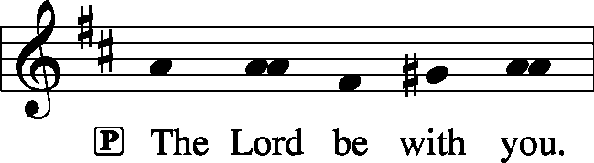
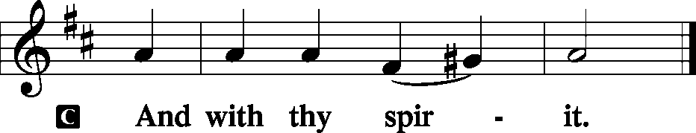

Benedicamus
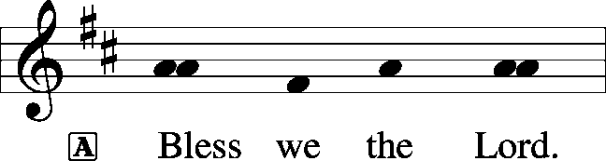
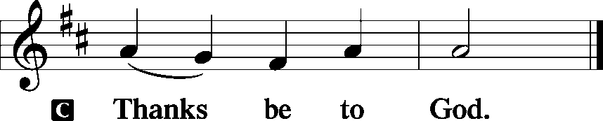

Benediction
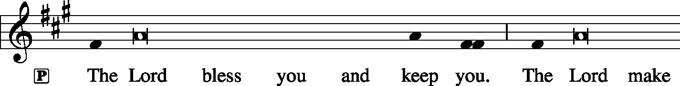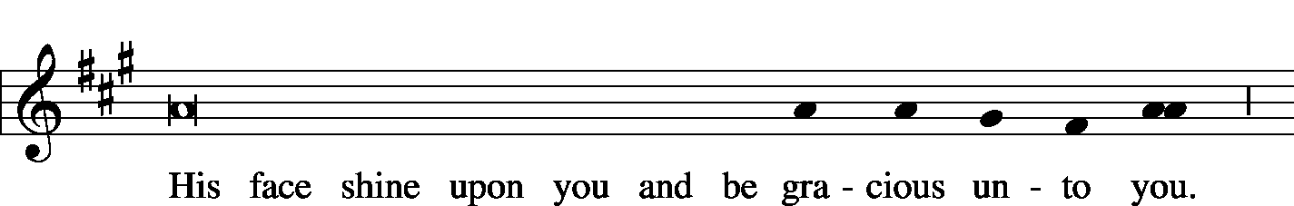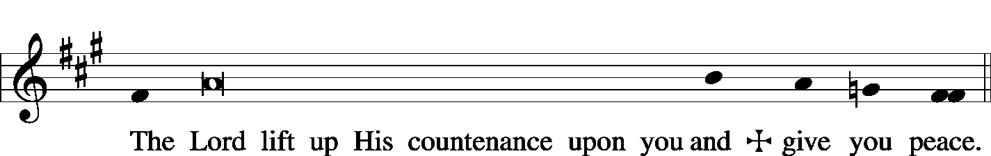
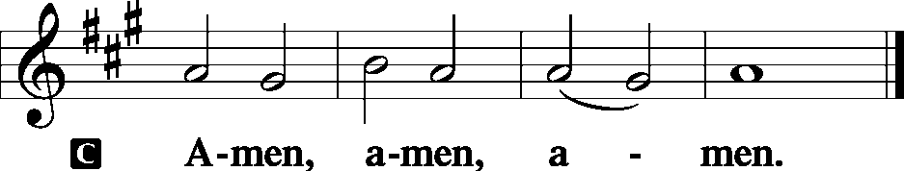

Sit

Hymn Lo! He Comes with Clouds Descending LSB 336

Postlude Lo! He Comes with Clouds Descending arr. Biery

Acknowledgments
Unless otherwise indicated, all scripture quotations are from The Holy Bible, English Standard Version, copyright © 2001 by Crossway Bibles, a division of Good News Publishers. Used by permission. All rights reserved. Created by Lutheran Service Builder © 2006 Concordia Publishing House.
LIFE AND LIVING ITEMS AT ZION
          

ADVENT AND CHRISTMAS SCHEDULE
December is a busy month, but our focus should be preparing for the joyful news of our Savior's birth and preparing to meet Him when He comes again in glory. Among all the other December activities, make sure that worship and church activities are central. All of us need to make choices as to how we will spend our time. What will your choices be? Will they reflect what is truly most important and of eternal significance? Or will your choices indicate a priority of the temporary over the eternal? Choose how you spend your time wisely. We look forward to seeing you at Zion at every opportunity!

PARSONAGE OPEN HOUSE – THIS SATURDAY
The Steins are happy to invite you all to the parsonage to give back one small piece of the generosity they have received from Zion. We are holding an open house on Saturday, December 14th, from 4 pm to 8 pm. You and your family are welcome to come and bring a friend. There will be many sweets, some savory options, Christmas music sheets on a piano and choral music playing on the television. Seminarian Stein would also like to see you all in your ugliest Christmas sweaters.

FAMILY MOVIE – THIS SATURDAY
The Men’s Club will present a double feature at 2:30 PM on Saturday, December 14th: The Little Shepherd (The very first Christmas) and the Muppet Christmas Carol. The Little Shepherd is the timeless Christmas story with a twist—young Joel embarks on the journey to becoming a shepherd when an unexpected event leads him and his pet lamb, Bramble, to the revelation that God provides the answer to every fear. In the Muppet Christmas Carol, Kermit the Frog, Miss Piggy and the Muppets join Michael Caine in this magical version of Charles Dickens classic tale about the true meaning of Christmas. Join us in the church basement for free movies, soda, candy, and popcorn.

CHILDREN’S CHRISTMAS PROGRAM – NEXT SUNDAY
Zion's annual Children's Christmas Program will be held next Sunday, December 15, 2019 during the 10:00 AM worship service. This year's program was written by Maggie Harlan and Pastor Clayton with a theme of seeing how prophesies that God made in the Old Testament were fulfilled in the birth, death, and resurrection of Jesus Christ. God made promises to Adam and Eve, to Abraham, to David, to King Ahaz through the prophet Isaiah, and God revealed additional details about the Messiah's birth through the prophet Micah. Students in costumes will portray all these Old Testament characters, as well as New Testament characters such as Mary, Joseph, Elizabeth, Gabriel, King Herod, the Wise Men, and Roman soldiers, as well as angels and shepherds. Throughout the program the focus is on God's faithfulness and tracing how God keeps His promises. We can trust Him in every situation because He is faithful. We encourage inviting family members and friends to come hear and see the wonderful Christmas message presented by our Sunday School students next Sunday morning, December 15th.

SECRET PAL PROGRAM
Today is the last day to sign up for the Secret Pal program. On December 15th and 22nd, we will draw Secret Pal names. You are to pray for this person and can send cards or leave cards or small gifts at church during the year. Names are revealed next December. See Glenda today.

DONATIONS NEEDED FOR UNITY SCHOOL, EAST ST. LOUIS
TODAY we have jars out in the back of the church for contributions to Unity Lutheran Christian Elementary School. They are having financial issues. This school is a vital tool to reach many young children and their families desperately needing to hear about God and His saving love, and we have the opportunity to support it NOW! The Ladies Aid will take up a collection at their Christmas Program, and this will be added to it as a donation from Zion.

CHRISTMAS CAROLERS NEEDED – TODAY!
Would you like to bring the sounds of the season to those who need to hear the joyous message of God's love to them in the Christ Child? Would you like to enjoy the fellowship and fun of a potluck with brothers and sisters in Christ? If so, please join us as we meet at church at 4:30 p.m. TODAY, Dec 8th. After we have made the rounds of caroling, we will return to the school for fellowship and a potluck supper.
Please bring a dish from the below list according to your last name:

A-J Salad/Vegetable K-Q Dessert R-Z Main Dish

WHAT: Christmas Caroling and Potluck
WHEN: Today, Dec 8 at 4:30 p.m.
WHERE: Meet in the church kitchen to carpool to caroling sites

LADIES AID CHRISTMAS POTLUCK
All ladies of the congregation are invited to join us on Thursday, Dec 19, for our annual Christmas party and potluck (side dishes only, meat will be furnished). We eat at 6:00 and then will have a short program. NOTE: We are not doing the $5 gift exchange this year, but rather bringing several items for the Mascoutah Food Pantry; if you have a Secret Pal, that gift may be brought also. We will take a special collection for Unity Lutheran Christian Elementary School. It’s a fun and special evening. Plan to attend. See Glenda for more details. BABYSITTING will be provided.

ZION’S 140th ANNIVERSARY COOKBOOKS – GREAT GIFT IDEA!
REDUCED PRICE! ONLY $10 EACH!
Zion has added many new members in the past eleven years; Get to know other members by their submitted recipes! . Have you looked through our cookbook? It contains more than 475 recipes, as well as some history about Zion and some fun entries as well. Don't forget our wonderful cookbooks as you look over your Christmas list. They make great gifts!

CHRISTIAN-THEMED CHRISTMAS CARDS AND CALENDARS
The Ladies Aid has beautiful Christian-themed 2020 calendars for sale. We still have a few left, so get yours now! They are $6 each. We also have a wide variety of Christmas Cards for sale at very reasonable prices. See the table in the hall outside the office to shop. See Candy or Glenda to pay.

IMMANUEL LUTHERAN CHRISTMAS STROLL FOOD COURT
Join us TODAY, December 8th, for our Christmas Stroll Food Court at Immanuel Lutheran School Gymnasium in Okawville. There will be a casserole bar from 11 AM – 3 PM. Sandwiches, desserts, and drinks are also available. Adults are $10, children age 3-8 are $5, and children 2 and under are free.

METRO EAST COMMUNITY CHORALE CONCERT
Join us for the Metro East Community Chorale Concert on Sunday, December 15th at 3 PM at St. Paul United Church of Christ in Belleville. Angela (Braeutigam) Wilkerson and her husband Matt will be performing in the orchestra.

OLIVE BRANCH GERMAN CHRISTMAS SERVICE
The Olive Branch German Christmas Service (Weihnachtsgottesdienst) will be on Sunday, December 15th at 3:00 PM. We are located at 11265 State Route 177 in Okawville. Rev. Darwin Schrader will preach. The text and sermon theme are Lukasevangelium 2: 10-11 and the theme “Fuerchtet euch nicht. Es is Weihnachten wieder.” Rev. Arthur Eichhorn will be the organist for the service. Please stay after to enjoy German cookies and refreshments. All are welcome enjoy God's word in German!

ANNUAL TREE OF HOPE CAMPAIGN
The Mascoutah Tuesday Women’s Club is excited to announce the annual Tree of Hope campaign. Donations will be used to provide Christmas gifts of shoes and clothes for the needy children of Mascoutah. Funds were also used to support the Mascoutah Township School Supply Drive through a donation of 100, $20 gift cards to provide shoes for children starting school. Thanks to the generosity of Mascoutah, donations totaling $10,580 for the Tree of Hope were received in 2018. We ask for your help again this year in order to fill the stockings of so many needy children. Please send your donation to: Tree of Hope, PO Box 244, Mascoutah, IL 62258. If you have any questions, call Rosalie Taylor at 618-566-2529.

CHURCH BASEMENT LADIES: AWAY IN THE BASEMENT
Take a trip back in time to 1959 and celebrate the holidays with the CHURCH BASEMENT LADIES: AWAY IN THE BASEMENT. The ladies and the pastor try to save the Church Christmas pageant from disaster in this fun, family-friendly musical presented by Clinton County Showcase at the Avon Theater in Breese on Dec. 8, 13, 14, & 15. Tickets now on sale at clintoncountyshowcase.com.

HANDEL’S MESSIAH AT ZION, BELLEVILLE
Zion’s Music and Ministry and Community will present Handel’s Messiah on Sunday, December 22, at 3:00PM at Zion, 1810 McClintock Ave, Belleville.

GOOD SHEPHERD CHRISTMAS CANTATA
On Sunday, December 29th at 3:00 PM, as a celebration of Christ’s coming at Christmas, the musicians of Good Shepherd Lutheran Church in Collinsville are presenting a special Christmas cantata featuring John Leavitt’s What Child Is This. The GSLS choir will be accompanied by member and guest professional instrumentalists. Good Shepherd Lutheran Church is located at 1300 Beltline Rd., Collinsville, IL. For more information, call 618-344-3151.

12TH DAY OF CHRISTMAS MUSIC FESTIVAL
Christ Our Savior Lutheran Church in Freeburg warmly invites you to a 12th Day of Christmas Music Festival on Sunday, January 5, 2020, at 3:00 PM. The music festival features organ, piano, handbell choir, brass, strings, flutes, and a large ensemble playing special arrangements of Christmas carols. The audience is invited to sing along on many familiar carols. A reception follows the music festival. There is no cost. Christ Our Savior is located at 612 North State Street in Freeburg. For more information, contact the church office at 618-539-5664 or email coslc@att.net.

THE JOINT CIRCUIT 7 & 8 EPIPHANY SERVICE
Join us on Monday, January 6th at 7:00 PM at Olive Branch Lutheran Church for a joint Epiphany Service. At 6:15 PM a joint Epiphany choir will gather to practice the choir anthem “In Thee is Gladness” by Scott Hyslop. All are invited to participate in the Epiphany choir. The Immanuel School Choir will also be singing in Divine Service. The offering will be going toward Christ the Vine Lutheran Mission. All are welcome to come and celebrate the coming of the magi!

LISTEN TO WORLDWIDE KFUO AM850
KFUO Radio, AM850, a media ministry extension of LCMS congregations, shares Christ for you anytime, anywhere on AM850 via worship services, Bible and theology studies, practical talk programs, and sacred music. You can find programs on demand at kfuo.org and wherever you get your podcasts! Find us on social: @KFUOradio on Facebook, Twitter, and Instagram. This week on KFUO AM850, tune in to Advent midweek service on Wednesday 12/18 at 12:00 p.m., hear sacred music for the seasons of Advent and Christmas from now until Epiphany, and study 1 & 2 Thessalonians on Sharper Iron's "Christ is Surely Coming" series (weekdays at 8:00 a.m.). Find your favorite programs on demand at kfuo.org.

EXPERT GUESTS, EXPANSIVE TOPICS, EXTOLLING CHRIST
Issues, Etc. is a radio talk show and podcast produced by Lutheran Public Radio in Collinsville, IL and hosted by LCMS Pastor Todd Wilken. Each week you'll hear interviews on topics like: Christianity & Culture, Media Coverage of Religion, Pop Christianity, Bible Stories, The Lutheran Confessions and Lutheran Catechesis. You can tune in live weekdays from 3-5 p.m. on KFUO, 850 AM in St. Louis. You can also listen on-demand at www.issuesetc.org and on the LPR mobile app.
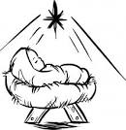
Reverse Advent
Calendar

An Advent calendar is a special calendar used to count the days of Advent in anticipation of Christmas. Traditionally, this countdown is marked by opening a small door of a calendar and retrieving a small candy or toy from a hidden compartment. This year, instead of receiving, let us give back in thankfulness for the ultimate gift of Jesus Christ our Lord and Savior.

Directions: Each day, add an item to a box. To keep this a mindful activity, this can be done in conjunction with your daily Advent devotional. On Christmas Eve, donate the contents to Mascoutah Food Pantry. The Food Pantry is open on Tuesdays and Saturdays from 10:00 - 12:00. You can also drop your box off at the church or call Beth Twenhafel (618-660-8872) for a pick up at your house.

December 1 - box of cereal
December 2 - peanut butter
December 3 - stuffing mix
December 4 - boxed potatoes
December 5 - macaroni and cheese
December 6 - canned tomatoes
December 7 - cream of mushroom soup
December 8 - canned tuna
December 9 - dessert mix
December 10 - jar of applesauce
December 11 - canned sweet potatoes
December 12 - cranberry sauce
December 13 - canned beans
December 14 - box of crackers
December 15 - package of rice
December 16 - package of oatmeal
December 17 - package of pasta
December 18 - spaghetti sauce
December 19 - chicken noodle soup
December 20 - tomato soup
December 21 - can corn
December 22- can mixed vegetables
December 23 - can carrots
THOSE WHO SERVE TODAY
Proclaimer: Rev. Kirk Clayton
Liturgist: Sem. Adam Wolfe
Liturgist: Sem. Don Stein
Organist: Nancy Peterson
Ushers: Karl Bretz, Joe Crismon, Bob Eldridge, & Ken Frey
Sound Tech: Buzz Kandler
Video Tech: Mark Hatcher
Welcome Team: Torri & Alicia Suedmeyer
Acolytes: Ella Bretz & Daniel Bretz
Altar Guild: Gail Frey

THOSE WHO SERVE NEXT WEEK, DECEMBER 15
Proclaimer: Rev. Kirk Clayton
Liturgist: Sem. Adam Wolfe
Liturgist: Sem. Don Stein
Organist: Nancy Peterson
Ushers: Lee Harlan, Mark Hatcher, Carl Sherrill, & Buzz Kandler
Sound Tech: Mike Segelhorst
Video Tech: Mark Hatcher
Welcome Team: Mike & Angie Twenhafel

THINGS WE ARE DOING AT ZION
Sun. Children’s Christmas Program Practice 8:45 AM
Bible Class 8:45 AM
Worship DS III w/communion 10:00 AM
Christmas Caroling and Potluck 4:30 PM
Mon. Echo Deadline
Wed. Choir Rehearsal 6:00 PM
Second Advent Midweek Service 7:00 PM
Thurs. Voter’s Meeting 7:00 PM
Fri. Senior Meal Delivery 10:30 AM
Sat. Children’s Christmas Program Practice 10:00 AM
Happy Birthday Jesus Party 12:00 PM
Parsonage Open House 4:00 – 8:00 PM
Sun. Children’s Christmas Program
Children’s Christmas Program Practice 8:45 AM
Bible Class 8:45 AM
Worship Matins 10:00 AM

ATTENDANCE NOVEMBER 28: Thanksgiving Day: 103
ATTENDANCE DECEMBER 1: Sunday: 168
Adult Bible Class: 20 High School: 6 Sunday School: 44
ATTENDANCE DECEMBER 4: Wednesday: 58

