Zion Lutheran Church
Mascoutah, Illinois
February 2, 2020
Septuagesima
Seventy Days before Easter

In the Name of Christ Jesus our Lord, we bid you a warm welcome to this worship service. May your experience of worship and fellowship this morning be spiritually refreshing and ready you for the week ahead.
 
Pastor: Rev. Kirk Clayton
Church Secretary: Robin Phillips
Choir Director Team: Josh and Nancy Peterson
_________________________________________________________________________________
Church Office Phone: 618-566-7345
Pastor Clayton Cell: 618-447-1306
Office Hours: 8:00 am to 12:00 pm
Email: ChurchOffice@ZionMascoutah.org
Pastor Clayton email: Pastor@ZionMascoutah.org
Web site: www.ZionMascoutah.org
Find us at @ZionMascoutah on Facebook, Twitter, and Instagram
Electronic Devices
Please TURN OFF all cell phones, pagers, electronic devices, apps and games when entering the sanctuary for worship so those around you may focus on the Word of God without electronic distraction. Thank you.

A Prayer to Begin Worship
Holy Spirit of the Godhead, who has called us into the marvelous light of Christ, lead us also in the footsteps of Christ that the sinner in us always gives way to our sainthood in Christ; through that same Jesus Christ, our Lord, who with You and the Father are one God with dominion over us forever.
DIVINE SERVICE II
LSB p. 167
Confession and Absolution

Prelude Hark, the Voice of Jesus Crying
arr. Behnke/Hildebrand

Hymn Glorious Things of You Are Spoken LSB 648

Stand

The sign of the cross may be made by all in remembrance of their Baptism.

Invocation
P In the name of the Father and of the T Son and of the Holy Spirit.
C Amen.

Exhortation
P If we say we have no sin, we deceive ourselves, and the truth is not in us.
C But if we confess our sins, God, who is faithful and just, will forgive our sins and cleanse us from all unrighteousness.

Silence for reflection on God's Word and for self-examination.

Confession with Absolution
P Let us then confess our sins to God our Father.
C Most merciful God, we confess that we are by nature sinful and unclean. We have sinned against You in thought, word, and deed, by what we have done and by what we have left undone. We have not loved You with our whole heart; we have not loved our neighbors as ourselves. We justly deserve Your present and eternal punishment. For the sake of Your Son, Jesus Christ, have mercy on us. Forgive us, renew us, and lead us, so that we may delight in Your will and walk in Your ways to the glory of Your holy name. Amen.
P Almighty God in His mercy has given His Son to die for you and for His sake forgives you all your sins. As a called and ordained servant of Christ, and by His authority, I therefore forgive you all your sins in the name of the Father and of the T Son and of the Holy Spirit.
C Amen.

Service of the Word

Introit Ps. 18:1–2a, 27, 32, 49; antiphon: Ps. 18:5–6a
P The cords of Sheol entangled me;
C the snares of death confronted me.
P In my distress I called upon the Lord.
C From His temple He heard my voice.
P I love You, O Lord, my strength.
C The Lord is my rock and my fortress and my deliverer,
P For You save a humble people,
C but the haughty eyes You bring down.
P [You have] equipped me with strength
C and made my way blameless.
P For this I will praise You, O Lord, among the nations,
C and sing to Your name.
Glory be to the Father and to the Son
and to the Holy Spirit;
as it was in the beginning,
is now, and will be forever. Amen.
P The cords of Sheol entangled me;
C the snares of death confronted me.
P In my distress I called upon the Lord.
C From His temple He heard my voice.

Kyrie LSB 168
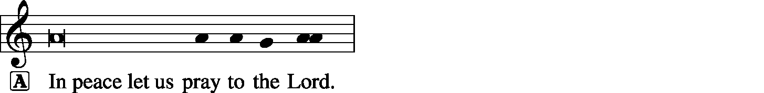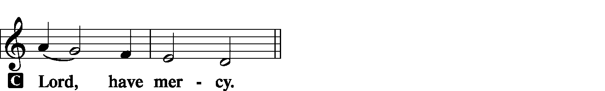

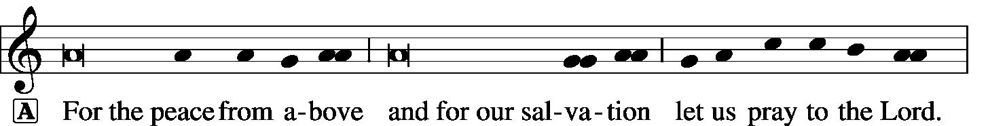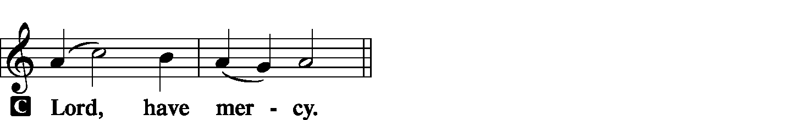

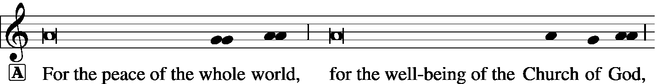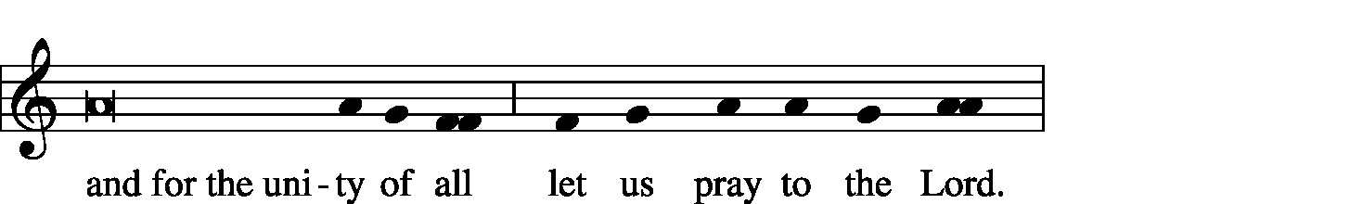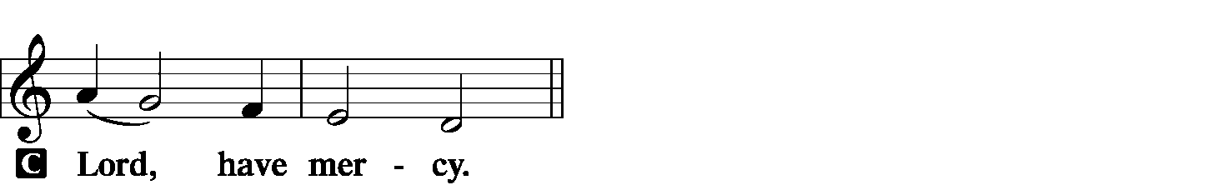

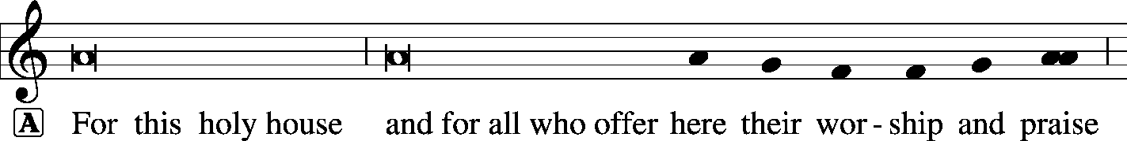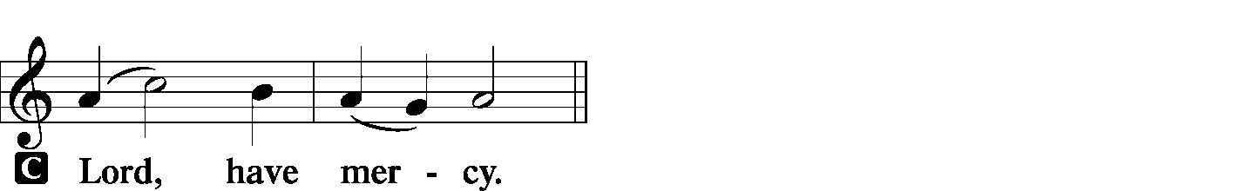

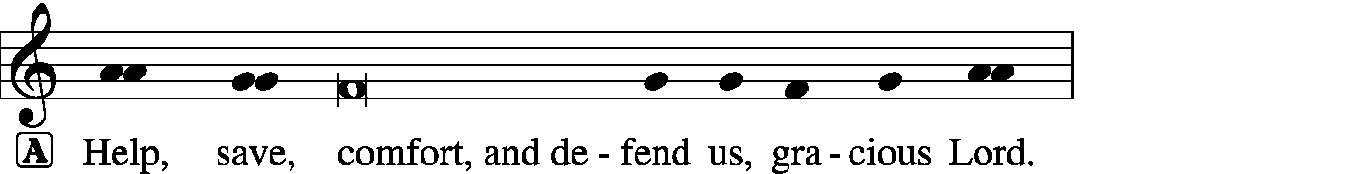
Hymn of Praise -- This is the Feast LSB 171
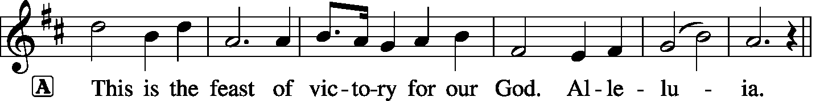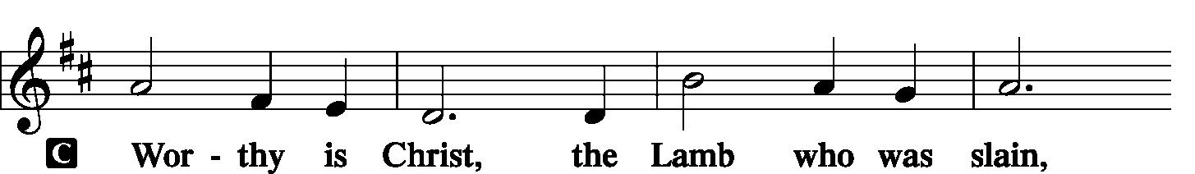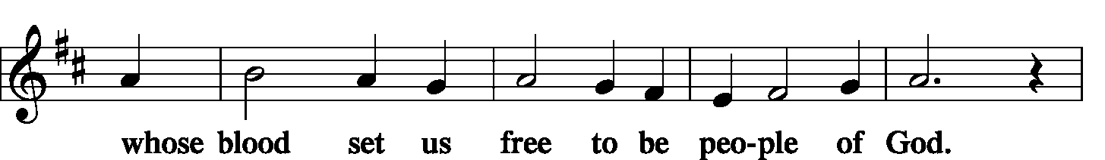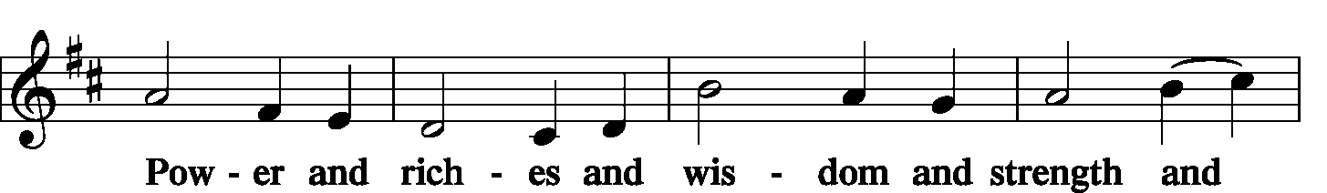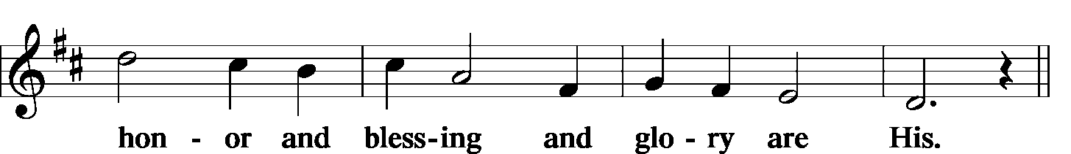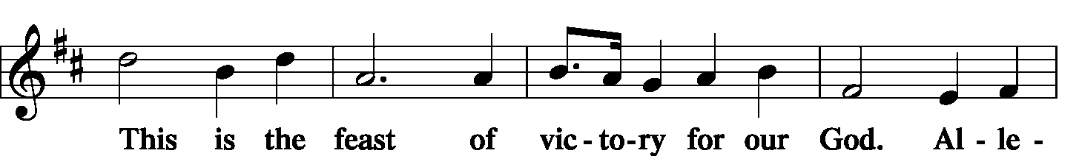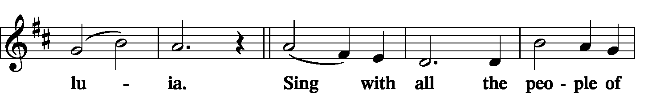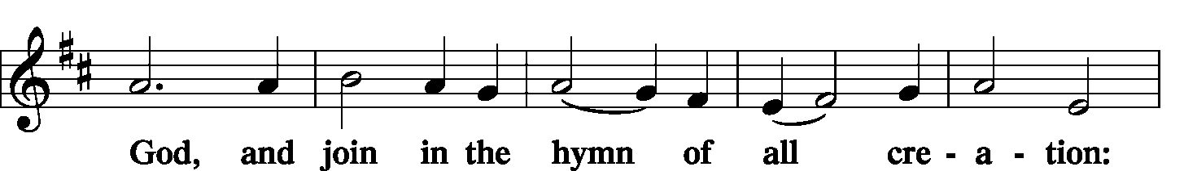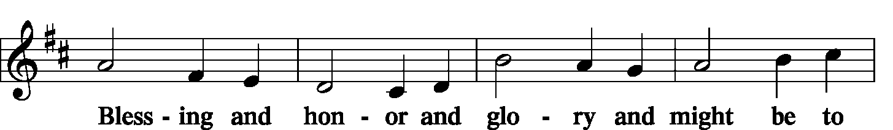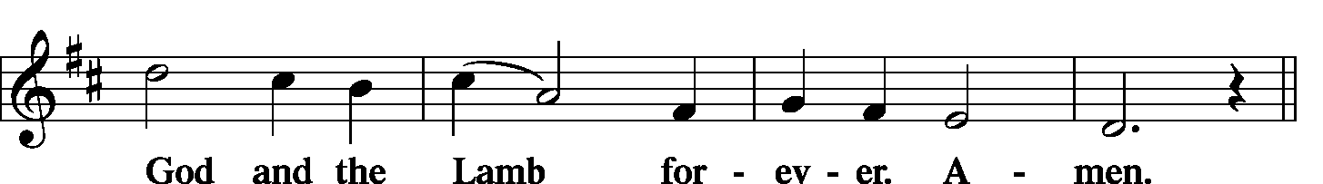

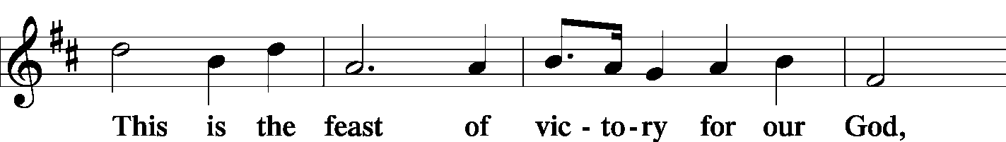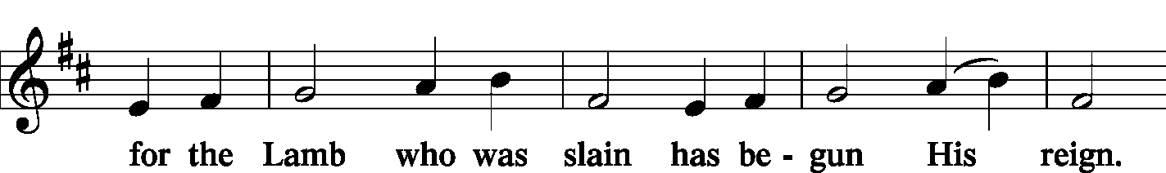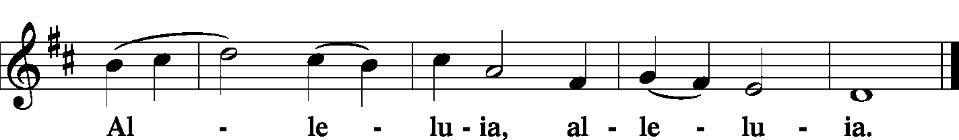

Salutation and Collect of the Day
P The Lord be with you.
C And also with you.
P Let us pray.
O Lord, graciously hear the prayers of Your people that we who justly suffer the consequence of our sin may be mercifully delivered by Your goodness to the glory of Your name; through Jesus Christ, Your Son, our Lord, who lives and reigns with You and the Holy Spirit, one God, now and forever.
C Amen.

Sit

Hymn Salvation unto Us Has Come LSB 555
(Stanzas 1-5)

Old Testament Reading Exodus 17:1–7
All the congregation of the people of Israel moved on from the wilderness of Sin by stages, according to the commandment of the Lord, and camped at Rephidim, but there was no water for the people to drink. Therefore the people quarreled with Moses and said, “Give us water to drink.” And Moses said to them, “Why do you quarrel with me? Why do you test the Lord?” But the people thirsted there for water, and the people grumbled against Moses and said, “Why did you bring us up out of Egypt, to kill us and our children and our livestock with thirst?” So Moses cried to the Lord, “What shall I do with this people? They are almost ready to stone me.” And the Lord said to Moses, “Pass on before the people, taking with you some of the elders of Israel, and take in your hand the staff with which you struck the Nile, and go. Behold, I will stand before you there on the rock at Horeb, and you shall strike the rock, and water shall come out of it, and the people will drink.” And Moses did so, in the sight of the elders of Israel. And he called the name of the place Massah and Meribah, because of the quarreling of the people of Israel, and because they tested the Lord by saying, “Is the Lord among us or not?”
P This is the word of the Lord.
C Thanks be to God.

Choir It Is Well with My Soul arr. Craig Courtney
Epistle 1 Corinthians 9:24—10:5
Do you not know that in a race all the runners compete, but only one receives the prize? So run that you may obtain it. Every athlete exercises self-control in all things. They do it to receive a perishable wreath, but we an imperishable. So I do not run aimlessly; I do not box as one beating the air. But I discipline my body and keep it under control, lest after preaching to others I myself should be disqualified.
I want you to know, brothers, that our fathers were all under the cloud, and all passed through the sea, and all were baptized into Moses in the cloud and in the sea, and all ate the same spiritual food, and all drank the same spiritual drink. For they drank from the spiritual Rock that followed them, and the Rock was Christ. Nevertheless, with most of them God was not pleased, for they were overthrown in the wilderness.
P This is the word of the Lord.
C Thanks be to God.

Stand

Alleluia and Verse
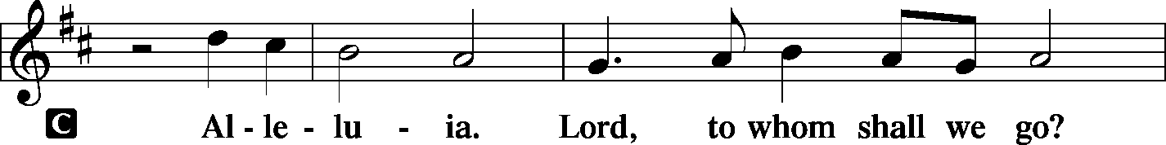
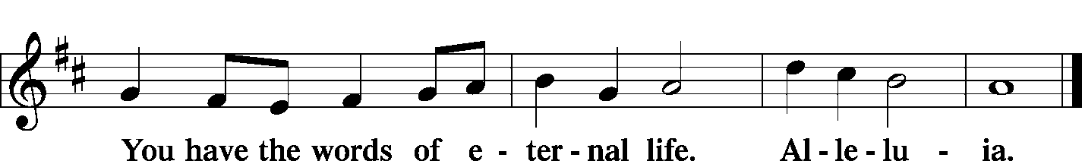

Holy Gospel Matthew 20:1–16
L The Holy Gospel according to St. Matthew, the 20th chapter.
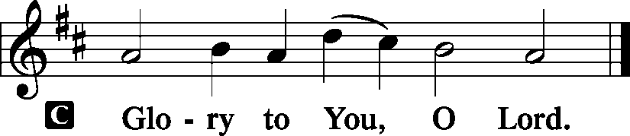
“For the kingdom of heaven is like a master of a house who went out early in the morning to hire laborers for his vineyard. After agreeing with the laborers for a denarius a day, he sent them into his vineyard. And going out about the third hour he saw others standing idle in the marketplace, and to them he said, ‘You go into the vineyard too, and whatever is right I will give you.’ So they went. Going out again about the sixth hour and the ninth hour, he did the same. And about the eleventh hour he went out and found others standing. And he said to them, ‘Why do you stand here idle all day?’ They said to him, ‘Because no one has hired us.’ He said to them, ‘You go into the vineyard too.’ And when evening came, the owner of the vineyard said to his foreman, ‘Call the laborers and pay them their wages, beginning with the last, up to the first.’ And when those hired about the eleventh hour came, each of them received a denarius. Now when those hired first came, they thought they would receive more, but each of them also received a denarius. And on receiving it they grumbled at the master of the house, saying, ‘These last worked only one hour, and you have made them equal to us who have borne the burden of the day and the scorching heat.’ But he replied to one of them, ‘Friend, I am doing you no wrong. Did you not agree with me for a denarius? Take what belongs to you and go. I choose to give to this last worker as I give to you. Am I not allowed to do what I choose with what belongs to me? Or do you begrudge my generosity?’ So the last will be first, and the first last.”
L This is the Gospel of the Lord.
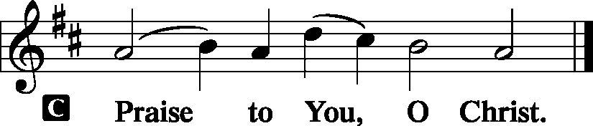

Sit

Children's Lunchbox Devotion

Hymn Salvation unto Us Has Come LSB 555
(Stanzas 6-10)

Sermon It’s Not Fair!

Stand

Apostles' Creed
C I believe in God, the Father Almighty, maker of heaven and earth.
And in Jesus Christ, His only Son, our Lord, who was conceived by the Holy Spirit, born of the virgin Mary, suffered under Pontius Pilate, was crucified, died and was buried. He descended into hell. The third day He rose again from the dead. He ascended into heaven and sits at the right hand of God the Father Almighty. From thence He will come to judge the living and the dead.
I believe in the Holy Spirit, the holy Christian Church, the communion of saints, the forgiveness of sins, the resurrection of the body, and the life T everlasting. Amen.

Sit

Offering
[Please fill out a sheet in the attendance book. Visitors, please include your address. If you have a prayer request for the church prayer chain, please write it at the top of the sheet.]

Special Offering Music Nathaniel Clayton

Stand

Offertory LSB 176
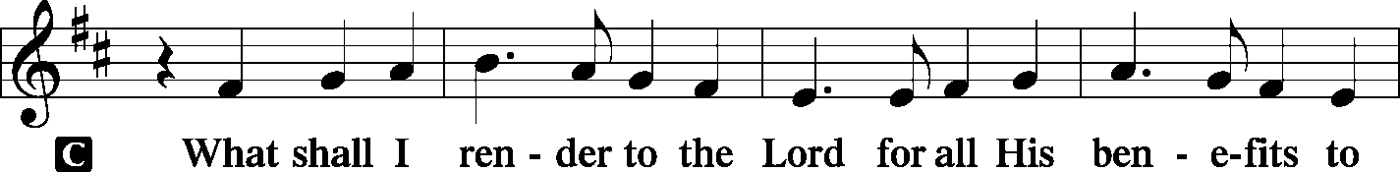
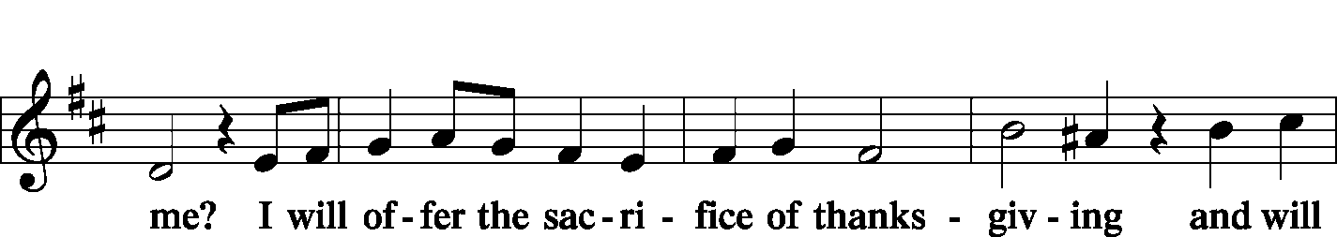
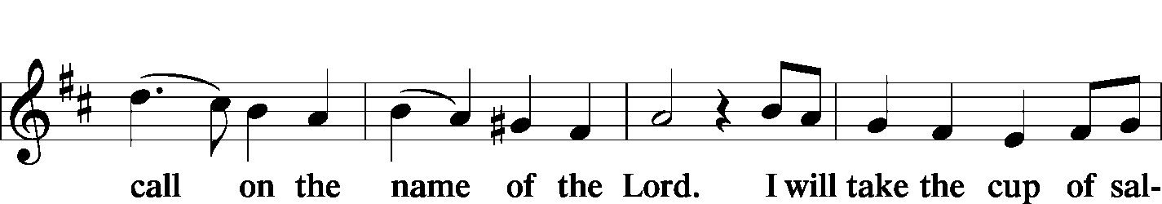
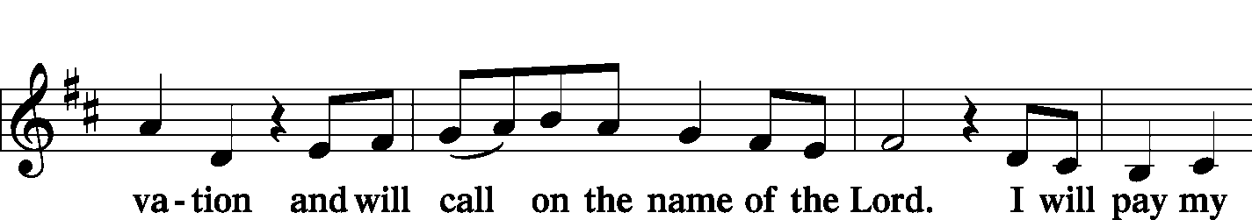
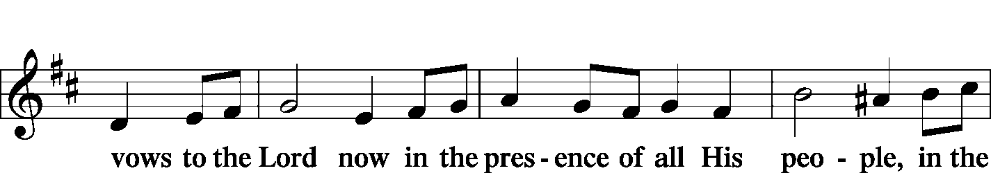
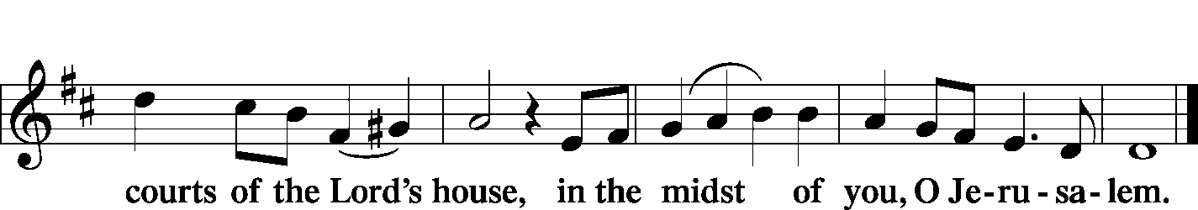

Prayer of the Church
P O Lord, our Light and Salvation, You are the Stronghold of our life.
C With You as our God, we face the world without fear.
P As the heavens are high above the earth, so Your ways are higher than our ways and Your thoughts higher than our thoughts.
C We behold Your beauty in the midst of Your sanctuary and dare to bring our petitions before You.
P We readily admit, O Lord, that our manner of life has not always been worthy of the Gospel.
C We have not always stood firm in one spirit, with one mind, striving side by side for the faith.
P We have failed to work diligently in Your vineyard and have too readily adopted the standards of the world in desiring rewards for our labors.
C For our lack of zeal to work in Your vineyard, forgive us, O Lord.
P For begrudging Your favors to those who have worked less than we,
C we ask Your forgiveness.
P For forgetting that You have already paid us with the gift of salvation,
C forgive us, O Lord.
P That we may be more enthusiastic about carrying out Your wishes, send us Your Holy Spirit.
C Help us to see the opportunities to do Your work, and according to Your mercy, grant success to our labors.
P Grant righteousness and peace to our nation and to the nations of the world.
C Use us to comfort the lonely and bring hope to the sick and discouraged.

WE GO TO THE LORD IN PRAYER FOR
- Mark Krausz, Adam Ahner, Brad Lockwood, Deb Heck, Alicia Suedmeyer, Sarah Linn, Ami Linnertz, Geremy Linnertz, and Nicholas Linnertz, as they celebrate their baptismal anniversaries this week.
- Grant Ahner, as he moves to “Nathan’s House” this week.
- Kyle Kandler, as he recovers from back surgery.
- Zion’s Elders, Board of Education, Sunday School staff, and Evangelism Committee.
- Faithfulness in our lives as Christian Stewards.

P Help us to feed the hungry and clothe the needy.
C This we ask in the name of Jesus. Amen

Lord's Prayer LSB 179
P Lord, remember us in Your kingdom and teach us to pray:
C Our Father who art in heaven, hallowed be Thy name, Thy kingdom come, Thy will be done on earth as it is in heaven; give us this day our daily bread; and forgive us our trespasses as we forgive those who trespass against us; and lead us not into temptation, but deliver us from evil. For Thine is the kingdom and the power and the glory forever and ever. Amen.

Collect for Grace
P O Lord, our heavenly Father, almighty and everlasting God, You have safely brought us to the beginning of this day. Defend us in the same with Your mighty power and grant that this day we fall into no sin, neither run into any kind of danger, but that all our doings, being ordered by Your governance, may be righteous in Your sight; through Jesus Christ, Your Son, our Lord, who lives and reigns with You and the Holy Spirit, one God, now and forever.
C Amen.

Benediction LSB 183
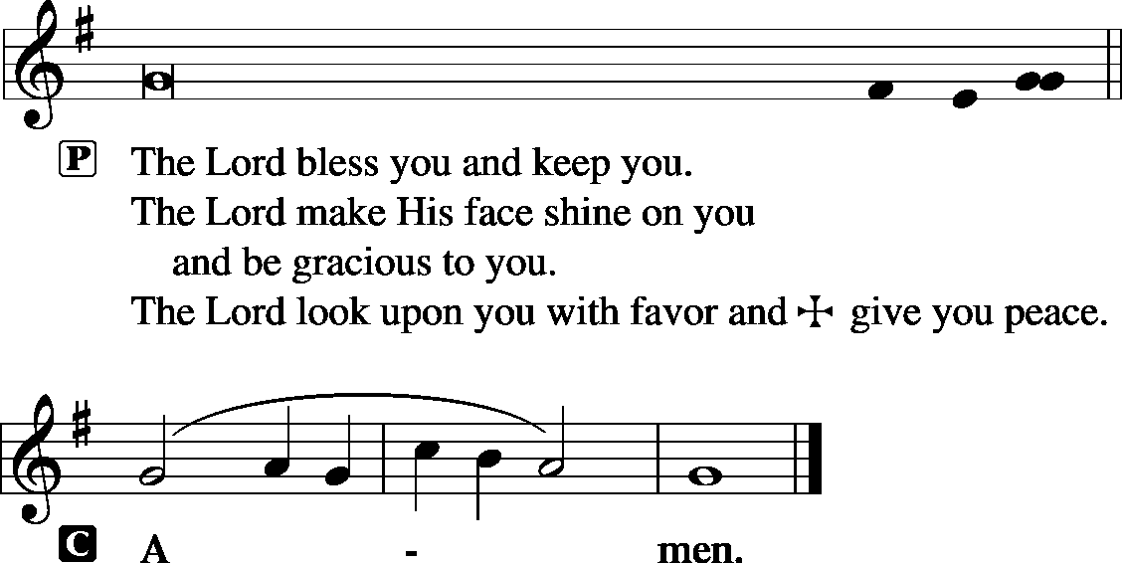

Sit

Hymn Hark, the Voice of Jesus Crying LSB 826

Postlude Glorious Things of Thee Are Spoken Joyce Jones

Acknowledgments
Unless otherwise indicated, all scripture quotations are from The Holy Bible, English Standard Version, copyright © 2001 by Crossway Bibles, a division of Good News Publishers. Used by permission. All rights reserved. Created by Lutheran Service Builder © 2006 Concordia Publishing House.
LIFE AND LIVING ITEMS AT ZION
          

MEN’S CLUB FAMILY MOVIE – THIS SATURDAY
The Men’s Club will present The Secret Life of Pets 2 for kids of all ages on Saturday, February 8th at 2:30 PM. This continues the story of Max, Gidget, Snowball and their friends by exploring the emotional bonds of pets and their families. Join us in the church basement for a free movie, soda, candy, and popcorn.

SUNDAY SCHOOL SINGING AT MARKA NEXT SUNDAY
Sunday School Pre-K through fourth grade has the opportunity to serve our community. On February 9th, we will be singing for the residents of Marka Nursing home in Mascoutah. Rather than come directly to Zion for Sunday school, please bring your child to Marka at 9:00 am. The children will sing their songs, pass out their Valentines, then you will bring them back to Sunday School, where the teachers will keep them until Sunday School time is over and it is time for service. Please talk to Emily Stein if you have any questions.

YOUTH GROUP MEETING NEXT SUNDAY
Zion's next Youth Group Meeting will be held right after church next week, February 9, starting about 11:30 AM. We will gather for a meal of "Tailgate Favorites" brought by families, and the event will also include a devotion and a youth meeting. The meal, devotion, and meeting will take place in the church basement. See you there!

PRESCHOOL REGISTRATION FOR THE 2020-2021 SCHOOL YEAR
Preschool registration for the 2020-2021 school year has begun. Members of Zion and returning students get first choice of classes. Open Registration for others begins March 1. Pick up forms in the church office or see Marlene Lockwood to obtain forms for yourself or others you know who want a quality Christian education for their young children.

BABY BOTTLE CAMPAIGN
Zion’s Ladies Aid is again this year participating in MOSAIC Pregnancy and Health Centers’ Baby Bottle Campaign. MOSAIC offers a wide variety of free and confidential pregnancy services, sexual health services, and medically accurate abortion information. They reach out to women, men and their unborn babies with free life-affirming medical services and the Gospel of Jesus Christ. Please take a bottle from the cart in the narthex and fill with coins, cash, or a check, and return to Zion by Sunday, February 16th. Please put filled bottles on narthex table, cart, or in church office on Sundays. They will be picked up each week.

YOUTH GROUP PUZZLE NIGHT
Do you enjoy building jigsaw puzzles? Then this event is for you! The Annual Puzzle Night will be hosted by Zion Youth Group on Saturday, March 7th. Doors open at 5:30 p.m., competition begins at 6:00 p.m. Tickets are $12 each or $40 for a table of 4. Sign-up/info sheets are in the Narthex. Any donations for baked goods to be sold by the youth on the night of the event are greatly appreciated! A sign-up sheet for baked goods is also in the Narthex. Babysitting for a donation is provided for your little ones during the event in the lower level of the church. Please contact Amanda or Mike Ganey if you have any questions. Hope to see you there!

ANNUAL REPORTS DUE
A year-end report is needed from every Board and Officer by the end of the month. This report will be printed in the 2019 Annual Report. Please email all documents to the church office. Thanks.

HAVE YOU EVER CONSIDERED BECOMING A PASTOR OR DEACONESS?
If so, Rev. Scott Holder from Concordia Seminary, St. Louis, would like to meet with you at Lutheran Church of Webster Gardens, 8749 Watson Road, Webster Groves, MO. on Wednesday, February 26, between 3 and 7 PM. Rev. Holder is interested in meeting with prospective students of all ages—elementary school age through adults. Appointments are individual, informal, and family/friends are welcome to come with you. Appointments are not necessary but encouraged. If you are interested in scheduling a specific time, please contact Rev. Holder at 314-505-7225 or holders@csl.edu.

18th ANNUAL USED BOOK FAIR AND BAKE SALE
HSHS St. Joseph’s Hospital Breese is holding their 18th Annual Used Book Fair and Bake Sale February 6-9 at the American Legion Hall, 575 N. Main, Breese, IL. Thursday, February 6, admission is $6 from 10-11 AM, and admission is $3 from 11 AM-8 PM. Friday, February 7, admission is free from 10 AM-7 PM and everything is half price from 3-7 PM. Bake sale is from 10 AM until sold out. Saturday, February 8, admission is free from 10 AM-5 PM and everything is half price. Sunday, February 9, $3 fill-a-bag (bags provided) from 9-10:30 AM and all items are free from 10:30 AM-noon. All proceeds to benefit HSHS St. Joseph’s Hospital Breese.

HELP SUPPORT MASCOUTAH FIRST PRIORITY CLUBS
Both Mascoutah High School and Mascoutah Middle School have “First Priority Clubs” to bring Bible study opportunities into the school buildings. The “First Priority Club” at the Mascoutah Middle School meets at 7:15 am on Tuesdays, and the “First Priority Club” at the Mascoutah High School meets at 7:05am on Thursdays. The groups are in need of donations for snacks for the meetings. Here’s how you can help: donate a monetary donation by check or cash with a memo that it is for club food (Sean Hall, Box 23, Belleville IL 62222). OR visit bit.ly/clubfood to sign up to bring a snack. OR contact Genie White at 618-978-4503 for pick up. Suggestions for donations include: individually wrapped cookies, chips, energy bars, pretzels, breakfast bars, fruit snacks, donuts, Little Debbies, OR Monetary donations for drinks, napkins, etc.

VALENTINES AND WINE WITH UNITY
Celebrate Valentine’s Day with an evening of wine and song on February 14th from 7:00 – 9:30 PM at Meridian Village, Glen Carbon, IL. Enjoy a vast array of wine samples with cheese and crackers. Entertainment will be provided by a vocal quintet led by soprano Katie Schuermann and pianist Jon Vieker, performing many of your favorite songs. Donations for Unity Scholarship Fund will be received at the door. For more information or to make reservations, call the school office at 618-874-6605.

LISTEN TO WORLDWIDE KFUO AM850
This week on KFUO AM850, hear meditation on scriptures on Moments of Assurance with Pastor Mark Hawkinson (weekdays at 12:00 p.m. & weekends at 7:45 a.m.), dig into curious theological topics on Cross Defense with Pastor Bryan Wolfmueller (2/3 at 2:00 p.m.), and continue in the Gospel of Matthew on Sharper Iron's "All Righteous Fulfilled" series (weekdays at 8:00 a.m.). Find programs on demand wherever you get your podcasts!

ISSUES ETC.
MORE TOPICS, MORE GUESTS, MORE JESUS...Issues, Etc. is a radio talk show and podcast produced by Lutheran Public Radio in Collinsville, IL and hosted by LCMS Pastor Todd Wilken. This week's topics include: A Post-Christian View of the Body, The Book of Colossians, The Baptismal Rite, The Solid Declaration of the Formula of Concord, and more. You can listen live or at your convenience at issuesetc.org and on the LPR mobile app.
THE FLOWERS ON THE LORD’S ALTAR
The flowers on the Lord’s altar are given to the glory of God by Glenda Pike and family, in memory of Gene, and by the Ahner family, as an expression of love and praying God’s blessings be with Grant as he moves to Nathan’s House this week.

THOSE WHO SERVE TODAY
Proclaimer: Sem. Don Stein
Liturgist: Rev. Kirk Clayton
Organist: Nancy Peterson
Ushers: Ray McDaniel, Dan Morra, Geoff Phillips,
& Randy Schorfheide
Sound Tech: Ken Frey
Video Tech: Mark Hatcher
Welcome Team: Dale & Lisa Wehmeyer
Acolytes: Mia Simon & Makena Suedmeyer

THOSE WHO SERVE NEXT WEEK, FEBRUARY 9
Proclaimer: Rev. Kirk Clayton
Liturgist: Sem. Don Stein
Organist: Nancy Peterson
Ushers: Andy Sax, Tom Sax, Matt Sink,
& Torri Suedmeyer
Sound Tech: Alex Tubbs
Video Tech: Mark Hatcher
Welcome Team: Eldon Ahner & Stacia Ahner
Acolytes: William Bretz & Rainer Bretz
Altar Guild: Gail Frey

THINGS WE ARE DOING AT ZION
Sun. Confirmation Class 8:30 AM
SS & Bible Class 8:45 AM
Worship DS II n/communion 10:00 AM
Mon. LifeLight 7:00 PM
Tues. Evangelism 7:00 PM
Wed. Choir Rehearsal 7:00 PM
Fri. Senior Meal Delivery 10:30 AM
Sun. Confirmation Class 8:30 AM
SS & Bible Class 8:45 AM
Worship DS III w/communion 10:00 AM

ATTENDANCE JANUARY 26: Sunday: 193
Adult Bible Class: 22 High School: 9 Sunday School: 52

