Zion Lutheran Church
Mascoutah, Illinois
February 23, 2020
Transfiguration of Our Lord
In the Name of Christ Jesus our Lord, we bid you a warm welcome to this worship service. May your experience of worship and fellowship this morning be spiritually refreshing and ready you for the week ahead.



Pastor: Rev. Kirk Clayton
Church Secretary: Robin Phillips
Choir Director Team: Josh and Nancy Peterson
_________________________________________________________________________________
Church Office Phone: 618-566-7345
Pastor Clayton Cell: 618-447-1306
Office Hours: 8:00 am to 12:00 pm
Email: ChurchOffice@ZionMascoutah.org
Pastor Clayton email: Pastor@ZionMascoutah.org
Web site: www.ZionMascoutah.org
Find us at @ZionMascoutah on Facebook, Twitter, and Instagram
Electronic Devices
Please TURN OFF all cell phones, pagers, electronic devices, apps and games when entering the sanctuary for worship so those around you may focus on the Word of God without electronic distraction. Thank you.

A Prayer to Begin Worship
Holy Spirit, by whose power Your servants are moved to speak for God, and by whom the Scriptures are infused with power to convince us of the truths of God, help us that, moved by Your direction to make known the Word, we may proclaim it with faithfulness; through Jesus Christ, our Lord, who with You and the Father are one God with dominion over us forever.

DIVINE SERVICE I WITH COMMUNION
LSB p. 151
Confession and Absolution

Prelude Rondeau David Lasky

Hymn From All That Dwell Below the Skies LSB 816

Stand

The sign of the cross may be made by all in remembrance of their Baptism.

Invocation
P In the name of the Father and of the T Son and of the Holy Spirit.
C Amen.

Exhortation
P If we say we have no sin, we deceive ourselves, and the truth is not in us.
C But if we confess our sins, God, who is faithful and just, will forgive our sins and cleanse us from all unrighteousness.

Silence for reflection on God's Word and for self-examination.

Confession of Sins and Absolution
P Let us then confess our sins to God our Father.
C Most merciful God, we confess that we are by nature sinful and unclean. We have sinned against You in thought, word, and deed, by what we have done and by what we have left undone. We have not loved You with our whole heart; we have not loved our neighbors as ourselves. We justly deserve Your present and eternal punishment. For the sake of Your Son, Jesus Christ, have mercy on us. Forgive us, renew us, and lead us, so that we may delight in Your will and walk in Your ways to the glory of Your holy name. Amen.
P Almighty God in His mercy has given His Son to die for you and for His sake forgives you all your sins. As a called and ordained servant of Christ, and by His authority, I therefore forgive you all your sins in the name of the Father and of the T Son and of the Holy Spirit.
C Amen.
Service of the Word
Introit Ps. 84:1–2a, 4, 10–11; antiphon: Ps. 77:18b
L Your lightnings lighted up the world;
C the earth trembled and shook.
L How lovely is Your dwelling place, O Lord of hosts!
C My soul longs, yes, faints for the courts of the Lord.
L Blessèd are those who dwell in Your house,
C ever singing Your praise!
L For a day in Your courts is better than a thousand elsewhere.
C I would rather be a doorkeeper in the house of my God than dwell in the tents of wickedness.
L For the Lord God is a sun and shield; the Lord bestows favor and honor.
C No good thing does He withhold from those who walk uprightly.
Glory be to the Father and to the Son and to the Holy Spirit
as it was in the beginning, is now, and will be forever. Amen.
L Your lightnings lighted up the world;
C the earth trembled and shook.

Kyrie LSB 152
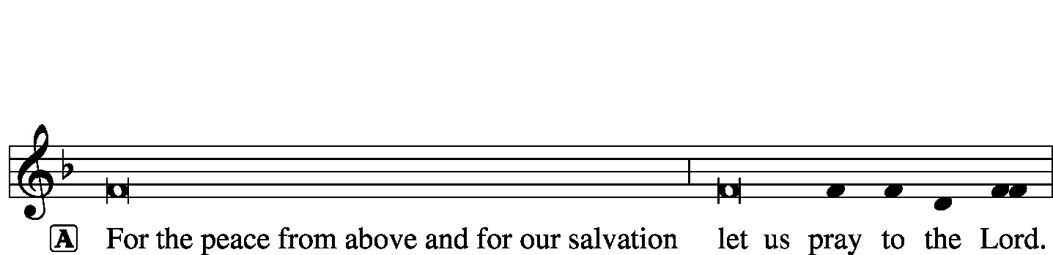
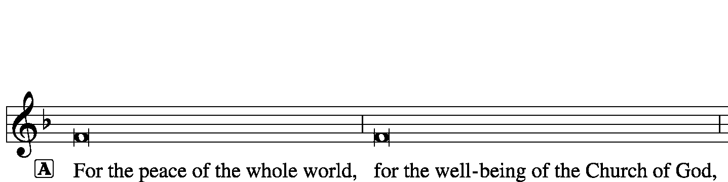
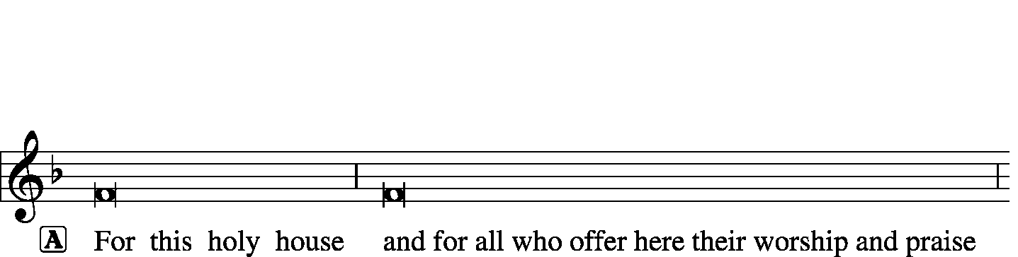
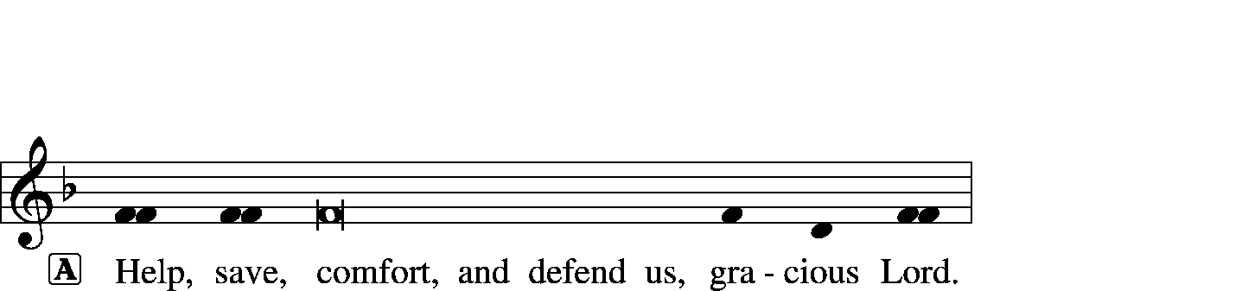
Hymn of Praise--This Is the Feast LSB 155
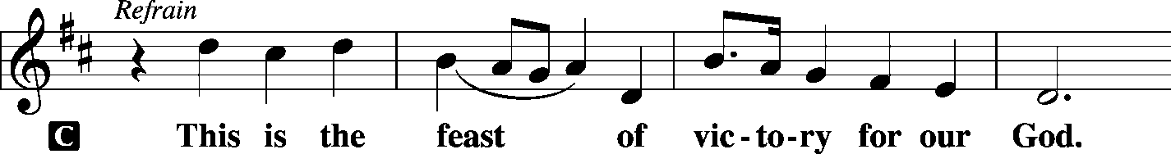
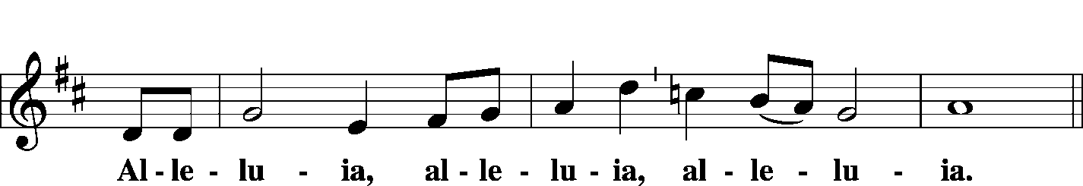
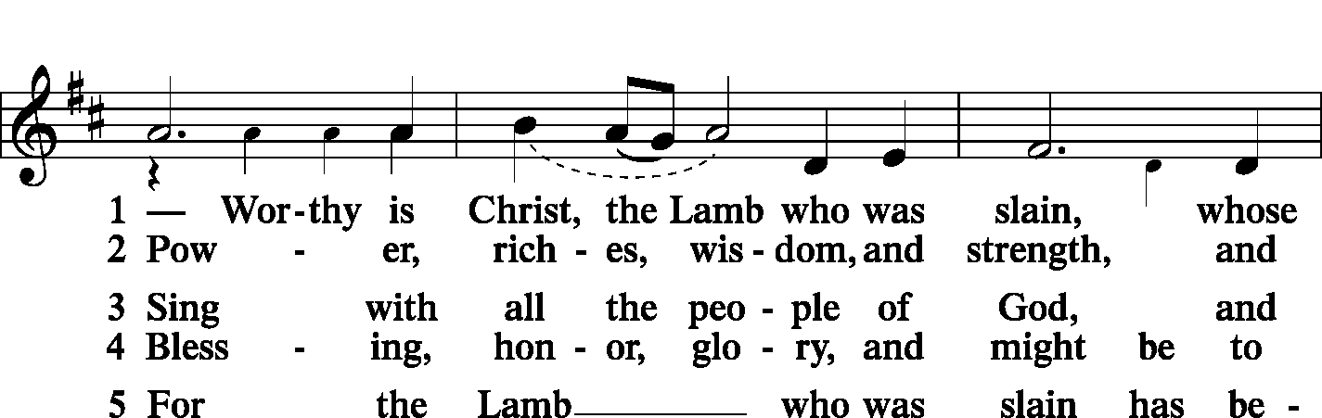
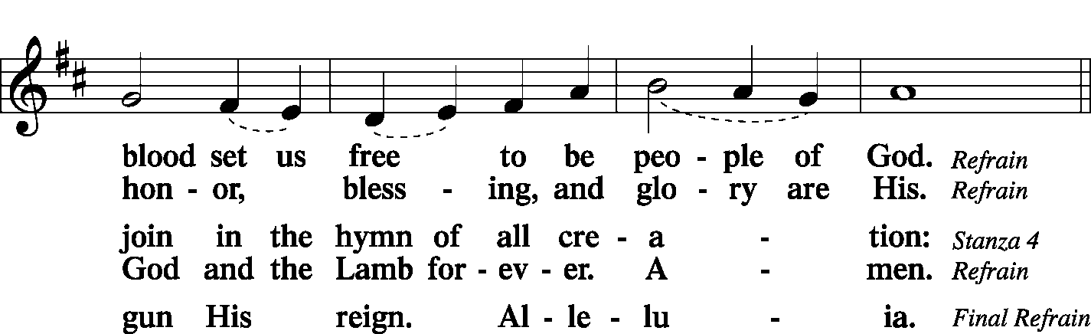
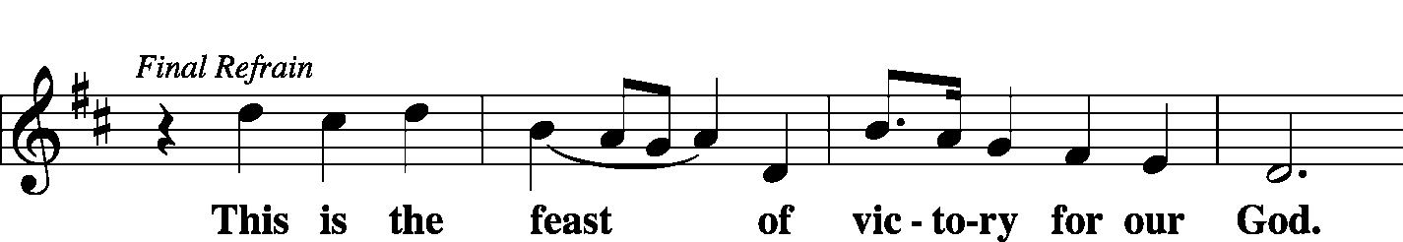
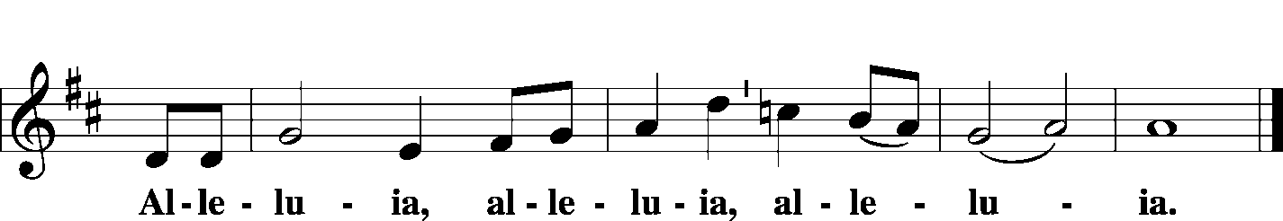

Salutation and Collect of the Day
P The Lord be with you.
C And also with you.
P Let us pray.
O God, in the glorious transfiguration of Your beloved Son You confirmed the mysteries of the faith by the testimony of Moses and Elijah. In the voice that came from the bright cloud You wonderfully foreshowed our adoption by grace. Mercifully make us co-heirs with the King in His glory and bring us to the fullness of our inheritance in heaven; through the same Jesus Christ, our Lord, who lives and reigns with You and the Holy Spirit, one God, now and forever.
C Amen.
Sit

Old Testament Reading Exodus 3:1-14
Now Moses was keeping the flock of his father-in-law, Jethro, the priest of Midian, and he led his flock to the west side of the wilderness and came to Horeb, the mountain of God. And the angel of the Lord appeared to him in a flame of fire out of the midst of a bush. He looked, and behold, the bush was burning, yet it was not consumed. And Moses said, “I will turn aside to see this great sight, why the bush is not burned.” When the Lord saw that he turned aside to see, God called to him out of the bush, “Moses, Moses!” And he said, “Here I am.” Then he said, “Do not come near; take your sandals off your feet, for the place on which you are standing is holy ground.” And He said, “I am the God of your father, the God of Abraham, the God of Isaac, and the God of Jacob.” And Moses hid his face, for he was afraid to look at God.
Then the Lord said, “I have surely seen the affliction of My people who are in Egypt and have heard their cry because of their taskmasters. I know their sufferings, and I have come down to deliver them out of the hand of the Egyptians and to bring them up out of that land to a good and broad land, a land flowing with milk and honey, to the place of the Canaanites, the Hittites, the Amorites, the Perizzites, the Hivites, and the Jebusites. And now, behold, the cry of the people of Israel has come to Me, and I have also seen the oppression with which the Egyptians oppress them. Come, I will send you to Pharaoh that you may bring My people, the children of Israel, out of Egypt.” But Moses said to God, “Who am I that I should go to Pharaoh and bring the children of Israel out of Egypt?” He said, “But I will be with you, and this shall be the sign for you, that I have sent you: when you have brought the people out of Egypt, you shall serve God on this mountain.”
Then Moses said to God, “If I come to the people of Israel and say to them, ‘The God of your fathers has sent me to you,’ and they ask me, ‘What is His name?’ what shall I say to them?” God said to Moses, “I am who I am.” And He said, “Say this to the people of Israel: ‘I am has sent me to you.’”
P This is the Word of the Lord.
C Thanks be to God.

Choir Christus Paradox arr. Alfred Fedak
The text of this choir anthem is profound. Please see a note about the amazing words of this song at the beginning of the Announcements section of the bulletin this morning to help understand the richness of the text.

Epistle 2 Peter 1:16–21
For we did not follow cleverly devised myths when we made known to you the power and coming of our Lord Jesus Christ, but we were eyewitnesses of His majesty. For when He received honor and glory from God the Father, and the voice was borne to Him by the Majestic Glory, “This is My beloved Son, with whom I am well pleased,” we ourselves heard this very voice borne from heaven, for we were with Him on the holy mountain. And we have something more sure, the prophetic word, to which you will do well to pay attention as to a lamp shining in a dark place, until the day dawns and the morning star rises in your hearts, knowing this first of all, that no prophecy of Scripture comes from someone’s own interpretation. For no prophecy was ever produced by the will of man, but men spoke from God as they were carried along by the Holy Spirit.
P This is the Word of the Lord.
C Thanks be to God.

Stand

Common Alleluia and Verse LSB 156
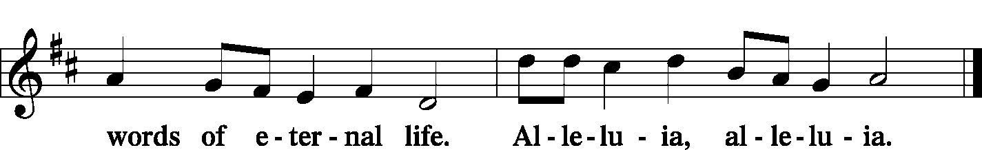

Holy Gospel Matthew 17:1–9
P The Holy Gospel according to St. Matthew, the 17th chapter.
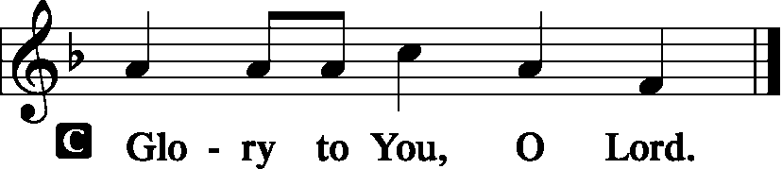
And after six days Jesus took with Him Peter and James, and John his brother, and led them up a high mountain by themselves. And He was transfigured before them, and His face shone like the sun, and His clothes became white as light. And behold, there appeared to them Moses and Elijah, talking with Him. And Peter said to Jesus, “Lord, it is good that we are here. If You wish, I will make three tents here, one for You and one for Moses and one for Elijah.” He was still speaking when, behold, a bright cloud overshadowed them, and a voice from the cloud said, “This is My beloved Son, with whom I am well pleased; listen to Him.” When the disciples heard this, they fell on their faces and were terrified. But Jesus came and touched them, saying, “Rise, and have no fear.” And when they lifted up their eyes, they saw no one but Jesus only. And as they were coming down the mountain, Jesus commanded them, “Tell no one the vision, until the Son of Man is raised from the dead.”
P This is the Gospel of the Lord.
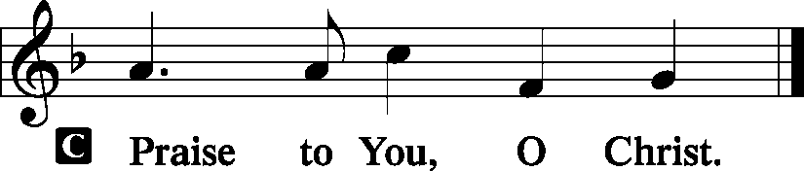

Sit

Hymn O Wondrous Type! O Vision Fair LSB 413

Sermon Lightbulb

Stand

Nicene Creed
C I believe in one God, the Father Almighty, maker of heaven and earth and of all things visible and invisible.
And in one Lord Jesus Christ, the only-begotten Son of God, begotten of His Father before all worlds, God of God, Light of Light, very God of very God, begotten, not made, being of one substance with the Father, by whom all things were made; who for us men and for our salvation came down from heaven and was incarnate by the Holy Spirit of the virgin Mary and was made man; and was crucified also for us under Pontius Pilate. He suffered and was buried. And the third day He rose again according to the Scriptures and ascended into heaven and sits at the right hand of the Father. And He will come again with glory to judge both the living and the dead, whose kingdom will have no end.
And I believe in the Holy Spirit, the Lord and giver of life, who proceeds from the Father and the Son, who with the Father and the Son together is worshiped and glorified, who spoke by the prophets. And I believe in one holy Christian and apostolic Church, I acknowledge one Baptism for the remission of sins, and I look for the resurrection of the dead and the life T of the world to come. Amen.

Prayer of the Church
P Almighty God, Lawgiver and Redeemer of the human race, we come before You in awe and reverence.
C Your laws have saved humanity from anarchy and chaos; Your statutes help preserve our existence on this earth.
P For preserving Your precepts through Moses, Elijah, and Your Son Jesus Christ,
C we give You most hearty thanks.
P We confess that, although You have made Your will known through the prophets and apostles and have preserved it to the present day, we have not sufficiently treasured Your Law and Gospel.
C We have transgressed Your Law and neglected many opportunities to spread Your Gospel.
P We have been guilty at times of doubting the divine revelation of Your Word.
C We have often given our own interpretation before searching Your Word for clarification.
P We have had itching ears, listening for new doctrines, the commandments of men.
C For our lack of careful concern in determining Your will, forgive us, O Lord.
P Through Your beloved Son Jesus Christ, You have revealed Your Word in the flesh.
C Send us Your Holy Spirit that we may hear Him speaking to us in Your Word.
P Give us the courage to hold high the light of Your Word to those who sit in darkness,
C and bless the hearts of those who hear it.

WE GO TO THE LORD IN PRAYER FOR
- Mark Manera and Makenna Gryga, as they celebrate their baptismal anniversaries this week.
- Lyle Lehde, father of Casey Beer, as he recovers from surgery.
- Rhiannon Corey, as she recovers from injuries from a car accident.
- Roger Drinnon, as he continues to battle aggressive cancer.
- Zion’s Men’s Club, Ladies Aid, and Youth Group.
- Faithfulness in personal witness and evangelism.

P Accept our thanks for permitting us to bask in the light of Your truth,
C and lead us one day into the presence of Him who is this world’s Light.
P Give vision and insight to the leaders of church and state.
C Accept our prayer for the sake of Jesus Christ, our Savior. Amen

Sit

Offering
[Please fill out a sheet in the attendance book. Visitors, please include your address. If you have a prayer request for the church prayer chain, please write it at the top of the sheet.]

Stand

Offertory LSB 159
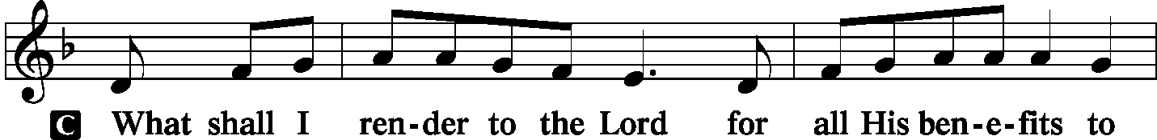
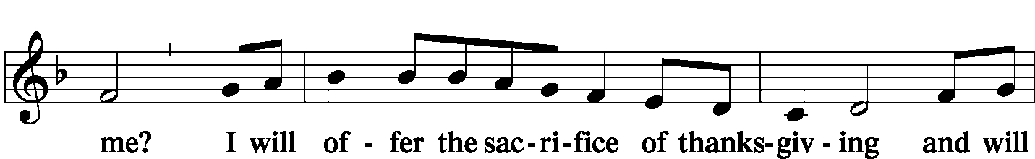
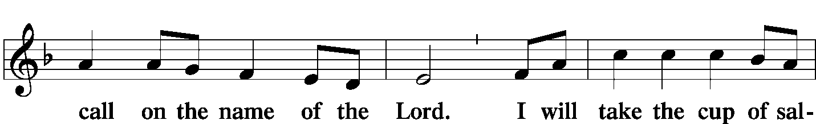
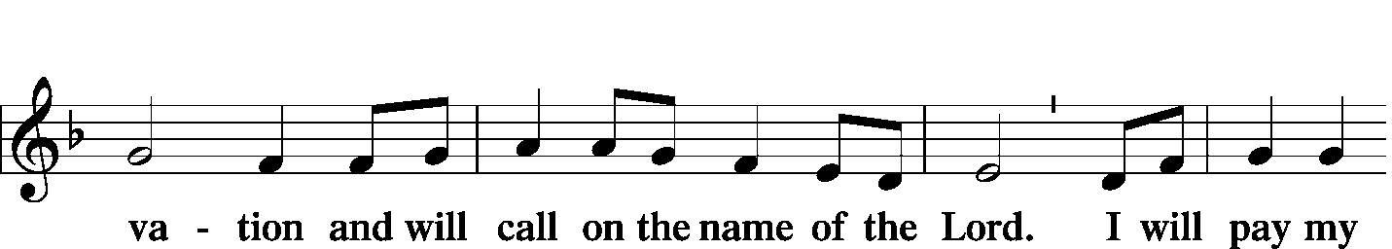
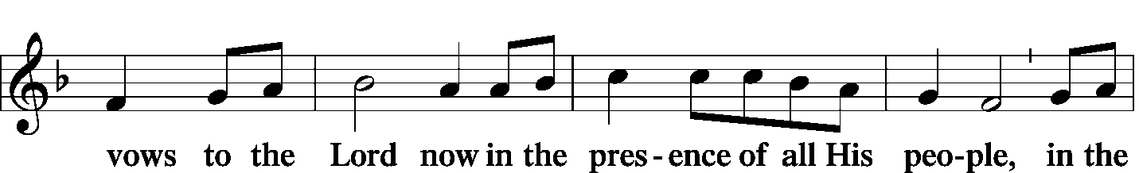
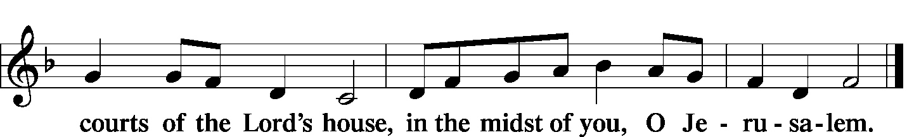

Service of the Sacrament
Preface LSB 160
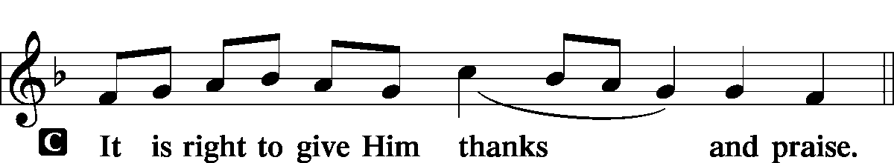

Proper Preface (Full)
P It is truly good, right, and salutary that we should at all times and in all places give thanks to You, holy Lord, almighty Father, everlasting God, through Jesus Christ, our Lord, who at His transfiguration revealed His glory to His disciples that they might be strengthened to proclaim His cross and resurrection and with all the faithful look forward to the glory of life everlasting. Therefore with angels and archangels and with all the company of heaven we laud and magnify Your glorious name, evermore praising You and saying:

Sanctus LSB 161
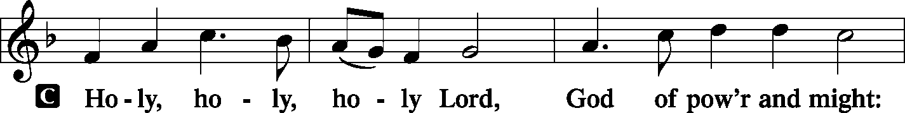
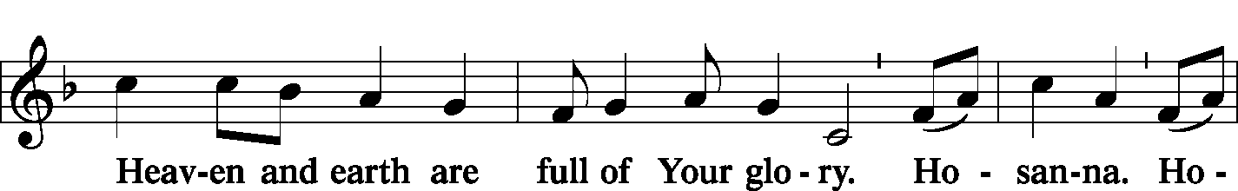
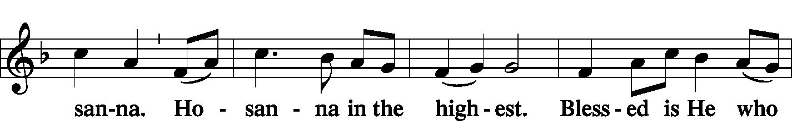
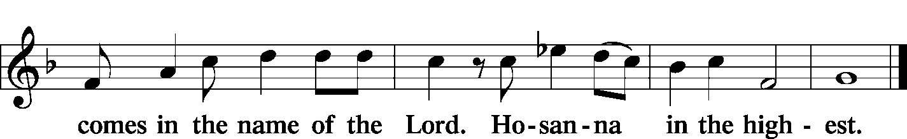

Prayer of Thanksgiving LSB 161
P Blessed are You, Lord of heaven and earth, for You have had mercy on those whom You created and sent Your only-begotten Son into our flesh to bear our sin and be our Savior. With repentant joy we receive the salvation accomplished for us by the all-availing sacrifice of His body and His blood on the cross.
Gathered in the name and the remembrance of Jesus, we beg You, O Lord, to forgive, renew, and strengthen us with Your Word and Spirit. Grant us faithfully to eat His body and drink His blood as He bids us do in His own testament. Gather us together, we pray, from the ends of the earth to celebrate with all the faithful the marriage feast of the Lamb in His kingdom, which has no end. Graciously receive our prayers; deliver and preserve us. To You alone, O Father, be all glory, honor, and worship, with the Son and the Holy Spirit, one God, now and forever.
C Amen.

Lord's Prayer LSB 162
P Lord, remember us in Your kingdom and teach us to pray:
C Our Father who art in heaven, hallowed be Thy name, Thy kingdom come, Thy will be done on earth as it is in heaven; give us this day our daily bread; and forgive us our trespasses as we forgive those who trespass against us; and lead us not into temptation, but deliver us from evil. For Thine is the kingdom and the power and the glory forever and ever. Amen.

The Words of Our Lord LSB 162
P Our Lord Jesus Christ, on the night when He was betrayed, took bread, and when He had given thanks, He broke it and gave it to the disciples and said: “Take, eat; this is My T body, which is given for you. This do in remembrance of Me.”
In the same way also He took the cup after supper, and when He had given thanks, He gave it to them, saying: “Drink of it, all of you; this cup is the new testament in My T blood, which is shed for you for the forgiveness of sins. This do, as often as you drink it, in remembrance of Me.”

Pax Domini LSB 163
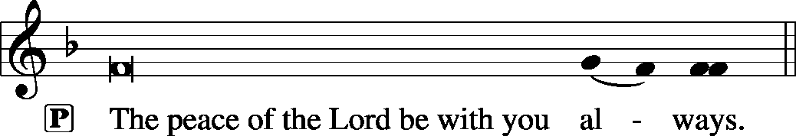

Agnus Dei LSB 163
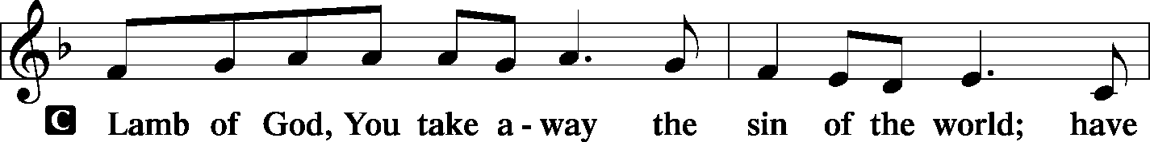
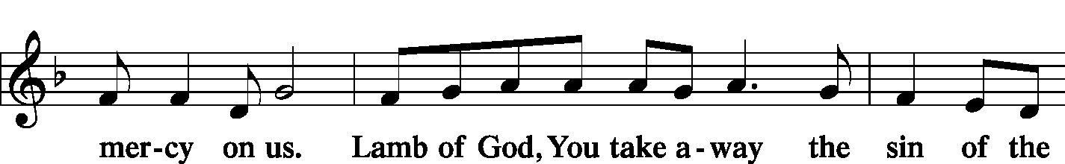
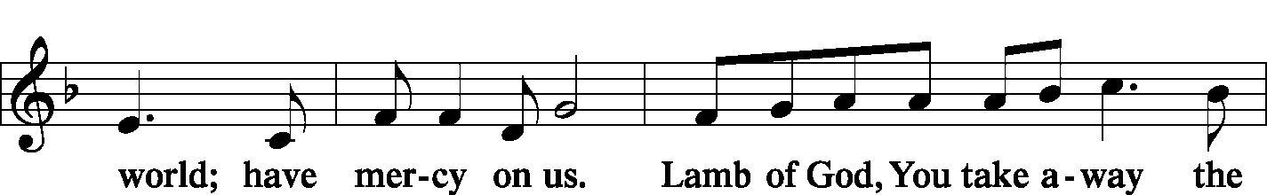
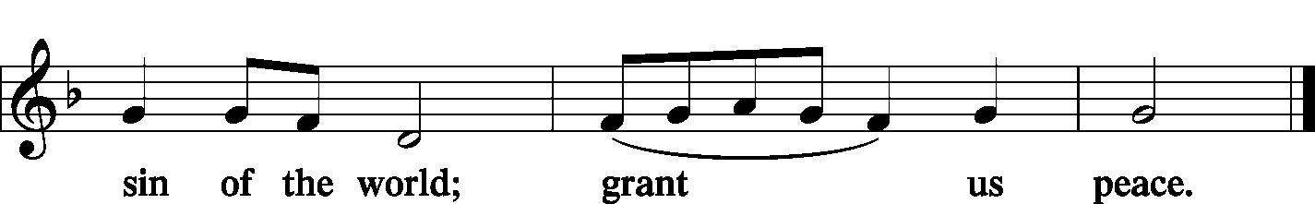

Sit

Distribution
Zion Lutheran practices the policy of close communion, communing only those who share our common Biblical view of the Lord's Supper. If you are not a confirmed LCMS Lutheran, please confer with the pastor before communing.

Hymn 'Tis Good, Lord, to Be Here LSB 414
Hymn Thine the Amen, Thine the Praise LSB 680
Hymn Alleluia! Sing to Jesus LSB 821

Stand

In dismissing the communicants, the following is said:

The Dismissal
P The body and blood of our Lord Jesus Christ strengthen and preserve you in body and soul to life everlasting. Depart T in peace.
C Amen.

Post-Communion Canticle--Thank the Lord LSB 164
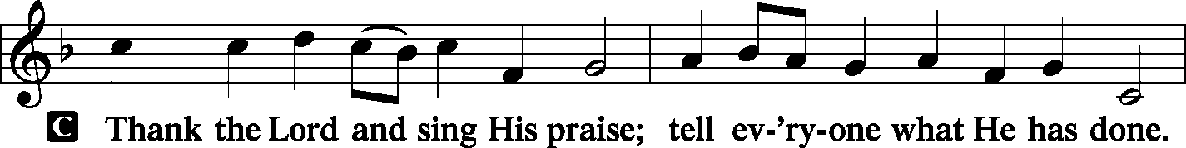
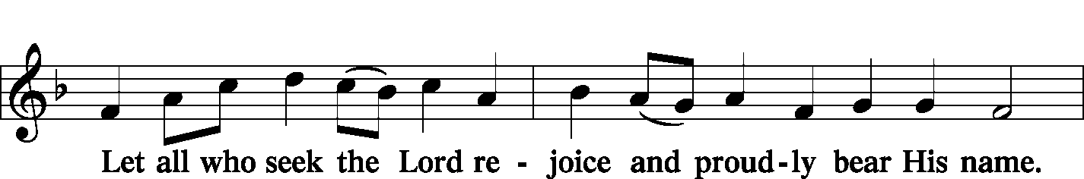
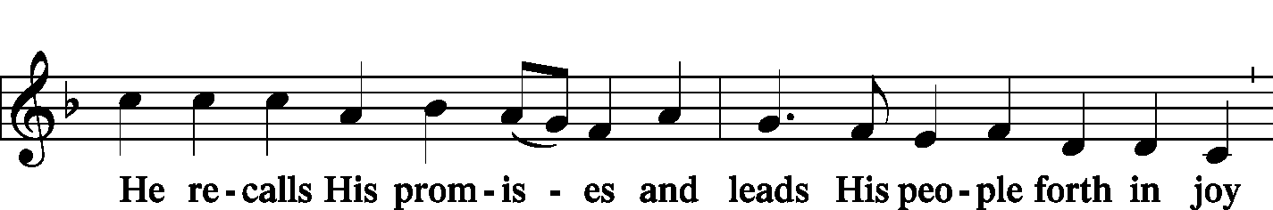
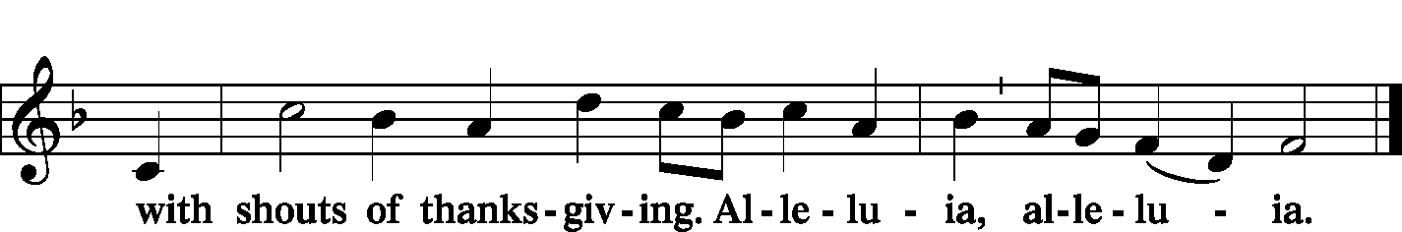

Post-Communion Collect and Benediction
P Let us pray.
We give thanks to You, almighty God, that You have refreshed us through this salutary gift, and we implore You that of Your mercy You would strengthen us through the same in faith toward You and in fervent love toward one another; through Jesus Christ, Your Son, our Lord, who lives and reigns with You and the Holy Spirit, one God, now and forever.

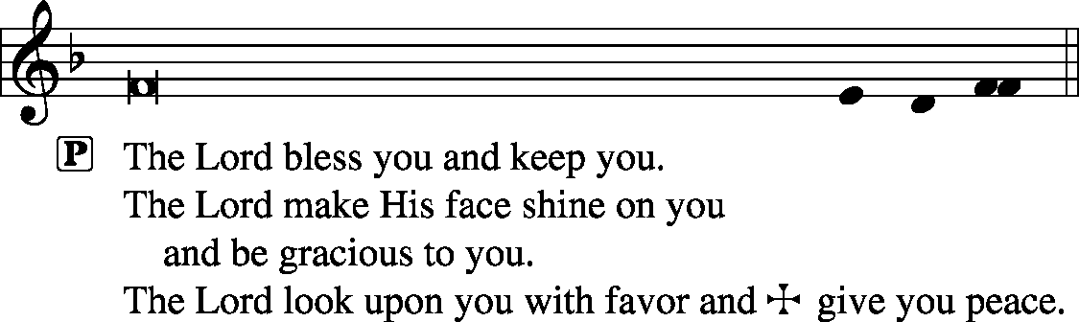

Remain standing

Hymn Alleluia, Song of Gladness LSB 417

Postlude Jubilation Jason Payne

Acknowledgments
Unless otherwise indicated, all scripture quotations are from The Holy Bible, English Standard Version, copyright © 2001 by Crossway Bibles, a division of Good News Publishers. Used by permission. All rights reserved. Created by Lutheran Service Builder © 2006 Concordia Publishing House.
LIFE AND LIVING ITEMS AT ZION
          

EXPLANATION ABOUT THE WORDS OF THE CHOIR ANTHEM
The Choir Anthem this morning, “Christus Pardox” has a fascinating text, which delves into deep teachings about Jesus Christ being both God and man. The doctrine of the two natures of Jesus Christ (Divine Nature and Human Nature) naturally generate paradoxical claims, all of which are true, while seeming to be contradictory. Sylvia Dunston, the author of the text for “Christus Paradox,” gives a powerful poetic meditation on the mysteries of the natures of Jesus Christ. Here is a description of some of the seemingly contradictory but true statements in the anthem, reprinted from an explanation published with the anthem itself: “Stanza 1 addresses Christ the Lord as both lamb and shepherd—a pair of images from John’s gospel, where Jesus is the sacrificial lamb of God who takes away the sin of the world, and also the Good Shepherd who lays down His life for the sheep. Again, Christ is both prince and slave; He’s the one who emptied Himself and took on the nature of a slave, and He’s also the one according to Acts 5 whom God exalted as “prince and savior.” Stanza 2 keeps the pattern of alternating status descriptions going with the phrase “shining in eternal glory: which probably refers back to Christ’s pre-existence. Then comes the phrase “beggar’d by a soldier’s toss,” which tells of the humiliation of being stripped by people who then gamble over your clothing. And every stanza addresses Christ as “the everlasting instant,” a phrase that gives us at once the universality and particularity of Christ, His divinity and humanity, His location on the human time strand and His transcendence of all times and strands.”

SIGN UP FOR LENT SUPPERS
Lent is almost here, so it is time to sign up for Lenten Meals. Meals will be served before each Midweek Lenten Service on Wednesday evenings from 5:30 to 6:30. Choir rehearsal will begin at 6:00 on those evenings, and the evening worship service will begin at 7:00 PM. Here is a list of dates available, which will be updated as more people sign up.
February 26: Ladies Aid – Meatloaf, Baked Potatoes, Hot Dogs
March 4:
March 11:
March 18: Elders - Lasagna, Salad, Bread
March 25:
April 1: Men’s Club - Tacos
April 8: Holy Week, no Wednesday service, no meal.

HELPING HANDS PROJECT COMING TO ZION
God places His people in congregations and communities to be His hands to serve His people. The Evangelism Committee has been brainstorming about ways to help the congregation recognize opportunities the Lord presents before us to serve those around us. There is a survey in today’s bulletin asking how members would be willing to serve, such as helping with transportation, indoor work like cooking and cleaning, and outdoor activities such as yard work. Please fill out your survey and place in the jars at the back of the church. After these responses are gathered, the Evangelism Committee will place a request card in the pews so that members can place a request for their brothers and sisters in Christ to come help them. Please begin thinking of what services you can offer to members of the congregation and community to provide a "Helping Hand" for those who might not be able to fulfill some of these tasks on their own. Thanks!

MOTHER-DAUGHTER BANQUET—SAVE THE DATE!
Write Saturday, April 25, 2020 down in your calendar if you are a grandmother, mother, daughter, or granddaughter! Zion’s Men’s Club will again be hosting a special night for the ladies of the congregation featuring a meal, some games, and a special guest speaker. The speaker this year will be Sarah Gulselth, a radio host from KFUO Radio, heard every weekday morning on The Coffee Hour, and weekly on the podcast called “Lutheran Ladies’ Lounge.” You will not want to miss this special evening of fellowship with your female relatives and friends on Saturday, April 25, 2020. A sign-up sheet will be available soon, but make plans now to attend!

PRESCHOOL DIRECTOR AND TEACHER NEEDED AT ZION
Zion Lutheran Church in Mascoutah, IL is seeking both a preschool director and a teacher for the 2020-2021 school year. The positions are each part-time for the morning hours, Monday-Friday. If interested, please contact Robin, Zion’s secretary, at 618-566-7345 for additional information.

SATURDAY FAMILY MOVIE
The Men’s Club will present Sing on Saturday, March 14th at 2:30 PM. This animated comedy features Buster Moon, an overly optimistic koala who stages the world’s greatest singing competition to save his crumbling theater; Rosita, an overworked and underappreciated mother of 25 piglets desperate to unleash her inner diva; and Ash, a punk rock porcupine with a beautiful voice. This is the last movie for this spring. Join us in the church basement for a free movie, soda, candy, and popcorn.

YOUTH GROUP PUZZLE NIGHT
Do you enjoy building jigsaw puzzles? Then this event is for you! The Annual Puzzle Night will be hosted by Zion Youth Group on Saturday, March 7th. Doors open at 5:30 p.m., competition begins at 6:00 p.m. Tickets are $12 each or $40 for a table of 4. Sign-up/info sheets are in the Narthex. Donations for baked goods to be sold by the youth on the night of the event are greatly appreciated! A sign-up sheet for baked goods is also in the Narthex. Babysitting for a donation is provided for your little ones during the event in the lower level of the church. Please contact Amanda or Mike Ganey if you have any questions. Hope to see you there!

HELP NEEDED FOR EASTER EGG HUNT
Winter is in full swing, and Easter is quickly approaching. The Board of Education is looking for someone to organize and run the Easter egg hunt this year. The date will be Saturday, April 4th. If you are interested please contact any of the BOE members, Christa Sink, Amanda Ganey, or Marianne McDaniel.

UNITY ASST. PRINCIPAL POSITION OPEN
Unity Lutheran School, East St. Louis, is currently accepting names of candidates for the position of Assistant Principal. The primary purpose of the position is to assist the school principal in overall administration of instructional programs, school operations, and development/financial strategies. Qualifications include being a member in good standing of an LCMS congregation, a minimum of a B.S. or B.A. Degree, and classroom teaching experience of three years. A Commissioned Minister of the LCMS is preferred. Candidate names or resumes may be sent to Rev. Aaron Dickerson at aaron-dickerson@att.net.

TRINITY LUTHERAN CHURCH ANNUAL SPAGHETTI DINNER
Trinity Lutheran Church at 503 E. Washington, Millstadt, IL will be hosting an all-you-can-eat spaghetti dinner on Sunday, March 8th from 10:30 AM-3:00 PM. Adults are $11, children 4-10 are $5, and children 3 and under are free. Carry-outs will be available.

IMMANUEL LUTHERAN PTL BREAKFAST
Immanuel Lutheran PTL is hosting an all-you-can-eat breakfast on Sunday, March 15th from 7:30 AM – 12:30 PM at the Immanuel Lutheran School Gym, 606 S. Hanover St., Okawville. Advance tickets are available from ILS students or the school office. Adults are $8 in advance or $9 at the door, children 6+ are $4 in advance or $5 at the door, and children 5 and under eat free. Dine-in or carry-outs available.

MATCHING GRANT AVAILABLE FOR LANSDOWNE COMMUNITY INITIATIVE IN EAST ST. LOUIS
The Lutheran Foundation of St. Louis has blessed Lansdowne Community Initiative (LCI), based out of Unity Lutheran Church in East St. Louis, with a matching grant of $10,000 if an additional $10,000 is raised by September, 2020. Congregations or individuals are allowed to donate up to $1,000 toward this matching fund. LCI is in the process of buying abandoned properties around the church in East St. Louis, rehabbing them, renting them to qualified occupants, and surrounding the process with home ownership training and financial training. For more information about LCI, check out their Facebook page at Lansdowne Community Initiative-LCI. To donate to the $10,000 match, you can contribute through a "Give Now" button on the Facebook page, or by sending a check with "Matching Grant Donation" in the memo line to: Lansdowne Community Initiative, c/o Unity Lutheran Church, 4200 Caseyville Ave., East St. Louis, IL 62204-1807. Thank you in advance for your generous support!

LIFESTYLE CHANGE PROGRAM
The clinical nutrition services team at HSHS St. Joseph’s Hospital Breese invites the community to learn more about the Lifestyle Change Program, a free workshop to promote weight loss to becoming a healthier you. Informational meetings to learn more about the program will be on the following dates:
- Thursday, Feb. 27, at noon in the hospital’s Heritage Room, Lunch and Learn, Registration required by calling Kayla Barnes at (618) 526-5336
- Monday, March 2, at 6 p.m. in the hospital’s Board Room, Registration is not necessary to attend
The Lifestyle Change Program will meet in groups with a trained lifestyle coach to learn ways to incorporate healthy eating, physical activity, problem-solving techniques, stress reduction and coping skills into their life. This workshop is for adults, ages 18 and older. Groups meet for one year. The initial six months consists of weekly meetings to gain knowledge on lifestyle changes. During the final six months, groups will meet 1-2 times per month to maintain the skills learned. If you are unable to attend an information meeting and would like to learn more, contact the dietitian or diabetes education offices by calling (618) 526-5336. For additional information, visit stjoebreese.com/Events-Classes.

HAVE YOU EVER CONSIDERED BECOMING A PASTOR OR DEACONESS?
If so, Rev. Scott Holder from Concordia Seminary, St. Louis, would like to meet with you at Lutheran Church of Webster Gardens, 8749 Watson Road, Webster Groves, MO, on Wednesday, February 26, between 3 and 7 PM. Rev. Holder is interested in meeting with prospective students of all ages—elementary school age through adults. Appointments are individual, informal, and family/friends are welcome to come with you. Appointments are not necessary but encouraged. If you are interested in scheduling a specific time, please contact Rev. Holder at 314-505-7225 or holders@csl.edu.

LISTEN TO WORLDWIDE KFUO AM850
KFUO Radio, AM850 & kfuo.org, a media ministry extension of LCMS congregations, shares Christ for you anytime, anywhere on AM850 via worship services, Bible and theology studies, practical talk programs, and sacred music. You can find programs on demand at kfuo.org and wherever you get your podcasts. Find us on social: @KFUOradio on Facebook, Twitter, and Instagram. This week on KFUO AM850 & kfuo.org, hear Ash Wednesday worship service from Peace Lutheran Barracksview on 2/26 at 11:00 a.m., begin studying the book of Zechariah on Thy Strong Word (weekdays at 11:00 a.m.), and hear comforting Gospel words on Moments of Assurance (weekdays at 12:00 p.m.). Find your favorite programs on demand at kfuo.org.

MORE TOPICS, MORE GUESTS, MORE JESUS
Issues, Etc. is a radio talk show and podcast produced by Lutheran Public Radio in Collinsville, IL and hosted by LCMS Pastor Todd Wilken. This week's topics include: The Book of 1 Thessalonians, "Love" in the New Testament, The Season of Lent, Jesus Feeds Five Thousand and more. You can tune in live weekdays from 3-5 p.m. on KFUO, 850 AM in St. Louis. You can also listen on-demand at issuesetc.org and on the LPR mobile app.

THOSE WHO SERVE NEXT WEEK, MARCH 1
Proclaimer: Sem. Don Stein
Liturgist: Rev. Kirk Clayton
Organist: Nancy Peterson
Ushers: Lee Harlan, Mark Hatcher, Carl Sherrill, & Buzz Kandler
Sound Tech: Jake Simon
Video Tech: Mark Hatcher
Welcome Team: Kurt & Rachel Bretz
Acolytes: Maggie Harlan & Michael Ganey
THE FLOWERS ON THE LORD’S ALTAR
The flowers on the Lord’s altar are given to the glory of God by Pinky Ahner in love and celebration of her siblings birthdays, Deloris Bramstedt and Norman Rowold.

THOSE WHO SERVE TODAY
Proclaimer: Rev. Kirk Clayton
Liturgist: Sem. Don Stein
Organist: Nancy Peterson
Ushers: Bob Walter, Dale Wehmeyer, Eldon Ahner, & Ted Ahner
Sound Tech: Matt Krausz
Video Tech: Mark Hatcher
Welcome Team: Joe & Konya Bloomquist
Acolytes: Phoebe Corey & Abigail Clayton
Altar Guild: Beth Twenhafel & Shirley Braeutigam

THOSE WHO SERVE ASH WEDNESDAY, FEBRUARY 26
Proclaimer: Rev. Kirk Clayton
Liturgist: Sem. Don Stein
Organist: Nancy Peterson
Ushers: Karl Bretz, Joe Crismon, Bob Eldridge, & Ken Frey
Sound Tech: Gadge Corey
Video Tech: Mark Hatcher
Altar Guild: Linda Hoskins

THINGS WE ARE DOING AT ZION
Sun. Confirmation Class 8:30 AM
SS & Bible Class 8:45 AM
Worship DS I w/communion 10:00 AM
Mon. LifeLight 7:00 PM
Board of Ed 7:00 PM
Wed. Imposition of Ashes 7:00 AM-7:00 PM
Choir Rehearsal 6:00 PM
Ash Wednesday Meal 5:30 PM-6:30 PM
Ash Wednesday Service 7:00 PM
Fri. Senior Meal Delivery 10:30 AM
Sun. Confirmation Class 8:30 AM
SS & Bible Class 8:45 AM
Worship DS II n/communion 10:00 AM

ATTENDANCE FEBRUARY 16: Sunday: 158
Adult Bible Class: 23 High School: 6 Sunday School: 41

“Those who serve next week” is printed on the previous page.

