Zion Lutheran Church
Mascoutah, Illinois
February 9, 2020
Sexagesima
Sixty Days before Easter

In the Name of Christ Jesus our Lord, we bid you a warm welcome to this worship service. May your experience of worship and fellowship this morning be spiritually refreshing and ready you for the week ahead.
 
Pastor: Rev. Kirk Clayton
Church Secretary: Robin Phillips
Choir Director Team: Josh and Nancy Peterson
_________________________________________________________________________________
Church Office Phone: 618-566-7345
Pastor Clayton Cell: 618-447-1306
Office Hours: 8:00 am to 12:00 pm
Email: ChurchOffice@ZionMascoutah.org
Pastor Clayton email: Pastor@ZionMascoutah.org
Web site: www.ZionMascoutah.org
Find us at @ZionMascoutah on Facebook, Twitter, and Instagram
Electronic Devices
Please TURN OFF all cell phones, pagers, electronic devices, apps and games when entering the sanctuary for worship so those around you may focus on the Word of God without electronic distraction. Thank you.

Prayer to Begin Worship
Lord of the planting and reaping, Husbandman of the Kingdom grainfields, nourish us with Your Holy Word and sacraments, cause us to produce fruit worthy of Your love, and keep us fit for the harvest when it comes; through Jesus Christ, our Lord, who with You and the Father are one God with dominion over us forever.

DIVINE SERVICE III WITH COMMUNION
LSB p. 184
Confession and Absolution
Prelude Thy Strong Word arr. Hildebrand

Hymn Thy Strong Word LSB 578

Stand

The sign of the cross may be made by all in remembrance of their Baptism.

Invocation
P In the name of the Father and of the T Son and of the Holy Spirit.
C Amen.

Exhortation
P Beloved in the Lord! Let us draw near with a true heart and confess our sins unto God our Father, beseeching Him in the name of our Lord Jesus Christ to grant us forgiveness.
P Our help is in the name of the Lord,
C who made heaven and earth.
P I said, I will confess my transgressions unto the Lord,
C and You forgave the iniquity of my sin.

Silence for reflection on God's Word and for self-examination.

Confession with Absolution
P O almighty God, merciful Father,
C I, a poor, miserable sinner, confess unto You all my sins and iniquities with which I have ever offended You and justly deserved Your temporal and eternal punishment. But I am heartily sorry for them and sincerely repent of them, and I pray You of Your boundless mercy and for the sake of the holy, innocent, bitter sufferings and death of Your beloved Son, Jesus Christ, to be gracious and merciful to me, a poor, sinful being.

P Upon this your confession, I, by virtue of my office, as a called and ordained servant of the Word, announce the grace of God unto all of you, and in the stead and by the command of my Lord Jesus Christ I forgive you all your sins in the name of the Father and of the T Son and of the Holy Spirit.
C Amen.

Service of the Word
Introit Ps. 44:1–2, 7–8; antiphon: Ps. 44:23, 25a, 26a
L Awake! Why are You sleeping, O Lord?
C Rouse Yourself! Do not reject us forever!
L For our soul is bowed down to the dust.
C Rise up; come to our help!
L O God, we have heard with our ears, our fathers have told us,
C what deeds You performed in their days, in the days of old:
L You with Your own hand drove out the nations, but them You planted;
C You afflicted the peoples, but them You set free.
L But You have saved us from our foes
C and have put to shame those who hate us.
L In God we have boasted continually,
C and we will give thanks to Your name forever.
L Awake! Why are You sleeping, O Lord?
C Rouse Yourself! Do not reject us forever!
L For our soul is bowed down to the dust.

Gloria Patri
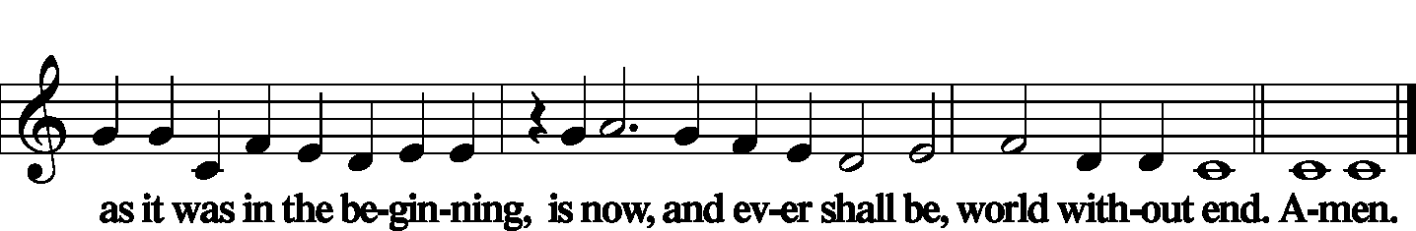
Kyrie LSB 186
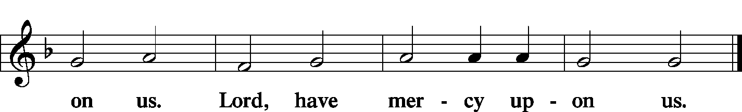

Gloria in Excelsis LSB 187
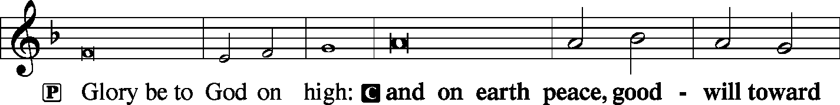
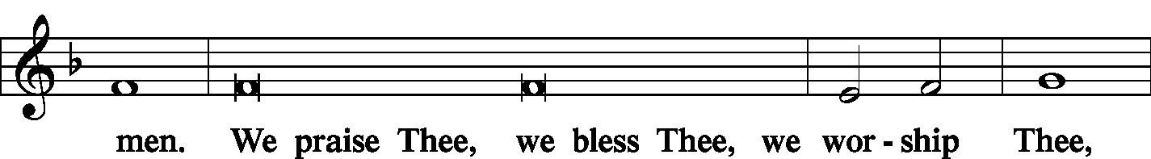
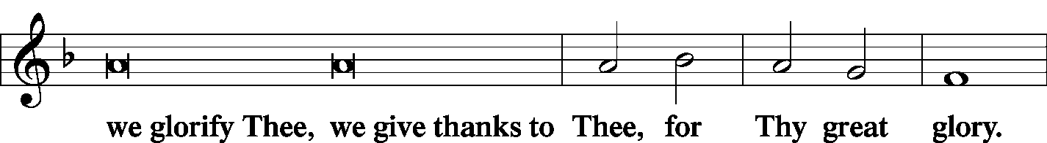
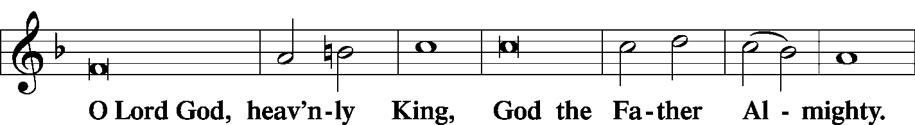
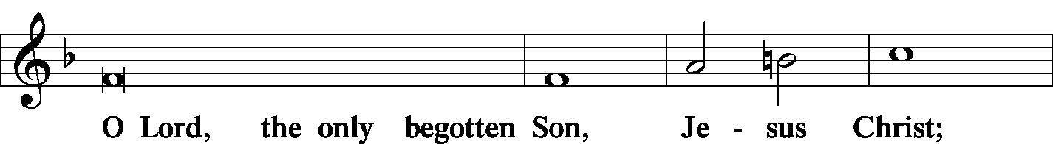
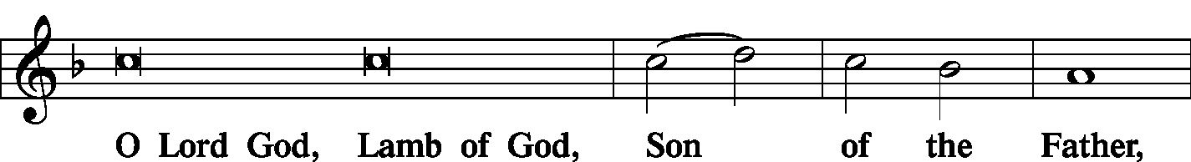
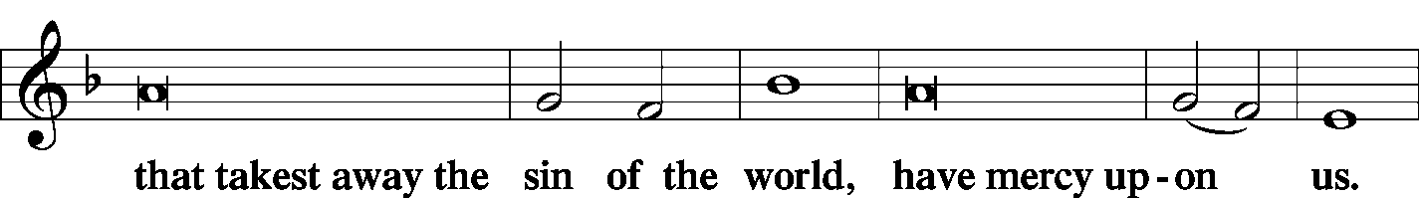
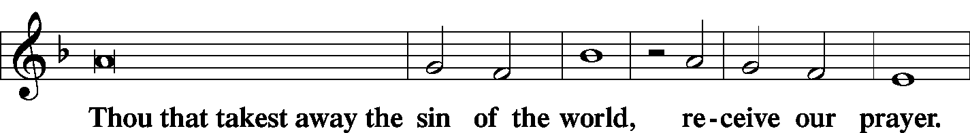
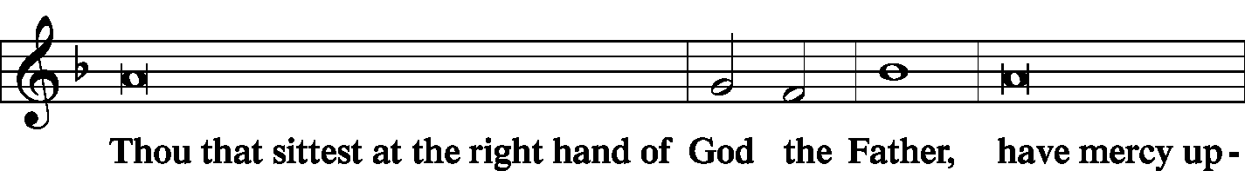
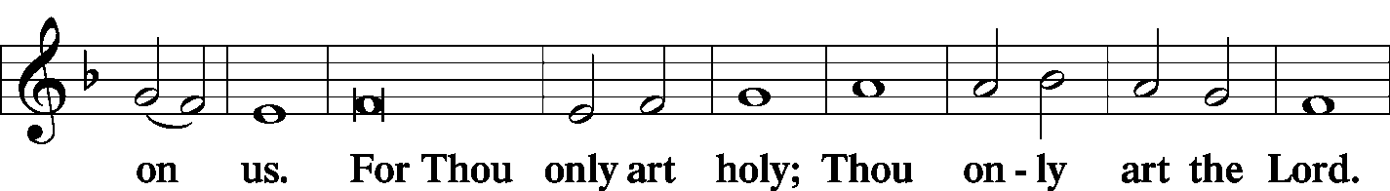
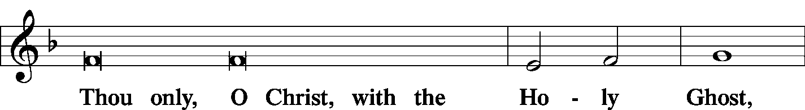
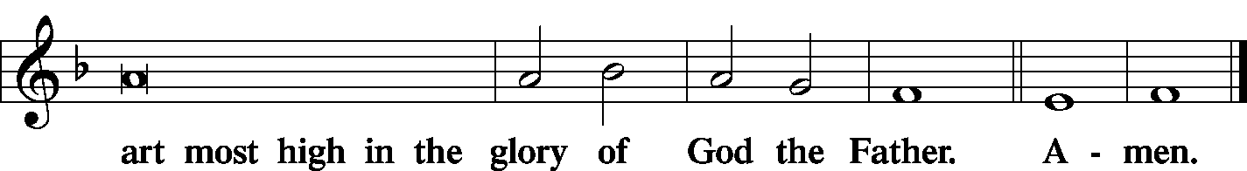

Salutation and Collect of the Day
L The Lord be with you.
C And with thy spirit.
L Let us pray.
O God, the strength of all who put their trust in You, mercifully grant that by Your power we may be defended against all adversity; through Jesus Christ, Your Son, our Lord, who lives and reigns with You and the Holy Spirit, one God, now and forever.
C Amen.

Sit

Old Testament Reading Isaiah 55:10–13
“For as the rain and the snow come down from heaven and do not return there but water the earth, making it bring forth and sprout, giving seed to the sower and bread to the eater, so shall My word be that goes out from My mouth; it shall not return to Me empty, but it shall accomplish that which I purpose, and shall succeed in the thing for which I sent it.
“For you shall go out in joy and be led forth in peace; the mountains and the hills before you shall break forth into singing, and all the trees of the field shall clap their hands. Instead of the thorn shall come up the cypress; instead of the brier shall come up the myrtle; and it shall make a name for the Lord, an everlasting sign that shall not be cut off.”
L This is the Word of the Lord.
C Thanks be to God.

Gradual
L Let Your enemies know that You alone, whose name is the LORD,
C are the Most High over all the earth.
L O my God, make them like whirling dust,
C like chaff before the wind.

Epistle 2 Corinthians 11:19—12:9
For you gladly bear with fools, being wise yourselves! For you bear it if someone makes slaves of you, or devours you, or takes advantage of you, or puts on airs, or strikes you in the face. To my shame, I must say, we were too weak for that!
But whatever anyone else dares to boast of—I am speaking as a fool—I also dare to boast of that. Are they Hebrews? So am I. Are they Israelites? So am I. Are they offspring of Abraham? So am I. Are they servants of Christ? I am a better one—I am talking like a madman—with far greater labors, far more imprisonments, with countless beatings, and often near death. Five times I received at the hands of the Jews the forty lashes less one. Three times I was beaten with rods. Once I was stoned. Three times I was shipwrecked; a night and a day I was adrift at sea; on frequent journeys, in danger from rivers, danger from robbers, danger from my own people, danger from Gentiles, danger in the city, danger in the wilderness, danger at sea, danger from false brothers; in toil and hardship, through many a sleepless night, in hunger and thirst, often without food, in cold and exposure. And, apart from other things, there is the daily pressure on me of my anxiety for all the churches. Who is weak, and I am not weak? Who is made to fall, and I am not indignant?
If I must boast, I will boast of the things that show my weakness. The God and Father of the Lord Jesus, He who is blessed forever, knows that I am not lying. At Damascus, the governor under King Aretas was guarding the city of Damascus in order to seize me, but I was let down in a basket through a window in the wall and escaped his hands.
I must go on boasting. Though there is nothing to be gained by it, I will go on to visions and revelations of the Lord. I know a man in Christ who fourteen years ago was caught up to the third heaven—whether in the body or out of the body I do not know, God knows. And I know that this man was caught up into paradise—whether in the body or out of the body I do not know, God knows— and he heard things that cannot be told, which man may not utter. On behalf of this man I will boast, but on my own behalf I will not boast, except of my weaknesses. Though if I should wish to boast, I would not be a fool, for I would be speaking the truth. But I refrain from it, so that no one may think more of me than he sees in me or hears from me. So to keep me from being too elated by the surpassing greatness of the revelations, a thorn was given me in the flesh, a messenger of Satan to harass me, to keep me from being too elated. Three times I pleaded with the Lord about this, that it should leave me. But He said to me, “My grace is sufficient for you, for My power is made perfect in weakness.” Therefore I will boast all the more gladly of my weaknesses, so that the power of Christ may rest upon me.
L This is the Word of the Lord.
C Thanks be to God.

Stand

Alleluia and Verse
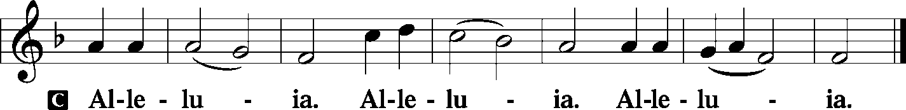

Holy Gospel Luke 8:4–15
P The Holy Gospel according to St. Luke, the 8th chapter.
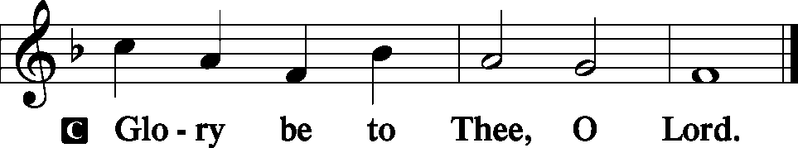
When a great crowd was gathering and people from town after town came to [Jesus], He said in a parable: “A sower went out to sow his seed. And as he sowed, some fell along the path and was trampled underfoot, and the birds of the air devoured it. And some fell on the rock, and as it grew up, it withered away, because it had no moisture. And some fell among thorns, and the thorns grew up with it and choked it. And some fell into good soil and grew and yielded a hundredfold.” As He said these things, He called out, “He who has ears to hear, let him hear.”
And when His disciples asked Him what this parable meant, He said, “To you it has been given to know the secrets of the kingdom of God, but for others they are in parables, so that ‘seeing they may not see, and hearing they may not understand.’ Now the parable is this: The seed is the word of God. The ones along the path are those who have heard. Then the devil comes and takes away the word from their hearts, so that they may not believe and be saved. And the ones on the rock are those who, when they hear the word, receive it with joy. But these have no root; they believe for a while, and in time of testing fall away. And as for what fell among the thorns, they are those who hear, but as they go on their way they are choked by the cares and riches and pleasures of life, and their fruit does not mature. As for that in the good soil, they are those who, hearing the word, hold it fast in an honest and good heart, and bear fruit with patience.”
P This is the Gospel of the Lord.
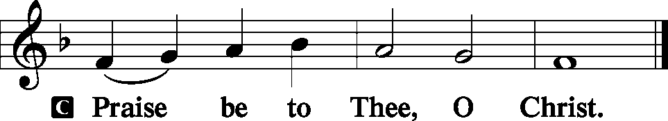

Nicene Creed
C I believe in one God, the Father Almighty, maker of heaven and earth and of all things visible and invisible.
And in one Lord Jesus Christ, the only-begotten Son of God, begotten of His Father before all worlds, God of God, Light of Light, very God of very God, begotten, not made, being of one substance with the Father, by whom all things were made; who for us men and for our salvation came down from heaven and was incarnate by the Holy Spirit of the virgin Mary and was made man; and was crucified also for us under Pontius Pilate. He suffered and was buried. And the third day He rose again according to the Scriptures and ascended into heaven and sits at the right hand of the Father. And He will come again with glory to judge both the living and the dead, whose kingdom will have no end.
And I believe in the Holy Spirit, the Lord and giver of life, who proceeds from the Father and the Son, who with the Father and the Son together is worshiped and glorified, who spoke by the prophets. And I believe in one holy Christian and apostolic Church, I acknowledge one Baptism for the remission of sins, and I look for the resurrection of the dead and the life T of the world to come. Amen.

Sit

Hymn Almighty God, Your Word Is Cast LSB 577

Sermon What Does This Mean?

Stand

Prayer of the Church
P O Lord God almighty Creator, You spoke and the universe came into being.
C By the exertion of Your will the earth was populated with herds and flocks.
P By Your Word vegetation and grain sprang forth to nourish all living things.
C We are grateful that Your power still exists among us.
P As the rain and the snow come down from heaven at Your command and nourish the earth,
C so You have promised that Your mighty Word, sown as seed in the hearts of men, women, and children everywhere will produce results.
P Send Your Holy Spirit to prepare our hearts to receive Your Holy Word.
C Prevent us from hardening our hearts so that Your Word cannot penetrate.
P Keep us from short lived emotional reaction to Your Word.
C Protect us from the thorns of coveting, which are able to choke out our faith.
P Make our hearts a fertile field so that Your Word may produce the fruits of faith a hundredfold.
C As we sow the seed of Your Word on the hearts of many, may Your Holy Spirit bless it that it may spring forth into a lively hope.
P When, O Lord, we see little or no results of the Word we have spread,
C encourage us to remain faithful sowers with Your promise that Your Word shall not return empty.
P Bless the administration of our government that it may help provide a healthy climate for the seed we sow to germinate and bring forth fruit.

WE GO TO THE LORD IN PRAYER FOR
- Torri Suedmeyer, Lydia Schorfheide, Abigail McDaniel, and Amber Schanz, as they celebrate their baptismal anniversaries this week.
- Buzz Kandler, as he battles an infection.
- Zachary Matthews, as he remains hospitalized.
- Roger Drinnon, as he suffers the effects of chemotherapy.
- Zion’s President, Vice President, Secretary, and Treasurer.
- Faithfulness in Christian Worship.

P This we ask in the name of the Lord of the harvest,
C even Jesus Christ, our Lord and Savior. Amen.

Sit

Offering
[Please fill out a sheet in the attendance book. Visitors, please include your address. If you have a prayer request for the church prayer chain, please write it at the top of the sheet.]

Special Offering Music Ashlee Eatherton

Stand

Offertory LSB 192
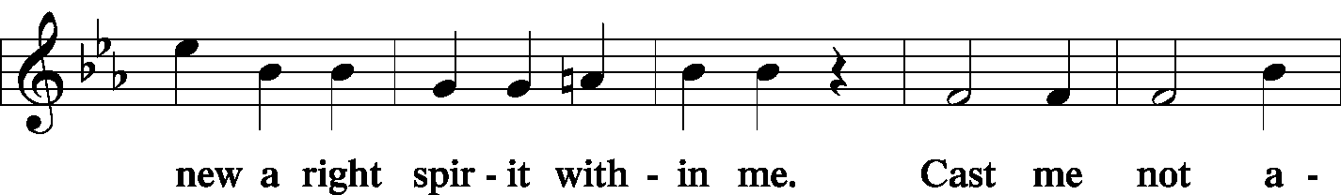
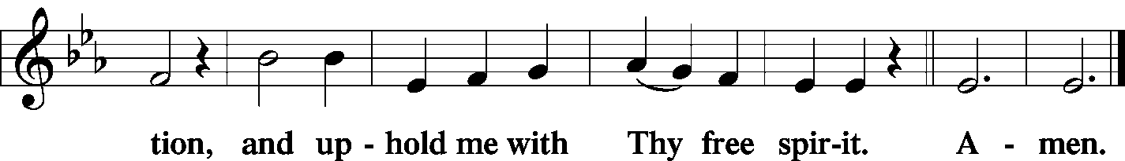

Service of the Sacrament
Preface LSB 194
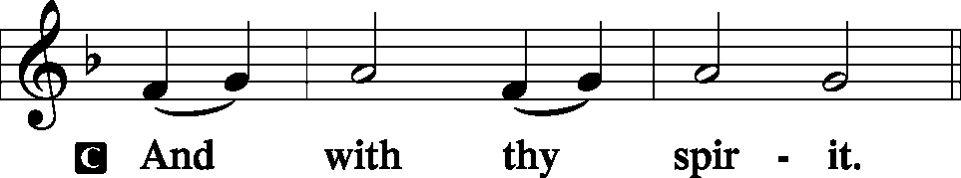
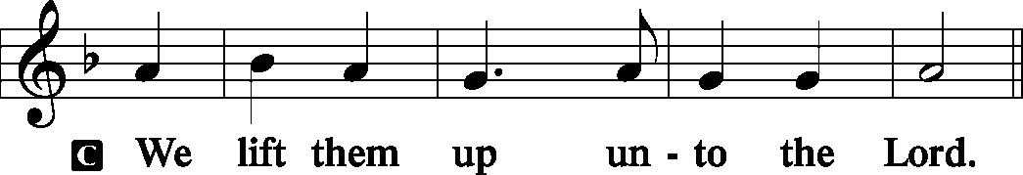
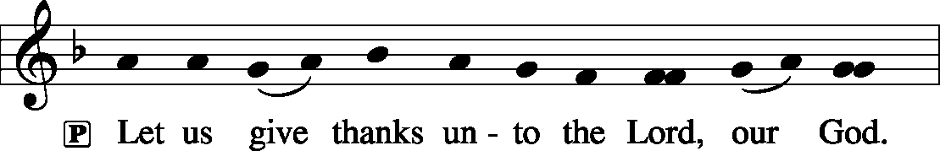

Proper Preface (Full)
P It is truly meet, right, and salutary that we should at all times and in all places give thanks to You, holy Lord, almighty Father, everlasting God, through Jesus Christ, our Lord; for what had been hidden from before the foundation of the world You have made known to the nations in Your Son. In Him, being found in the substance of our mortal nature, You have manifested the fullness of Your glory. Therefore with angels and archangels and with all the company of heaven we laud and magnify Your glorious name, evermore praising You and saying:
Sanctus LSB 195
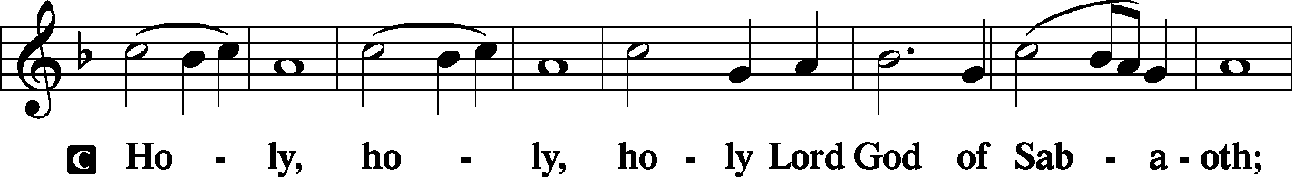
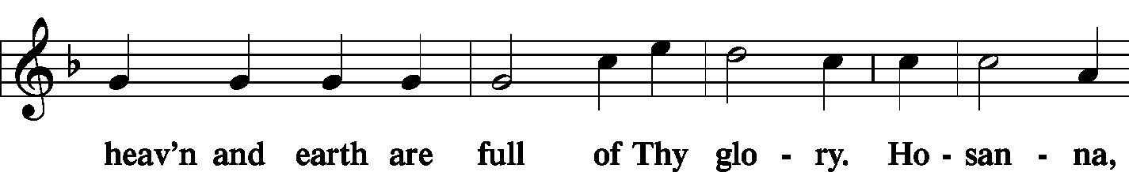
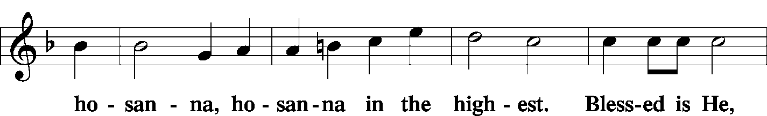
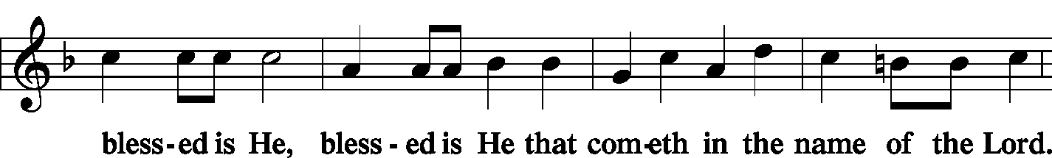
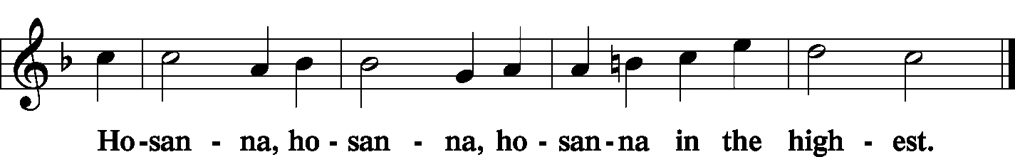

Lord's Prayer LSB 196
P Our Father who art in heaven, hallowed be Thy name, Thy kingdom come, Thy will be done on earth as it is in heaven; give us this day our daily bread; and forgive us our trespasses as we forgive those who trespass against us; and lead us not into temptation, but deliver us from evil.
C | 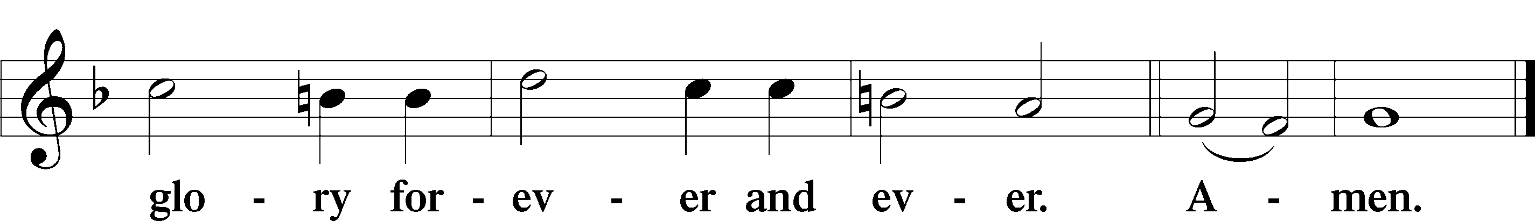

The Words of Our Lord LSB 197
P Our Lord Jesus Christ, on the night when He was betrayed, took bread, and when He had given thanks, He broke it and gave it to the disciples and said: “Take, eat; this is My T body, which is given for you. This do in remembrance of Me.”
P In the same way also He took the cup after supper, and when He had given thanks, He gave it to them, saying: “Drink of it, all of you; this cup is the new testament in My T blood, which is shed for you for the forgiveness of sins. This do, as often as you drink it, in remembrance of Me.”

Pax Domini LSB 197
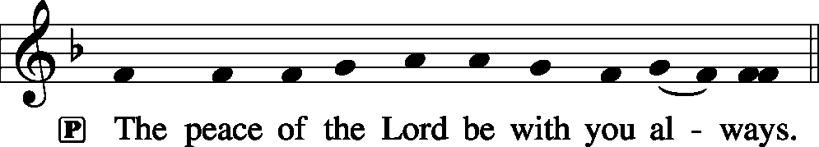
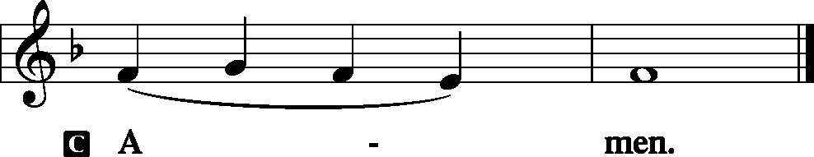

Agnus Dei LSB 198
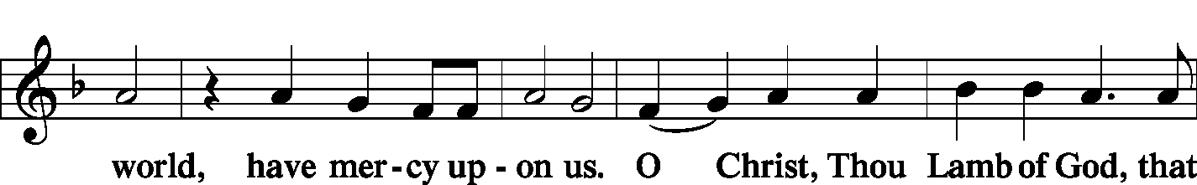
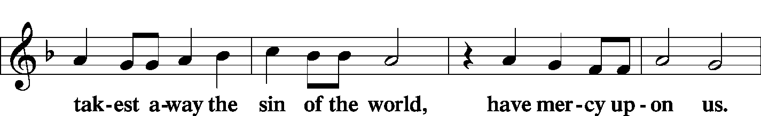
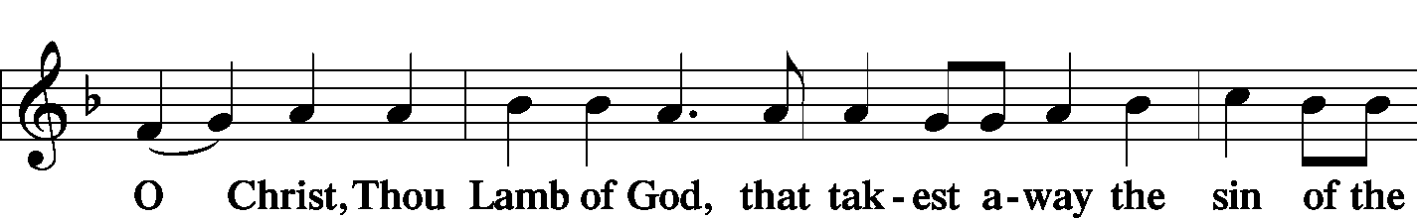

Sit

Distribution
Zion Lutheran practices the policy of close communion, communing only those who share our common Biblical view of the Lord's Supper. If you are not a confirmed LCMS Lutheran, please confer with the pastor before communing.

The pastor and those who assist him receive the body and blood of Christ first and then distribute them to those who come to receive, saying:

Take, eat; this is the true body of our Lord and Savior Jesus Christ, given into death for your sins.
Amen.

Take, drink; this is the true blood of our Lord and Savior Jesus Christ, shed for the forgiveness of your sins.
Amen.

Hymn Just as I Am, without One Plea LSB 570

Hymn In the Shattered Bliss of Eden LSB 572

Hymn Almighty Father, Bless the Word LSB 923

Stand

In dismissing the communicants, the following is said:

The Dismissal
P The body and blood of our Lord Jesus Christ strengthen and preserve you in body and soul to life everlasting. Depart T in peace.
C Amen.

Nunc Dimittis LSB 199
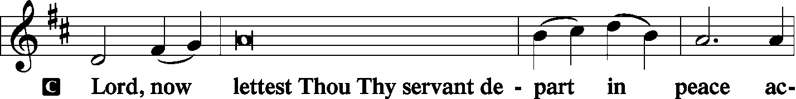
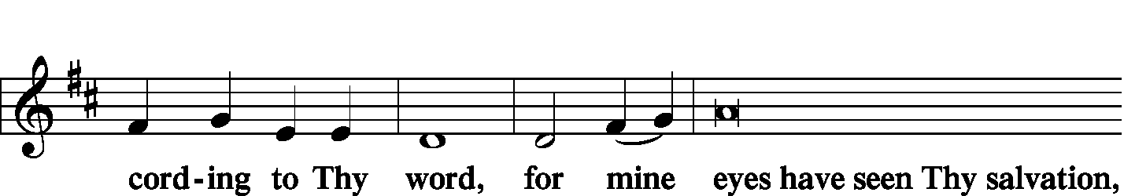
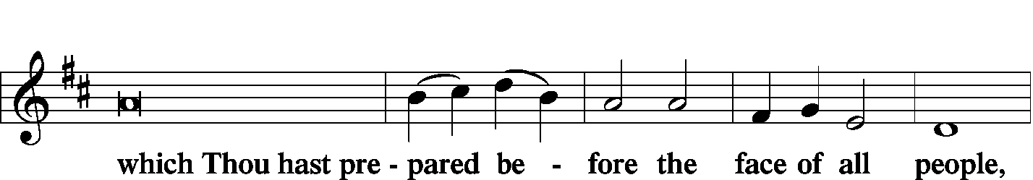
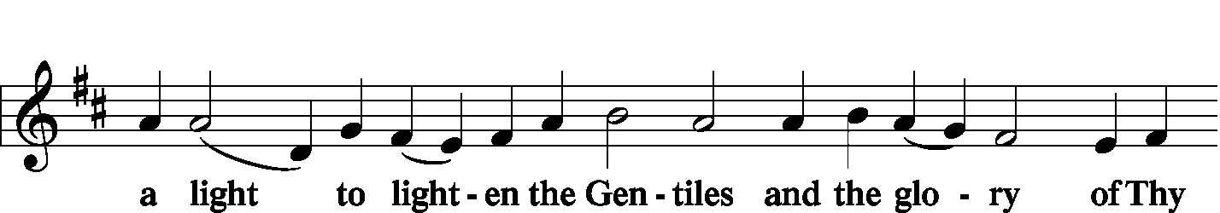
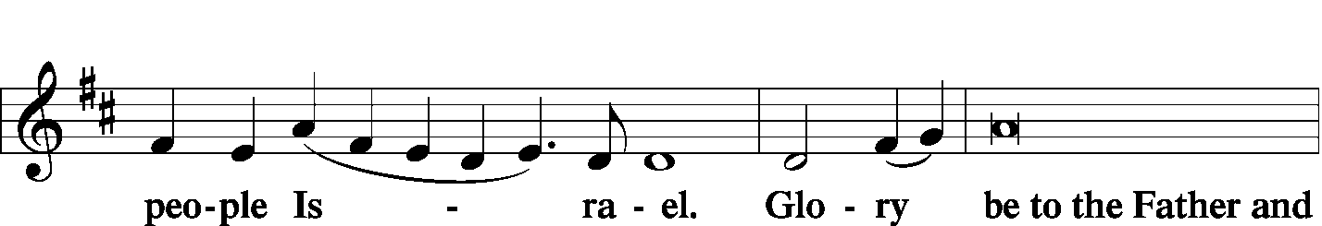
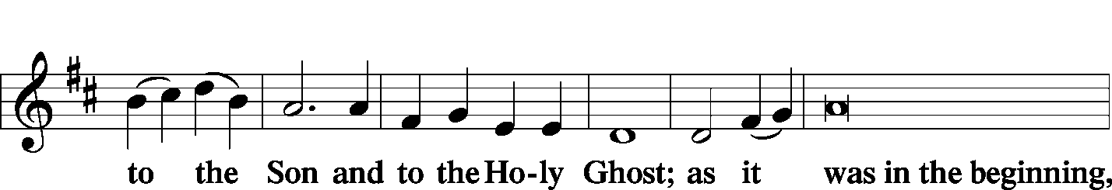
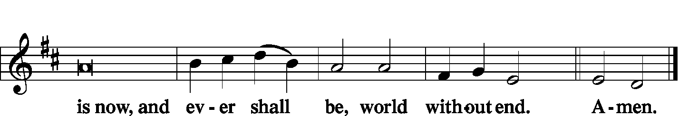
Thanksgiving LSB 200
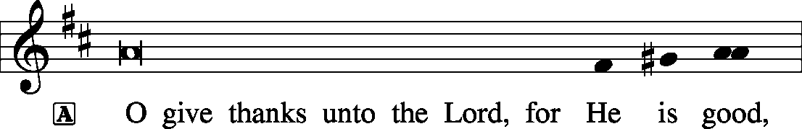

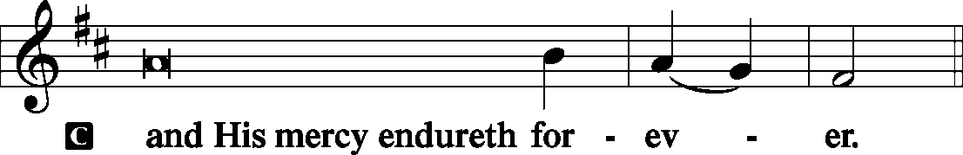

Post-Communion Collect
P Let us pray.
We give thanks to You, almighty God, that You have refreshed us through this salutary gift, and we implore You that of Your mercy You would strengthen us through the same in faith toward You and in fervent love toward one another; through Jesus Christ, Your Son, our Lord, who lives and reigns with You and the Holy Spirit, one God, now and forever.

Salutation and Benedicamus
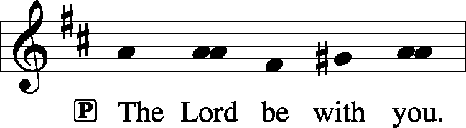
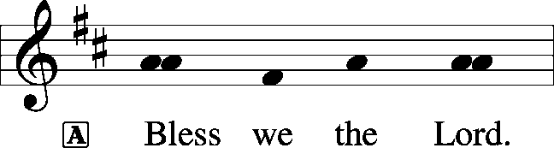

Benediction LSB 202
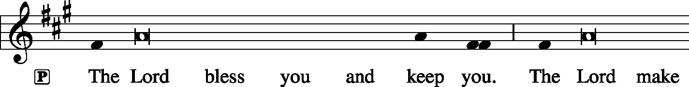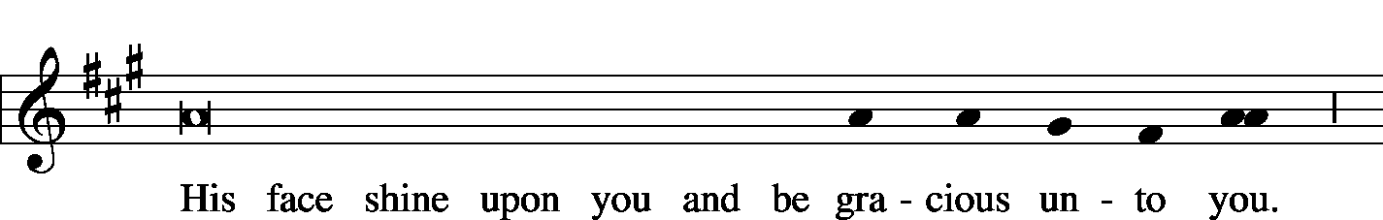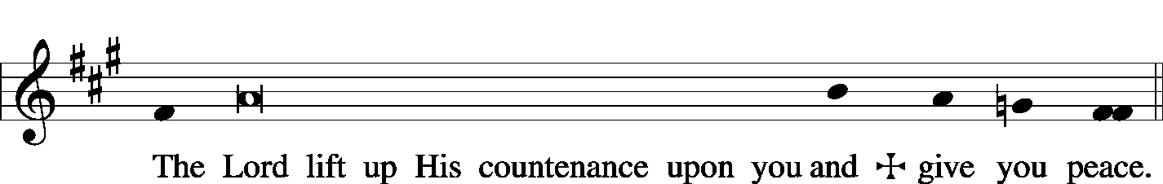

Sit

Hymn On What Has Now Been Sown LSB 921

Postlude On What Has Now Been Sown arr. Deasly

Acknowledgments
Unless otherwise indicated, all scripture quotations are from The Holy Bible, English Standard Version, copyright © 2001 by Crossway Bibles, a division of Good News Publishers. Used by permission. All rights reserved. Created by Lutheran Service Builder © 2006 Concordia Publishing House.

LIFE AND LIVING ITEMS AT ZION
          

YOUTH GROUP MEETING TODAY
Zion's Youth Group Meeting will be held right after church today, February 9th, starting about 11:30 AM. We will gather for a meal of "Tailgate Favorites" brought by families, and the event will also include a devotion and a youth meeting. The meal, devotion, and meeting will take place in the church basement.

SOUP/SALAD LUNCH THANK YOU!
Thank you to everyone who contributed food, money, and attended Ladies Aid’s Soup/Salad Lunch Sunday, Jan 26th, in support of our seminary Adopt-a-Student, Seminarian Brett Jones. It was a wonderful success, and we raised enough to cover our sponsorship of him for this year. Again, thanks for being part of helping him with his goal of becoming a preacher and reaching many souls for Christ.

HELP NEEDED FOR EAST EGG HUNT
Winter is in full swing, and Easter is quickly approaching. The Board of Education is looking for someone to organize and run the Easter egg hunt this year. The date will be Saturday, April 4th. If you are interested, please contact any of the BOE members, Christa Sink, Amanda Ganey, or Marianne McDaniel.
BABY BOTTLE CAMPAIGN
Zion’s Ladies Aid is again this year participating in MOSAIC Pregnancy and Health Centers’ Baby Bottle Campaign. MOSAIC offers a wide variety of free and confidential pregnancy services, sexual health services, and medically accurate abortion information. They reach out to women, men and their unborn babies with free life-affirming medical services and the Gospel of Jesus Christ. Please take a bottle from the cart in the narthex and fill with coins, cash, or a check, and return to Zion by Sunday, February 16th. Please put filled bottles on narthex table, cart, or in church office on Sundays. They will be picked up each week.

PRESCHOOL REGISTRATION FOR THE 2020-21 SCHOOL YEAR
Preschool registration for the 2020-2021 school year has begun. Members of Zion and returning students get first choice of classes. Open Registration for others begins March 1. Pick up forms in the church office or see Marlene Lockwood to obtain forms for yourself or others you know who want a quality Christian education for their young children.

TRIVIA NIGHT BENEFIT FOR BRIAN MOLL
Please join us for trivia night to benefit Brian Moll. The benefit will take place on Saturday, February 22nd at the Mascoutah Sportsmen’s Club, 1535 N. County Rd., Mascoutah. The doors open at 6:15 PM and trivia begins at 7:00 PM. The cost is $100 for a table of 8. Cash prizes will be awarded. There will also be a silent auction (cash and checks only accepted; NO credit cards). Snacks are welcome, but please no drinks. There will be a cash bar. For reservations please mail checks Barb Carstens, 430 Vancroft Place, O’Fallon, IL 62269. Make checks payable to “The B Team”. Deadline for reservations is February 19th.

YOUTH GROUP PUZZLE NIGHT
Do you enjoy building jigsaw puzzles? Then this event is for you! The Annual Puzzle Night will be hosted by Zion Youth Group on Saturday, March 7th. Doors open at 5:30 p.m., competition begins at 6:00 p.m. Tickets are $12 each or $40 for a table of 4. Sign-up/info sheets are in the Narthex. Donations for baked goods to be sold by the youth on the night of the event are greatly appreciated! A sign-up sheet for baked goods is also in the Narthex. Babysitting for a donation is provided for your little ones during the event in the lower level of the church. Please contact Amanda or Mike Ganey if you have any questions. Hope to see you there!

UNITY ASST. PRINCIPAL POSITION OPEN
Unity Lutheran School, East St. Louis, is currently accepting names of candidates for the position of Assistant Principal. The primary purpose of the position is to assist the school principal in overall administration of instructional programs, school operations, and development/financial strategies. Qualifications include being a member in good standing of an LCMS congregation, a minimum of a B.S. or B.A. Degree, and classroom teaching experience of three years. A Commissioned Minister of the LCMS is preferred. Candidate names or resumes may be sent to Rev. Aaron Dickerson at aaron-dickerson@att.net.

MATCHING GRANT AVAILABLE FOR LANSDOWNE COMMUNITY INITIATIVE IN EAST ST. LOUIS
The Lutheran Foundation of St. Louis has blessed Lansdowne Community Initiative (LCI), based out of Unity Lutheran Church in East St. Louis, with a matching grant of $10,000 if an additional $10,000 is raised by September, 2020. Congregations or individuals are allowed to donate up to $1,000 toward this matching fund. LCI is in the process of buying abandoned properties around the church in East St. Louis, rehabbing them, renting them to qualified occupants, and surrounding the process with home ownership training and financial training. For more information about LCI, check out their Facebook page at Lansdowne Community Initiative-LCI. To donate to the $10,000 match, you can contribute through a "Give Now" button on the Facebook page, or by sending a check with "Matching Grant Donation" in the memo line to: Lansdowne Community Initiative, c/o Unity Lutheran Church, 4200 Caseyville Ave., East St. Louis, IL 62204-1807. Thank you in advance for your generous support!

VALENTINES AND WINE WITH UNITY
Celebrate Valentine’s Day with an evening of wine and song on February 14th from 7:00 – 9:30 PM at Meridian Village, Glen Carbon, IL. Enjoy a vast array of wine samples with cheese and crackers. Entertainment will be provided by a vocal quintet led by soprano Katie Schuermann and pianist Jon Vieker, performing many of your favorite songs. Donations for Unity Scholarship Fund will be received at the door. For more information or to make reservations, call the school office at 618-874-6605.

HELP SUPPORT MASCOUTAH FIRST PRIORITY CLUBS
Both Mascoutah High School and Mascoutah Middle School have “First Priority Clubs” to bring Bible study opportunities into the school buildings. The “First Priority Club” at the Mascoutah Middle School meets at 7:15 am on Tuesdays, and the “First Priority Club” at the Mascoutah High School meets at 7:05 am on Thursdays. The groups are in need of donations for snacks for the meetings. Here’s how you can help: donate a monetary donation by check or cash with a memo that it is for club food (Sean Hall, Box 23, Belleville IL 62222). OR visit bit.ly/clubfood to sign up to bring a snack. OR contact Genie White at 618-978-4503 for pick up. Suggestions for donations include: individually wrapped cookies, chips, energy bars, pretzels, breakfast bars, fruit snacks, donuts, Little Debbie’s, OR monetary donations for drinks, napkins, etc.

HAVE YOU EVER CONSIDERED BECOMING A PASTOR OR DEACONESS?
If so, Rev. Scott Holder from Concordia Seminary, St. Louis, would like to meet with you at Lutheran Church of Webster Gardens, 8749 Watson Road, Webster Groves, MO, on Wednesday, February 26, between 3 and 7 PM. Rev. Holder is interested in meeting with prospective students of all ages—elementary school age through adults. Appointments are individual, informal, and family/friends are welcome to come with you. Appointments are not necessary but encouraged. If you are interested in scheduling a specific time, please contact Rev. Holder at 314-505-7225 or holders@csl.edu.

LISTEN TO WORLDWIDE KFUO AM850
KFUO Radio, AM850, a media ministry extension of LCMS congregations, shares Christ for you anytime, anywhere on AM850 via worship services, Bible and theology studies, practical talk programs, and sacred music. You can find programs on demand at kfuo.org and wherever you get your podcasts! Find us on social: @KFUOradio on Facebook, Twitter, and Instagram. This week on KFUO AM850, dig into a Mental Health topic on The Coffee Hour with Deaconess Heidi Goehmann (2/10 at 9:00 a.m.), continue studying the Gospel of Matthew on Sharper Iron (weekdays at 8:00 a.m.), and dive in-depth into our Lutheran Confessions on Concord Matters (2/11 at 2:00 p.m.). Find your favorite programs on demand at kfuo.org!

WHERE CHRISTIANITY MEETS CULTURE
Issues, Etc. is a radio talk show and podcast produced by Lutheran Public Radio in Collinsville, IL and hosted by LCMS Pastor Todd Wilken. This week's subjects include: Defending Boyhood, The Academy Awards, The Death of Education, Rebuilding Institutions and more. You can tune in live weekdays from 3-5 p.m. on KFUO, 850 AM in St. Louis. You can also listen on-demand at issuesetc.org and on the LPR mobile app.
THE FLOWERS ON THE LORD’S ALTAR
The flowers on the Lord’s altar are given to the glory of God by Kim Drinnon in loving memory of Berniece Shaffer.

THOSE WHO SERVE TODAY
Proclaimer: Rev. Kirk Clayton
Liturgist: Sem. Don Stein
Organist: Nancy Peterson
Ushers: Andy Sax, Tom Sax, Matt Sink, & Torri Suedmeyer
Sound Tech: Alex Tubbs
Video Tech: Mark Hatcher
Welcome Team: Eldon Ahner & Stacia Ahner
Acolytes: William Bretz & Rainer Bretz
Altar Guild: Gail Frey

THOSE WHO SERVE NEXT WEEK, FEBRUARY 16
Proclaimer: Rev. Kirk Clayton
Liturgist: Sem. Don Stein
Organist: Nancy Peterson
Ushers: Lionel Timmerman, Alex Tubbs, Mike Twenhafel,
& Terry Twenhafel
Sound Tech: Mark Krausz
Video Tech: Mark Hatcher
Welcome Team: Ted & Dawn Ahner
Acolytes: Ella Bretz & Daniel Bretz

THINGS WE ARE DOING AT ZION
Sun. Confirmation Class 8:30 AM
SS & Bible Class 8:45 AM
Worship DS III w/communion 10:00 AM
Men’s Club 6:30 PM
Mon. ECHO DEADLINE
LifeLight 7:00 PM
Tues. Evangelism 7:00 PM
Wed. Choir Rehearsal 7:00 PM
Fri. Senior Meal Delivery 10:30 AM
Prom Dress Sale Set-up 6:00 – 9:00 PM
Sat. Prom Dress Sale 10:00 AM – 2:00 PM
Sun. Confirmation Class 8:30 AM
SS & Bible Class 8:45 AM
Worship Matins 10:00 AM

ATTENDANCE FEBRUARY 2: Sunday: 178
Adult Bible Class: 19 High School: 6 Sunday School: 35

